INTERNATIONAL ELECTROTECHNICAL COMMISSION SYSTEM FOR CERTIFICATION TO STANDARDS RELATING TO EQUIPMENT FOR USE IN EXPLOSIVE ATMOSPHERES (IECEx SYSTEM)

TITLE: IECEx Assessment Report for the acceptance of LabTest Certification Inc., Canada as an Accepted IECEx Certification Body (ExCB) within the
IECEx System

Circulation to: Members of the IECEx Management Committee, ExMC

INTRODUCTION

This document contains the IECEx Assessment Report for the acceptance of LabTest Certification Inc., Canada as an Accepted IECEx Certification Body (ExCB) within the IECEx System.

This report is hereby submitted for consideration during the ExMC Fortaleza Meeting.

Chris Agius

IECEx Secretariat

Address:  SAI Global Building  286 Sussex Street  Sydney NSW 2000  Australia | Contact Details:  Tel: +61 2 8206 6940  Fax: +61 2 8206 6272  e-mail: chris.agius@iecex.com  http://www.iecex.com

IECEx ASSESSMENT REPORT FOR
LabTest Certification Inc., Richmond, British Columbia, Canada
(IECEx Certification Body ExCB)

Type of Assessment:

Initial Assessment for Candidate ExCB X

Re-Assessment of ExCB

Scope Extension of ExCB

- OBJECT AND FIELD OF APPLICATION

  - Country:

Canada

  - Name of Candidate ExCB

LabTest Certification Inc.

  - Members of the Assessment Team

Heinz Berger – IECEx Officer - IECEx Lead Assessor
Herbert Peters – IECEx Expert Assessor

  - Places and Dates of Assessment

3133-20800 Westminster Hwy.
Richmond, British Columbia
V6V 2W3
Canada

October 24th – 26th, 2011, September 11th - 12th, 2012 and April 8th - 10th, 2013

  - Assessment References

- IECEx 02 Equipment Scheme Rules (current version)
- IECEx OD 003 Assessment Procedures (current version)
- IECEx OD 005-1, -2 and -3; Manufacturer Assessment (current versions)
- IECEx OD 009 Equipment Scheme Procedures(current version)
- IECEx OD 007 Checklist Guide 65 (current version)
- IECEx OD 017 Drawings and Documentation(current version)
- IECEx OD 024 Witness Testing/manufacturers and users Facility
- IECEx OD 025 Guidelines Manufacturer Assessments(current version)
- IEC 80079-34 Explosive atmospheres - Part 34: Application of quality systems for equipment manufactures
- IECEx Document F-001 (QAR Form)
- ISO/IEC Guide 65:1996
- ExCB application documents dated June 19th, 2011
- Application for additional standards dated July 24th, 2012
- Application for an additional standard (60079-18) as per Email dated September 10th, 2012
- Application for additional standards (60079-1 and 60079-31) dated February 10th, 2013

  - Scope of Application

Number | Title | Acceptance
60079-0  Edition 5  Edition 6 | Explosive atmospheres -  Part 0: Equipment - General requirements | YES
60079-1  Edition 6 | Explosive atmospheres -  Part 1: Equipment protection by type "d" | YES
60079-2  Edition 4  Edition 5 | Explosive atmospheres -  Part 2: Equipment protection by pressurized enclosures 'p' | YES
60079-6  Edition 2  Edition 3 | Explosive atmospheres -  Part 6: Equipment protection by oil immersion 'o' | YES
60079-11  Edition 6 | Explosive atmospheres -  Part 11: Equipment protection by intrinsic safety 'i' | YES
60079-15  Edition 3  Edition 4 | Explosive atmospheres -  Part 15: Equipment protection by type of protection 'n' | YES
60079-18  Edition 2  Edition 3 | Electrical apparatus for explosive gas atmospheres -  Part 18: Construction, test and marking of type of protection encapsulation 'm' electrical apparatus | YES
60079-31  Edition 1 | Explosive atmospheres -  Part 31: Equipment dust ignition protection by enclosure "t" | YES

  - Candidate ExCB Persons Interviewed

Name | Position
Kavinder Dhillon | Certification Manager
Ruben Ugarte | Quality Manager
Sandeep Bhayana | Safety Testing Manager
Douglas Kirk | Project Handler
Amreen Grewal | Project Handler

  - Legal Entity of the Candidate ExCB

LABTEST CERTIFICATION INC. is incorporated under the laws of British Columbia, Canada, under the number 673313 since July 11th, 2003. The document was checked during the assessment and found to meet the requirements of the IECEx.

  - Associated Testing Laboratories

The ExTL is integral with the ExCB.

  - Associated Certification Functions

- EMC (Industry Canada)
- EMC (FCC testing)
- SRCC (Solar panels)
- SCC (Sanitary equipment)
- SCC (Gas appliances)
- SCC (Energy efficiency)

  - National Marks and Certificates

- LC Certification Mark belongs to LABTEST and is recognized by the Standards Council of Canada
- EMC (Industry Canada) 
- EMC (FCC Testing)

  - Financial Support

LABTEST Certification Inc. is self-financed by its income from testing, certification and inspections.

  - History

LabTest was incorporated under the laws of British Columbia, Canada, July 2003. Its principal line of business was product safety testing, soon after the incorporation LabTest was qualified and accepted as testing subcontractor by several international certification bodies. (CSA, UL, TÜV Rheinland and SÜD, and DNV)
In February 2007 LabTest was accredited by International Accreditation Service (IAS) for electrical safety, EMC, environmental & energy, and maritime product evaluation and testing to ISO 17025.

In July 2007, LabTest was accredited by the Standards Council of Canada (SCC) for electrical safety certification under ISO Guide 65, in April 2011 LabTest acquired accreditation to 17020 as an Inspection Body.

  - Standards Accepted

See clause 1.6 of this report.

  - National Differences to IEC Standards

Please refer to the latest IECEx Bulletin for national differences of Canada and the USA.

- ORGANISATION

  - Names, Titles and Experience of the Senior Executives

Name | Title | Experience Ex/Overall
Kavinder Dhillon | President and CEO, Certification Manager | 18 years in Ex, 21 years Certification and testing, considerable managerial experience operating accredited organization.

  - Name, Title and Experience of the Quality Management Representative

Name | Title | Experience
Ruben Ugarte | Quality Manager | 3 years Certification and Testing, 7 years Quality ISO 9001
Kavinder Dhillon | Deputy Quality Manager | 18 years in Ex, 21 years Certification and Testing, considerable managerial experience operating accredited organization.

  - Name and Title of Nominated Principal Contact

Name | Title | Comments
Kavinder Dhillon | Certification Manager | kdhillon@labtestcert.com

  - Name and Title of Signatories for Certification

Name | Title | Comments
Kavinder Dhillon | Certification Manager | kdhillon@labtestcert.com
Sandeep Bhayana | Safety Testing Manager | sbhayana@labtestcert.com

  - Other Employees in ExCB activity

Name | Title | Responsibility and Experience in Ex
Sandeep Bhayana | Safety Testing Manager | Training and Project handling Since 2006
Ruben Ugarte | P. Eng; Quality Manager | Quality System; under training in Ex
Douglas Kirk | Project Handler | Project Evaluation; 10 years intrinsic safety developments
Amreen Grewal | EIT; Project Handler | In Training
Ron Webb | Contractor | About 35 years in Ex

  - Organizational Structure

See attached organization charts in ANNEXES 1a and 1b

  - Administration (including Indemnity Insurance)

The ExCB is supported by two secretaries.

LABTEST Certification Inc. holds a "Professional Liability Insurance Policy" from South Western Group Ltd, Canada trough HUB International Insurance Brokers (TOS). The policy number is LM 0187. The current contract covers the period of March 24th, 2013 to March 24th, 2014, and can be renewed every year. The contract was checked during the assessment and found to meet the requirements of the IECEx.

- RESOURCES

Eleven persons are active in the IECEx field including administration personnel.

- COMMITTEES / Governing Board / Appeals / Advisory Board

- Canadian Advisory Council on Electrical Safety (CACES)
- LabTest Certification Advisory Committee (LCAC)

All information concerning the Advisory Committee (LCAC) was provided by LabTest Inc., checked and found to meet the requirements of the IECEx.

- CERTIFICATION OPERATIONS

  - National Approval/Certification Methods

There is National Certification Body Program for hazardous locations equipment according to the Standards Council of Canada.

  - Certification Policy

2001 Policy Manual, Certification section 4.5, LabTest Quality System. The content of this chapter was checked during the assessment and found to meet the requirements of the IECEx.

  - Application for Certification

2001 Policy Manual, Certification section 8, Application for LabTest Certification. The content of this chapter was checked during the assessment and found to meet the requirements of the IECEx.

  - Certification Decision

Certification decision is described in the 2001 Policy Manual in chapter 4.6. The content of this chapter was checked during the assessment and found to meet the requirements of the IECEx. A review of the procedures shows a clear separation between the activities of testing and the certification decision.

  - Suspension and Cancellation of Certificates

Suspension and Cancellation of Certificates is described in the 2001 Policy Manual in chapter 4.6. The content of this chapter was checked during the assessment and found to meet the requirements of the IECEx.

STATISTICS

- Certificates Issued
Number of certificates issued under the IECEx (if any) and/or national/regional schemes in the preceding four years for each type of protection:

Standards | Title | Number of issued certificates
 |  | 2008 | 2009 | 2010 | 2011/  2012/  2013 | Total
60079-0 | Explosive atmospheres -  Part 0: Equipment - General requirements |  |  |  |  | Part 0 included in numbers below
60079-1 | Explosive atmospheres –Part 1: Equipment protection by type "d" | --- | --- | 1 | 1 | 2
60079-2 | Explosive atmospheres - Part 2: Equipment protection by pressurized enclosures 'p' | --- | --- | --- | 2 | 2
60079-6 | Explosive atmospheres - Part 6: Equipment protection by oil immersion 'o' | 1 | --- | --- | 7 | 8
60079-11 | Explosive atmospheres - Part 11: Equipment protection by intrinsic safety 'i' | --- | --- | 1 | 2 | 3
60079-15 | Explosive atmospheres - Part 15: Equipment protection by type of protection 'n' | 2 | 2 | 1 | 6 | 11
60079-18 | Electrical apparatus for explosive gas atmospheres -  Part 18: Construction, test and marking of type of protection encapsulation 'm' electrical apparatus | --- | --- | --- | --- | 0
60079-31 | Explosive atmospheres - Part 31: Equipment dust ignition protection by enclosure "t" | --- | --- | --- | 1 | 1

- DOCUMENTATION

  - Quality Manual

There are two quality manuals. One is related to certification and inspection (Guide 65), the other quality manual concerns testing and evaluation (ISO/IEC 17025).

- Document # 2001: Policy Manual Certification and Inspection
- Document # 1003: Policy Manual Laboratory Program Testing and Evaluation

The quality manual, sub-manuals, procedures, forms, etc, are available to all personnel through a web interface (Intranet). The latest version document is available and documents are protected from alteration. Search function is provided by document number or keyword.

Parts of the quality manuals and selected procedures were checked during the assessment and found to meet the requirements of the IECEx.

  - Procedures

All relevant procedures can be found in the two quality manuals. Some of them were checked during the assessment and found to meet the requirements of the IECEx. Document # 1000 gives a comprehensive overview of procedures and forms.

  - Work Instructions

Work instructions are used minimally as most procedures are covered in the procedures and data sheets such as document 1060 "Uncertainty Estimating Worksheet". Other documents will be created as required.

  - Records

Records are retained according to retention policy based on type of record.
Test records and projects are maintained on a secured site password protected and accessible by authorized persons only.

  - Document Change Control

Document control is described in a subdocument carrying the number 1027. The last version (Rev. 3, dated 2011-02-02) was checked during the assessment and found to meet the requirements of the IECEx.

- CONFIDENTIALITY

The confidentiality issue is described in # 2001 quality manual in chapter 4.10. Several documents are available such as "1019 Subcontractor Agreement", 1039 Service Agreement, dealing with confidentiality. The content of this clause was checked during the assessment and found to meet the requirements of the IECEx.

A number of CV's were checked and properly signed and confidentiality agreements were found in the employment documentation.

- PUBLICATIONS

LabTest Inc. is presented on the Internet under www.labtestcert.com. Printed brochures are available as well.

- NATIONAL ACCREDITATION

LabTest Inc. holds an accreditation as a Certification Body (ISO/IEC Guide 65) from SCC (Standards Council of Canada). The accreditation number is 1003-10/52. The initial accreditation date is 2007-07-18. The current accreditation is valid until 2015-07-31. Ex equipment is covered by this accreditation. See ANNEX 2 for the certificate. The next surveillance audit is scheduled for August, week of the 12th, 2013.

SCC CB certificate

LabTest also holds accreditation according to ISO/IEC 17020 (Inspection Body), issued by the Standard Council of Canada under the number 1003-6/18. It is valid until April 2015. See ANNEX 3 for the certificate. The next surveillance assessment is scheduled for May 23rd and 24th, 2013.

- RECOGNITION AND AGREEMENTS

There are presently two agreements in the area of Ex. DNV (Norway), Intertek UK.

- INTERNAL AUDIT AND PERIODIC MANAGEMENT REVIEW

Internal audits are described in the # 2001 quality manual in chapter 4.7. The audit plan for 2013 was presented. The audits will be performed until the end of September 2013.

Management reviews are described in the # 2001 quality manual in chapter 4.7. The last management meeting was held on December 11th, 2012. The minutes were reviewed during the assessment. The next meeting is scheduled for June 2013. It is planned to perform two management meetings per year.

- SUBCONTRACTING, USE OF OTHER LABS AND USE OF OTHER LOCATIONS

LabTest Inc. uses subcontracting for standard IEC 60079-0, clause 26.10 (UV).

- TRAINING

The issue of training is described in the # 2001 quality manual in chapter 5.2. A comprehensive training concept was presented during the assessment and found to meet the requirements of the IECEx. By checking the CVs of employees training records were found. Furthermore, an extensive technical training was performed in November 2012 by a well experienced person active in the IECEx System for many years.

- ASSESSMENT OF MANUFACTURERS AND ISSUE OF QARS

At present LabTest Inc. does not perform QAR assessments by its personnel. However, a well qualified person is under contract acting as QAR auditors and QAR reviewers. The contractor is listed on the list of contractors and subcontractors.

It is the intention of LabTest Inc. to train its own personnel in order to qualify them as QAR assessors in the IECEx 02 scheme. This will be carried out with the help of the contractor.

- COMPLAINTS AND APPEALS (Including appeals to IECEx)

Complaints and appeals are described in the # 2001 quality manual in chapter 7. The content of this chapter was checked and found to meet the requirements of the IECEx.

- SPECIAL FACTS TO BE NOTED

  - Supporting Documentation

Copies of additional supporting information for this assessment have been provided to the applicant and the IECEx Secretariat. These include:

- Details of issues raised and how these have been resolved
- Competence Matrix
- List of Subcontractors and Contractors
- Checklist for ISO/IEC Guide 65

- COMMENTS (Including issues found during assessment)

During the assessment several non conformances were found concerning the advisory board, the accreditation, the IECEx certification policy and subcontracting. All open issues were resolved to the satisfaction of the assessment team.

- RECOMMENDATION

Based on the initial assessments performed from October 24th to 26th, 2011, September 11th & 12th 2012 and April 8th to 10th, 2013, the ExCB of LabTest Inc. is recommended for acceptance in the IECEx Scheme as an IECEx Certification Body (ExCB) according to the scope of the standards listed in this document .

Lead Assessor  Heinz Berger | Expert Assessor  Herbert Peters

Dates: October 26th, 2011, September 12th, 2012 and April 10th, 2013

List of Annexes:

Annex 1a: Overall Organization Chart of LabTest Inc.
Annex 1b: Organization Chart of Ex activities
Annex 2: Accreditation Certificate for ExCB of LabTest Inc. for ISO/IEC 65
Annex 3: Accreditation Certificate Inspection Body of LabTest for ISO/IEC 17020

ANNEX 1a: Overall Organization Chart of LabTest Inc.

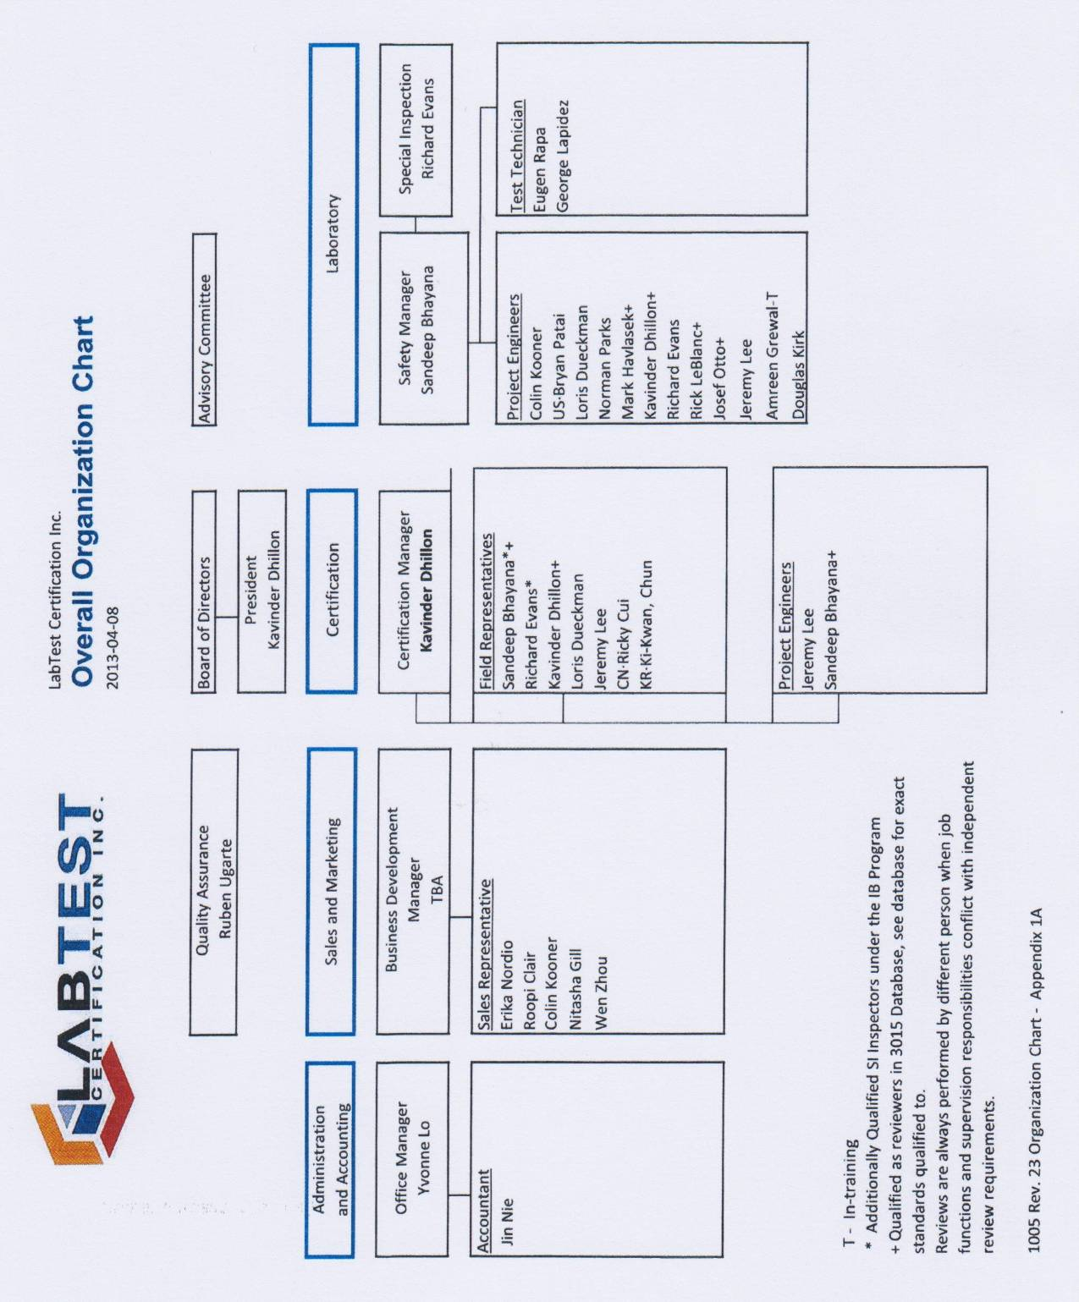

ANNEX 1b: Organization Chart of Ex activities

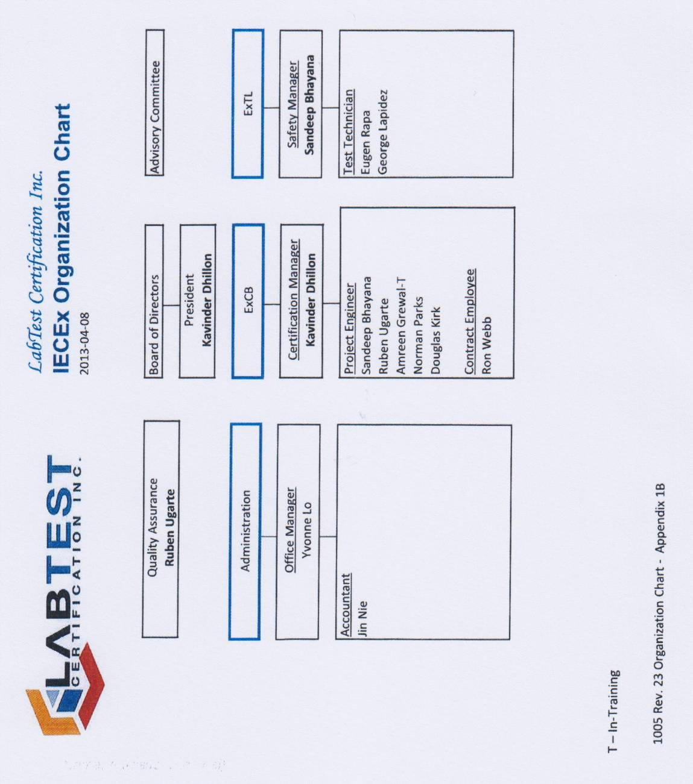

ANNEX 2: Accreditation Certificate for ExCB of LabTest Inc. for ISO/IEC 65

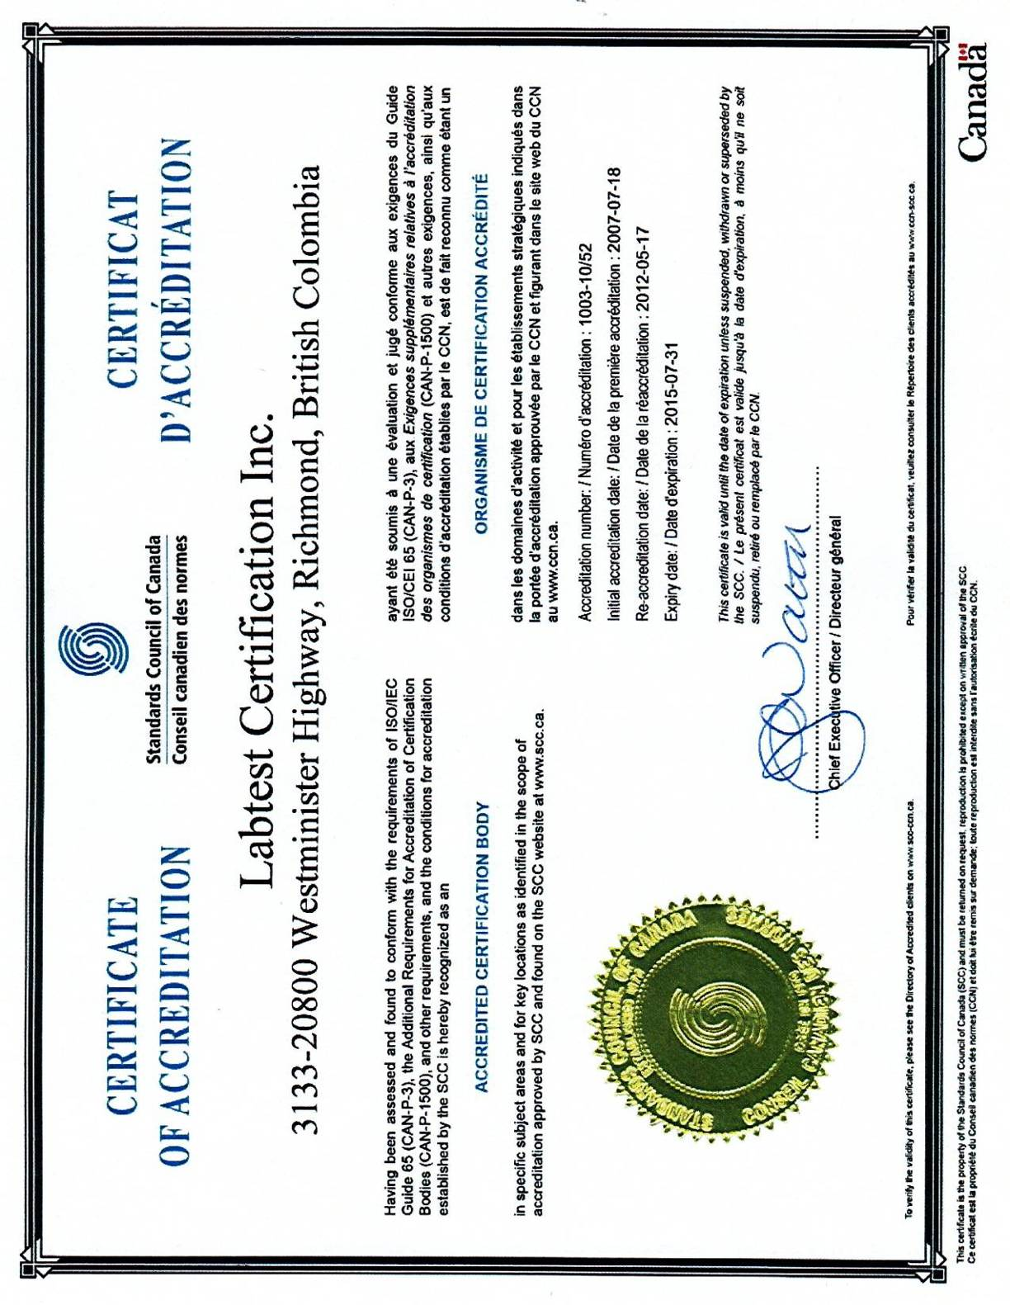

Annex 3: Accreditation Certificate Inspection Body of LabTest for ISO/IEC 17020

