INTERNATIONAL ELECTROTECHNICAL COMMISSION SYSTEM FOR CERTIFICATION TO STANDARDS RELATING TO EQUIPMENT FOR USE IN EXPLOSIVE ATMOSPHERES (IECEx SYSTEM)

TITLE: Re-assessment Report for the continued acceptance of IECEx ATF Intertek Italia SpA, Italy

Circulation to: Members of the IECEx Management Committee, ExMC

INTRODUCTION

In accordance with the 5 Year re-assessment plan for the surveillance and monitoring of bodies within the IECEx System, the following document contains the IECEx Re-assessment Report for the continued acceptance of IECEx ATF Intertek Italia SpA, Italy.

This report is hereby submitted for endorsement during the 2026 ExMC Beijing Meeting.

Chris Agius

IECEx Secretariat

Address:  Level 17, Angel Place  123 Pitt Street  Sydney NSW 2000  Australia | Contact Details:  Tel: +61 2 46 28 4690  Fax: +61 2 46 27 5285  e-mail: info@iecex.com  http://www.iecex.com

IEC System for certification to standards relating to equipment for use in Explosive Atmospheres (IECEx System)

IECEx Assessment Report Form, F-003

IECEx assessment report form for use by IECEx assessment teams to report assessments conducted according to the relevant IECEx assessment procedures of:

Operational Document IECEx OD 003-2 for the Certified Equipment Scheme

Operational Document IECEx OD 316-* for the Certified Service Facility Scheme

Operational Document IECEx OD 422 for the IECEx Conformity Mark Licensing Scheme

Operational Document IECEx OD 501 for the Personnel Competence Scheme

IECEx ATF assessment report for Intertek Italia SpA, Italy

INTERNATIONAL
ELECTROTECHNICAL
COMMISSION

CONTENTS
(Update when report is complete – by right click, Update field, Update entire table)
1 Assessment information 5
1.1 Type of body covered by this assessment: 5
1.2 Type of assessment: 5
1.3 Details of body 5
1.3.1 Country 5
1.3.2 Name of body 5
1.3.3 Name and title of nominated principal contact 5
1.4 Assessment information 5
1.4.1 Members of the assessment team 5
1.4.2 Place(s) of assessment 5
1.4.3 Assessment date(s) 6
1.5 Application information and background information on the assessment 6
1.6 Scopes 6
1.6.1 ExCB scope for equipment certification scheme 6
1.6.2 ExTL scope 6
1.6.3 ATF Scope 6
1.6.4 ExCB scope for Service Facilities Scheme 6
1.7 ExCB scope for Conformity Mark Licensing Scheme 6
1.8 ExCB scope for IECEx Personnel Competence Scheme 6
2 Common information 7
2.1 Legal entity of body 7
2.2 Financial support 7
2.3 History 7
2.4 Documentation 8
2.4.1 Quality manual 8
2.4.2 Procedures 8
2.4.3 Work instructions 8
2.4.4 Records (including test records where relevant) 9
2.4.5 Document change control 9
2.5 Confidentiality 9
2.6 Communication with public and customers (Hard copy and Electronic) 9
2.7 Recognitions and agreements 9
2.8 Internal audit 10
2.9 Management review 10
2.10 Contracting, subcontracting and witness testing 10
2.10.1 Contracting 10
2.10.2 Subcontracting 10
2.10.3 Off-site and Witness testing 10
2.11 Training and competence 10
2.12 Complaints and appeals (including appeals to IECEx) 11
2.13 Impartiality 11
2.14 Active involvement in development of Decision Sheets 11
2.15 Special facts to be noted 11
2.16 Supporting documentation 11
2.17 Recommendations 12
3 ExCB for IECEx Certified Equipment Scheme 13
4 ExTL for IECEx Certified Equipment Scheme 13
5 ATF for IECEx Certified Equipment Scheme 13
5.1 Assessment references 13
5.1.1 General references 13
5.1.2 Additional references applied for this assessment 13
5.2 Candidate ATF persons interviewed 13
5.3 Associated ExTL 13
5.4 Organisation 14
5.4.1 Names, titles and experience of the senior executives 14
5.4.2 Name, title and experience of the quality management representative 14
5.4.3 Other employees in ATF activity 14
5.5 Organizational structure 14
5.6 Resources 14
5.7 Test reports issued 14
5.8 National accreditation 15
5.9 Calibration 15
5.10 Tests witnessed during the assessment visit 15
5.11 Participation in IECEx Proficiency Testing Programs 16
5.12 Comments (including issues found during assessment) 17
6 ExCB for Certified Service Facilities Scheme 17
7 ExCB for IECEx Personnel Competence Scheme 17
8 Annexes 17
Annex A Scope for IECEx Certified Equipment Scheme 18
A.1 Current standards 18
Annex B Overall Organisation Chart 19
Annex C Organisation Chart of ATF 21
Annex D Accreditation Certificate for ISO/IEC 17025 22

Assessment information

Type of body covered by this assessment:
ExCB for IECEx Certified Equipment Scheme
ExTL for IECEx Certified Equipment Scheme
ATF for IECEx Certified Equipment Scheme
ExCB for IECEx Certified Service Facilities Scheme
ExCB for IECEx Conformity Mark Licensing System
ExCB for IECEx Certification of Personnel Competency Scheme

NOTE 1 ExCB - IECEx Certification Body
NOTE 2 ExTL - IECEx Testing Laboratory
NOTE 3 ATF - Additional Testing Facility

Type of assessment:
Pre-assessment for candidate body
Initial assessment for candidate body
Surveillance
Re-assessment
Scope extension

Details of body

Country
Italy

Name of body
Intertek Italia SpA, Italy, hereafter referred to “ITS Italy”, operating as an additional testing facility (ATF) of Intertek Testing and Certification Ltd, UK (ITS UK).

Name and title of nominated principal contact
Name | Title | E-mail address
Adrian Smart | Senior Consultant Engineer / Head of Approved Body | adrian.smart@intertek.com

Assessment information

Members of the assessment team
Name | Role
Jianping Xu | IECEx Lead Assessor

Place(s) of assessment
Intertek Italia SpA  An ATF under control of Intertek Testing and Certification Ltd UK (ITS UK)  Note: This reassessment was conducted at the operational site of the ATF. | Operational site of the ATF:  Intertek Italia SpA Electrical  Via Principe di Udine, 114  33030 Campoformido (UD), Italy  Registered address:  Intertek Italia SpA  Via Guido Miglioli, 2/A  20063 Cernusco sul Naviglio (MI), Italy

Assessment date(s)
6 - 8 October 2025

Application information and background information on the assessment
It is an on-site IECEx re-assessment of the additional testing facility (ATF), which is supervised by the ExTL - Intertek Testing and Certification Ltd UK (ITS UK).
This assessment was conducted based on existing scope with updates to latest editions of standards as indicated in Annex A.
ITS Italy submitted a request for the updates via Form F-011, which was endorsed by its supervising ExTL (ITS UK) and subsequently acknowledged by IECEx secretariat.

Scopes

ExCB scope for equipment certification scheme
Not applicable for this assessment.

ExTL scope
This is not applicable for the present assessment, however it has been confirmed that all the standards within the ATF as listed in Annex A fall within the scope of the supervising ExTL (ITS UK).

ATF Scope
The scope for the ATF is shown in Annex A.

ExCB scope for Service Facilities Scheme
Not applicable for this assessment.

ExCB scope for Conformity Mark Licensing Scheme
Not applicable for this assessment.

ExCB scope for IECEx Personnel Competence Scheme
Not applicable for this assessment.

Common information

Legal entity of body
Intertek Italia SpA (ITS Italy) is legally registered in following address, with registration number AC21MWS7YCF2D9102D56E.
Via Guido Miglioli, 2/A
20063 Cernusco sul Naviglio (MI), Italy
The business scope of Intertek Italia SpA covers various tests for a wide range of equipment, including basic safety and essential performance, electrical, medical, EMC, lighting, gas and etc.
The testing laboratory for operation of electrical business including the Ex testing laboratory (Intertek Italia SpA Electrical) resides at Via Principe di Udine, 114, 33030 Campoformido (Udine). The testing laboratory address is covered by the registration document.

Financial support
ITS Italy as well as its supervising ExTL (ITS UK) are a self-financing test and certification company.

History
The electrical laboratory of “Intertek Italia S.p.A.” operating in Campoformido Udine Italy, started its activities in year 2000 when Intertek Group acquired the EMC laboratory of Electrolux already operating in the actual building. The laboratory operated under the legal entity “Intertek Testing Services (Italy) S.r.l.” as Competent Body for the EMC EU Directive 89/336 for CE Mark. In the beginning of year 2001, the laboratory expanded its activities to electrical safety, testing products for Intertek ETL Mark for North America Market. In year 2005 started energy performance testing.
From January 2005 to December 2006 the laboratory operated under the legal entity “Intertek ETL Semko (Italy) S.r.l.”, from January 2007 to December 2013 under the legal entity “Intertek ITALIA S.r.l.”, and finally since January 2014 under the legal entity “Intertek Italia S.p.A.”.
In August 2010, the laboratory got the approval as CBTL laboratory for the IECEE CB Scheme under the NCB Intertek Semko AB.
In December 2010 the laboratory has been accredited by IAS according ISO/IEC 17025 for Energy Star program requirements for Clothes Washers, Dishwashers, Refrigerators/Freezers, and Commercial Refrigerators and Freezers. The initial accreditation scope has then been expanded for electrical safety for Appliances; Luminaires; Information Technology Equipment; Measurement, Control and Laboratory Use Equipment; Medical Electrical Equipment; Explosive Atmospheres Testing.
In 2011 the laboratory got the approval as testing laboratory for GS Mark and in 2012 for the ENEC mark.
The Ex Testing Laboratory at Intertek Italia SpA Electrical has been completed and started operations in 2013 in liaison with Intertek Testing and Certification Ltd, UK. These operations cover ATEX and Hazloc activities for equipment used in explosive atmospheres.
Since 2015, ITS Italy operates as an ATF under IECEx system, with control by Intertek Testing and Certification Ltd, UK, as a supervising ExTL (ITS UK).
For the purpose of the IECEx Scheme, ITS Italy operates according to the procedures of ITS UK (Accepted ExTL).

Documentation

Quality manual
The complete set of “GMS - Global Management System Documents” that are used at corporate level throughout Intertek, worldwide are applicable to Intertek Italia SpA and are available on the company intranet.
Following this assessment, another set of 8 “SMS - Global Specific Management System Documents – IECEx” is now applicable to the Ex Activities both at UK level and Italy. This addresses the main elements of ISO/IEC 17025 and also addresses IECEx Scheme rules and relevant requirements from IECEx.
More locally, a set of “LMS Italy - Facilities Maintenance / Calibrations” completed by a set of LMS Italy - Operations & Certification / Conformity Assessment & Performance documents e.g.: LMS-EMEA-IT-OP-07-1 titled “IECEx Applicable UK Work Instructions”. This LMS procedure is a complement to GMS-OP-07 outlining the UK Work Instructions and variants to be applied by Intertek Italy as additional testing facility (ATF) for the IECEx 02 Scheme under the ITS UK.
The quality systems are based on, and compliant with ISO/IEC 17025, IECEx rules and procedures, in noting that the relevant IECEx rules and operational procedures were properly incorporated within Intertek Quality Management System. All the documents are available on the Intertek Intranet at the page “Management System Documents Master List”.

Procedures
More detail under the quality systems is included in specific procedures relevant to the quality system. These all apply to Intertek Italia SpA Electrical. Procedures that are used for Testing are usually adopted without modifications from Intertek Testing and Certification Ltd, UK or may be variants produced by Intertek Italia SpA Electrical ATEX/Hazloc BU taking in consideration local features. But any such variants for local conditions must be approved by Intertek UK before being used.
For operation of IECEx testing and certification within Intertek, there is a dedicated global testing procedure SMS-IECEx-OP-19 IECEx Certified Equipment Scheme at revision date 21 March 2023, which is also used at Intertek Italia SpA Electrical for implementation of all the relevant IECEx rules and operational procedures by direct links to the IECEx Webpages. This fulfils the requirements of IECEx.

Work instructions
Each department at Intertek Italia SpA Electrical maintains its own documents relevant to their specific area of testing. This applies to the Ex activities. The work instructions relevant to the proposed IECEx work by Intertek Italia SpA Electrical are normally copied directly from the Intertek Testing and Certification Ltd, UK work instructions as mentioned above. Modifications may be made to make the instructions relevant to the actual equipment at Intertek Italia SpA Electrical. The work instructions taken from Intertek Testing and Certification Ltd, UK cover both testing and assessment procedures. These work instructions formally became part of the Intertek Italia SpA Electrical Quality System in October 2013, when published by Intertek Testing & Certification Ltd on the global intranet. In complement to the existing local Ex Working Instructions, a complete set of Work Instructions is available and is maintained updated with the global ones. All are to be approved by Intertek Testing and Certification Ltd, UK before being used.
At the time of this site assessment, there are 24 local procedures and work instructions according to the document “Italy - ExATL Local Procedures/ Work Instructions Master List” dated 18 September 2025, which covers specific localized testing instructions including IP tests, flammability test, calibration of oxygen analyser before use for explosion tests, spark ignition test, surface resistance measurement, datasheet templates and project notebook (Hazloc) and etc.
Examples of these work instructions were reviewed, revealing that some specifications therein did not accurately align with those as set out in the relevant standards, nor did they properly reference the latest editions of the IEC 60079 standards. This has subsequently been resolved to the satisfaction of the assessment team.

Records (including test records where relevant)
The procedures GMS-FM-15Control & Disposal of Records at revision date 3 October 2023 and GMS-FM-16Project File Transfer Between Offices/Sites at revision date 3 October 2023 specify the way the records are controlled for keeping format, duration and record transfer), and require a minimum ten-year retention time after certification termination for all the product testing and certification records. In addition, the assessor noted that the dedicated procedure SMS-IECEx-OP-19 IECEx Certified Equipment Scheme is referred to OD 207 Guidance on the Retention of Records for completion of IECEx requirements on retention time.
Intertek Italia SpA Electrical complies to the GMS procedures for keeping jobs and storing data associated with them. In this document, modifications of electronic documents are done in a controlled manner. Test plans, Datasheets and TRs are kept in electronic format in the Intertek Testing and Certification Ltd, UK server and in the local server of Intertek Italia SpA Electrical (this according to the procedure LMS-EMEA-IT-FM-15 and LMS-EMEA-IT-OP-19-4 (Italy – IECEx Testing under Intertek UK TL and CB)).
Example of records were checked and satisfactory. All the electronic records are kept in computer server with access controlled and subjected central IT backup by Intertek IT department.

Document change control
All quality documents reside on the Intranet. The procedure GMS-QC-16 Control of Intertek Issued Controlled Document at revision date 3 October 2023 describes the document change control process, which applies to all documents and records, including internal quality documents and external standards used for testing, certification and inspection services. The control of the electronic Global Management System is specifically addressed in the procedure GMS-QC-21 Management System Document Issuance and Change Process at revision date 3 October 2023.

Confidentiality
The ATF implements the global procedure GMS-QC-04 Protection of Client Confidential Information and Proprietary Rights at revision date 3 October 2023, which describes the confidentiality issue for all staff including new employees.
Each employee must attend an on-line training with final exam about the Code of Ethics and Anti-bribery guidance. The exam shall be repeated every year. Each employee signs a code of conduct, HR Form.
Examples of signed documents and exam records were reviewed during the assessment, and found to comply with the requirements of Intertek management system, and fully meet with the requirements of IECEx.

Communication with public and customers (Hard copy and Electronic)
Intertek Italia SpA Electrical has no publications but does make use of its website as a communication medium. https://www.intertek.com/contact/ema/italy/

Recognitions and agreements
The electrical laboratory of ITS Italy is an accepted CBTL laboratory for the IECEE CB Scheme under the NCB Intertek Semko AB.
There is a signed ExCB/ExTL-ATL Agreement according to IECEx dated 15 February 2015 between Intertek Testing and Certification Ltd, UK and Intertek Italia SpA. It ensures that the control of projects resides with Intertek Testing and Certification Ltd, UK in its role as supervising ExTL, and that the operations at Intertek Italia SpA Electrical operate as an extension of the Intertek Testing and Certification Ltd, UK ExTL. This meets the requirements of IECEx for operation of the ATF co-ordinately with its supervising ExTL.

Internal audit
The procedure GMS-QC-13 Internal Auditing at revision date 6 March 2025 describes the internal quality audit. Audits are foreseen once a year at minimum with coverage of all the requirements of ISO/IEC 17025 and IECEx. The assessor noted that there is a sub-report for the last internal technical audit focused on the ATF
conducted on 24 September 2025 by the expert from its supervising ExTL according to the agreement signed with the supervising ExTL. The report indicates that the operation of the ATF is in line with the requirements of ECEx, with no non-conformities and observation raised. This demonstrates that the supervising ExTL has fulfilled its due role for the work of the ATF.

Management review
The annual management review is addressed in global Intertek procedure GMS-QC-08 Management Review at revision date 3 October 2023 and in the local document LMS-EMEA-IT-QC-08 Italy - Management review at revision date 29 May 2018.
The report from the management review meeting of the ATF that took place on 23 April 2025 was reviewed, and found to be in line with the procedures mentioned above, and in compliance with the requirements of the ISO/IEC 17025 and IECEx. The complete report with four action items of the ATF management review is available at the global SharePoint which makes possible for the supervising ExTL to be used as input to the ExTL’s management review. The assessor satisfied with that all improvement items are being promoted as planned.

Contracting, subcontracting and witness testing

Contracting
Not applicable for ATF.

Subcontracting
Not applicable for ATF.

Off-site and Witness testing
Not applicable for ATF.

Training and competence
Intertek’s staff Training and competency qualification describes in the procedures GMS-SP-02 General Staff Training at revision date 3 October 2023 and GMS-SP-05 Qualification of Technical Staff Competence at revision date 16 September 2025. Intertek Italia SpA Electrical uses training facilities and supports provided by Intertek Testing and Certification Ltd, UK. Training is a part of the agreement existing between the two organizations. A matrix of competence for operation of the ATF is available and is referenced as SCMI (Skill Competence Matrix for Italy) as listed on the “Management System Documents Master List”.
Examples of the records on staff training and competence qualification were reviewed, and noted the training on a regular basis covers the operations, testing and procedures related to IECEx.
Details of staff competencies against IECEx scope are included in the site assessment report. The staff competence matrix is same as the qualification results listed in the Global Intertek SharePoint area.

Complaints and appeals (including appeals to IECEx)
The detailed process is addressed in the procedures GMS-QC-02 dated 14 August 2025 and GMS-QC-03 dated 9 May 2025, which include both complaint handing and appeals. The records for handing of complaints and appeals are registered as corrective action and preventive action (CAPA) database in SharePoint. There is no complaints and appeals for the ATF registered for the recent years.
In addition, the assessor noted that the application form (TF-IECEx-SC-02）also provides a possible way for appeals to IECEx. IECEx appeals will be handled according to the Intertek Testing and Certification Ltd, UK ExCB procedures.

Impartiality
The impartiality is managed according to the global Intertek procedures GMS-OP-42 Safeguarding impartiality at revision date 10 July 2025, with same approach as for Intertek Testing and Certification Ltd, UK.
In addition, Intertek Global Quality Policy Manual (GQPM) also addresses a statement that Intertek does not provide services, which may place the company in a position where a conflict of interest may occur. The company policy on independence and impartiality is also described in the document “Our Core of Ethics”.
Intertek maintains a Global Safeguarding Committee, which meets annually for review the risks to impartiality specific to the HazLoc business, including possible action necessary related to IECEx. These fulfil the requirements of ISO/IEC 17025 and IECEx.

Active involvement in development of Decision Sheets
IECEx OD 035 is referenced in the global Intertek procedure SMS-IECEx-OP-19. Currently the commenting on draft ExTAG decision sheets and where appropriate raise their own are directly performed by Intertek Testing and Certification Ltd, UK.

Special facts to be noted
The assessor is satisfied with the ATF’s management system, staff competence and testing resources according to their IECEx scope, and also appreciates that a representative (Senior Consultant Engineer and Head of Approved Body) from the supervising ExTL - Intertek Testing and Certification Ltd, UK was present in person for the full duration of the assessment.

Supporting documentation
Copies of additional supporting information for this assessment have been provided to the applicant and the IECEx Secretariat. These are included in a site assessment report or provided separately and include:
- Details of issues raised and how these have been resolved
- Checklist for ISO/IEC 17025
- Completed Technical Capability Document (TCD)
- Photos of the facilities/tests witnessed are included in the above TCD
- Information on competencies
- Assessors’ notes

Recommendations
Based on the assessment performed from 6th to 8th, October 2025, Intertek Italia SpA, Italy is recommended for continued acceptance in the IECEx scheme as:
- An ATF in the IECEx Certification Equipment Scheme
This is according to the scope of the standards and corresponding test items listed in Annex A of this document.

Jianping XU
IECEx Lead Assessor
Date: May 2026

ExCB for IECEx Certified Equipment Scheme
Not applicable for this assessment.

ExTL for IECEx Certified Equipment Scheme
Not applicable for this assessment.

ATF for IECEx Certified Equipment Scheme

Assessment references

General references
- IECEx 02 IECEx Certified Equipment Scheme covering equipment for use in explosive atmospheres – Rules of Procedure
- IECEx OD 003-2 Assessment, surveillance assessment and re-assessment of ExCBs and ExTLs operating in the IECEx 02, IECEx Certified Equipment Scheme
- ISO/IEC 17025 General requirements for the competence of testing and calibration laboratories
- IECEx OD 018 Harmonised check list for testing and calibration laboratories ISO/IEC 17025
- TECHNICAL CAPABILITY DOCUMENT - TCD IECEx 02 Certified Equipment Scheme
- ExTAG decision sheets (DSs)
- IECEx OD 202 IECEx Certified Equipment Scheme – IECEx Proficiency Testing Program
NOTE The latest editions of the above documents were applied, unless otherwise specified.

Additional references applied for this assessment
- IECEx OD 033 IECEx Operations Manual – IECEx Unit Verification Certificates
- Intertek Italia SpA’s Quality Management System

Candidate ATF persons interviewed
Name | Position
Intertek Testing And Certification Ltd, Uk
Adrian Smart | Senior Consultant Engineer / Head of Approved Body
Intertek Italia SpA – Udine (Intertek Italia SpA Electrical)
Arianna Fogar | General Manager Italy, France, Spain & Portugal  Electrical & Transportation Technologies BL
Stefano Bonetti | Operations Manager, Electrical
Roberto Morgante | Quality Director
Andrea Smetana | Quality Manager
Ivan Bortolussi | Project Engineer
Fabrizio Massei | Project Engineer
Marco Simone Ghisu | ATEX Manager

Associated ExTL
Intertek Testing and Certification Ltd UK (ITS UK) at:
Units C & D, Imperial Park
Randalls Way, Leatherhead
Surrey, KT22 7TS
UNITED KINGDOM

Organisation

Names, titles and experience of the senior executives
Name | Title | Experience (years)
Adrian Smart | Senior Consultant Engineer / Head of Approved Body | 33
Arianna Fogar | General Manager Italy, France, Spain & Portugal  Electrical & Transportation Technologies BL | 25
Stefano Bonetti | Operations Manager  Electrical | 15

Name, title and experience of the quality management representative
Name | Title | Experience (years)
Roberto Morgante | Quality Director | 47 Years with more than 33  Years in Quality
Andrea Smetana | Quality Manager | 7 Years in Quality

Other employees in ATF activity
Name | Title/responsibility | Experience in Ex (years)
Ivan Bortolussi | Project Engineer | 10
Fabrizio Massei | Certification Officer | 12
Marco Simone Ghisu | ATEX Manager | 16

Organizational structure
Refer to Annex B and Annex C.

Resources
ITS Italy has sufficient resources in terms of buildings, test equipment/facilities, qualified staff and appropriate procedures/work instructions to be able to carry out the testing within their IECEx scope according to their current level of business.
At the time of this assessment, ITS Italy has 3 competent staff involving in testing for equipment used in explosive atmospheres. In addition, there are 1 mandated ExTR reviewer and 2 qualified staff for auditing of manufacturer qualified by ITS UK.
ITS Italy maintains a current competency matrix for their testing capabilities within IECEx scope.

Test reports issued
Number of test reports issued in the preceding two years for each type of test covered by the standards listed in the Scope.
Standard numbers | Type of protection or other identifying information | Number of issued reports (for last 2 years) |  |  | Total
Standard numbers | Type of protection or other identifying information | 2023 | 2024 | 2025* | Total
IEC 60079-0 | Explosive atmospheres - Part 0: Equipment - General requirements | 4 | 12 | 6 | 22
IEC 60079-1 | Explosive atmospheres - Part 1: Equipment – Equipment Protection by flameproof enclosures “d” | 2 | 9 | 1 | 12
IEC 60079-7 | Explosive atmospheres - Part 7: Equipment protection by increased safety “e” | 2 | 1 | 3 | 6
IEC 60079-11 | Explosive atmospheres - Part 11: Equipment protection by intrinsic safety “i” | 1 | 1 | 1 | 3
IEC 60079-15 | Explosive atmospheres – Part 15: Equipment protection by type of protection "n" | 0 | 0 | 0 | 0
IEC 60079-18 | Explosive atmospheres – Part 18: Equipment protection by encapsulation “m” | 0 | 1 | 3 | 4
IEC 60079-26 | Explosive atmospheres - Part 26: Equipment with Separation Elements or combined Levels of Protection | 0 | 0 | 0 | 0
IEC 60079-31 | Explosive atmospheres – Part 31: Equipment dust ignition protection by enclosure "t" | 4 | 10 | 3 | 17
NOTE 1 Above include reports to IEC 60079-0 unless otherwise shown.
NOTE 2 The number of issued reports for 2025 is as of August 2025.

National accreditation
ITS Italy holds national accreditation from International Accreditation Service (IAS), an ILAC member, in accordance with ISO/IEC 17025:2017 for the provision of testing services.
The accreditation certificate No. TL-451 is effective on 19 April 2024, exoiring January 2030, and remains valid subject to regular national surveillance audits, which are conducted biennially for Intertek Italy in compliance with IAS accreditation policy. The current accreditation scope covers the standards IEC/EN/UL 60079-0, 1, 2, 7, 11, 15, 18, 26, 31 and EN ISO 80079-36, 37, which fully encompasses all standards within its IECEx scope.
The current national accreditation certification for ISO/IEC 17025 is shown in Annex D.
NOTE The national accreditation is checked annually by the IECEx Secretariat.

Calibration
Although ITS Italy operates as an IAS accredited calibration laboratory (No. CL-289) according to ISO/IEC 17025, with scope of temperature, DC/AC voltage, current, power and time frequency and etc., the measuring equipment used for Ex testing is mainly outsourced to be calibrated by using external national accredited laboratories. The detailed policies on calibration are described in the Global procedures GMS-FM-11, -12, -13 and -14. The procedures specify that the measuring equipment shall be calibrated at an interval not exceeding one year for electrical, electronic and mechanical test equipment, and three years for mechanical test equipment made of solid materials not subject to deterioration.
All the measuring equipment are listed in the “Equipment list section” of the Italy E&NA Management Sharepoint with sufficient information for management on calibration. All the equipment used in the laboratory are uniquely identified with calibration status. Examples of the equipment calibration certificates were reviewed and verified against specific equipment used for witnessed tests, and found the calibration system meets with the requirements of ISO/IEC 17025 and IECEx.

Tests witnessed during the assessment visit
The following tests were witnessed during the assessment visit:
Standard and edition | Clause number | Test | Comments
IEC 60079-0:2017 Ed.7.0 | 26.4.2 | Resistance to impact | Satisfactory
IEC 60079-0:2017 Ed.7.0 | 26.5.1 | Temperature measurement for EPL Da equipment | Satisfactory
IEC 60079-0:2017 Ed.7.0 | 26.6 | Torque test for bushing | Satisfactory
IEC 60079-0:2017 Ed.7.0 | 26.14 | Measurement of Capacitance | Satisfactory
IEC 60079-1:2017 Ed.7.0 | 15.2.2 | Determination of explosion pressure for IIC Group (Hydrogen) | Satisfactory
IEC 60079-1:2017 Ed.7.0 | 15.2.3 | Overpressure test | Satisfactory
IEC 60079-1:2017 Ed.7.0 | 15.3 | Test for non-transmission of an internal ignition | Satisfactory
IEC 60079-7:2017 Ed.5.1 | 6.1 | Dielectric strength | Satisfactory
IEC 60079-7:2017 Ed.5.1 | 6.10 | Terminal insulating material tests | Satisfactory
IEC 60079-11:2023 Ed.7.0 | 9.1 | Spark ignition test for IIC equipment | Satisfactory
IEC 60079-11:2023 Ed.7.0 | 9.4.3 | Mechanical test on partitions for EPL Gb | Satisfactory
IEC 60079-15:2017 Ed.5.0 | 11.2.3.2 | Tests for sealed devices (Method 1) | Satisfactory
IEC 60079-15:2017 Ed.5.0 | 11.3.2 | Restricted-breathing testing | Satisfactory
IEC 60079-18:2017 Ed.5.0 | 8.1.1 | Water absorption test on the compound | Satisfactory
IEC 60079-31:2022 Ed.3.0  IEC 60079-0:2017 Ed.7.0 | 6.1.1.4  26.4.5 | IP6X test for EPL Da equipment  IP X4 test according to IEC 60529 | Satisfactory  Satisfactory
The assessor was satisfied with the staff capability and well-equipped testing facilities, which are sufficient for conducting all the scheduled witness tests. Details are described in the F-004 Site Assessment Report.

Participation in IECEx Proficiency Testing Programs
Program: PTB Ex PT Scheme
Year(s) of participation | IECEx Proficiency Testing program | General information about results
2011-2012 | Program 1 "Explosion pressure" | N/A
2011-2012 | Program 2 "Spark ignition" | N/A
2013-2014 | Program 3 "Flame Transmission" | N/A
2013-2014 | Program 4 "Temperature Classification" | N/A
2015-2016 | Program 5 "Electrostatic Charge" | N/A
2015-2016 | Program 6 "Intrinsic Safety" | N/A
2017-2018 | Program 7 "Explosion Pressure" | N/A
2017-2018 | Program 8 "Pressurized Enclosure" | N/A
2019-2020 | Program 9 “Battery Testing” | N/A
2019-2020 | Program 10 “Tests of Enclosures” | N/A
2021-2022 | Program 11 "Flameproof Joints" | Results are acceptable, within the assigned values.
2021-2022 | Program 12 “Small Component Temperature” | Registered, and results will be re-uploaded soon.
2023-2024 | Program 13 “Explosion Pressure” | Program successfully completed with an individual Report issued on 2026-06-24.
2023-2024 | Program 14 “Connection and Junction Boxes” | Satisfactory, with no warning or action signals.
2025-2026 | Program 15 “Spark test apparatus calibration” | Registered at the time of this assessment.  Ongoing program.
2025-2026 | Program 16 “Maximum surface temperature for EPL Da” | Registered. Ongoing program.
All the relevant IECEx PT programs are now participated and are being progressed effectively with the support of PTB experts. The IECEx Secretariat will monitor the progress.

Comments (including issues found during assessment)
A number of issues and observations relating with the ATF were raised during this assessment, and reported to and accepted by the management of ITS Italy and its supervising ExTL (ITS UK) at the end of this assessment.
The main issues and observations relate to work instruction maintenance, impact test facility configuration, IECEx PTS participation, OD 024 application, commenting on ExTAG decision sheets, staff training, Internal audit, and so on.
All identified issues have subsequently been resolved to the satisfaction of the assessor. Details of issues and how these have been resolved were clearly listed in Annex B of the IECEx site assessment report (F-004).

ExCB for Certified Service Facilities Scheme
Not applicable for this assessment.

ExCB for IECEx Personnel Competence Scheme
Not applicable for this assessment.

Annexes
See Contents.
- Scope for IECEx Certified Equipment Scheme
  - Current standards
Number | Title | Comments
IEC 60079-0  Edition 7.0 | Explosive atmospheres - Part 0: Equipment - General requirements | Updated to the new edition, with the following exclusion:  - Clause 26.10 Resistance to light
IEC 60079-1  Edition 7.0 | Explosive atmospheres - Part 1: Equipment protection by flameproof  enclosures “d” | Existing scope, with no exclusions
IEC 60079-7  Edition 5.1 | Explosive atmospheres - Part 7: Equipment protection by increased  safety "e" | Updated to the new edition, with the following exclusions:  - Clause 6.3.5 Sulphur dioxide test for level of protection “eb” for the connection of bi-pin lamps caps to lamp holders  - Clause 6.3.6 Vibration test for level of protection "eb" for luminaires with bi-pin lamps  - Clause 6.3.9 Test for starter holders for luminaires in Level of Protection “ec”  - Clause 6.6 Verification and tests for cells and batteries of Level of Protection “eb”  - Clause 6.7 Verification and tests for cells and batteries of Level of Protection “ec”
IEC 60079-11  Edition 7.0 | Explosive atmospheres - Part 11: Equipment protection by intrinsic safety “i” | Updated to the new edition, with the following exclusions:  - Clause 9.14. tests for cells, batteries and super capacitors  - Clause 9.15 Determination of storable energy in common mode chokes  - Annex D Excess transient energy test
IEC 60079-15  Edition 5.0 | Explosive atmospheres – Part 15: Equipment protection by type of protection "n" | Updated to the new edition, with no exclusions
IEC 60079-18  Edition 5.0 | Explosive atmospheres – Part 18: Equipment protection by encapsulation “m” | Updated to the new edition, with no exclusions
IEC 60079-26  Edition 4.0 | Explosive atmospheres - Part 26: Equipment with Separation Elements or combined Levels of Protection | Updated to the new edition, with no exclusions
IEC 60079-31  Edition 3.0 | Explosive atmospheres – Part 31: Equipment dust ignition protection by enclosure "t" | Updated to the new edition, with no exclusions
NOTE: Acceptance of the latest standard and its associated test items shall also enable you to carry out testing against earlier editions of the standard and their corresponding test items.
- Overall Organisation Chart

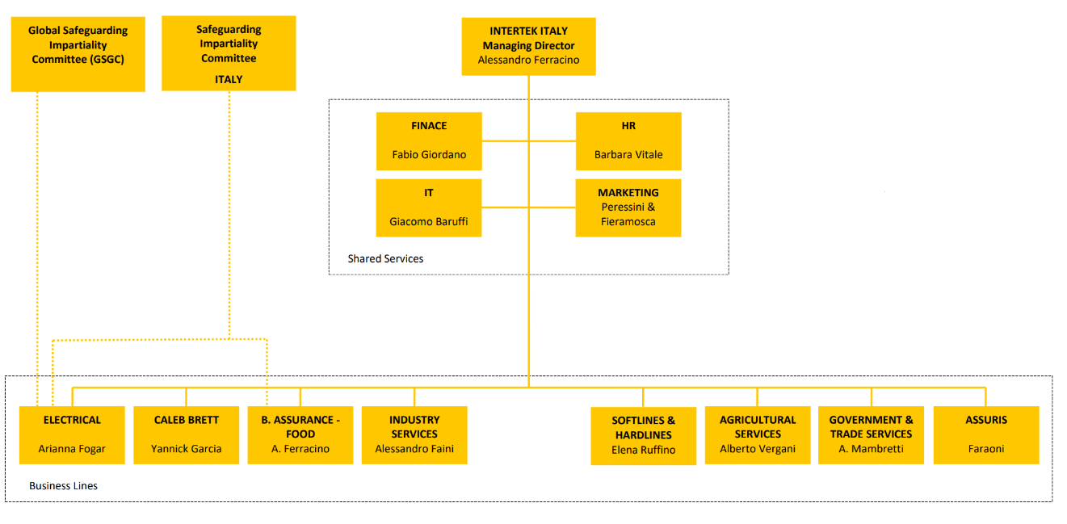
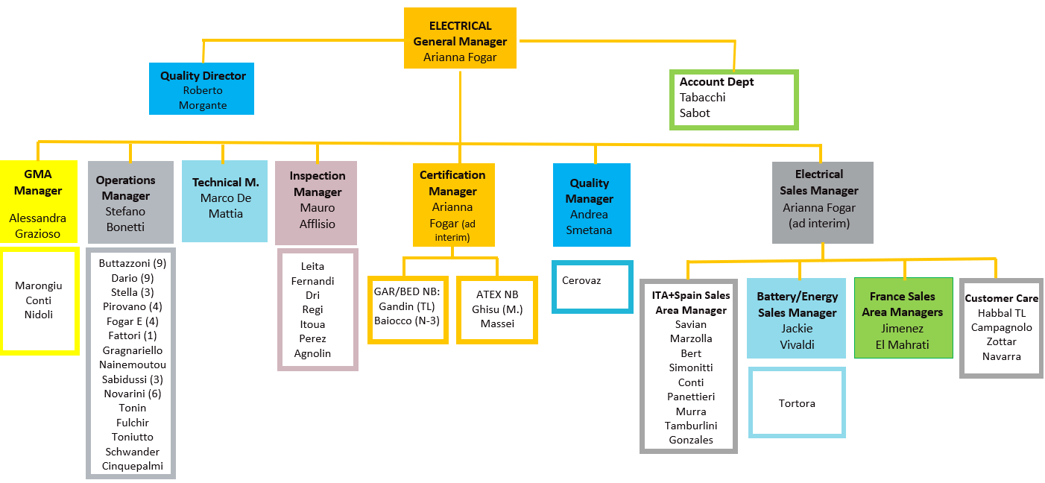

Annex B
Overall Organisation Chart (Cont.)

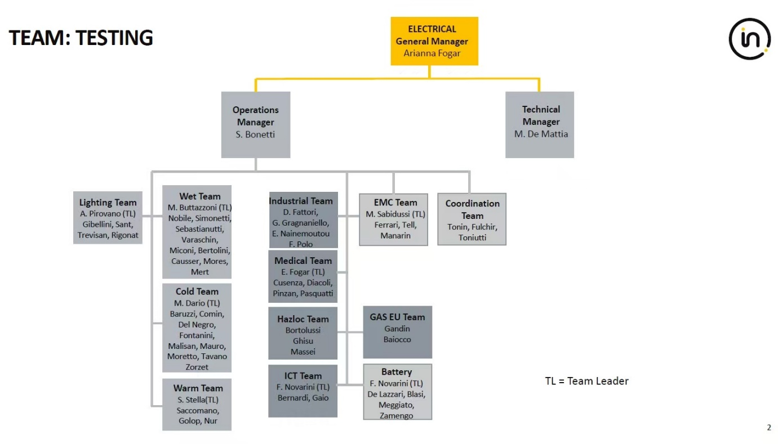

- Organisation Chart of ATF

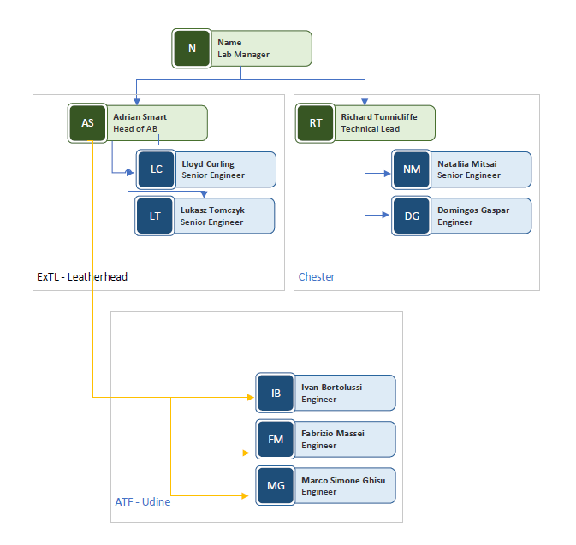

- Accreditation Certificate for ISO/IEC 17025

