INTERNATIONAL ELECTROTECHNICAL COMMISSION (IEC) SYSTEM FOR CERTIFICATION TO STANDARDS RELATING TO EQUIPMENT FOR USE IN EXPLOSIVE ATMOSPHERES (IECEx SYSTEM)

Title: ExTAG/761A/CD, Draft ExTAG Decision Sheet - The threaded joint width of the operating rod

Circulated to: ExTAG – IECEx Testing and Assessment Group

INTRODUCTION

This document, ExTAG/761A/CD Draft ExTAG Decision Sheet - The threaded joint width of the operating rod has been prepared by CCCMT, CN, and is issued for consideration by ExTAG.

This revised version of the document has been prepared taking into account comments received on ExTAG/761/CD, and contained in ExTAG/768/CC.

In accordance with OD 035 this document is issued for a six week comment period.

Please submit comments on this new Draft DS, by – 2026 05 19

Christine Kane

ExTAG Secretariat

Address:  Level 17, Angel Place  123 Pitt Street  Sydney NSW 2000  Australia | Contact Details:  Tel: +61 2 46 28 4690  Fax: +61 2 46 27 5285  e-mail: info@iecex.com  http://www.iecex.com

COLLECTION OF IECEx / ExTAG DECISIONS
Standard:  IEC 60079-1:2014  IEC 60079-1:2007 | Clauses:  5.3  7  Table 4 | Draft Decision Sheet:  ExTAG/761A/CD  April 2026
Subject:  - The threaded joint width of the operating rod  Status of document:  Draft | Key words:  - Width of the threaded joint  - Operating rods  - Cylindrical threaded joints | Date:  Originator of proposal:  CCCMT CN  TC/SC involved:  MT 600079-1
BACKGROUND:
The requirements of operating rods have been given in Clause 7 of IEC 60079-1:2014.Where an operating rod passes through the wall of a flameproof enclosure, the following requirements shall be met:
-- if the diameter of the operating rod exceeds the minimum width of the joint specified in Tables 2 and 3, the width of the joint shall be at least equal to this diameter but without, however, having to exceed 25 mm;
-if the diametrical clearance is liable to be enlarged as a result of wear in normal service,appropriate arrangements shall be made to facilitate a return to the original state, for example, by means of a replaceable bushing. Alternatively, gap enlargement due to wear may be prevented by the use of bearings complying with Clause 8.
The requirements of cylindrical threaded joints have been given in Table 4 of IEC 60079-1:2014.
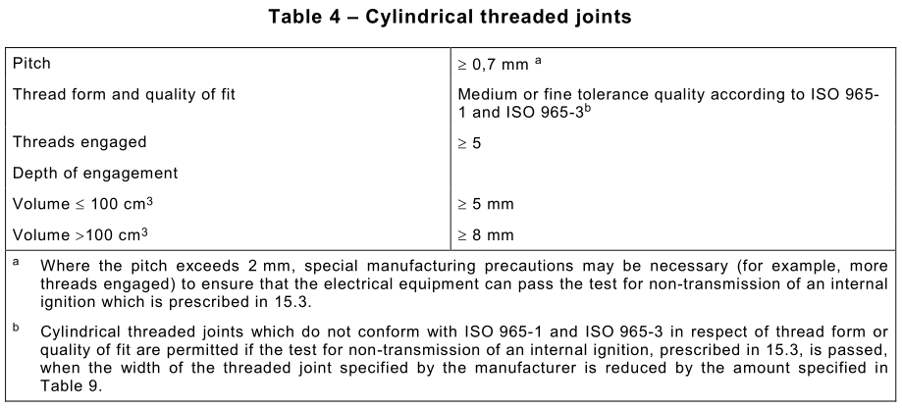
In practice, some explosion-proof equipments have an operating rod structure with a cylindrical threaded joint (see Figure 1). Does the width of the threaded joint need to be at least equal to the major diameter of the thread (but not exceeding 25mm) or is this structure allowed to be used ? And it seems that different ExCBs/ExTLs have their different opinions on the threaded joint rod. For example, If the thread size is M10 , what is the minimum width of the threaded joint ?
There are three different perspectives on the minimum width of the M10 threaded joint for the operating rod.
--Viewpoint 1: Clause 7 of IEC 60079-1:2014 is not applicable as it only pertains to Tables 2 and 3,and not to Table 4. According to Table 4 of IEC 60079-1:2014, the minimum width of the M10 threaded joint for the operating rod is 8mm.
--Viewpoint 2: Clause 7 of IEC 60079-1:2014 is applicable because this operating rod rotates during use and is a dynamic explosion-proof joint. The minimum width of the M10 threaded joint for the operating rod is 10mm.
--Viewpoint 3: This structure should not be allowed to be used.
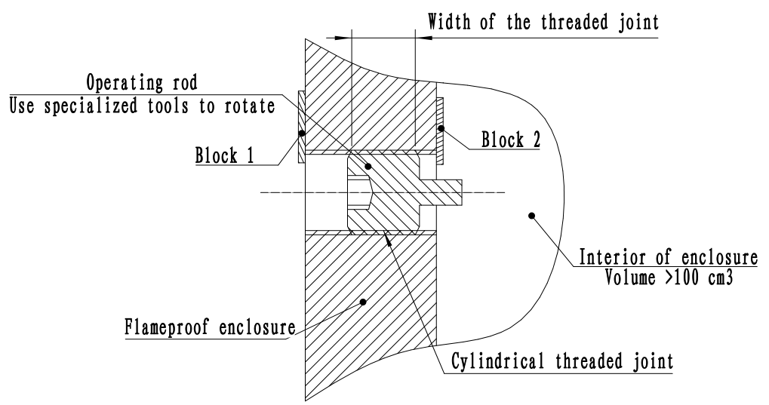
Figure 1 –operating rods with a threaded joint
QUESTION 1:
Is the dynamic structure with a cylindrical threaded joint an operating rod as defined in Clause 3.9 of IEC 60079-1?
ANSWER 1:
No.
The threaded rod is not an operating rod as defined in Clause 3.9 of IEC 60079-1.
QUESTION 2:
Does Clause 7 of IEC 60079-1:2014 apply to the operating rods with a threaded joint ? Does the width of the threaded joint need to be at least equal to the major diameter of the thread (but not exceeding 25mm) ?
ANSWER 2:
No.
Clause 7 of IEC 60079-1:2014 does not involve Table 4. Cylindrical threaded joints, whether stationary or having the potential to be rotated in use shall only need to comply with 5.3 and the thread engagement per the enclosure internal volume per Table 4.
Of course, it is necessary to add a note in the instruction manual to pay attention to thread wear and mechanical strength of the blocks.Threaded rods are only allowed in occasional use, such as when performing adjustment operations or testing components.
How the proposed draft decision sheet affects existing certified products :
The proposed draft decision only for the new certifications and their subsequent revisions.No impact on existing certified products .
The DS shall be applicable to:
– only for the new certifications and their subsequent revisions.

