INTERNATIONAL ELECTROTECHNICAL COMMISSION IEC SYSTEM FOR
CERTIFICATION TO STANDARDS RELATING TO EQUIPMENT FOR USE IN
EXPLOSIVE ATMOSPHERES (IECEx SYSTEM)

TITLE: IECEx Assessment Report for the acceptance INSEMEX to participate as an Accepted Certification Body, ExCB, and an Accepted Test Laboratory, ExTL, in the IECEx System, Equipment Scheme, IECEx 02.

INTRODUCTION

This document contains the IECEx Assessment Report for the acceptance of INSEMEX as an IECEx Certification Body (ExCB) and IECEx Testing Laboratory (ExTL), in the IECEx System, Equipment Scheme, IECEx 02.

The report is hereby submitted for voting by the ExMC.

Please consider the assessment report and return the completed voting form, a separate Word document, to the Secretariat by 2017 01 30.

Your speedy response to the voting process will be very much appreciated.

Chris Agius

IECEx Secretary

Visiting address:  IECEx Secretariat  Level 33, Australia Square  264 George Street  Sydney NSW 2000  Australia | Contact Details:  Tel: +61 2 4628 4690  Fax: +61 2 4627 5285  E-mail: info@iecex.com  http://www.iecex.com

IEC System for certification to standards relating to equipment for use in Explosive Atmospheres (IECEx System)

IECEx Assessment Report Form

IECEx Assessment Report Form for use by IECEx Assessment Teams to report Assessments conducted according to the IECEx Assessment Procedures of

- Operational Document IECEx OD 003-2 for the Certified Equipment Scheme
- Operational Document IECEx OD 016 for the Certified Service Facility Scheme
- Operational Document IECEx OD 022 for the IECEx Conformity Mark Licensing System

IECEx ExCB/ExTL assessment report for INSEMEX

INTERNATIONAL
ELECTROTECHNICAL
COMMISSION

CONTENTS
(Update when report is complete – by right click, Update field, Update entire table)
1 Assessment information 5
1.1 Type of Body covered by this assessment: <retain appropriate marks> 5
1.2 Type of assessment: <retain appropriate marks> 5
1.3 Details of body 5
1.3.1 Country 5
1.3.2 Name of body 5
1.3.3 Name and title of nominated principal contact 5
1.4 Assessment information 5
1.4.1 Members of the assessment team 5
1.4.2 Place(s) of assessment 5
1.4.3 Assessment date(s) 5
1.5 Application information 5
1.6 Scopes 5
1.6.1 ExCB scope for equipment certification scheme 5
1.6.2 ExTL scope 6
2 Common information 6
2.1 Legal entity of body 6
2.2 Financial support 6
2.3 History 6
2.4 Documentation 7
2.4.1 Quality manual 7
2.4.2 Procedures 7
2.4.3 Work instructions 7
2.4.4 Records (including test records where relevant) 7
2.4.5 Document change control 8
2.5 Confidentiality 8
2.6 Publications (Hard cover and Electronic) 8
2.7 Recognition and agreements 8
2.8 Internal audit 8
2.9 Management review 9
2.10 Contracting, subcontracting, use of other labs and use of other locations 9
2.11 Training and competence 10
2.12 Complaints and appeals (including appeals to IECEx) 11
2.13 Special facts to be noted 11
2.13.1 Supporting documentation 11
2.13.2 Witnessed Tests 12
2.14 Recommendations 12
3 ExCB for IECEx Certified Equipment Scheme 13
3.1 Assessment references 13
3.2 Candidate ExCB persons interviewed 13
3.3 Associated ExTL(s) 13
3.4 Associated certification functions 13
3.5 National marks and certificates 13
3.6 Standards accepted 13
3.7 National differences to IEC standards 13
3.8 Organisation 14
3.8.1 Names, titles and experience of the senior executives 14
3.8.2 Name, title and experience of the quality management representative 14
3.8.3 Name and title of signatories for certification 14
3.8.4 Other employees in ExCB activity 14
3.9 Organizational structure 15
3.10 Indemnity insurance 15
3.11 Resources 15
3.12 Committees (such as governing or advisory boards) 15
3.13 Certification operations 16
3.13.1 National approval/certification methods 16
3.13.2 Certification policy 16
3.13.3 Application for certification 16
3.13.4 Certification decision 16
3.13.5 Suspension and cancellation of certificates 16
3.14 Certificates issued 17
3.15 National accreditation 17
3.16 Assessment of manufacturers and issue of QARs 17
3.17 Comments (including issues found during assessment) 18
4 ExTL for IECEx Certified Equipment Scheme 19
4.1 Assessment references 19
4.2 Candidate ExTL persons interviewed 19
4.3 Associated ExCB(s) 19
4.4 Organisation 19
4.4.1 Names, titles and experience of the senior executives 19
4.4.2 Name, title and experience of the quality management representative 19
4.4.3 Other employees in ExTL activity 19
4.5 Organizational structure 20
4.6 Resources 20
4.7 Test reports issued 20
4.8 National accreditation 21
4.9 Calibration 21
4.10 Comments (including issues found during assessment) 22
Annex A Overall Organisation Chart 23
Annex B Organisation charts of INSEMEX-OEC/SECEEX and INSEMEX GLI 24

Assessment information

Type of Body covered by this assessment: <retain appropriate marks>
ExCB for IECEx Certified Equipment Scheme | ✓
ExTL for IECEx Certified Equipment Scheme | ✓
ExCB for IECEx Certified Service Facilities Scheme
ExCB for IECEx Conformity Mark Licensing System

NOTE 1 ExCB - IECEx Certification Body
NOTE 2 ExTL - IECEx Testing Laboratory

Type of assessment: <retain appropriate marks>
Pre-assessment for candidate body
Initial assessment for candidate body | ✓
Surveillance
Re-assessment
Scope extension

Details of body

Country
Romania

Name of body
INSEMEX, incorporating ExCB (SECEEX, which is part of the broader INSEMEX certification body INSEMEX-OEC) and ExTL (which is part of the broader laboratory INSEMEX-GLI).

Name and title of nominated principal contact
Name | Title | E-mail address
Sorin Burian | Head of SECEEx | Sorin.Burian@insemex.ro

Assessment information

Members of the assessment team
Name | Role (modify as necessary)
Jim Munro | Lead Assessor
Alexander Zalogin | Expert Assessor

Place(s) of assessment
At INCD-INSEMEX Petrosani headquarters | Petrosani, 32-34 G-ral Vasile Milea street, Hunedoara County, Romania

Assessment date(s)
19 to 21 October 2015 with a follow up visit by Jim Munro on 17 October 2016

Application information
30 April 2015

Scopes

ExCB scope for equipment certification scheme
Number | Title
IEC 60079-0  Edition 6 | Explosive atmospheres - Part 0: Equipment - General requirements
IEC 60079-1  Edition 7 | Explosive atmospheres - Part 1: Equipment protection by flameproof  enclosures “d”
IEC 60079-11  Edition 6 | Explosive atmospheres - Part 11: Equipment protection by intrinsic safety “i”
IEC 60079-31  Edition 2 | Explosive atmospheres – Part 31: Equipment dust ignition protection by enclosure "t"
NOTE 1 Standards shown with an asterisk (*) are superseded standards
NOTE 2 Unless otherwise indicated, earlier editions of standards (even if with a different number) are considered to be covered in the above scope for the purposes of the assessment.
NOTE 3 The above list highlights any extension of scope in the list above for new standards or later editions of standards already in scope.

ExTL scope
The ExTL scope is the same as for the ExCB.

Common information

Legal entity of body
The legal entity of the body is represented by INSEMEX (National Research and Development Institute for Mining Safety and Protection to Explosion). The Romanian company registration certificate number 2114756 shows the VAT registration as 2664676 dated 18 January 1993 and the trading registration as J20/1504/09/06.1992. The name shown on the certificate is INSEMEX PETROSANI.

Financial support
The financial and material support is provided by the legal entity INSEMEX. The income from the Ex testing and certification is received into the central accounts system of INSEMEX.

History
The National Institute for Research and Development in Mine Safety and Explosion Protection (INSEMEX) was first founded in 1949 as a testing and research station for the mining industry, operating as a National Research and Development Institute. The activity of testing of equipment and protective systems intended for use in explosive atmospheres began in 1952 -1953 as part of Petrosani Mine Safety Station which was established for the purposes of research for the prevention of underground explosions. At that time the electrical laboratory of this Station did some of its own development of methods for the testing of electrical equipment for use in firedamp mines.
In 1974 the Petrosani Mine Safety Station was reorganized as a Research Center, with national authority status for activities including laboratory testing and certification of equipment for mining activities and also non mining activities with explosion hazards. In 1990 the Research Center became Mine Safety Institute of Petrosani and 1992 became Institute for the Mine Safety and Protection to Explosion - INSEMEX, with the status of national authority, including laboratory testing services and certification for explosion-protected equipment.
From 1953, the Laboratory for Electrical and Mechanical Safety (LSEM) provided all the tests required for the certification in explosive mixtures of equipment and personal protective equipment for use in potentially explosive atmospheres. In 1998 separation of the certification activity and the testing activities was achieved by the creation of the SECEEx Certification Body within INSEMEX - Petrosani.
In 2007 INSEMEX-OEC, which had been established under the INCD INSEMEX as certification body, became a notified body at the European level (NB 1809).
In 2012 a new entity, GLI (Group of Testing Laboratories), was created to incorporate all the testing laboratories within INCD-INSEMEX. GLI is accredited at national level according the ISO/IEC 17025 standard. INSEMEX-OEC is organized and operates according to the requirements of ISO/IEC 17065.

Documentation

Quality manual
There are separate quality systems and hence separate quality manuals for the ExCB and ExTL.
The quality manual of the certification body INSEMEX-OEC (within which sits the ExCB, SECEEx) is MC-01, which was at Edition 2 Revision 0 dated September 2014 for the first assessment visit. It describes five levels of documentation including (I) the quality manual (II) general procedures (III) specific procedures (IV) quality records or other documents, and (V) rules of organisation and operation.
The quality manual of the testing laboratory INSEMEX-GLI (part of which comprises the ExTL) is MC-01, which was at Edition 0 Revision 1 dated September 2014 for the first assessment visit.

Procedures
There are also separate procedures for the ExCB and ExTL. For the ExCB there are also some 'rules'. The use of these are addressed in ROF-01.
The procedures for INSEMEX-OEC are numbered from PS-01 to PS15. In addition there are specific procedures: PSp-01 to PSp-48 of which the specific procedures PSp-01 to PSp-07 are used by the SECEEx Service to assess the conformity of explosion protected equipment and the quality systems of the manufacturers.
The procedues for INSEMEX-GLI are numbered from PS-01 to PS-24.
At the time of the first assessment visit there were draft specific IECEx procedures for the IECEx ExCB and IECEx ExTL. One procedure for the ExCB is PSp-11 IECEx SECEEX Procedures IECEx Equipment Certificate of Conformity. At the time of the assessment visit this procedure was based on an IECEx OD but not customised for INSEMEX. This was subsequently done and the assessment team was satisfied it met the requirements of IECEx.
The second procedure for the ExCB is PSp-27IECEx SECEEX Procedures IECEx Quality Assessment. At the time of the assessment visit this procedure was based on an IECEx OD but not customised for INSEMEX. This was subsequently done and the assessment team was satisfied it met the requirements of IECEx. The annexes to this document are the IECEx Quality Assessment Report and the IECEx Quality Assessment Report - Nonconformity report.
The procedure for the ExTL is PS-24 GLI Procedures - Guidance for the development, compilation, issuing and receipt of ExTRs. However, at the time of the assessment visit this procedure was based on an IECEx OD but not customised for INSEMEX. This was subsequently done and the assessment team was satisfied it met the requirements of IECEx.

Work instructions
The guiding rules for certification are included in the specific procedures for certification. There are some work instructions specific to testing rigs that are extracts from procedures and that may be attached adjacent to the testing rig. At the time of the first assessment visit, there was a numbering system to link the work instruction back to the procedures but there was nothing in the document control system to ensure the work instruction is revised and replaced at the same time the procedure is revised and replaced. In addition, the extracted annex did not show pages and so it was difficult to be sure it was complete. These issues were subsequently resolved to the satisfaction of the assessment team.

Records (including test records where relevant)
Records are maintained in the filing system of each of the certification services within INSEMEX-OEC. The records are archived and maintained in accordance with the provisions of the procedure PS-04 - Recording and archiving the quality system documents. The technical certification file (containing the test records) is archived and maintained for a period of 10 years. All records are stored in hard copy form. When hard copy records exceed their retention period, they are burned at INSEMEX. Only one hard copy of each document is controlled. At the end of a project all information related to the project, including the original test data, resides on the file in the certification body archive system.

Document change control
INSEMEX-OEC has established and documented the procedures: PS-03 (Edition 2 Revision 0) "Drawing up and control of the quality system documents" and PS-04 "Recording and archiving of quality system documents", addressed its certification functions. Staff can access read-only versions of the documents electronically on the network.
INSEMEX-GLI has essentially the same procedures to the above but differing where appropriate to make them relevant to the laboratory. Documentation control is in PS-20. For recording and archiving, the relevant procedure is PS-04.

Confidentiality
(For staff, contractors and members of advisory bodies)
Quality Manual 5.2.7 addresses confidentiality. In addition, confidentiality is addressed in procedure PS-13 (for INSEMEX-OEC) and PS-12 (for INSEMEX-GLI) Confidentiality. Declarations of confidentiality and conflict of interest are signed by all the personnel involved in each certification project. These can be found in the technical certification file for the project. Auditors are also required to sign a confidentality agreement.
The members of the committee are required to sign a confidentially and conflict of interest form before they review any project files. This is addressed in INSEMEX-OEC rule ROF-02 which addresses the activities of that committee. Examples of forms signed by staff were sighted (eg file number 294/27.06.12). Examples of forms signed by the committee were also sighted.

Publications (Hard cover and Electronic)
INSEMEX-OEC updates and makes available on applicants' requests, by publishing, by electronic means or other means, the certification schemes, the assessment procedures and all other information required for certification. The information regarding publications is provided in System procedure PS-08 - Publication and reporting to the competent authorities. INSEMEX-OEC publishes twice a year an information bulletin regarding the certificates that have been issued in the proceeding period and this information is also published on the website of INSEMEX.

Recognition and agreements
INSEMEX-OEC is recognized as a certification body at the European level (notified body no. 1809 according to several European Directives, including ATEX 2014/34/EU). The certificates issued by INSEMEX-OEC according the European Directives are recognized and accepted in Romania and in the European Union.
Prior to entering the European Union and becoming an ATEX notified body, INSEMEX had an arrangement whereby PTB could accept their testing for a Romanian manufacturer for the purpose of PTB issuing ATEX certificates. This was also done on one occasion for certification in Russia by NANIO CCVE.

Internal audit
Internal audit is performed according the ExCB system procedure PS-10 (Edition 2 Revision 0) - Internal audit and quality system analysis. The internal audit is performed according to an internal audit schedule which is drawn up at the beginning of each year. The internal audit is planned to be performed at least once per year or more often under certain circumstances defined in the procedure.
For the ExTL, the procedure is PS-11 (Edition 0, Revision 1). The internal audit is performed at least once per year or more often if non-conforming testing activities were recorded.
The audit plan (COD PAIP -2014) and report for the latest audit of the ExCB was reviewed. The planned audit team includes the Quality Manager and someone from the quality compartment. All auditors undergo training and hold certification as an internal auditor. The list showing this was reviewed. The auditor team is approved by the General Manager. The auditors doing the above audit were on that list. The audit reviewed at the first assessment visit took place on 19 November 2014. The audit report was also reviewed. There were no non-conformities or observations raised by the report.
For the INSEMEX-GLI, internal audit took place over a week from 22 to 26 September 2014 covering all laboratories, not just Ex laboratories. There were three auditors. It was advised that two were from the quality area (including the quality responsible person from the ExTL) and the third was an expert in testing. The audit plan and associated reports were reviewed. There were no non-conformities or observations raised by the main report but there was a comprehensive conclusion in the report. There were comprehensive reports for each of the tests (and associated procedures) carried out in the laboratories.
At the follow up assessment a later report of an internal audit of the ExCB that took place on 28 to 30 October 2015 was reviewed. Two minor NCRs and one observation were raised . Corrective actions were raised for NCRs and were resolved.

Management review
For the ExCB, management review is performed once per year according the INSEMEX-OEC system procedure PS-07 - Management review. All the interested parties participate to this review. At least once every 12 months. The review is conducted by the General Manager of INSEMEX, head of certification body and certification services and the quality manager.
A similar process takes place for the ExTL according to ExTL procedure PS-17. Conducted by the General Manager of INSEMEX, head of laboratory, the test responsible and quality responsible person (who reports to the quality manager).
The minutes of the certification review meeting on 20 November 2014 were reviewed and the items addressed included the agenda items required by ISO/IEC 17065. Measures for improvement where identified in the meeting.
The minutes of the testing laboratory review meeting on 29 September 2014 were reviewed and the items addressed included the agenda items required by ISO/IEC 17025. Measures for improvement where identified in the meeting.
At the time of the first assessment visit, neither of the procedures for management review made reference to IECEx. This was subsequently resolved to the satisfaction of the assessment team.

Contracting, subcontracting, use of other labs and use of other locations
Subcontracting and witness testing is addressed in INSEMEX-OEC system procedure PS-06 (Edition 2 Revision 0) - Subcontracting of test audit, supervision and inspection services. The procedure addresses the need to seek the use of bodies which have appropriate accreditation and the measures that will be taken by INSEMEX in accepting and using a subcontractor. There is no corresponding procedure for INSEMEX-GLI as this procedure addresses all aspects of subcontracting and witness testing and places responsibility on the ExCB for managing this process. At the time of the first assessment visit, there was nothing specific to IECEx in the procedures for subcontracting. This was subsequently resolved to the satisfaction of the assessment team.
INSEMEX have identified the tests that they wish to subcontract. Full details of these are included in the site assessment report. For this subcontracting they plan to use Ex-Agencija in Croatia and PTB in Germany. Both are IECEx accepted ExCBs and ExTLs. The agreements with those bodies was viewed at the follow up assessment visit. The following are the tests that will be subcontracted:
- Sintered element tests (IEC 60079-1 Annex B)
- Dielectric and short-circuit test- Short-circuit current test (IEC 60079-11 Clause 10.11.3.3)
- Verification of ratings of ventilating fans (IEC 60079-0 Clause 26.15)
- Resistance to light (IEC 60079-0 Clause 26.10)
- Resistance to chemical agents for Group I electrical equipment (IEC 60079-0 Clause 26.11)
- Thermal tests – determination of maximum surface temperature for "ta" equipment (IEC 60079-31 Clause 6.1.2)
INSEMEX is in the process of developing its own capability for a few of the above tests.
In the case of witness testing, the approach to be taken is defined, for example the need to test in accordance with ISO/IEC 17025, and the need for tests that are witnessed to be specifically identified in the test report with all the important characteristics regarding the testing to be written down (including the sample(s) tested, place where the test was performed, equipment, calibration and serial numbers) . However, at the time of the assessment visit the procedure for witness testing did not address the requirements of IECEx OD024, for example those as shown in the NOTE below and there was no reference to OD024, although in other aspects the procedure is quite comprehensive. This was subsequently resolved to the satisfaction of the assessment team.
NOTE The following should be addressed during the assessment to address compliance with OD024:
- That if off-site and witness testing is done, or proposed to be done, OD024 is referenced and incorporated in procedures
- If it is being done, that contracts have been put in place
- For witness testing (only) - according to 6.3.5 of OD024 - Registration of the manufacturer or user test facility has been made with the IECEx Secretariat and updating of the current information in the Register
- That ExTRs reviewed clearly indicate when there has been witness testing done

Training and competence
INSEMEX-OEC keeps the records regarding training and maintaining of personnel competency in the professional portfolio of the personnel involved in the certification process.
Maintaining the competence and training of the personnel involved in the certification activity is made according the provisions of the ExCB System procedure PS-02 (Edition 2 Revision 0) - Hiring, training and maintaining staff competence. New applicants are required to pass a test to check their technical competence. There is an annual assessment of competence for which a plan is drawn up. Each of the positions with the ExCB have a clearly defined list of qualifications/experience necessary for the position.
There is a competency matrix showing the people in the ExCB who are deemed competent for ATEX but at the time of the first assessment visit there was no indication in that matrix of the standards involved. This was subsequently resolved to the satisfaction of the assessment team.
The personnel involved in the certification process are periodically trained (participating on different training sessions organized by different training providers) according to a schedule that is each year updated to show the current training needs. A training plan is developed for each person at the company level so that people performing both ExCB and ExTL roles only have one plan.
A company-wide plan for training in 2015 was viewed. It included a comprehensive range of training to be undertaken, broken down by the number of people in each area who were expected to undertake that training. It also indicated personnel undertaking post graduate training, including 14 doctorate candidates.
Also, the personnel involved in the certification process are involved in research activities and participate each year at national or international symposiums, conferences or workshops. Maintaining the competence is assured also by active participation at the national or international standardization organizations. For example Dr Sorin Burian – Head of SECEEx is chairman of the national technical committee CT 137 – Apparatus for explosive atmospheres. There is also involvement in the international standardization for the development of the IEC standards related to explosion protection).
For INSEMEX-GLI there is procedure PS-04 ( Edition 0 Revision 1) for hiring and competence of personnel. But this needed updating to showing the process of designating staff as competent to assess and test to the IEC Ex standards. This was subsequently resolved to the satisfaction of the assessment team.
At the time of the first assessment visit there was no competency matrix relevant to IECEx in the ExCB or ExTL. A competency matrix was subsequently produced that was found by the assessment team to meet the requirements of IECEx. Some addition information was also subsequently included in procedures to show the underpinning criteria that leads to competency being designated and the process for approving competency. Reference was also included on OD026 on qualification of auditors. A copy of the competency matrix is included in the site assessment report.
It was advised that training had been carried out in regard to IECEx rules and other documents. This was done as part of the pre-assessment process. The record of attendance for this training was viewed. There were two staff involved in delivering the training and twenty three staff attended. There was no record of the content of that training and INSEMEX have undertaken to do this in the future. They will also be providing training on the revised IECEx procedures that were changed as a result of the assessment process.
Examples of personnel files containing qualifications, and records of training and experience were viewed. These contained certificates for external study and training. The files also contain annual reports on each person by their superior. These are then signed off by more senior people in the organisation, including the General Manager. External training certificates included one from training at PTB. The files also include job description for current and former positions held. Records of training of laboratory staff were also viewed.

Complaints and appeals (including appeals to IECEx)
Complaints and appeals are treated according the ExCB system procedures PS-09 (Edition 2 Revision 1) - Appeals handling and PS-11 (Edition 2 Revision 0) - Complaints treating. These documents make provision for complaints to first be dealt with within the ExCB, but appeals are directed to the Commission shown below.
There is a rule RCTC (Edition 2 Revision 0) that deals the formation of a Commission for treating complaints and appeals. There are two independent people appointed to this commission with a secretariat provided by INSEMEX. It was advised that there had been no appeals to date.
At the time of the first assessment visit there was no procedures that address appeals to IECEx. There was also no mechanism to advise applicants of their right of appeal to IECEx. These issues were corrected to the satisfaction of the assessment team.

Special facts to be noted

Supporting documentation
Copies of additional supporting information for this assessment have been provided to the applicant and the IECEx Secretariat. These are included in a site assessment report or provided separately and include:
- Details of issues raised and how these have been resolved
- Checklist for ISO/IEC 17065
- Checklist for ISO/IEC 17025
- Completed Technical Capability Document (TCD)
- Photos of the facilities/tests witnessed are included in the above TCD
- Assessor notes from the follow up visit.

Witnessed Tests
The following tests were witnessed during the assessment visit:
- IEC 60079-0 Clause 26.4.2 - Resistance to impact test for Group I
- IEC 60079-0 Clause 26.5.1 - Temperature rise,
- IEC 60079-0 Clause 26.5.3 - Small component ignition test
- IEC 60079-0 Clause 26.8 - Thermal endurance to heat
- IEC 60079-0 Clause 26.13 - Surface resistance test of parts of enclosures of non-metallic materials
- IEC 60079-0 Clause 26.14 - Measurement of capacitance
- IEC 60079-1 Clause 15.1.2 - Flameproof pressure determination
- IEC 60079-1 Clause 15.1.3 - Overpressure test
- IEC 60079-1 Clause 15.2 - Flameproof non-transmission test with hydrogen
- IEC 60079-11 Clause 10.1 - Spark ignition test.
- IEC 60079-11 Cause 10.5.2 a) - Electrolyte leakage test for cells and batteries, short circuit test of battery.
- IEC 60079-31 6.1.1.3 Pressure test for "ta" following by IP6X test to IEC 60529 and IEC 60079-0 Clause 26.4.5
- IEC 60529 and IEC 60079-0 Clause 26.4.5 - IP X4 test, IP X6 test

Recommendations
Based on the assessment performed on 19 to 21 October 2015 and 17 October 2016, INSEMEX is recommended for acceptance in the IECEx scheme as:
- An ExCB in the IECEx Certified Equipment Scheme
- An ExTL in the IECEx Certified Equipment Scheme
This is according to the scope of the standards listed in this document

Jim Munro | Alexander Zalogin
Lead Assessor | IECEx Assessor
Date: 30 October 2016

ExCB for IECEx Certified Equipment Scheme

Assessment references
- IECEx02 IECEx Certified Equipment Scheme covering equipment for use in explosive atmospheres – Rules of Procedure
- OD003-2 Assessment, surveillance assessment and re-assessment of ExCBs and ExTLs operating in the IECEx 02, IECEx Certified Equipment Scheme
- ISO/IEC 80079-34 Edition 1, Explosive atmospheres – Part 34: Application of quality systems for equipment manufacture
- OD009 Issuing of CoCs, ExTRs and QARs
- IECEx Document OD 025 Guidelines on the Management of Assessment and Surveillance programs for the assessment of Manufacturer’s Quality Systems in accordance with the IECEx Scheme
- OD0026 IECEx Certified Equipment Scheme – Guidelines for the qualification of Lead Auditor and Auditors, in accordance with the IECEx System
- ISO/IEC 17065: 2012, Edition 1, General requirements for bodies operating product certification systems Conformity assessment — Requirements for bodies certifying products, processes and services
- IECEx Document OD17 Drawing and documentation guidance
- IECEx Technical Capability Document (TCD)
- ExTAG decision sheets (DSs)
NOTE The latest editions of the above documents were applied

Candidate ExCB persons interviewed
Name | Position
Sorin Burian | Head of SECEEx
Lucian Moldovan | Scientific Researcher III
Cristian Cioara | Quality Responsible

Associated ExTL(s)
INSEMEX-GLI is the associated ExTL and is located within the same overall legal entity.

Associated certification functions
In addition to ATEX certification INSEMEX issues certification under other European Union directives, including PPE - 686/89/CEE; Explosives for civil use -93/15/EC; and Pyrotechnics-2013/29/EU. The same notified body number is used for all directive, namely NB1809.

National marks and certificates
As part of the European Union, INSEMEX issues ATEX certificates under 2014/34/EU (formerly ATEX-94/9/EC) with the notified body number shown above. There are no other national marks relevant to explosion protected equipment.

Standards accepted
See clause 1.6 of this report.

National differences to IEC standards
National differences to IEC standards are those for the European Union differences listed in the latest version of the IECEx Scheme Bulletin.

Organisation

Names, titles and experience of the senior executives

Name | Title | Experience
George Artur Găman | General Manager | 31 years
Constantin Lupu | Head of INSEMEX-OEC | 36 years
Sorin Burian | Head of SECEEx | 25 years

Name, title and experience of the quality management representative

Name | Title | Experience
Marius Morar | Head of CMSSM compartment | 13 years

Name and title of signatories for certification

Name | Title | Comments
Sorin Burian | Head of SECEEx  Also  Head of EEExCS Lab | 25 years experience.  Additional role occurred after first assessment visit. Procedures have taken into account potential clash of ExCB and ExTL roles.
Lucian Moldovan | Scientific Researcher III | Designated deputy of Head of SECEEx

Other employees in ExCB activity

Name | Title | Responsibility and Experience in Ex
Ionescu Jeana | Head of EEExCS Lab | Case responsible / Member in the technical working group (31 years) - retired between assessment visits
Mihaela Pârăian | Head of ENExEMEIP Lab | Case responsible / Member in the technical working group (36 years)
Mihai Magyari | Head of EEExP Lab | Case responsible / Member in the technical working group (21 years)
Martin Friedmann | PhD EEExP Lab | Case responsible / Member in the technical working group (36 years) - retired between assessment visits
Lucian Moldovan | PhD EEExP Lab | Case responsible / Member in the technical working group (14 years)
Csaszar Tiberiu | PhD EEExCS Lab | Case responsible / Member in the technical working group (16 years)
Marius Darie | PhD EEExCS Lab | Case responsible / Member in the technical working group (21 years)
Adrian Jurca | PhD ENExEMEIP Lab | Case responsible / Member in the technical working group (14 years)
Florin Păun | PhD ENExEMEIP Lab | Case responsible / Member in the technical working group (14 years)
Leonard Lupu | PhD ENExEMEIP Lab | Case responsible / Member in the technical working group (11 years)
Niculina Vătavu | PhD ENExEMEIP Lab | Case responsible / Member in the technical working group (36 years)
Adriana Andriş | Eng EEExCS | Case responsible / Member in the technical working group (21 years)
Dragoş Fotău | PhD EEExP | Member in the technical working group (5 years)
Cosmin Colda | PhD EEExCS Lab | Member in the technical working group (4 years)
Marcel Rad | PhD Student EEExP | Member in the technical working group (3 years)

Organizational structure
The ExCB within INSEMEX is SECEEx. It is part of the certification body INSEMEX-OEC which is responsible for all the certification activities within INSEMEX.
The ExTL within INSEMEX comprises the manager of INSEMEX-GLI and the three departmental laboratories dealing with explosion protection, ie EEExCS, ENExEMEIP and EEExP laboratories.
INSEMEX-OEC organizational structure comprises three levels:
- Steering Committee
- Certification Services
- Technical Working Groups.
Annex A shows the overall structure and Annex B shows where the ExCB and ExTL sit within the structure.

Indemnity insurance
INCD-INSEMEX has indemnity insurance for the assessment and certification activities. The provider of indemnity insurance is the company Groupama and the indemnity insurance number is RC 955129186 / 24 August 2016 valid to 23 August 2017. The indemnity insurance is internationally valid, both for Romania and outside Romania. An earlier policy was in place at the time of the first assessment visit.

Resources
INSEMEX-OEC has the facilities and resources needed for the certification. The rooms, office equipment and other facilities are made available by INCD INSEMEX. All facilities are the property of INCD INSEMEX Petrosani. The ExCB is staffed with personnel with the necessary competency for carrying out its tasks. A significant proportion of the engineers hold a PhD degree.
INSEMEX-OEC receives legal, administrative, supply, financial and accounting services from INCD INSEMEX.

Committees (such as governing or advisory boards)
INSEMEX-OEC has its own Steering Committee to address impartiality. The operation of the Steering Committee is addressed in rule ROF-02 (Edition 2 Revision 0). The Steering Committee includes representatives of interested organizations in relevant areas, namely:
- Specialists: from the fields of research, design and higher education;
- Users: from mining, gas, chemical and petrochemical industry, wood processing industry and geological prospecting;
- Authorities and public administration: Ministry of Education, Ministry of Labour, Family and Social Protection, Ministry of Economy, Ministry of Administration and Internals.
- Suppliers: manufacturers and importers.
The Steering Committee is chaired by Ion Fotău from the University of Petrosani. At the time of the first assessment visit there was no mention of IECEx in the rule for the committee. This was subsequently resolved to the satisfaction of the assessment team.

Certification operations

National approval/certification methods
At the national level, certification of explosion protected equipment is made according the methods described in the Government Decision 245/2016, which represents the implementation of ATEX Directive 2014/34/EU into the Romanian legislation system. The certificates issued by INSEMEX-OEC according the ATEX Directive 2014/34/EU are recognized and accepted in Romania and in the European Union.

Certification policy
The certification policy is included in the quality policy (INSEMEX-OEC Quality Manual MC-01, pg. 3). This policy is signed by the Chairman of the Steering Committee and General Manager of INCD-INSEMEX.

Application for certification
There is a general procedure that addresses application for certification by the manufacturer of the product or by its authorized representative. The process is described in the quality manual MC-01 and in the specific procedures of the certification service. For Ex equipment the application for the certification process is described in the specific procedures of SECEEx PSp-01 to PSp-07 but at the time of the first assessment visit these only addressed ATEX applications. ATEX reports are included in test files, but in a format different to the IECEx ExTR format. It was advised that they only issue the ATEX test report if specifically requested from the applicant and that this rarely occurs.
As noted above, at the time of the assessment visit, there were no issued application procedures that were specific to IECEx and no application form. In addition there were no procedures addressing contract review and preparation of the test/project plan. The relevant procedures were subsequently produced and found by the assessment team to meet the requirements of IECEx.

Certification decision
According to the ExCB Quality manual MC-01 art. 7.6, the certification decision, in case of explosion protected equipment is made by the Head of SECEEx service or his deputy. Subsequently produced procedures for IECEx clarified this process and included provision for Lucian Moldovan to also make this decision, for example if the person in the Head of SECEEx role had been involved in a project in an ExTL role.

Suspension and cancellation of certificates
INSEMEX-OEC/SECEEx can suspend or cancel certificates in case the conditions considered for certification are no longer found to be fulfilled. These conditions are documented in the quality manual MC-01, art. 7.11 and specific SECEEx procedures. However, at the time of the first assessment visit there were no procedures addressing suspension and cancellation of IECEx certificates. The relevant procedures were subsequently produced to make it clear how SECEEx can suspend and cancel IECEx certificates. These procedures werer found by the assessment team to meet the requirements of IECEx.

Certificates issued
Number of certificates issued under for the preceding four years for each type of protection. For this application the numbers shown are for ATEX certificates.
Standard numbers | Type of protection or other identifying information | Number of issued certificates (for last 4 years)
Standard numbers | Type of protection or other identifying information | 2013 | 2014 | 2015 | 2016 | Total
60079-0  60079-1  60079-7 | d + e | 4 | 8 | 0 | 17 | 29
60079-0  60079-1  60079-7  60079-31 (61241-1) | d + e + t (tD) | 3 | 17 | 28 | 0 | 48
60079-0  60079-1 | d | 11 | 18 | 7 | 9 | 45
60079-0  60079-1  60079-31 (61241-1) | d + t | 8 | 0 | 2 | 0 | 10
60079-0  60079-31 | t | 0 | 2 | 0 | 1 | 3
60079-0  60079-15  60079-31 | n + t | 0 | 0 | 0 | 0 | 0
60079-0  60079-11 | i | 3 | 1 | 1 | 0 | 5
60079-0  60079-1  60079-11 | d + i | 1 | 0 | 0 | 1 | 2
60079-0  60079-7  60079-31 | e + t | 0 | 2 | 0 | 0 | 2
TOTAL |  |  |  |  |  | 144

National accreditation
INSEMEX-OEC is accredited at the national level by the national accreditation body RENAR (Romanian Accreditation Association) according the standard SR EN ISO / CEI 17065:2013 with the number of accreditation certificate ON 046. Certificates issued according to the accredited field of competence bear the RENAR mark. The certification is shown in Annex C. The certification addresses the ATEX Directive 2014/34/EU and it replaces the certification that was provided to the former ATEX Directive that was current at the time of the first assessment visit.
At the time of the first IECEx visit the last RENAR assessment visit was in 11 November 2014. There was a subsequent RENAR visit in April 2016 in relation to the change of the ATEX directive.

Assessment of manufacturers and issue of QARs
At the time of the first assessment visit there was only a draft procedure for the issue of QARs which was essentially just text extracted from OD009. There were no procedures addressing OD025 and OD026. There was only a draft competency matrix which covered competency of auditors. The relevant procedures and matrix were subsequently produced and found by the assessment team to meet the requirements of IECEx.

Comments (including issues found during assessment)
A number of issues relevant to the ExCB where found during the assessment visit. These have been referred to during this report. The details of these, including how they were resolved to the satisfaction of the assessment team are included in the site assessment report. Most issues related to the lack of relevant procedures specific to IECEx. INSEMEX now has a comprehensive list of procedure specific to IECEx.

ExTL for IECEx Certified Equipment Scheme

Assessment references
- IECEx02 IECEx Certified Equipment Scheme covering equipment for use in explosive atmospheres – Rules of Procedure
- IECEx OD003-2 Assessment, surveillance assessment and re-assessment of ExCBs and ExTLs operating in the IECEx 02, IECEx Certified Equipment Scheme
- IECEx OD009 Issuing of CoCs, ExTRs and QARs
- ISO/IEC 17025:2005 Edition 2, General requirements for the competence of testing and calibration laboratories
- IECEx Document OD17 Drawing and documentation guidance
- IECEx Technical Capability Document (TCD)
- ExTAG decision sheets (DSs)
NOTE The latest editions of the above documents were applied.

Candidate ExTL persons interviewed
Name | Position
Ionescu Jeana | Head of EEExCS Lab
Mihaela Pârăian | Head of ENExEMEIP Lab
Mihai Magyari | Head of EEExP Lab
Lucian Moldovan | PhD EEExP Lab / Test responsible / operator
Csaszar Tiberiu | PhD EEExCS Lab / Test responsible / operator
Marius Darie | PhD EEExCS Lab / Test responsible / operator
Adrian Jurca | PhD ENExEMEIP Lab / Test responsible / operator
Florin Păun | PhD ENExEMEIP Lab / Test responsible / operator
Niculina Vătavu | PhD ENExEMEIP Lab / Test responsible / operator
Sorin Zsido | Eng EEExP Lab / Test responsible / operator
Michael Sylvester | Technician EEExP Lab / operator
Dan Gabor | Eng. ENExEMEIP Lab Test responsible / operator

Associated ExCB(s)
SECEEx(within the broader certification body INSEMEX-OEC) is the associated ExCB and is located within the same overall legal entity.

Organisation

Names, titles and experience of the senior executives

Name | Title | Experience
Emilian Ghicioi | Head of INSEMEX-GLI | 21 years

Name, title and experience of the quality management representative

Name | Title | Experience
Cristian Cioara | Quality Responsible | 11 years

Other employees in ExTL activity

Name | Title/responsibility | Experience in Ex
Ionescu Jeana | Head of EEExCS Lab | 31 years- retired since audit
Mihaela Pârăian | Head of ENExEMEIP Lab | 36 years
Mihai Magyari | Head of EEExP Lab | 21 years
Lucian Moldovan | PhD EEExP Lab / Test responsible / operator | 14 years
Csaszar Tiberiu | PhD EEExCS Lab / Test responsible / operator | 17 years
Marius Darie | PhD EEExCS Lab / Test responsible / operator | 21 years
Adrian Jurca | PhD ENExEMEIP Lab / Test responsible / operator | 14 years
Florin Păun | PhD ENExEMEIP Lab / Test responsible / operator | 14 years
Leonard Lupu | PhD ENExEMEIP Lab / Test responsible / operator | 11 years
Niculina Vătavu | PhD ENExEMEIP Lab / Test responsible / operator | 36 years
Adriana Andriş | Eng EEExCS lab / Test responsible / Operator | 21 years
Dragoş Fotău | PhD Student EEExP Lab / Test responsible / operator | 5 years
Cosmin Colda | PhD EEExCS Lab / Test responsible / operator | 4 years
Marcel Rad | PhD Student EEExP Lab/ operator | 3 years
Sorin Zsido | Eng EEExP Lab / Test responsible / operator | 15 years
Michael Sylvester | Technician EEExP Lab / operator | 30 years
Dan Gabor | Eng. ENExEMEIP Lab Test responsible / operator | 14 years
Sorin Oprea | Technician ENExEMEIP Lab / operator | 4 years

Organizational structure
The Group of Testing Laboratories INSEMEX -GLI is a technical entity to perform testing under accreditation within INCD INSEMEX (which bears the legal responsibility for the carried out activities).

Resources
Material and financial resources of INSEMEX-GLI are made available by INCD INSEMEX that bears the legal responsibility of the activities carried out by INSEMEX-GLI.
All financial and accounting related operations of INSEMEX-GLI are provided by INCD INSEMEX Petrosani by its Finance - Accounting Compartment and the Economic-Commercial manager.
INSEMEX was found to have the appropriate laboratory conditions, testing equipment, qualified staff and procedures/test instructions to carry out the work required of its proposed scope under IECEx. A significant proportion of the staff hold PhD degrees.

Test reports issued
Number of test reports issued under for the preceding four years for each type of protection for the purpose of ATEX certification.

Standard numbers | Type of protection or other identifying information | Number of issued reports (for ATEX scheme) (for last 4 years)
 |  | 2013 | 2014 | 2015 | 2016 | Total
60079-1 | d | 20 | 32 | 23 | 15 | 90
60079-11 | i | 3 | 1 | 1 | - | 5
60079-31 | t | - | 6 | - | - | 6
 |  |  |  |  |  | 101
NOTE 1 Above include reports to IEC 60079-0
NOTE 2 Only the test reports for the types of protection for which the application was made were mentioned.

National accreditation
INSEMEX-GLI is accredited at national level by the national accreditation body RENAR (Romanian Accreditation Association) according the standard SR EN / ISO CEI 17025:2005. The number of accreditation certificate is LI 374 and this was last updated 04.09.2015. Test reports (corresponding to each of the carried out tests) issued according to the accreditation scope bear the RENAR mark.
There is a separate RENAR scope of accreditation for each of the three laboratories. At the time of the assessment visit the scopes of accreditation included IEC 60079-0, 60079-1 and 60079-11. But they did not include IEC 60079-31 and did not cover the latest edition of IEC 60079-1. This was still the case at the follow up visit but resolution of this matter was expected once a further visit takes place from RENAR.
The report for the last RENAR surveillance visit for the INSEMEX-GLI laboratories which was held on 24 July 2015 was viewed. There were no non-conformities or observations listed in the report.

Calibration
Regarding the calibration of equipment used to perform all the specific tests, the provisions of the quality manual INSEMEX-GLI MC 01, article 5.5 and System procedure PS-07 address calibration of testing and measuring equipment.
A plan is drawn up each year by INSEMEX-GLI for the equipment to be calibrated in the next twelve months and that plan is approved by the General Manager. There is provision for internal intermediate verifications.
At the time of the first assessment visit, three years was advised as being the standard period and there was provision to extend for an additional year. There was provision for inter-comparison tests to be done. The register of these tests was viewed. It indicated that the number of these inter-comparisons tests had declined in recent years with none done in 2013 and one in 2014. Four were shown for 2015 to the end of September that year. There were 24 done in 2010.
At the follow up visit it was advised that the standard period had been extended to six years, but with annual inter-comparisons mandated, and that this approach had been accepted by their accreditation body, RENAR. There was evidence that the annual inter-comparisons are being done. The approach was stated to be that the value provided in the original calibration report is checked to determine if the value still stays within the original value with any uncertainties of measurement of the original report taken into account. However, in the internal reports that were reviewed this was not clearly documented. INSEMEX have undertaken to improve the information provided in the internal reports to made clear how the check is done against the original report for each reading and evidence was provided that this is being implemented.
It is intended to monitor the above approach in subsequent assessment visits.
It was advised that instruments and the associated certification reports are checked when instruments return from calibration. However, there were no records of this process. This was raised as an observation.
The major providers of calibration services for INSEMEX-GLI testing equipments are INM (National Institute of Metrology), BRML (Romanian Bureau of Legal Metrology) and PTB Germany.
All equipment checked during the assessment visit were in calibration.
For the environmental chamber, the humidity was only calibrated up to 50 %. A new calibration was done that established calibration at higher humidity.

Comments (including issues found during assessment)
A number of issues relevant to the ExTL were found during the assessment visit. The issues raised included,
- Lack of involvement in the IECEx proficiency testing program
- Document control and data protection.
- Calibration of the environmental chamber.
- Dust circulation in the dust chamber.
- Validation of calculation of oxygen measurement
- Staff knowledge of decision sheets
- Temperature measurement techniques
- Evidence of calibration of water nozzles
- Use of undated standard references in procedures
- Test procedures needing reference to IECEx decision sheets and operational documents
- Lack of specification of thermal range of conductive paste for temperature measurement
- The need to specify the spark test apparatus in the relevant procedure
- Increasing the range of the available voltage for the test determination of parameters of loosely specified components
- Improving the method of identification of test equipment in the test reports
- Increasing the range of voltage for the supply to cover all equipment to be tested.
The details of above issues, including how they were resolved to the satisfaction of the assessment team, are included in the site assessment report.
For IECEx proficiency testing they, have now committed to some programs, (Note their application was made prior to involvement becoming mandatory).
Annexes
See Contents.
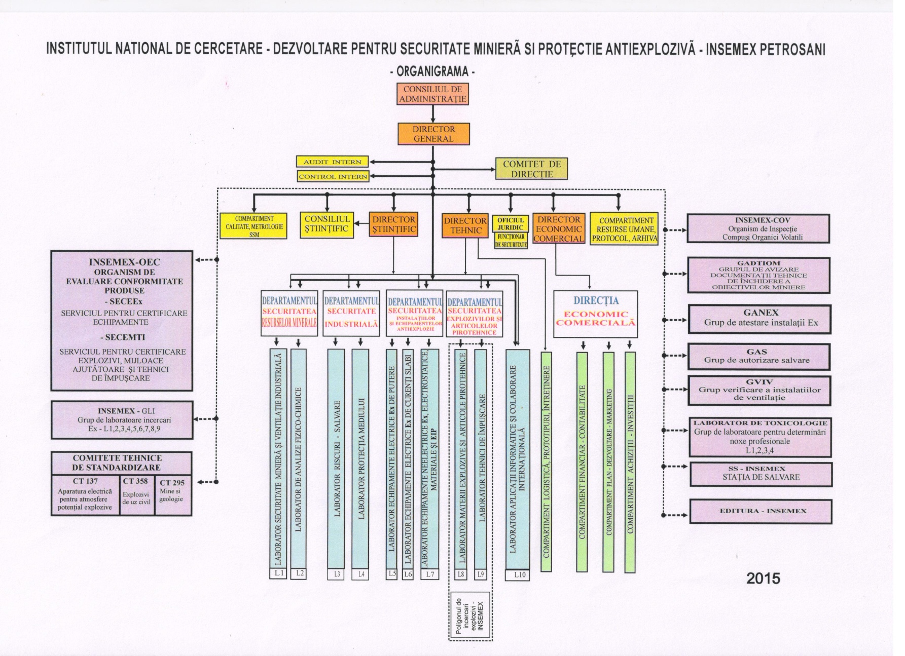
- Overall Organisation Chart

- Organisation charts of INSEMEX-OEC/SECEEX and INSEMEX GLI
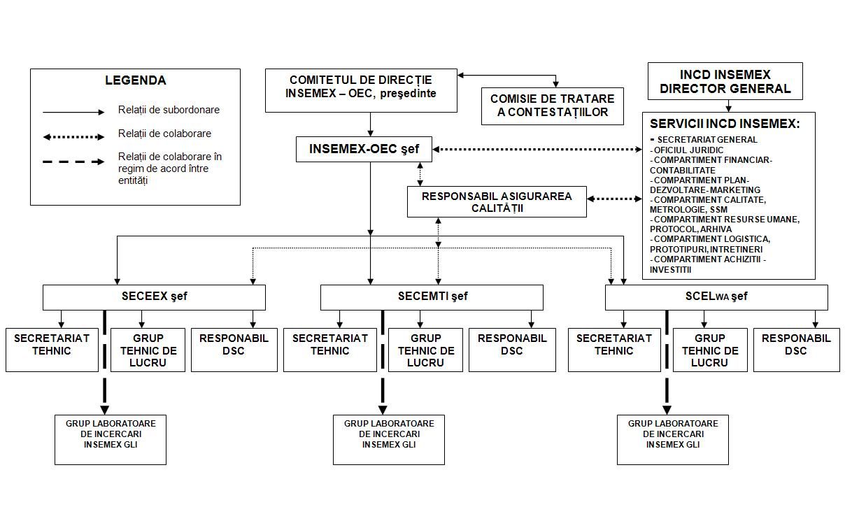

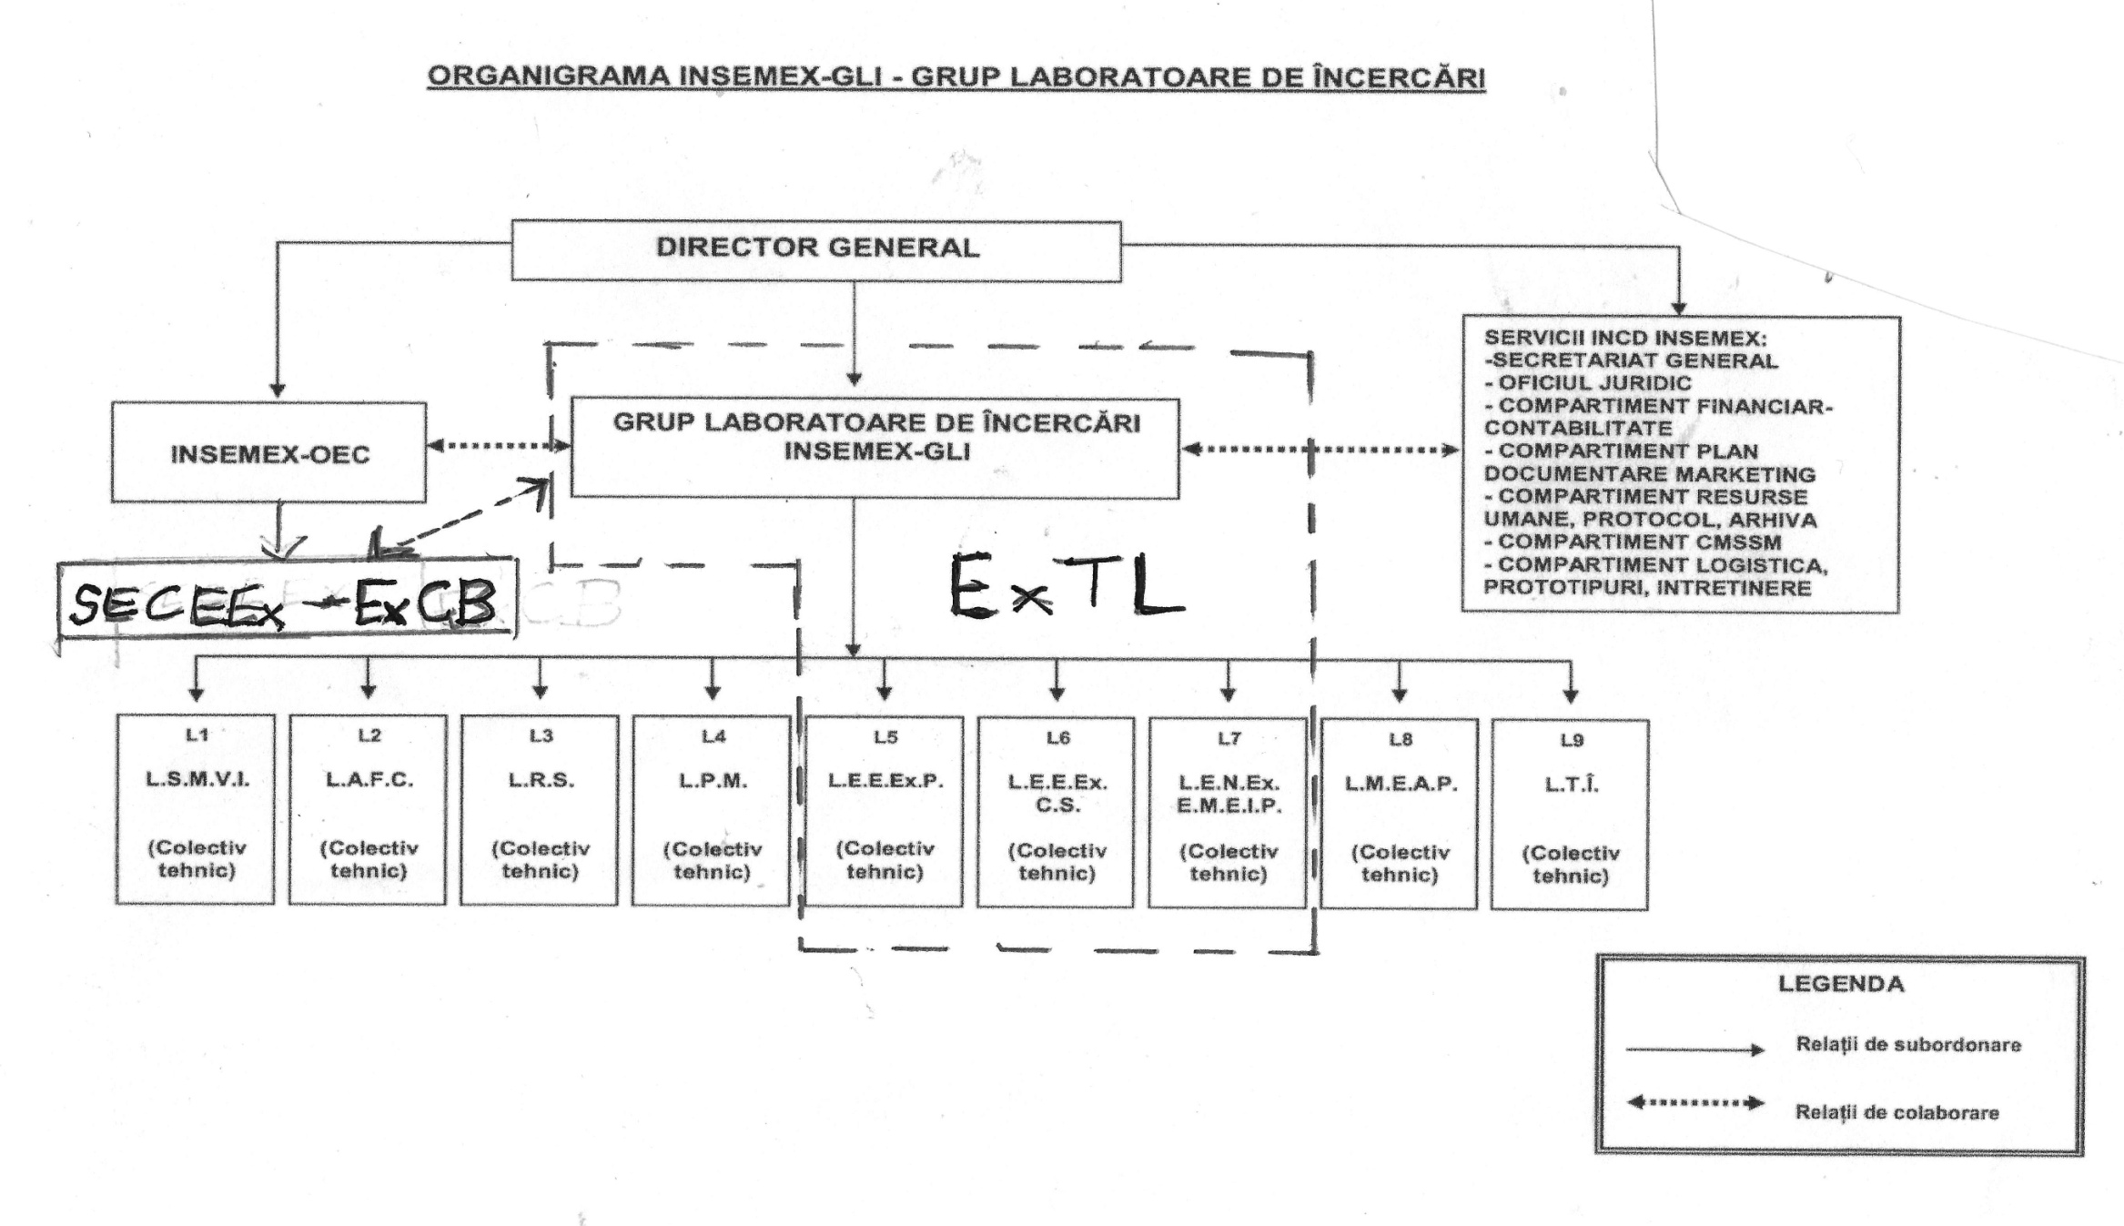

Annex C ISO/IEC 17065 Accreditation

Annex D ISO/IEC 17025 Accreditation

