**INTERNATIONAL ELECTROTECHNICAL COMMISSION SYSTEM FOR CERTIFICATION TO STANDARDS RELATING TO EQUIPMENT FOR USE IN EXPLOSIVE ATMOSPHERES (IECEx SYSTEM)**

**Title:** **Re-assessment Report for the continued acceptance** **of** **Technology Institution of Industrial Safety, TIIS, an Accepted Certification Body, ExCB, and an Accepted Test Laboratory, ExTL, within the IECEx Equipment Scheme 02.**

**Circulation to: Members of the IECEx Management Committee, ExMC**

**INTRODUCTION**

In accordance with the 5 Year re-assessment plan for the surveillance and monitoring of bodies within the IECEx System, the following document contains the Re-assessment Report for the continued acceptance of Technology Institution of Industrial Safety, TIIS, an Accepted Certification Body, ExCB, and an Accepted Test Laboratory, ExTL, within the IECEx Equipment Scheme 02

This report is hereby submitted for endorsement during the 2025 Kyoto ExMC Meeting.

**Chris Agius**

|  |  |
| --- | --- |
| **Visiting address:**  **IECEx Secretariat**  **Level 17 Angel Place 123 Pitt Street  Sydney NSW 2000 Australia** | **Contact Details:**  **Tel: +61 2 4628 4690**  **Fax: +61 2 4627 5285**  **E-mail: info@iecex.com**  [**http://www.iecex.com**](http://www.iecex.com) |

IEC System for certification to standards relating to equipment for use in Explosive Atmospheres (IECEx System)

IECEx Assessment Report Form, F-003

IECEx assessment report form for use by IECEx assessment teams to report assessments conducted according to the relevant IECEx assessment procedures of:

Operational Document IECEx OD 003-2 for the Certified Equipment Scheme

Operational Document IECEx OD 316-* for the Certified Service Facility Scheme

Operational Document IECEx OD 422 for the IECEx Conformity Mark Licensing Scheme

Operational Document IECEx OD 501 for the Personnel Competence Scheme

IECEx ExCB/ExTL assessment report for

Technology Institution of Industrial Safety

INTERNATIONAL  
ELECTROTECHNICAL  
COMMISSION

CONTENTS

1 Assessment information 6

1.1 Type of body covered by this assessment: 6

1.2 Type of assessment: 6

1.3 Details of body 6

1.3.1 Country 6

1.3.2 Name of body 6

1.3.3 Name and title of nominated principal contact 6

1.4 Assessment information 6

1.4.1 Members of the assessment team 6

1.4.2 Place(s) of assessment 6

1.4.3 Assessment date(s) 7

1.5 Application information and background information on the assessment 7

1.6 Scopes 7

1.6.1 ExCB scope for equipment certification scheme 7

1.6.2 ExTL scope 7

1.6.3 ATF Scope 7

1.6.4 ExCB scope for Service Facilities Scheme 7

1.7 ExCB scope for Conformity Mark Licensing Scheme 7

1.8 ExCB scope for IECEx Personnel Competence Scheme 7

2 Common information 8

2.1 Legal entity of body 8

2.2 Financial support 8

2.3 History 8

2.4 Documentation 8

2.4.1 Quality manual 8

2.4.2 Procedures 9

2.4.3 Work instructions 9

2.4.4 Records (including test records where relevant) 9

2.4.5 Document change control 9

2.5 Confidentiality 9

2.6 Communication with public and customers (Hard copy and Electronic) 9

2.7 Recognitions and agreements 9

2.8 Internal audit 10

2.9 Management review 10

2.10 Contracting, subcontracting and witness testing 10

2.10.1 Contracting 10

2.10.2 Subcontracting 10

2.10.3 Off-site and Witness testing 10

2.11 Training and competence 10

2.12 Complaints and appeals (including appeals to IECEx) 11

2.13 Impartiality 11

2.14 Active involvement in development of Decision Sheets 11

2.15 Special facts to be noted 11

2.16 Supporting documentation 11

2.17 Recommendations 11

3 ExCB for IECEx Certified Equipment Scheme 13

3.1 Assessment references 13

3.1.1 General references 13

3.1.2 Additional references applied for this assessment 13

3.2 ~~Candidate~~ ExCB persons interviewed 13

3.3 Associated ExTL(s) 13

3.4 Associated certification functions 13

3.5 National marks and certificates 14

3.6 Standards accepted 14

3.7 National differences to IEC standards 14

3.8 Organisation 14

3.8.1 Names, titles and experience of the senior executives 14

3.8.2 Name, title and experience of the quality management representative 15

3.8.3 Name and title of signatories for certification 15

3.8.4 Other employees in ExCB activity 15

3.9 Organizational structure 15

3.10 Indemnity insurance 15

3.11 Resources 15

3.12 Committees (such as governing or advisory boards) 15

3.13 Certification operations 16

3.13.1 National approval/certification methods 16

3.13.2 Certification policy 16

3.13.3 Application for certification 16

3.13.4 Certification decision 16

3.13.5 Suspension and cancellation of certificates 17

3.14 Certificates issued 17

3.15 National accreditation 17

3.16 Assessment of manufacturers and issue of QARs 17

3.17 Comments (including issues found during assessment) 18

4 ExTL for IECEx Certified Equipment Scheme 19

4.1 Assessment references 19

4.1.1 General references 19

4.1.2 Additional references applied for this assessment 19

4.2 ~~Candidate~~ ExTL persons interviewed 19

4.3 Associated ExCB(s) 19

4.4 Organisation 19

4.4.1 Names, titles and experience of the senior executives 19

4.4.2 Name, title and experience of the quality management representative 19

4.4.3 Other employees in ExTL activity 20

4.5 Organizational structure 20

4.6 Resources 20

4.7 Test reports issued 20

4.8 National accreditation 20

4.9 Calibration 21

4.10 Tests witnessed during the assessment visit 21

4.11 Participation in IECEx Proficiency Testing Programs 21

4.12 Comments (including issues found during assessment) 22

5 Annexes 23

Annex A Scope for IECEx Certified Equipment Scheme 24

A.1 Current standards 24

A.2 Superseded standards 25

Annex B Overall Organisation Chart 26

Annex C Organisation Chart of ExCB/ExTL 27

Annex D Accreditation Certificate for ISO/IEC 17065 28

Annex E Accreditation Certificate for ISO/IEC 17025 31

# Assessment information

## Type of body covered by this assessment:

|  |  |
| --- | --- |
| ExCB for IECEx Certified Equipment Scheme |  |
| ExTL for IECEx Certified Equipment Scheme |  |
| ATF for IECEx Certified Equipment Scheme |  |
| ExCB for IECEx Certified Service Facilities Scheme |  |
| ExCB for IECEx Conformity Mark Licensing System |  |
| ExCB for IECEx Certification of Personnel Competency Scheme |  |

NOTE 1 ExCB - IECEx Certification Body

NOTE 2 ExTL - IECEx Testing Laboratory

NOTE 3 ATF - Additional Testing Facility

## Type of assessment:

|  |  |
| --- | --- |
| Pre-assessment for candidate body |  |
| Initial assessment for candidate body |  |
| Surveillance |  |
| Re-assessment |  |
| Scope extension |  |

## Details of body

### Country

Japan

### Name of body

Technology Institution of Industrial Safety (TIIS)

### Name and title of nominated principal contact

|  |  |  |
| --- | --- | --- |
| Name | Title | E-mail address |
| Mr Minari Kogane | Executive Managing Director  Director of PH  Representative of ExCB and ExTL  Certification Manager | kogane@tiis.or.jp |

## Assessment information

### Members of the assessment team

|  |  |
| --- | --- |
| Name | Role |
| Katy Holdredge | IECEx Lead Assessor |
| Herbert Peters | IECEx Assessor |

### Place(s) of assessment

|  |  |
| --- | --- |
| Technology Institution of Industrial Safety (TIIS) | 2-16-26 Hirosedai, Sayama-shi, Saitama 350-1328, JAPAN |

### Assessment date(s)

29 to 31 July 2024

## Application information and background information on the assessment

TIIS submitted an application for scope extension to include IECEx OD 290, Harmonized procedures for IECEx certification of equipment, components and systems associated with the production, dispensing and use of gaseous hydrogen. This application was provided to the Secretariat and checked during this assessment visit. The review at the assessment visit confirmed they have the capability to assess and test to this standard.

## Scopes

### ExCB scope for equipment certification scheme

The scope for the ExCB is shown in Annex A.

NOTE 1 Unless otherwise indicated, earlier editions of standards (even if with a different number) are considered to be covered in the above scope for the purposes of the assessment.

### ExTL scope

The ExTL scope is the same as for the ExCB.

### ATF Scope

N/A

### ExCB scope for Service Facilities Scheme

N/A

## ExCB scope for Conformity Mark Licensing Scheme

N/A

## ExCB scope for IECEx Personnel Competence Scheme

N/A

# Common information

## Legal entity of body

The Technology Institution of Industrial Safety (TIIS) is registered as a legal entity (in its Japanese name of 産業安全技術協会) as a legal entity under the Civil Law of Japan, under the registration number of 0300-05-004315. The document showing this registration was viewed. TIIS is also a Public Interest Corporation (公益社団法人) authorized by the Cabinet Office, the Government of Japan, on March 28, 2011 under Fu-Eki-Tan No.2761.

## Financial support

TIIS is self-financed by its income which is primarily from testing and certification, safety evaluation, safety seminars, and sales of technical documents. It also receives grants from the Government for research. TIIS publishes its financial data on its website and the information shows that it is financially stable.

## History

In April 1965, TIIS was founded as a private organization. The initial name was Research Institution of Industrial Safety.

In June 1970, it was approved as a corporate legal entity by the Minister of Labour, Japan.

In January 1971, it was designated for a testing and certification body of Ex-equipment by the Director-General of Labour Standards Bureau of the Ministry of Labour.

In October 1972, it was approved for a Designated Type Examination Agency on Ex-equipment by the Minister of Labour, Japan.

In August 1976, it changed its name to the existing name of TIIS.

In March 2004, TIIS was registered as a Registered Type Examination Agency for 11 machines and equipment including Ex-equipment in accordance with the enactment of amended Occupational Safety and Health Law of Japan. The registration was made by the Minister of Health, Labour and Welfare of Japan.

In March 2009, TIIS received a notice of the renewal of the Registered Type Examination Agency for 11 machines and equipment from the Ministry of Health, Labour and Welfare of Japan.

In March 2011, TIIS was authorized as a Public Interest Corporation by the Cabinet Office of the Government of Japan.

In April 2014, TIIS was accepted as ExCB and ExTL within the IECEx System.

In November 2014, TIIS opened an Osaka office in Izumi City, Osaka, but with no Ex role. (Currently closed)

In May 2017, TIIS became a registered certification body for functional safety devices for boilers.

In May 2024, TIIS opened new Osaka branch in Osaka City, Osaka. There is one engineer at this location that is involved in IECEx work

## Documentation

### Quality manual

For IECEx there are two quality manuals. One is related to certification and inspection (ISO/IEC 17065), TIIS-ExCB-00000-Q, and the other is related to testing and evaluation (ISO/IEC 17025), ExTL-00000-P. The postscript letters indicate the issue status of the two manuals at the time of the assessment visit. The ExCB manual was last issued on 10 July 2023. The changes were made to reflect revisions to standard names and titles.

In addition to the above manuals, there is an ISO 9001:2015 QMS Manual, 00-01. This was at issue AN at the time of the assessment visit. TIIS has certification for the quality system covered by this manual.

All documentation in the QMS resides are uploaded on an external SharePoint file server.

The manuals and quality procedures for IECEx are written with dual text, i.e., Japanese and English.

### Procedures

All relevant procedures are referenced in the two quality manuals, and where appropriate, they are also covered in relevant rules.

There are a range of procedures specifically related to IECEx.

### Work instructions

There are work instructions for all the relevant tests in the TIIS scope. These are only in Japanese. These are listed in the TCD. All these instructions are uploaded on an external SharePoint file server with only the copy on the server being controlled.

### Records (including test records where relevant)

Procedure ‘Rules for Control of Records’ TIIS-ExCB-03000, Rev. N, addresses record storage. Critical records are defined as being stored for 30 years. Old records are stored on optical disk, but records are now stored on external file server with regular backups and periodic archival of records. There is an organisation procedure that establishes a committee to deal with record storage. There was an issue identified in the retention times for staff competency records and records for procedures and work instructions. This was resolved subsequent to the assessment and found to meet the requirements of the IECEx OD 207.

### Document change control

Document control is described in “Rules for control of documents (TIIS-ExCB-02000-N)” and 4.4 of ExTL Manual. It breaks documents into two categories of internal and external. Evidence that staff are aware of updates to external documents for IECEx was provided. It supplements a more general TIIS procedure on control of documents 10-01. This procedure clarifies that printed documents are not controlled.

## Confidentiality

Confidentiality is described in 4.5, 6.1.3 a) and 7.12.2 of ExCB Manual and in 4.1.5 c) and 4.7.1 of ExTL Manual. All personnel of TIIS are required not to disclose confidential information in accordance with “Working Regulation” of TIIS. TIIS has signed agreements, Form 76, with their clients for maintaining confidentiality. All staff sign a separate agreement related to confidentiality, Form 70. Examples of both forms were viewed during the reassessment.

## Communication with public and customers (Hard copy and Electronic)

TIIS appears on the Internet under https://www.tiis.or.jp/ for Japanese and https://tiis.t4u.bz/eng/ for English. TIIS also publishes a quarterly magazine, TIIS-NEWS. Printed brochures are available as well.

## Recognitions and agreements

TIIS has made mutual recognition agreements in the area of Ex-equipment with overseas testing laboratories. Agreements with laboratories shown in the following table include acceptance of TIIS's test data by the laboratories.

|  |  |
| --- | --- |
| Country/Region | Name of Testing Laboratories |
| China | NEPSI, CQST |
| South Korea | KOSHA, KTL, KGS, KTR, SZU.KO, ICR |
| Taiwan | ITRI |
| Germany | PTB |
| France | INERIS, LCIE |
| Netherlands | CNEX-Global |
| Canada | LabTest |
| Malaysia | SIRIM QAS |
| Turkey | SCA with Ex proof TENKO Turkey Ltd. |
| Poland | OBAC, ICR Polska |

## Internal audit

Internal audit is described in “Rules for internal audits (10-03 (Ed. F) )”, in 8.6 of ExCB Manual, and in 4.14 of the ExTL Manual. An annual plan for internal audit is prepared each year in March. Audits are conducted once a year, and the last audit was conducted from 2024-07-19 to 2024-07-25. The Ex procedure supplements the ISO 9001 procedures and makes use of appropriate forms which form part of that system. The procedure incorporates a comprehensive approach to internal auditing and meets the requirements of the IECEx.

## Management review

Management review is described in 8.5 of ExCB Manual, and in 4.1.6, 4.10 and 4.15 of ExTL. It is also addressed in the organisation’s ISO 9001 QMS which defines management review meetings as occurring twice a year. The last management review was done 2024-04-10 for the second half of 2023 and included the relevant members of senior staff. The previous management review was done on 2023-10-17 for first half of 2023. These reviews were found to meet the requirements of the IECEx.

## Contracting, subcontracting and witness testing

### Contracting

There are presently no contractors used.

### Subcontracting

Subcontracting is described in 6.6 of the ExTL Manual.

However, there are presently no subcontractors used. TIIS has indicated that it intends to do all tests at its laboratories except for some tests that the TCD allows the ExTL to do as witness testing.

### Off-site and Witness testing

Clauses 6.3.5 and 6.4.2 of the ExTL Manual, TIIS-ExTL-0000, refer to the use of OD 024 when testing is done at other sites or non-TIIS equipment is used for testing. An example of the use of IECEx OD 024 was viewed and it was confirmed that the facility was included in the IECEx OD 024 register, and that a signed agreement was available and on site assessment was done. The ExTR also clearly indicated that where the witness testing had been done, which meets the requirements of the IECEx.

## Training and competence

Training of personnel is described in 6.1.2 b) and 6.1.2.2 d) of the ExCB Manual and 5.2 of the ExTL Manual. Competence of personnel is described in 6.1.2 of the ExCB manual and in 5.2 of the ExTL Manual. Training, competence and records of training are controlled according to “Rules for training/education of personnel” TIIS-ExCB-08000-O.

There is a comprehensive Excel document that addresses competences of staff. It looks at competency for testing against each standard with levels 1 to 3. Separately it addresses competencies of people to review ExTRs, QARs and CoCs. There was an issue identified in staff competency records. This was resolved subsequent to the assessment and found to meet the requirements of the IECEx.

## Complaints and appeals (including appeals to IECEx)

Complaints and appeals are dealt with according to Rules for dealing with appeals and complaints (TIIS-ExCB-05000-J). The procedure includes appropriate processes and includes provision for appeal to IECEx. There have been no complaints or appeals involving IECEx for TIIS.

## Impartiality

Impartiality is addressed in Clause 4.2.4 of the ExCB Manual. TIIS does not have any operations within its control that are likely to impact on impartiality. There are no separate legal entities that could compromise impartiality.

There is a committee for identifying risks to impartiality, Certification Control Committee. There is a Management Table of Impartiality Risks, Form 35, on their SharePoint website. The last meeting of the committee was 2024-05-21. It covered management of risks and was found to meet the requirements of the IECEx.

## Active involvement in development of Decision Sheets

A procedure is in place to ensure comments are provided on all ExTAG documents. For each document, a person is assigned responsibility to draft a response. This is then discussed with a group of staff at the ExCB/ExTL. The procedure is documented in "Procedure of considering and commenting to ExTAG draft Decision Sheet" (TIIS-ExCB-20001-C).

## Special facts to be noted

None other than those listed above

## Supporting documentation

Copies of additional supporting information for this assessment have been provided to the applicant and the IECEx Secretariat. These are included in a site assessment report or provided separately and include:

* Details of issues raised and how these have been resolved
* Completed Technical Capability Document (TCD)
* Photos of the facilities/tests witnessed are included in the above TCD
* Information on competencies
* Information on contracting/subcontracting
* Assessors’ notes

## Recommendations

Based on the assessment performed on 2024-07-29 to 2024-07-31, TIIS is recommended for continued acceptance in the IECEx scheme as:

* An ExCB in the IECEx Certified Equipment Scheme
* An ExTL in the IECEx Certified Equipment Scheme

This is according to the scope of the standards listed in this document including the extension of scope, subject to resolution of the issues found during the assessment.

|  |  |
| --- | --- |
| Katy A. Holdredge | Herbert Peters |
| IECEx Lead Assessor | IECEx Assessor |

Date: 2025-03-31

# ExCB for IECEx Certified Equipment Scheme

## Assessment references

### General references

1. IECEx 02 IECEx Certified Equipment Scheme covering equipment for use in explosive atmospheres – Rules of Procedure
2. IECEx OD003-2 Assessment, surveillance assessment and re-assessment of ExCBs and ExTLs operating in the IECEx 02, IECEx Certified Equipment Scheme
3. ISO/IEC 80079-34 Explosive atmospheres – Part 34: Application of quality systems for equipment manufacture
4. IECEx OD 009 Issuing of CoCs, ExTRs and QARs
5. IECEx OD 025 Guidelines on the Management of Assessment and Surveillance programs for the assessment of Manufacturer’s Quality Systems in accordance with the IECEx Scheme
6. IECEx OD 026 IECEx Certified Equipment Scheme – Guidelines for the qualification of Lead Auditor and Auditors, in accordance with the IECEx System
7. ISO/IEC 17065 General requirements for bodies operating product certification systems Conformity assessment — Requirements for bodies certifying products, processes and services
8. IECEx OD 107 Harmonised check list for certification bodies ISO/IEC 17065
9. IECEx OD 060 IECEx Guide for Business Continuity – Management of Extraordinary Circumstances or Events Affecting IECEx Certification Schemes and Activities
10. IECEx Technical Capability Document (TCD)
11. ExTAG decision sheets (DSs)

NOTE The latest editions of the above documents were applied, unless otherwise specified

### Additional references applied for this assessment

1. IECEx OD 233, IECEx Certified Equipment Scheme - Assessment of Ex “s" Equipment
2. IECEx OD 280, IECEx Certified Equipment Scheme – Guide to Certification of Non-electrical Equipment and Protective Systems
3. IECEx OD 290, IECEx Certified Equipment Scheme - Harmonized procedures for IECEx certification of equipment, components and systems associated with the production, dispensing and use of gaseous hydrogen

## ~~Candidate~~ ExCB persons interviewed

|  |  |
| --- | --- |
| Name | Position |
| Minari Kogane (Mr) | Executive Managing Director  Director of PH  Representative of ExCB and ExTL  Certification Manager |
| Other people shown in 3.8.3 below. |  |

## Associated ExTL(s)

ExTL of TIIS is an associated ExTL as an integrated unit for IECEx work. The allocation of an ExCB or ExTL role to a person will be done on a job-by-job basis with the intent of ensuring separation of ExCB and ExTL roles for that job.

## Associated certification functions

TIIS has been issuing national certificates of Ex-equipment as an Examination Agency since 1971. In 2014, the scope of certification of TIIS was expanded to 12 machines and equipment including Ex-equipment in accordance with the enactment of Occupational Safety and Health Law of Japan. TIIS currently issues national certificates for the following machines and equipment in addition to Ex-products.

(1) automatic electric-shock prevention devices in AC arc welding equipment,

(2) personal insulation equipment in high- or low-voltage electrical work,

(3) Insulation equipment for use on electrically live parts,

(4) safety devices for press and shear machines,

(5) press machines equipped with a safety device,

(6) emergency stop devices for rubber, rubber-compound or plastic-compound mixing rolls (for controlled types other than electrically controlled type only),

(7) safety devices for circular saws used in woodwork,

(8) safety helmets,

(9) particulate respirators,

(10) gas masks, and

(11) PAPR: Powered Air Purifying Respirators.

## National marks and certificates

The following is the national mark used by TIIS when issuing local certification:

|  |  |  |
| --- | --- | --- |
|  | | |
|  | 労（　年　月　）検 |  |
| 型式検定合格番号 |
| 型式検定合格証の交付を受けた者又はその承継人の氏名又は名称 |
|  | | |

## Standards accepted

See clause ANNEX A

of this report

## National differences to IEC standards

National differences to IEC standards are those for the Japan differences listed in the latest version of the IECEx System Bulletin. It was noted during the reassessment that the new IECEx On-line Bulletin did not contain full information for Japan as required by Clause 7.3 of IECEx 02.

## Organisation

### Names, titles and experience of the senior executives

|  |  |  |
| --- | --- | --- |
| Name | Title | Experience (years) |
| Mizuki Yamaguma (Mr) | President of TIIS | 11 years in Ex |
| Minari Kogane (Mr) | Executive Managing Director  Director of PH  Representative of ExCB and ExTL  Certification Manager | 31 Years in Ex |

### Name, title and experience of the quality management representative

|  |  |  |
| --- | --- | --- |
| Name | Title | Experience (years) |
| Akira Matsuki (Mr) | Management Representative of QMS | 28 years in quality management |

### Name and title of signatories for certification

|  |  |  |
| --- | --- | --- |
| Name | Title | Comments |
| Minari Kogane (Mr) | Executive Managing Director  Director of PH  Representative of ExCB and ExTL  Certification Manager | 31 years in Ex  TIIS procedures make provision for other personnel to act as a signatory when Mr Kogane is absent. |

### Other employees in ExCB activity

|  |  |  |
| --- | --- | --- |
| Name | Title | Experience in Ex (years) |
| Takuro Kubo (Mr /Ph.D.) | Chief of ExCB  Senior Certification Engineer  Quality Assessor | 13 years in Ex |
| Takeshi Gotoh (Mr) | Senior Certification Engineer | 27 years in Ex |
| Hidenori Satou (Mr) | Senior Certification Engineer | 15 years in Ex |
| Izumi Yamane (Mr) | Senior Certification Engineer  Quality Assessor | 17 years in Ex |
| Toru Hinouchi (Mr) | Senior Certification Engineer | 13 Years in Ex |
| Shigeaki Tanabe (Mr) | Senior Certification Engineer  Senior Quality Assessor | 12 years in Ex |
| Sungmi Jung (Ms./Ph.D.) | Certification Engineer  Quality Assessor | 8 years in Ex |
| Yuan Shen (Mr) | Quality Assessor | 5 years in Ex |

## Organizational structure

As noted earlier, the staff of the ExCB may also have an ExTL role. Separation of responsibilities between ExCB and ExTL is achieved on a project by project basis. Staff in the IECEx ExCB and ExTL also have other responsibilities in TIIS, for example for local certification.

Annexes B and C show the organisational structure of TIIS, and the IECEx ExCB and ExTL.

## Indemnity insurance

TIIS holds an “Indemnity Insurance Policy for Professional Work” from Tokio Marine & Nichido Fire Insurance Co., Ltd, under policy number of Y197401664 valid to 1 February 2025 (Japanese year Reiwa 7). The policy is for 100,000,000 Yen. The policy was viewed during the reassessment.

## Resources

The TIIS ExCB has sufficient numbers of competent staff for its IECEx operation, supported by appropriate procedures.

## Committees (such as governing or advisory boards)

TIIS has a ‘Certification Control Committee' which is composed of TIIS-internal and external committee members with a balance of interests. Its operation is addressed in “Rules for certification control committee” (TIIS-ExCB-01100-E). The rules describe provisions for its roles and composition, etc. These roles cover handling of appeals, complaints and disputes, and impartiality.

The procedure states that the committee shall be comprised of administrative agency responsible for Ex-equipment relevant industry such as manufacturers, impartial experts. During the reassessment an example of a completed confidentiality agreement from a member, Form 70-2, was viewed.

There is also a Board of TIIS. The role of the Board is addressed in the articles of association for TIIS. It meets four times a year. There are currently 21 members of the Board including some staff from TIIS. Its role includes:

* Oversight of the finances of TIIS and for this it has two independent auditors;
* Deciding the annual plan of business;
* Appointment of senior management; and
* Review of work performance of senior management.

## Certification operations

### National approval/certification methods

TIIS is a Registered Examination Agency under Occupational Safety and Health Law, and required by the Ministry of Health, Labour and Welfare to comply with Ordinance on Examination of Machines and Other Equipment (Ordinance of the Ministry of Health, Labour and Welfare) and Constructional Requirements (Structural Codes) for Electrical Equipment for Explosive Atmospheres (Notice of the Ministry of Health, Labour and Welfare) for national certification of Ex-products.

The system for certification of Ex products is different to the IECEx system. Certificates are issued based on a type test and there is no assessment of manufacturers. Manufacturers are normally required to test their products prior to submission to TIIS and their test results may be used for the purpose of issuing TIIS certification. Manufacturers are required to have in place a QMS system and test facilities for Ex, but these are not subject to inspection by TIIS.

### Certification policy

TIIS has a quality policy that includes reference to certification and meets the requirements of IECEx. The policy is prominently shown in various places in TIIS.

### Application for certification

Application for certification is described in 7.2 of the ExCB Manual and in 4 to 9 of “Rules for certification of Ex-products,” TIIS-ExCB-01000-S, which was at revision S at the time of the reassessment visit. The document describes the procedures for certification of Ex-products under equipment certification scheme of IECEx. This a comprehensive document that clearly describes the processes related to handling of applications for IECEx certification and associated reports. It includes reference to the relevant associated procedures and forms, and also includes processes for relevant critical aspects for ISO/IEC 17065.

IECEx “Procedure for the issuing of IECEx Certificates of Conformity, IECEx Test Reports and IECEx Quality assessment Reports” TIIS-ExCB-OD009, was at revision S at the time of the reassessment visit. This provides a summary of the certification process based on IECEx OD 009 and includes critical aspects, such as the means to ensure that for any given project, staff involved in ExTL aspects of that project do not take on an ExCB role for that project. It meets the requirements of IECEx.

### Certification decision

Certification decision is described in 7.6 of ExCB Manual and in 4.5 of the “Rules for certification of Ex-products” above. The decision is taken by the Certification Manager on recommendation from a relevant senior engineer. The certificate and associated reports are issued once approval is given by the Executive Managing Director. The decision is taken by the Certification Manager.

### Suspension and cancellation of certificates

Suspension and cancellation of certificates is described in 7.11 of ExCB Manual and 8 of “Rules for certification of Ex-products”. Further procedures are in TIIS-ExCB-OD009. The procedures include the need to consult with the IECEx Secretariat. At the time of the reassessment, TIIS had no suspended certificates. The procedures meet the requirements of IECEx.

## Certificates issued

Number of certificates issued under for the preceding two years for each type of protection. For new applications these should be for national or regional schemes and for currently accepted bodies IECEx certificates should be shown (certificates for other schemes may also be shown):

|  |  |  |  |  |
| --- | --- | --- | --- | --- |
| Standard numbers | Type of protection or other identifying information | Number of issued certificates (for last 2 years) | | Total |
| 2023 | 2024 |
| IEC 60079-1 | Equipment protection by flameproof enclosures “d” | 9 | 5 | 14 |
| IEC 60079-2 | Equipment protection by pressurized enclosure «p» | 0 | 16 | 16 |
| IEC 60079-7 | Equipment protection by increased safety "e" | 3 | 1 | 4 |
| IEC 60079-11 | Equipment protection by intrinsic safety “i” | 2 | 17 | 19 |
| IEC 60079-15 | Equipment protection by type of protection "n" | 1 | 0 | 1 |
| IEC 60079-25 | Intrinsically safe electrical systems | 0 | 14 | 14 |
| IEC 60079-31 | Equipment dust ignition protection by enclosure "t" | 1 | 0 | 1 |
| ISO 80079-36 | Non-electrical equipment for explosive atmospheres – Basic method and requirements | 0 | 1 | 1 |
| ISO 80079-37 | Non-electrical equipment for explosive atmospheres – Nonelectrical type of protection constructional safety ”c” control of ignition source ”b”, liquid immersion ”k” | 0 | 1 | 1 |

NOTE Above include certificates to IEC 60079-0 unless otherwise shown

## National accreditation

The national accreditation certification for ISO/IEC 17065 is shown in Annex D. It was confirmed that their accreditor did a witness assessment of TIIS doing an assessment of a manufacturer as evident in the Asnite ISO/IEC 17065 report. The Asnite assessor went on the audit on 2022-07-08 under JP/TIIS/QAR19.0001/03. The summary indicates that the audit was conducted appropriately and meets the requirements of the IECEx.

## Assessment of manufacturers and issue of QARs

Under the national certification scheme, TIIS does not perform QAR assessments by its personnel as national certification does not require QARs. However, TIIS conducts the audit of manufacturer’s QMS by its personnel upon the requests from overseas certification bodies according to technical agreements with those bodies.

Under the IECEx certification scheme, TIIS performs QAR assessments by its personnel as an accepted ExCB. The ExCB Manual includes reference in Clause 3 to assessment of the manufacturer's quality management systems and the issue of a QAR, which references ISO/IEC 80079-34. TIIS is currently doing all quality assessments in person.

TIIS has the following procedures on how the requirements of IECEx are implemented.

* Procedures for the issuing of CoC ExTR and QAR (TIIS-ExCB-OD009-S ;
* Procedure for the qualifying Lead Auditors and Auditors (TIIS-ExCB-OD026-C);
* Procedure for the Management of Assessment & Surveillance for Manufacturer’s QMS (TIIS-ExCB-OD025-F and
* TIIS uses own checklist Form 50, which is identical to IECEx Form F-001

## Comments (including issues found during assessment)

TIIS has the necessary staff, competency, and resources for their scope.

An interview with ExCB staff was conducted for their IECEx OD 290 scope expansion. TIIS has two individuals that are participating members of ExMC WG19, Sungmi Jung and Minari Kogane. At the present they intend to fully witness all testing in accordance with IECEx OD 024. However, in the future, they may transition to subcontracting of some testing for IECEx 290 as allowed in the TCD. There was an issue identified in their quality documentation for IECEx OD 290. This was resolved subsequent to the assessment and found to meet the requirements of the IECEx. Based on the evidence provided during and subsequent to the reassessment it was determined that TIIS has sufficient staff, competency and resources to certify gaseous hydrogen fuel dispensers.

There were some issues related to the following topics:

* Records of performance monitoring;
* Outdated reference in quality assessment form;
* Inconsistency between an ExTR and CoC for applied standards;
* Incomplete records for the verification of conditions of use for incorporated equipment;
* Insufficient manuals/policies/procedures/work instructions for
* Use of the IECEx OD 209 and IECEx OD 205;
* IECEx OD 290;
* Maintenance of assessment database for inactive manufacturers;
* Record retention in accordance with IECEx OD 207.

These were resolved subsequent to the assessment and found to meet the requirements of the IECEx.

# ExTL for IECEx Certified Equipment Scheme

## Assessment references

### General references

1. IECEx 02 IECEx Certified Equipment Scheme covering equipment for use in explosive atmospheres – Rules of Procedure
2. IECEx OD003-2 Assessment, surveillance assessment and re-assessment of ExCBs and ExTLs operating in the IECEx 02, IECEx Certified Equipment Scheme
3. IECEx OD 009 Issuing of CoCs, ExTRs and QARs
4. ISO/IEC 17025 General requirements for the competence of testing and calibration laboratories
5. IECEx OD 018 Harmonised check list for testing and calibration laboratories ISO/IEC 17025
6. IECEx TCD 60079, ISO 80079 Series and ISO 16852 Technical Capability Document
7. ExTAG decision sheets (DSs)
8. IECEx OD 202 IECEx Certified Equipment Scheme – IECEx Proficiency Testing Program

NOTE The latest editions of the above documents were applied, unless otherwise specified.

### Additional references applied for this assessment

1. IECEx OD 233, IECEx Certified Equipment Scheme - Assessment of Ex “s" Equipment
2. IECEx OD 280, IECEx Certified Equipment Scheme – Guide to Certification of Non-electrical Equipment and Protective Systems
3. IECEx OD 290, IECEx Certified Equipment Scheme - Harmonized procedures for IECEx certification of equipment, components and systems associated with the production, dispensing and use of gaseous hydrogen

## ~~Candidate~~ ExTL persons interviewed

|  |  |
| --- | --- |
| Name | Position |
| Other people shown in 4.4.3 below. |  |

## Associated ExCB(s)

The ExCB of TIIS is an associated ExCB as an integrated unit for IECEx work. As noted earlier, the allocation of an ExCB or ExTL role to a person will be done on a job-by-job basis with the intent or ensuring separation of ExCB and ExTL roles for that job.

## Organisation

### Names, titles and experience of the senior executives

|  |  |  |
| --- | --- | --- |
| Name | Title | Experience (years) |
| Mizuki Yamaguma (Mr/Ph.D.) | President of TIIS | 11 years in Ex |
| Minari Kogane (Mr) | Executive Managing Director  Director of PH | 31 years in Ex |

### Name, title and experience of the quality management representative

| Name | Title | Experience (years) |
| --- | --- | --- |
| Akira Matsuki (Mr) | Management Representative of QMS | 28 years in quality management |

### Other employees in ExTL activity

|  |  |  |
| --- | --- | --- |
| Name | Title/responsibility | Experience in Ex (years) |
| Toru Hinouchi (Mr) | Chief of ExTL  Senior Testing Engineer | 13 years in Ex |
| Takashi Gotoh (Mr) | Senior Testing Engineer | 27 years in Ex |
| Hidenori Satou (Mr) | Senior Testing Engineer | 15 years in Ex |
| Izumi Yamane (Mr) | Senior Testing Engineer | 17 years in Ex |
| Takuro Kubo (Mr/Ph.D.) | Senior Testing Engineer | 13 years in Ex |
| Shinji Ogawa (Mr) | Senior Testing Engineer | 16 years in Ex |
| Shigeaki Tanabe (Mr) | Senior Testing Engineer | 12 years in Ex |
| Shinpei Sakaguchi (Mr) | Testing Engineer | 10 years in Ex |
| Kouji Nakaya (Mr) | Testing Engineer | 9 years in Ex |
| You Kojima (Mr) | Testing Engineer | 7 years in Ex |
| Yuan Shen (Mr) | Testing Engineer | 5 years in Ex |
| Nobuyuki Nakagome (Mr) | Testing Engineer | 5 years in Ex |
| Tatsuya Yamaguchi (Mr) | Testing Engineer | 5 years in Ex |

## Organizational structure

The organisational structure is described in 3.9 above. Annexes B and C show the organisational structure of TIIS, and the IECEx ExCB and ExTL.

## Resources

TIIS ha~~d~~s the necessary resources of staff, procedures and equipment to carry out testing to the standards in the scope of their ExTL. Evidence of this is included in the TCD.

## Test reports issued

Number of test reports (ExTRs) issued under for the preceding two years for each type of protection. ~~For new applications these should be for national or regional schemes and for currently accepted bodies IECEx ExTRs should be shown (test reports for other schemes may also be shown):~~

| Standard numbers | Type of protection or other identifying information | Number of issued reports (ExTRs) (for last 2 years) | | Total |
| --- | --- | --- | --- | --- |
| 2023 | 2024 |
|  | ExTRs relating IECEx CoCs listed in 3.14 | See 3.14 | See 3.14 | See 3.14 |
|  | The following partial ExTRs |  |  |  |
| IEC 60079-1 | Equipment protection by flameproof enclosures “d”  Determination of Explosion Pressure | 0 | 1 | 1 |
| IEC 60079-7 | Equipment protection by increased safety "e"  Determination of CTI | 0 | 1 | 1 |
| IEC 60079-11 | Equipment protection by intrinsic safety “i”  Spark Ignition Test | 0 | 1 | 1 |

NOTE 1 Above include reports to IEC 60079-0 unless otherwise shown

## National accreditation

The national accreditation certification for ISO/IEC 17025 is shown in Annex E.

NOTE The national accreditation is checked annually by the IECEx Secretariat.

## Calibration

The system for calibration of test equipment is addressed in Testing Laboratory procedures which were reviewed during the assessment and found to comply with ISO/IEC 17025 and IECEx requirements.

All equipment requiring calibration is calibrated by external accredited calibration service providers.

The status of confirmation of metrological control of a given equipment is recorded in the equipment digital card and confirmed by a sticker on the equipment.

All equipment used for witnessed testing was found to be in calibration. Calibration system was checked and found meeting the requirements of ISO/IEC 17025 and IECEx.

## Tests witnessed during the assessment visit

The following tests were witnessed during the assessment visit:

|  |  |  |  |
| --- | --- | --- | --- |
| Standard and edition | Clause number | Test | Comments |
| IEC 60079-0, Ed. 7.0 | 26.5.1 | Temperature measurement (Determination of the Service temperature and the Temperature Class at an Ex-e enclosure equipped with Ex-e Connectors) | - |
| IEC 60079-1, Ed. 7.0 | 15.2.2 | Determination of explosion pressure (reference pressure) | The calculation of the suitable O2-Concentration was done by an Excel File. It was recommended to validate this calculation with the suitable tolerances of the IEC 60079-1 resp. IEC 60079-11 (see comment below). |
| IEC 60079-11, Ed. 7.0 | 9.1 | Spark ignition test | See comment above |
| IEC 60079-28, Ed. 2.0 | 5.2.2.2 | Measurement of the optical power | - |
| IEC 60079-28, Ed. 2.0 | 5.2.2.3 | Measurement of the optical irradiance | - |
| IECEx OD 290, Ed. 1.0 | A.2.7 | Electrostatic discharge test | - |
| IECEx OD 290, Ed. 1.0 | A.2.11 | Marking and label adhesion and legibility test | - |

## Participation in IECEx Proficiency Testing Programs

Program: PTB Ex PT Scheme

| Year(s) of participation | IECEx Proficiency Testing program | General information about results |
| --- | --- | --- |
| 2011-2012 | Program "Explosion pressure" | Verified during last reassessment. |
| 2011-2012 | Program "Spark ignition" | Verified during last reassessment. |
| 2013-2014 | Program "Flame Transmission" | Verified during last reassessment. |
| 2013-2014 | Program "Temperature Classification" | Verified during last reassessment. |
| 2015-2016 | Program "Electrostatic Charge" | Verified during last reassessment. |
| 2015-2016 | Program "Intrinsic Safety" | Verified during last reassessment. |
| 2017-2018 | Program "Explosion Pressure" | Verified during last reassessment. |
| 2017-2018 | Program "Pressurized Enclosure" | Verified during last reassessment. |
| 2019-2020 | Program "Tests of Enclosures" | No warning/action signal.  Procedure is not modified. |
| 2019-2020 | Program "Battery Testing" | No warning/action signal.  Fixing method was reviewed. |
| 2021-2022 | Program "Flameproof Joints" | No warning/action signal.  Measurement procedure is documented. |
| 2021-2022 | Program "Small Component Temperature" | No warning/action signal.  Procedure is not modified. |
| 2023-2024 | Program "Explosion Pressure" | No warning/action signal, however, test apparatus will be improved.  Addition of valves near the sample. |
| 2023-2024 | Program "Connection and Junction Boxes" | No warning/action signal, however, test procedure will be improved.  For wall mount equipment, test sample will be wall mounted in testing, rather than free-air installation. |

## Comments (including issues found during assessment)

An interview with two ExTL staff was conducted for the IECEx OD 290 scope expansion to verify their competencies. All qualified staff attended training workshops held on various dates from 2024-02-01 to 2024-03-14. Subsequent to the training there was an examination to confirm the learning. Additional information is under 3.17 above.

There were some issues related to the following topics:

* Verification of compliance with ExTAG DS for witnessed testing;
* Insufficient results - remarks in ExTRs;
* Insufficient records of compliance in the ExTRs for construction requirements, e.g., PE connections, fault conditions & analysis, separately certified equipment, etc.
* Insufficient records of compliance for impact, dielectric and sealed device testing;

These were resolved subsequent to the assessment and found to meet the requirements of the IECEx.

# Annexes

1. Scope for IECEx Certified Equipment Scheme
   1. Current standards

| Number | Title | Comments |
| --- | --- | --- |
| IEC 60079-0  Edition 7.0 | Explosive atmospheres - Part 0: Equipment - General requirements | In IECEx, ISO 17065 and ISO 17025 scopes |
| C 60079-1  Edition 7.0 | Explosive atmospheres - Part 1: Equipment protection by flameproof  enclosures “d” | In IECEx, ISO 17065 and ISO 17025 scopes |
| IEC 60079-2  Edition 6.0 | Explosive atmospheres - Part 2: Equipment protection by pressurized enclosure “p’ | In IECEx, ISO 17065 and ISO 17025 scopes |
| IEC 60079-5  Edition 4.1 | Explosive atmospheres - Part 5: Equipment protection by powder filling “q” | In IECEx, ISO 17065 and ISO 17025 scopes |
| IEC 60079-6  Edition 4.1 | Explosive atmospheres - Part 6: Equipment protection by liquid immersion “o” | In IECEx, ISO 17065 and ISO 17025 scopes |
| IEC 60079-7  Edition 5.1 | Explosive atmospheres - Part 7: Equipment protection by increased  safety "e" | In IECEx, ISO 17065 and ISO 17025 scopes |
| IEC 60079-11  Edition 7.0 | Explosive atmospheres - Part 11: Equipment protection by intrinsic safety “i” | In IECEx, ISO 17065 and ISO 17025 scopes |
| IEC 60079-13  Edition 2.0 | Explosive atmospheres -  Part 13: Equipment protection by pressurized room "p" and artificially ventilated room "v" | In IECEx, ISO 17065 and ISO 17025 scopes |
| IEC 60079-15  Edition 5.0 | Explosive atmospheres – Part 15: Equipment protection by type of protection "n" | In IECEx, ISO 17065 and ISO 17025 scopes |
| IEC 60079-18  Edition 4.1 | Explosive atmospheres – Part 18: Equipment protection by encapsulation “m” | In IECEx, ISO 17065 and ISO 17025 scopes |
| IEC 60079-25  Edition 3.0 | Explosive atmospheres – Part 25: Intrinsically safe electrical systems | In IECEx, ISO 17065 and ISO 17025 scopes |
| IEC 60079-26  Edition 3.0 | Explosive atmospheres - Part 26: Equipment with equipment protection level (EPL) Ga | In IECEx, ISO 17065 and ISO 17025 scopes |
| IEC 60079-28  Edition 2.0 | Explosive atmospheres - Part 28: Protection of equipment and transmission systems using optical radiation | In IECEx, ISO 17065 and ISO 17025 scopes |
| IEC/IEEE 60079-30-1  Edition 1.0 | Explosive atmospheres – Part 30-1: Electrical resistance trace heating – General and testing requirements | In IECEx, ISO 17065 and ISO 17025 scopes |
| IEC 60079-31  Edition 3.0 | Explosive atmospheres – Part 31: Equipment dust ignition protection by enclosure "t" | In IECEx, ISO 17065 and ISO 17025 scopes |
| IEC 60079-33  Edition 1.0 | Explosive atmospheres – Part 33: Equipment protection by special protection “s” | In IECEx, ISO 17065 and ISO 17025 scopes |
| IS0 80079-36  Edition 1.0 | Explosive atmospheres - Part 36: Non-electrical equipment for explosive atmospheres – Basic method and requirements | In IECEx, ISO 17065 and ISO 17025 scopes |
| ISO 80079-37  Edition 1.0 | Explosive atmospheres - Part 37: Non-electrical equipment for explosive atmospheres – Nonelectrical type of protection constructional safety ”c” control of ignition source ”b”, liquid immersion ”k” | In IECEx, ISO 17065 and ISO 17025 scopes |
| IEC TS 60079-46  Edition 1.0 | Explosive atmospheres – Part 46 - Equipment assemblies | In IECEx, ISO 17065 and ISO 17025 scopes |
| IEC 62784  Edition 1.1 | Vacuum cleaners and dust extractors providing equipment protection level Dc for the collection of combustible dusts - Particular requirements | In IECEx, ISO 17065 and ISO 17025 scopes |

* 1. Superseded standards

The following superseded standards may form part of a body’s scope, generally for historical reasons.

| Number | Title | Comments |
| --- | --- | --- |
| N/A |  |  |

1. Overall Organisation Chart

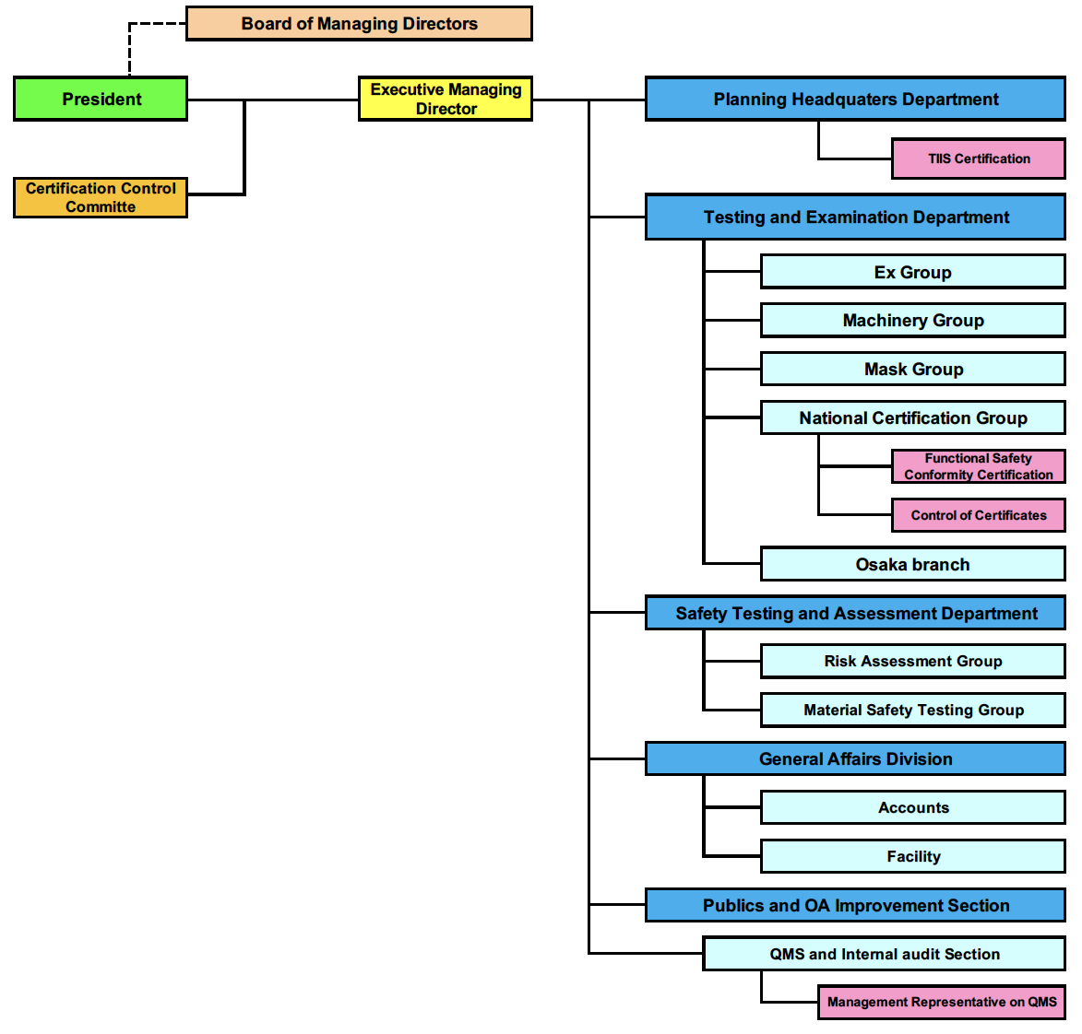

1. Organisation Chart of ExCB/ExTL

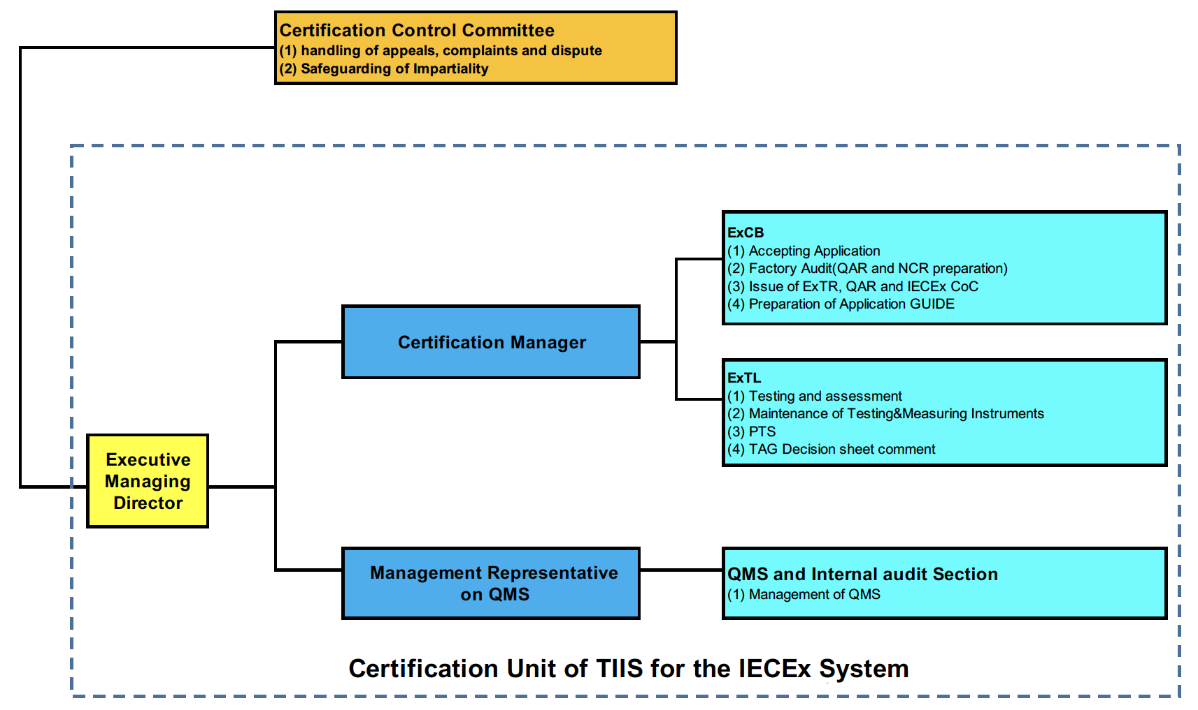

1. 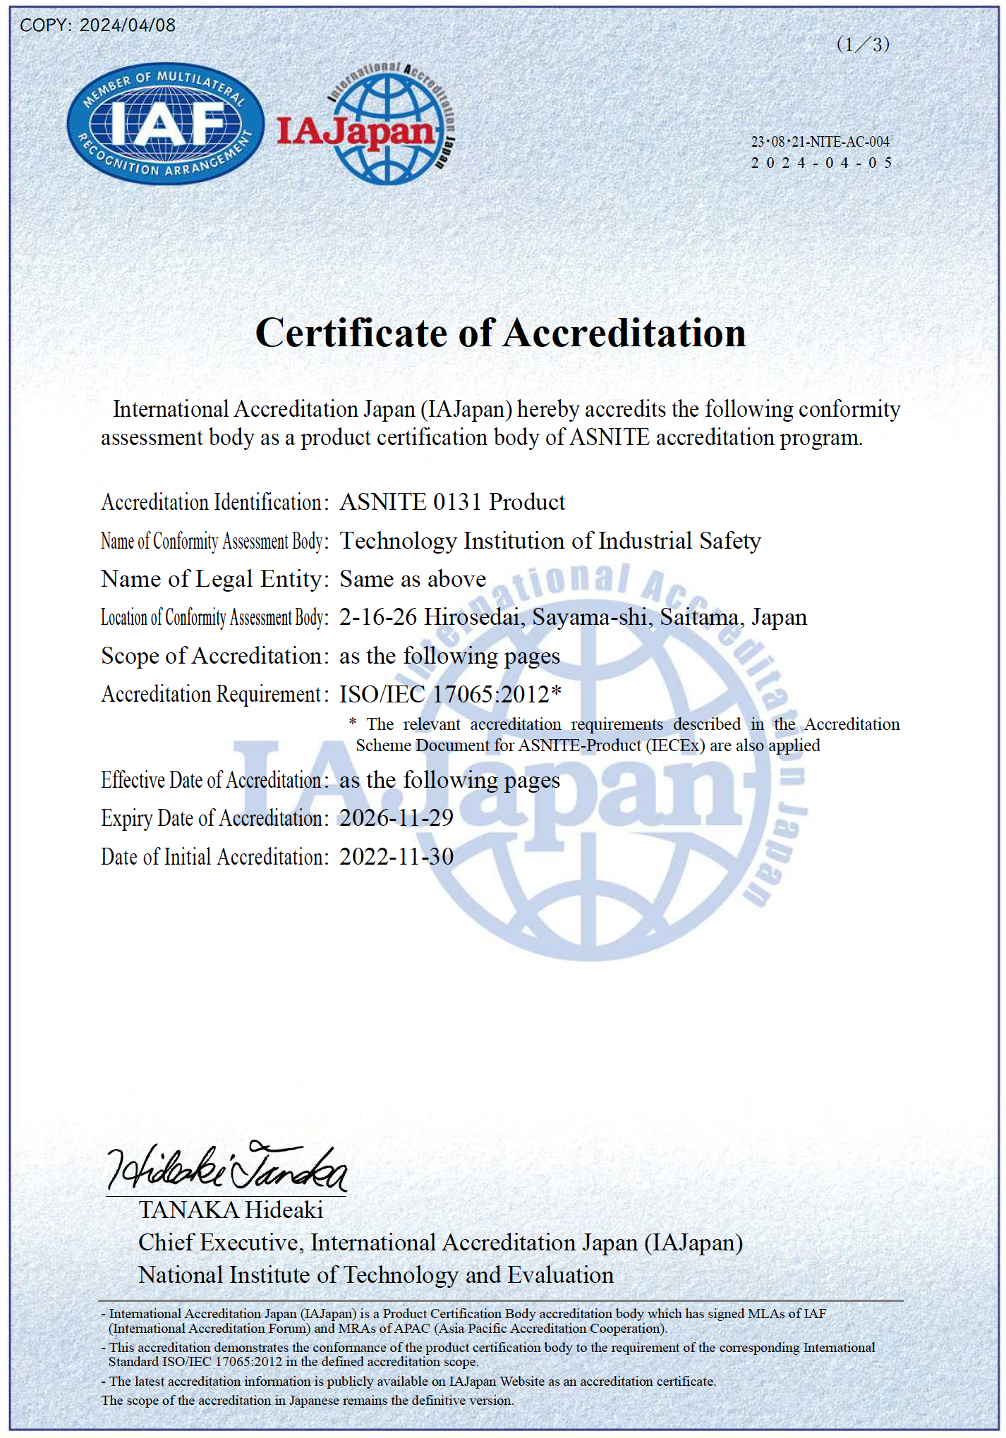  
   Accreditation Certificate for ISO/IEC 17065

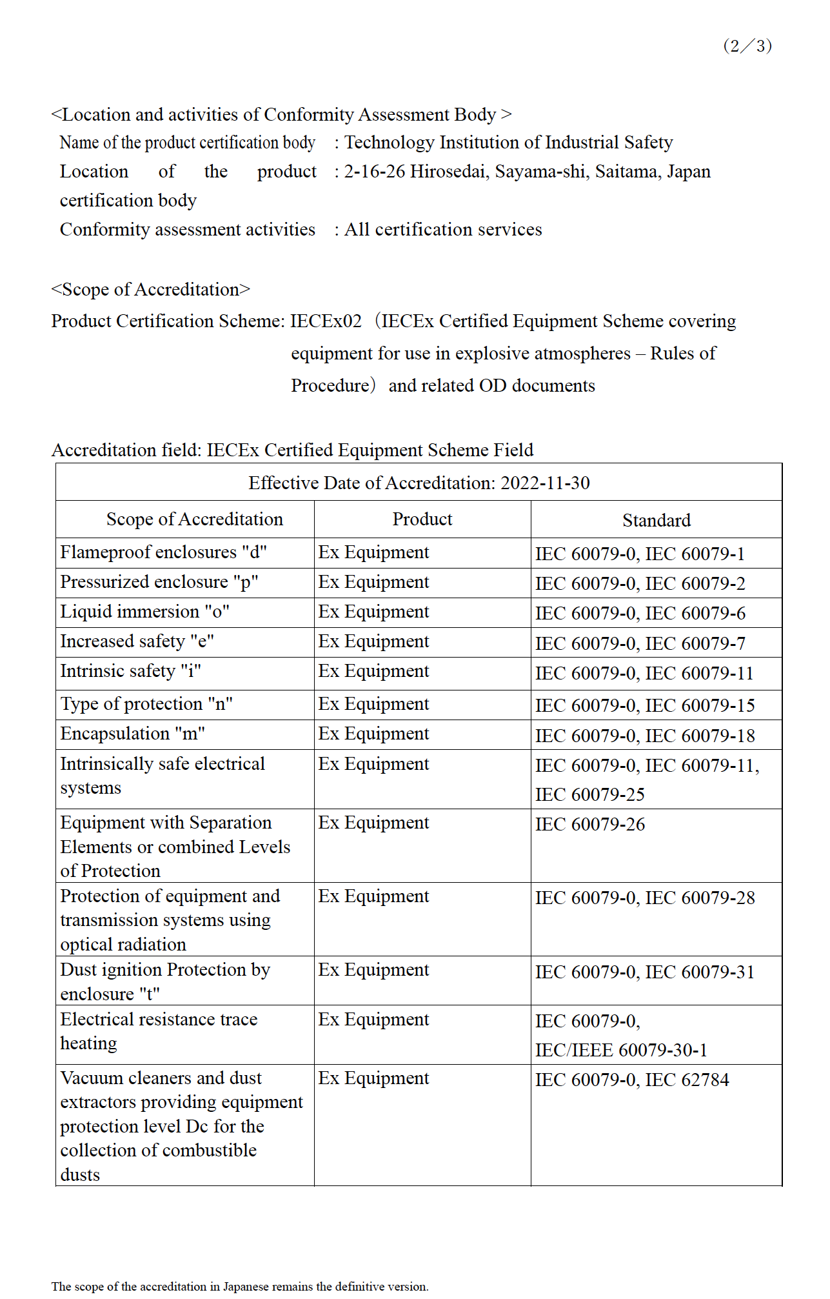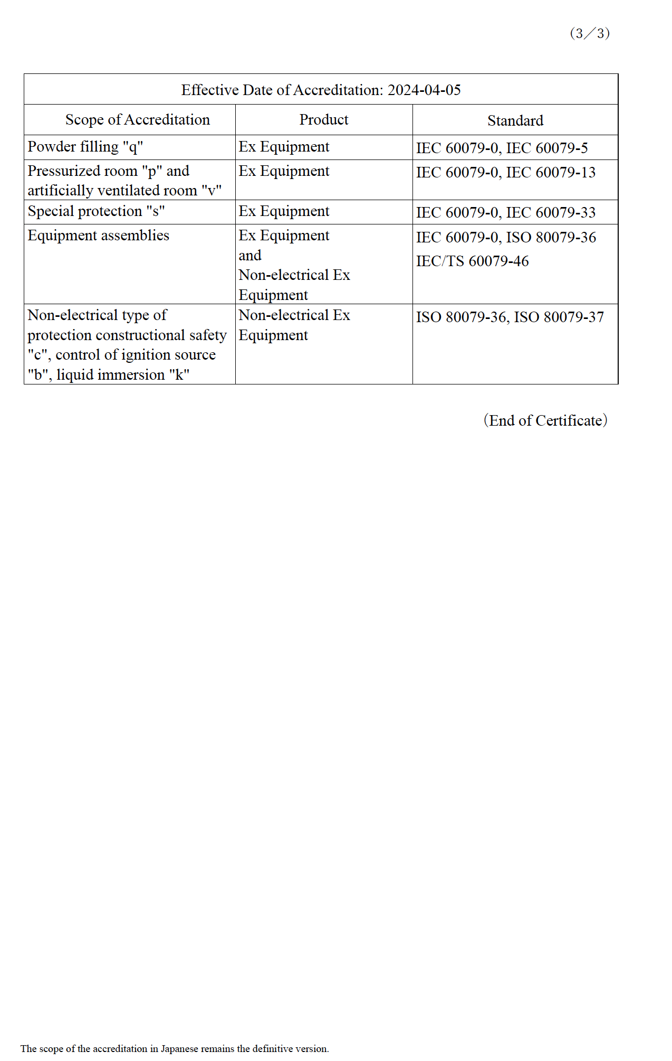

1. 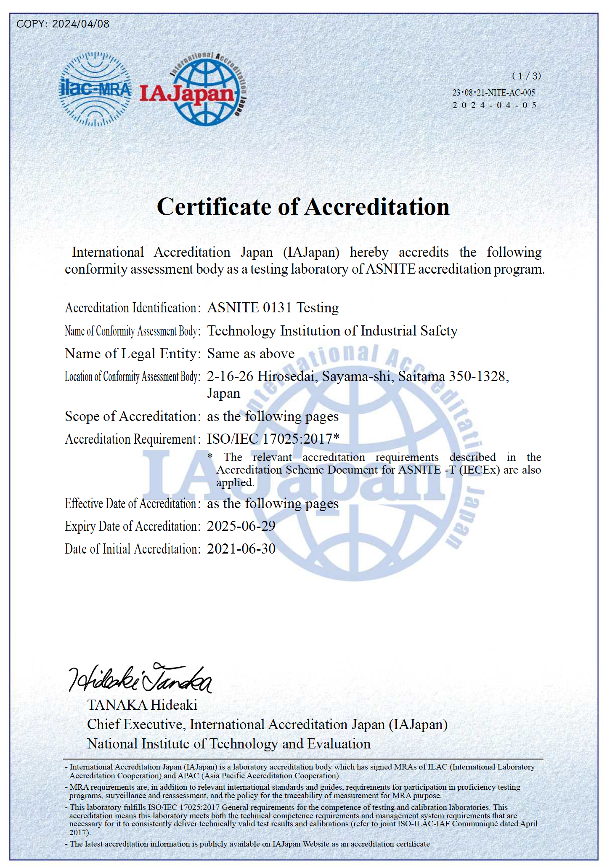  
   Accreditation Certificate for ISO/IEC 17025

