INTERNATIONAL ELECTROTECHNICAL COMMISSION SYSTEM FOR
CERTIFICATION TO STANDARDS RELATING TO EQUIPENT FOR USE
IN EXPLOSIVE ATMOSPHERES (IECEx SYSTEM)

GENERAL INFORMATION
ON THE MEETINGS OF THE IECEx SYSTEM
to be held in Kyoto, Japan
15th September to 19th September 2025

Dear Colleagues,

This document contains the finalised details about the 2025 IECEx System Meetings and associated events to be held in Kyoto, Japan over the period of 15th to 19th September 2025.
We thank you in anticipation of your participation and invite you to contact us should you have any questions relating to the meetings.

Kind regards,
IECEx Secretariat

Address:  Level 17, Angel Place  123 Pitt Street  Sydney NSW 2000, Australia | Contact Details:  Email: Info@iecex.com

GENERAL INFORMATION
ON THE MEETINGS OF THE IECEx SYSTEM
to be held in Kyoto, Japan over 15th September to 19th September 2025
The 2025 series of IECEx Annual meetings will be held in Kyoto, Japan, which is considered to be the cultural capital of Japan. Kyoto was the capital of Japan for about 1,100 years and has more than 3,000 temples and 1,700 shrines, making a wonderful city full of history and tradition with 17 Word Heritage Sites by UNESCO. It is said that each year, more than 50 million tourists from both inside and outside Japan visit Kyoto, making it one of Japan’s leading tourist destinations.
MEETING VENUE
Kyoto International Conference Center (ICC Kyoto)
422 Iwakura Osagicho, Sakyo Ward,
Kyoto, 606-0001, Japan

MEETING SCHEDULE
Date | Event / Meeting
Monday, 15th Sept 2025, 9:00AM to 12:00 | Peer Assessor Training
Monday, 15th Sept 2025, 1:00PM to 5:00PM | ExPCC Meeting
Tuesday 16th Sept 2025, ALL DAY | ExTAG Meeting
Wednesday, 17th Sept 2025, 9:00AM to 12:00 | ExSFC Meeting
Wednesday, 17th Sept 2025, 1:00PM to 5:00PM | Industrial Symposium  *Final Program to be advised at a later date
Thursday, 18th Sept 2025, ALL DAY | ExMC Meeting
Friday, 19th Sept 2025, ALL DAY | ExMC Meeting

MEETING HOURS: 9.00 a.m. to 12.00 p.m.
1.00 p.m. to 5.00 p.m.
NOTE: A meeting room for a small group up to 16 persons is available for WG Meetings from 9:00 a.m. to 9:00 p.m. from Monday to Wednesday (first in, first served). Booking requests to be done via the IECEx Secretariat as early as possible.
Beverages will be available throughout the meetings. There will be two official coffee breaks with light refreshments during the meetings at approximately 10.00 a.m. to 11.00 a.m. and 2.30 p.m. to 3.30 p.m.

LUNCH:
Lunch break will normally be from 12.00 p.m. to 1.00 p.m. and lunch will be provided for ExTAG delegates on Tuesday and for ExMC delegates on Thursday and Friday.
Please note that ExAG assessor training session participants, ExPCC delegates and ExSFC delegates on Monday and Wednesday will need to make their own arrangements for lunch. There are several facilities in and around the venue, ICC Kyoto where lunch can be enjoyed.

ExMC DINNER
ExMC delegates and accompanying persons are invited to attend a dinner in the evening of Thursday, 18th September 2025 commencing at 6:00 p.m. The dinner will be held at Banquet Hall Sakura inside the ICC Kyoto. The Dress code is Business Casual.

IECEx MEETINGS & SEMINAR REGISTRATION
Please register BEFORE 11th August 2025 for participation (refer below for Meeting Eligibility requirements) in the Industrial Symposium and relevant IECEx MEETINGS by completing the Online Registration System form accessible via the following link:
https://forms.office.com/e/zSBgEA9X8i
NOTE: The delegates of IECEx meetings are welcome to attend the Industrial Symposium however priority will be given to Japanese users and manufacturers. If the number of registrations exceeds capacity in the venue delegates may be asked to give their seats to Japanese users and manufacturers. IECEx delegates will be individually contacted if there is a need to request them to NOT attend the Symposium.

If you have any questions or have any problems using the Online Registration System, please contact mark.amos@iecex.com
MEETING PARTICIPATION & ELIGIBILITY
- For the ExPCC Meeting sessions permitted participation is as follows:
The following may participate as active delegates with access to speak during the meeting:
- ExPCC Members ONLY
NOTE: Delegates wishing to attend as Observers shall be endorsed by the relevant National Member Body by advice to the IECEx Secretariat prior to registration. Permission to attend as an Observer is subject to Chairman approval and seating capacity on the day.
- For the ExTAG Meeting sessions permitted participation is as follows:
The following may participate as active delegates with access to speak during the meeting:
- Representatives from ExCBs / ExTLs Operating in the IECEx 02 Equipment Scheme
- Chair and/or Secretaries of IEC TC 31 and subcommittees (as ex officio members)
- IEC TC31 & IECEx Liaison
NOTE: Delegates wishing to attend as Observers shall be endorsed by the relevant National Member Body by advice to the IECEx Secretariat prior to registration. Permission to attend as an Observer is subject to Chairman approval and seating capacity on the day.
- For the ExSFC Meeting sessions permitted participation is as follows:
The following may participate as active delegates with access to speak during the meeting:
- ExSFC Members ONLY
NOTE: Delegates wishing to attend as Observers shall be endorsed by the relevant National Member Body by advice to the IECEx Secretariat prior to registration. Permission to attend as an Observer is subject to Chairman approval and seating capacity on the day.

- For the ExTAG Meeting sessions permitted participation is as follows:
The following may participate as active delegates with access to speak during the meeting:
- Representatives from ExCBs / ExTLs Operating in the IECEx 02 Equipment Scheme
- Chair and/or Secretaries of IEC TC 31 and subcommittees (as ex officio members)
- IEC TC31 & IECEx Liaison
- IECEx Executive members
NOTE 1: Delegates wishing to attend as Observers shall be endorsed by the relevant National Member Body by advice to the IECEx Secretariat prior to registration. Permission to attend as an Observer is subject to Chairman approval and seating capacity on the day.

- For the ExMC Meeting sessions permitted participation is as follows:
- A maximum of three persons per country may participate as active delegates with access to speak during the meeting. For countries where more than three persons wish to register as participants, the additional delegates may join the meetings as Observers subject to a request to the IECEx Secretariat from the National Member Body for Observer status being approved. In this situation, the IECEx Secretariat requests that the National Member Body confirm the names of the three active delegates and advise which delegate will be the Head Delegate. In the absence of this information from the National Member Body, the ExMC Chair and Executive Secretary shall decide whom may actively participate.
additionally, the following may also participate as active delegates with access to speak during the meeting:
- Chair and Secretary of IEC TC 31
- IEC TC31 & IECEx Liaison
- Chairs of IEC SC 31s
- IECEx Executive members
- IECEx Committee Chairs or Deputy Chairs
- ExMC Working Group Convenors
NOTE 1: The Head of Delegation (HoD) is responsible for speaking on behalf and voting on behalf of their respective IECEx National Member Body and may invite other delegates to speak.
NOTE 2: Delegates wishing to attend as Observers shall be endorsed by the relevant National Member Body by advice to the IECEx Secretariat prior to registration. Permission to attend as an Observer is subject to Chairman approval and seating capacity on the day.

MEETING PROTOCOLS
- A Consent Agenda will be used for the ExMC Meeting
- The agenda and documents will be shared on the computer screen during discussions
- The Chair or a requested person will introduce the document at the appropriate time
- Meeting Decisions to be prepared live on screen and individually confirmed during the meeting according to the following process:
- The draft decisions will be shared on the computer screen and the text can be modified until it appears that there is consensus on the final draft Decision.
- The final draft Decision text will then be displayed and read aloud.
- The Chair will then seek agreement on the Decision text. Decisions will be presumed as unanimously agreed unless any Head Delegate indicates their objections.
- In the event of sustained objections, the discussion may, at the discretion of the Chair, be continued to find consensus.
- If no consensus can be found the Chair shall determine the course of action which may be to either postpone the matter OR to advise that a vote by correspondence on will be organised by the IECEx Secretariat on the item in question
- A list of all agreed Decisions will be issued following the meeting.

ACCOMMODATION

Recommended accommodation (approximately 2 minutes walk from the meeting venue) is:
The Prince Kyoto Takaragaike
1092-2 Iwakurahataeda-cho, Sakyo-ku,Kyoto (Official registered address)
Zip Code: 606-0015
Phone: +81-(0)75-712-1111
Website: https://www.princehotels.com/kyoto
and booking details for this hotel are as follows:

Dedicated Reservation Webpage: https://amarys-jtb.jp/IECEx2025/

Special Discounted Room Rates for IECEx Delegates:
[ Forest Floor Twin room (2-4F, 36.9 m²)] (in limit of rooms’ availability)
- For one person: 27,500 JPY/night (for 14th: 39,500 JPY)
- For two persons: 32,000 JPY/night (for 14th: 44,000 JPY)
- For three persons (with extra bed): 41,400 JPY (for 14th: 55,500 JPY)
Room Rate Inclusion:
- Taxes & fees
- Breakfast
- Wi-Fi service
- Access to the Fitness Room
NOTE: Delegates are advised that the special discounted room rates are only available for reservations made on or before 11th August 2024.

Kyoto city showcases a wide range of hotels and other alternative accommodations. The following webpage can be used to find other alternatives nearby the meeting venue, ICC Kyoto.
https://www.icckyoto.or.jp/en/accommodation/hotels-in-kyoto-2/

TRAVEL & VISITOR INFORMATION
ARRIVAL BY AIR
There are two international airports close to Kyoto: Kansai International Airport (KIX) and Osaka International Airport (Itami Airport) (ITM). Kansai Airport (KIX) is located approximately 120 minutes away from the venue. Osaka (Itami) Airport (ITM) is located approximately 80 minutes away from the venue.
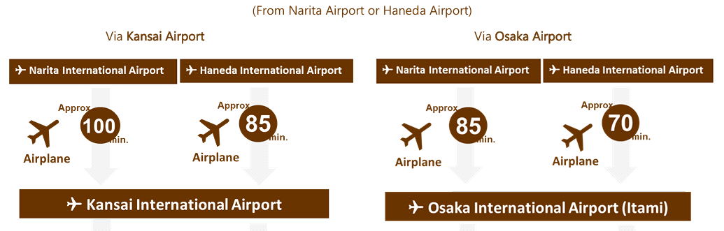
You can come directly to Kansai airport (KIX) or Osaka (Itami) airport (ITM) or come first to Haneda airport (HND) or Narita airport (NRT) and then use a domestic connecting flight to Kansai Airport (KIX) or Osaka Airport (ITM).
The following diagram shows how to access the venue from Kansai airport (KIX) and Osaka airport (ITM) to the recommended hotel and venue:
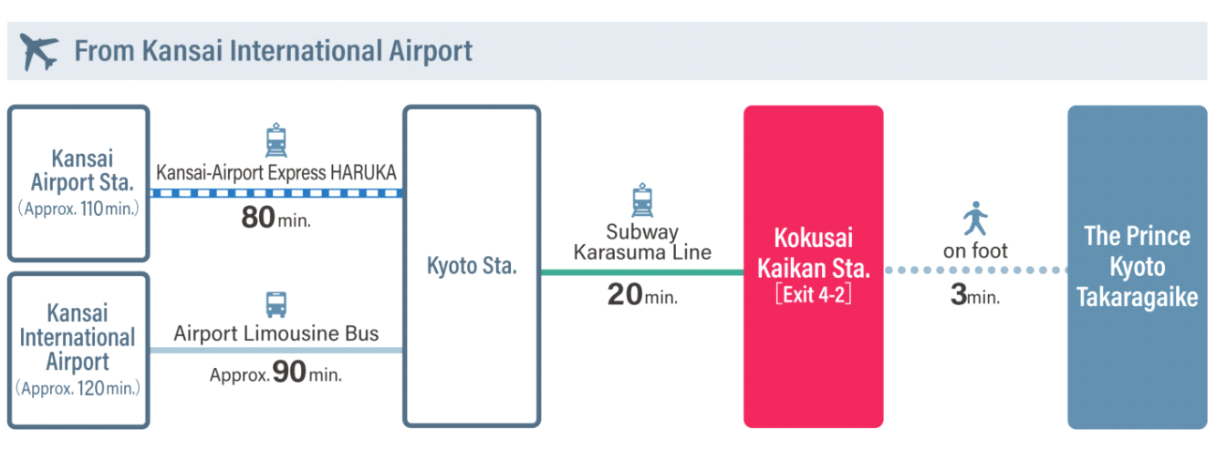
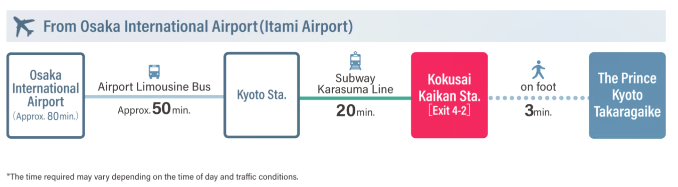
From Haneda airport (HND) and Narita airport (NRT), you can use a train and Shinkansen to Kyoto station however as this is complicated and time-consuming we recommend flying directly to Kansai Airport (KIX) or Osaka (Itami) Airport (ITM). If your flight options are limited, the following shows how to travel from Narita airport (NRT) and Haneda airport (HND) to Central Tokyo (Shinagawa/Tokyo Station) where you can take the Shinkansen to Kyoto.
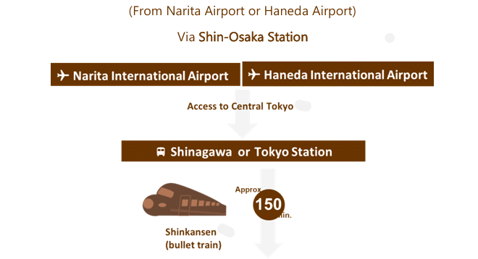
*From Narita Airport (NRT) to Shinagawa/Tokyo Station: (Access Top | NARITA INTERNATIONAL AIRPORT)
**From Haneda Airport (HND) to Shinagawa /Tokyo Station: (Access | Haneda Airport Passenger Terminal)

PASSPORT, VISA, AND VACCINATION
All visitors need a valid passport to enter Japan. Details of regulations related to all countries are available from all Japanese embassies. Participants are advised to check the following website about Exemption of Visa for Short-term Stay. More information is available via Exemption of Visa (Short-Term Stay) | Ministry of Foreign Affairs of Japan

If needed, TIIS will send an official invitation to delegates. Please contact Ms. Sungmi JUNG: jung@tiis.or.jp for that purpose.

In addition, it is recommended to visit the Visit Japan Web and create QR codes before arriving in Japan to save time during immigration clearance and customs declaration.* More information is available at the Visit Japan Web | Digital Agency Services

CLIMATE AND CLOTHING
Kyoto is still quite hot and humid in September. The average temperature is 29°C (84°F) however it feels more like 33°C (92°F) because of the humidity.

CREDIT CARDS
Visa, American Express, Diners Club, and Mastercard are accepted in most hotels, restaurants, and shops in the tourist spots. However, Japan is still much a cash-based society, so it is strongly recommended to keep some cash on you.

CURRENCY
Local currency is Japanese Yen. It's easy to exchange any currency into Japanese yen once you arrive in the country. Japan is very much a cash-based society, so keep cash on you. Tipping is not practiced in Japan. For more details, refer to the following websites.
* More information is available at the Japan National Tourist Organization's Website via Japan Currency Exchange | Travel Japan Currency Exchange | JNTO
** More information is available at the Japan National Tourist Organization's Website via Tipping in Japan | Travel Japan | JNTO

ELECTRICITY SUPPLY
100 V at 60 Hz. The following figures illustrate the standard plug and receptacle configurations used in western Japan. (* 50 Hertz in eastern Japan)
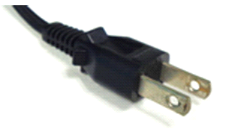TYPE A
* More information is available at the Japan National Tourist Organization's Website via Japan Electrical Outlet | Travel Japan | JNTO

EMERGENCY and INSURANCE
The emergency number for paramedic, police, and fire services is 1-1-9. Attendees are responsible for obtaining travel, medical, personal, accident, and luggage insurance in their country prior to departure. The hosts, JISC and TIIS accept no liability for any loss or injury incurred. *More information is available at the Japan National Tourist Organization's Website via Japan Visitor Hotline | Travel Japan | JNTO

Earthquakes in Japan: Although they should not deter you from visiting Japan, natural disasters such as earthquakes do occur. Compared to other countries, earthquakes are common in Japan, so it's best to be prepared.
* More information is available at the Japan National Tourist Organization's Website via Staying Safe in Japan | Japan Safety | Travel Japan | JNTO

TIME ZONE
The time zone in Kyoto is JST (UTC+9)

