**INTERNATIONAL ELECTROTECHNICAL COMMISSION SYSTEM FOR CERTIFICATION TO STANDARDS RELATING TO EQUIPMENT FOR USE IN EXPLOSIVE ATMOSPHERES (IECEx SYSTEM)**

**Title:** **Re-assessment Report for the continued acceptance** **of Nanyang Explosion Protected Electrical Apparatus Research Institute (CNE) an Accepted ExCB and China National Quality Survey and Test Centre for Explosion Protected Electrical Products (CQST) an Accepted Test Laboratory, within the IECEx Equipment Scheme 02.**

**Circulation to: Members of the IECEx Management Committee, ExMC**

**INTRODUCTION**

In accordance with the 5 Year re-assessment plan for the surveillance and monitoring of bodies within the IECEx System, the following document contains the IECEx Re-assessment Report for the continued acceptance of Nanyang Explosion Protected Electrical Apparatus Research Institute (CNE) an Accepted ExCB and

China National Quality Survey and Test Centre for Explosion Protected Electrical Products (CQST) an Accepted Test Laboratory, within the IECEx Equipment Scheme 02.

This report is hereby submitted for endorsement during the 2025 ExMC Kyoto Meeting.

**Chris Agius**

|  |  |
| --- | --- |
| **Visiting address:**  **IECEx Secretariat**  **Level 17 Angel Place 123 Pitt Street  Sydney NSW 2000 Australia** | **Contact Details:**  **Tel: +61 2 4628 4690**  **Fax: +61 2 4627 5285**  **E-mail: info@iecex.com**  [**http://www.iecex.com**](http://www.iecex.com) |

IEC System for certification to standards relating to equipment for use in Explosive Atmospheres (IECEx System)

IECEx assessment report form for use by IECEx assessment teams to report assessments conducted according to the relevant IECEx assessment procedures of:

Operational Document IECEx OD 003-2 for the Certified Equipment Scheme

Operational Document IECEx OD 316-* for the Certified Service Facility Scheme

Operational Document IECEx OD 422 for the IECEx Conformity Mark Licensing Scheme

Operational Document IECEx OD 501 for the Personnel Competence Scheme

_________________________________________________

IECEx ExCB/ExTL Re-assessment report for

ExCB: Nanyang Explosion Protected Electrical Apparatus Research Institute (CNE)

ExTL: China National Quality Survey and Test Centre for Explosion Protected Electrical Products (CQST)

INTERNATIONAL  
ELECTROTECHNICAL  
COMMISSION

CONTENTS

1 Assessment information 6

1.1 Type of body covered by this assessment: 6

1.2 Type of assessment: 6

1.3 Details of body 6

1.3.1 Country 6

1.3.2 Name of body 6

1.3.3 Name and title of nominated principal contact 6

1.4 Assessment information 7

1.4.1 Members of the assessment team 7

1.4.2 Place(s) of assessment 7

1.4.3 Assessment date(s) 7

1.5 Application information and background information on the assessment 7

1.6 Scopes 7

1.6.1 ExCB scope for equipment certification scheme 7

1.6.2 ExTL scope 7

1.6.3 ATF Scope 8

1.6.4 ExCB scope for Service Facilities Scheme 8

1.7 ExCB scope for Conformity Mark Licensing Scheme 8

1.8 ExCB scope for IECEx Personnel Competence Scheme 8

2 Common information 8

2.1 Legal entity of body 8

2.2 Financial support 8

2.3 History 8

2.4 Documentation 9

2.4.1 Quality manual 9

2.4.2 Procedures 9

2.4.3 Work instructions 10

2.4.4 Records (including test records where relevant) 10

2.4.5 Document change control 10

2.5 Confidentiality 10

2.6 Communication with public and customers (Hard copy and Electronic) 10

2.7 Recognitions and agreements 10

2.8 Internal audit 11

2.9 Management review 11

2.10 Contracting, subcontracting and witness testing 11

2.10.1 Contracting 11

2.10.2 Subcontracting 12

2.10.3 Off-site and Witness testing 12

2.11 Training and competence 12

2.12 Complaints and appeals (including appeals to IECEx) 12

2.13 Impartiality 12

2.14 Active involvement in development of Decision Sheets 13

2.15 Special facts to be noted 13

2.16 Supporting documentation 13

2.17 Recommendations 13

3 ExCB for IECEx Certified Equipment Scheme 14

3.1 Assessment references 14

3.1.1 General references 14

3.1.2 Additional references applied for this assessment 14

3.2 Candidate ExCB persons interviewed 14

3.3 Associated ExTL(s) 14

3.4 Associated certification functions 15

3.5 National marks and certificates 15

3.6 Standards accepted 15

3.7 National differences to IEC standards 15

3.8 Organisation 15

3.8.1 Names, titles and experience of the senior executives 15

3.8.2 Name, title and experience of the quality management representative 15

3.8.3 Name and title of signatories for certification 15

3.8.4 Other employees in ExCB activity 16

3.9 Organizational structure 16

3.10 Indemnity insurance 16

3.11 Resources 16

3.12 Committees (such as governing or advisory boards) 16

3.13 Certification operations 17

3.13.1 National approval/certification methods 17

3.13.2 Certification policy 17

3.13.3 Application for certification 17

3.13.4 Certification decision 17

3.13.5 Suspension and cancellation of certificates 17

3.14 Certificates issued 17

3.15 National accreditation 17

3.16 Assessment of manufacturers and issue of QARs 18

3.17 Comments (including issues found during assessment) 18

4 ExTL for IECEx Certified Equipment Scheme 19

4.1 Assessment references 19

4.1.1 General references 19

4.1.2 Additional references applied for this assessment 19

4.2 Candidate ExTL persons interviewed 19

4.3 Associated ExCB(s) 20

4.4 Organisation 20

4.4.1 Names, titles and experience of the senior executives 20

4.4.2 Name, title and experience of the quality management representative 20

4.4.3 Other employees in ExTL activity 21

4.5 Organizational structure 21

4.6 Resources 21

4.7 Test reports issued 21

4.8 National accreditation 22

4.9 Calibration 22

4.10 Tests witnessed during the assessment visit 22

4.11 Participation in IECEx Proficiency Testing Programs 23

4.12 Comments (including issues found during assessment) 24

5 ATF for IECEx Certified Equipment Scheme 25

6 ExCB for Certified Service Facilities Scheme 25

7 IECEx Conformity Mark Licensing Scheme 25

8 ExCB for IECEx Personnel Competence Scheme 25

9 Annexes 26

Annex A Scope for IECEx Certified Equipment Scheme 27

A.1 Current standards 27

A.2 Superseded standards 28

Annex B Overall Organisation Chart 29

Annex C Organisation Chart of ExCB/ExTL 30

Annex D Accreditation Certificate for ISO/IEC 17065 32

Annex E Accreditation Certificate for ISO/IEC 17025 37

# Assessment information

## Type of body covered by this assessment:

|  |  |
| --- | --- |
| ExCB for IECEx Certified Equipment Scheme |  |
| ExTL for IECEx Certified Equipment Scheme |  |
| ATF for IECEx Certified Equipment Scheme |  |
| ExCB for IECEx Certified Service Facilities Scheme |  |
| ExCB for IECEx Conformity Mark Licensing System |  |
| ExCB for IECEx Certification of Personnel Competency Scheme |  |

NOTE 1 ExCB - IECEx Certification Body

NOTE 2 ExTL - IECEx Testing Laboratory

NOTE 3 ATF - Additional Testing Facility

## Type of assessment:

|  |  |
| --- | --- |
| Pre-assessment for candidate body |  |
| Initial assessment for candidate body |  |
| Surveillance |  |
| Re-assessment |  |
| Scope extension |  |

## Details of body

### Country

People's Republic of China

### Name of body

ExCB: Nanyang Explosion Protected Electrical Apparatus Research Institute Co., Ltd (CNE).

ExTL: China National Quality Survey and Test Centre for Explosion Protected Electrical Products (CQST).

### Name and title of nominated principal contact

|  |  |  |
| --- | --- | --- |
| Name | Title | E-mail address |

|  |  |  |
| --- | --- | --- |
| Mr. Jun Wang (ExTL) | Director of CQST | [wangjun@cn-ex.com](mailto:wangjun@cn-ex.com) |
| Mr Forrest Zhang (ExCB) | Development Manager | Zhangyt@cn-ex.com |

## Assessment information

### Members of the assessment team

|  |  |
| --- | --- |
| Name | Role |

|  |  |
| --- | --- |
| Ajay Maira | IECEx Lead Assessor |
|  |  |

### Place(s) of assessment

|  |  |
| --- | --- |
| 20 North Zhongjing Road  Nanyang City  Henan Province  People's Republic of China | On-site and also by Remote using web conferencing |

### Assessment date(s)

Onsite: 20 to 22 March 2024

By remote: 16 April 2024 to 31 August 2024

## Application information and background information on the assessment

ExCB CNE: Previous IECEx CB report was ExMC/1452/DV for the first assessment conducted on 7 to 8 August 2018.

ExTL CQST: Previous IECEx TL report was ExMC/1766/R for a re-assessment conducted on 16 to 23 March 2021. It is associated with the IECEx CB CNE described above.

CNE is owned by CNEX (China), the same organisation that also owns CQST, and is located at the same premises as CQST.

It may also be noted here that CNEX (China) also holds another IECEx CB “CNEx-Global” in Netherlands.

There have been no changes in the list of Standards since the previous assessments, although several more recent issues of the Standards have been included in the scope by declarations made by CQST.

The current re-assessments were due to be conducted by two IECEx assessors drawn from Ex CB and ExTL but due to a medical emergency at the last moment, the audit continued as an on-site visit by the one Lead Assessor focussing on those parts of the assessment that benefit from checking the test equipment and witness tests in person, including discussions with the technical engineers and manufacturer quality system assessors. The on-site assessment was followed by a remote assessment in accordance with OD 060 to prepare the IECEx assessment reports, review of the 17025 and 17065 checklists, and review of the issued reports.

Desk top review was conducted by IECEx secretariat prior to this assessment.

## Scopes

### ExCB scope for equipment certification scheme

The scope for the ExCB is shown in Annex A.

### ExTL scope

The ExTL scope is the same as for the ExCB.

The ExTL is owned by the same organisation CNEX that owns the ExCB, and hence while at the same premises, it is not considered completely integral with the ExCB, The scope of the ExTL is included as an additional column in Annex A.

### ATF Scope

There is no ATF included in the scope of this re-assessment.

### ExCB scope for Service Facilities Scheme

There is no Service Facility included in the scope of this re-assessment.

## ExCB scope for Conformity Mark Licensing Scheme

There is no Conformity Mark Licensing Scheme included in the scope of this re-assessment.

## ExCB scope for IECEx Personnel Competence Scheme

There is no IECEx Personnel Competence Scheme included in the scope of this re-assessment.

# Common information

## Legal entity of body

CNE / CQST has presented a Business License issued by National Enterprise Credit Information Publicity System (www.gsxt.gov.cn) showing the legal name of CQST “Nanyang Explosion Protected Electrical Apparatus Research Institute Company Limited” at No. 20 North Zhongjing Road, Nanyang City, Henan, China with Uniform Social Credit Code 9141130041904693X0 as a Limited Liability Company with term of validity Sep 30, 2006 to Sep 29, 2038.

The scope includes providing services of calibration, verification, testing, certification, and standardization for the relevant electrical apparatus, including instruments, luminaries, electrical motors, control panels etc.

## Financial support

The operation is financed from its services of testing, verification, inspection, national certification and standardization work. Sometimes they can get investment from local or central government in order to support research work.

## History

In 1958 the predecessor of CNE/CQST was founded in northeast China as Research House of Ex-motor of First Machinery Industrial Department.

In 1970, it moved to Nanyang as the Nanyang Explosion Protected Electrical Apparatus Research Institute (CNEX), becoming a State owned explosion protection research institute and establishing an Ex-Testing Station.

In 1977, the first formal China National Standards (GB-1336-77) were drawn up.

In 1995, Ex-Testing Station of CNEX was approved as China National Test Center for Explosion Protected Electrical Products (CQST), representing China to carry out science research, testing, certification, quality survey and other management functions.

In 1999 CQST was recommended as China ExTL for the IECEx Scheme by General Administration of Quality Survey, Inspection and Quarantine of the People’s Republic of China (AQSIQ).

In 2007, Nanyang Key Laboratory of Explosion Protection & Fire Prevention was set up, which takes the legal entity of CQST.

In 2010, CQST was accepted as an IECEx TL with the associated IECEx CB being CQM.

In 2018, CNCA (Certification and Accreditation Administration of the PRC) gave permission to CNEX to act as certification body for the Chinese market as well as for application to the IECEx with document CNAC-R-2018-379, issued on January 3, 2018 and validity until January 3, 2030. Hence CNEX then was assessed and accepted as an IECEx CB.

In 2024, both CNE and CQST now have their 5 yearly re-assessment cycles coincided to allow a single visit to cover both the bodies being assessed.

## Documentation

### Quality manual

CQST has a comprehensive manual CNEX-QM 2022 addressing all the elements of ISO/IEC 17025:2017 and IECEx requirements. The quality system consists of the following levels:

Level 1: Policy

Level 2: Quality Manual CNEX-QM

Level 3: Procedures

Level 4: Working Instruction – Standard Operating procedures (SOP)

Level 5: Forms (these are supporting Technical Records and Forms (CQST-TR) and Management Records and Forms (CQST-MR)

All levels were reviewed during the reassessment. The requirements of IECEx are met.

The quality system of CNE is presently independent of the CQST described above. It consists of four levels described in CNEX-CB-QM-002:

Level 1: Regulations (document CNEX-CB-QR-…); and

Level 2: Quality Manual CNEX-CB-QM-001 E Ver 4.0;

Level 3: Procedures CNEX-CB-QP-…);

Level 4: Quality records/forms (CNEX-CB-FM-…).

The Quality Manual describes the activities as ExCB and related technical activities towards certification. The quality manual meets the requirements of the IECEx,

### Procedures

CQST: Procedures are described in CNEX-QP-documents. These are listed in CNEX-QP-III-2023. Several procedures were reviewed during the assessment and found to meet the requirements of IECEx,

Procedure CNEX-QP-9.2-2022 describes the procedure for testing and the application for certification.

CNE: These are listed in CNEX-CB-QM-000 with several of these procedures relevant to certification for the IECEx System.

Procedure CNEX-CB-QP-007E Ver 2.0 describes the IECEx certification process. Certificates issued by CNE have the IECEx CNEx prefix. This procedure was reviewed during the re-assessment.

Witness / off-site testing is described in CNEX-CB-QP-010.

The above procedures were reviewed in detail during the reassessment and found to meet the requirements of the IECEx,

### Work instructions

CQST: CQST has operation instructions (Working Instruction) for the technical work. These are listed in CQST-ZD-000, Sample operation instructions were used and checked during the witness testing.

CNE: Work instructions concerning IECEx Scheme 02 are combined and listed in CNEX-CB-QM-000.

Several of these procedures were reviewed and found to meet the requirements of IECEx

### Records (including test records where relevant)

CQST: CQST retain detailed test records on file. Requirements are covered in Procedure for Control Recording CNEX-QP-8.4-2022. Samples of completed records were reviewed in detail during the assessment and found to meet the requirements of IECEx.

CNE: Covered by CNEX-CB-QP-102EC, Version 2. Record Control, was found to meet IECEx requirements of OD 207 Guidance on the Retention of Records

### Document change control

CQST: Document change control is covered in CNEX-QP-8.3-2022. All documents have an issue number. All documents reviewed were in compliance with the CQST procedure.

An assigned person collects IEC standards and IECEx information. They also receive notification of new or changed documents from IECEx,

CNE: CNEX-CB-QP-101EC, Version 3 Procedure for Control of Documents, describes control and procedure to change documents. The list of controlled documents is found in CNEX-CB-QM-000 and includes both internal as well as IECEx Rules and ODs. The procedure was checked and found to meet the IECEx requirements.

## Confidentiality

CQST: Confidentiality is described in procedure CNEX-4.2-2022. Each member of staff signs a confidentiality agreement. These were found to meet the requirements of the IECEx.

CNE: Confidentiality is covered in CNEX-CB-QP-108EC, Version 1.0, Issue Date 2017.7.16, Procedure for Independence, impartiality, integrity and confidentiality. All staff involved in the ExCB signed a document, CNEX-CB-FM-102EC, regarding impartiality and confidentiality. During the assessment, these were were checked and found to meet the IECEx requirements.

The Certification Committee signs the same confidentiality form CNEX-CB-FM-102EC,

## Communication with public and customers (Hard copy and Electronic)

This is generally through the CNEX website (http://www.china-ex.com/English) with subsequent communication by email cqst@cn-ex.com) / [cnex-cb@cn-ex.com](mailto:cnex-cb@cn-ex.com) and phone (+86 377 63258564),

## Recognitions and agreements

There are several recognition agreements available and listed on their website.

CQST has signed a Product Testing Implementation agreement with Presafe/DNV/Nemko Norway for acceptance of test and manufacturer audit results.

It is an associated ExTL for CNEx Global.

CQST has a signed contract with CQM China Quality Mark Certification Group Co Ltd Beijing for obtaining IECEx certification activities.

CQST (and also CNE) have signed Memorandum of Understanding with UL for acceptance of test data.

CQST has signed Memorandum of Understanding with Ineris France for acceptance of test data.

CQST has signed agreement with Nanio-CCVE Russia for acceptance of test data.

CNE has signed agreements with SGS Baseefa to provide training and accept auditor reports for obtaining CCC Ex product certificates. (The CCC Mark, is a compulsory safety mark for many products imported, sold or used in the Chinese market).

## Internal audit

CQST: Internal audit is covered by procedure CNEX-QP-8.8-2022. The Quality Manual specifies that audit to be conducted once a year. There is a plan for the audits that covers all the main requirements of ISO/IEC 17025 for all the areas of CQST. Detailed technical procedure audits are also carried out. A summary is produced of the audits indicating where the need for corrective action has been identified. The last audit conducted on 2023-09-05 was sighted. Several procedures were included in the report. Non-conformance reports were completed. NCR register was available. The internal audit plan was found to meet the requirements of the IECEx.

CNE: Internal audit is covered by CNEX-CB-QP-105EC, Version 1.0, Internal Audit Control Procedure. The internal audit for the ExCB is done at least once a year by the Technical & Quality Manager and other internal auditors. All audit records are retained. The last audits conducted on 2023-09-27 and 2024-08-06 were reviewed. Several auditors were used to split up the work involved. A list of observation and non-compliances were raised as applicable and dealt with in a timely and satisfactory manner..

## Management review

CQST: Management review is covered in procedure CNEX-QP-8.9-2022. The review is presided over by the Director. The minutes for meeting of 2024-01-05 was sighted. The top executives and the internal auditors attended the meeting. The list of items to be discussed were recorded. The extensions to technical Standards, the reference documents, the quality goals, CNAS assessment results, new test equipment, training, risk assessment etc were discussed.

The records included minutes, with agenda including results of external audits, and recommendations for improvements in the organizational structure to improve speed of delivery of services,

CNE: Management review is covered by CNEX-CB-QP-104EC, Version 2.0. The last management review took place on Jan 2024. Senior members of the organization attended the meeting. Previous actions were followed up. Compliance with internal and external audits were followed up. Non-compliances in the system were followed up. Customer feedback and interactions were discussed. Operation of the test lab were discussed. The statistics of number of certificates (local and international) were discussed. Risk factors were discussed. Safety committee updates were reviewed. Improvement suggestions were checked. The minutes of this meeting were reviewed and found to meet the requirements of the IECEx.

## Contracting, subcontracting and witness testing

### Contracting

CQST / CNE do not use any external contractors.

### Subcontracting

CQST / CNE do not use any subcontracting for IECEx processes. (National certification uses nominated subcontractors).

### Off-site and Witness testing

CQST: The procedure is provided in CNEX-QP-6.3-2022. Contracts are put into place with the manufacturer and information. Details are listed by CNE (see below).

CNE: The requirement and procedure for witness testing is covered by CNEX-CB-QP-010EC, Version 1.0, Witness testing at Ex manufacturer site, which references IECEx OD024 and found to meet the requirements of the IECEx.

Operation of this procedure was reviewed by examining records and entries made in the IECEx register. A sample agreement with Wolong Electric dated 2024-03-05 was examined. This was registered in the IECEx OD 024 register. This satisfies IECEx requirements.

## Training and competence

The laboratory is well resourced with skilled and competent staff working in excellent facilities and comprehensive procedures.

CQST: CNEX-QP-6.2:2022 provides the procedures for the staff at CQST to carry out their assigned scope and competencies. Annex in the TCD has details of the chart.

CNE: The main procedure for training is CNEX-CB-QP-115EC, Version 2.0, Personnel Training and Development. This procedure lists the steps for personnel to be trained. This procedure also provides judgement for personnel competencies, including who can make those decisions. There are lists with signatures showing the relevant competencies. Finally, there is a competence matrix covering the various techniques in testing, verification, ExTR review, QAR reviewer and certification decision. The training records for 2022-2023 were listed in a register with photos of the training material and photos of the attendees. Training plans were available as well. These were found to meet the requirements of the IECEx.

Details of staff competencies are included in the site assessment report F-004 (competence matrix).

## Complaints and appeals (including appeals to IECEx)

CQST: Procedure CNEX-QP-7.9-2022 is the procedure for complaints. The procedure was reviewed and found to meet the requirements of the IECEx. If an appeal is made by the applicant / manufacturer and is not able to be resolved using the Quality system, the complainant has the right for the appeal to be made to the independent Impartiality Committee of CNE. No complaint was received concerning IECEx,

CNE: Customer complaints are covered in procedure CNEX-CB-QP-110EC, Version 2.0. This includes the process that would be used if the complaint happened.

A survey is also made of customers each year, seeking their feedback. The form is available to customers on the website. The results are scored, and an average calculated to rate the service. Generally excellent reports were seen. No complaints or appeals about Ex testing was found in the past year.

## Impartiality

CQST: Procedure CNEX-QP-4.1-2022 for Declaration of Impartiality and ensures full impartiality and credibility of the provided service.

CNE: Confidentiality is covered in CNEX-CB-QP-108EC, Version 1.0, Independence, impartiality, integrity and confidentiality. All staff have signed agreements regarding impartiality and confidentiality of their work. During the assessment, several signed documents were checked. It was found to meet the IECEx requirements.

## Active involvement in development of Decision Sheets

CQST and CNE: Staff are well versed in the application of IECEx Decision Sheets during their test and report preparation. Draft TAG decision sheets are circulated amongst the concerned staff and responses are directed

Instructions for commenting on ExTAG documents are in the CNEX-CB-QP-011, Version 2.0, Procedure for management of information submission as certification body. The assigned persons are senior personnel that were interviewed during this assessment. The policy in China is that CQM Beijing coordinates all the IECEx comments and reports back to IECEx, however it has been noted at the IECEx secretariat that CNE/CQST has been active in sending comment directly to IECEx as well.

## Special facts to be noted

This IECEx assessment examined several issued IECEx test reports, as was required within the scope of the ExTL assessment of CQST, but additionally also examined IECEx certificates issued by CNE based on the reports prepared by CQST. The reports are adequately prepared and reviewed. Some editorial issues were noted, and in one case, a certificate had been issued to an edition of an IEC Standard whereas the test report had been issued to an earlier edition of that Standard. During the course of this assessment, a revised test report to the correct edition was prepared and issued, closing the issue satisfactorily.

## Supporting documentation

Copies of additional supporting information for this assessment have been provided to the applicant and the IECEx Secretariat. These are included in a site assessment report and further documents provided separately and include:

* Details of issues raised and how these have been resolved
* Checklist for ISO/IEC 17065
* Checklist for ISO/IEC 17025
* Completed Technical Capability Document (TCD)
* Photos of the facilities/tests witnessed are included in the above TCD
* Information on competencies
* Information on contracting/subcontracting

## Recommendations

Based on the assessment performed on 2024-03-20 and onwards till 2024-08-31, CNE and CQST are recommended for continued acceptance in the IECEx scheme as:

* An ExCB in the IECEx Certified Equipment Scheme
* An ExTL in the IECEx Certified Equipment Scheme

This is according to the scope of the standards listed in this document (including the extension of scope), (subject to resolution of the issues found during the assessment).

|  |  |  |
| --- | --- | --- |
| Ajay Maira |  |  |
| IECEx Lead Assessor |  |  |

Date: 2024-11-04

# ExCB for IECEx Certified Equipment Scheme

## Assessment references

### General references

1. IECEx 02 IECEx Certified Equipment Scheme covering equipment for use in explosive atmospheres – Rules of Procedure
2. IECEx OD003-2 Assessment, surveillance assessment and re-assessment of ExCBs and ExTLs operating in the IECEx 02, IECEx Certified Equipment Scheme
3. ISO/IEC 80079-34 Explosive atmospheres – Part 34: Application of quality systems for equipment manufacture
4. IECEx OD 009 Issuing of CoCs, ExTRs and QARs
5. IECEx OD 025 Guidelines on the Management of Assessment and Surveillance programs for the assessment of Manufacturer’s Quality Systems in accordance with the IECEx Scheme
6. IECEx OD 026 IECEx Certified Equipment Scheme – Guidelines for the qualification of Lead Auditor and Auditors, in accordance with the IECEx System
7. ISO/IEC 17065 General requirements for bodies operating product certification systems Conformity assessment — Requirements for bodies certifying products, processes and services
8. IECEx OD 107 Harmonised check list for certification bodies ISO/IEC 17065
9. IECEx OD 060 IECEx Guide for Business Continuity – Management of Extraordinary Circumstances or Events Affecting IECEx Certification Schemes and Activities
10. IECEx Technical Capability Document (TCD)
11. ExTAG decision sheets (DSs)

### Additional references applied for this assessment

a) OD 280 IECEx Certified Equipment Scheme –Guide to Certification of Non-Electrical Equipment and Protective Systems

b) OD 233 IECEx Certified Equipment Scheme - Assessment of Ex “s" Equipment

c) OD 060 IECEx Guide for Business Continuity – Management of Extraordinary Circumstances or Events Affecting IECEx Certification Schemes and Activities

~~c) OD 203 Guidance on the definition of ‘manufacturer’ in relation to trade agents’ and ‘local assemblers’~~

~~d) OD 033 IECEx Operations Manual – IECEx Unit Verification Certificates~~

~~NOTE To be added by assessment team. For example, ODs for non-electrical or Ex s where applicable~~

## ExCB persons interviewed

|  |  |
| --- | --- |
| Name | Position |
| KOU Xiaoguang (Alice Kou) | Deputy Director |
| Jane Jia | Auditing Manager |
| He Hongwen | Product Manager |
| Zhang Yitao (Forrest Zhang) | Development manager |
| MU Dayu (David Mu) | Director |
| Viola Jiang | Vice Director, quality responsible person |
| ZHANG Lily | Vice Director, technical responsible person |
|  |  |

## Associated ExTL(s)

CQST is the associated ExTL to CNE. They maintain separation between Testing and Certification decisions as required by ISO/IEC 17065 as described in Clause 4.3.3 of CNEX-CB-QP-007E Ver 2.0.

## Associated certification functions

In China, CNE is authorized by Certification and Accreditation Administration of the People’s Republic of China (CNCA) as Certification Body with the right to certify Ex equipment for the Chinese Market. There is considerable activity in their role in the China Compulsory Certification (CCC) scheme.

.

## National marks and certificates

The CCC approval mark is used as the National mark. Certificates of compliance are issued authorizing the clients to use the applicable mark,

## Standards accepted

See clause 1.6 of this report

## National differences to IEC standards

National differences to IEC standards are those for the China listed in the latest version of the IECEx System Bulletin.

## Organisation

See ANNEX A and B for the organization charts.

### Names, titles and experience of the senior executives

|  |  |  |
| --- | --- | --- |
| Name | Title | Experience (years) |

|  |  |  |
| --- | --- | --- |
| WANG Jun | General manager | 34 years at CQST,-CNE and in Ex field |
| MU Dayu (David Mu) | Director | 32 years at CQST,-CNE and in Ex field |

### Name, title and experience of the quality management representative

|  |  |  |
| --- | --- | --- |
| Name | Title | Experience (years) |

|  |  |  |
| --- | --- | --- |
| Viola Jiang | Vice Director, quality responsible person | 12 years at CQST,-CNE and in Ex field |
| ZHANG Lily | Vice Director, technical responsible person | 32 years at CQST,-CNE and in Ex field |

### Name and title of signatories for certification

|  |  |  |
| --- | --- | --- |
| Name | Title | Comments |

|  |  |  |
| --- | --- | --- |
| MU Dayu (David Mu) | Vice GM | Certification officer, Lead auditor  32 years at CQST,-CNE and in Ex field |
| KOU Xiaoguang (Alice Kou) | Deputy Director | Final Reviewer, QAR Reviewer, Lead Auditor  40 years at CQST,-CNE and in Ex field |
| ZHANG Lily | Vice Director, technical responsible person | Final Reviewer, QAR Reviewer, Lead Auditor  34 years at CQST,-CNE and in Ex field |
| JIA Juanmin (Jane Jia) | Auditing Manager | Lead Auditor  20 years at CQST,-CNE and in Ex field |

### Other employees in ExCB activity

|  |  |  |
| --- | --- | --- |
| Name | Title | Experience in Ex (years) |

|  |  |  |
| --- | --- | --- |
| Zhang Yitao (Forrest Zhang) | Development manager | 20 years at CQST,-CNE and in Ex field |
| JIA Juanmin (Jane Jia) | Auditing Manager | Lead Auditor  20 years at CQST,-CNE and in Ex field |
| He Hongwen | Product Manager | 36 years at CQST,-CNE and in Ex field |
| Wang Shunwu | Engineer | 36 years at CQST,-CNE and in Ex field |
| Wang Defang | Engineer | 35 years at CQST,-CNE and in Ex field |
| LI Dan | Engineer | 18 years at CQST,-CNE and in Ex field |

## Organizational structure

See Annex A for the organization chart.

## Indemnity insurance

CNE holds indemnity insurance from the Allianz JD with validity to July 17, 2025. The number is 101-1-311-15-000005-000-08. It is renewed every year.

## Resources

CNE are very well resourced with appropriate facilities, comprehensive procedures, and competent staff for carrying out activities for the standards.

CNEX employs greater than 200 people in total, in which 51 personnel professionally working on testing and assessment of equipment for use in explosive atmospheres (CQST), and 21 personnel working in the Certification Body CNE.

## Committees (such as governing or advisory boards)

CNEX-CB-QP 108, Version 1.0, Procedure for Independence, impartiality, integrity and confidentiality and CNEX-CB-QP-112, Version 2.0, Regulation for the Certification Committee cover activities related to the Certification Committee.

The Certification Committee is comprised of representatives from industry, certification body, consumers, users, and associations of Ex manufacturer. The committee is responsible for providing guidance and advice on the formulation of policies relating to impartiality of the conformity assessment activities of CNE.

The committees meet once a year. The meetings are held as 5 year sessions. The last Certification Committee meeting was the 1st of the second session, and took place on 2023-08-01. The minutes were viewed, with reports presented by the CB, and which included topics such as internal audits, management review, external audits, customer survey and complaints),with a 5 yearly report by the Deputy Director. Risk evaluation report for the previous year and also the planning for the next year was presented (to be conducted on 2024-09-20). This adequately covered the requirements of ISO/IEC 17065 and CNE quality management system.

The confidentiality declarations of all board members were reviewed as well as the minutes of the last meeting and found to meet the requirements of the IECEx.

## Certification operations

### National approval/certification methods

CNE maintains national certification methods according to Chinese regulation covering all the types of protection for Ex electrical equipment and non-electrical equipment,

### Certification policy

CNE has a quality policy as follows:

Provide an impartial certification system incorporating: Justice and Precision；Scientific and Reliable；High quality and Efficiency；Continual improvement

The quality policy has been described in Quality Manual CNEX-CB-QM-001 Version 2.0

NOTE Typically this may be a separate policy or included in the quality policy

### Application for certification

Procedure CNEX-CB-QP-007E Ver 2.0 and application form, CNEX-CB-FM-200EC, Version 1.0, were reviewed and found to meet the requirements of the IECEx.

### Certification decision

CNEX-CB-QP-204, Version 2. Procedure for certification review and certification decision, and CNEX-CB-FM-206EC ExCB certification review form, Version 2.0, were reviewed and found to meet the requirements of the IECEx>

### Suspension and cancellation of certificates

CNEX-CB-QP-007E, Version 2.0, which includes reference to IECEx OD 209, was reviewed and found to meet the requirements of the IECEx. Presently there is only one certificate which is in the process of being suspended under request by the customer.

## Certificates issued

Number of certificates issued under for the preceding two years for each type of protection are provided in the table below.

|  |  |  |  |  |
| --- | --- | --- | --- | --- |
| Standard numbers | Type of protection or other identifying information | Number of issued certificates (for last 2 years) | | Total |
| 2022 | 2023 |

|  |  |  |  |  |
| --- | --- | --- | --- | --- |
| IEC 60079-1 | Flameproof | 12 | 3 | 15 |
| IEC 60079-2 | Pressurization | 2 | 0 | 2 |
| IEC 60079-7 | Increased safety | 5 | 0 | 5 |
| IEC 60079-11 | Intrinsic safety | 7 | 7 | 7 |

|  |  |  |  |  |
| --- | --- | --- | --- | --- |
| IEC 60079-1 | Flameproof | 12 | 3 | 15 |
| IEC 60079-2 | Pressurization | 2 | 0 | 2 |
| IEC 60079-7 | Increased safety | 5 | 0 | 5 |
| IEC 60079-11 | Intrinsic safety | 7 | 7 | 14 |

NOTE Above include certificates to IEC 60079-0 unless otherwise shown

## National accreditation

CNE has accreditation as a Product Certification Body (Registration No. CNAS C208-P from China National Accreditation Service for Conformity Assessment, a recognised body that is member of IAF national accreditation certification for ISO/IEC 17065 is shown in Annex D. It is currently valid.

## Assessment of manufacturers and issue of QARs

CNEX-CB-QP-114EC, Version 1.0, Auditing of Ex manufacturers, was reviewed and found to meet the requirements of the IECEx.

## Comments (including issues found during assessment)

CNE has the necessary staff and quality system in place for their acceptance as an ExCB. Several discussions took place by web meetings to review reports and procedures, and to examine records of meetings, with translations provided where requested.

All issues were revised to the satisfaction of the assessment team and now meet the requirements of the IECEx.

# ExTL for IECEx Certified Equipment Scheme

## Assessment references

### General references

1. IECEx02 IECEx Certified Equipment Scheme covering equipment for use in explosive atmospheres – Rules of Procedure
2. IECEx OD003-2 Assessment, surveillance assessment and re-assessment of ExCBs and ExTLs operating in the IECEx 02, IECEx Certified Equipment Scheme
3. IECEx OD009 Issuing of CoCs, ExTRs and QARs
4. ISO/IEC 17025 General requirements for the competence of testing and calibration laboratories
5. IECEx OD 018 Harmonised check list for testing and calibration laboratories ISO/IEC 17025
6. IECEx TCD 60079, ISO 80079 Series and ISO 16852 Technical Capability Document
7. ExTAG decision sheets (DSs)
8. IECEx OD 202 IECEx Certified Equipment Scheme – IECEx Proficiency Testing Program

NOTE The latest editions of the above documents were applied, unless otherwise specified.

### Additional references applied for this assessment

1. OD 280 IECEx Certified Equipment Scheme –Guide to Certification of Non-Electrical Equipment and Protective Systems
2. OD 233 IECEx Certified Equipment Scheme - Assessment of Ex “s" Equipment
3. OD 060 IECEx Guide for Business Continuity – Management of Extraordinary Circumstances or Events Affecting IECEx Certification Schemes and Activities

## Candidate ExTL persons interviewed

|  |  |
| --- | --- |
| Name | Position |

|  |  |
| --- | --- |
| Zhang Lixiao (Lily) | Manager of Ex apparatus test lab |
| Hou Yandong (Richard) | Vice Director |
| Ma Quiju (Julia) | Manager of motor test lab |
| Cheng Shuguang | Manager of instrument functional and safety test lab |
| Li Yue | Manager of motor test lab |
| Li Yang | Tester |
| Qin Yuanfeng | Tester |
| Xie Xiaochuan | Tester |
| Zhao Tuo | Tester |
| Wang Xitong | Tester |
| Feng Wei | Tester |
| Chen Jinhao | Tester |
| Zhang Shuai | Tester |
| Wei Baozhi | Tester |
| Hu Yingzhen | Tester |
| Guo Xiaopuo | Tester |
| Zhou Guo | Tester |
| Bi Dong | Tester |

## Associated ExCB(s)

The IECEx TL CQST has the following associated IECEx CB’s:

- CNE which has the same location and ownership as CQST. This is the primary ExCB and were re-assessed as part of this visit.

- CNEx Global B.V. located in Arnhem, Netherlands, represented by Alice Kou.

- CQM China Quality Mark Certification Group Co. Ltd, located in Beijing, China, represented by Ms. Liu Jia， Current agreement dated 2023-12-01 is available and was checked.

## Organisation

### Names, titles and experience of the senior executives

|  |  |  |
| --- | --- | --- |
| Name | Title | Experience (years) |

|  |  |  |
| --- | --- | --- |
| Wang Jun | Director of CQST | 36 years at CNEX |
| Mu Dayu | Executive director of CQST,  Quality responsible person | 35 years |
| Yang Li | Vice director of CQST | 37 years |
| Hou Yandong (Richard) | Vice director of CQST | 30 years |
| Ma Qiuju | Manager of Intls. dept | 27 years |
| Zhang Lixiao (Lily) | Manager of Ex apparatus test lab | 29 years |
| Wang Xitong | Manager of Ex instrument & meter test lab | 24 years |
| LI Yue | Manager of motor test lab | 22 years |

### Name, title and experience of the quality management representative

|  |  |  |
| --- | --- | --- |
| Name | Title | Experience (years) |

|  |  |  |
| --- | --- | --- |
| HOU Yandong (Richard Hou) | Quality Director | 30 years at CQST,-CNE and in Ex field |

### Other employees in ExTL activity

|  |  |  |
| --- | --- | --- |
| Name | Title/responsibility | Experience in Ex (years) |

|  |  |  |
| --- | --- | --- |
| Wang Jun | Director | 35 years |
| Mu Dayu | Vice Director, Quality Director | 34 years |
| Yang Li | Vice Director | 36 years |
| Hou Yandong (Richard) | Vice Director | 28 years |
| Cheng Shuguang | Vice Director | 32 years |
| Ma Qiuju (Julia Ma) | Manager of motor test lab | 23 years |
| Zhang Lixiao (Lily Zhang) | Vice Director | 25 years |
| Li Yuen | Project Engineer | 20 years |
| Chen Rui | Project Engineer | 27 years |
| Xie Xiaochuan | Inspection worker | 13 years |
| Zhou Guo | Inspector | 9 years |
| Hu Yingzhen | Inspector | 9 years |
| Zhang Yu | Inspector | 11 years |
| Li Tongxin | Inspector | 31 years |
| Li Yang | Inspector | 12 years |
| ZHAO Tuo | Certification Engineer | 10 years at CQST,-CNE and in Ex field |
| LIU Sijing | Certification Engineer, assistant of Certification Officer | Auditor  15 years at CNEx and in Ex field |
| Cheng Shuguang | Manager of Management office | ExTR Reviewer  30 years at CQST,-CNE and in Ex field |

## Organizational structure

Annex B shows the organisation block structure and the organisational structure of CQST.

## Resources

CQST has the complete set of test equipment to cover all the tests in the Standards listed in their scope. The infrastructure has been planned adequately to allow heavy equipment to be lifted using overhead cranes. Gas pipe lines, for flammable as well as oxygen, compressed air, are sufficiently identified and laid out. Exhaust lines from all the Ex d test vessels are vented out and above the roof height. Laboratories for IP testing, mechanical testing, environmental climatic chambers, light emissions, spark testing are all well-furnished. 51 experienced staff work in the laboratories and there are a total of 150 staff at the site

.

## Test reports issued

Number of test reports (IECExTRs) issued under for the preceding two years for each type of protection. For new applications these should be for national or regional schemes and for currently accepted bodies IECEx ExTRs should be shown (test reports for other schemes may also be shown):

|  |  |  |  |
| --- | --- | --- | --- |
| Standard numbers | Type of protection or other identifying information | Number of issued reports (IECExTRs) (for last 2 years) | Total |

|  |  |  |  |  |
| --- | --- | --- | --- | --- |
|  |  | 2022 | 2023 |  |
| IEC 60079-1 | Flameproof | 34 | 36 | 70 |
| IEC 60079-2 | Pressurization | 1 | 0 | 1 |
| IEC 60079-7 | Increased safety | 16 | 8 | 24 |
| IEC 60079-11 | Intrinsic safety | 7 | 1 | 8 |
| IEC 60079-15 | Non-sparking | 0 | 1 | 1 |
| IEC 60079-28 | Op is | 4 | 0 | 4 |
| IEC 60079-31 | Dust | 17 | 18 | 35 |
| Others | Encapsulation (IEC60079-18) | 3 | 1 | 4 |

## National accreditation

China National Quality Survey and Test Centre for Explosion Protected Electrical Products (CQST) has national accreditation through CNAS for their Chinese equivalent Standards to the IEC Standards.

The national accreditation certification for ISO/IEC 17025 is shown in Annex E. T. It is currently valid.

NOTE The national accreditation is checked annually by the IECEx Secretariat.

## Calibration

The equipment is maintained under calibration using an annual schedule “CQST equipment calibration schedule” and a download at the current date of this audit was obtained and checked and found all equipment correctly calibrated. Some new equipment that has been recently bought will be calibrated before put into use. Test equipment examined during the lab tour are listed in the TCD and witness testing were generally found adequately calibrated. The calibration procedure CNEX-QP-6.4-2022 was reviewed and found to meet IECEx requirements

## Tests witnessed during the assessment visit

The following tests were witnessed during the assessment visit:

|  |  |  |  |
| --- | --- | --- | --- |
| Standard and edition | Clause number | Test | Comments |
| IEC 60079-0:2017 | 26.4.2 | Impact test at 7J on a plastic enclosure at -40C | Proforma for the test record was enhanced to ensure full conditions of the test were evident. Satisfactory |
| IEC 60079-0:2017 | 26.17 | Transferred Charge test on reference disk and plastic enclosure | Test procedure was enhanced to identify the scope of the equipment being tested. |
| IEC 60079-0:2017 | 26.4.5 | IP5X test on a plastic enclosure | Test procedure was revised to provide better control of the pressure inside the equipment being tested during the start up phase of the test |
| IEC 60079-1:2017 | 15.2.2 | Determination of explosion pressure with ethylene on suitable sample for Group IIB testing | Satisfactory |
| IEC 60079-1:2017 | 15.3 | Test for non transmission of internal ignition with methane on suitable sample | Pressure measurements during the test were low, but tests conducted using gas mixture prepared in two different methods provided similar results.  Satisfactory. |
| IEC 60079-11:2023 | 9.1 | Spark testing using Group I Safety factor 1.5 test gas | Testing was satisfactory, but application of the new IEC 60079-11:2023 Oversensitivity tests required further procedures and methods to achieve lower calibration currents.  Can be managed. Satisfactory. |
| IEC 60079-2:2014 | 16.4.2 | Purging test for a pressurized enclosure where the protective gas is air | Proforma for the test record was enhanced to ensure full conditions of the test were evident.  This includes recording the Oxygen analyser zero and span tests.  Formula results were placed on further rows to provide clarity. Satisfactory. |
| IEC 60079-7:2017 | 5.3.7 | Maximum service temperature on suitable LED luminaire sample | Satisfactory |
| IEC 60079-18:2017 | 8.1.1 | Water absorption test with suitable sample | Satisfactory |
| IEC 60079-18:2014 | 8.1.2 | Dielectric strength test with suitable sample | Satisfactory |
| IEC 60079-28:2015 | 5.2.2.3 | Measurement of optical irradiance for a LED array for Ga application | Proforma for the test record was enhanced to ensure full conditions of the test were evident. Satisfactory |
| IEC 60079-5:2015 | 5.1.3 | Dielectric strength test of the filling material | Satisfactory |
| IEC 60079-11:2023 | 9.15 | Determination of storable energy in chokes on suitable sample | Satisfactory |
| IEC/IEEE 60079-30-1:2015 | 5.1.4 | Flammability test on suitable sample | Satisfactory |

The TCD has further details.

## Participation in IECEx Proficiency Testing Programs

Program: PTB Ex PT Scheme

|  |  |  |
| --- | --- | --- |
| Year(s) of participation | IECEx Proficiency Testing program | General information about results |

|  |  |  |
| --- | --- | --- |
| 2015 | Electrostatic Charge | Participated. Satisfactory |
| 2015 | Intrinsic Safety | Participated. Satisfactory |
| 2017 | Explosion pressure | Participated. Satisfactory |
| 2017 | Pressurized Enclosure | Participated. Satisfactory |
| 2019 | Tests for Enclosures | Participated. Satisfactory |
| 2019 | Battery Testing | Participated. Satisfactory |
| 2021 | Flameproof Joints | Participated. Reviewed results  Satisfactory |
| 2021 | Small Component Temperature | Participated. Reviewed results  Satisfactory |
| 2023 | Explosion Pressure | Participated. Reviewed interim report results  Satisfactory |
| 2023 | Connection and Junction Boxes | Participated. Reviewed interim report results  Satisfactory |

Detailed analysis of the results are provided in the Site Assessment report.

## Comments (including issues found during assessment)

CQST shows a very high technical capability, in terms of availability of the appropriate test equipment, environmental conditions, staff competence. They have issued a large number of Ex reports and certificates for types of protection ‘d’, ‘e’ and relatively lesser certificates for ‘i’.

Technical issues raised were minor in nature and were attended to after the on-site assessment, showing the commitment of the organisation to produce IECEx reports and certificates at a high quality level.

# ATF for IECEx Certified Equipment Scheme

There is no ATF included in the scope of this re-assessment.

# ExCB for Certified Service Facilities Scheme

There is no Service Facility included in the scope of this re-assessment.

# IECEx Conformity Mark Licensing Scheme

There is no Conformity Mark Licensing Scheme included in the scope of this re-assessment.

# ExCB for IECEx Personnel Competence Scheme

There is no IECEx Personnel Competence Scheme included in the scope of this re-assessment.

# Annexes

1. Scope for IECEx Certified Equipment Scheme
   1. Current standards

| **Number** | **Title** | **CNE** | **CQST** |
| --- | --- | --- | --- |
| IEC 60079-0  Edition 7.0 | Explosive atmospheres - Part 0: Equipment - General requirements | Already in scope | Already in scope |
| IEC 60079-1  Edition 7.0 | Explosive atmospheres - Part 1: Equipment protection by flameproof  enclosures “d” | Already in scope | Already in scope |
| IEC 60079-2  Edition 6.0 | Explosive atmospheres - Part 2: Equipment protection by pressurized  enclosure “p’ | Already in scope | Already in scope |
| IEC 60079-5  Edition 4.1 | Explosive atmospheres - Part 5: Equipment protection by powder filling “q” | Already in scope | Already in scope |
| IEC 60079-6  Edition 4.1 | Explosive atmospheres - Part 6: Equipment protection by oil immersion “o” | Already in scope | Already in scope |
| IEC 60079-7  Edition 5.1 | Explosive atmospheres - Part 7: Equipment protection by increased  safety "e" | Already in scope | Already in scope |
| IEC 60079-11  Edition 6.0 | Explosive atmospheres - Part 11: Equipment protection by intrinsic safety “i” | Already in scope | Already in scope |
| IEC 60079-13  Edition 2.0 | Explosive atmospheres -  Part 13: Equipment protection by pressurized room "p" and artificially ventilated room "v" | Already in scope | Already in scope |
| IEC 60079-15  Edition 5.0 | Explosive atmospheres – Part 15: Equipment protection by type of protection "n" | Already in scope | Already in scope |
| IEC 60079-16  Edition 1.0 | Electrical apparatus for explosive gas atmospheres. -Part 16: Artificial ventilation for the protection of analyser(s) houses | Already in scope | Already in scope |
| IEC 60079-18  Edition 4.1 | Explosive atmospheres – Part 18: Equipment protection by encapsulation “m” | Already in scope | Already in scope |
| IEC 60079-25  Edition 3.0 | Explosive atmospheres – Part 25: Intrinsically safe electrical systems | Already in scope | Already in scope |
| IEC 60079-26  Edition: 4.0 | Explosive atmospheres - Part 26: Equipment with Separation Elements or combined Levels of Protection | Already in scope | Already in scope |
| IEC 60079-27  Edition: 2.0 | Explosive atmospheres - Part 27: Fieldbus intrinsically safe concept (FISCO) | Already in scope | Already in scope |
| IEC 60079-28  Edition 2.0 | Explosive atmospheres - Part 28: Protection of equipment and transmission systems using optical radiation | Already in scope | Already in scope |
| IEC/IEEE 60079-30-1  Edition 1.0 | Explosive atmospheres – Part 30-1: Electrical resistance trace heating – General and testing requirements | Already in scope | Already in scope |
| IEC 60079-31  Edition: 3.0 | Explosive atmospheres – Part 31: Equipment dust ignition protection by enclosure "t" | Already in scope | Already in scope |
| IEC 60079-33  Edition 1.0 | Explosive atmospheres – Part 33: Equipment protection by special protection “s” | Already in scope | Already in scope |
| IS0 80079-36  Edition 1.0 | Explosive atmospheres - Part 36: Non-electrical equipment for explosive atmospheres – Basic method and requirements | Already in scope | Already in scope |
| ISO 80079-37  Edition 1.0 | Explosive atmospheres - Part 37: Non-electrical equipment for explosive atmospheres – Non electrical type of protection constructional safety ”c” control of ignition source ”b”, liquid immersion ”k” | Already in scope | Already in scope |
| IEC TS 60079-46  Edition 1.0 | Explosive atmospheres – Part 46 - Equipment assemblies | Already in scope | Already in scope |
| IEC 62086-1  Edition: 1 | Electrical apparatus for explosive gas atmospheres - Electrical resistance trace heating - Part 1: General and testing requirements | Already in scope | Already in scope |

* 1. Superseded standards

Where Standards listed in the above Table at A.1 have superseded previous Standards, they are considered to be included in the scope of this Ex CB and ExTL

1. Overall Organisation Chart

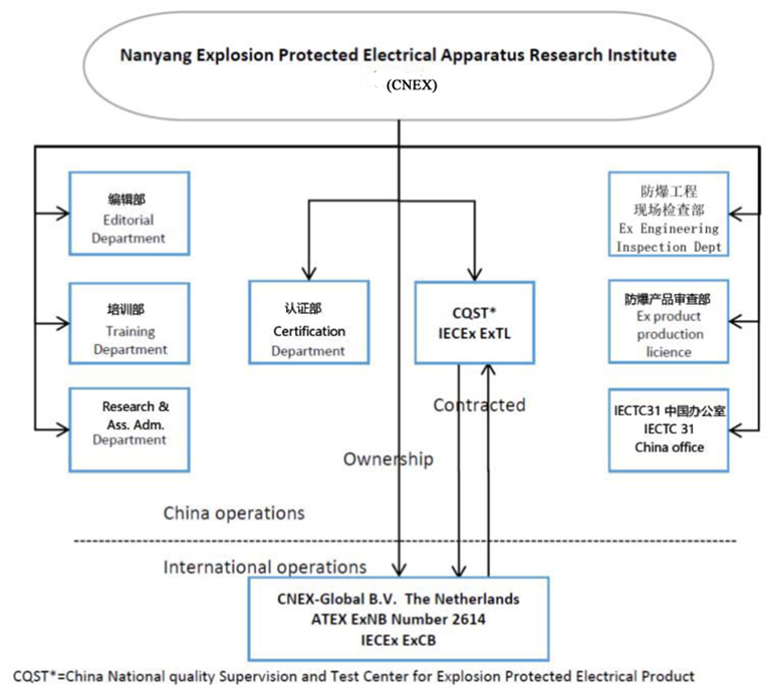

1. Organisation Chart of ExCB/ExTL

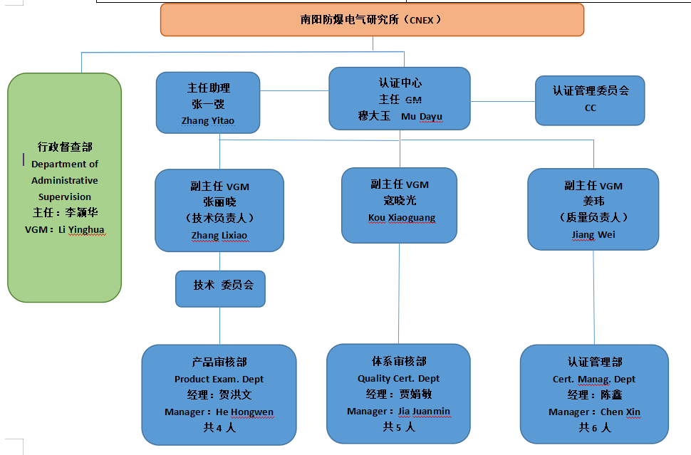

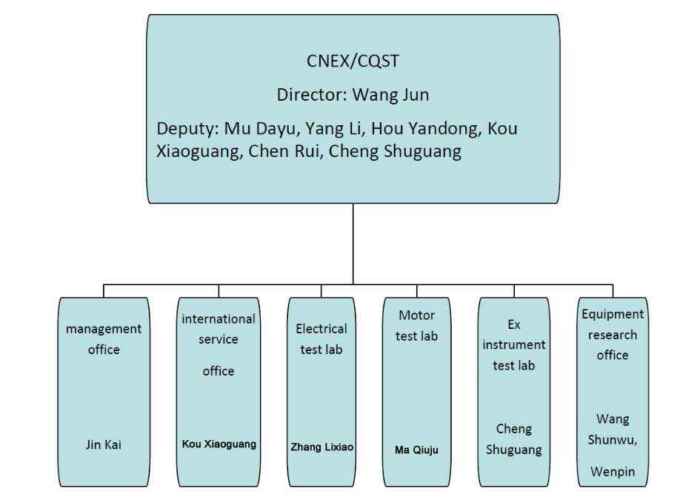

1. Accreditation Certificate for ISO/IEC 17065

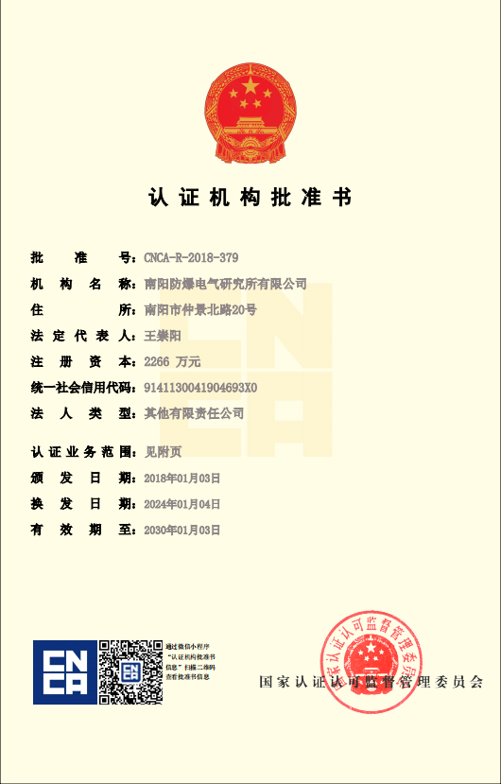

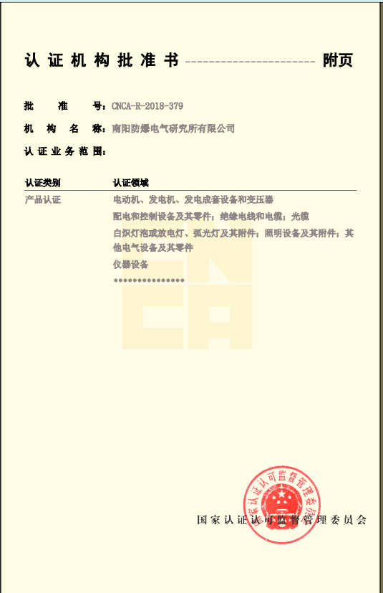

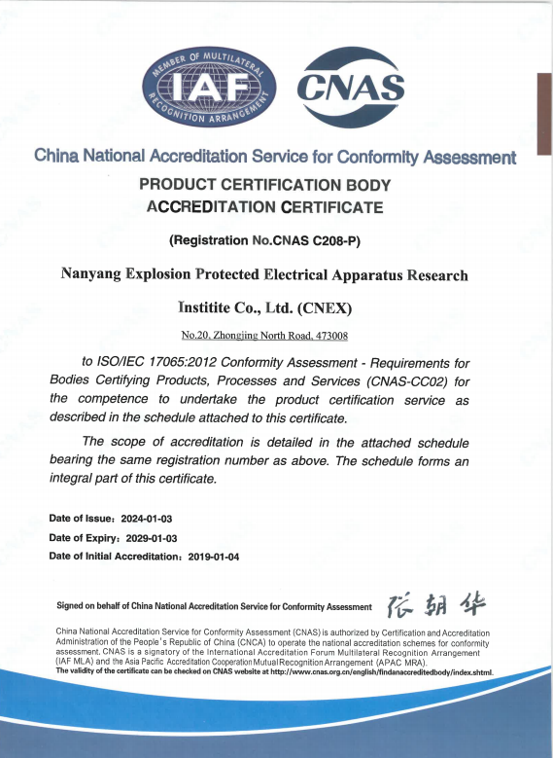

1. Accreditation Certificate for ISO/IEC 17025

