**INTERNATIONAL ELECTROTECHNICAL COMMISSION (IEC) SYSTEM FOR CERTIFICATION TO STANDARDS RELATING TO EQUIPMENT FOR USE IN EXPLOSIVE ATMOSPHERES (IECEx SYSTEM)**

**Title: Special Assessment for Jiamusi Explosion-Proof Electric Machine Institute Co., Ltd. Wuxi Branch JExM (WX), as an Additional Testing Facility (ATF) operating under**

**IECEx TL** **Jiamusi Explosion-Proof Electric Machine Institute Co. Ltd (JExM) Formerly known as CHEM)**

**Circulation to: ExMC – IECEx Management Committee**

**INTRODUCTION**

The IECEx Secretariat has received an application from IECEx TL Jiamusi Explosion-Proof Electric Machine Institute Co. Ltd (JExM) Formerly known as CHEM), to conduct IECEx testing at, Jiamusi Explosion-Proof Electric Machine Institute Co., Ltd. Wuxi Branch (JExM (WX), under the IECEx Additional Testing Facilities (ATF) arrangements.

In accordance with IECEx 02 the IECEx Secretariat arranged for special assessment to be performed by an IECEx Lead Assessor. The special assessment is treated as an extension of scope for Jiamusi Explosion-Proof Electric Machine Institute Co. Ltd (JExM) Formerly known as CHEM), to include the new ATF location, in the People’s Republic of China.

***This document is hereby submitted for ExMC approval via correspondence using the IECEx on-line voting system.  ExMC Members are requested to submit their vote via the IECEx On-line*** [***Ballot System***](https://www.iecex.com/ballot) ***by the closing date 2023 11 03.***

***Please refer to OD 050 for guidance on the “IECEx On-line voting system.”***

**IECEx Secretariat**

|  |  |
| --- | --- |
| **IECEx Secretariat**  **Australia Square**  **Level 33,**  **264 George Street**  **Sydney NSW 2000**  **Australia** | **Tel: +61 2 4628 4690**  **Fax: +61 2 4625 3480**  **Email:info@iecex.com** |

IEC System for certification to standards relating to equipment for use in Explosive Atmospheres (IECEx System)

IECEx Assessment Report Form, F-003

IECEx assessment report form for use by IECEx assessment teams to report assessments conducted according to the relevant IECEx assessment procedures of:

Operational Document IECEx OD 003-2 for the Certified Equipment Scheme

Operational Document IECEx OD 316-* for the Certified Service Facility Scheme

Operational Document IECEx OD 422 for the IECEx Conformity Mark Licensing Scheme

Operational Document IECEx OD 501 for the Personnel Competence Scheme

IECEx ATF assessment report for

Jiamusi Explosion-Proof Electric Machine Institute Co., Ltd. Wuxi Branch JExM (WX)

INTERNATIONAL  
ELECTROTECHNICAL  
COMMISSION

CONTENTS

1 Assessment information 5

1.1 Type of body covered by this assessment: 5

1.2 Type of assessment: 5

1.3 Details of body 5

1.3.1 Country 5

1.3.2 Name of body 5

1.3.3 Name and title of nominated principal contact 5

1.4 Assessment information 5

1.4.1 Members of the assessment team 5

1.4.2 Place(s) of assessment 5

1.4.3 Assessment date(s) 6

1.5 Application information and background information on the assessment 6

1.6 Scopes 6

1.6.1 ExCB scope for equipment certification scheme 6

1.6.2 ExTL scope 6

1.6.3 ATF Scope 6

1.6.4 ExCB scope for Service Facilities Scheme 6

1.7 ExCB scope for Conformity Mark Licensing Scheme 6

1.8 ExCB scope for IECEx Personnel Competence Scheme 6

2 Common information 7

2.1 Legal entity of body 7

2.2 Financial support 7

2.3 History 7

2.3.1 Quality manual 7

2.3.2 Procedures 7

2.3.3 Work instructions 7

2.3.4 Records (including test records where relevant) 7

2.3.5 Document change control 8

2.4 Confidentiality 8

2.5 Communication with public and customers (Hard copy and Electronic) 8

2.6 Recognitions and agreements 8

2.7 Internal audit 8

2.8 Management review 8

2.9 Contracting, subcontracting and witness testing 8

2.9.1 Contracting 8

2.9.2 Subcontracting 9

2.9.3 Off-site and Witness testing 9

2.10 Training and competence 9

2.11 Complaints and appeals (including appeals to IECEx) 9

2.12 Impartiality 9

2.13 Active involvement in development of Decision Sheets 9

2.14 Special facts to be noted 9

2.15 Supporting documentation 9

2.16 Recommendations 10

3 ATF for IECEx Certified Equipment Scheme 11

3.1 Assessment references 11

3.1.1 General references 11

3.1.2 Additional references applied for this assessment 11

3.2 Associated ExTL 11

3.3 Organisation 11

3.3.1 Names, titles and experience of the senior executives 11

3.3.2 Name, title and experience of the quality management representative 11

3.3.3 Other employees in ATF activity 11

3.4 Organizational structure 12

3.5 Resources 12

3.6 Test reports issued 12

3.7 National accreditation 13

3.8 Calibration 13

3.9 Tests witnessed during the assessment visit 14

3.10 Participation in IECEx Proficiency Testing Programs 14

3.11 Comments (including issues found during assessment) 15

4 Annexes 16

Annex A Scope for IECEx ATF JExM (WX) 17

A.1 Current standards 17

A.2 Superseded standards 17

Annex B Overall Organisation Chart 18

Organisation Chart of JExM with reference to JExM (WX) too 18

Annex C Organisation Chart of ATF 19

Annex D Accreditation Certificate for ISO/IEC 17065 20

Not applicable 20

Annex E Accreditation Certificate for ISO/IEC 17025 21

Certificate and Accredited Testing Scope from CNAS for JExM head office and JExM (WX) as an operating location (see next page) 21

Annex F Accreditation Certificate for ISO/IEC 17024 23

Not applicable 23

# Assessment information

## Type of body covered by this assessment:

|  |  |
| --- | --- |
| ExCB for IECEx Certified Equipment Scheme |  |
| ExTL for IECEx Certified Equipment Scheme |  |
| ATF for IECEx Certified Equipment Scheme |  |
| ExCB for IECEx Certified Service Facilities Scheme |  |
| ExCB for IECEx Conformity Mark Licensing System |  |
| ExCB for IECEx Certification of Personnel Competency Scheme |  |

NOTE 1 ExCB - IECEx Certification Body

NOTE 2 ExTL - IECEx Testing Laboratory

NOTE 3 ATF - Additional Testing Facility

## Type of assessment:

|  |  |
| --- | --- |
| Pre-assessment for candidate body |  |
| Initial assessment for candidate body |  |
| Surveillance |  |
| Re-assessment |  |
| Scope extension |  |

## Details of body

### Country

Peoples Republic of China

### Name of body

Jiamusi Explosion-Proof Electric Machine Institute Co.,Ltd. Wuxi Branch (JExM (WX) as the ATF under supervision of IECEx TL Jiamusi Explosion-Proof Electric Machine Institute Co. Ltd (JExM) Formerly known as CHEM)

### Name and title of nominated principal contact

|  |  |  |
| --- | --- | --- |
| Name | Title | E-mail address |
| Zeng Xin | Quality administrator of JExM | rubyzx@126.com |

## Assessment information

### Members of the assessment team

|  |  |
| --- | --- |
| Name | Role |
| Ajay Maira | IECEx Lead Assessor |
| Yin Hong | IECEx Assessor/Translator |

### Place(s) of assessment

|  |  |
| --- | --- |
| 28 Chengtang Road, Huishan District,  Wuxi City, Jiangsu Province |  |

### Assessment date(s)

2023-04-10 to 2023-04-14 Due to international travel restrictions, this IECEx peer assessment was conducted by IECEx Lead Assessor under IECEx OD 060, but utilizing an IECEx Assessor on site.

## Application information and background information on the assessment

Jiamusi Explosion-Proof Electric Machine Institute Co., Ltd. is an IECEx TL (abbr JExM). They have now applied to include Jiamusi Explosion-Proof Electric Machine Institute Co.,Ltd. Wuxi Branch – (abbr JExM (WX)) as an Additional Test Facility ATF under their supervision.

Jiamusi Explosion-Proof Electric Machine Institute Co., Ltd. is the legal entity of both JExM and JExM (WX).

Jiamusi Explosion-Proof Electric Machine Institute Co., Ltd. (JExM) was formerly abbreviated as CHEM. It is associated with several IECEx CBs. See Section 1.6 for details.

## Scopes

### ExCB scope for equipment certification scheme

The scope for the ATF is shown in Annex A.

JExM is an IECEx TL and are associated with several IECEx CB’s:

* China Quality Certification Center (CQC)
* China Quality Mark Certification Group Co., Ltd. (CQM)
* Shanghai Inspection and Testing Institute of Instruments and Automatic Systems Co., Ltd. (SITIIAS) / National Supervision and Inspection Centre for Explosion Protection and Safety of Instrumentation (NEPSI)

The scope of the ExCB’s includes all the Standards within the scope of the IECEx TL (JExM).

### ExTL scope

The ExTL (JExM) is not integral with the ExCB,

### ATF Scope

The ATF has submitted a list of Standards and testing services. See Annex A for the details.

### ExCB scope for Service Facilities Scheme

Not within the scope of this application.

## ExCB scope for Conformity Mark Licensing Scheme

Not within the scope of this application.

## ExCB scope for IECEx Personnel Competence Scheme

Not within the scope of this application.

# Common information

## Legal entity of body

As a branch company, JExM (WX) is not a legal entity, and JExM, which is a legal entity, undertakes the legal responsibilities of JExM (WX).

The consequences and responsibilities of all testing activities are undertaken by JExM.

## Financial support

JExM, which is a legal entity, is also responsible for the profits and losses for JExM(WX).

## History

The applicant ATF JExM (WX) was established in Dec.2020, and located in 28 Chengtang Road, Huishan District, Wuxi City, Jiangsu Province，with testing area of 1447 m2. There are 23 employees in total, among them 15 employees concerning testing.

There are 85 sets of instruments and equipment, all of them are self owned.

CNAS (China National Accreditation Service for Conformity Assessment) has provided accreditation certificate CNAS L0484 to JExM for laboratory operations under ISO/IEC 17025:2017 for two sites – at Jiamusi and Wuxi.

See Annex E for detail.

### Quality manual

JExM (WX) is part of the supervising ExTL (JExM). It carries out testing activities under the same quality management system of the supervision ExTL.

Quality management documents contains: quality manual, procedure documents, working instructions, and records forms. In many cases, these are updated to the specific equipment and requirements of JExM (WX).

Quality policy is in 2.2 of Quality Manual, “Fair, scientific and accurate inspection, high-quality, efficient and satisfactory service.”

comprehensive list of Quality controlled procedures, work instructions, forms has been provided as “Annex V Rules abided by JExM (WX).

The overall procedure CX-D30-2022 “IECEx Work Procedure” sets out the method of accepting applications and delivering reports between the IECEx CB, ExTL (JExM) and the ATF (JExM (WX)). The procedures were reviewed during the assessment and found to meet the requirements of the IECEx.

### Procedures

A comprehensive list of Quality controlled procedures, work instructions, forms has been provided as “Annex V Rules abided by JExM (WX).

The overall procedure CX-D30-2022 “IECEx Work Procedure” sets out the method of accepting applications and delivering reports between the IECEx CB, ExTL (JExM) and the ATF (JExM (WX)). The procedures were reviewed during the assessment and found to meet the requirements of the IECEx.

### Work instructions

See 2.3.2

### Records (including test records where relevant)

CX-D02-2021Procedure for documents control

CX-D10-2021 Control procedure of records, method and results of testing activities are recorded as prescribed in this procedure. Documents are stored to provide a permanent test record.

CX-D10-2021 requires that record templates are implemented after preparation, review and approval by the authorized person, and the latest record templates are available in the OA system, so they are current, complete and accurate, and all records are stored in the Archives storage room, where they can only be accessed by permission.

Procedures address retention period for IECEx, including the reference to IECEx OD-207 and an indication that these requirements take precedence over the corporate requirements.

### Document change control

JExM (WX) has an office automation (OA) system for updating, implementing and recording changes to the quality management documents.

Based on office automation system, all the obsolete data are promptly removed from documents and reference data maintained are in an up-to-date condition.

The Procedure was reviewed during the assessment and found to meet the requirements of the IECEx.

## Confidentiality

(For staff, contractors and members of advisory bodies)

CX-D01-2020 “Procedures document for protecting customer confidential information and ownership”.

Confidentiality is ensured through training and supervision of this procedure.

The system was reviewed and found to meet the requirements of ISO/IEC 17025 and IECEx.

## Communication with public and customers (Hard copy and Electronic)

Public access procedures are available at:

<https://www.jexm.net/>

## Recognitions and agreements

The procedure mentioned in 2.3.2 governs the agreement between the ATF JExM (WX) and the associated ExTL JExM.

## Internal audit

CX-D11-2020 Procedure for internal audits. In September 2021 the applicant ATF has made the first internal audit, and in September 2022, the applicant ATF has made a second internal audit with follow up actions completed in October 2022.

## Management review

In October 2021 the applicant AFT has made the first management review.

In October 2022 the applicant AFT has made the second management review.

## Contracting, subcontracting and witness testing

### Contracting

JExM (WX) does not directly subcontract any of the testing or assessment to external contractors. Any subcontracting is by the IECEx TL (JExM) and hence is not applicable for ATF.

### Subcontracting

The ATF does not have further subcontracting arrangements and hence is not applicable for ATF

### Off-site and Witness testing

Not applicable for ATF

The ATF does not offer direct agreements with their customer to carry out off-site or witness testing. If required, the ExTL (JExM) will sign the agreement and arrange for JExM (WX) to carry out the testing on their behalf.

## Training and competence

CX-D13-2020 Personnel training and supervision procedure.

Details of staff competencies are included in the site assessment report.

Standards of professional ability, skills and job descriptions been prescribed in Clause 6.2.2 Qualification and CX-D34-2020 Personnel management procedure.

The testing lab makes training plan and then implements training based on the plan, and all training was applied to attain and maintain skills with due attention to quality requirements.

## Complaints and appeals (including appeals to IECEx)

CX-D08-2020 Corrective action procedure is available. Procedure was reviewed and found to be in compliance with IECEx and IEC requirements.

## Impartiality

Impartiality procedures are provided in JExM-SC-09/2023“Quality Manual Section 0.1 Statement of Impartiality. Staff have signed regarding impartiality, honesty and confidentiality of their work. The process meets the requirements for ISO/IEC 17025 and IECEx.

## Active involvement in development of Decision Sheets

Not applicable to ATF.

The ATF provides comments through JExM and the relevant ExCB, and implements all Decision Sheets in the procedures used.

## Special facts to be noted

The technical staff have been trained to work independently with their expertise demonstrated during this IECEx assessment,

## Supporting documentation

Copies of additional supporting information for this assessment have been provided to the applicant and the IECEx Secretariat. These are included in a site assessment report or provided separately and include:

* Details of issues raised and how these have been resolved
* Checklist for ISO/IEC 17025
* Completed Technical Capability Document (TCD)
* Photos of the facilities/tests witnessed are included in the above TCD
* Information on competencies
* Assessors’ notes
* PTB PTP Enclosures program 2019

## Recommendations

Based on the assessment performed on 2023-04-10 to 2023-04-14, JExM (WX) is recommended for acceptance in the IECEx scheme as:

* An ATF in the IECEx Certification Equipment Scheme

This is according to the scope of the standards listed in this document subject to resolution of the issues found during the assessment).

|  |  |  |
| --- | --- | --- |
| Ajay Maira | Yin Hong |  |
| IECEx Lead Assessor | IECEx Assessor |  |

Date: 2023-09-18

# ATF for IECEx Certified Equipment Scheme

## Assessment references

### General references

1. IECEx02 IECEx Certified Equipment Scheme covering equipment for use in explosive atmospheres – Rules of Procedure
2. IECEx OD003-2 Assessment, surveillance assessment and re-assessment of ExCBs and ExTLs operating in the IECEx 02, IECEx Certified Equipment Scheme
3. ISO/IEC 17025 General requirements for the competence of testing and calibration laboratories
4. IECEx OD 018 Harmonised check list for testing and calibration laboratories ISO/IEC 17025
5. IECEx TCD 60079, ISO 80079 Series and ISO 16852 Technical Capability Document
6. ExTAG decision sheets (DSs)
7. IECEx OD 202 IECEx Certified Equipment Scheme – IECEx Proficiency Testing Program

NOTE The latest editions of the above documents were applied, unless otherwise specified.

### Additional references applied for this assessment

Nil.

## Associated ExTL

Jiamusi Explosion-Proof Electric Machine Institute Co.,Ltd (JExM)

## Organisation

### Names, titles and experience of the senior executives

|  |  |  |
| --- | --- | --- |
| **Name** | **Title** | **Experience (years)** |
| Wang Weiyue | Director of JExM & JExM (WX) | 31 |

### Name, title and experience of the quality management representative

|  |  |  |
| --- | --- | --- |
| **Name** | **Title** | **Experience (years)** |
| Xu Jie | Quality manager of JExM (WX) and also Ex-testing lab 3 | 11 |

### Other employees in ATF activity

|  |  |  |
| --- | --- | --- |
| **Name** | **Title/responsibility** | **Experience in Ex (years)** |
| Xu Qiangqiang | Test engineer | 13 |
| Kang Jian | Manager Ex-testing lab 4 | 13 |
| Zhang Huanpeng | Test engineer | 11. |
| Han Shuyu | Test engineer | 29. |
| Zhang Hao | Test engineer | 2. |
| Jiang Shuai | Test engineer | 2. |
| Fan Suhao | Test engineer | 4. |
| Lv Hongmin | Test engineer | 2. |
| Ji Chao | Test engineer | 2. |
| Liu Lijia | Test engineer | 2. |

## Organizational structure

See Annex B, C.

## Resources

CX-D19-2020 Test sample management procedure, prescribed implemented for the handling, storage and return to the client of materials and samples. Samples are only accessible to authorized persons. The testing lab has appropriate storage areas arranged to prevent deterioration or damage to the sample.

The list of calibrated equipment used for all measurements for tests nominated by the ATF was provided during the assessment (Annex III List of testing instruments)

JExM (WX) establishes relevant organizational structure, equips itself with relevant resources (incl. personnel, facilities and environment), establishes quality management system, and generates and publishes Quality Manual, Procedure Documents and relevant Work instructions, which shall be conscientiously followed during testing and certification.

JExM (WX) carries out internal audit and management assessment regularly as required to improve the effectiveness of the quality system continually and enhance testing service quality

## Test reports issued

Number of national test reports issued in the preceding two years for each type of test covered by the standards listed in the Scope.

|  |  |  |  |  |
| --- | --- | --- | --- | --- |
| Standard numbers | Type of protection or other identifying information | Number of issued test reports (for last 2 years) | | Total |
| 2021 | 2022 |
| IEC 60079-0  Edition 7.0 | Explosive atmospheres - Part 0: Equipment - General requirements | 2 | 4 | 6 |
| IEC 60079-1  Edition 7.0 | Explosive atmospheres - Part 1: Equipment protection by flameproof enclosures “d” | 1 | 1 | 2 |
| IEC 60079-2  Edition 6.0 | Explosive atmospheres - Part 2: Equipment protection by pressurized enclosure “p” | 0 | 1 | 1 |
| IEC 60079-7  Edition 5.1 | Explosive atmospheres - Part 7: Equipment protection by increased safety "e" | 1 | 1 | 2 |
| IEC 60079-11  Edition 6.0 | Explosive atmospheres - Part 11: Equipment protection by intrinsic safety “i” | 1 | 1 | 2 |
| IEC 60079-15  Edition 5.0 | Explosive atmospheres – Part 15: Equipment protection by type of protection "n" | 0 | 1 | 1 |
| IEC 60079-18  Edition 4.1 | Explosive atmospheres – Part 18: Equipment protection by encapsulation “m” | 0 | 1 | 1 |
| IEC 60079-31  Edition 2.0 | Explosive atmospheres – Part 31: Equipment dust ignition protection by enclosure "t" | 1 | 0 | 1 |
| IEC 60079-31  Edition 3.0 | Explosive atmospheres – Part 31: Equipment dust ignition protection by enclosure "t" | 0 | 1 | 1 |
| IEC/IEEE 60079-30-1  Edition 1.0 | Explosive atmospheres. Part 30-1: Electrical resistance trace heating. General and testing requirements | 0 | 1 | 1 |

NOTE 1 Above include reports to IEC 60079-0 unless otherwise shown

NOTE 2 Where the number of reports is low, assessors are expected to carefully check current capability and document the process in this report.

## National accreditation

The national accreditation certification for ISO/IEC 17025 is shown in Annex E.

NOTE The national accreditation is checked annually by the IECEx Secretariat.

## Calibration

CX-D16-2022 Management procedure for measurement equipment，the testing lab make annual Verification and calibration plan to ensure that all the equipment is of accuracy compatible with the assessment and testing undertaken

The testing lab make annual Verification and calibration plan to ensure that all the equipment is of accuracy compatible with the assessment and testing undertaken. Monthly checks are made for all test equipment mentioned in a spreadsheet to check for calibration,

The facility provides appropriate environments provided for handling, control, storage and maintenance of all testing and measuring equipment.

CX-D17-2021 Control procedure for measurement traceability,

## Tests witnessed during the assessment visit

The following tests were witnessed during the assessment visit:

|  |  |  |  |
| --- | --- | --- | --- |
| **Standard and edition** | **Clause number** | **Test** | **Comments** |
| IEC 60079-1 Ed 7.0 | 15.2.2 | Flameproof pressure determination for a Motor | Satisfactory.  Procedure revised to use manual valves close to the sample to obtain correct reference pressure results.  Added details to check analyser span and zero before use. |
| IEC 60079-1 Ed 7.0 | 15.2.3 | Flameproof over pressure test for a motor | Satisfactory.  Test was conducted using dynamic testing method using pre-compression of gases to achieve 1.5*reference pressure. |
| IEC 60079-0 Ed 7.0 | 26.4.5 | IP6X test for a motor to IEC 60529 | Satisfactory.  Procedure revised to ensure extraction does not exceed 80 volumes when flow rate < 40 V/hr |
| IEC 60079-0 Ed 7.0 | 26.4.5 | IPX6 test for a motor to IEC 60529 | Satisfactory.  Procedure revised to ensure water is directed at the sample from all practicable directions. |
| IEC 60079-0 Ed 7.0 | 26.5.1 | Temperature rise, preferably of an Ex e luminaire | Satisfactory. |
| IEC 60079-0 Ed 7.0 | 26.13 | Surface resistance test on non-metallic enclosure | Satisfactory. |
| IEC 60079-2 Ed 6.0 | A.3 | Purging test for Pressurized enclosure where the protective gas is Nitrogen | Satisfactory.  Procedure revised to use a two decimal digit oxygen analyser to ensure better accuracy of the result. |
| IEC 60079-11 Ed 6.0 | 10.10 | Transformer test for Intrinsic Safety infallible transformer | Satisfactory. |
| IEC 60079-1 Ed 7.0 | 15.4.3 | Thermal test of breathing and draining device | Satisfactory.  . |
| IEC 60079-11 Ed 6.0 | 10.1 | Use of spark test apparatus using Group II with safety factor 1.5, preferably on a current project | Satisfactory.  Revised procedure to specify the method of mixing test gas and the setting of the test voltages and currents. |
| IEC 60079-11 Ed 6.0 | 10.3 | Dielectric strength test on Intrinsic safety equipment with metallic case | Satisfactory. |
| IEC 60079-18 Ed 4.1 | 8.1.1 | Water absorption test on Ex m compound | Satisfactory. |

## Participation in IECEx Proficiency Testing Programs

Program: PTB Ex PT Scheme

| **IECEx Proficiency Testing program** | **Program years** | Participated?  **Y/N/NA** | Comment on results |
| --- | --- | --- | --- |
| Program 1 "Explosion pressure" | 2011-2012 | N | Not applicant at that time |
| Program 2 "Spark ignition" | 2011-2012 | N | Not applicant at that time |
| Program 3 "Flame Transmission" | 2013-2014 | N | Not applicant at that time |
| Program 4 "Temperature Classification" | 2013-2014 | N | Not applicant at that time |
| Program 5 "Electrostatic Charge" | 2015-2016 | N | Not applicant at that time |
| Program 6 "Intrinsic Safety" | 2015-2016 | N | Not applicant at that time |
| Program 7 "Explosion Pressure" | 2017-2018 | N | Not applicant at that time |
| Program 8 "Pressurized Enclosure" | 2017-2018 | N | Not applicant at that time |
| Program 9 “Battery Testing” | 2019-2020 | Y | JExM (WX) participated. There were no warning or alerts in the report. |
| Program 10 “Tests of Enclosures” | 2019-2020 | Y | JExM (WX) participated. There were no warning or alerts in the report.. |
| Program 11 "Flameproof Joints" | 2021-2022 | Y | JExM (WX) provided evidence of confirmation dated 2023-06-07 from PTB PTS that they are now a participant in this program. Result will be discussed at the next assessment. |
| Program 12 "Small Component Temperature” | 2021-2022 | NA | Not in scope of tests of ATF |
| Program 13:  “Explosion Pressure” | 2023-2024 | NA | JExM (WX) provided evidence of confirmation of participation in the 2023 IECEx Prof Test program for EP Explosion Pressure |
| Program 14:  “Connection and Junction Boxes” | 2023-2024 | NA | JExM (WX) provided evidence of confirmation of participation in the 2023 IECEx Prof Test program for CJB Junction and Connection Box. |

The ATF has limitations for some tests in their scope (for example, they do not have small component temperature rise test in their scope) and hence these programs in the IECEx Proficiency Test program are not applicable.

## Comments (including issues found during assessment)

JExM(WX) has the necessary staff and systems in place for their scope as an ATF. Issues were identified during the assessment however all issues were revised to the satisfaction of the assessment team and now meet the requirements of the IECEx. Details are contained in Site Assessment Report F-004

# Annexes

1. Scope for IECEx ATF JExM (WX)
   1. Current standards

| Number | Title | Tests excepted from the scope of the Standard |
| --- | --- | --- |
| IEC 60079-0  Edition 7.0 | Explosive atmospheres - Part 0: Equipment - General requirements | 26.5.3 Small component ignition test  26.10 Resistance to UV light  26.17 Transferred charge test |
| IEC 60079-1  Edition 7.0 | Explosive atmospheres - Part 1: Equipment protection by flameproof  enclosures “d” | 10.9 Breathing devices and draining devices when used as Ex components  Annex B(normative) Additional requirements for elements, with non-measurable paths of breathing and draining device |
| IEC 60079-2  Edition 6.0 | Explosive atmospheres - Part 2: Equipment protection by pressurized  enclosure “p’ | Nil |
| IEC 60079-7  Edition 5.1 | Explosive atmospheres - Part 7: Equipment protection by increased  safety "e" | 6.2.3.1.2 Impulse ignition test for Level of Protection “eb” stator insulation systems“eb”  6.3 Luminaires灯具  6.4 Measuring instruments and instrument transformers  6.6 Verification and tests for cells and batteries of Level of Protection “eb”  6.7 Verification and tests for cells and batteries of Level of Protection “ec” |
| IEC 60079-11  Edition 6.0 | Explosive atmospheres - Part 11: Equipment protection by intrinsic safety “i” | Nil |
| IEC 60079-15  Edition 5.0 | Explosive atmospheres – Part 15: Equipment protection by type of protection "n" | Nil |
| IEC 60079-18  Edition 4.1 | Explosive atmospheres – Part 18: Equipment protection by encapsulation “m” | Nil |
| IEC/IEEE 60079-30-1  Edition 1.0 | Explosive atmospheres – Part 30-1: Electrical resistance trace heating – General and testing requirements | 5.1.16 Outdoor exposure test |
| IEC 60079-31  Edition 3.0 | Explosive atmospheres – Part 31: Equipment dust ignition protection by enclosure "t" | Nil |

* 1. Superseded standards

Nil.

1. Overall Organisation Chart

Organisation Chart of JExM with reference to JExM (WX) too

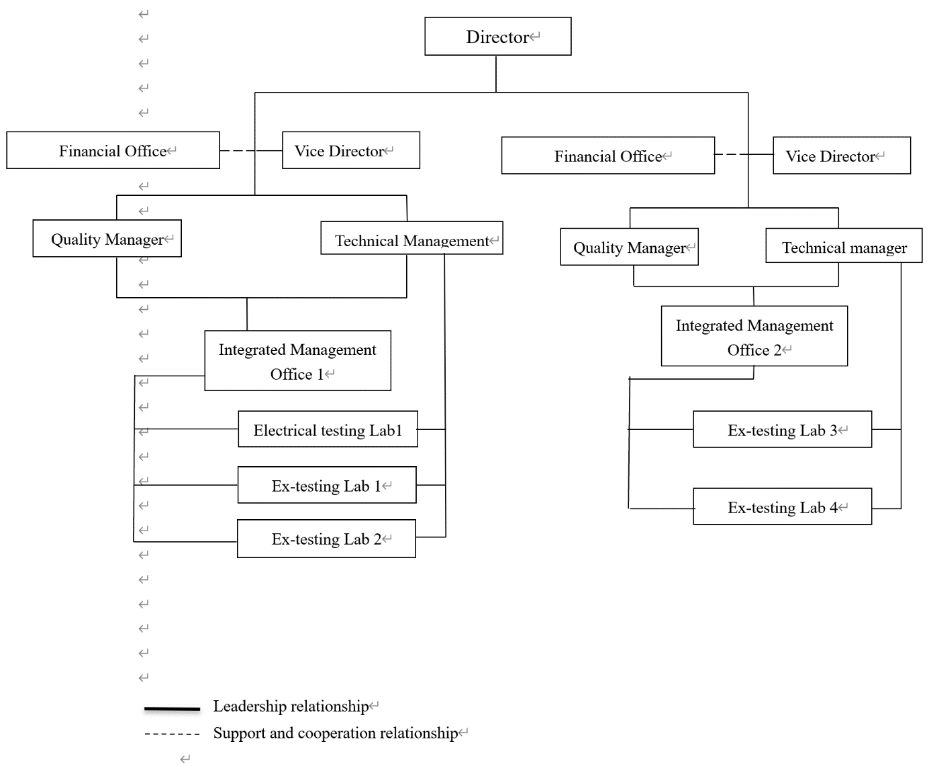

1. Organisation Chart of ATF

Organisation Chart of JExM(WX)

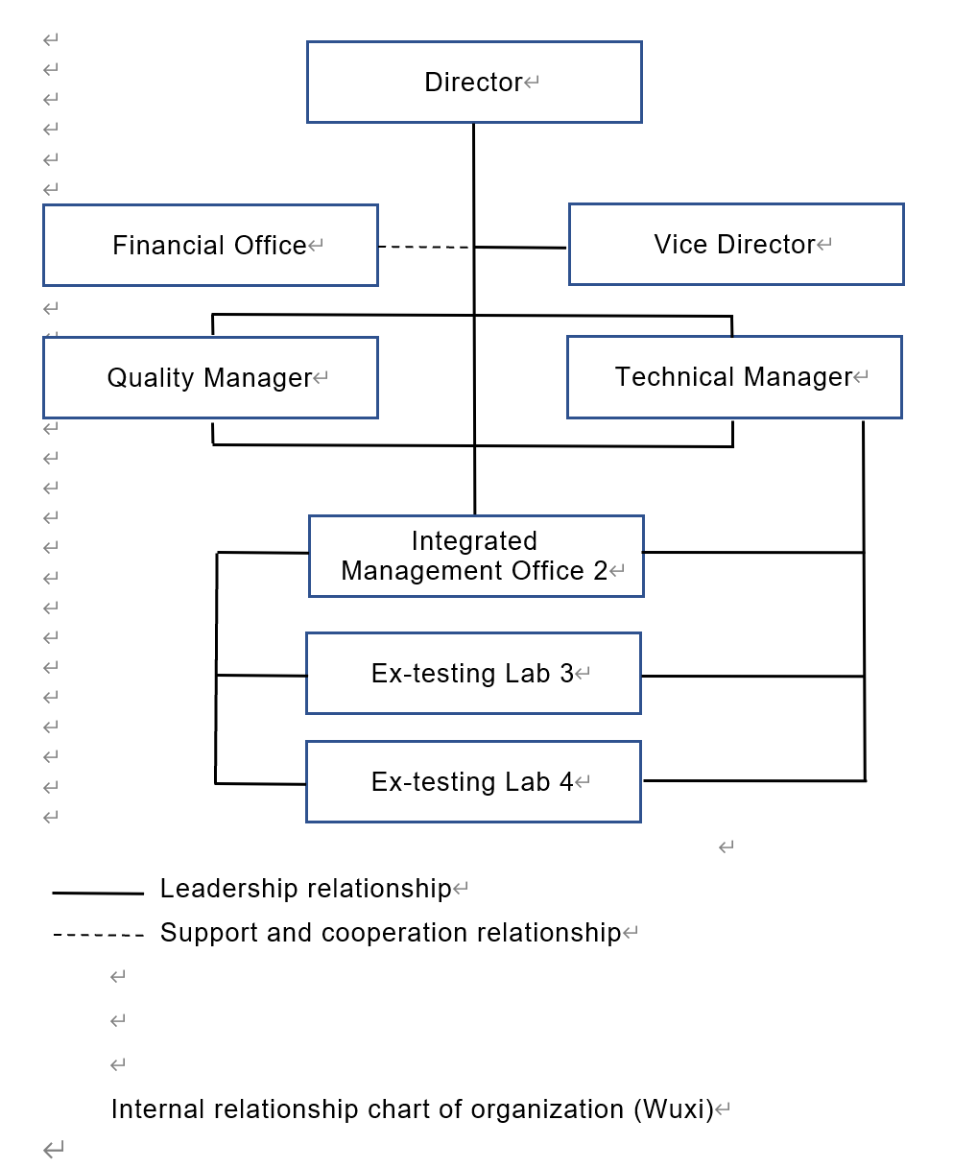

1. Accreditation Certificate for ISO/IEC 17065

Not applicable

1. Accreditation Certificate for ISO/IEC 17025

Certificate and Accredited Testing Scope from CNAS for JExM head office and JExM (WX) as an operating location (see next page)

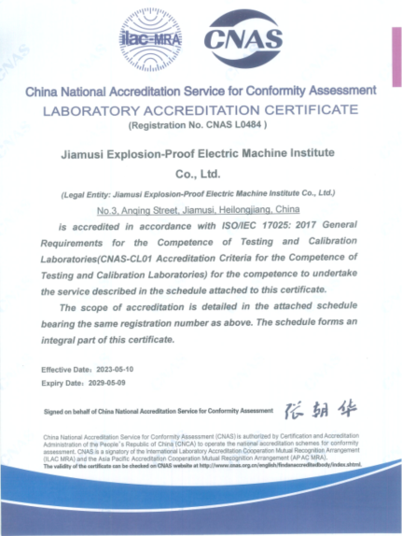

Excerpt from the 97 page scope that contains all the Standards of Annex A:

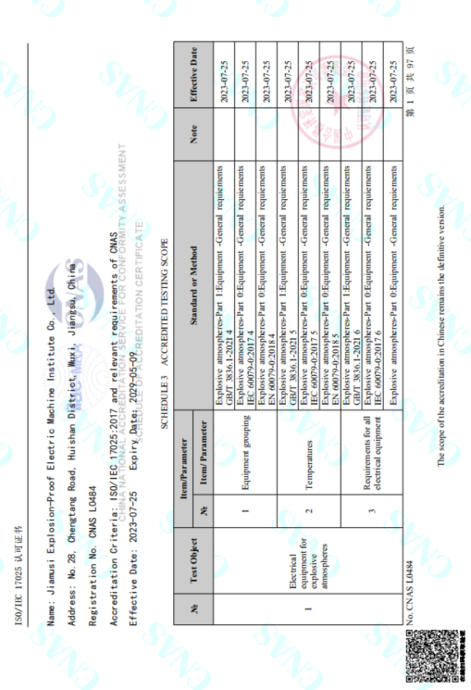

1. Accreditation Certificate for ISO/IEC 17024

Not applicable