ExMC/1969/CD
July 2023
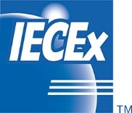

INTERNATIONAL ELECTROTECHNICAL COMMISSION SYSTEM FOR
CERTIFICATION TO STANDARDS RELATING TO EQUIPMENT FOR USE
IN EXPLOSIVE ATMOSPHERES (IECEx SYSTEM)

Title: US Recommendation to return to annual IECEx Operational Meetings

To: Members of the IECEx Management Committee, ExMC

Introduction

This document contains comments for the USNC/IECEx regarding a return to scheduled annual IECEx Operational Meetings.

These comments along with other matters will be considered during the September 2023 IECEx Management Committee meeting in Edinburgh.

IECEx Secretariat

Address:  Level 33, Australia Square  264 George Street  Sydney NSW 2000  Australia | Contact Details:  Tel: +61 2 4628 4690  Fax: +61 2 4627 5285  e-mail:info@iecex.com  http://www.iecex.com

___________________________________________________________________________________
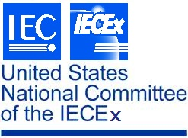
Chair: S. Kiddle USNC/IECEx
Vice Chair: K. Holdredge c/o NEMA
Vice Chair: K. Wolf 1300 North 17th St., Ste. 900
Past Chair: E. Massey Arlington, VA 22209
Treasurer: J. Anderson
_________________________________________________________________________________

6 July 2023

VIA E-MAIL TRANSMISSION

Mr. Chris Agius
IECEx Secretariat
c/o IEC Central Office
3, rue de Varembé
P.O. BOX 131
CH-1211 Geneva 20, Switzerland

Subject: USNC/IECEx comment on annual operational meetings for Work Groups

Dear Chris:

The USNC/IECEx would like to thank the Working Groups of ExMC and ExTAG for their maintenance of the Operational Documents within the IECEx. Prior to the pandemic, these WGs had the opportunity to meet in person and address changes or improvements to ODs.

The USNC/IECEx would like to request the reissuance of annual operational meetings for Work Groups to help ensure their effectiveness in maintaining IECEx Operational Documents.

Thank you for your attention to this matter. Please contact me if you have any questions.

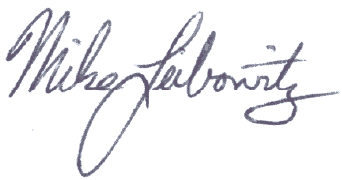
Sincerely,

Mike Leibowitz
USNC/IECEx Secretary
MGL
cc: S. Kiddle

