**INTERNATIONAL ELECTROTECHNICAL COMMISSION SYSTEM FOR CERTIFICATION TO STANDARDS RELATING TO EQUIPMENT FOR USE IN EXPLOSIVE ATMOSPHERES (IECEx SYSTEM)**

**Title: Re-assessment Report for the continued acceptance of CSA Group an Accepted Certification Body, (ExCB), and Accepted Ex Testing Laboratories (ExTLs) within the IECEx System, Equipment Scheme 02.**

**Circulation to: Members of the IECEx Management Committee, ExMC**

**INTRODUCTION**

In accordance with the 5 year Re-assessment plan for the surveillance and monitoring of bodies within the IECEx System, this document contains the IECEx Re-assessment Report for the continued acceptance of CSA Group, as an Accepted Certification Body (ExCB) and Accepted Ex Testing Laboratories (ExTLs) within the IECEx System, Equipment Scheme 02.

This report is hereby submitted for endorsement during the 2023 ExMC Meeting.

**Chris Agius**

**IECEx Secretariat**

|  |  |
| --- | --- |
| **IECEx Secretariat**  **Australia Square**  **Level 33, 264 George Street**  **Sydney NSW 2000**  **Australia** | **Tel: +61 2 4628 4690**  **Fax: +61 2 46 27 5285**  **Email: info@iecex.com** |

IEC System for certification to standards relating to equipment for use in Explosive Atmospheres (IECEx System)

IECEx Assessment Report Form, F-003

IECEx assessment report form for use by IECEx assessment teams to report assessments conducted according to the relevant IECEx assessment procedures of:

Operational Document IECEx OD 003-2 for the Certified Equipment Scheme

Operational Document IECEx OD 316-* for the Certified Service Facility Scheme

Operational Document IECEx OD 422 for the IECEx Conformity Mark Licensing Scheme

Operational Document IECEx OD 501 for the Personnel Competence Scheme

IECEx ExCB/ExTL/ATF assessment report for CSA group

INTERNATIONAL  
ELECTROTECHNICAL  
COMMISSION

CONTENTS

1 Assessment information 6

1.1 Type of body covered by this assessment: 6

1.2 Type of assessment: 6

1.3 Details of body 6

1.3.1 Country 6

1.3.2 Name of body 6

1.3.3 Name and title of nominated principal contact 6

1.4 Assessment information 6

1.4.1 Members of the assessment team 6

1.4.2 Place(s) of assessment 6

1.4.3 Assessment date(s) 7

1.5 Application information and background information on the assessment 7

1.6 Scopes 7

1.6.1 ExCB scope for equipment certification scheme 7

1.6.2 ExTL scope 7

1.7 ExCB scope for Conformity Mark Licensing Scheme 7

2 Common information 8

2.1 Legal entity of body 8

2.2 Financial support 8

2.3 History 8

2.4 Documentation 8

2.4.1 Quality manual 8

2.4.2 Procedures 8

2.4.3 Work instructions 8

2.4.4 Records (including test records where relevant) 8

2.4.5 Document change control 8

2.5 Confidentiality 9

2.6 Communication with public and customers (Hard copy and Electronic) 9

2.7 Recognitions and agreements 9

2.8 Internal audit 9

2.9 Management review 9

2.10 Contracting, subcontracting and witness testing 9

2.10.1 Contracting 9

2.10.2 Subcontracting 9

2.10.3 Off-site and Witness testing 10

2.11 Training and competence 10

2.12 Complaints and appeals (including appeals to IECEx) 10

2.13 Impartiality 10

2.14 Active involvement in development of Decision Sheets 10

2.15 Special facts to be noted 10

2.16 Supporting documentation 10

2.17 Recommendations 11

3 ExCB for IECEx Certified Equipment Scheme 12

3.1 Assessment references 12

3.1.1 General references 12

3.1.2 Additional references applied for this assessment 12

3.2 ExCB persons interviewed 12

3.3 Associated ExTL(s) 12

3.4 Associated certification functions 13

3.5 National marks and certificates 13

3.6 Standards accepted 13

3.7 National differences to IEC standards 13

3.8 Organisation 13

3.8.1 Names, titles and experience of the senior executives 13

3.8.2 Name, title and experience of the quality management representative 13

3.8.3 Name and title of signatories for certification 13

3.8.4 Other employees in ExCB activity 14

3.9 Organizational structure 14

3.10 Indemnity insurance 14

3.11 Resources 14

3.12 Committees (such as governing or advisory boards) 14

3.13 Certification operations 14

3.13.1 National approval/certification methods 14

3.13.2 Certification policy 15

3.13.3 Application for certification 15

3.13.4 Certification decision 15

3.13.5 Suspension and cancellation of certificates 15

3.14 Certificates issued 15

3.15 National accreditation 16

3.16 Assessment of manufacturers and issue of QARs 16

3.17 Comments (including issues found during assessment) 16

4 ExTL for IECEx Certified Equipment Scheme 17

4.1 Assessment references 17

4.1.1 General references 17

4.1.2 Additional references applied for this assessment 17

4.2 ~~Candidate~~ ExTL persons interviewed 17

4.3 Associated ExCB(s) 17

4.4 Organisation 17

4.4.1 Names, titles and experience of the senior executives 17

4.4.2 Name, title and experience of the quality management representative 18

4.4.3 Other employees in ExTL activity 18

4.5 Organizational structure 18

4.6 Resources 18

4.7 Test reports issued 19

4.8 National accreditation 19

4.9 Calibration 20

4.10 Tests witnessed during the assessment visit 20

4.10.1 Toronto Location 21

4.10.2 Cleveland Location 21

4.10.3 Edmonton Location 22

4.10.4 Dallas Location 22

4.11 Participation in IECEx Proficiency Testing Programs 23

4.12 Comments (including issues found during assessment) 23

5 Annexes 24

Annex A Scope for IECEx Certified Equipment Scheme 25

Annex B Overall Organisation Chart 27

Annex C Organisation Chart of ExCB/ExTL/ATF 28

Annex D Accreditation Certificate for ISO/IEC 17065 32

Annex E Accreditation Certificate for ISO/IEC 17025 33

E.1 Toronto 33

E.2 Cleveland 33

E.3 Edmonton 34

E.4 Dallas 34

# Assessment information

## Type of body covered by this assessment:

|  |  |
| --- | --- |
| ExCB for IECEx Certified Equipment Scheme |  |
| ExTL for IECEx Certified Equipment Scheme |  |
| ATF for IECEx Certified Equipment Scheme |  |
| ExCB for IECEx Certified Service Facilities Scheme |  |
| ExCB for IECEx Conformity Mark Licensing System |  |
| ExCB for IECEx Certification of Personnel Competency Scheme |  |

NOTE 1 ExCB - IECEx Certification Body

NOTE 2 ExTL - IECEx Testing Laboratory

NOTE 3 ATF - Additional Testing Facility

## Type of assessment:

|  |  |
| --- | --- |
| Pre-assessment for candidate body |  |
| Initial assessment for candidate body |  |
| Surveillance |  |
| Re-assessment |  |
| Scope extension |  |

## Details of body

### Country

Canada

### Name of body

CSA Group

### Name and title of nominated principal contact

|  |  |  |
| --- | --- | --- |
| Name | Title | E-mail address |
| Gabriel Lippa | Product Group Manager | Gabriel.lippa@csagroup.org |

## Assessment information

### Members of the assessment team

|  |  |
| --- | --- |
| Name | Role |
| Bernard PIQUETTE | IECEx Lead Assessor |

### Place(s) of assessment

|  |  |
| --- | --- |
| CSA Group Toronto – ExCB/ExTL | **178 Rexdale Boulevard, Toronto, ON M9W 1R3, Canada** |
| CSA Group Edmonton - ExTL | **1707-94 Street NW, Edmonton, AB T6N 1E6, Canada** |
| CSA Group Cleveland - ExTL | **8501/8801 East Pleasant Valley Road Independence, OH 44131-5516, USA** |
| CSA Group Dallas - ExTL | **2860 Guilder Drive, Plano, TX 75074, USA** |

### Assessment date(s)

In light of the travel restrictions associated with COVID-19, this assessment was conducted as a remote assessment under the provisions of new IECEx OD 060. The assessment plan was adjusted to facilitate a remote assessment with the following key points to be noted:

• Full access to CSA group. procedures,

• Interviews with certification and testing staff were conducted

The assessment was conducted :

|  |  |
| --- | --- |
| CSA Group Toronto – ExCB/ExTL | October 4 – 6, 2022 |
| CSA Group Edmonton - ExTL | October 11 – 14, 2022 |
| CSA Group Cleveland - ExTL | September 27 – 28, 2022 |
| CSA Group Dallas - ExTL | October 25-29, 2022 |

## Application information and background information on the assessment

Due to problems with travelling caused by the COVID-19 a remote assessment was conducted under the provisions of IECEX OD 060, as agreed with the Secretariat

## Scopes

### ExCB scope for equipment certification scheme

The scope for the ExCB is shown in Annex A.

### ExTL scope

The ExCB scope is covered by the scope of all associated ExTL. the scope of each ExTL part of this assessment is included in Annex A.

## ExCB scope for Conformity Mark Licensing Scheme

CSA Group is not in the Mark Licensing scheme.

# Common information

## Legal entity of body

Independent organization, incorporated under Canadian Laws

## Financial support

The commercial activities related to Ex activity are self-financing through customer fees

## History

CSA Group, of which CSA Group Certification and Testing is a division of, was established in 1919 and works in the area of standards development and the application of standards through product certification. CSA Group, Certification and Testing division operates laboratories to support the product certification program. CSA Group Certification and Testing division’s programs of product certification and laboratory testing are accredited by the Standards Council of Canada (SCC). The first accreditation of CSA certification programs was done by SCC in June 1983.

## Documentation

### Quality manual

CSA Group has a comprehensive quality manual supported by other procedural documents, which refer to ISO/IEC 17025 standards and ISO/IEC 17065 and meets the requirements of IECEx. The reference of the quality manual is QD-1001-MAN-GLB-Quality System Manual.

The General Quality Manual was checked and found to meet the requirements of the IECEx System

### Procedures

CSA Group has a very comprehensive range of procedures covering all aspects of the Certification operations, including testing, and were audited as part of this assessment. Where applicable each procedure has with it an associated test sheet for completion by the staff. A new numbering of the quality documents was implemented on July 11, 2022. A correspondence between the new numbering system and the old system has been established.

The documentation was checked and found to meet the IECEx System requirements.

### Work instructions

Work Instructions are incorporated with the CSA Group Procedures All testing is covered in appropriate work instructions.

They were reviewed and found to meet IECEx.

### Records (including test records where relevant)

All records are maintained according to QD-1251-SOP-GLB Management of Quality Records. Most records are kept electronically. The retention time of the records is over 10 years.

The records storage system was found to meet the requirements of IECEx recommendations in OD 207 Guidance on the Retention of Records

### Document change control

The QD-1001-MAN-GLB-Quality System Manual and QD-1232-SOP-GLB Document Control address document control. All documentation is on the intranet site and also available to employees on the CSA web based portal. A monthly notification goes out to advise staff of changes. This also addresses documentation specific to the Scheme. All QDs are reviewed periodically. Staff is provided with access to standards through ‘IHS’ website. Once printed these contain a statement that they are a reference copy only. Distribution and control of other materials are the responsibility of the Principle Technical Lead for the Ex area

The document change control system meets the requirements of IECEx

## Confidentiality

All new employees have on-line training and commitment to confidentiality which is recorded in a database. Previously this was done in hard copy but existing employees were also required to do the training in the new system. These records are maintained by HR and available on the intranet. There is a system of security control at the main entrance gates and entrance to buildings is controlled by key (RFID badge). The QD-1001 Quality Manual indicated requirement for confidentiality and avoiding conflict of interest.

The same system applies to contractors.

Records have been reviewed during the assessment.

The above was found to meet the requirements for IECEx.

## Communication with public and customers (Hard copy and Electronic)

CSA has a wide range of publications covering both technical and general/marketing information. Application form can also be found on their website. The documentation include information on IECEx scheme.

## Recognitions and agreements

As the CSA Group is in the IECEx scheme, it no longer has an agreement in the Ex activity with other certification bodies

## Internal audit

Internal audits are carried out once a year for each type of operation at each location. Internal Audit procedure is QD-1127-SOP-QMS Management System Audit Program.

The latest internal audit for each location was reviewed and found complying the requirements of IECEx.

## Management review

The Management review is defined in the Quality Manual and is conducted annually by location.

The latest Management review for each location was reviewed and found complying with the requirements of IECEx.

## Contracting, subcontracting and witness testing

### Contracting

There are no tests that CSA Group has to contract for testing to IEC standards applicable to the IECEx scope.

There are some contractors performing audit for CSA group. Contract between the contractor and CSA group have been reviewed and found complying the IECEx requirement.

### Subcontracting

There are requirements for subcontracting in the QM and associated procedure QD-1223-SOP-CERT. However, at present, there are no tests that CSA Group had to subcontract for testing applicable to the IECEx scope

### Off-site and Witness testing

There is a procedure covering witnessing testing at manufacturer’s premises QD-1202-SOP-CERT WMTC and TMPC and instructions in QD-1180-SOP-CERT-IECEX to update the IECEx Testing Registry with the scope of qualifications of the locations where tests were witnessed by the CSA ExTL’s when OD024 apply.

The OD 024 register count about 14 manufacturers.

Documents and reports have been reviewed and found complying the IECEx requirements

## Training and competence

All staff employed are selected for qualifications and/or experience relevant to their responsibilities. There is a competency matrix for all Activity branches which include the ExCB and the ExTL tasks.

All trainings are managed through a Learning Management System. The Training with mentors is recorded in this system.

Details of staff competencies are included in the site assessment report

The system indicates the competence of the staff, and their competency was verified during the assessment as meeting the requirements of IECEx.

## Complaints and appeals (including appeals to IECEx)

QD-1180-SOP-CERT-IECEX Guidelines for IECEx Scheme give instructions to deal with complaints regarding ExCB and ExTL including appeals to IECEx.

## Impartiality

CSA quality documents cover the requirements for impartiality. QD-1264-SOP-QMS Impartiality Committee addressees the impartiality aspects in accordance with ISO/IEC 17025 and ISO/IEC 17065

The last meeting of the impartiality committee took place the 26th of May 2022. The minutes of this meeting has been reviewed by the assessment team.

The system was found to meet the requirements of IECEx.

## Active involvement in development of Decision Sheets

It was verified that ExTAG documents are received and reviewed. The staff is informed about newly released and existing ExTAG decision sheets and their application by internal e-mail

## Special facts to be noted

None other than those matters identified throughout this report.

## Supporting documentation

Copies of additional supporting information for this assessment have been provided to the applicant and the IECEx Secretariat. These are included in a site assessment report or provided separately and include:

* Details of issues raised and how these have been resolved
* Checklist for ISO/IEC 17065
* Checklist for ISO/IEC 17025
* Completed Technical Capability Document (TCD)
* Photos of the facilities/tests witnessed are included in the above TCD
* Information on competencies
* Assessors’ notes

## Recommendations

Based on the assessment performed on September 27 to October 29, CSA Group is recommended for continued acceptance in the IECEx scheme as:

* An ExCB in the IECEx Certified Equipment Scheme (CSA Group Toronto)
* An ExTL in the IECEx Certified Equipment Scheme (CSA Group Toronto, CSA Group Dallas, CSA Group Cleveland, CSA Group Edmonton)

This is according to the scope of the standards listed in this document.

|  |
| --- |
| Bernard Piquette |
| IECEx Lead Assessor |

Date: 2022.12.18

# ExCB for IECEx Certified Equipment Scheme

## Assessment references

### General references

1. IECEx 02 IECEx Certified Equipment Scheme covering equipment for use in explosive atmospheres – Rules of Procedure
2. IECEx OD003-2 Assessment, surveillance assessment and re-assessment of ExCBs and ExTLs operating in the IECEx 02, IECEx Certified Equipment Scheme
3. ISO/IEC 80079-34 Explosive atmospheres – Part 34: Application of quality systems for equipment manufacture
4. IECEx OD 009 Issuing of CoCs, ExTRs and QARs
5. IECEx OD 025 Guidelines on the Management of Assessment and Surveillance programs for the assessment of Manufacturer’s Quality Systems in accordance with the IECEx Scheme
6. IECEx OD 026 IECEx Certified Equipment Scheme – Guidelines for the qualification of Lead Auditor and Auditors, in accordance with the IECEx System
7. ISO/IEC 17065 General requirements for bodies operating product certification systems Conformity assessment — Requirements for bodies certifying products, processes and services
8. IECEx OD 107 Harmonised check list for certification bodies ISO/IEC 17065
9. IECEx OD 060 IECEx Guide for Business Continuity – Management of Extraordinary Circumstances or Events Affecting IECEx Certification Schemes and Activities
10. IECEx Technical Capability Document (TCD)
11. ExTAG decision sheets (DSs)

NOTE The latest editions of the above documents were applied, unless otherwise specified

### Additional references applied for this assessment

IECEx OD 280 - Guide to Certification of Non-electrical Equipment and Protective Systems

## ~~Candidate~~ ExCB persons interviewed

|  |  |
| --- | --- |
| Name | Position |
| Matthew Fielding | Audits Team Manager |
| Rosemary Mohammed | Quality Assurance Coordinator - Toronto |
| Clema Pereira | Quality Assurance Coordinator - Toronto |
| Dorin Stochitoiu | Principle Technical Lead (PTL) |

## Associated ExTL(s)

|  |  |
| --- | --- |
| CSA Group Toronto | 178 Rexdale Boulevard, Toronto, ON M9W 1R3, Canada |
| CSA Group Edmonton | 1707-94 Street NW, Edmonton, AB T6N 1E6, Canada |
| CSA Group Cleveland | 8501/8801 East Pleasant Valley Road Independence, OH 44131-5516, USA |
| CSA Group Dallas | 2860 Guilder Drive, Plano, TX 75074 USA |
| CSA Group Bayern GmbH | Straubinger Straße 100  94447 Plattling Germany |

## Associated certification functions

Beside IECEx certifications, CSA Group carries out a wide range of certification activities. These include electrical, mechanical, plumbing, gas products, house-hold, sports etc. CSA is also a member of the IECEE Scheme.

.

## National marks and certificates

The national mark for electrical and Ex products is the CSA mark. There are also marks for ordinary locations, gas products and energy efficiency

## Standards accepted

See clause 1.6 of this report referring to Annex A

## National differences to IEC standards

National differences to IEC standards are those for the Canadian differences listed in the latest version of the IECEx System Bulletin.

## Organisation

### Names, titles and experience of the senior executives

|  |  |  |
| --- | --- | --- |
| Name | Title | Experience |
| Ana Restovic | Vice-President - Technical Management | 12 years in CSA |
| Dave Magee | Senior Director Operations | 5 years in CSA |
| James May | Senior Director – Technical Support & Oversight | 12 years in CSA, 12 years in Ex |
| Michelle Halliwell | Director Operations | 12 years in CSA, 12 years in Ex |
| Dean Lloyd | Technical Manager | 15 years in CSA, 10 years in Ex |

### Name, title and experience of the quality management representative

|  |  |  |
| --- | --- | --- |
| Name | Title | Experience |
| Ted Greenberg | Quality & Accreditations Senior Manager, Americas | 21 years in CSA |
| Clema Pereira | Quality Assurance Coordinator - Toronto | 5 years in CSA |
| Ken Rutledge | Quality Assurance Coordinator - Edmonton | 25 years in CSA |
| Mark Abbott | Quality Assurance Coordinator – Cleveland and Dallas | 15 years in CSA |
| Rosemary Mohammed | Quality Assurance Coordinator - Toronto | 2 years in CSA |

### Name and title of signatories for certification

|  |  |  |
| --- | --- | --- |
| Name | Title | Comments |
| Dave Magee | Senior Director Operations |  |
| Michelle Halliwell | Director Operations |  |

### Other employees in ExCB activity

|  |  |  |
| --- | --- | --- |
| Name | Title | Experience in Ex (years) |
| Vicki Madden | Confidential Secretary | 44 years in CSA, 19 years in Ex |
| Dorin Stochitoiu | Principle Technical Lead (PTL) | 22 years in CSA, 22 years in Ex |
| Jay McVeigh | Principle Technical Lead (PTL) | 18 years in CSA, 18 years in Ex |
| Bryn Spencer | Principle Technical Lead (PTL) | 16 years in CSA, 16 years in Ex |

## Organizational structure

See Annex

## Indemnity insurance

Canadian Standards Association, operating as CSA Group has insurance cover for professional liability insurance until 5 000 000 CAD.

The Memorandum of Insurance is available at <https://www.csagroup.org/legal/evidence-of-insurance>.

The current Memorandum of Insurance was viewed and seen to be satisfactory.

## Resources

There are over 60 employees working for the CSA Group in Toronto, Edmonton, Cleveland and Dallas locations for Ex Certification, mainly including product managers, certifiers, laboratory technicians, and administration staff. More than a third of the number of employees have more than 10 years Ex experience. Detailed staff experience and qualifications statistics were provided

There are also about 20 auditors.

CSA Group have an adequate number of staff for the current level of business. Each laboratory and office are located in industrial units which provide an adequate environment for the work. The testing equipment at each location is suitable for the range of tests carried out in house.

.

## Committees (such as governing or advisory boards)

There is an impartiality committee which can be involved in case of a question on this topic appears.

There is a procedure for handling appeals, though none has been made during the past five years. IECEx related appeals are handled per procedure shown in CSA document QD-1180-SOP-CERT-IECEX and QD-1347-SOP-GLB

## Certification operations

### National approval/certification methods

CSA Group operates in the two national Ex certification schemes. CSA Group is accredited by the Standards Council of Canada for which they can issue the CSA mark. This follows a similar procedure to that for IECEx scheme. There are unannounced factory inspections generally between two and four times a year which look at product, how it has been manufactured, and how it complies with the certification. It does not look at the whole quality system. Where CSA Group does work associated with the ATEX Directives it conducts in similar fashion to the IECEx Scheme.

### Certification policy

The Quality Manual include a quality policy which makes reference to product certification and conformity with the requirements of ISO/IEC 17065.

This policy meets the requirements of IECEx.

### Application for certification

The applicant can ask for an application for certification by using the application forms which are available on CSA Group website. Once an application has been received, a quote or estimate and lead-time are provided to the applicant.

### Certification decision

IECEx Certification process is described QD-1180-SOP-CERT-IECEX. The certification decision resides with the ExCB and is based on existence of valid QAR’s for applicant and manufacturing locations and satisfactory review of applicable ExTR’s. Where staff are used in the ExCB who also have an ExTL role, it is clearly specified that they must not have been involved in any project for which they are performing that ExCB role.

### Suspension and cancellation of certificates

QD-1180-SOP-CERT-IECEX include provisions for suspension and cancellation of certificates

The procedures meet the requirements of IECEx

## Certificates issued

Number of certificates issued under for the preceding two years for each type of protection :

| Standard numbers | Type of protection or other identifying information | Number of issued certificates (for last 2 years) | | Total |
| --- | --- | --- | --- | --- |
| 2020 | 2021 |
| IEC 60079-1 | Ex d | 43 | 32 | 75 |
| IEC 60079-2 | Ex p | 2 | 3 | 5 |
| IEC 60079-5 | Ex q | 0 | 1 | 1 |
| IEC 60079-7 | Ex e | 30 | 31 | 61 |
| IEC 60079-11 | Ex i | 49 | 40 | 89 |
| IEC 60079-15 | Ex n | 24 | 16 | 40 |
| IEC 60079-18 | Ex m | 3 | 3 | 6 |
| IEC 60079-26 | Ga | 5 | 3 | 8 |
| IEC 60079-28 | Optical radiation | 1 | 1 | 2 |
| IEC 60079-29-1 | Performance of Combustible Gas Detectors | 0 | 1 | 0 |
| IEC 60079-30-1  IEC/IEEE 60079-30-1 | Trace heating | 3 | 4 | 7 |
| IEC 60079-31 | Ex t | 22 | 13 | 35 |
| IEC 80079-36 | Non-electrical | 1 | 1 | 2 |
| IEC 80079-37 | Non-electrical | 1 | 1 | 2 |
| IEC 61241-0 | General requirements dusts (older standard) | 0 | 0 | 0 |
| IEC 61241-1 | Dusts (older standard) | 0 | 0 | 0 |
| IEC 61241-1-1 | Dusts (older standard) | 0 | 0 | 0 |
|  |  |  |  |  |
|  |  |  |  |  |

## National accreditation

The national accreditation certification for ISO/IEC 17065 is shown in Annex D.

CSA Group is accredited by the Standards Council of Canada (SCC). Copies of the accreditation certificates are shown in the Annex D. The SCC accredits against ISO/IEC 17065 and their website indicates the accreditation is active and in good standing.

## Assessment of manufacturers and issue of QARs

The procedures for assessment of manufacturers are contained in QD-1180-SOP-CERT-IECEX, Guidelines for processing of application in the IECEx Scheme. CSA QARs are done by employees that have extensive experience in the Ex field in addition to auditing.

## Comments (including issues found during assessment)

Issues were raised during the site assessment requiring action. These were cleared to the satisfaction of the assessment team. Details of issues and how these have been resolved are listed in the site assessment report.

These included :

Structure of the ExCB

# ExTL for IECEx Certified Equipment Scheme

## Assessment references

### General references

1. IECEx02 IECEx Certified Equipment Scheme covering equipment for use in explosive atmospheres – Rules of Procedure
2. IECEx OD003-2 Assessment, surveillance assessment and re-assessment of ExCBs and ExTLs operating in the IECEx 02, IECEx Certified Equipment Scheme
3. IECEx OD009 Issuing of CoCs, ExTRs and QARs
4. ISO/IEC 17025 General requirements for the competence of testing and calibration laboratories
5. IECEx OD 018 Harmonised check list for testing and calibration laboratories ISO/IEC 17025
6. IECEx TCD 60079, ISO 80079 Series and ISO 16852 Technical Capability Document
7. ExTAG decision sheets (DSs)
8. IECEx OD 202 IECEx Certified Equipment Scheme – IECEx Proficiency Testing Program

NOTE The latest editions of the above documents were applied, unless otherwise specified.

### Additional references applied for this assessment

IECEx OD 280 - Guide to Certification of Non-electrical Equipment and Protective Systems

## ~~Candidate~~ ExTL persons interviewed

|  |  |
| --- | --- |
| Name | Position |
| Clema Pereira | Quality Assurance Coordinator - Toronto |
| Albert Jansen | Product Group Manager - Toronto |
| Tim Mc Coy | Team Lead - Cleveland |
| Scott Wallace | Product Group Manager - Cleveland |
| Dennis Jeffrey | Product Group Manager - Cleveland |
| Dennis Smith | Product Group Manager - Dallas |
| Logan Brauer | Product Group Manager - Edmonton |
| Tim Friesen | Product Group Manager - Edmonton |
| Ken Rutledge | Quality Assurance Coordinator - Edmonton |
| John Tanksley | Senior Technician - Dallas |

## Associated ExCB(s)

CSA group

## Organisation

### Names, titles and experience of the senior executives

| Name | Title | Experience | Location |
| --- | --- | --- | --- |
| Rich Weiser | Executive Vice President - Operations |  | Global |
| Inga Hipz | Regional Vice President - Operations |  | Americas |
| Dave Magee | Senior Director Operations - Toronto | 15 years in CSA | Toronto |
| John McCormick | Director Operations - Edmonton | 5 years in CSA, 9 years in Ex | Edmonton |
| John Rimac | Director Operations – Cleveland | 14 years in CSA | Cleveland |
| Adam Traverse | Product Group Manager - Toronto | 8 years in CSA, 8 years in Ex | Toronto |
| Logan Brauer | Product Group Manager - Edmonton | 2 years in CSA, 5 years in Ex | Edmonton |
| Dennis Smith | Product Group Manager - Dallas | 21 years in CSA, 6 years in Ex | Dallas |
| Albert Jansen | Product Group Manager - Toronto | 6 years in CSA, 5 years in Ex | Toronto |
| Gabriel Lippa | Product Group Manager - Toronto | 35 years in CSA, 9 years in Ex | Toronto |
| Tim Friesen | Product Group Manager - Edmonton | 6 years in CSA, | Edmonton |
| Scott Wallace | Product Group Manager - Cleveland | 15 years in CSA, 15 years in Ex | Cleveland |
| Dennis Jeffrey | Product Group Manager - Cleveland | 11 years in CSA, 11 years in Ex | Cleveland |

### Name, title and experience of the quality management representative

|  |  |  |
| --- | --- | --- |
| Name | Title | Experience |
| Ted Greenberg | Quality & Accreditations Senior Manager, Americas | 21 years in CSA |
| Clema Pereira | Quality Assurance Coordinator - Toronto | 5 years in CSA |
| Ken Rutledge | Quality Assurance Coordinator - Edmonton | 26 years in CSA |
| Mark Abbott | Quality Assurance Coordinator – USA and Mexico | 15 years in CSA |
| Rosemary Mohammed | Quality Assurance Coordinator - Toronto | 2 years in CSA |

### Other employees in ExTL activity

There are over 60 employees working for the CSA Group in Toronto, Edmonton, Cleveland and Dallas locations for Ex Certification, mainly including product managers, certifiers, laboratory technicians, and administration staff. More than a third of the number of employees have more than 10 years Ex experience. Detailed staff experience and qualifications statistics were provided.

## Organizational structure

See Annex C

The CSA Group Toronto ExTL supervise also two ATFs one in China (CSA Kunshan) and in India (ELCA).

## Resources

CSA Group has an adequate number of staff for the current level of business. The staff are experienced in hazardous area evaluation and testing. Each laboratory and offices are located in industrial units which provide an adequate environment for the work. The testing equipment at each location is suitable for the range of tests carried out in house.

## Test reports issued

Number of test reports (ExTRs) issued under for the preceding two years for each type of protection :

|  |  |  |  |  |
| --- | --- | --- | --- | --- |
| Standard numbers | Type of protection or other identifying information | Number of issued certificates (for last 2 years) | | Total |
| 2020 | 2021 |
| IEC 60079-1 | Ex d | 43 | 32 | 75 |
| IEC 60079-2 | Ex p | 2 | 3 | 5 |
| IEC 60079-5 | Ex q | 0 | 1 | 1 |
| IEC 60079-7 | Ex e | 30 | 31 | 61 |
| IEC 60079-11 | Ex i | 49 | 40 | 89 |
| IEC 60079-15 | Ex n | 24 | 16 | 40 |
| IEC 60079-18 | Ex m | 3 | 3 | 6 |
| IEC 60079-26 | Ga | 5 | 3 | 8 |
| IEC 60079-28 | Optical radiation | 1 | 1 | 2 |
| IEC 60079-29-1 | Performance of Combustible Gas Detectors | 0 | 1 | 0 |
| IEC 60079-30-1  IEC/IEEE 60079-30-1 | Trace heating | 3 | 4 | 7 |
| IEC 60079-31 | Ex t | 22 | 13 | 35 |
| IEC 80079-36 | Non-electrical | 1 | 1 | 2 |
| IEC 80079-37 | Non-electrical | 1 | 1 | 2 |
| IEC 61241-0 | General requirements dusts (older standard) | 0 | 0 | 0 |
| IEC 61241-1 | Dusts (older standard) | 0 | 0 | 0 |
| IEC 61241-1-1 | Dusts (older standard) | 0 | 0 | 0 |
|  |  |  |  |  |
|  |  |  |  |  |

## National accreditation

**Toronto**

The Toronto ExTL is accredited according ISO/IEC 17025 by International Accreditation Services (IAS).

The national accreditation certification for ISO/IEC 17025 is shown in Annex E1.

**Cleveland**

The Cleveland ExTL is accredited according ISO/IEC 17025 by International Accreditation Services (IAS).

The national accreditation certification for ISO/IEC 17025 is shown in Annex E2.

**Edmonton**

The Edmonton ExTL is accredited according ISO/IEC 17025 by International Accreditation Services (IAS).

The national accreditation certification for ISO/IEC 17025 is shown in Annex E3.

**Dallas**

The Dallas ExTL is accredited according ISO/IEC 17025 by International Accreditation Services (IAS).

The national accreditation certification for ISO/IEC 17025 is shown in Annex E4.

## Calibration

Within CSA Group, the metrology laboratory operates as a comprehensive calibration laboratory accredited by IAS for internally providing calibration related services of CSA internal test equipment and instruments, including working standards. Some of the equipment is outsourced to be calibrated

The Calibration Management System, a selection of calibration certificates as well as calibration tags on the equipment were reviewed during the assessment and found to meet the requirements of IECEx.

## Tests witnessed during the assessment visit

The following tests were witnessed during the assessment visit:

### Toronto Location

|  |  |  |  |
| --- | --- | --- | --- |
| Standard and edition | Clause number | Test | Comments |
| IEC 60079-0: 2017 General Requirements | 26.13 | Surface resistance test of part of enclosure of non-metallic enclosure | Acceptable |
|  | 26.4.5 | Degree of protection (IP) by enclosures | Acceptable |
| IEC 60079-11: 2011 Intrinsic Safety ‘i’ | 10.1 | Spark ignition | Acceptable |
|  | 10.5.3 | Spark ignition and surface temperature of cells and batteries | Acceptable |
| IEC 60079-18: 2014 Encapsulation | 8.1.1 and 8.1.2 | Water absorption and Dielectric strength | Acceptable |
| IEC 60079-15: 2017 Type of protection “n” | 11.2.3 | Leakage tests on sealed devices | Acceptable |
| IEC 60079-29-1: 2016 Gas detectors - Performance requirements of detectors for flammable gases | 5.4.15 | Time of response | Acceptable |
| IEC 60079-31: 2013 Protection by enclosure “t” | 6.1.2 | Thermal tests | “ta” testing  Acceptable |

### Cleveland Location

|  |  |  |  |
| --- | --- | --- | --- |
| Standard and edition | Clause number | Test | Comments |
| IEC 60079-0: 2017 General Requirements | 26.13 | Surface resistance test of part of enclosure of non-metallic enclosure | Acceptable |
|  | 26.4.5 | Degree of protection (IP) by enclosures | Acceptable |
| IEC 60079-1: 2014 Flameproof enclosures ‘d’ | 15.2.2 | Determination of explosion pressure | Acceptable |
|  | 15.4.3 | Thermal tests – Breathing and draining devices | Acceptable |
| IEC 60079-7: 2015 Increased Safety ‘e’ | 6.3.4.1.1 | Level of Protection “eb”, rectification test | Acceptable |
| IEC 60079-18: 2014 Encapsulation | 8.1.1 and 8.1.2 | Water absortion and Dielectric strength | Acceptable |
| IEC 60079-15: 2017 Type of protection “n” | 11.2.3 | Leakage tests on sealed devices | Acceptable |
| IEC 60079-31: 2013 Protection by enclosure “t” | 6.1.2 | Thermal tests | “ta” testing  Acceptable |

### Edmonton Location

|  |  |  |  |
| --- | --- | --- | --- |
| Standard and edition | Clause number | Test | Comments |
| IEC 60079-0: 2017 General Requirements | 26.13 | Surface resistance test of part of enclosure of non-metallic enclosure | Acceptable |
|  | 26.4.5 | Degree of protection (IP) by enclosures | Acceptable |
| IEC 60079-1: 2014 Flameproof enclosures ‘d’ | 15.2.2 | Determination of explosion pressure | Acceptable |
|  | 15.4.3 | Thermal tests – Breathing and draining devices | Acceptable |
| IEC 60079-11: 2011 Intrinsic Safety ‘i’ | 10.1 | Spark ignition | Acceptable |
|  | 10.5.3 | Spark ignition and surface temperature of cells and batteries | Acceptable |
| IEC 60079-18: 2014 Encapsulation | 8.1.1 and 8.1.2 | Water absortion and Dielectric strength | Acceptable |
| IEC 60079-15: 2017 Type of protection “n” | 11.2.3 | Leakage tests on sealed devices | Acceptable |
| IEC 60079-31: 2013 Protection by enclosure “t” | 6.1.2 | Thermal tests | “ta” testing  Acceptable |

### Dallas Location

|  |  |  |  |
| --- | --- | --- | --- |
| Standard and edition | Clause number | Test | Comments |
| IEC 60079-0: 2017 General Requirements | 26.13 | Surface resistance test of part of enclosure of non-metallic enclosure | Acceptable |
|  | 26.4.5 | Degree of protection (IP) by enclosures | Acceptable |
| IEC 60079-1: 2014 Flameproof enclosures ‘d’ | 15.2.2 | Determination of explosion pressure | Acceptable |
|  | 15.4.3 | Thermal tests – Breathing and draining devices | Acceptable |
| IEC 60079-11: 2011 Intrinsic Safety ‘i’ | 10.1 | Spark ignition | Acceptable |
|  | 10.5.3 | Spark ignition and surface temperature of cells and batteries | Acceptable |
| IEC 60079-18: 2014 Encapsulation | 8.1.1 and 8.1.2 | Water absorption and Dielectric strength | Acceptable |
| IEC 60079-15: 2017 Type of protection “n” | 11.2.3 | Leakage tests on sealed devices | Acceptable |
| IEC 60079-31: 2013 Protection by enclosure “t” | 6.1.2 | Thermal tests | “ta” testing  Acceptable |

## Participation in IECEx Proficiency Testing Programs

Program: PTB Ex PT Scheme

CSA Group participated in all IECEx Proficiency Testing Programs PTB Ex PT Scheme, since inception of the PT program. All IECEx accredited location participate individually and directly as per instruction provided by the Ex PT program provider, PTB.

|  |  |  |
| --- | --- | --- |
| Year(s) of participation | IECEx Proficiency Testing program | General information about results |
| 2011 | Program 1 "Explosion pressure"  (Edmonton, Cleveland) | Results are included in the final report provided by the Ex PT provider |
| 2011 | Program 2 "Spark ignition" (Toronto, Edmonton, Cleveland) | Results are included in the final report provided by the Ex PT provider |
| 2013 | Program 3 "Flame Transmission"  (Edmonton, Cleveland) | Results are included in the final report provided by the Ex PT provider |
| 2013 | Program 4 "Temperature Classification" (Edmonton, Cleveland) | Results are included in the final report provided by the Ex PT provider |
| 2015 | Program 5 "Electrostatic Charge"  (Toronto, Edmonton, Cleveland, Dallas) | Results are included in the final report provided by the Ex PT provider |
| 2015 | Program 6 "Intrinsic Safety"  (Toronto, Edmonton, Cleveland, Dallas) | Results are included in the final report provided by the Ex PT provider |
| 2017 | Program 7 "Explosion Pressure"  (Edmonton, Cleveland, Dallas) | Results are included in the final report provided by the Ex PT provider |
| 2017 | Program 8 "Pressurized Enclosure"  (Toronto, Edmonton, Cleveland, Dallas) | Results are included in the final report provided by the Ex PT provider |
| 2019 | Program 9 “Battery Testing”  (Edmonton, Cleveland, Dallas) | Results are included in the final report provided by the Ex PT provider |
| 2019 | Program 10 “Tests of Enclosures”  (Toronto, Edmonton, Cleveland, Dallas) | Results are included in the final report provided by the Ex PT provider |
| 2021 | Program 11 “flameproof joints”  (Edmonton, Cleveland, Dallas) | Results are included in the final report provided by the Ex PT provider |
| 2021 | Program 12 “small components temperature”  (Toronto, Edmonton) | Results are included in the final report provided by the Ex PT provider |

## Comments (including issues found during assessment)

Issues were raised during the site assessment requiring action. These were cleared to the satisfaction of the assessment team.

These included :

* structure of the Cleveland ExTL
* filling of ExTR and Certificates
* test consumables

All the issues have been resolved to the satisfaction of the assessment team. Details of issues and how these have been resolved are listed in the site assessment report.

# Annexes

1. Scope for IECEx Certified Equipment Scheme

| **Standard** | **Toronto**  **(ExCB)** | **Toronto**  **(ExTL)** | **Edmonton**  **(ExTL)** | **Dallas**  **(ExTL)** | **Cleveland ExTL)** |
| --- | --- | --- | --- | --- | --- |
| IEC 60079-0  Edition 7.0 | ✓ | ✓ | ✓ | ✓ | ✓ |
| IEC 60079-1  Edition 7.0 | ✓ | ✓ | ✓ | ✓ | ✓ |
| IEC 60079-2  Edition 6.0 | ✓ | ✓ | ✓ | ✓ | ✓ |
| IEC 60079-5  Edition 4.0 | ✓ | ✓ | ✓ | ✓ | ✓ |
| IEC 60079-6  Edition 4.1 | ✓ | ✓ | ✓ | ✓ | ✓ |
| IEC 60079-7  Edition 5.1 | ✓ | ✓ | ✓ | ✓ | ✓ |
| IEC 60079-11  Edition 6.0 | ✓ | ✓ | ✓ | ✓ | ✓ |
| IEC 60079-13  Edition 2.0 | ✓ | ✓ | ✓ | ✓ | ✓ |
| IEC 60079-15  Edition 5.0 | ✓ | ✓ | ✓ | ✓ | ✓ |
| IEC 60079-18  Edition 4.1 | ✓ | ✓ | ✓ | ✓ | ✓ |
| IEC 60079-25  Edition 3.0 | ✓ | ✓ | ✓ | ✓ | ✓ |
| IEC 60079-26  Edition 3.0 | ✓ | ✓ | ✓ | ✓ | ✓ |
| IEC 60079-28  Edition 2.0 | ✓ | ✓ |  |  |  |
| IEC 60079-29-1 Edition 2.1 | ✓ | ✓ | ✓ |  |  |
| IEC 60079-29-4 Edition 1.0 | ✓ | ✓ |  |  |  |
| IEC 60079-30-1Edition 1 | ✓ | ✓ | ✓ |  |  |
| IEC/IEEE 60079-30-1  Edition 1.0 | ✓ | ✓ | ✓ |  |  |
| IEC 60079-31  Edition 2.0 | ✓ | ✓ | ✓ | ✓ | ✓ |
| IEC TS 60079-40 Edition 1.0 | ✓ | ✓ | ✓ | ✓ | ✓ |
| IEC TS 60079-46 Edition 1 | ✓ | ✓ | ✓ |  |  |
| IEC TS 60079-47 Edition 1 | ✓ | ✓ | ✓ | ✓ | ✓ |
| ISO 80079-36  Edition 1.0 | ✓ | ✓ |  |  |  |
| ISO 80079-37  Edition 1.0 | ✓ | ✓ |  |  |  |

**SUPERSEDED**

| **Standard** | **Toronto**  **(ExCB)** | **Toronto**  **(ExTL)** | **Edmonton**  **(ExTL)** | **Dallas**  **(ExTL)** | **Clerveland ExTL)** |
| --- | --- | --- | --- | --- | --- |
| DS 2015/001A | ✓ | ✓ |  |  |  |
| IEC 60079-27  Edition 2.0 | ✓ | ✓ | ✓ | ✓ |  |
| IEC 61241-0  Edition 1.0 | ✓ | ✓ | ✓ | ✓ | ✓ |
| IEC 61241-1  Edition 1.0 | ✓ | ✓ | ✓ | ✓ | ✓ |
| IEC 61241-1-1  Edition 2 | ✓ | ✓ | ✓ | ✓ | ✓ |
| *IEC 61241-4  Edition 1.0 | ✓ | ✓ | ✓ | ✓ | ✓ |
| *IEC 61241-11  Edition 1.0 | ✓ | ✓ | ✓ | ✓ | ✓ |
| *IEC 61241-18  Edition 1.0 | ✓ | ✓ | ✓ | ✓ | ✓ |
| IEC 61779-1  Edition 1 | ✓ | ✓ | ✓ |  |  |
| IEC 61779-4  Edition 1 | ✓ | ✓ | ✓ |  |  |
| IEC 61779-5  Edition 1 | ✓ | ✓ | ✓ |  |  |

1. Overall Organisation Chart

1. Organisation Chart of ExCB/ExTL/ATF

ExCB

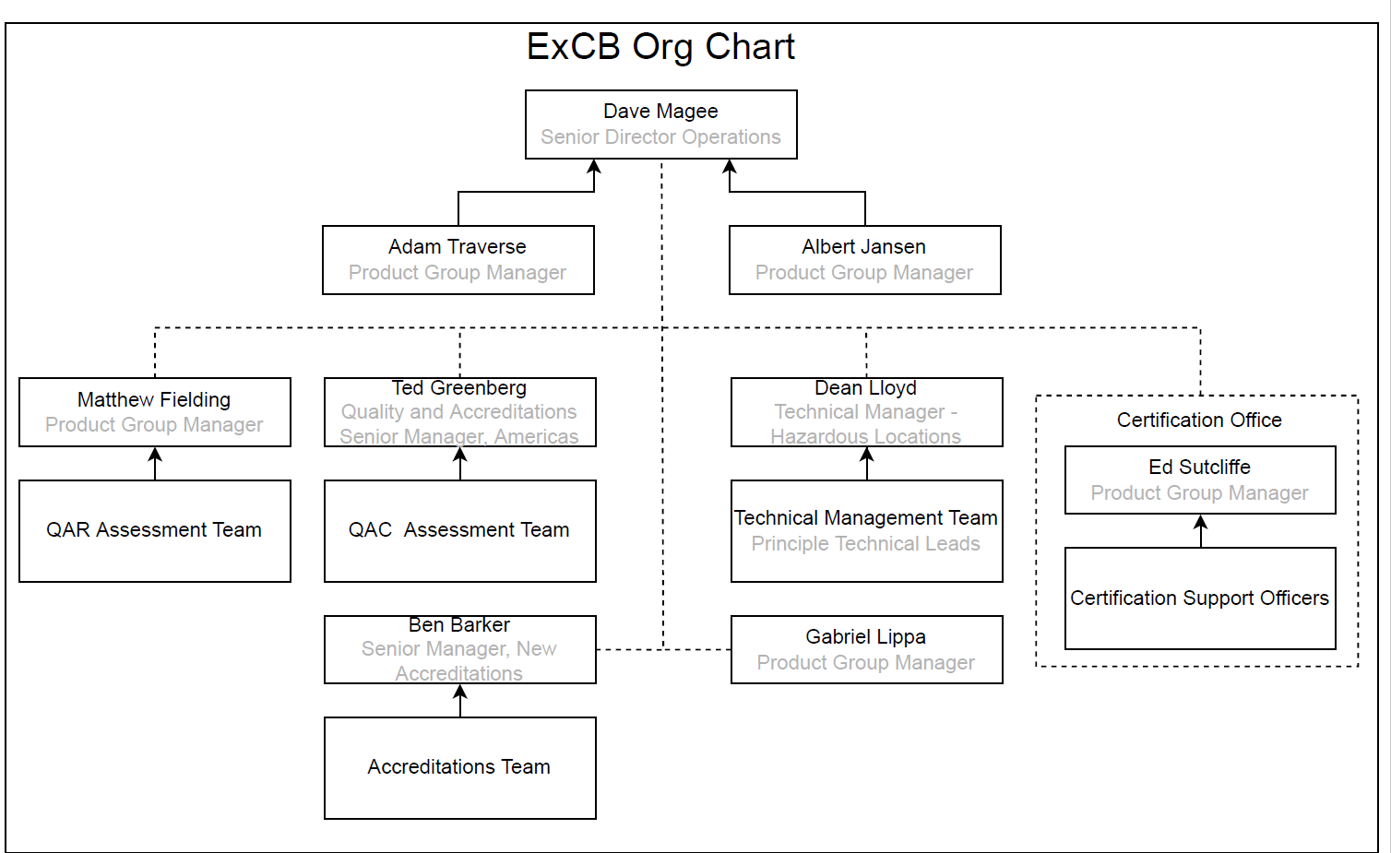

Toronto ExTL

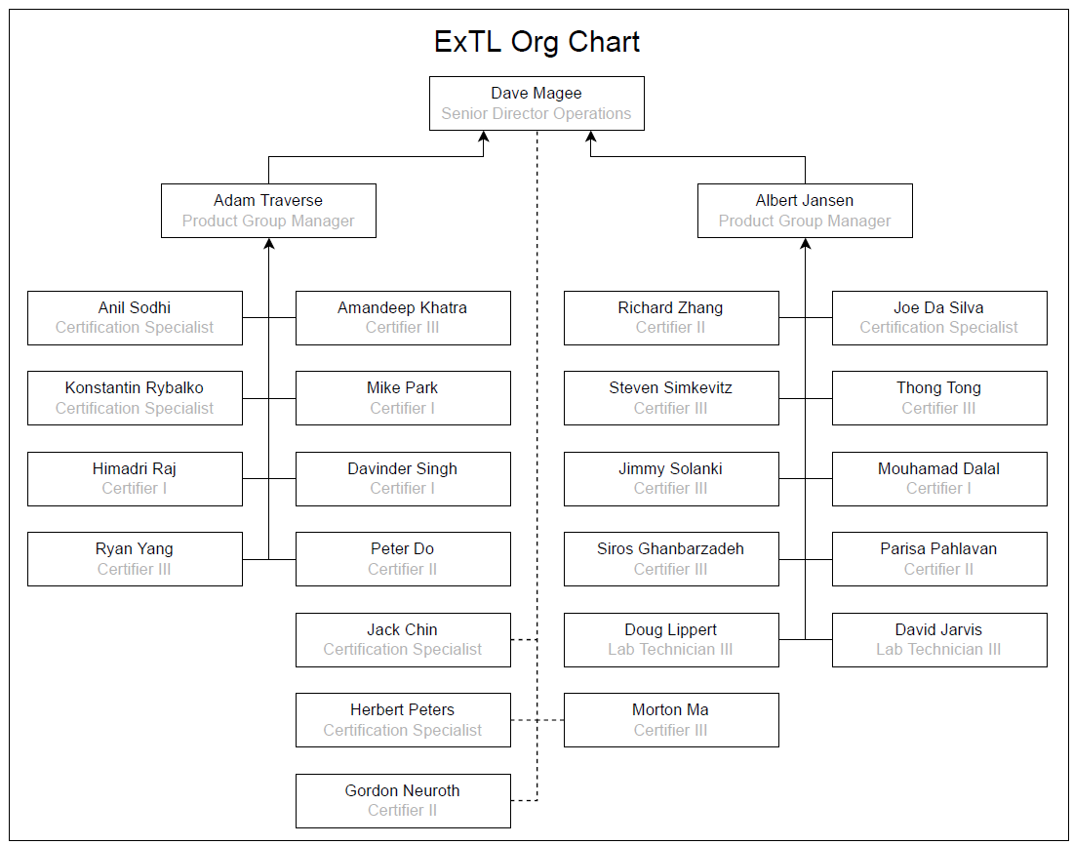

Cleveland ExTL

Edmonton ExTL

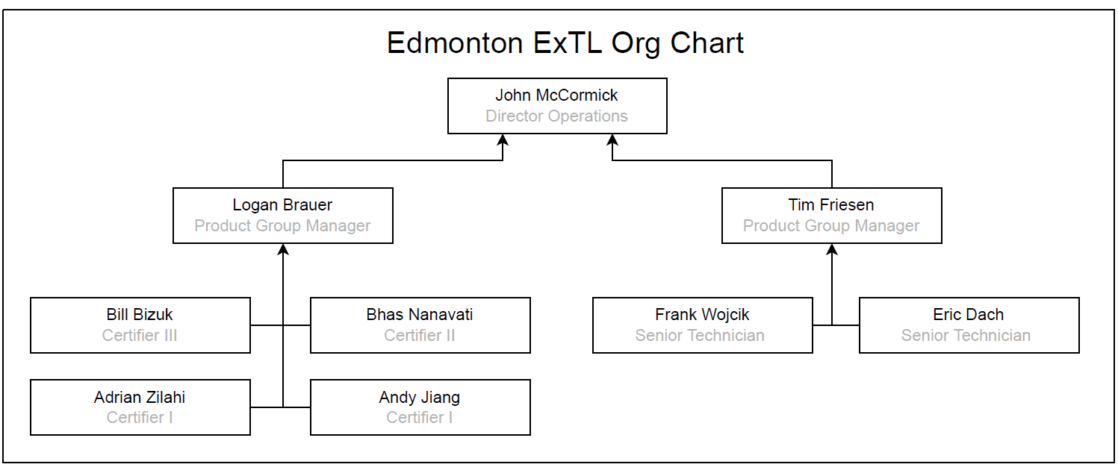

Dallas ExTL

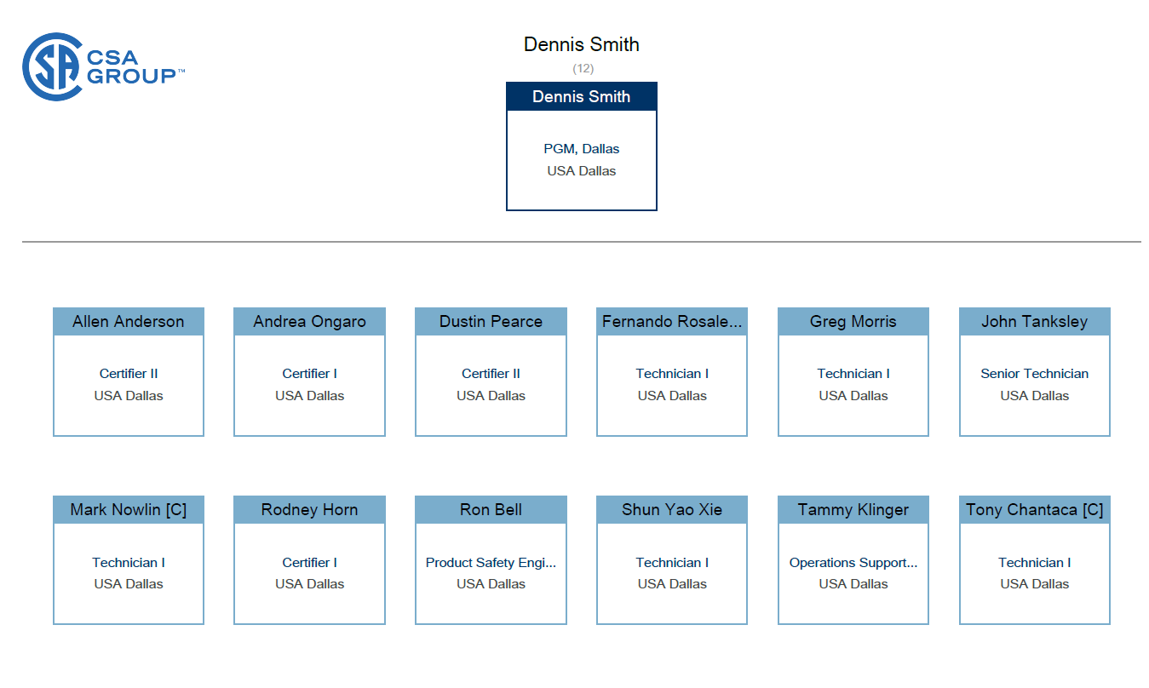

1. Accreditation Certificate for ISO/IEC 17065

1. Accreditation Certificate for ISO/IEC 17025
   1. Toronto

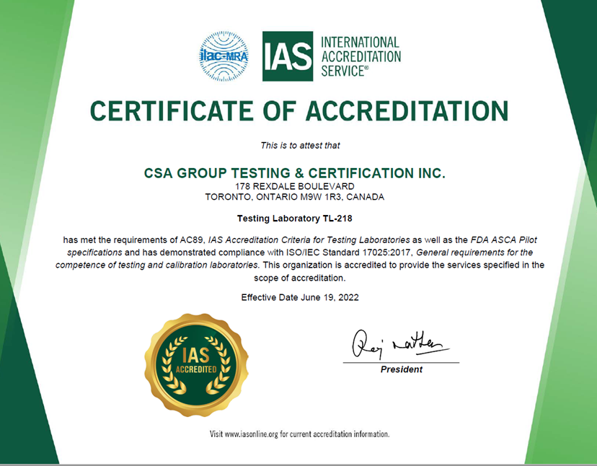

* 1. Cleveland

* 1. Edmonton

* 1. Dallas

