INTERNATIONAL ELECTROTECHNICAL COMMISSION (IEC) SYSTEM
FOR CERTIFICATION TO STANDARDS RELATING TO EQUIPMENT FOR USE
IN EXPLOSIVE ATMOSPHERES (IECEx SYSTEM)

Title: Report from Tim Krause, Convenor ExTAG WG 10, Proficiency Testing
Circulated to: Ex Testing and Assessment Group (ExTAG)

INTRODUCTION

This document, ExTAG/685/R is a report prepared by Tim Krause the Convenor of ExTAG WG10, Proficiency Testing. The report will be presented by Mr. Tim Krause during the ExTAG 2022 IECEx Annual Meetings (to be held remotely) for discussion and consideration.

IECEx Secretariat

Visiting address:  IECEx Secretariat  Level 33, Australia Square  264 George Street  Sydney NSW 2000  Australia | Contact Details:  Tel: +61 2 4628 4690  Fax: +61 2 4627 5285  E-mail: info@iecex.com  http://www.iecex.com

Report by the convenor of ExTAG WG 10 “Proficiency Testing”, Tim Krause, for the Annual ExTAG Meetings 2022 (to be held remotely).

- News about the IECEx/PTB Ex PT Scheme

The first phase (Phase I) of the current programs/test rounds of cycle 2021/2022 “Flameproof Joints – Test Round 2021” (FJ2021) and “Small Component Temperature – Test Round 2021” (SCT2021) is completed and the interim reports have been published. The second phase (Phase II; “improvement loop”) is currently running and will end with the final reports in October/November 2022. The cycle 2021/2022 ends at the end of the year 2022.
Since November 2021 Mr. Niels Springer supports the PT Team of the Provider PTB.

The following programs of the previous program cycles are closed:

- Explosion Pressure - Test Round 2010
- Spark Ignition - Test Round 2010
- Flame Transmission - Test Round 2013
- Temperature Classification - Test Round 2013
- Electrostatic Charge - Test Round 2015
- Intrinsic Safety - Test Round 2015
- Pressurized Enclosure - Test Round 2017
- Explosion Pressure - Test Round 2017

The programs that are currently available are:

- Tests of Enclosures - Test Round 2019
- Battery Testing - Test Round 2019
- Flameproof Joints - Test Round 2021
- Small Component Temperature - Test Round 2021

- Status of the current programs 2021/2022 “Flameproof Joints” (FJ2021) and “Small Component Temperature” (SCT2021)

Description of program “FJ2021”: For the program “Flameproof Joints (“FJ”) - Test Round 2021” the general routine procedure is described by the standard “Explosive atmospheres - Part 1: Equipment protection by flameproof enclosures “d”” - IEC 60079-1, Edition 7.0.

In the field of the type of protection flameproof enclosures, the equipment often has joints due to the constructional design or to ensure functionality. These joints must be designed in a way that they prevent flame transmission of an internal ignition in order to fulfill the requirements of the type of protection. To ensure this, the joints must comply with certain dimensional requirements specified in the standard mentioned above. All flameproof joints, whether permanently closed or designed to be opened from time to time, shall comply, in the absence of pressure, with the appropriate requirements of clause 5. Furthermore, the determination of the test gap forms the basis for the test for non-transmission of an internal ignition (clause 15.3). Therefore, the maximum gap of the flameproof joint has been selected as the measurand of interest which is to be compared in the program “Flameproof Joints – Test Round 2021”. In addition to this measurand of interest, the program also addresses the aspect of preparing/performing the test for non-transmission of an internal ignition (theoretical only).

The Test Sample “FJ” is a simplified construction for the simulation/representation of different flameproof joints consisting of three bolts and a hole plate with various borings. The outer dimensions are 320 mm x 100 mm x 52 mm (L x W x H). The simple and robust design and homogeneity tests guarantee homogeneity and stability throughout the whole test round. In addition, the selected design of the test sample offers convenient manufacturing, preparation, and transport possibilities. To ensure comparability and homogeneity, all Test Samples “FJ” are completely produced, prepared, and provided by the coordinator.

The workload to perform this program is approximately 3 working days.

Status of program “FJ2021”: A total of 82 Ex laboratories are registered for the program. 74 out of 84 IECEx laboratories are registered. The non-registration of the 10 remaining IECEx laboratories has been agreed with the IECEx secretariat (not part of the scope of the IECEx laboratory) or is currently being followed up. 68 out of 74 registered IECEx laboratories have uploaded results in Phase I and are included in the interim report.
The schedule was slightly delayed until the end of Phase I due to the still difficult situation around COVID-19. Meanwhile, the schedule is back on time. Phase I of the program is completed and the interim report was published in June 2022. The associated PT Workshops 2022 were conducted as online workshops in June 2022 due to the COVID-19 situation. Currently, Phase II of the program runs, the schedule of the program is on time. The deadline for repeating the tests and uploading the results of Phase II is the 31st of August 2022. The final report will be published in October/November 2022. Publishing the final report is also the completion of program “Flameproof Joints - Test Round 2021”.

Description of program “’SCT2021”: For the program “Small Component Temperature (“SCT”) - Test Round 2021” the general routine procedure is described by the standard “Explosive atmospheres – Part 0: Equipment – General requirements” - IEC 60079-0, Edition 7.

An important aspect for the testing and assessment of the explosion protection is the test for small components, for example transistors or resistors, whose temperature exceeds that permitted for the temperature classification, described in clause 5.3.3. In the program the test sample (small component for T4 temperature classification) should be tested with flammable mixture in accordance with clause 26.5.3, to investigate if it causes temperature ignition of the flammable mixture. Therefore, the number of ignitions has been selected as the characteristic of interest which is to be compared in the program “Small Component Temperature - Test Round 2021”.

The test sample is an all-ceramic heating element made of silicon nitride and aluminium nitride. The size of the test sample is 7 mm x 3 mm x 1.5 mm (L x W x H). Due to the properties of the ceramic and the low mass, the test sample can be heated up and cooled down quickly. Furthermore, a homogeneous temperature distribution can be provided. Two samples (one of the samples serves as reserve) will be provided by the coordinator at the beginning of the program. To ensure comparability and homogeneity, all Test Samples “SCT” are completely selected, prepared, and provided by the coordinator.

The time required to complete the program is approximately 3 working days.

Status of program “SCT2021”: A total of 83 Ex laboratories have registered for the program. 74 out of 84 IECEx laboratories are registered. The non-registration of the 10 remaining IECEx laboratories has been agreed with the IECEx secretariat (not part of the scope of the IECEx laboratory) or is currently being followed up. 58 out of 74 registered IECEx laboratories have uploaded results in Phase I and are included in the interim report.
The schedule was slightly delayed until the end of Phase I due to the still difficult situation around COVID-19. Meanwhile, the schedule is back on time. Phase I of the program is completed and the interim report was published in June 2022. The associated PT Workshops 2022 were conducted as online workshops in June 2022 due to the COVID-19 situation. Currently, Phase II of the program runs, the schedule of the program is on time. The deadline for repeating the tests and uploading the results of Phase II is the 31st of August 2022. The final report will be published in October/November 2022. Publishing the final report is also the completion of program “Small Component Temperature - Test Round 2021”.

- Results of the current IECEx/PTB Ex PT Programs “FJ2021” and “SCT2021”
A small excerpt of the results (from the interim report) of program “FJ2021” is shown in Figure 1:
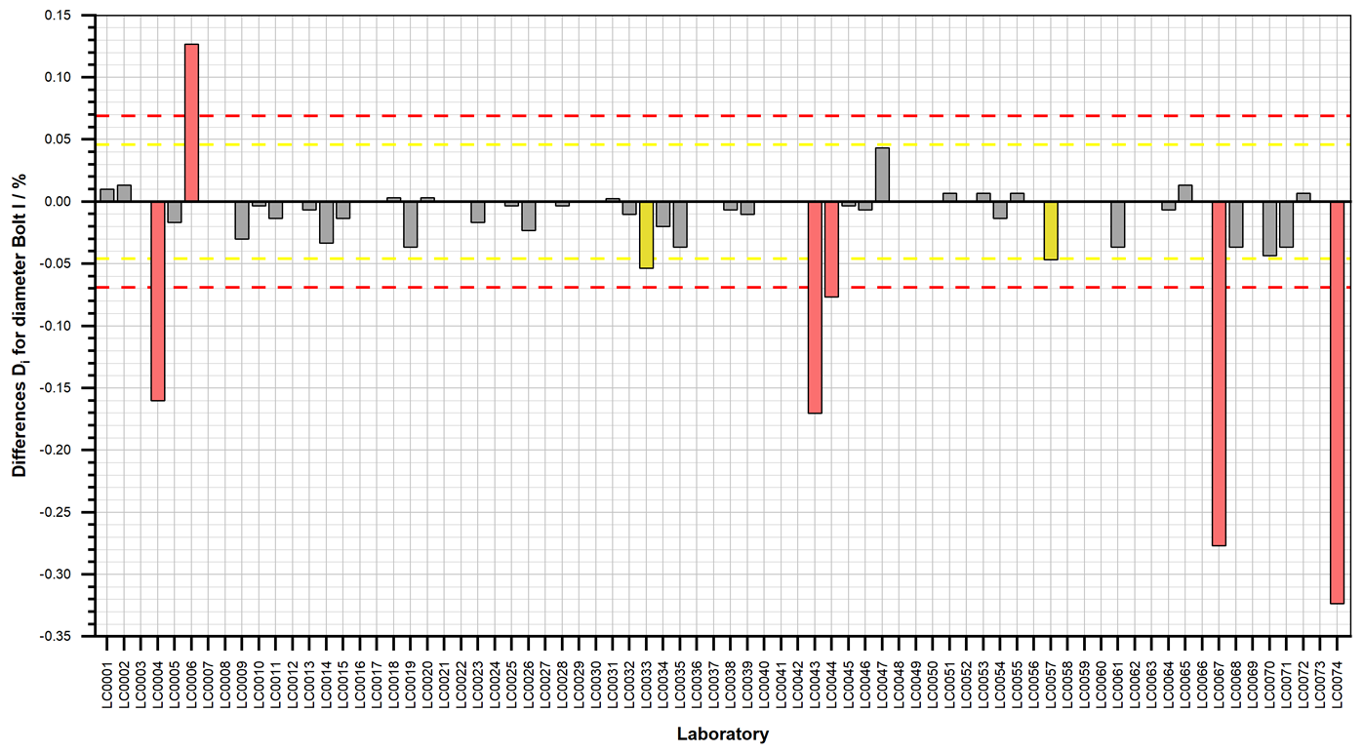
Figure 1: Participant's results for percentage difference of diameters Bolt I with limits for warning (yellow) and action (red) signals
It can be seen that 74 participants have performed the measurement of the diameter for Bolt I. 2 participants got a result D_{i} in the range ± 0.046 % which is considered to give a warning signal. 6 participants got a result D_{i} in the range ± 0.069 % which is considered to be unacceptable (or action signal). The laboratories with warning signals and action signals can use Phase II to repeat the tests and to improve the results.
A small excerpt of the results (from the interim report) of program “SCT2021” is shown in Figure 2:
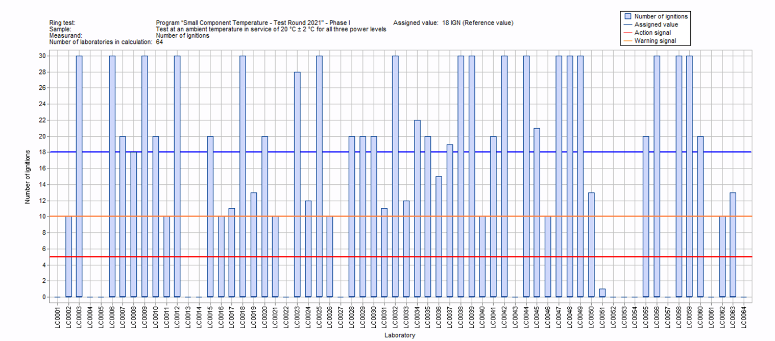Figure 2: Participant's results for Number of ignitions for the small component ignition test performed at an ambient temperature in service of 20 °C ± 2 °C for all three power levels
It can be seen that 64 participants have performed the small component ignition test. No participant got results in the range 10 > x ≥ 5 ignitions which shall be considered to give a “warning signal”. 15 participants got results in the range 5 > x ≥ 0 which shall be considered to give an “action signal”. The laboratories with warning signals and action signals can use Phase II to repeat the tests and to improve the results.
- PTB Ex PT Workshops 2022

The PTB Ex PT Workshops 2022 were organized as online workshops due to the still difficult situation regarding the corona restrictions and the related travel restrictions. The workshops consisted of pre-recorded presentations as well as videos of practical experiments. Furthermore, questions from the participants were collected and discussed during two online discussion session on June 15, 2022.

Despite all the circumstances, the workshops were a success with more than 100 participants.

Nevertheless, it is absolutely intended to hold the future PTB Ex PT Workshops again on site at PTB, because an online event cannot completely replace the exchange of experience and the practical experience in the laboratories.

- New PT programs of the IECEx/PTB Ex PTS for the cycle 2023/2024

Suggestions for programs may be made by the IECEx PTS Provider based on questionnaires circulated under the participating laboratories, by proposals of the ExTAG WG 10 “Proficiency Testing” or by other experts. The IECEx PTS Provider will then take a decision on the programs to provide, taking those suggestions and any recommendations by ExTAG into account. At present, a survey is being conducted on proposed topics for new programs.

Agenda of the next ExTAG WG10 meeting

Date and time: August 24, 2022 from 07:00 to 09:30 (UTC)
Venue: Remote meeting
Number of participants: About 10 people

1. News about the IECEx/PTB Ex PT Scheme
2. Review and results of Phase I of the IECEX/PTB Ex PT Programs “FJ2021” and “SCT2021" of cycle 2021/2022
3. PTB Ex PT Workshops - Review of the PT Workshops 2022 (online)
4. Status of the current programs 2021/2022 “FJ2021" and "SCT2021"
5. New programs for program cycle 2023/2024
6. Any other business

