INTERNATIONAL ELECTROTECHNICAL COMMISSION IEC SYSTEM FOR
CERTIFICATION TO STANDARDS RELATING TO EQUIPMENT FOR USE IN
EXPLOSIVE ATMOSPHERES (IECEx SYSTEM)

TITLE: Scope Extension Assessment Report for Shanghai Institute of Quality Inspection and Technical Research-China National Lighting Fitting Quality Inspection and Testing Centre (SQI_ZM) an Accepted ExTL within the IECEx System, Equipment Scheme 02, to include IEC 60079-2, IEC 60079-5, IEC 60079-13, IEC 60079-25 and ISO 80079-36 and ISO 80079-37 in their scope.

Circulated To: Members of the IECEx Management Committee, ExMC

Introduction

Shanghai Institute of Quality Inspection and Technical Research-China National Lighting Fitting Quality Inspection and Testing Centre (SQI_ZM) and an Accepted ExTL within the IECEx System, Equipment Scheme 02, has applied to include the following Standards within their scope. A special assessment was arranged and conducted in accordance with OD060.

Scope Extension

IEC 60079-2 Edition 6.0 Explosive atmospheres - Part 2: Equipment protection by pressurized
enclosure “p’

IEC 60079-5 Edition 4.0 Explosive atmospheres - Part 5: Equipment protection by powder filling “q”

IEC 60079-13 Edition 2.0 Explosive atmospheres - Part 13: Equipment protection by pressurized room "p" and artificially ventilated room "v"

IEC 60079-25 Edition 3.0 Explosive atmospheres – Part 25: Intrinsically safe electrical systems

IS0 80079-36 Edition 1.0 Explosive atmospheres - Part 36: Non-electrical equipment for explosive atmospheres – Basic method and requirements

ISO 80079-37 Edition 1.0 Explosive atmospheres - Part 37: Non-electrical equipment for explosive atmospheres – Non electrical type of protection constructional safety” c” control of ignition source” b”, liquid immersion ”k”

This report details the assessment findings of this scope extension with the IECEx
Assessment Team recommending the acceptance of the above scope extension.

This document is hereby submitted for ExMC approval via correspondence using the IECEx on-line voting system. ExMC Members are requested to submit their vote via the IECEx On-line Ballot System by the closing date 2022 05 16

Please refer to OD 050 for guidance on the “IECEx On-line voting system.”

Chris Agius

IECEx Secretary

IECEx Secretariat  Australia Square  Level 33, 264 George Street  Sydney. NSW 2000 Australia | Tel: +61 2 4628 4690  Fax: +61 2 46 27 5285  Email: info@iecex.com

IEC System for certification to standards relating to equipment for use in Explosive Atmospheres (IECEx System)

IECEx Assessment Report Form, F-003

IECEx assessment report form for use by IECEx assessment teams to report assessments conducted according to the relevant IECEx assessment procedures of:

Operational Document IECEx OD 003-2 for the Certified Equipment Scheme

Operational Document IECEx OD 316-* for the Certified Service Facility Scheme

Operational Document IECEx OD 422 for the IECEx Conformity Mark Licensing Scheme

Operational Document IECEx OD 501 for the Personnel Competence Scheme

IECEx ExTL assessment report for
Shanghai Institute of Quality Inspection and Technical Research-China National Lighting Fitting Quality Inspection and Testing Centre (SQI_ZM)

INTERNATIONAL
ELECTROTECHNICAL
COMMISSION

CONTENTS
(Update when report is complete – by right click, Update field, Update entire table)
1 Assessment information 5
1.1 Type of body covered by this assessment: 5
1.2 Type of assessment: 5
1.3 Details of body 5
1.3.1 Country 5
1.3.2 Name of body 5
1.3.3 Name and title of nominated principal contact 5
1.4 Assessment information 5
1.4.1 Members of the assessment team 5
1.4.2 Place(s) of assessment 5
1.4.3 Assessment date(s) 6
1.5 Application information and background information on the assessment 6
1.6 Scopes 6
1.6.1 ExCB scope for equipment certification scheme 6
1.6.2 ExTL scope 7
1.6.3 ATF Scope 7
1.6.4 ExCB scope for Service Facilities Scheme 7
1.7 ExCB scope for Conformity Mark Licensing Scheme 7
1.8 ExCB scope for IECEx Personnel Competence Scheme 7
2 Common information 8
2.1 Legal entity of body 8
2.2 Financial support 8
2.3 History 8
2.4 Documentation 8
2.4.1 Quality manual 8
2.4.2 Procedures 8
2.4.3 Work instructions 8
2.4.4 Records (including test records where relevant) 8
2.4.5 Document change control 8
2.5 Confidentiality 8
2.6 Communication with public and customers (Hard copy and Electronic) 8
2.7 Recognitions and agreements 8
2.8 Internal audit 8
2.9 Contracting, subcontracting and witness testing 9
2.9.1 Contracting 9
2.9.2 Subcontracting 9
2.9.3 Off-site and Witnes testing 9
2.10 Training and competence 9
2.11 Complaints and appeals (including appeals to IECEx) 9
2.12 Impartiality 9
2.13 Active involvement in development of Decision Sheets 9
2.14 Special facts to be noted 9
2.15 Supporting documentation 9
2.16 Recommendations 9
3 ExCB for IECEx Certified Equipment Scheme 11
4 ExTL for IECEx Certified Equipment Scheme 12
4.1 Assessment references 12
4.1.1 General references 12
4.1.2 Additional references applied for this assessment 12
4.2 ExTL persons interviewed 12
4.3 Associated ExCB(s) 12
4.4 Organisation 13
4.4.1 Names, titles and experience of the senior executives 13
4.4.2 Name, title and experience of the quality management representative 13
4.4.3 Other employees in ExTL activity 13
4.5 Organizational structure 13
4.6 Resources 13
4.7 Test reports issued 13
4.8 National accreditation 13
4.9 Calibration 14
4.10 Tests witnessed during the assessment visit 14
4.11 Participation in IECEx Proficiency Testing Programs 14
4.12 Comments (including issues found during assessment) 14
5 ExCB for Certified Service Facilities Scheme 17
6 IECEx Conformity Mark Licensing Scheme 18
7 ExCB for IECEx Personnel Competence Scheme 19
8 Annexes 20
Annex A Scope for IECEx Certified Equipment Scheme 21
A.1 Current standards 21
Annex B Overall Organisation Chart 22
Annex C Organisation Chart of ExTL 23
Annex D Accreditation Certificate for ISO/IEC 17065 24
Annex E Accreditation Certificate for ISO/IEC 17025 25
Annex F Accreditation Certificate for ISO/IEC 17024 26

Assessment information

Type of body covered by this assessment:

ExCB for IECEx Certified Equipment Scheme
ExTL for IECEx Certified Equipment Scheme
ATF for IECEx Certified Equipment Scheme
ExCB for IECEx Certified Service Facilities Scheme
ExCB for IECEx Conformity Mark Licensing System
ExCB for IECEx Certification of Personnel Competency Scheme

NOTE 1 ExCB - IECEx Certification Body
NOTE 2 ExTL - IECEx Testing Laboratory
NOTE 3 ATF - Additional Testing Facility

Type of assessment:

Pre-assessment for candidate body
Initial assessment for candidate body
Surveillance
Re-assessment
Scope extension

Details of body

Country
Peoples Republic of China

Name of body
Shanghai Institute of Quality Inspection and Technical Research-China National Lighting Fitting Quality Inspection and Testing Centre (SQI_ZM)

Name and title of nominated principal contact
Name | Title | E-mail address
Ms. Yang Yue | Vice-general manager | yangyue@sqi.org.cn

Assessment information

Members of the assessment team
Name | Role
Mr. Ajay Maira | IECEx Lead Assessor

Place(s) of assessment
(By remote)  No. 900 JiangYue Road, Shanghai Main Ex Testing Laboratory | No. 3, Lane 21, NanDa Road, Shanghai

Assessment date(s)
2021-10-18 to 2021-10-20 with follow ups till 2022-03-17

Application information and background information on the assessment
SQI_ZM was assessed and accepted as an IECEx Testing Laboratory in 2018 as recorded in ExMC/1453/DV with the scope of Standards as recorded in the Annex A of this document. SQI_ZM have now applied for an extension in scope of Standards.
SQI_ZM have an agreement with IMQ S.p.A. which is recognized as ExCB in IECEx Certified Equipment Scheme. The relationship between the laboratory and the ExCB was reviewed and accepted in the earlier assessment of 2018.
SQI_ZM have also developed an agreement with CQM China which is recognized as ExCB in IECEx Certified Equipment Scheme. The relationship between the laboratory and the ExCB was reviewed and accepted in 2019. (ref ExMC/1525/DV).
This assessment was carried out by Remote as per OD 060 with the witnessed tests at both the locations listed under 1.4.2. See details in 4.8 of this report.
The responsibilities for testing were identified to be with Mr. Chen Chaozhong, the Laboratory Vice-Director of SQI_ZM.
The list of equipment for Ex testing was checked for the major items needed.
The scope of the Standards requested was checked to be within the scope of IMQ as the ExCB for most of the Standards except IEC 60079-2 and IEC 60079-13.
The scope of the Standards requested was checked to be within the scope of CQM as the ExCB.
It was noted that SQI_ZM participate in the IECEx PTP program.

Scopes

ExCB scope for equipment certification scheme
The request for extension of scope is by the ExTL
IEC 60079-2 Edition 6.0 Explosive atmospheres - Part 2: Equipment protection by pressurized
enclosure “p’

IEC 60079-5 Edition 4.0 Explosive atmospheres - Part 5: Equipment protection by powder filling “q”

IEC 60079-13 Edition 2.0 Explosive atmospheres - Part 13: Equipment protection by pressurized room "p" and artificially ventilated room "v"

IEC 60079-25 Edition 3.0 Explosive atmospheres – Part 25: Intrinsically safe electrical systems

IS0 80079-36 Edition 1.0 Explosive atmospheres - Part 36: Non-electrical equipment for explosive atmospheres – Basic method and requirements

ISO 80079-37 Edition 1.0 Explosive atmospheres - Part 37: Non-electrical equipment for explosive atmospheres – Non electrical type of protection constructional safety ”c” control of ignition source ”b”, liquid immersion ”k”
The scope of the Standards requested was checked to be within the scope of IMQ as the ExCB for most of the Standards except IEC 60079-2 and IEC 60079-13.
The scope of the Standards requested was checked to be within the scope of CQM as the ExCB.
See scope of ExTL in Annex A.
NOTE 1 Unless otherwise indicated, earlier editions of standards (even if with a different number) are considered to be covered in the above scope for the purposes of the assessment.

ExTL scope
The ExTL scope is included in Annex A.

ATF Scope
Not applicable.

ExCB scope for Service Facilities Scheme
Not applicable.

ExCB scope for Conformity Mark Licensing Scheme
Not applicable.

ExCB scope for IECEx Personnel Competence Scheme
Not applicable.

Common information

Legal entity of body
The legal entity of SQI_ZM was assessed and accepted in ExMC/1453/DV. This has not changed, except for an update of the name from:
“Shanghai Institute of Quality Inspection and Technical Research - China National Lighting Fitting Quality Supervision Testing Centre (SQI_ZM)”
to
“Shanghai Institute of Quality Inspection and Technical Research - China National Lighting Fitting Quality Inspection and Testing Centre (SQI_ZM)”

Financial support
The financial support of the legal entity of SQI_ZM was assessed and accepted in ExMC/1453/DV. There is no change.

History
As recorded in ExMC/1453/DV. There is no change.

Documentation

Quality manual
As recorded in ExMC/1453/DV. There is no change.

Procedures
As recorded in ExMC/1453/DV, with additional procedures for the tests and assessments for the increased scope of Standards.

Work instructions
As recorded in ExMC/1453/DV, with additional work instructions for the tests and assessments for the increased scope of Standards

Records (including test records where relevant)
As recorded in ExMC/1453/DV. There is no change.

Document change control
As recorded in ExMC/1453/DV. There is no change.

Confidentiality
As recorded in ExMC/1453/DV. There is no change.

Communication with public and customers (Hard copy and Electronic)
As recorded in ExMC/1453/DV. There is no change.

Recognitions and agreements
As recorded in ExMC/1453/DV for the agreement between SQI_ZM and IMQ.
Additionally, as recorded in ExMC/1525/DV between SQI_ZM and CQM.

Internal audit
As recorded in ExMC/1453/DV. This was not additionally assessed.

Contracting, subcontracting and witness testing

Contracting
SQI_ZM only uses IMQ and CQM as contractors to deliver IECEx services.

Subcontracting
As recorded in ExMC/1453/DV. There is no change.

Off-site and Witnes testing
As recorded in ExMC/1453/DV. There is no change.

Training and competence
As recorded in ExMC/1453/DV. There is no change. The training and competence of the staff for the scope extensions was based on interviews and practical demonstration of witness tests.
Details of staff competencies are included in the site assessment report.

Complaints and appeals (including appeals to IECEx)
As recorded in ExMC/1453/DV. There is no change.

Impartiality
As recorded in ExMC/1453/DV. There is no change

Active involvement in development of Decision Sheets
As recorded in ExMC/1453/DV. There is no change.

Special facts to be noted
The application for the extension in scope was reviewed and discussed during the assessment and was voluntarily reduced to that shown in Annex A due to time urgencies.

Supporting documentation
Copies of additional supporting information for this assessment have been provided to the applicant and the IECEx Secretariat. These are included in a site assessment report provided separately and include:

- Details of issues raised and how these have been resolved
- Completed Technical Capability Document (TCD)
- Photos of the facilities/tests witnessed are included in the above TCD
- Information on competencies

Recommendations
Based on the assessment performed on 2021-10-18 to 2021-10-20 with follow ups till 2022-03-17, SQI_ZM is recommended for continued acceptance in the IECEx scheme and extension in the scope of Standards as provided in Annex A as:
- An ExTL in the IECEx Certified Equipment Scheme

The scope of the national laboratory accreditation CNAS does not include ISO 80079-36 and ISO 80079-37. This shall be taken into account by IECEx for annual surveillance.

All issues found during the assessment have been resolved.

Ajay Maira
IECEx Lead Assessor
Date: 2022-03-28

ExCB for IECEx Certified Equipment Scheme
This assessment report is for ExTL only.

ExTL for IECEx Certified Equipment Scheme

Assessment references

General references
- IECEx02 IECEx Certified Equipment Scheme covering equipment for use in explosive atmospheres – Rules of Procedure
- IECEx OD003-2 Assessment, surveillance assessment and re-assessment of ExCBs and ExTLs operating in the IECEx 02, IECEx Certified Equipment Scheme
- IECEx OD009 Issuing of CoCs, ExTRs and QARs
- ISO/IEC 17025 General requirements for the competence of testing and calibration laboratories
- IECEx OD 018 Harmonised check list for testing and calibration laboratories ISO/IEC 17025
- IECEx TCD 60079, ISO 80079 Series and ISO 16852 Technical Capability Document
- ExTAG decision sheets (DSs)
- IECEx OD 202 IECEx Certified Equipment Scheme – IECEx Proficiency Testing Program
NOTE The latest editions of the above documents were applied, unless otherwise specified.

Additional references applied for this assessment
Application form ExMC/251B/Q completed by SQI_ZM on 2021-03-05 was used for this assessment.
OD 280 Guide to Certification of Non-electrical Equipment and Protective Systems

ExTL persons interviewed
Name | Position
Chen Chaozhong | General Manager
Yue Yang | Vice-general Manager
Zaidao Yu | Vice-general Manager
Jihong Qiu | Quality Manager
Licheng Yu | Quality Consultant
Erli Liu | Marketing Manager
Bo Zhang | Technical vice-Manager
Jigang Lin | Technical vice-Manager
Hui juan Yang | Device Administrator
Fancang Gong | Technical vice-Manager
Changqing Ru | Engineer
Wentao Zhang | Engineer
Bing Huang | Young Engineer
Lu Zhang | Quality Engineer

Associated ExCB(s)
The associated ExCB’s are IMQ S.p.A. and CQM, both of which are recognized as ExCB’s in IECEx Certified Equipment Scheme.
IMQ S.p.A: Refer to ExMC/1453/DV for the agreement between SQI_ZM and IMQ S.p.A. It is noted that IMQ does not currently have IEC 60079-2 and IEC 60079-13 in their scope.
CQM: Refer to ExMC/1525/DV for the agreement between SQI_ZM and CQM. It is noted that CQM has all the Standards requested by SQI_ZM in their scope.

Organisation

Names, titles and experience of the senior executives

Name | Title | Experience (years)
Yu Yimin | Director | 6 years
Chen Chaozhong | General Manager | 41 years
Yue Yang | Vice-general Manager | 18 years
Zaidao Yu | Vice-general Manager | 11 years
Bo Zhang | Technical vice-Manager | 14 years
Jigang Lin | Technical vice-Manager | 18 years
Fancang Gong | Technical vice-Manager | 37 years

Name, title and experience of the quality management representative

Name | Title | Experience (years)
Jihong Qiu | Quality Manager | 29 years

Other employees in ExTL activity

Name | Title/responsibility | Experience in Ex (years)
Changqing Ru | Engineer | 3 years
Wentao Zhang | Engineer | 8 years
Bing Huang | Young Engineer | 1 year
Lu Zhang | Quality Engineer | 12 years

Organizational structure
This has been included in Annex B.

Resources
SQI_ZM was found to have the appropriate procedures, staff resources and testing equipment to carry out assessment and testing to the standards shown in the proposed extension of scope. Staff with suitable skills and competency were witnessed during the assessment.

Test reports issued
As this is a scope extension application, there are currently no IECEx reports issued yet. Several partial reports were available for the scope extension.

National accreditation
It was checked that SQI_ZM have CNAS accreditation for 17025 certificate L0128 and scope covering the full scope of the Standards that have been requested. The certificate is in the name of the head office at Cang Wu Road, with the several locations including the main location for Ex Testing of SQI_ZM at 900, Jiangyue Road, Shanghai. The location at No. 3, Lane 21, Nada Road, Shanghai is where most of the Ex tests are conducted.
The national accreditation certification for ISO/IEC 17025 is shown in Annex E.
The scope of the national laboratory accreditation CNAS does not include ISO 80079-36 and ISO 80079-37. This shall be taken into account by IECEx for annual surveillance.

Calibration
All equipment used to take measurements for the extension in scope was found adequately calibrated

Tests witnessed during the assessment visit
The following tests were witnessed during the assessment visit:
Standard and edition | Clause number | Test | Comments
IEC 60079-2:2014  (Ed 6.0) | 16.4 | Purge test | Satisfactory
IEC 60079-5:2015  (Ed 4.0) | 5.1.3 | Dielectric strength test of the Filling Material | Satisfactory
*IEC 60079-11:2011  (Ed 6.0) | 10.2 | Dielectric Test | Satisfactory
*IEC 60079-11:2011  (Ed 6.0) | 10.1 | Spark Ignition Test | Satisfactory. But see Additional comments below
IEC 60079-25:2020  (Ed 3.0) | 12 | IS System assessment Test | Satisfactory
ISO 80079-36:2016  (Ed 1.0) | Annex D | Charging tests with non-conductive materials | Satisfactory
ISO 80079-36:2016  (Ed 1.0) | 5 | Mechanical Ignition Hazard Test | Satisfactory
ISO 80079-36:2016  (Ed 1.0) | 8.2.2 | Small Component Thermal Ignition Test | Satisfactory
Additional comments: *Witness testing for Spark Ignition IEC 60079-11:2011 Clause 10.1 was satisfactory, even though later it was mutually decided not to include IEC 60079-11 in the scope extension recommendation.

Participation in IECEx Proficiency Testing Programs
Program: PTB Ex PT Scheme:
Year(s) of participation | IECEx Proficiency Testing program | General information about results
2017 | Explosion Pressure test | Satisfactory
2019: | Battery testing, | Satisfactory
2019 | Tests for Enclosures | Satisfactory
2021: | Flameproof measurements | Participation under progress
2021 | Small component thermal ignition test | Participation under progress

Comments (including issues found during assessment)
Several issues were identified, discussed, and subsequently resolved satisfactorily. Additionally, the capability of SQI_ZM to prepare IECEx reports for all the types of protection that they have requested in their extension of scope was checked and found satisfactory. Items raised and closed during the assessment included the following:
- Investigation was conducted by SQI_ZM into the extensive time required for purging the Ex p enclosure. It revealed a damaged door seal, and its subsequent repair allowed the test to be completed satisfactorily
- Updated procedures for the oxygen analyser to require initialising oxygen zero and span calibration at the start of the day and during testing when required
- Spark testing procedure was improved to maintain the power supply source at the maximum spark current limit and using only series infallible resistors for the spark testing.
- Assessment of intrinsic safety segregation distances was postponed presently as it was decided to defer the scope extension for intrinsic safety to another assessment.
- Dielectric test report was revised to add further details of the test voltage calculations.
- The Ignition Hazard Assessments for the non-electrical equipment was improved to add further hazards and their resolution.
ATF for IECEx Certified Equipment Scheme
This assessment report is for ExTL only.

ExCB for Certified Service Facilities Scheme
This assessment report is for ExTL only.

IECEx Conformity Mark Licensing Scheme
This assessment report is for ExTL only.

ExCB for IECEx Personnel Competence Scheme
This assessment report is for ExTL only.

Annexes
- Scope for IECEx Certified Equipment Scheme
  - Current standards
Number | Title | Comments
IEC 60079-0  Edition 7.0 | Explosive atmospheres - Part 0: Equipment - General requirements | Already in scope
IEC 60079-1  Edition 7.0 | Explosive atmospheres - Part 1: Equipment protection by flameproof  enclosures “d” | Already in scope
IEC 60079-2  Edition 6.0 | Explosive atmospheres - Part 2: Equipment protection by pressurized  enclosure “p’ | Applied for scope extension
IEC 60079-5  Edition 4.0 | Explosive atmospheres - Part 5: Equipment protection by powder filling “q” | Applied for scope extension
IEC 60079-7  Edition 5.1 | Explosive atmospheres - Part 7: Equipment protection by increased  safety "e" | Already in scope
IEC 60079-13  Edition 2.0 | Explosive atmospheres -  Part 13: Equipment protection by pressurized room "p" and artificially ventilated room "v" | Applied for scope extension
IEC 60079-15  Edition 5.0 | Explosive atmospheres – Part 15: Equipment protection by type of protection "n" | Already in scope
IEC 60079-18  Edition 4.1 | Explosive atmospheres – Part 18: Equipment protection by encapsulation “m” | Already in scope
IEC 60079-25  Edition 3.0 | Explosive atmospheres – Part 25: Intrinsically safe electrical systems | Applied for scope extension
IEC 60079-28  Edition 2.0 | Explosive atmospheres - Part 28: Protection of equipment and transmission systems using optical radiation | Already in scope
IEC 60079-31  Edition 2.0 | Explosive atmospheres – Part 31: Equipment dust ignition protection by enclosure "t" | Already in scope
IS0 80079-36  Edition 1.0 | Explosive atmospheres - Part 36: Non-electrical equipment for explosive atmospheres – Basic method and requirements | Applied for scope extension
ISO 80079-37  Edition 1.0 | Explosive atmospheres - Part 37: Non-electrical equipment for explosive atmospheres – Non electrical type of protection constructional safety ”c” control of ignition source ”b”, liquid immersion ”k” | Applied for scope extension
- Overall Organisation Chart

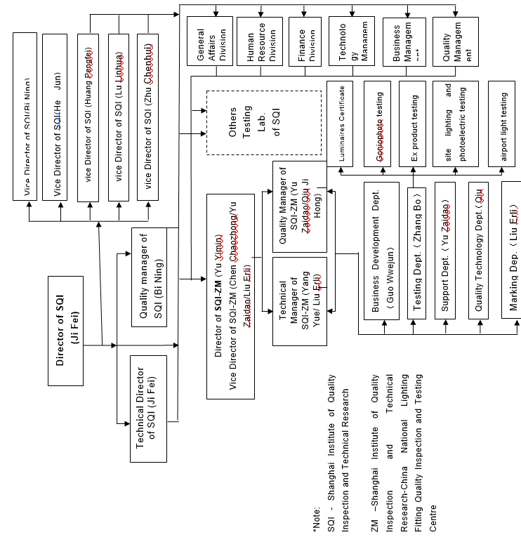
- Organisation Chart of ExTL
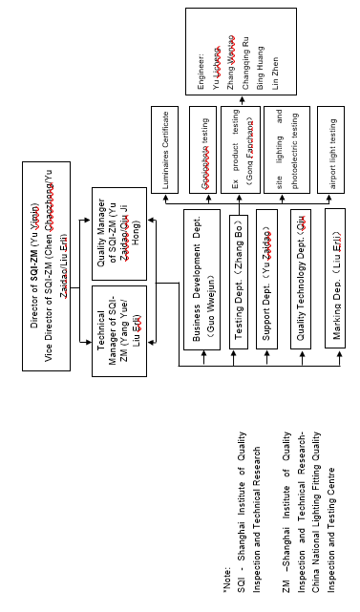
- Accreditation Certificate for ISO/IEC 17065
Not applicable
- Accreditation Certificate for ISO/IEC 17025
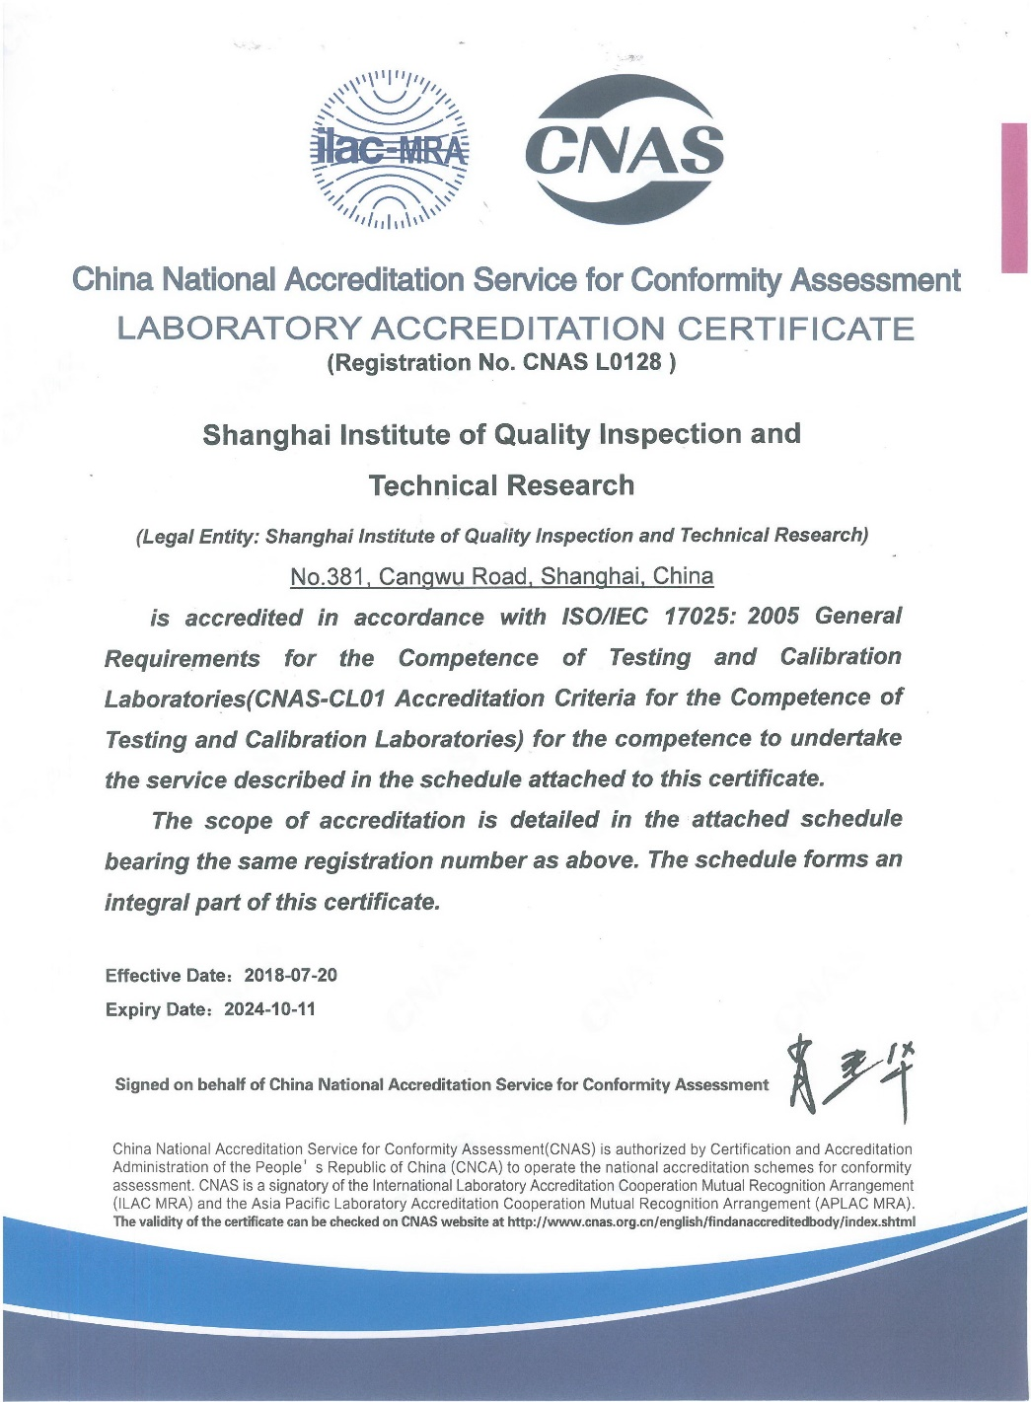
- Accreditation Certificate for ISO/IEC 17024
Not applicable

