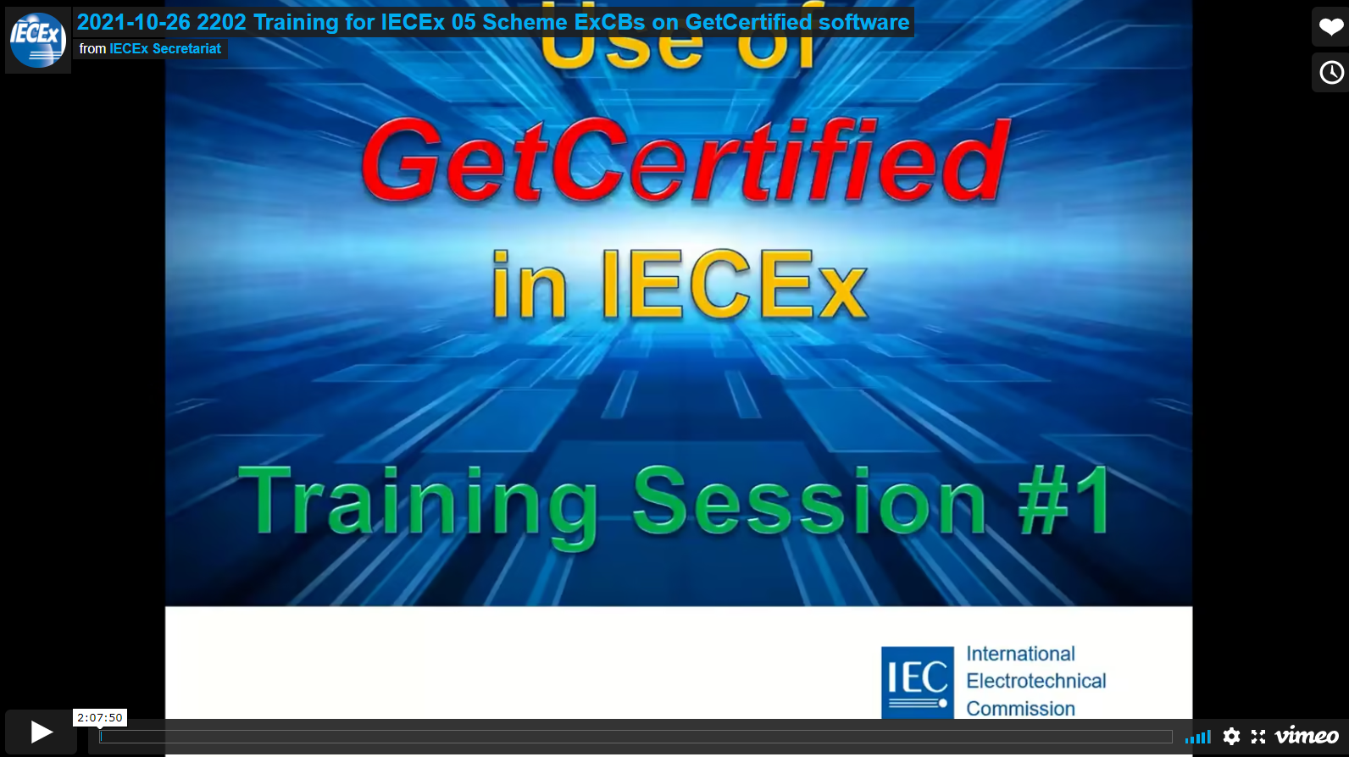

**2021-10-26 2202 Training for IECEx 05 Scheme ExCBs on GetCertified software**

**Please click the link to access the training session. The link will take you to Vimeo**

[**https://vimeo.com/user103574758/review/639325392/05b902f0c7**](https://vimeo.com/user103574758/review/639325392/05b902f0c7)