INTERNATIONAL ELECTROTECHNICAL COMMISSION SCHEME
FOR CERTIFICATION TO STANDARDS RELATING TO EQUIPMENT FOR
USE IN EXPLOSIVE ATMOSPHERES (IECEx SCHEME)

Title: DRAFT: IECEx Guide – Guidance for making Applications for and Use of IECEx Conformity Mark

Circulated to: Members of the IECEx Conformity Mark Committee, ExMarkCo

INTRODUCTION

The IECEx Conformity Mark Committee (ExMarkCo) considered a preliminary Draft Guide on the use of the IECEx Conformity Mark during their meetings of 12 March 2008 (Singapore) and 3 June 2008 (Geneva).

This updated version takes into account the decisions of the ExMarkCo meeting and is submitted to Members for final consideration.

Therefore please advise the Secretariat by 19 June 2008 of any concerns or objections. Following this it is planned to submit this draft for final approval by ExMC.

It is intended that this document be published as IECEx 04 Supplement A.

Thanking you in advance

Chris Agius
IECEx Secretary

Document History
Date | Summary
2008 XX | Original Issue (Version 1)

Address:  IECEx Secretariat  SAI Global Building  286 Sussex Street  Sydney NSW 2000  Australia | Contact Details:  Tel: +61 2 8206 6940  Fax: +61 2 8206 6272  e-mail: chris.agius@iecex.com  http://www.iecex.com
INTRODUCTION

The IECEx Scheme is the Scheme of the IEC for Conformity Assessment to Standards relating to Equipment for Use in Explosive Atmospheres, as provided for in accordance with Article 2 of the IEC Statutes and Rules, 2001 edition, (incorporating amendments approved by Council in 2004 and 2005).
The IECEx facilitates the operation of certification programs in strict accordance with the IECEx Scheme Basic Rules, IECEx 01, as approved by the IEC Conformity Assessment Board (CAB). The IECEx, through the IECEx Management Committee (ExMC) approves the appointment of Certification Bodies that may operate in the IECEx Scheme. These Certification Bodies are known as ExCBs and take the sole decision when issuing Certificates of Conformity under the IECEx Certified Equipment Program (IECEx 02 Scheme).
The objective of the IECEx Scheme is to facilitate international trade in equipment intended for use in explosive atmospheres (referred to as Ex equipment) and services related to that industry. It is a voluntary certification scheme intended to facilitate global trade as follows:
- Reducing testing and certification costs to manufacturer.
- Reducing barriers to entry in to established and emerging market places.
- Reduced time to market.
- Providing International confidence in the assessment process of Ex products and services.
- Providing one international database listing of all issued reports, certificates and licences.
The final objective of the IECEx Scheme is world-wide acceptance of one standard, one certificate and one mark.
While the IECEx Certificates of Conformity, issued by ExCBs, provide evidence of conformity, there is a need to display such conformance through the use of an “IECEx Conformity Mark”.
The use of Marks on products and packaging and other material, to demonstrate conformity is widespread. The IECEx Conformity Mark is a single Global Mark that is intended to negate the need for separate individual Marks being used. The growing industry support and use of the IECEx Scheme has fuelled the demand for an International Mark in this field.
The Ex Mark provides greater assurance and ultimately enhanced confidence for governments, safety regulators, and industry that the equipment being operated, repaired or supplied for use in explosive atmospheres meets the worlds most respected and vigorous safety standards as established by the IEC.
This document provides guidance for applicants of IECEx Conformity Mark Licenses (e.g. manufactures, certified service facilities etc), as well as guidance on the use of the Marks on products and packaging and other material. It shows the steps and processes required for manufacturers to gain and use an IECEx Conformity Mark License.
Note: The details of the rules and process are given in other IECEx documents available from the IECEx Internet website or the IECEx Secretariat via the IEC Central Office, http://www.iecex.com. These will be referred to in the text.

Overview
This guide has been prepared to assist manufacturers and certified service facilities understand that while technically rigorous, the process of achieving an IECEx Conformity Mark License is rather straightforward.
Gaining an IECEx Conformity Mark License and Using the Mark on products and packaging and other material demonstrates the following to users and consumers:
- Products comply with the requirements of the relevant IEC Standard(s) without any national differences and/or Essential Differences in Requirements (EDRs), and with other IECEx recognized normative documents, approved by the IECEx Management Committee.
- The manufacturer or certified service facility is operating a dedicated quality management system, meeting the specific IECEx requirements.
- The manufacturer or certified service facility is under on-going surveillance by an Internationally assessed and recognised IECEx Certification Body (ExCB).
As proof of this achievement the International IECEx Conformity Mark Licensing Schedule is on FULL public display via the IECEx Official Internet Website. http://www.iecex.com
IECEx Conformity Mark License System like the IECEx Certification Scheme is not mandatory and is a voluntary marking system, as such manufactures or certified service facilities may elect to mark their entire Ex Product range, this is permissible provided that -
- The manufacture holds a valid IECEx Certificate of Conformity (CoC) for each and every product, and that the Manufacturer holds an IECEx Conformity Mark License, with those CoC’s listed in the Mark License Schedule and where the IECEx CoC and IECEx Conformity Mark License has been issued by the same ExCB:or
- The IECEx Certified Service Facility holds a valid IECEx Certificate of Conformity (CoC) for the scope of service (product) being provided, and that the IECEx Certified Service Facility holds an IECEx Conformity Mark License, with that CoC (and scope) listed in the Mark License Schedule and where the IECEx CoC and IECEx Conformity Mark License has been issued by the same ExCB.
Where valid IECEx CoC’s have been issued by different ExCB’s over a product range, an IECEx Conformity Mark License needs to be sort from each of the ExCB’s where the IECEx CoC’s have been issued by the ExCB. Issued Mark License Schedules shall only cover nominated product IECEx CoC’s issued by the issuing ExCB.
The IEC is not a certifier (I.e. like other third-party notify bodies PTB, TUV, CESI, SIRA etc), but owns the Mark whom it allows Approved IECEx Certification bodies such as those listed on the IECEx website the right to issue the Mark Licenses to manufactures or IECEx Certified Service Facilities meeting the IECEx requirements.

Rules and Procedures for the Licensing System
The IECEx Conformity Mark Licensing System – Regulations document IECEx 04 & operational documents OD022 & OD023; can be found on the IECEx website (http://www.iecex.com).
1
A full and up to date listing of ExCBs approved to operate under the IECEx Scheme is maintained on the IECEx website (http://www.iecex.com).
2
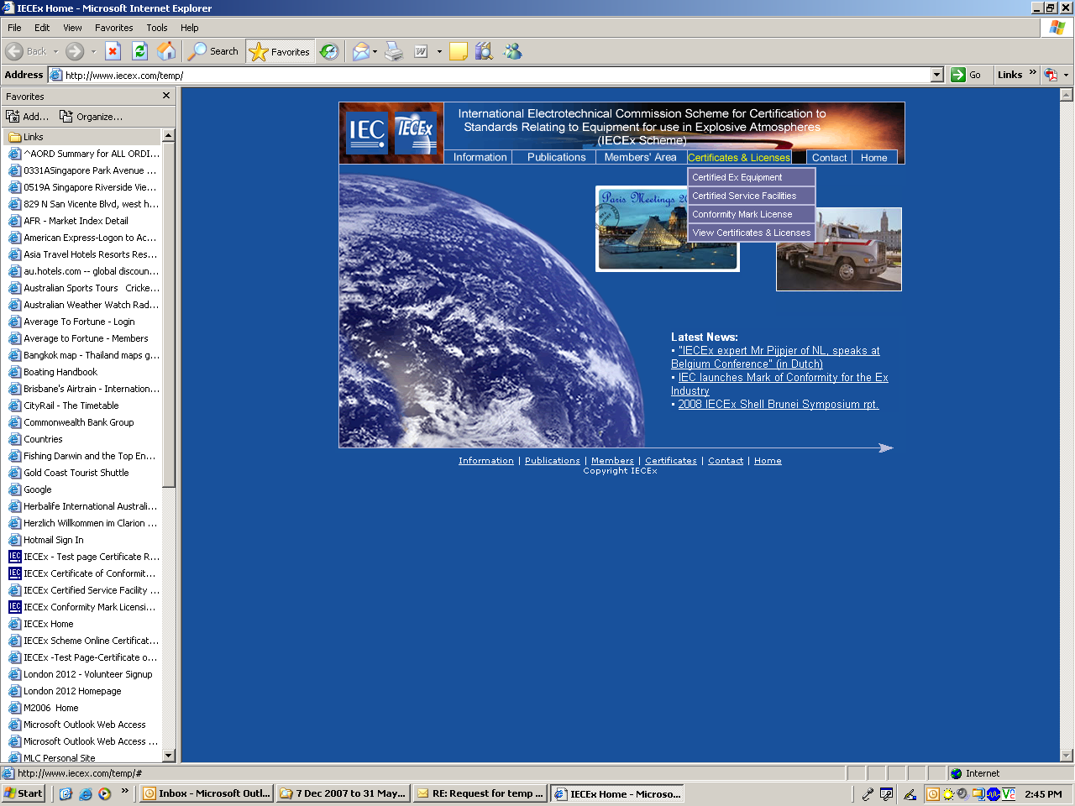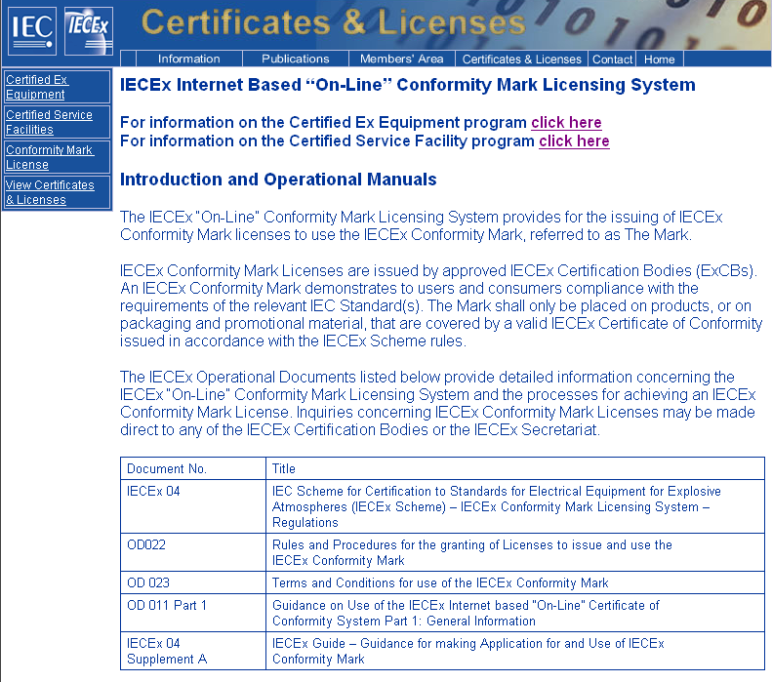
1
2

Application process
Applicant applies to a Conformity Mark Licensing System authorised ExCB
Refer to HYPERLINK "http://www.iecex.com"
www.iecex.com under “Information > ExCBs”
ExCB assesses the applicant to ensure control of the usage of the Mark in accordance with IECEx 04, OD022 & OD023

Application successful
-
Licence issued
by the ExCB

Applications for an IECEx Conformity Mark License, under the IECEx Conformity Mark Licensing System, are lodged directly with IECEx Certification Bodies (ExCBs) whom themselves have successfully undertaken the IECEx Peer Assessment Program for acceptance into the IECEx System.

Making an application
The application for IECEx Conformity Mark License begins with contacting the ExCB, as required by the IECEx Rules, IECEx 04. A special form may not be necessary, but the following information will generally be required by the ExCB:
- Letter formally requesting an IECEx Conformity Mark License.
- Exact details of the nominated products (including valid IECEx Certificate of Conformity Numbers) to be covered by the License.
- Exact details on how each nominated product is to be marked with the Mark; including documentation, packaging and promotional material as well as usage in catalogues and on websites.
- Demonstration that the manufacturer’s or certified service facilities quality management system details how they protect the use of the IECEx Mark, such as:
  - A policy that the IECEx Mark shall only be used and associated with Ex products covered by an IECEx Certificate of Conformity, listed on the IECEx Mark License Schedule and in accordance with IECEx rules and operational documents (e.g. IECEx 04, OD022 & OD023) (refer 1.1).
  - Defined procedures for the design and release of promotional material, including website to ensure the above policy is maintained and which position in the organisation shall have this responsibility and authority.
- The manufacture or certified service facility shall ensure that all requirements of the IECEx Conformity Mark Licensing System Rules and Procedures have been met.
The ExCB will estimate the time and cost to complete the License application.
Upon acceptance of the application the ExCB will review the nominated IECEx CoC’s for validity.
Upon a successful review of the nominated IECEx CoC’s the ExCB will undertake the assessment and audit of the applicant’s procedures for compliance with IECEx requirements.
If successful the ExCB will conduct an assessment and audit of the applicant’s proposed design and use of the IECEx Conformity Mark.
Upon a successful application license registered on the IECEx Website and applicant informed of the license being issued.

IECEx Conformity Mark

Master symbol for photographic reproduction
The Mark includes the IEC logo and an Identification Code to identify both the License Number and the Certification Body which has granted the License to use the Mark.
The IECEx Conformity Mark, reproduced below, may be used for photographic reproduction.
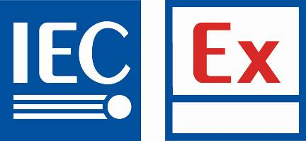 Area for Identification Code issued by the ExCB to Licensee.
Figure 1 The IECEx Conformity Mark
NOTE The pictogram shown above is for illustrative purposes only.

Proportional dimensions of the symbol
All reproductions of the IECEx Conformity Mark shall comply with the dimensional and colour proportions as determined by the IECEx Management Committee and specified by the ExCB issuing the IECEx Conformity Mark License.
The Mark shall have a minimum IEC logo text size of 2.5mm in height.
The Identification Code issued by the ExCB shall be placed in the box indicated in Figure 1; the Identification Code font shall be “Arial” with a minimum character (Text) size of 1mm in height.

Available electronic formats
The Mark is available in a verity of different electronic file formats including but not limited to *.eps, *.ps, *.ai, *.jpg, *.dwg, and,*.dxf, these are available from the IECEx Conformity Mark License issuing ExCBs.

Use of the Mark
The Mark shall only be placed on such products, or their documentation, packaging and promotional material, which are covered by a valid IECEx Certificate of Conformity (CoC), as listed on the issued IECEx Conformity Mark License Schedule.
The Mark shall remain traceable at all times; the Identification Code shall appear with the IECEx Conformity Mark, wherever it is used.
The Mark shall not be used for any purpose other than to indicate that all the requirements of the Mark Licensing System are being met.
All details of the usage and placement of the Mark must be approved by the ExCB issuing the IECEx Conformity Mark License.

Use: - Product marking:
- The Mark shall, in principle, be placed on the product itself in close proximity to the IECEx certification marking or on a label directly affixed to the product. If this is not practical, the Mark may be placed on the product packaging, a label attached to the product, the Instructions for use or other accompanying documentation (refer 2.4.2).
- The Mark may be enlarged or reduced arbitrarily in the same form and ratio, provided that the letters and identification code remain well legible, however, not smaller than 6 x 13 mm and shall be in accordance with 2.2.
- The colour of the mark is shown in Figure 1. Use of black or white and an appropriate transparent background colour is permitted provided that it is not less than 100% coverage of the total label marking and upon agreement by the ExCB issuing the IECEx Conformity Mark License. In all cases the Mark shall remain well legible (See Example in Figure 2).
- It is not permissible to modify the colour of the Mark.
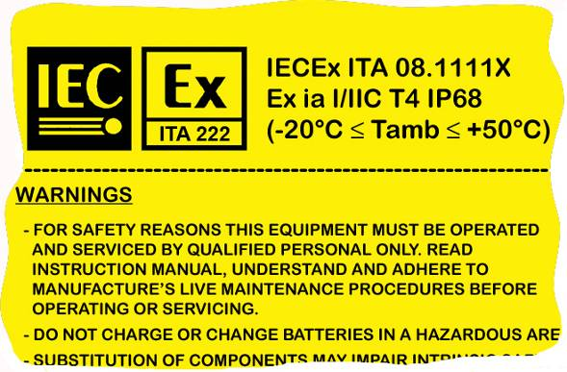 NOTE The pictogram shown above is for illustrative purposes only.
Figure 2 – Example of a contrasting colour being used.

Use: - Documentation, Packaging and Promotional Material:
- The Mark may be affixed to the product packaging, or used in Instructions for use or other accompanying documentation only where such products are covered by a valid IECEx Certificate of Conformity (CoC) and listed on the IECEx Conformity Mark License Schedule.
- The Mark may only be used in advertising where there is a clear association with the products covered by a valid IECEx CoC and listed on the IECEx Conformity Mark License Schedule. The Mark may only be used in catalogues and on websites where there is a clear association with the products covered by a valid IECEx CoC and listed on the IECEx Conformity Mark License Schedule.
- It is not permissible to use the Mark in catalogues or on websites where a list contains products which are not covered by a valid IECEx CoC and listed on the IECEx Conformity Mark License Schedule.
- The Mark may be enlarged or reduced arbitrarily in the same form and ratio, provided that the letters and identification code remain well legible, however, not smaller than 10 x 21.5 mm and shall be in accordance with 2.2.
- It is not permissible to modify the colour of the Mark. Use of black and white is permitted.

Use: - IECEx Certified Services Program: Documentation (i.e. Reports), and Promotional Material:
- The Mark may only be used on printed matter such as letter/report headings and envelopes, or published otherwise, where there is a clear direct association with the Service(s) (scope) covered under a valid IECEx Certified Services Program Certificate of Conformity (CoC) and listed on the IECEx Conformity Mark License Schedule, in all circumstances.
- It is not permissible under any circumstances to affix the Mark on new, repaired or overhauled product, equipment, apparatus, etc.
- The Mark may only be used in advertising where there is a clear association with the Service(s) (scope) covered by the valid IECEx Certified Services Program (CoC) and listed on the IECEx Conformity Mark License Schedule.
- The Mark may be enlarged or reduced arbitrarily in the same form and ratio, provided that the letters and identification code remain well legible, however, not smaller than 10 x 21.5 mm and shall be in accordance with 2.2.
- It is not permissible to modify the colour of the Mark. Use of black and white is permitted only where all the letter/report headings and envelopes are printed in black and white.

IECEx Conformity Mark License sample
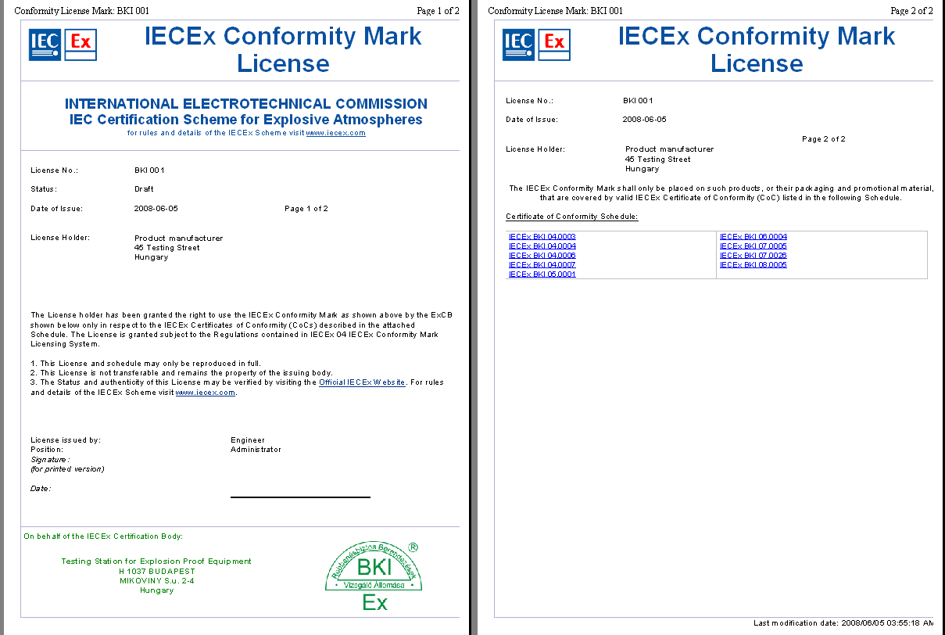
NOTE The pictograms shown above are for illustrative purposes only, the format may change without notice.

IECEx Conformity Mark License & Schedule availability
The IECEx Conformity Mark License will be available live on the “Online Certificates” database. http://www.iecex.com

