INTERNATIONAL ELECTROTECHNICAL COMMISSION (IEC) SYSTEM FOR CERTIFICATION TO STANDARDS RELATING TO EQUIPMENT FOR EXPLOSIVE ATMOSPHERES (IECEx SYSTEM)

TITLE: IECEx Assessment Report for the acceptance of KR Hellas Ltd (KAPA RO HELLAS CERTIFICATION AND INSPECTION ORGANIZATION) to become an Accepted Ex Certification Body, ExCB, within the IECEx Equipment Scheme, 02.

Circulated to: IECEx Management Committee, ExMC

INTRODUCTION

This document contains the IECEx Assessment Report for the acceptance of KR Hellas Ltd, GR, to become an Accepted Ex Certification Body, ExCB, within the IECEx Equipment Scheme, 02.

This document is hereby submitted for ExMC approval via correspondence using the IECEx on-line voting system. ExMC Members are requested to submit their vote via the IECEx On-line Ballot System by the closing date 2020 01 30.
Please refer to OD 050 for guidance on the “IECEx On-line voting system.”

Chris Agius

IECEx Secretariat

Visiting address:  IECEx Secretariat  Level 33, Australia Square  264 George Street  Sydney NSW 2000  Australia | Contact Details:  Tel: +61 2 4628 4690  Fax: +61 2 4627 5285  E-mail: info@iecex.com  http://www.iecex.com

IEC System for certification to standards relating to equipment for use in Explosive Atmospheres (IECEx System)

IECEx Assessment Report Form

IECEx Assessment Report Form for use by IECEx Assessment Teams to report Assessments conducted according to the IECEx Assessment Procedures of

- Operational Document IECEx OD003-2 for the Certified Equipment Scheme
- Operational Document IECEx OD316-5 for the Certified Service Facility Scheme
- Operational Document IECEx OD422 for the IECEx Conformity Mark Licensing System

IECEx ExCB/ExTL assessment report for KR Hellas

INTERNATIONAL
ELECTROTECHNICAL
COMMISSION

CONTENTS
1 Assessment information 5
1.1 Type of Body covered by this assessment: 5
1.2 Type of assessment: 5
1.3 Details of body 5
1.3.1 Country 5
1.3.2 Name of body 5
1.3.3 Name and title of nominated principal contact 5
1.4 Assessment information 5
1.4.1 Members of the assessment team 5
1.4.2 Place(s) of assessment 5
1.4.3 Assessment date(s) 5
1.5 Application information and background information on the assessment 5
1.6 Scope 6
1.6.1 ExCB scope for equipment certification scheme 6
1.6.2 ExTL scope 6
1.6.3 ExCB scope for Service Facilities Scheme 6
1.6.4 ExCB scope for ExMark Scheme 6
2 Common information 7
2.1 Legal entity of body 7
2.2 Financial support 7
2.3 History 7
2.4 Documentation 7
2.4.1 Quality manual 7
2.4.2 Procedures 7
2.4.3 Work instructions 7
2.4.4 Records (including test records where relevant) 7
2.4.5 Document change control 8
2.5 Confidentiality 8
2.6 Communication with public and customers (Hard copy and Electronic) 8
2.7 Recognitions and agreements 8
2.8 Internal audit 8
2.9 Management review 8
2.10 Contracting, subcontracting and witness testing 8
2.10.1 Contracting 8
2.10.2 Subcontracting 8
2.10.3 Witness testing 8
2.11 Training and competence 8
2.12 Complaints and appeals (including appeals to IECEx) 9
2.13 Impartiality 9
2.14 Commenting on ExTAG Documents 9
2.15 Special facts to be noted 9
2.16 Supporting documentation 9
2.17 Recommendations 9
3 ExCB for IECEx Certified Equipment Scheme 10
3.1 Assessment references 10
3.1.1 General references 10
3.1.2 Additional references applied for this assessment 10
3.2 Candidate ExCB persons interviewed 10
3.3 Associated ExTL(s) 10
3.4 Associated certification functions 10
3.5 National marks and certificates 11
3.6 Standards accepted 11
3.7 National differences to IEC standards 11
3.8 Organisation 11
3.8.1 Names, titles and experience of the senior executives 11
3.8.2 Name, title and experience of the quality management representative 11
3.8.3 Name and title of signatories for certification 11
3.8.4 Other employees in ExCB activity 11
3.9 Organizational structure 11
3.10 Indemnity insurance 11
3.11 Resources 11
3.12 Committees (such as governing or advisory boards) 11
3.13 Certification operations 12
3.13.1 National approval/certification methods 12
3.13.2 Certification policy 12
3.13.3 Application for certification 12
3.13.4 Certification decision 12
3.13.5 Suspension and cancellation of certificates 12
3.14 Certificates issued 12
3.15 National accreditation 13
3.16 Assessment of manufacturers and issue of QARs 13
3.17 Comments (including issues found during assessment) 13
Annex A Overall Organisation Chart 14
Annex B Accreditation Certificate for ISO/IEC 17065 15
Annex C Accreditation certificate for ISO/IEC 17020 18
Annex D Accreditation certificate for ISO/IEC 17021 19

Assessment information

Type of Body covered by this assessment:
ExCB for IECEx Certified Equipment Scheme | ✓
ExTL for IECEx Certified Equipment Scheme
ExCB for IECEx Certified Service Facilities Scheme
ExCB for IECEx Conformity Mark Licensing System

NOTE 1 ExCB - IECEx Certification Body
NOTE 2 ExTL - IECEx Testing Laboratory

Type of assessment:
Pre-assessment for candidate body
Initial assessment for candidate body | ✓
Surveillance
Re-assessment
Scope extension

Details of body

Country
Greece

Name of body
KR Hellas Ltd (KAPA RO HELLAS CERTIFICATION AND INSPECTION ORGANIZATION)

Name and title of nominated principal contact
Name | Title | E-mail address
Nikos Katiforis | Quality Manager | nikoskatiforis@krs.co.kr

Assessment information

Members of the assessment team
Name | Role
Ron Webb | IECEx Lead Assessor
Eduardo Galera | IECEx Assessor

Place(s) of assessment
KR HELLAS LTD STATUS CENTER, 41, ATHINAS AV., VOULIAGMENI, GR-16671, ATHENS, GREECE | KR HELLAS LTD Technical Department,  4F, 36, Myeongji Ocean city 9-ro, Gangseo-gu, Busan, 46762, Republic of Korea

Assessment date(s)
4 November 2019 – Busan, Korea  Ron Webb and Eduardo Galera | 7 November 2019 – Athens, Greece  Ron Webb

Application information and background information on the assessment
Information relevant to the Secretariat review process: Application form plus information as required by IECEx 02.

Scope

ExCB scope for equipment certification scheme
Number | Title | Comments, eg if scope change
IEC 60079-0  Edition 7.0 | Explosive atmospheres - Part 0: Equipment - General requirements | ✓
IEC 60079-1  Edition 7.0 | Explosive atmospheres - Part 1: Equipment protection by flameproof  enclosures “d” | ✓
IEC 60079-2  Edition 6.0 | Explosive atmospheres - Part 2: Equipment protection by pressurized  enclosure «p» | ✓
IEC 60079-7  Edition 5.0 | Explosive atmospheres - Part 7: Equipment protection by increased  safety "e" | ✓
IEC 60079-11  Edition 6.0 | Explosive atmospheres - Part 11: Equipment protection by intrinsic safety “i” | ✓
IEC 60079-15  Edition 4.0 | Explosive atmospheres – Part 15: Equipment protection by type of protection "n" | ✓
IEC 60079-18  Edition 4.0 | Explosive atmospheres – Part 18: Equipment protection by encapsulation “m” | ✓
IEC 60079-26  Edition 3.0 | Explosive atmospheres - Part 26: Equipment with equipment protection  level (EPL) Ga | ✓
IEC 60079-28  Edition 2.0 | Explosive atmospheres - Part 28: Protection of equipment and transmission systems using optical radiation | ✓
IEC 60079-31  Edition 2.0 | Explosive atmospheres – Part 31: Equipment dust ignition protection by enclosure "t" | ✓
NOTE 1 Standards shown with an asterisk (*) are superseded standards
NOTE 2 Unless otherwise indicated, earlier editions of standards (even if with a different number) are considered to be covered in the above scope for the purposes of the assessment.
NOTE 3 The above list highlights any extension of scope in the list above for new standards or later editions of standards already in scope.

ExTL scope
KR Hellas have an agreement with KTL as an ExTL. The ExTL scope of KTL covers the ExCB scope requested by KR Hellas in 1.6.1

ExCB scope for Service Facilities Scheme
Not included

ExCB scope for ExMark Scheme
Not included

Common information

Legal entity of body
KR Hellas Ltd, (KAPA RO HELLAS CERTIFICATION AND INSPECTION ORGANIZATION) is a single Limited Company” with its headquarters in “STATUS CENTER, Athinas Avenue 41, Vouliagmeni, GR 166 71, Athens, Tax Number: 997957331, Tax Office: Glyfada, GEMH Number: 9459801000 legally represented by CEO Mr. Park Joo-sung based on the No 21907/09-08-2019 codified legal statute.

Financial support
KR Hellas is supported by fees charged to clients

History
KR Hellas Ltd was established in 2008 in Greece. It is a certification/inspection body accredited by ESYD and notified by Ministry of Development and Economy and Ministry of Digital Policy for nine (9) European Union Directives and Regulations. Amongst them is the ATEX Directive 2014/34/EU relating to equipment and protective systems intended for use in potentially explosive atmospheres.
KR Hellas Ltd was recently accredited by ESYD for the inspection of pressure receptacles and portable tanks according to Chapters 6.2. and 6.7. of “European Agreement concerning the International Carriage of Dangerous Goods by Road (ADR)” and the “Regulations concerning the International Carriage of Dangerous Goods by Rail (RID)“.
KR Hellas Ltd headquarters are located in Greece. KR Hellas Ltd also maintains a Branch Office in Busan, Republic of Korea. The main technical certification/inspection activities are conducted in Republic of Korea by the Technical Team consisting of 14 persons including Technical Manager, Inspectors and Auditors. Of this Technical Team 3 members are involved in IECEx work. Certification activities are managed and controlled from the head office in Greece. On this basis both locations were visited by the assessment team.

Documentation

Quality manual
The quality manual is document KRH-QM Rev 14
The QM is complete and accessible by all employees via the local server. The QM was checked during the assessment and found to meet the requirements of the IECEx.

Procedures
There is a set of procedures specific to IECEx. These were reviewed during the visit and meet the requirements of the IECEx

Work instructions
There are forms for the inspectors/auditors to be completed as part of the work carried out.
KR Hellas has comprehensive ranges of work instructions detailing the general procedure and sets out in WI documents.
The work instruction are readily available to all staff via the local server and were found to meet the requirements of the IECEx

Records (including test records where relevant)
There is a procedure KRH-QP-03 regarding control of records. All records, including scanned copies of handwritten notes are stored electronically on the local server and backed up.
IECEx Certification documents are retained for 10 years after expiry of the certificate. Other documents are retained for other periods as listed in KRH-QP-03.
This meets the requirements of the IECEx.

Document change control
KRH-QP-02 is the procedure for document control. All controlled procedures are available in pdf format. The original is in Word format with access only to the Athens Quality Team who have the necessary write access.

Confidentiality
All staff have signed a confidentiality agreement on joining the company. Scans of the hard copy of the signed forms are held by the Athens Quality Team.
Examples of these were sighted and found to meet the requirements of the IECEx

Communication with public and customers (Hard copy and Electronic)
KR Hellas have a website which details the services offered.
http://www.krhellas.com/

Recognitions and agreements
There is an agreement with KTL to provide ExTL services. The signed agreement was sighted and found to meet IECEx requirements.

Internal audit
Procedure KRH-QP-09 covers internal audit. It covers the work in Athens and Busan.
The last audit for the Busan site was in December 2018. There were no NCRs or observations.
A supplementary internal audit was carried out for the Busan site in October 2019 covering ATEX activities in Busan. Two observations were found and are in the process of being actioned.
The last audit for the Athens site was in September 2019. There were no NCRs or observations.

Management review
The last management review was carried out in July 2019. It covered Ex activities (ATEX) and will cover IECEx in the future.

Contracting, subcontracting and witness testing

Contracting
No contracting

Subcontracting
No subcontracting

Witness testing
Not relevant for ExCB

Training and competence
All staff employed are selected for qualifications and/or experience relevant to their responsibilities. Staff competence and training is described in KRH-QP-04 and includes the process for establishing and monitoring competence. Details of staff competencies are included in the site assessment report. Training records were viewed and were in compliance with the IECEx requirements. Various members of staff were interviewed and found to be competent and an understanding of the standards and IECEx processes.

Complaints and appeals (including appeals to IECEx)
The process for handling complaints and appeals is detailed in KRH-QP-10 which is in compliance with the requirements of the IECEx.

Impartiality
Impartiality is reconfirmed annually by all staff. KRH-QP-07 covers this. A signed copy of the ‘Pledge for Certification Work’ was sighted. A signed copy of the ‘Questionnaire for Impartiality’ form was sighted. This is also confirmed annually.
Management addresses risks to impartiality annually during the steering committee meeting.

Commenting on ExTAG Documents
N/A

Special facts to be noted
It was clear that the Certification was being controlled from Athens, with the technical reviews being carried out in Busan. The final review and Certification Decision is coming from Athens based persons.

Supporting documentation
Copies of additional supporting information for this assessment have been provided to the applicant and the IECEx Secretariat. These are included in a site assessment report or provided separately and include:

- Details of issues raised and how these have been resolved
- Checklist for ISO/IEC 17065
- Assessors’ notes

Recommendations
Based on the assessment performed on 4 November 2019 and 7 November 2019, KR Hellas is recommended for acceptance in the IECEx scheme as:
- An ExCB in the IECEx Certified Equipment Scheme
This is according to the scope of the standards listed in this document

Ron Webb | Eduardo Galera
IECEx Lead Assessor | IECEx Assessor
Date: 16 December 2019

ExCB for IECEx Certified Equipment Scheme

Assessment references

General references
- IECEx02 IECEx Certified Equipment Scheme covering equipment for use in explosive atmospheres – Rules of Procedure
- OD003-2 Assessment, surveillance assessment and re-assessment of ExCBs and ExTLs operating in the IECEx 02, IECEx Certified Equipment Scheme
- ISO/IEC 80079-34 Edition 2, Explosive atmospheres – Part 34: Application of quality systems for equipment manufacture
- OD009 Issuing of CoCs, ExTRs and QARs
- IECEx Document OD 025 Guidelines on the Management of Assessment and Surveillance programs for the assessment of Manufacturer’s Quality Systems in accordance with the IECEx Scheme
- OD0026 IECEx Certified Equipment Scheme – Guidelines for the qualification of Lead Auditor and Auditors, in accordance with the IECEx System
- ISO/IEC 17065: 2012, Edition 1, General requirements for bodies operating product certification systems Conformity assessment — Requirements for bodies certifying products, processes and services
- IECEx Technical Capability Document (TCD)
- ExTAG decision sheets (DSs)
NOTE The latest editions of the above documents were applied

Additional references applied for this assessment
N/A

Candidate ExCB persons interviewed
During Busan visit
Name | Position
Nikos Katiforis | Quality Manager
Lee, Ho-Kyoung | Senior Surveyor
Cho, Wook-Rae | Senior Surveyor
Yu, Ji-Hoon | Senior Surveyor
Yu, Chang-Yeul | Korea Branch Manager

During Athens visit
Name | Position
Nikos Katiforis | Quality Manager
Vasilis Evangelidis | Quality assistant
Joo-sung Park | Chief Executive Officer

Associated ExTL(s)
The formal agreement with KTL was signed in April 2019. KTL has been an accepted ExCB and ExTL in the IECEx Scheme as an ExTL in 2008. The scope is sufficient to cover the work required by the ExCB

Associated certification functions
KR Hellas are a Notified Body No. NB 2198 under several European directives, including ATEX.

National marks and certificates
None

Standards accepted
See clause 1.6 of this report

National differences to IEC standards
National differences to IEC standards are those for the European differences listed in the latest version of the IECEx Scheme Bulletin.

Organisation

Names, titles and experience of the senior executives

Name | Title | Experience
Park, Joo-Sung | CEO | 20 years in Certification

Name, title and experience of the quality management representative

Name | Title | Experience
Nikos Katiforis | Quality Manager | 20+ years in certification

Name and title of signatories for certification

Name | Title | Comments
Nikos Katiforis | Quality Manager | 20+ years in certification

Other employees in ExCB activity

Name | Title | Responsibility and Experience in Ex
Vasilis Evangelidis | Quality assistant | 1.5 years in Ex

Organizational structure
See Annex A

Indemnity insurance
Sight was made of the professional indemnity insurance cover for KR Hellas by DB Insurance. The policy holder is the Korean Register of shipping (KR), with KR Hellas Ltd noted as insured as an affiliated company of KR. The cover was considered adequate.

Resources
Sufficient certification personnel are located in Athens, Greece, where the contract review and the Certification Decision are made. The technical aspects of the ExCB are undertaken by staff in Busan, Republic of Korea. Again, there are adequate staff in Busan for the tasks involved.

Committees (such as governing or advisory boards)
There are two committees. A steering committee and a Certification committee. There is procedure KRH-QP-06 which covers operation of the committees and meets the requirements of ISO/IEC 17065 and the IECEx requirements.

Certification operations

National approval/certification methods
KR Hellas issue ATEX EU Certificates under NB number 2198. They are accredited by ESYD to ISO/IEC 17065, ISO/IEC 17021-1 and ISO/IEC 17020.

Certification policy
There is a Certification Policy (Quality Policy) which states the objectives of the organisation and was seen to be in conformity with the requirements of ISO/IEC 17065 and IECEx 02. This was signed by the CEO of KR Hellas. There is a ‘KRH Quality Objectives 2019’ document, also signed by the CEO.

Application for certification
Application forms are available for completion by the applicant. Form FP-15-01 covers this.
Applications are controlled from Athens and the contract review is carried out from Athens. The test plan is then prepared and the necessary test work carried out by KTL, the associated ExTL.

Certification decision
The Certification Decision is made by the Certification Committee of KR Hellas in Athens in accordance with KRH-QP-06. If successful, a member of the Quality Management Team then issues the certificate using the on-line system.

Suspension and cancellation of certificates
Suspension and cancellation of certificates is described in KRH-QP-15. The procedures meet the requirements of IECEx.

Certificates issued
Number of certificates issued under for the preceding four years for each type of protection. These are ATEX Certificates
Standard numbers | Type of protection or other identifying information | Number of issued certificates (for last 4 years) |  |  |  | Total
Standard numbers | Type of protection or other identifying information | 2016 | 2017 | 2018 | 2019
EN 60079-0 | General requirements | 52 | 24 | 28 | 32 | 136
EN 60079-1 | Flameproof | 38 | 9 | 18 | 21 | 86
EN 60079-2 | pressurised | 6 | 3 | 1 | 4 | 14
EN 60079-7 | Increased safety | 21 | 14 | 14 | 16 | 65
EN 60079-11 | Intrinsic safety | 2 | 2 | 2 | 2 | 8
EN 60079-15 | Type ‘n’ | 5 | 7 | 3 | 5 | 20
EN 60079-18 | encapsulation | 4 | 6 | 4 | 2 | 16
EN 60079-26 | EPL Ga | 0 | 0 | 0 | 0 | 0
EN 60079-28 | Optical radiation | 0 | 0 | 0 | 1 | 1
EN 60079-31 | Dust protection | 6 | 2 | 2 | 4 | 14

National accreditation
KR Hellas have accreditation from Hellenic Accreditation System in Greece to ISO/IEC 17065.
The certificate is attached as Annex B
KR Hellas also have accreditation as a certification body for management systems and an inspection body. Relevant certificates are shown in Annexes C and D

Assessment of manufacturers and issue of QARs
There is a procedure for QAR visits within procedure KRH-QP-15. This meets the requirements of the IECEx.

Comments (including issues found during assessment)
Minor issues concerning procedural detail and provision of a competency matrix were cleared to the satisfaction of the assessment team and now meet the requirements of the IECEx.

- Overall Organisation Chart
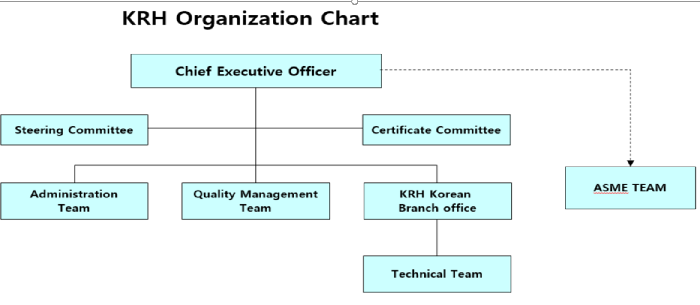
- Accreditation Certificate for ISO/IEC 17065
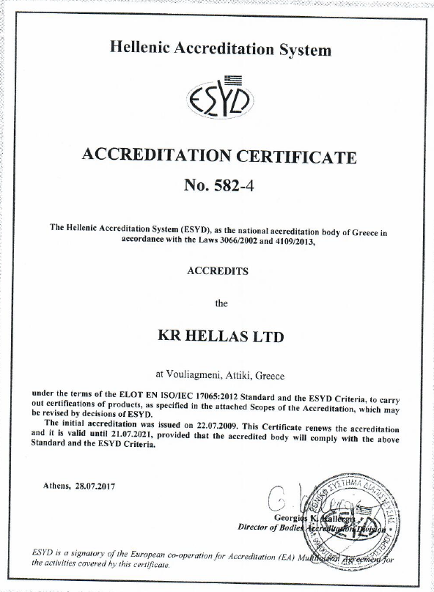

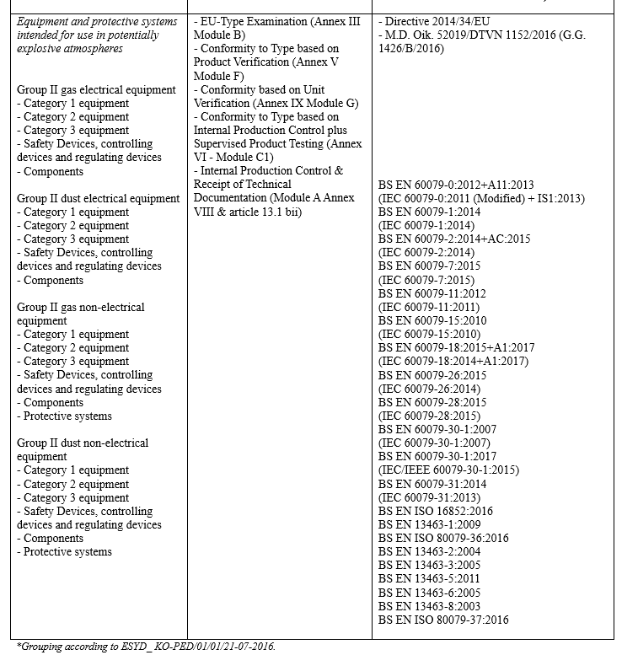
- Accreditation certificate for ISO/IEC 17020
- Accreditation certificate for ISO/IEC 17021

