**INTERNATIONAL ELECTROTECHNICAL COMMISSION SYSTEM FOR CERTIFICATION TO STANDARDS RELATING TO EQUIPMENT FOR USE IN EXPLOSIVE ATMOSPHERES (IECEx SYSTEM)**

**TITLE: Re-assessment and Scope Extension Report for the continued acceptance of** **LabTest Certification Inc., an Accepted Certification Body, (ExCB), and an Accepted Ex Testing Laboratory (ExTL) within the IECEx System, Equipment Scheme 02, to include IEC 60079-13, IEC 60079-28, IEC/IEEE 60079-30-1, IEC 60079-33, IEC/TS 60079-46, ISO 80079-36 and ISO 80079-37 in their scope.**

**Circulation to: Members of the IECEx Management Committee, ExMC**

**INTRODUCTION**

In accordance with the 5 year re-assessment plan for the surveillance and monitoring of bodies within the IECEx System, the following document contains the IECEx Re-assessment and Scope Extension Report for the continued acceptance of LabTest Certification Inc., as an Accepted Certification Body (ExCB) and an Accepted Ex Testing Laboratory (ExTL) within the IECEx System, Equipment Scheme 02.

During the re-assessment the IECEx Assessment Team took the opportunity to also assess, LabTest Certification Inc., equipment and competence to undertake testing and certification for the following extension of scope –

|  |  |  |
| --- | --- | --- |
| **Standard** | **Edition** | **Title** |
| IEC 60079-13 | 2.0 | Part 13: Equipment protection by pressurized room "p" and artificially ventilated room "v" |
| IEC 60079-28 | 2.0 | Part 28: Protection of equipment and transmission systems using optical radiation |
| IEC/IEEE 60079-30-1 | 1.0 | Part 30-1: Electrical resistance trace heating - General and testing requirements |
| IEC 60079-33 | 1.0 | Part 33: Equipment protection by special protection 's' |
| IEC/TS 60079-46 | 1.0 | Edition 1 Explosive atmospheres - Part 46: Equipment assemblies |
| ISO 80079-36 | 1.0 | Part 36: Non-electrical equipment for explosive atmospheres - Basic method and requirements |
| ISO 80079-37 | 1.0 | Part 37: Non-electrical equipment for explosive atmospheres - Non electrical type of protection constructional safety "c", control of ignition source "b", liquid immersion "k" |

***This document is hereby submitted for ExMC approval via correspondence using the IECEx on-line voting system.  ExMC Members are requested to submit their vote via the IECEx On-line*** [***Ballot System***](https://www.iecex.com/ballot) ***by the closing date 2019 07 26***

***Please refer to OD 050 for guidance on the “IECEx On-line voting system.”***

***Chris Agius***

**IECEx Secretariat**

|  |  |
| --- | --- |
| **IECEx Secretariat**  **Australia Square**  **Level 33, 264 George Street**  **Sydney NSW 2000**  **Australia** | **Tel: +61 2 4628 4690**  **Fax: +61 2 4625 3480**  **Email: chris.agius@iecex.com** |

IEC System for certification to standards relating to equipment for use in Explosive Atmospheres (IECEx System)

IECEx Assessment Report Form

IECEx Assessment Report Form for use by IECEx Assessment Teams to report Assessments conducted according to the IECEx Assessment Procedures of

1. Operational Document IECEx OD003-2 for the Certified Equipment Scheme
2. Operational Document IECEx OD316-5 for the Certified Service Facility Scheme
3. Operational Document IECEx OD422 for the IECEx Conformity Mark Licensing System

IECEx ExCB/ExTL assessment report for LabTest Certification Inc.

INTERNATIONAL  
ELECTROTECHNICAL  
COMMISSION

CONTENTS

1 Assessment information 6

1.1 Type of Body covered by this assessment: 6

1.2 Type of assessment: 6

1.3 Details of body 6

1.3.1 Country 6

1.3.2 Name of body 6

1.3.3 Name and title of nominated principal contact 6

1.4 Assessment information 6

1.4.1 Members of the assessment team 6

1.4.2 Place(s) of assessment 6

1.4.3 Assessment date(s) 6

1.5 Application information and background information on the assessment 6

1.6 Scopes 7

1.6.1 ExCB scope for equipment certification scheme 7

1.6.2 ExTL scope 8

2 Common information 8

2.1 Legal entity of body 8

2.2 Financial support 8

2.3 History 8

2.4 Documentation 8

2.4.1 Quality manual 8

2.4.2 Procedures 9

2.4.3 Work instructions 9

2.4.4 Records (including test records where relevant) 9

2.4.5 Document change control 9

2.5 Confidentiality 9

2.6 Communication with public and customers (Hard copy and Electronic) 9

2.7 Recognitions and agreements 9

2.8 Internal audit 9

2.9 Management review 9

2.10 Contracting, subcontracting and witness testing 9

2.10.1 Contracting 9

2.10.2 Subcontracting 9

2.10.3 Witness testing 10

2.11 Training and competence 10

2.12 Complaints and appeals (including appeals to IECEx) 10

2.13 Impartiality 10

2.14 Commenting on ExTAG Documents 10

2.15 Special facts to be noted 10

2.16 Supporting documentation 10

2.17 Recommendations 10

3 ExCB for IECEx Certified Equipment Scheme 12

3.1 Assessment references 12

3.1.1 General references 12

3.1.2 Additional references applied for this assessment 12

3.2 Candidate ExCB persons interviewed 12

3.3 Associated ExTLs(s) 12

3.4 Associated certification functions 12

3.5 National marks and certificates 12

3.6 Standards accepted 13

3.7 National differences to IEC standards 13

3.8 Organisation 13

3.8.1 Names, titles and experience of the senior executives 13

3.8.2 Name, title and experience of the quality management representative 13

3.8.3 Name and title of signatories for certification 13

3.8.4 Other employees in ExCB activity 13

3.9 Organizational structure 14

3.10 Indemnity insurance 14

3.11 Resources 14

3.12 Committees (such as governing or advisory boards) 14

3.13 Certification operations 14

3.13.1 National approval/certification methods 14

3.13.2 Certification policy 14

3.13.3 Application for certification 14

3.13.4 Certification decision 14

3.13.5 Suspension and cancellation of certificates 14

3.14 Certificates issued – pending to be provided at audit opening meeting 15

3.15 National accreditation 15

3.16 Assessment of manufacturers and issue of QARs 15

3.17 Comments (including issues found during assessment) 15

4 ExTL for IECEx Certified Equipment Scheme 16

4.1 Assessment references 16

4.1.1 General references 16

4.1.2 Additional references applied for this assessment 16

4.2 Candidate ExTL persons interviewed 16

4.3 Associated ExCB(s) 16

4.4 Organisation 16

4.4.1 Names, titles and experience of the senior executives 16

4.4.2 Name, title and experience of the quality management representative 17

4.4.3 Other employees in ExTL activity 17

4.5 Organizational structure 17

4.6 Resources 17

4.7 Test reports issued – to be provided at opening meeting 18

4.8 National accreditation 18

4.9 Calibration 18

4.10 Tests witnessed during the assessment visit-pending 18

4.11 Participation in IECEx Proficiency Testing Programs-pending 20

4.12 Comments (including issues found during assessment) 20

5 Annexes 20

Annex A Overall Organisation Chart 21

Annex B Organisation Chart of ExCB and ExTL 22

Annex C Accreditation Certificate for ISO/IEC 17065 23

Annex D Accreditation Certificate for ISO/IEC 17025 24

Annex E Accreditation Certificate for ISO/IEC 17020 25

# Assessment information

## Type of Body covered by this assessment:

|  |  |
| --- | --- |
| ExCB for IECEx Certified Equipment Scheme | ✓ |
| ExTL for IECEx Certified Equipment Scheme | ✓ |
| ExCB for IECEx Certified Service Facilities Scheme |  |
| ExCB for IECEx Conformity Mark Licensing System |  |

NOTE 1 ExCB - IECEx Certification Body

NOTE 2 ExTL - IECEx Testing Laboratory

## Type of assessment:

|  |  |
| --- | --- |
| Pre-assessment for candidate body |  |
| Initial assessment for candidate body |  |
| Surveillance |  |
| Re-assessment | ✓ |
| Scope extension | ✓ |

## Details of body

### Country

Canada

### Name of body

LabTest Certification Inc.

### Name and title of nominated principal contact

|  |  |  |
| --- | --- | --- |
| Name | Title | E-mail address |
| Kavinder Dhillon | Certification Manager | kdhillon@labtestcert.com |

## Assessment information

### Members of the assessment team

|  |  |
| --- | --- |
| Name | Role |
| Heinz Berger | IECEx Lead Assessor |
| Allan Ogden | IECEx Assessor |

### Place(s) of assessment

|  |  |
| --- | --- |
| 205 – 8291 92 street, Delta, BC Canada |  |

### Assessment date(s)

June 26-28, 2018 plus post visit reviews of updated documents.

## Application information and background information on the assessment

Scope extension application was made on March 12th, 2018.

## Scopes

### ExCB scope for equipment certification scheme

| Number | Title | Comments, e.g. if scope change |
| --- | --- | --- |
| IEC 60079-0  Edition 6.0 | Explosive atmospheres - Part 0: Equipment - General requirements | OK |
| IEC 60079-1  Edition 7.0 | Explosive atmospheres - Part 1: Equipment protection by flameproof  enclosures “d” | OK |
| IEC 60079-2  Edition 6.0 | Explosive atmospheres - Part 2: Equipment protection by pressurized  enclosure «p» | OK |
| IEC 60079-6  Edition 4.0 | Explosive atmospheres - Part 6: Equipment protection by oil immersion «o» | OK |
| IEC 60079-7  Edition 5.0 | Explosive atmospheres - Part 7: Equipment protection by increased  safety "e" | OK |
| IEC 60079-11  Edition 6.0 | Explosive atmospheres - Part 11: Equipment protection by intrinsic safety “i” | OK |
| IEC 60079-13  Edition 1.0 | Explosive atmospheres -  Part 13: Equipment protection by pressurized room 'p' | Scope extension  OK |
| IEC 60079-15  Edition 4.0 | Explosive atmospheres – Part 15: Equipment protection by type of protection "n" | OK |
| IEC 60079-18  Edition 4.0 | Explosive atmospheres – Part 18: Equipment protection by encapsulation “m” | OK |
| IEC 60079-25  Edition 2.0 | Explosive atmospheres – Part 25: Intrinsically safe electrical systems | OK |
| IEC 60079-26  Edition 3.0 | Explosive atmospheres - Part 26: Equipment with equipment protection  level (EPL) Ga | OK |
| IEC 60079-28  Edition 2.0 | Explosive atmospheres - Part 28: Protection of equipment and transmission systems using optical radiation | Scope extension  OK |
| IEC/IEEE 60079-30-1  Edition 1.0 | Explosive atmospheres – Part 30-1: Electrical resistance trace heating – General and testing requirements | Scope extension  OK |
| IEC 60079-31  Edition 2.0 | Explosive atmospheres – Part 31: Equipment dust ignition protection by enclosure "t" | OK |
| IEC 60079-33 | Part 33: Equipment protection by special protection “s” | Scope extension  OK |
| IS0 80079-36  Edition 1.0 | Explosive atmospheres - Part 36: Non-electrical equipment for explosive atmospheres – Basic method and requirements | Scope extension  OK |
| ISO 80079-37  Edition 1.0 | Explosive atmospheres - Part 37: Non-electrical equipment for  explosive atmospheres – Non-electrical type of protection  constructional safety” c” control of ignition source” b”, liquid immersion” k” | Scope extension  OK |
| IEC/TS 60079-46  Edition 1.0 | Edition 1 Explosive atmospheres - Part 46: Equipment assemblies | Scope extension  OK |

### ExTL scope

The ExTL scope is the same as for the ExCB.

# Common information

## Legal entity of body

LABTEST CERTIFICATION INC. is incorporated under the laws of British Columbia, Canada, under the number 673313 since July 11th, 2003. The document was reviewed during the assessment and found to meet the requirements of the IECEx.

## Financial support

LABTEST Certification Inc. is self-financed by its income from testing, certification and inspections. The financial situation was reviewed during the assessment and was found to meet the requirements of the IECEx.

## History

LabTest was incorporated under the laws of British Columbia, Canada, in July 2003. Its principal line of business was product safety testing, soon after the incorporation LabTest was qualified and accepted as testing subcontractor by several international certification bodies. (CSA, UL, TÜV Rheinland and SÜD, and DNV).

In February 2007. LabTest was accredited by International Accreditation Service (IAS) for electrical safety, EMC, environmental & energy, and maritime product evaluation and testing to ISO 17025. In July 2007, LabTest was accredited by the Standard Council of Canada (SCC) for electrical safety certification under ISO 17065, in April 2011 LabTest acquired accreditation to ISO 17020 as an Inspection Body.

## Documentation

### Quality manual

There are two quality manuals. One is related to certification and inspection (ISO/IEC 17065), the other quality manual concerns testing and evaluation (ISO/IEC 17025).

* Document DCN 2001: Policy Manual Certification and Inspection. This manual is dealing with the requirements of ISO/IEC 17065 and ISO/IEC 17020. The QS consist of three levels: the QM DCN 2001, the procedures (2000 numbers) and forms (3000 numbers). The DCN document, last revised on 30.3.2018, was partially reviewed as well as procedures and forms and found to meet the requirements of the IECEx.

* Document DCN 1003: Policy Manual Laboratory Program Testing and Evaluation. This manual is dealing with the requirements of ISO/IEC 17025. The QS consist of three levels. The DCN document, last revised in December 2017 and the procedures and forms (all with 1000 numbers). Documents were reviewed during the assessment and found to meet the requirements of the IECEx.

The quality manual, sub-manuals, procedures, forms, etc., are available to all personnel through a web interface Application**.** The latest version document is available, and documents are protected from alteration. Search function is provided by document number or keyword.

### 2.4.2 Procedures

See above 2.4.1 All relevant procedures can be found in the two quality manuals

### Work instructions

See above 2.4.1

### Records (including test records where relevant)

All records are in www.labtestcert.com/cloud. Records are retained according to retention policy based on type of record. Test records and projects are maintained on a secured site password protected and accessible by authorized persons only. According to procedure 1080 records will be kept for more than 10 years on the cloud server.

### Document change control

Document control is described in DCN 1027. Revision 8 (December 2016). The procedure was reviewed during the assessment and found to meet the requirements of the IECEX.

## Confidentiality

The confidentiality issue is described in DCN 2001 quality manual in chapter 4.10. Several documents are available such as DCN 1069 Employee Agreement, DCN 1019 Subcontractor Agreement and DCN 1039 Service Agreement, dealing with confidentiality. Confidentiality agreements of all employees active in IECEx, contractors, service providers and members of the LCAC (advisory board) were checked during the assessment and found to meet the requirements of the IECEx.

## 2.6 Communication with public and customers (Hard copy and Electronic)

LabTest Inc. is presented on the Internet under www.labtestcert.com. Printed brochures are available as well.

## Recognitions and agreements

There are presently two agreements concerning Ex.The service agreements are with Kiwa N.V., Netherlands and Intertek UK which are outside the IECEx System

## Internal audit

Internal audits are described in the DCN 2001 quality manual in chapter 4.7. There is an audit plan for 2018 in DCN 1020. The Internal audits concerning IECEx were performed in March 2018. The reports were reviewed during the assessment and found to meet the requirements of the IECEx.

## Management review

Management reviews are described in the DCN 2001 quality manual in chapter 4.7. At the time of the site visit the assessment noted that the last management meeting was held on December 18th, 2017. The minutes are recorded in DCN 1030. The minutes were reviewed during the assessment and found to meet the requirements of the IECEx.

## Contracting, subcontracting and witness testing

### 2.10.1 Contracting

DCN 1053 describes this process.

### Subcontracting

While DCN 1053 describes this process. Presently, no tests are subcontracted.

### Witness testing

DCN 1053 describes this process. There is presently one contract under OD024. The contract was reviewed and found to meet the requirements of the IECEx.

## Training and competence

The issue of training is described in the DCN 2001 quality manual in chapter 5.2. A, DCN 2018, DCN 2016 and records of competence are maintained in the intranet 3015 Database. Details of staff competencies are included in the site assessment report. The training program for 2018 was reviewed as well as training records.

## Complaints and appeals (including appeals to IECEx)

Complaints and appeals are described in the DCN 2001 quality manual in chapter 7 and in DCN 2009. In IECEx, so far no complaints experienced.

## 2.13 Impartiality

DCN 2032 Risk to Impartiality. Other documents addressing impartiality are the DCN 1069, DCN 1039. Based on DCN 2032, an annual review is performed helping to identify possible risks and impartiality situations. The last review was performed on January 15th, 2018 (for 2017) and no issue was found.

## Commenting on ExTAG Documents

Labtest has a system, in Document DC 2029, rev. 3, November 2018, that covers updates and comments on ExTAG documents. The document was reviewed and found to meet the requirements of the IECEx.

## Special facts to be noted

None

## Supporting documentation

Copies of additional supporting information for this assessment have been provided to the applicant and the IECEx Secretariat. These are included in a site assessment report or provided separately and include:

* Details of issues raised and how these have been resolved
* Checklist for ISO/IEC 17065
* Checklist for ISO/IEC 17025
* Completed Technical Capability Document (TCD)
* Photos of the facilities/tests witnessed are included in the above TCD
* Assessors’ notes
* Other

## Recommendations

Based on the assessment performed on June 26th to 28th, 2018, LabTest Certification Inc, and completion of follow up actions, is recommended for continued acceptance in the IECEx scheme as:

* An ExCB in the IECEx Certified Equipment Scheme
* An ExTL in the IECEx Certified Equipment Scheme

This is according to the scope of the standards listed in this document (including the extension of scope). All issues raised during the assessment were resolved to the satisfaction of the assessment team.

|  |  |  |
| --- | --- | --- |
| Heinz Berger | Allan Ogden |  |
| IECEx Lead Assessor | IECEx Assessor |  |

Date: March, 2019

# ExCB for IECEx Certified Equipment Scheme

## Assessment references

### General references

1. IECEx02 IECEx Certified Equipment Scheme covering equipment for use in explosive atmospheres – Rules of Procedure
2. OD003-2 Assessment, surveillance assessment and re-assessment of ExCBs and ExTLs operating in the IECEx 02, IECEx Certified Equipment Scheme
3. ISO/IEC 80079-34 Edition 1, Explosive atmospheres – Part 34: Application of quality systems for equipment manufacture
4. OD009 Issuing of CoCs, ExTRs and QARs
5. IECEx Document OD 025 Guidelines on the Management of Assessment and Surveillance programs for the assessment of Manufacturer’s Quality Systems in accordance with the IECEx Scheme
6. OD0026 IECEx Certified Equipment Scheme – Guidelines for the qualification of Lead Auditor and Auditors, in accordance with the IECEx System
7. ISO/IEC 17065: 2012, Edition 1, General requirements for bodies operating product certification systems Conformity assessment — Requirements for bodies certifying products, processes and services
8. IECEx Technical Capability Document (TCD)
9. ExTAG decision sheets (DSs)

NOTE The latest editions of the above documents were applied

### Additional references applied for this assessment

1. OD 280 IECEx Certified Equipment Scheme – Guide to Certification of Non-electrical Equipment

## Candidate ExCB persons interviewed

|  |  |
| --- | --- |
| Name | Position |
| Kavinder Dhillon | President |
| Ruben Ugarte | Project Holder / QM |
| Nasser Mirfassihi | QM in training for IECEx |

## Associated ExTLs(s)

The ExTL is integral with the ExCB.

## Associated certification functions

* EMC (Industry Canada)
* EMC (FCC testing)
* SRCC (Solar panels)
* SCC (Sanitary equipment)
* SCC (Gas appliances)
* SCC (Energy efficiency)

## National marks and certificates

* LC Certification Mark belongs to LABTEST and is recognized by the Standards Council of Canada
* EMC (Industry Canada) 
* EMC (FCC Testing)

## Standards accepted

See clause 1.6 of this report

## National differences to IEC standards

National differences to IEC standards are those for Canada as listed in the latest version of the IECEx Scheme Bulletin.

## Organisation

See Organisation Charts in Annex A & B (overall and IECEx specific)

### Names, titles and experience of the senior executives

|  |  |  |
| --- | --- | --- |
| Name | Title | Experience |
| Kavinder Dhillon | Certification Manager | 21 years in Ex, 24 years Certification and testing, considerable managerial experience operating accredited organization. |

### Name, title and experience of the quality management representative

|  |  |  |
| --- | --- | --- |
| Name | Title | Experience |
| Ruben Ugarte | Quality Manager (intermediate) | 6 years Certification and Testing, 5 years in Ex systems, 7 years Quality ISO 9001 |
| Kavinder Dhillon | Deputy Quality Manager | 23 years in Ex, 25 years Certification and Testing, considerable managerial experience operating accredited organization. |
| Nasser Mirfassihi | Quality Manager | QM in training for IECEx |

### Name and title of signatories for certification

|  |  |  |
| --- | --- | --- |
| Name | Title | Comments |
| Kavinder Dhillon | Certification manager | kdhillon@labtestcert.com |
| Sandeep Bhayana | VP Engineering | sbhayana@labtestcert.com |

### Other employees in ExCB activity

|  |  |  |
| --- | --- | --- |
| Name | Title | Responsibility and Experience in Ex |
| Sandeep Bhayana | VP Engineering | Review exTR and evaluation. 7 years in Ex. |
| Amandeep Jathaul | Project Holder | 1 year in Ex |
| Neelofar Naheed | Project Holder | 3 years in Ex |
| Ron Webb | Contractor | Review, training, 35 years in Ex |
| Ruben Ugarte | Project Holder - Contractor | 5 years in Ex |
| Robert Grady | Project Holder | Operation Mgr. Vegas |
| Gursher Sidhu | Project Holder | 2 years in Ex |

## Organizational structure

See organisation charts in annex A & B

## Indemnity insurance

LABTEST Certification Inc. holds a "Professional Liability Insurance Policy" from Lloyd’s through HUB International Insurance Brokers (TOS). The number is PFS-P- 00015957 and is valid until 24.3.2020. The document was presented during the assessment and found to meet the requirements of the IECEx.

## Resources

See organisation charts in annex A & B. Labtest has an adequate number of staff for the current level of business. They are experienced in Ex activities – a competence matrix is included in F004. The testing equipment is suitable for the range of tests carried out in house.

## Committees (such as governing or advisory boards)

* Canadian Advisory Council on Electrical Safety (CACES)
* LabTest Certification Advisory Committee (LCAC)

The LCAC consist of three members. All members signed an agreement including a confidentiality declaration. The last annual meeting was performed on 19.10.2016. Based on the internal audit issue, the meeting will now be performed annually.

## Certification operations

### National approval/certification methods

There is a National Certification Body Program for hazardous locations equipment according to the Standards Council of Canada.Add It has procedures for compliance with IECEx Rules and Operational Documents.

### Certification policy

DCN 2001 Policy Manual, Certification section 4.5, LabTest Quality System. The Policy was reviewed during the assessment and found to meet the requirements of the IECEx.

### Application for certification

DCN 3004 concerns the application. The form was reviewed during the assessment and found to meet the requirements of the IECEx.

### Certification decision

Certification decision is described in the 2001 Policy Manual in chapter 4.6, DCN 2015 Certification program and DCN 2029 IECEx program. The document was reviewed during the assessment and found to meet the requirements of the IECEx. The issue for separation between testing and the certification decision is according to ISO/IEC 17065.

### Suspension and cancellation of certificates

Certification decision is described in the 2001 Policy Manual in chapter 4.6, DCN 2015 Certification program and DCN 2029 IECEx program. The document was reviewed during the assessment and found to meet the requirements of the IECEx.

## Certificates issued – pending to be provided at audit opening meeting

Number of certificates issued for the preceding four years for each type of protection: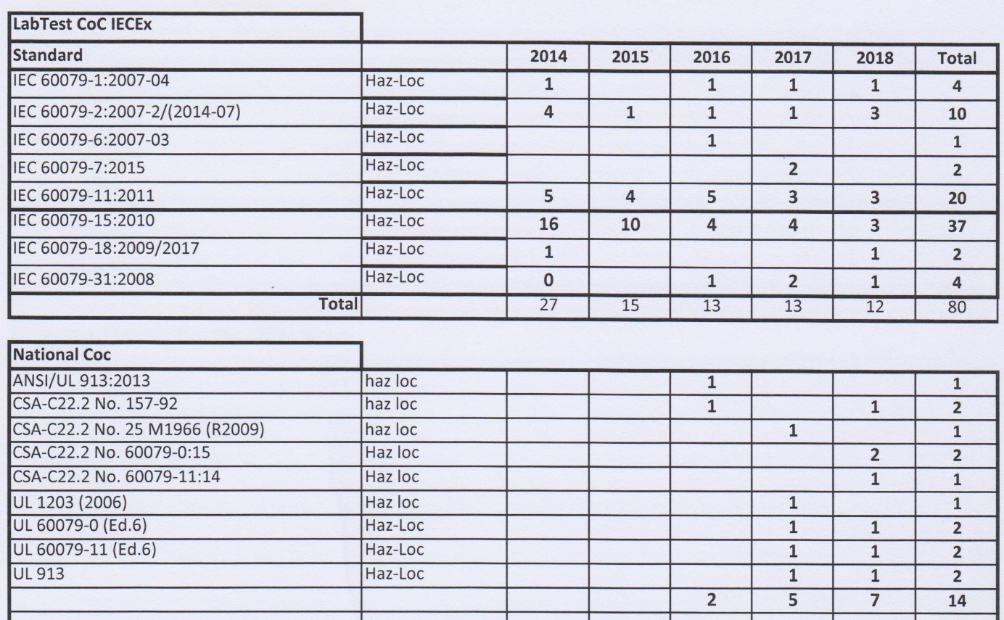

**NOTE Above include certificates to IEC 60079-0 unless otherwise shown**

## National accreditation

LabTest Certification Inc. holds accreditation according to ISO/IEC 17065 from Standards Council of Canada (SCC) under number 10052. The certificate is valid until July 1st, 2020. See the certificate under Annex C.

LabTest Certification Inc. holds an accreditation according to ISO/IEC 17020 from Standard council of Canada (SCC) under number 06018. The certificate is valid until July 1st, 2020. See the certificate under Annex E.

## Assessment of manufacturers and issue of QARs

## DCN 2029 IECEx program. QARs issue according to IECEx 02, OD 009 and OD025.

Five complete files were reviewed during the assessment and found to meet the requirements of the IECEx. Details of the QARs are listed in the on-site assessment report F004.

## Comments (including issues found during assessment)

During the assessment issues were raised concerning the system for documenting of test plans and QAR planning. Detailed information on this is shown in the site assessment report. All issues were resolved to the satisfaction of the assessment team.

# ExTL for IECEx Certified Equipment Scheme

## Assessment references

### General references

1. IECEx02 IECEx Certified Equipment Scheme covering equipment for use in explosive atmospheres – Rules of Procedure
2. IECEx OD003-2 Assessment, surveillance assessment and re-assessment of ExCBs and ExTLs operating in the IECEx 02, IECEx Certified Equipment Scheme
3. IECEx OD009 Issuing of CoCs, ExTRs and QARs
4. ISO/IEC 17025:2005 Edition 2, General requirements for the competence of testing and calibration laboratories
5. IECEx Technical Capability Document (TCD)
6. ExTAG decision sheets (DSs)
7. OD 202 IECEx Certified Equipment Scheme – IECEx Proficiency Testing Program

NOTE The latest editions of the above documents were applied.

### Additional references applied for this assessment

1. OD 280:2016 IECEx Certified Equipment Scheme – Guide to Certification of Non-Electrical Equipment and Protective Systems

## Candidate ExTL persons interviewed

|  |  |
| --- | --- |
| Name | Position |
| Sandeep Bhayana | Vice President Engineering |
| Ruben Urgate | Project Holder |
| Ovidiu Harpa | Project Holder |
| Amandeep Jathaul | Project Holder |
| Eugen Rappa | Project Holder |
| Neelofar Naheed | Project Holder |

## Associated ExCB(s)

The ExTL is integral with the ExCB.

## Organisation

See organisation charts in Annex A & B

### Names, titles and experience of the senior executives

|  |  |  |
| --- | --- | --- |
| Name | Title | Experience |
| Sandeep Bhayana | VP Engineering | [7](mailto:sbhayana@labtestcert.com) years in Ex |

### Name, title and experience of the quality management representative

|  |  |  |
| --- | --- | --- |
| Name | Title | Experience |
| Ruben Ugarte | Quality Manager (Acting, Contractor) | 6 years Certification and Testing, 5 years in Ex systems, 7 years Quality ISO 9001 |
| Kavinder Dhillon | Deputy Quality Manager | 23 years in Ex, 25 years Certification and Testing, considerable managerial experience operating accredited organization. |
| Nasser Mirfassihi | QM in training for IECEx | 23 years in QM |

### Other employees in ExTL activity

|  |  |  |
| --- | --- | --- |
| Name | Title/responsibility | Experience in Ex |
| Sandeep Bhayana | VP Engineering | Review exTR and evaluation. 7 years in Ex. |
| Amandeep Jathaul | Project Holder | Evaluation, testing, 1 years |
| Neelofar Naheed | Project Holder | Evaluation, testing, 3 years |
| Gursher Sidhu | Project Holder | Evaluation, testing, 2 years |
| Eugen Rapa | Test technician | Testing, 6 years |
| Ron Webb | Contractor | Review, training, 35 years in Ex |
| Ruben Ugarte | Project Holder - Contractor | Evaluation, testing, 5 years |
| Ovidiu Harpa | Project Holder | Evaluation, testing, 3 years |

## Organizational structure

See organisation charts in Annex A & B.

## Resources

The assessment team considers that Labtest have sufficient resources to conduct its business. See organisation charts in Annex A & B.

## Test reports issued

Number of test reports (ExTRs) issued under for the preceding four years for each type of protection: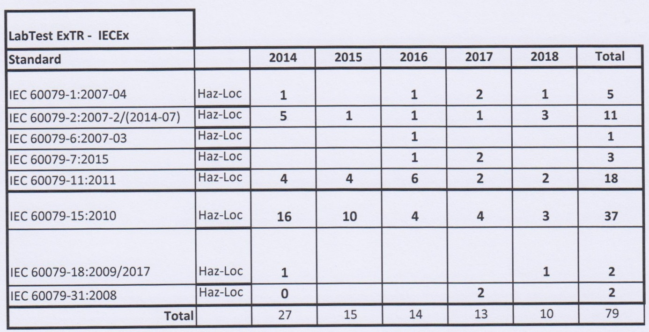

**NOTE 1 Above include reports to IEC 60079-0 unless otherwise shown**

## National accreditation

LabTest Certification Inc. holds accreditation from International Accreditation Service (IAS) for ISO/IEC 17025. The number is TL-367. The certificate is valid until February, 1st 2020. See Annex D for the certificate. Some of the standards in the scope extension will undergo an accreditation assessment by IAS in December 2018.

However, by check of the latest scope of accreditation from IAS TL-367, and although the present scope was extended to 1.2.2020, the standards under the scope extension are still not listed As a result, standards 60079-13, 60079-28, 60079-30-1 and 60079-33 and 60079-46 will require an annual surveillance assessment until these Standards have been included in Labtest’s accreditation.

## Calibration

Calibration is described in DCN 1046. Equipment is calibrated by external calibration suppliers. Calibrations are done by accredited 17025 Calibration Laboratories identified in the “Approved Suppliers Database” under the Approved Suppliers section. There is a calibration database for verification of calibration and information about recalibration. The database was reviewed during the assessment as well as the recalibration process and calibration tags on the instruments. It fulfills the requirements of the IECEx.

Procedures are in place that requires all equipment used in the ExTL to be calibrated before use by 17025 calibration laboratories including borrowed, rented, repaired and similar situations.

## Tests witnessed during the assessment visit-pending

The following tests were witnessed during the assessment visit and to the satisfaction of the assessment team:

**Standard IEC and edition: IEC 60079-0: 2011 Edition 6**

|  |  |
| --- | --- |
| Clause - Number: | Description: |
| Clause 26.4.5 | Degree of protection (IP) by enclosures IPX6 test on enclosure |
| Clause Annex A clause A.3.1.1 | Cable glands with clamping by the sealing ring |

**Standard IEC and edition: IEC 60079-1: 2014 Edition 7**

|  |  |
| --- | --- |
| Clause - Number: | Description: |
| Clause 15.2.2 | Pressure Determination Tests for IIB Enclosure or Motor |

**Standard IEC and edition: IEC 60079-7: 2015**

|  |  |
| --- | --- |
| Clause - Number: | Description: |
| 6.10 | Terminal insulating material tests |

**Standard IEC and edition: IEC 60079-6 2015 Edition** 4

|  |  |
| --- | --- |
| Clause - Number: | Description: |
| Clause 6.1.1 | Overpressure test on sealed enclosures |

**Standard IEC and edition: IEC 60079-2:2015 Edition 6**

|  |  |
| --- | --- |
| Clause - Number: | Description: |
| Clause 6.4.2 | Pressurized enclosure where the protective gas is air |

**Standard IEC and edition: IEC 60079-31:2009 Edition 1**

|  |  |
| --- | --- |
| Clause - Number: | Description: |
| Clause 6.2.1 | Thermal tests for Level of Protection ta |

**Standard IEC and edition: IEC 60079-13:2013 Edition 1**

|  |  |
| --- | --- |
| Clause - Number: | Description: |
| Clause 6.4.5 | Minimum pressure differential test for types of protection px, py and pz |

**Standard IEC and edition: IEC 60079-28:2015 Edition 2**

|  |  |
| --- | --- |
| Clause - Number: | Description: |
| Clause 5.2.2.3 | Ex op Measurement of Optical irradiance |

**Standard IEC and edition: IEC/ISO 80079-36**

|  |  |
| --- | --- |
| Clause - Number: | Description: |
| Annex D | Transferred charge test |

## 

## Participation in IECEx Proficiency Testing Programs-pending

LabTest Certification Inc. has enrolled in the PTP program and will participate in the upcoming test.

|  |  |  |
| --- | --- | --- |
| Year(s) of participation | IECEx Proficiency Testing program | General information about results |
| 2018 | Transmission test | Pending |
| 2018 | Purging test | Pending |

## 

## Comments (including issues found during assessment)

Issues raised in the area of IECEx training, test plan, and QAR documentation, inclusion of more detailed information in CoCs, listing of contractors, use of OD 24 refer to operation, calibration, information of test data sheet, test equipment, performance of test clause and test facility. All issues raised since the site visit have been resolved to the satisfaction of the assessment team.

# Annexes

1. Overall Organisation Chart

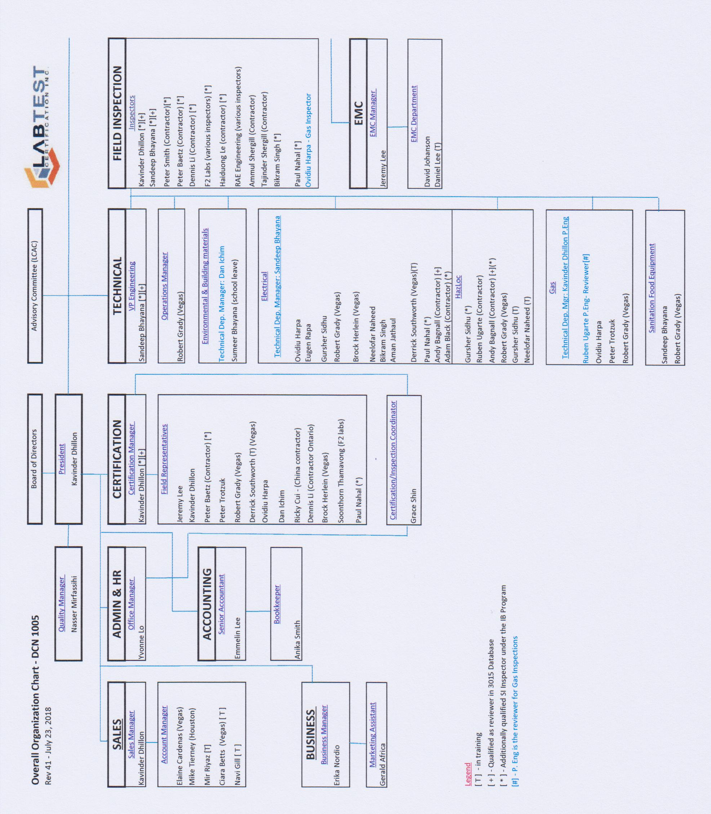

1. Organisation Chart of ExCB and ExTL

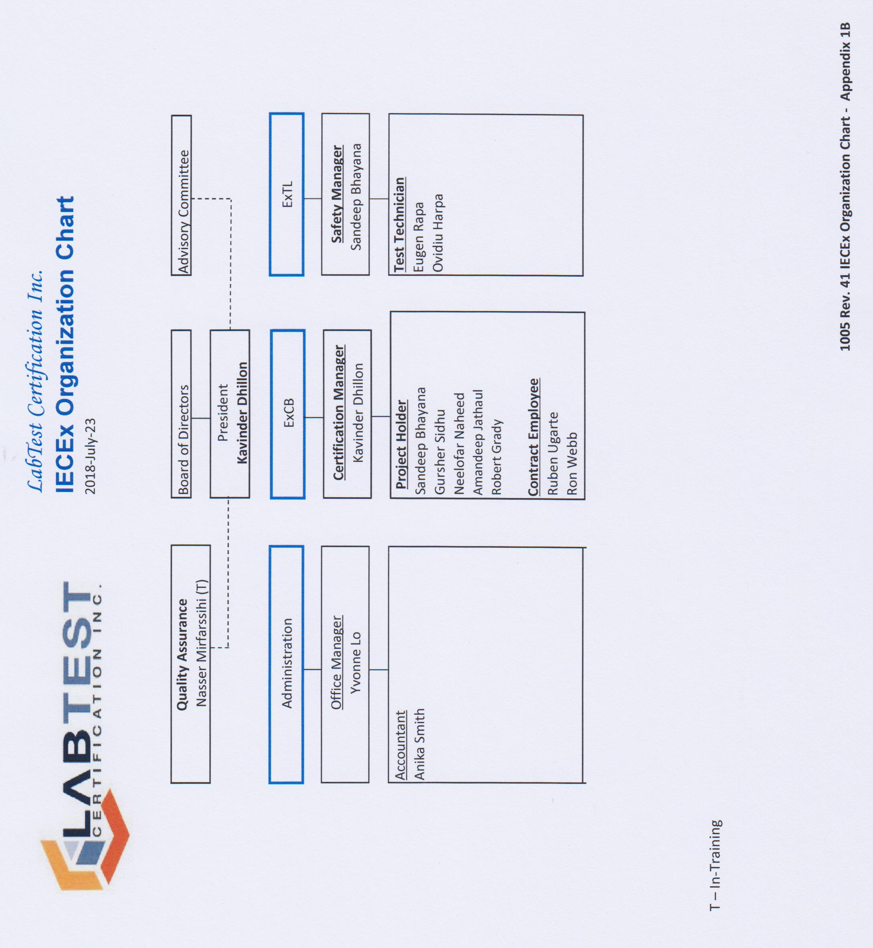

1. Accreditation Certificate for ISO/IEC 17065

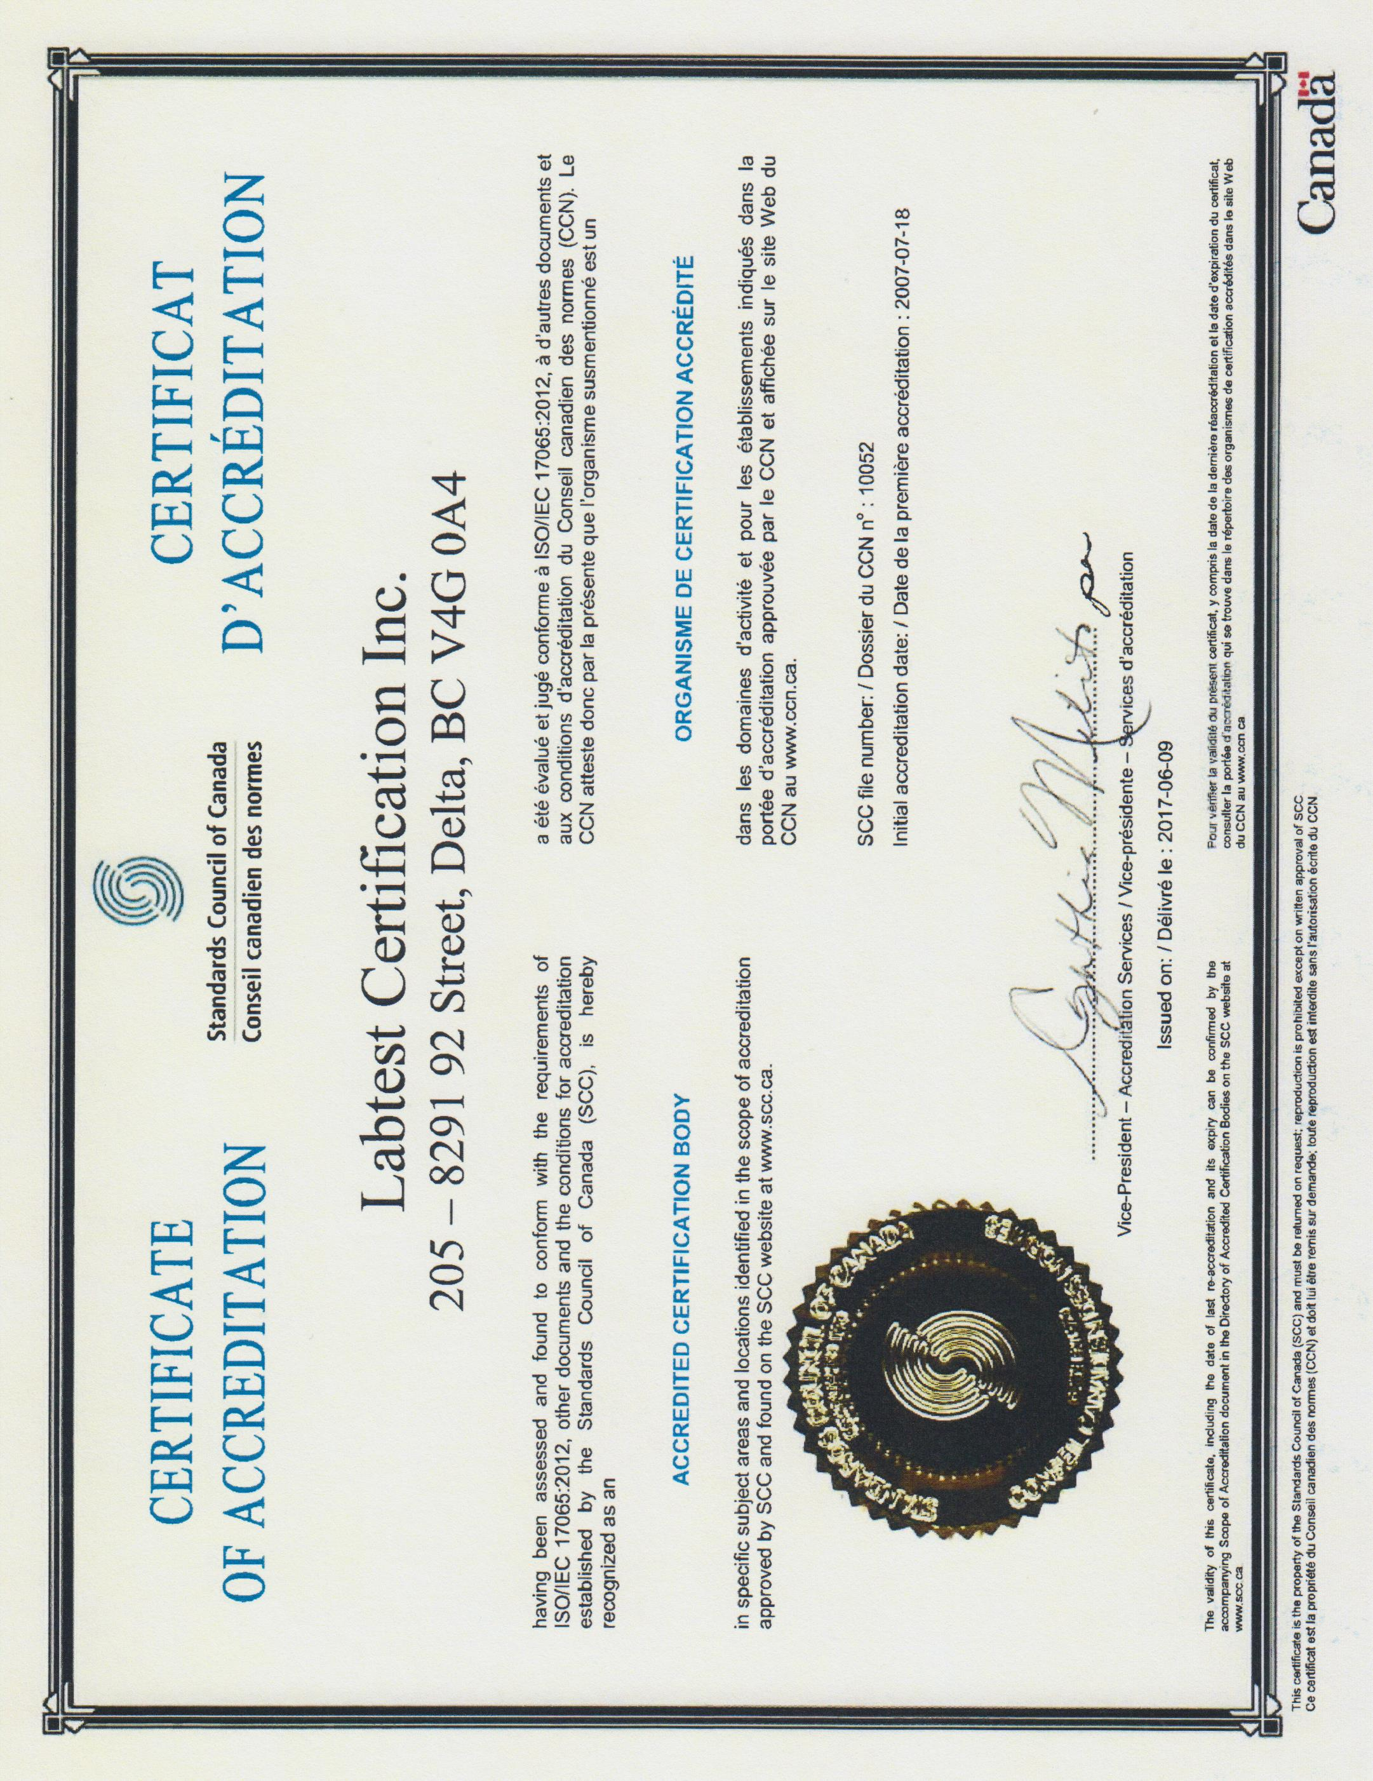

Annex D ISO/IEC 17025 Accreditation

Annex E Accreditation Certificate for ISO/IEC 17020

