INTERNATIONAL ELECTROTECHNICAL COMMISSION (IEC) SYSTEM
FOR CERTIFICATION TO STANDARDS RELATING TO EQUIPMENT FOR USE
IN EXPLOSIVE ATMOSPHERES (IECEx SYSTEM)

Title: Report from Dr Uwe Klausmeyer, Convenor ExTAG WG 10, Proficiency Testing
Circulated to: Ex Testing and Assessment Group (ExTAG)

INTRODUCTION

This document is a report prepared by Dr. Uwe Klausmeyer the Convenor of ExTAG WG10, Proficiency Testing. The report will be presented by Mr. Tim Krause during the ExTAG
Umhlanga Meeting for discussion and consideration.

ExTAG Secretary

Address:  IECEx Secretariat  Level 33 Australia Square  264 George Street  Sydney NSW 2000  Australia  Web: www.iecex.com | ExTAG Secretary  Mr Julien Gauthier  LCIE S.A.  33 Avenue du General Leclerc  92260 Fontenay-aux-Roses  FRANCE  Tel: +33 1 40 95 55 26  Fax: +33 1 40 95 89 37  Email : julien.gauthier@fr.bureauveritas.com

Report of the convenor of ExTAG WG 10 “Proficiency Testing”, Dr. Klausmeyer, for the ExTAG meeting in Umhlanga 2016

- New convenor for the ExTAG WG 10 to be elected

The current convenor of ExTAG WG 10, Mr. Uwe Klausmeyer, wants to retire from his position. Therefore a new convenor needs to be elected. Mr. Klausmeyer suggests to the members of ExTAG WG 10 to nominate Mr. Tim Krause as new convenor.

- Status of the current programs 2015/2016 “Electrostatic Charge” (program 5) and “Intrinsic Safety” (program 6)

Description of the program 5: In the program “Electrostatic Charge”, the quantities selected which are to be compared (measurands of interest), are the surface resistance and the transferred charge (optional). The general routine procedure is described by the standard “Explosive atmospheres – Part 0: Equipment – General requirements” - IEC 60079-0 Edition 6. Furthermore the standard “Explosive atmospheres – Part 32-2: Electrostatics hazards - Tests” - IEC 60079-32-2 deals with the subject of electrostatics. The general routine procedure to determine the surface resistance is described in clause 26.13 of IEC 60079-0 and clause 4.2 of IEC 60079-32-2. The test for transferred charge is described by the standard IEC 60079-32-2, clause 4.11. The measurands of interest are determined with the Test Sample “EC” for six different material samples / components of different substances with various properties for surface resistance and transferred charge.
Per component, two surface resistance tests are performed in accordance to the standards IEC 60079-0 and IEC 60079-32-2 (optional). Furthermore the test for transferred charge is performed for two material samples (optional). Thus, a total of three test series are performed for program “Electrostatic Charge”.
Status of program 5: Phase I of the program is completed and the interim report was published in May 2016. The corresponding PT Workshop was held at PTB in May/June 2016 with 76 participants. Currently, Phase II of the program runs, the schedule of the program is on time. The deadline for repeating the tests and uploading the results of Phase II is the 31st of July, 2016. The final report will be published in August, 2016. Publishing the final report is also the completion of program “Electrostatic Charge - Test Round 2015”.

Description of the program 6: For the program “Intrinsic Safety IS” the general routine procedure is described by the standard “Explosive atmospheres - Part 11: Equipment protection by intrinsic safety "i" “-IEC 60079-11:2011 Edition 6.
During the program “Intrinsic Safety – Test Round 2015” an assessment of Intrinsic Safety has to be performed based on a safety barrier [Ex ia Ga] IIC. Safety barriers are used in a broad application area to separate intrinsically safe (Ex i) circuits from non-intrinsically safe circuits. The barriers limit the power supply (electrical power/energy) towards the hazardous area. It provides an intrinsically safe output circuit with level of protection “ia”. In the program “Intrinsic Safety” no practical tests or measurements are necessary. During the assessment the participants shall uncover non-conformances and inconsistencies, where the requirements of the standards are not fulfilled or the documentation is insufficient. These non-conformances/inconsistencies are the characteristic of interest.
Status of program 6 Phase I of the program is completed and the draft final report was published in May 2016. Due to characteristic of the program “IS”, there is no Phase II. The corresponding PT Workshop was held at PTB in June 2016 with 64 participants. Currently, the coordinator (PTB Ex PT Team) collects remarks by participants to update the report. The final report will be published in August, 2016. Publishing the final report is also the completion of program “’Intrinsic Safety - Test Round 2015”.

- Results of the PTB Ex PT programs “Electrostatic Charge” (program 5) and “Intrinsic Safety” (program 6)

A small excerpt of the results (from the interim report) of program 5 is shown in Figure 1:

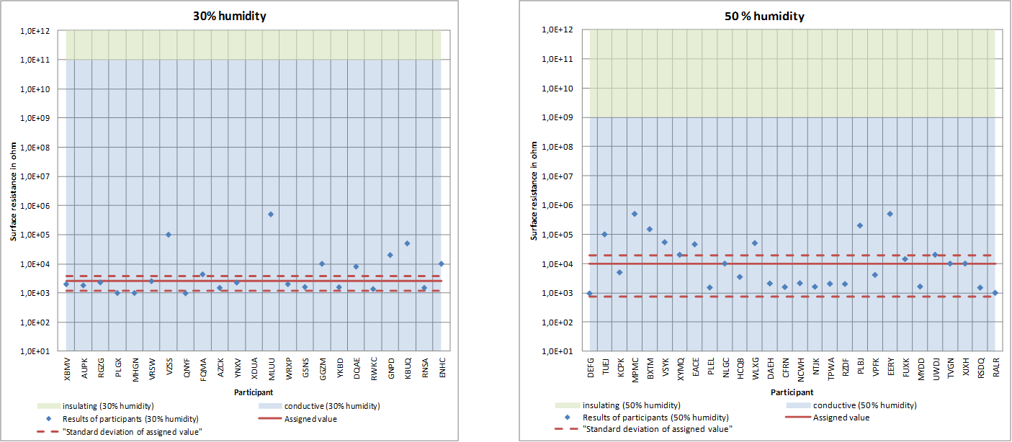
Figure 1: Participant's results with resistance limits for surface resistance test in accordance to IEC 60079-0 on Surface 1 with 30% humidity and 50% humidity
It can be seen that 23 participants perform the tests with 30 % humidity and 28 participants perform the tests with 50 % humidity. In reflecting the complexity of electrostatics, the results are very satisfying, but showing still an improvement potential for several laboratories. Furthermore Figure 1 shows an increased scattering and higher standard deviation at 50% humidity compared to the results at 30 % humidity.
A small excerpt of the results (from the draft final report) of program 6 is shown in Figure 2:

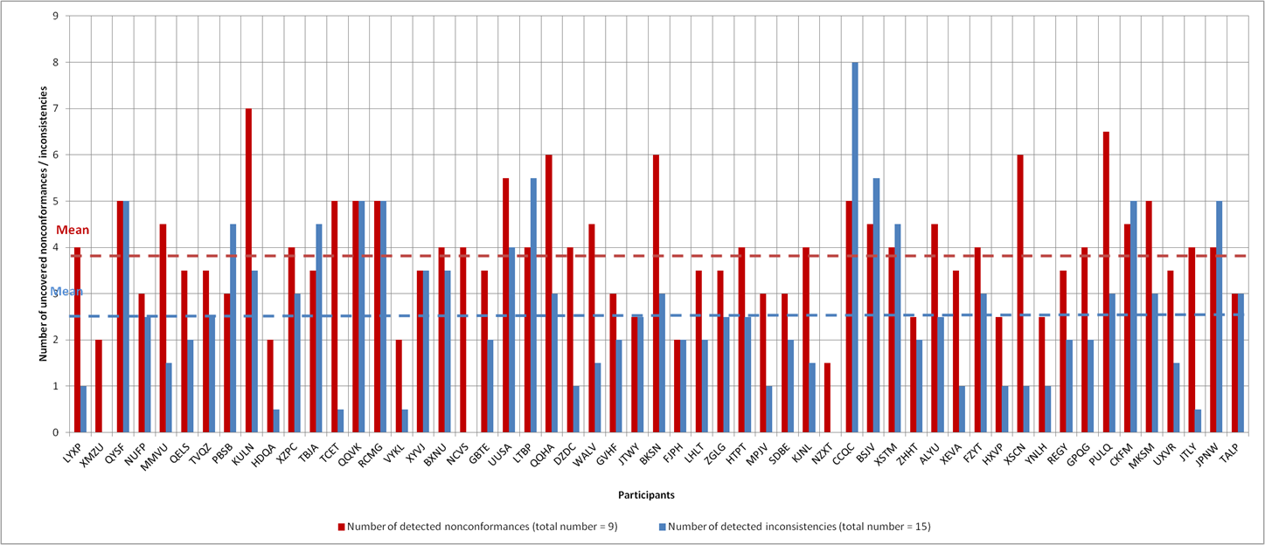
Figure 2: Number of uncovered non-conformances and inconsistencies for each participant
Figure 2 shows the number of uncovered non-conformances and inconsistencies for each of the 55 participants. A total of nine non-conformances and fifteen inconsistencies have been determined. The result of assessment of the sample “IS” barrier was that all participants concluded correctly that the sample IS barrier “Failed” to comply with IEC 60079-11. This is a good result by all participants. However, the existing scattering between the results is (due to the character of the program) caused by a high number of degrees of freedom for potential fault scenarios resp. the related interpretation range and does not indicate any major problem for the competence of the ExTLs.

- Revision of IECEx OD 202 Edition 1 “IECEx Proficiency Testing Program”

One year of working with Edition 1 of the IECEX OD 202 has shown some issues with this document and its implementation in the daily work. A revised draft version is in preparation by the coordinator of the PTB Ex Proficiency Testing Scheme. The draft will be discussed also by the ExTAG WG 10, convening one day before the ExTAG meeting.

- New PT programs of the PTB Ex PTS for the cycle 2017/2018

The coordinator (PTB Ex PT Team) makes a preselection of suggestions (preselection based on what the coordinator is able to develop and organize) for new programs based on questionnaires circulated under the participating laboratories, the PT workshop participants and PTB experts. Based on such suggestions ExTAG WG 10 makes recommendations for new PT programs for approval by the ExMC on a recommendation by the ExTAG.

Draft agenda of the next ExTAG WG 10 meeting

Date and time: Monday, 05th of September, 2016, 05:30 pm
Venue: ?

- New convenor for the ExTAG WG 10
- Status of the current programs “EC” & “IS”
- Presentation of the Results of the PTB Ex PT programs “EC” & “IS”
- Revision of IECEx OD 202 Edition 1 “IECEx Proficiency Testing Program”
- New PT programs of the PTB Ex PTS for the cycle 2017/2018
- Noting of the the 4th revision of the TCD, prepared by the ExMC/WG 2
- Any other business

