INTERNATIONAL ELECTROTECHNICAL COMMISSION (IEC) SYSTEM FOR CERTIFICATION TO STANDARDS RELATING TO EQUIPMENT FOR USE IN EXPLOSIVE ATMOSPHERES (IECEx SYSTEM)

Title: ExTAG/535A/CD Draft ExTAG Decision Sheet - Undercut of internal metric threads in Ex d enclosure.

Circulated to: ExTAG – IECEx Testing and Assessment Group

INTRODUCTION

This document, ExTAG/535A/CD Draft Decision Sheet - Undercut of internal metric threads in Ex d enclosure has been prepared by CQST, CN. And replaces the previous version ExTAG/535/CD as this revised version now includes an additional Figure 2.

ExTAG/535A/CD has been prepared for a 6 weeks circulation comment period, with preliminary discussion to be held during the ExTAG Cannes, France, Meeting.

Please submit comments using the comments table, a separate document by –

2018 10 22

Christine Kane

Julien Gauthier

Julien Gauthier
ExTAG Secretary

Address:  IECEx Secretariat  Level 33 Australia Square  264 George Street  Sydney NSW 2000  Australia  Web: www.iecex.com | ExTAG Secretary  Mr Julien Gauthier  LCIE S.A.  33 Avenue du General Leclerc  92260 Fontenay-aux-Roses  FRANCE  Tel: +33 1 40 95 55 26  Fax: +33 1 40 95 89 37  Email : julien.gauthier@fr.bureauveritas.com

COLLECTION OF IECEx / ExTAG DECISIONS
Standard:  IEC 60079-1: 2014(Ed 7) | Clauses:  13.1
Subject: Undercut of internal metric threads in Ex d enclosure  Status of document: Draft | Key words:  - Cable entry  - threads  - undercut | Date: September 2018  Originator of proposal: CQST

Background:
IEC60079-1 Clause 13.1 indicates that: internal metric threads with a tolerance class of c6H or better according to ISO 965-1 and ISO 965-3, and any chamfer or undercut is limited to a maximum depth of 2 mm from the external wall surface:

In the following figure, explosion-proof product integrated special cable entry, the thread length and the threads engaged are in line with the standard requirements, but only applicable to this product, the relevant cable clamping test, sealing performance and mechanical strength test were done on enclosure.
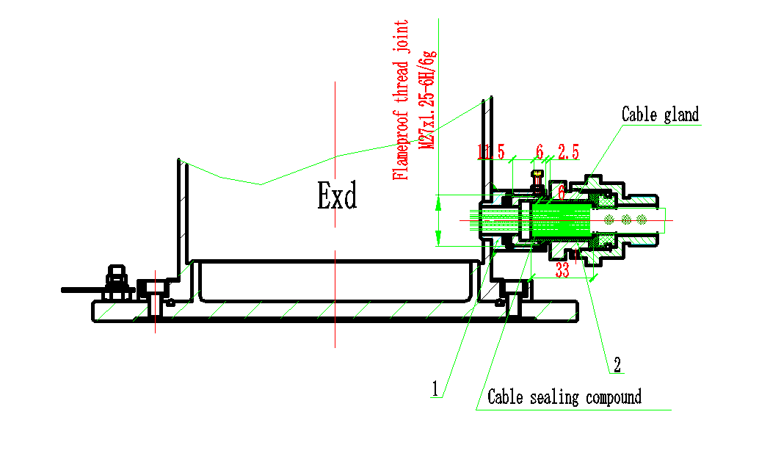
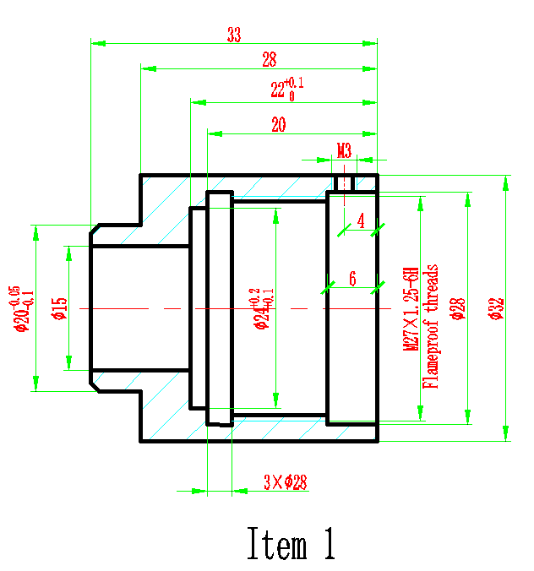

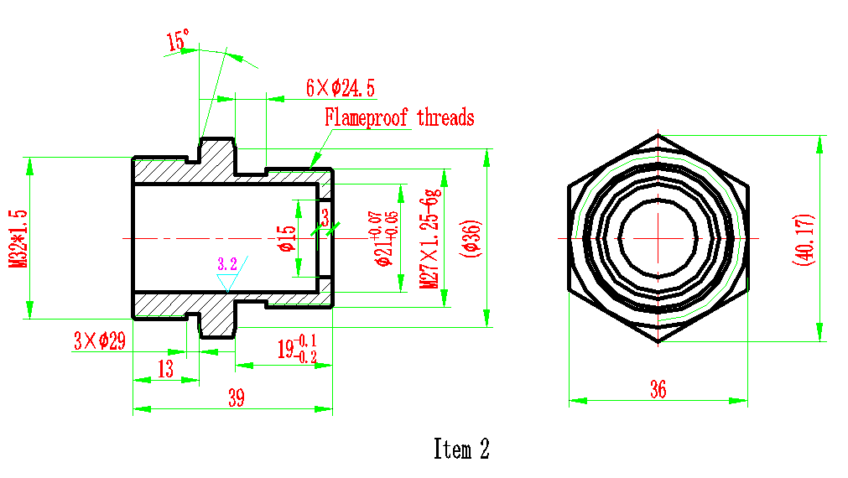
The metric threads of item 1 (M27X1.25-6H) is 6mm at the deepest distance from the outer wall surface, and the item 2 metric thread (M27X1.25-6g) is also 6mm. The engaged length and threads engaged fulfill the requirement.
QUESTION: Is this structure acceptable, since this kind of cable entry is non-replaceable and the certification body can add “X” condition for it’s safe use?
ANSWER:
For this kind of special cable gland, if we make it an “X” condition to indicate it’s non-replaceable, we can accept it.

