INTERNATIONAL ELECTROTECHNICAL COMMISSION IEC SYSTEM FOR
CERTIFICATION TO STANDARDS RELATING TO EQUIPMENT FOR USE IN
EXPLOSIVE ATMOSPHERES (IECEx SYSTEM)

TITLE: Re-assessment and Scope Extension Report for the continued acceptance of Korea Gas Safety Corporation, KGS, an Accepted Certification Body (ExCB), and Accepted Ex Testing Laboratory (ExTL) within the IECEx System, Equipment Scheme 02.

Circulation to: Members of the IECEx Management Committee, ExMC

INTRODUCTION

In accordance with the 5 year re-assessment plan for the surveillance and monitoring of bodies within the IECEx System, this document contains the IECEx Re-assessment and Scope Extension Report for the continued acceptance of Korea Gas Safety Corporation, KGS, as an Accepted Certification Body(ExCB) and an Accepted Ex Testing Laboratory(ExTL) within the IECEx System, Equipment Scheme 02.

During the re-assessment the team also conducted a review and assessment of the ExCB’s capability to include the following standards within its scope.-

ISO 80079-36 Edition 1 Explosive atmospheres – Part 36: Non-electrical Equipment for explosive atmospheres - Basic method and requirements

ISO 80079-37 Edition 1 Explosive atmospheres – Part 37: Non-electrical Equipment for explosive atmospheres – Non-electrical type of protection constructional safety “c”, control of ignition source “b”, liquid immersion “k”

This report covers both the re-assessment and the scope extension for IEC 80079-36 and 37.

Chris Agius

IECEx Secretariat

IECEx Secretariat  Australia Square  Level 33, 264 George Street  Sydney NSW 2000  Australia | Tel: +61 2 4628 4690  Fax: +61 2 46 27 5285  Email: info@iecex.com

IEC System for certification to standards relating to equipment for use in Explosive Atmospheres (IECEx System)

IECEx Assessment Report Form

IECEx Assessment Report Form for use by IECEx Assessment Teams to report Assessments conducted according to the IECEx Assessment Procedures of

- Operational Document IECEx OD003-2 for the Certified Equipment Scheme
- Operational Document IECEx OD316-5 for the Certified Service Facility Scheme
- Operational Document IECEx OD422 for the IECEx Conformity Mark Licensing System

IECEx ExCB/ExTL assessment report for KGS

INTERNATIONAL
ELECTROTECHNICAL
COMMISSION

CONTENTS

1 Assessment information 6
1.1 Type of Body covered by this assessment: <retain appropriate marks> 6
1.2 Type of assessment: <retain appropriate marks> 6
1.3 Details of body 6
1.3.1 Country 6
1.3.2 Name of body 6
1.3.3 Name and title of nominated principal contact 6
1.4 Assessment information 6
1.4.1 Members of the assessment team 6
1.4.2 Place(s) of assessment 6
1.4.3 Assessment date(s) 6
1.5 Application information and background information on the assessment 6
1.6 Scopes 7
1.6.1 ExCB scope for equipment certification scheme 7
1.6.2 ExTL scope 7
1.6.3 ExCB scope for Service Facilities Scheme 8
1.6.4 ExCB scope for ExMark Scheme 8
2 Common information 9
2.1 Legal entity of body 9
2.2 Financial support 9
2.3 History 9
2.4 Documentation 9
2.4.1 Quality manual 9
2.4.2 Procedures 9
2.4.3 Work instructions 9
2.4.4 Records (including test records where relevant) 9
2.4.5 Document change control 10
2.5 Confidentiality 10
2.6 Publications (Hard cover and Electronic) 10
2.7 Recognition and agreements 10
2.8 Internal audit and periodic management review 10
2.9 Contracting, subcontracting, use of other labs and use of other locations 10
2.10 Training and competence 10
2.11 Complaints and appeals (including appeals to IECEx) 11
2.12 Special facts to be noted 11
2.12.1 Scope extension for ISO 80079-36 and ISO 80079-37 11
2.12.2 Supporting documentation 11
2.13 Recommendations 11
3 ExCB for IECEx Certified Equipment Scheme 13
3.1 Assessment references 13
3.1.1 General references 13
3.1.2 Additional references applied for this assessment 13
3.2 ExCB persons interviewed 13
3.3 Associated ExTL(s) 13
3.4 Associated certification functions 13
3.5 National marks and certificates 13
There is a national mark and certificate for 13
3.6 Standards accepted 13
3.7 National differences to IEC standards 14
3.8 Organisation 14
3.8.1 Names, titles and experience of the senior executives 14
3.8.2 Name, title and experience of the quality management representative 14
3.8.3 Name and title of signatories for certification 14
3.8.4 Other employees in ExCB activity 14
3.9 Organizational structure 14
3.10 Administration 14
3.10.1 Administrative structure 14
3.10.2 Indemnity insurance 14
3.11 Resources 14
3.12 Committees (such as governing or advisory boards) 15
3.13 Certification operations 15
3.13.1 National approval/certification methods 15
3.13.2 Certification policy 15
3.13.3 Application for certification 15
3.13.4 Certification decision 15
3.13.5 Suspension and cancellation of certificates 15
3.14 Certificates issued 15
3.15 National accreditation 16
3.16 Assessment of manufacturers and issue of QARs 17
3.17 Comments (including issues found during assessment) 17
4 ExTL for IECEx Certified Equipment Scheme 18
4.1 Assessment references 18
4.1.1 General references 18
4.1.2 Additional references applied for this assessment 18
4.2 ExTL persons interviewed 18
4.3 Associated ExCB(s) 18
4.4 Organisation 18
4.4.1 Names, titles and experience of the senior executives 18
4.4.2 Name, title and experience of the quality management representative 18
4.4.3 Other employees in ExTL activity 19
4.5 Organizational structure 19
4.6 Resources 19
4.7 Test reports issued 19
4.8 National accreditation 20
4.9 Calibration 20
4.10 Uncertainty 20
4.11 Tests witnessed during the assessment visit 20
4.12 Participation in IECEx Proficiency Testing Programs 21
4.13 Comments (including issues found during assessment) 21
5 ExCB for Certified Service Facilities Scheme 22
5.1 Assessment references 22
5.2 ExCB persons interviewed 22
5.3 Organisation 22
5.3.1 Names, titles and experience of the senior executives 22
5.3.2 Name, title and experience of the quality management representative 22
5.3.3 Name and title of signatories for certification 22
5.3.4 Other employees in ExCB activity 22
5.4 Organizational Structure 23
5.5 Resources 23
5.6 Certification operations 23
5.6.1 National approval/certification Methods 23
5.6.2 Application for certification 23
5.6.3 Withdrawal and cancellation of certificates 23
5.7 Statistics 23
5.8 National accreditation 23
5.9 Comments (including issues found during assessment) 23
6 Annexes 24
Annex A Overall Organisation Chart 25
Annex B Organisation Chart of ExCB and ExTL 26
Annex C Accreditation Certificate for ISO/IEC 17065 27
Annex D Accreditation Certificate for ISO/IEC 17025 30

Assessment information

Type of Body covered by this assessment: <retain appropriate marks>
ExCB for IECEx Certified Equipment Scheme | ✓
ExTL for IECEx Certified Equipment Scheme | ✓
ExCB for IECEx Certified Service Facilities Scheme | ✓
ExCB for IECEx Conformity Mark Licensing System

NOTE 1 ExCB - IECEx Certification Body
NOTE 2 ExTL - IECEx Testing Laboratory

Type of assessment: <retain appropriate marks>
Pre-assessment for candidate body
Initial assessment for candidate body
Surveillance
Re-assessment | ✓
Scope extension | ✓

Details of body

Country
Republic of Korea

Name of body
Korea Gas Safety Corporation (KGS)

Name and title of nominated principal contact
Name | Title | E-mail address
Gihoi Kim | General Manager | Kgh0803@kgs.or.kr

Assessment information

Members of the assessment team
Name | Role
Ron Webb | IECEx Lead Assessor
Gordana Ostojic | IECEx Assessor

Place(s) of assessment
1390 Wonjung-ro, Maengdong-myeon, Eumseong-gun, Chungcheongbuk-do, Rep of Korea

Assessment date(s)
20-23 November 2017 and 17 April 2018 (Ron Webb)

Application information and background information on the assessment
Re-assessment and Scope extension

Scopes

ExCB scope for equipment certification scheme
Number | Title | Comments, eg if scope change
IEC 60079-0  Edition 6 | Explosive atmospheres - Part 0: Equipment - General requirements | ✓
IEC 60079-1  Edition 7 | Explosive atmospheres - Part 1: Equipment protection by flameproof  enclosures “d” | ✓
IEC 60079-2  Edition 6 | Explosive atmospheres - Part 2: Equipment protection by pressurized  enclosure «p» | ✓
IEC 60079-6  Edition 4 | Explosive atmospheres - Part 6: Equipment protection by liquid immersion «o» | ✓
IEC 60079-7  Edition 5 | Explosive atmospheres - Part 7: Equipment protection by increased  safety "e" | ✓
IEC 60079-11  Edition 6 | Explosive atmospheres - Part 11: Equipment protection by intrinsic safety “i” | ✓
IEC 60079-15  Edition 4 | Explosive atmospheres – Part 15: Equipment protection by type of protection "n" | ✓
IEC 60079-18  Edition 4 | Explosive atmospheres – Part 18: Equipment protection by encapsulation “m” | ✓
IEC 60079-26  Edition 3 | Explosive atmospheres - Part 26: Equipment with equipment protection  level (EPL) Ga | ✓
IEC 60079-31  Edition 2 | Explosive atmospheres – Part 31: Equipment dust ignition protection by enclosure "t" | ✓
ISO 80079-36  Edition 1 | Explosive atmospheres – Part 36: Non-electrical Equipment for explosive atmospheres - Basic method and requirements | Scope Extension
ISO 80079-37  Edition 1 | Explosive atmospheres – Part 37: Non-electrical Equipment for explosive atmospheres – Non-electrical type of protection constructional safety “c”, control of ignition source “b”, liquid immersion “k” | Scope Extension
NOTE 1 Unless otherwise indicated, earlier editions of standards (even if with a different number) are considered to be covered in the above scope for the purposes of the assessment.
NOTE 2 The above list highlights any extension of scope in the list above for new standards or later editions of standards already in scope.

ExTL scope
The ExTL scope is the same as for the ExCB.

ExCB scope for Service Facilities Scheme
60079-19  Edition 3 | Explosive atmospheres – Part 19: Equipment repair, overhaul and reclamation
Plus the following types of protection | ID
Flameproof Enclosure "d" | d
Increased Safety "e" | e
Type of Protection "n" | n
Pressurisation "p" | p

ExCB scope for ExMark Scheme
Not in scope

Common information

Legal entity of body
KGS is a public body established under Article 28 of the High Pressure Gas Safety Control Law. There is a certificate of registration 133-82-02018 with the Taxation Department for KGS.

Financial support
KGS receives about 40% financial support from the Government. The rest is met from inspection, training, R&D, testing and certification income.

History
Initially established in 1974 with the name KGS being used since 1979.

In 1995, the Institute of Gas Safety Technology was established as an annex research centre.

In 1998, it became an affiliate of the Ministry of Commerce, Industry and Energy, and was designated as a certification body for electrical explosion-proof performance.

In 2003, KGS was accepted in the IECEx Certified Equipment Scheme as an ExCB and an ExTL

In 2012, KGS was accepted in the IECEx Service Facility Scheme as an ExCB.

Documentation

Quality manual
KGS established a comprehensive quality management system to operate Ex certification and testing in accordance with ISO/IEC 17025 and ISO/IEC 17065 with each section numbered Ex-M-xx.
Checklists against ISO/IEC 17025 and ISO/IEC 17065 were prepared and found to meet the requirements of each section.

Procedures
The next level in the system is the procedures which are numbered Ex-P-xx.

Work instructions
The next level in the system is the instructions which are numbered Ex-I-xx.

Records (including test records where relevant)
KGS has established documented procedure Ex-P-13 to specify the requirement on records.
All records related to Ex testing and certification activities are retained a minimum of 10 years in hard copy.

Document change control
Document control is covered in Ex-P-04. All procedures and related documents are in printed form and subject to a document change control process. Document control was reviewed during the assessments and found to meet the requirements of the IECEx.

Confidentiality
Confidentiality is addressed in Ex-M-27. Each staff member is required to sign a confidentiality agreement. The file containing the signed forms was viewed and found to be acceptable in meeting IECEx Requirements.

Publications (Hard cover and Electronic)
There is a magazine that is circulated by KGS every month.

Recognition and agreements
There are mutual recognition agreements in place with a number of bodies including
Baseefa, CSA (Sira) in the UK,
LCIE in France
NANIO CCVE in Russia
NEPSI in China
Simtars in Australia
FTZU in the Czech Republic
PTB, Dekra Exam in Germany
Dekra in the Netherlands
INTERTEK in US
CSA in Canada
IMQ in Italy.

Internal audit and periodic management review
The Internal audit is in Ex-M-14 and Ex-P-14.
The internal audit for 13~15 Feb. 2017 was viewed. It used a lead ISO auditor and a technical expert who is also an external auditor of manufacturers (not in the Ex field). The audit indicates it covers ISO/IEC 17025 and 17020. NCRs were found but not in the Ex department.

The Management review is in Ex-M-15 and Ex-P-15 and which is carried out once a year. The review carried out on 28 April 2017 was viewed and found to meet the requirements of the IECEx.

Contracting, subcontracting, use of other labs and use of other locations
KGS subcontract with KTL for the measurement of screw threads, vibration tests for bi-pin tubes in luminaires, the impact test for Ex e batteries and the charging test in IEC 60079-0. There is no sub-contracting to other bodies. There is a file covering the subcontracting to KTL which shows the tests covered, the relevant accreditation from KOLAS is included in file and there is a signed contract that also includes a confidentiality agreement.

Witness testing requirements are contained in Ex-P-18 Certification and Test.
It was found to use the methods required by OD24.

Training and competence
Training and competence is addressed in Ex-M-17 and Ex-P-16.
The computer system is used to record all external training, duty statements and qualifications.

A plan is developed for internal and external training each year and recorded in a file. The file shows the information about who attended the training and the information about what was covered.
Instruction Ex-I-04 Operating audit addresses the assigning of competency to staff members. Instruction Ex-I-06 Certification of Employee addresses the assigning of competency to staff members.
Ex-P-23 Assuring the Quality also covers how a plan is made for employees

Complaints and appeals (including appeals to IECEx)
Procedure Ex-P-09 addresses appeals, complaints and disputes. It includes specific reference to the potential use of the IECEx Board of Appeal by the ExCB or the applicant. The process is managed by the Quality Manager. There have not been any Ex related complaints.

Special facts to be noted

Scope extension for ISO 80079-36 and ISO 80079-37
Interviews with staff members regarding non-electrical equipment showed that they had a good understanding of the concept and a need an Ignition Hazard assessment to be prepared, usually by the manufacturer in conjunction with KGS.
Although no certificates had been prepared, KGS staff carried out an Ignition Hazard Assessment on an electrically driven pressure pump. The result was reviewed by the assessment team and found to be acceptable. They also prepared a report on the pump using the IECEx templates. Again, this was seen to be acceptable.
It was noted that the requirements of OD 280 had been incorporated into the quality system.

Supporting documentation
Copies of additional supporting information for this assessment have been provided to the applicant and the IECEx Secretariat. These are included in a site assessment report and include:
- Details of issues raised and how these have been resolved
- Checklist for ISO/IEC 17065
- Checklist for ISO/IEC 17025
- Completed TCD
- Photos of the facilities/tests witnessed are included in the TCD
- Assessors’ notes

Recommendations
Based on the assessments performed on 20-23 November 2017 and a further visit on 17 April 2018, which was made to carry out to finalise outstanding issues as well as carry out a further scope extension, KGS is recommended for continued acceptance in the IECEx scheme as:
- An ExCB in the IECEx Certified Equipment Scheme
- An ExTL in the IECEx Certified Equipment Scheme
- An ExCB in the IECEx Certified Service Facilities Scheme
This is according to the scope of the standards listed in this document including the extension of scope.
As the scope extension standards are not yet on the KOLAS accreditation KGS will be subject to annual surveillance by an IECEx assessment team. This first Surveillance visit to be carried out within six months.

Ron Webb | Gordana Ostojic
Lead Assessor | Expert Assessor
Date: 17 April 2018

ExCB for IECEx Certified Equipment Scheme

Assessment references

General references
- IECEx02 IECEx Certified Equipment Scheme covering equipment for use in explosive atmospheres – Rules of Procedure
- OD003-2 Assessment, surveillance assessment and re-assessment of ExCBs and ExTLs operating in the IECEx 02, IECEx Certified Equipment Scheme
- ISO/IEC 80079-34 Edition 1, Explosive atmospheres – Part 34: Application of quality systems for equipment manufacture
- OD009 Issuing of CoCs, ExTRs and QARs
- IECEx Document OD 025 Guidelines on the Management of Assessment and Surveillance programs for the assessment of Manufacturer’s Quality Systems in accordance with the IECEx Scheme
- OD0026 IECEx Certified Equipment Scheme – Guidelines for the qualification of Lead Auditor and Auditors, in accordance with the IECEx System
- ISO/IEC 17065: 2012, Edition 1, General requirements for bodies operating product certification systems Conformity assessment — Requirements for bodies certifying products, processes and services
- IECEx Technical Capability Document (TCD)
- ExTAG decision sheets (DSs)
NOTE The latest editions of the above documents were applied

Additional references applied for this assessment
- OD 280:2016 IECEx Certified Equipment Scheme – Guide to Certification of Non-Electrical Equipment and Protective Systems

ExCB persons interviewed
Name | Position
Gihoi Kim | Department Leader, Quality Manger
Inchoon Park | Manger

Associated ExTL(s)
The KGS ExTL is integral with the ExCB

Associated certification functions
KGS issues certificates for gas appliances; it issues certification to ISO 9001 for all areas; to ISO 14000; and national Ex certification.

National marks and certificates

There is a national mark and certificate for


Standards accepted
See clause 1.6 of this report

National differences to IEC standards
National differences to IEC standards are those listed in the latest version of the IECEx Scheme Bulletin.

Organisation

Names, titles and experience of the senior executives

Name | Title | Experience
JongSam Moon | Director | 32 years at KGS
Gihoi Kim | Department Leader | 22 years at KGS and 10 years in Ex

Name, title and experience of the quality management representative

Name | Title | Experience
Gihoi Kim | General Manager, Ex Testing and Certification Department and Quality Manager | 22 years at KGS and 10 years in Ex

Name and title of signatories for certification

Name | Title | Comments
Gihoi Kim | As above | Kgh0803@kgs.or.kr

Other employees in ExCB activity

Name | Title | Responsibility and Experience in Ex
Inchoon Park | Manger | 7 years at KGS and 6 years in Ex

Organizational structure
The total staff of the ‘Hazardous Locations’ group in KGS is now 11 with two personnel in the ExCB. The most recent change in structure was in January 2015 when the reporting structure of the group was changed and Gihoi Kim became Department Leader of the group in addition to his role as head of the ExCB.
The organisational structures are shown in Annex A and B of this report and also appear in Ex-M-02 of the Manual.

Administration

Administrative structure
See Annex B

Indemnity insurance
KGS indemnity is covered by the government as it is a government agency. In addition it has an indemnity insurance cover for of KRW10,000,000,000. This policy was viewed.

Resources
Principally there are 2 dedicated persons in the ExCB plus additional technical resources used as KGS Audit Resources plus dedicated admin support. These resources cover both the IECEx 02 and 03 Schemes.

Committees (such as governing or advisory boards)
There is an internal audit group for auditing of finances and implementation of policies, compliance with regulations etc. The head of this group is appointed by the Government.
KGS also has a board that covers a range of high level functions, including supervision of finances, approval of major capital expenditure, major policy issues and the structure of KGS. It is not directly involved with certification functions.

Certification operations

National approval/certification methods
There is a national mark and certificate for Ex

Certification policy
The quality policy is defined in the Manual in Ex-M-0B. The policy includes reference to ISO/IEC 17025 and 17065 and specific reference to certification and testing. The policy is signed by the General Manager under delegation from the President.

Application for certification
KGS has an application form for clients to use when applying for IECEx certification. The procedures for dealing with applications for certification are contained in Ex-P-05 Application and contract review. This document defines the responsibilities of the relevant personnel and the scope.
Feedback is obtained in accordance with procedure Ex-P-08 Service to the Client. This is done by means of a questionnaire.
As seen in Annex B, separation between ExCB and ExTL is achieved through the use of different personnel in each area. In addition, as noted earlier, the certification committee also provides an independent role in the certification process.

Certification decision
There is a Certification Committee with its terms of reference defined in the procedure Ex-P-18 Certification and Test (5.5, 6.5). The General Manager is the Chairman of this committee. It comprises minimum 5 members, including the General Manager from KGS and 4 other people both from within and outside the Ex Testing & Certification Service Department. There are no external people.

Suspension and cancellation of certificates
Ex-I-02 Maintenance of Certification Registration addresses suspension, withdrawal and cancellation of certificates and ExTRs. The decision on cancellation is taken by the Certification Committee

Certificates issued
Number of certificates issued under for the preceding four years for each type of protection.
Standard numbers | Type of protection or other identifying information | Number of issued certificates (for last 4 years)
 |  | 2014 | 2015 | 2016 | 2017 | Total
IEC 60079-0 | Explosive atmospheres – Part 0 :  Equipment – General requirements | 20 | 27 | 40 | 19 | 106
IEC 60079-1 | Explosive atmospheres – Part 1 :  Equipment protection by flameproof enclosures “d” | 18 | 24 | 33 | 13 | 88
IEC 60079-2 | Explosive atmospheres – Part 2 :  Equipment protection by pressurized enclosure “p” | 0 | 0 | 0 | 0 | 0
IEC 60079-6 | Explosive atmospheres – Part 6 :  Equipment protection by oil immersion “o” | 0 | 0 | 0 | 0
IEC 60079-7 | Explosive atmospheres – Part 7 :  Equipment protection by increased safety “e” | 12 | 20 | 24 | 11 | 67
IEC 60079-11 | Explosive atmospheres – Part 11 :  Equipment protection by intrinsic safety “i” | 0 | 0 | 0 | 1 | 1
IEC 60079-15 | Explosive atmospheres – Part 15 :  Equipment protection by type of protection “n” | 0 | 1 | 0 | 3 | 4
IEC 60079-18 | Explosive atmospheres – Part 18 :  Equipment protection by encapsulation “m” | 8 | 11 | 20 | 4 | 43
IEC 60079-26 | Explosive atmospheres – Part 26 :  Equipment with protection level (EPL) Ga | 0 | 0 | 0 | 0 | 0
IEC 60079-31 | Explosive atmospheres – Part 31 :  Equipment dust ignition protection by enclosure “t” | 2 | 4 | 6 | 4 | 16
NOTE Above include certificates to IEC 60079-0 unless otherwise shown

National Certificates issued
 | 2014 | 2015 | 2016 | Oct 31 2017 | Total
Ex d | 239 | 428 | 454 | 207 | 1328
Ex p | 31 | 105 | 78 | 76 | 290
Ex e | 137 | 152 | 179 | 112 | 580
Ex i | 0 | 0 | 8 | 5 | 13
Ex n | 33 | 55 | 43 | 52 | 183
Ex m | 0 | 0 | 0 | 5 | 5
Ex t | 88 | 153 | 119 | 76 | 436

National accreditation
The Government authorises KGS to issue National Ex certificates. They also have formal accreditation as a certifying body to ISO/IEC 17065 from the Korea Accreditation System KAS
– See Annex C.

This is valid until 20 April 2021. The scope of accreditation that forms part of the certificate does not explicitly mention Ex activities although section 289 is stated to be relevant for Ex equipment. The scope Category covers sections:
281 – Electrical equipment manufacturing: motor, generator, electrical converter, electrical supply controller manufacturing.
284 – Bulb or lighting fixtures manufacturing: Lighting fixture manufacturing
289 – Other electrical equipment manufacturing: Other electrical equipment manufacturing.
Mechanical (non-electrical) equipment is not mentioned. Therefore, on this basis an annual surveillance assessment is to be carried out.

Assessment of manufacturers and issue of QARs
The manufacturing assessments are generally done by ExCB staff, but use may be made by Ex experts from the ExTL. Staff are also under training as an IECEx assessor of manufacturers. The procedure for this is Ex-I-01 and 04.

Comments (including issues found during assessment)
There were some issues found which were cleared to the satisfaction of the assessment team. These included documentation regarding OD024 and subcontract agreements.

ExTL for IECEx Certified Equipment Scheme

Assessment references

General references
- IECEx02 IECEx Certified Equipment Scheme covering equipment for use in explosive atmospheres – Rules of Procedure
- IECEx OD003-2 Assessment, surveillance assessment and re-assessment of ExCBs and ExTLs operating in the IECEx 02, IECEx Certified Equipment Scheme
- IECEx OD009 Issuing of CoCs, ExTRs and QARs
- ISO/IEC 17025:2005 Edition 2, General requirements for the competence of testing and calibration laboratories
- IECEx Technical Capability Document (TCD)
- ExTAG decision sheets (DSs)
- OD 202 IECEx Certified Equipment Scheme – IECEx Proficiency Testing Program
NOTE The latest editions of the above documents were applied.

Additional references applied for this assessment
a) OD 280:2016 IECEx Certified Equipment Scheme – Guide to Certification of Non-Electrical Equipment and Protective Systems

ExTL persons interviewed
Name | Position
Myonju Choi | Senior Manger
Woosuk Kim | Manager
Jonghyun Kim | Assistant Manager
Heejeong Choi | Assistant Manager
Sooyoung Kwon | Trainee
Seonghun Shim | Assistant Manager

Associated ExCB(s)
The KGS ExCB is integral with the ExTL

Organisation

Names, titles and experience of the senior executives

Name | Title | Experience
JongSam Moon | Director | 32 years at KGS
Gihoi Kim | Department Leader | 22 years at KGS and 10 years in Ex

Name, title and experience of the quality management representative

Name | Title | Experience
Gihoi Kim | General Manager, Ex Testing and Certification Department and Quality Manager | 22 years at KGS and 10 years in Ex

Other employees in ExTL activity

Name | Title/responsibility | Experience in Ex
Changhun Yoo | Technical Manager of ExTL | 22 years at KGS and 9 years in Ex

Organizational structure
See Annex B

Resources
The ExTL has a shared General Manager with the ExCB and eight staff. It is well resourced with test equipment.

Test reports issued
Number of test reports (ExTRs) issued under for the preceding four years for each type of protection.
Standard numbers | Type of protection or other identifying information | Number of issued reports (ExTRs) (for last 4 years)
 |  | 2014 | 2015 | 2016 | 2017 | Total
IEC 60079-0 | Explosive atmospheres – Part 0 :  Equipment – General requirements | 20 | 27 | 40 | 19 | 106
IEC 60079-1 | Explosive atmospheres – Part 1 :  Equipment protection by flameproof enclosures “d” | 18 | 24 | 33 | 13 | 88
IEC 60079-2 | Explosive atmospheres – Part 2 :  Equipment protection by pressurized enclosure “p” | 0 | 0 | 0 | 0 | 0
IEC 60079-6 | Explosive atmospheres – Part 6 :  Equipment protection by oil immersion “o” | 0 | 0 | 0 | 0 | 0
IEC 60079-7 | Explosive atmospheres – Part 7 :  Equipment protection by increased safety “e” | 12 | 20 | 24 | 11 | 67
IEC 60079-11 | Explosive atmospheres – Part 11 :  Equipment protection by intrinsic safety “i” | 0 | 0 | 0 | 1 | 1
IEC 60079-15 | Explosive atmospheres – Part 15 :  Equipment protection by type of protection “n” | 0 | 1 | 0 | 3 | 4
IEC 60079-18 | Explosive atmospheres – Part 18 :  Equipment protection by encapsulation “m” | 8 | 11 | 20 | 4 | 43
IEC 60079-26 | Explosive atmospheres – Part 26 :  Equipment with protection level (EPL) Ga | 0 | 0 | 0 | 0 | 0
IEC 60079-31 | Explosive atmospheres – Part 31 :  Equipment dust ignition protection by enclosure “t” | 2 | 4 | 6 | 4 | 16
NOTE 1 Above include reports to IEC 60079-0 unless otherwise shown

Local Reports - only internal use. These test reports are not issued to the clients:
 | 2014 | 2015 | 2016 | 2017 | Total
Ex d | 239 | 428 | 454 | 207 | 1328
Ex p | 31 | 105 | 78 | 76 | 290
Ex e | 137 | 152 | 179 | 112 | 580
Ex i | 0 | 0 | 8 | 5 | 13
Ex n | 33 | 55 | 43 | 52 | 183
Ex m | 0 | 0 | 0 | 5 | 5
Ex t | 88 | 153 | 119 | 76 | 436

National accreditation
KGS has national accreditation according ISO/IEC 17025 from KOLAS number KT186 (see Annex D). At the time of the assessment visit the scope of this accreditation did not cover the latest editions. The assessment was carried out in Oct 2017.Mechanical (non-electrical) equipment is not mentioned. Therefore, on this basis an annual surveillance assessment is to be carried out.

Calibration
All equipment used to take measurements is calibrated. Calibration is controlled by procedure EX-P-20. The certification is carried out by external laboratories having National Accreditation. Sample certificates were viewed and found to be in accordance with the requirements.

Uncertainty
Procedure EX-P-19 covers uncertainty. It refers to OD012. Sample uncertainty budgets were viewed.

Tests witnessed during the assessment visit
The following tests were witnessed during the assessment visit:
Standard and edition | Clause number | Test | Comments
IEC 60079-1 Ed 7 | 15.2.2.2 | Reference pressure determination | IIC test carried out successfully
IEC 60079-1 Ed 7 | 15.3.3.2 | Non-transmission test | IIC test carried out successfully
IEC 60079-0 Ed 6 | 26.13 | Surface resistance | Test carried out successfully
IEC 60079-18 Ed 4 | 8.1.2 | Dielectric strength Ex m | Test carried out successfully
IEC 60079-0 Ed 6 | 26.4.5.1 | Dust test IP5X/6X | Test carried out successfully
IEC 60079-0 Ed 6 | 26.5.1 | Temperature rise Ex d lamp | Set up in draught proof room. Survey with IR to determine hotspots
IEC 60079-11 Ed 6 | 10.1.3.2 | STA calibration for IIC, 1.5 SF | Calibration successful. Ignition at 240 revolutions

Participation in IECEx Proficiency Testing Programs
Program: PTB Ex PT Scheme

Year(s) of participation | IECEx Proficiency Testing program | General information about results
2010 | Program “Explosion Pressure – Test Round 2010” | Finished - Acceptable
2010 | Program “Spark Ignition – Test Round 2010” | Finished - Acceptable
2013 | Program “Flame Transmission – Test Round 2013” | Finished - Acceptable
2013 | Program “Temperature Classification – Test Round 2013” | Finished – Acceptable following discussions with PT provider
Not participated | Program “Electrostatic Charge – Test Round 2015”
2015 | Program “Intrinsic Safety – Test Round 2015” | Finished - Acceptable
Registered | Program “Explosion Pressure – Test Round 2017” *
Not registered | Program “Pressurized Enclosure – Test Round 2017” *

Comments (including issues found during assessment)
There were some issues that were cleared to the satisfaction of the assessment team.
These included:
the need for clear records of test conditions and measurements
the need to give clarity to test procedures
the provision of full justification where tests are waived

ExCB for Certified Service Facilities Scheme

Assessment references
- IECEx 03-5 IECEx Certified Service Facilities Scheme covering repair and overhaul of Ex equipment – Rules of Procedure
- IECEx OD 313-5, IECEx Certified Service Facilities Scheme – Part 5: Repair, overhaul and reclamation of Ex equipment, Assessment and Certification of Service Facilities involved in the repair, overhaul and reclamation of Ex equipment – Procedures
- IECEx OD 314-5, IECEx Certified Service Facilities Scheme – Part 5: Repair, overhaul and reclamation of Ex equipment, Quality Management System requirements for IECEx Service Facilities involved in the repair, overhaul and reclamation of Ex equipment IECEx
- IECEx OD 315-5, IECEx Certified Service Facilities Scheme – Part 5: Repair, overhaul and reclamation of Ex equipment, Additional requirements for IECEx Service Facilities involved in the repair, overhaul and reclamation of Ex equipment
- IECEx OD 316-5, IECEx Certified Service Facilities Scheme – Part 5: Repair, overhaul and reclamation of Ex equipment, Assessment procedures for IECEx acceptance of Candidate Certification Bodies (ExCBs) for the purpose of issuing IECEx Certificates to Ex Service Facilities involved in the repair, overhaul and reclamation of Ex equipment
- ISO/IEC 17065, General requirements for bodies operating product certification systems
- IEC 60079-19 Explosive atmospheres – Part 19: Equipment repair, overhaul and reclamation
NOTE The latest editions of the above documents were applied

ExCB persons interviewed
Name | Position
Myonju Choi | Senior Manager
Woosok Kim | Manager

Organisation

Names, titles and experience of the senior executives

Name | Title | Experience
JongSam Moon | Director | 32 years at KGS
Gihoi Kim | Department Leader | 22 years at KGS and 10 years in Ex

Name, title and experience of the quality management representative

Name | Title | Experience
Gihoi Kim | General Manager, Ex Testing and Certification Department and Quality Manager | 22 years at KGS and 10 years in Ex

Name and title of signatories for certification

Name | Title | Comments
Gihoi Kim | As above | Kgh0803@kgs.or.kr

Other employees in ExCB activity

Name | Title/responsibility | Experience in Ex
Myonju Choi | Senior Manager | 22 years at KGS and 6 years in Ex
Woosok Kim | Manager | 7 years at KGS and 7 years in Ex

Organizational Structure
See Annex B

Resources
See 3.11

Certification operations

National approval/certification Methods
N/A

Application for certification
KGS has an application form for clients to use when applying for IECEx certification. The procedures for dealing with applications for certification are contained in Ex-P-05 Application and contract review. This document defines the responsibilities of the relevant personnel and the scope.

Withdrawal and cancellation of certificates
Ex-I-02 Maintenance of Certification Registration addresses withdrawal and cancellation of certificates. The decision on cancellation is taken by the Certification Committee

Statistics
KGS have carried out five facilities assessment and issued a certificate during past 2 years for the types of protection shown below
flameproof d
increased safety e
type of protection n
pressurization p

National accreditation
N/A

Comments (including issues found during assessment)
none

Annexes
See Contents. (add,modify or delete annexes as necessary). Please note the following
- Overall Organisation Chart
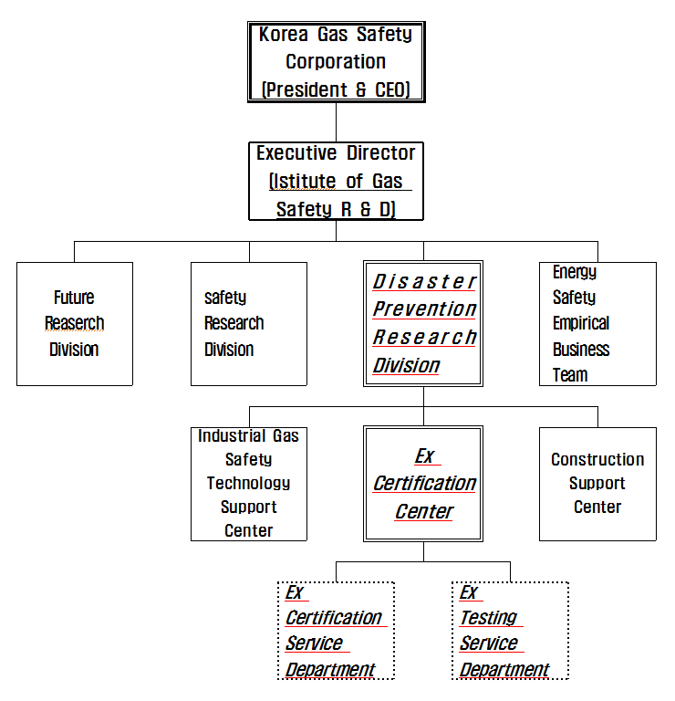
- Organisation Chart of ExCB and ExTL
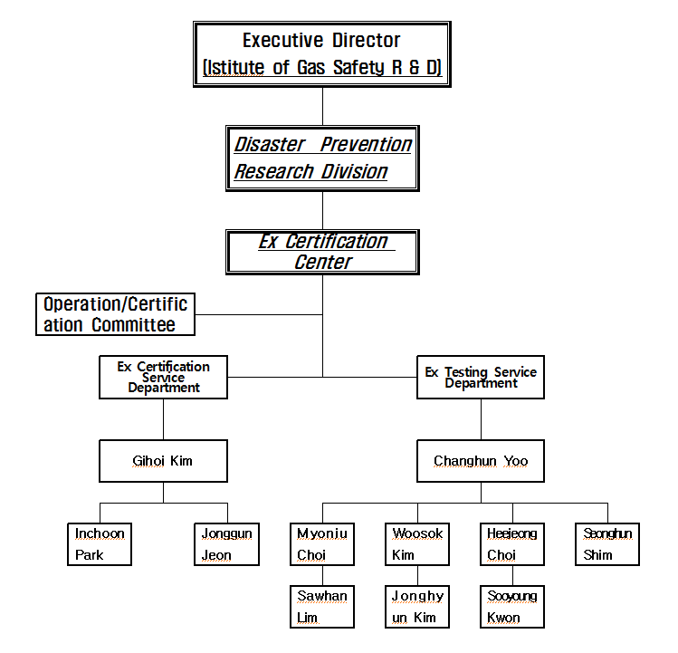
- Accreditation Certificate for ISO/IEC 17065
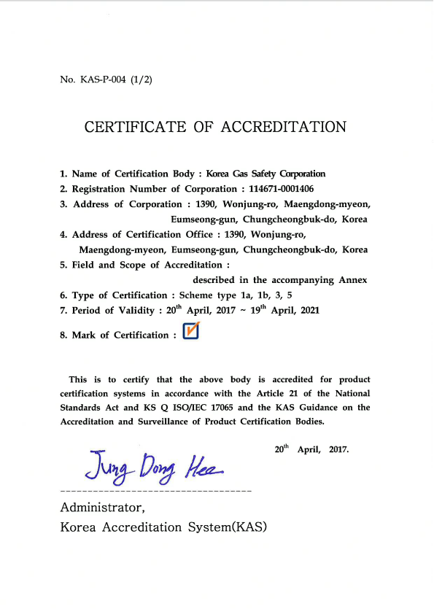
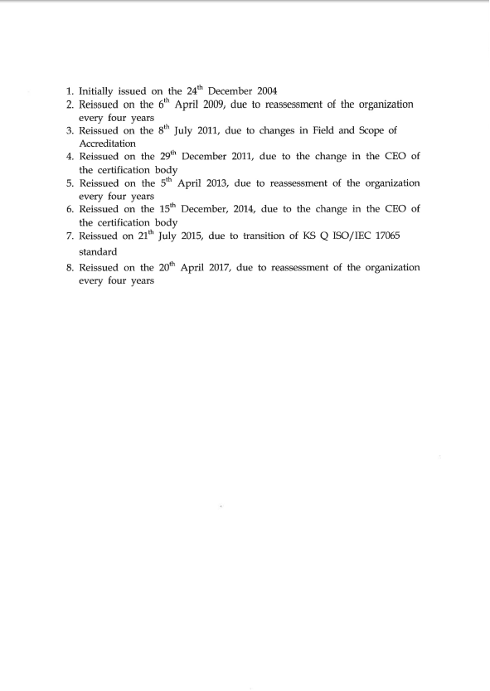
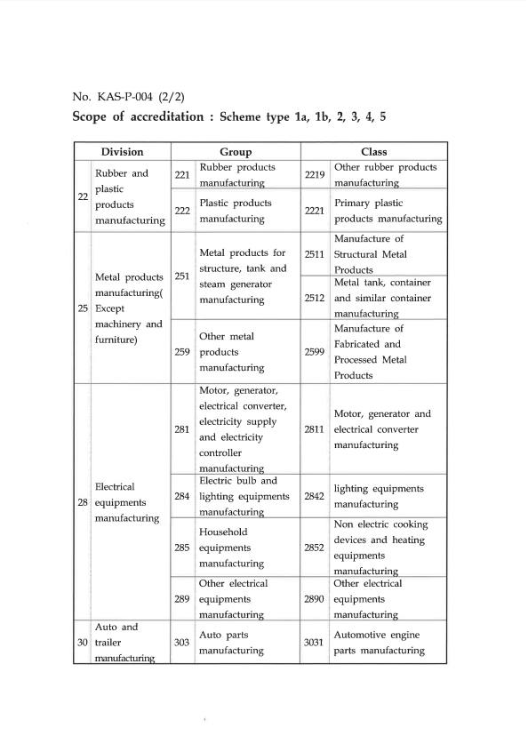
- Accreditation Certificate for ISO/IEC 17025
