INTERNATIONAL ELECTROTECHNICAL COMMISSION IEC SYSTEM FOR
CERTIFICATION TO STANDARDS RELATING TO EQUIPMENT FOR USE IN
EXPLOSIVE ATMOSPHERES (IECEx SYSTEM)

TITLE: IECEx Assessment Report for an extension of scope for Korea Gas Safety Corporation, KGS, an existing Accepted Ex Certification Body (ExCB) and an Accepted Ex Test Laboratory, ExTL, within the IECEx System, Equipment Scheme 02, to include IEC 60079-28, within their scope.

INTRODUCTION

This document contains the IECEx Assessment Report for KGS, KR, an existing Accepted Ex Certification Body (ExCB) and an Accepted Ex Test Laboratory ExTL, within the IECEx System, Equipment Scheme 02, to include IEC 60079-28 within their scope.

The report is hereby submitted for voting by the ExMC.

Please consider the assessment report and return the completed voting form to the Secretariat by

2018 07 30.

Your speedy response to the voting process will be very much appreciated.

Chris Agius

IECEx Secretariat

IECEx Secretariat  Level 33, Australia Square  264 George Street  Sydney NSW 2000  Australia | Tel: +61 2 8206 6940  Fax: +61 2 8206 6272  Email: chris.agius @iecex.com  Web: www.iecex.com

IEC System for certification to standards relating to equipment for use in Explosive Atmospheres (IECEx System)

IECEx Assessment Report Form

IECEx Assessment Report Form for use by IECEx Assessment Teams to report Assessments conducted according to the IECEx Assessment Procedures of

- Operational Document IECEx OD 003-2 for the Certified Equipment Scheme
- Operational Document IECEx OD 016 for the Certified Service Facility Scheme
- Operational Document IECEx OD 022 for the IECEx Conformity Mark Licensing System

IECEx ExCB/ExTL assessment report for KGS scope extension

INTERNATIONAL
ELECTROTECHNICAL
COMMISSION

CONTENTS

1 Assessment information 5
1.1 Type of Body covered by this assessment: <retain appropriate marks> 5
1.2 Type of assessment: <retain appropriate marks> 5
1.2.1 Country 5
1.2.2 Name of body 5
1.2.3 Name and title of nominated principal contact 5
1.3 Assessment information 5
1.3.1 Members of the assessment team 5
1.3.2 Place of assessment 5
1.3.3 Assessment date 5
1.4.1 ExCB scope for equipment certification scheme 6
1.4.2 Additional Standard for ExCB and ExTL scope for equipment certification scheme 7
1.4.3 ExTL Scope…………………………………………………………… 7
2 Common Information.. 8
2.1 Legal entity of body 8
2.2 Financial support 8
2.3 History 8
2.4 Documentation 8
2.4.1 Quality manual 8
2.4.2 Procedures 8
2.4.3 Work instructions 8
2.4.4 Records (including test records where relevant) 8
2.4.5 Document change control 8
2.5 Confidentiality 8
2.6 Publications (Hard cover and Electronic) 8
2.7 Recognition and agreements 9
2.8 Internal audit and periodic management review 9
2.9 Contracting, subcontracting, use of other labs and use of other locations 9
2.10 Training and competence 9
2.11 Complaints and appeals (including appeals to IECEx) 9
2.12 Special facts to be noted 9
2.12.1 Supporting documentation 9
2.13 Recommendations 9
3 ExCB for IECEx Certified Equipment Scheme 10
3.1 Assessment references 10
3.2 Candidate ExCB persons interviewed 10
3.3 Associated ExTL(s) 10
3.4 Associated certification functions 10
3.5 National marks and certificates 10
3.6 Standards accepted in scope extension 10
3.7 National differences to IEC standards 11
3.8 Organisation 11
3.8.1 Names, titles and experience of the senior executives 11
3.8.2 Name, title and experience of the quality management representative 11
3.8.3 Name and title of signatories for certification 11
3.8.4 Other employees in ExCB activity 11
3.9 Organizational structure 11
3.10 Administration 11
3.10.1 Administrative structure 11
3.10.2 Indemnity insurance 11
3.11 Resources 11
3.12 Committees (such as governing or advisory boards) 11
3.13 Certification operations 12
3.13.1 National approval/certification methods 12
3.13.2 Certification policy 12
3.13.3 Application for certification 12
3.13.4 Certification decision 12
3.13.5 Suspension and cancellation of certificates 12
3.14 Certificates issued 12
3.15 National accreditation 12
3.16 Assessment of manufacturers and issue of QARs 12
3.17 Comments (including issues found during assessment) 12
4 ExTL for IECEx Certified Equipment Scheme 13
4.1 Assessment references 13
4.2 Candidate ExTL persons interviewed 13
4.3 Associated ExCB(s) 13
4.4 Organisation 13
4.4.1 Names, titles and experience of the senior executives 13
4.4.2 Name, title and experience of the quality management representative 13
4.4.3 Other employees in ExTL activity 13
4.5 Organizational structure 14
4.6 Resources 14
4.7 Test reports issued 14
4.8 National accreditation 14
4.9 Calibration 14
4.10 Comments (including issues found during assessment) 14
4.11 Tests witnessed 14
Annex A Organisation chart – overall 15
Annex B Organisation chart – ExCB and ExTL 16

Assessment information

Type of Body covered by this assessment: <retain appropriate marks>
ExCB for IECEx Certified Equipment Scheme | ✓
ExTL for IECEx Certified Equipment Scheme | ✓
ExCB for IECEx Certified Service Facilities Scheme
ExCB for IECEx Conformity Mark Licensing System

NOTE 1 ExCB - IECEx Certification Body
NOTE 2 ExTL - IECEx Testing Laboratory

Type of assessment: <retain appropriate marks>
Pre-assessment for candidate body
Initial assessment for candidate body
Surveillance
Re-assessment
Scope extension | ✓
This site assessment is part of the processing of a scope extension request from KGS for inclusion of IEC 60079-28.

Country
Republic of Korea

Name of body
Korea Gas Safety Corporation KGS

Name and title of nominated principal contact
Name | Title | E-mail address
Gihoi Kim | General Manager | Kgh0803@kgs.or.kr

Assessment information

Members of the assessment team
Name | Role (modify as necessary)
Ron Webb | Lead Assessor

Place of assessment
1390 Wonjung-ro, Maengdong-myeon, Eumseong-gun, Chungcheongbuk-do, Rep of Korea

Assessment date
16 April 2018

1.4 Scope

1.4.1 ExCB scope for equipment certification scheme
Number | Title
IEC 60079-0-am1 Ed.3  Ed.3.1  Ed.4.0  Ed.5  Ed.6.0  Ed.7.0 | Explosive atmospheres - Part 0: Equipment - General requirements
IEC 60079-1 Ed.3.2  Ed.4  Ed.5  Ed.6  Ed.7.0 | Explosive atmospheres – Part 1: Equipment protection by flameproof enclosures "d"
IEC 60079-2  Ed.4  Ed.5  Ed.6 | Explosive atmospheres – Part 2: Equipment protection by pressurized enclosure "p"
IEC 60079-6  Ed.3  Ed.4.0 | Explosive atmospheres - Part 6: Equipment protection by liquid immersion "o"
EC 60079-7  Ed.3  Ed.4  Ed.5.0 | Explosive atmospheres - Part 7: Equipment protection by increased safety "e"
IEC 60079-11  Ed.4  Ed.5  Ed.6.0 | Explosive atmospheres – Part 11: Equipment protection by intrinsic safety "i"
IEC 60079-15  Ed.1  Ed.2  Ed.3 Ed.4  Ed.5.0 | Explosive atmospheres - Part 15: Equipment protection by type of protection "n"
IEC60079-18  Ed.1  Ed.2.0  Ed.3  Ed.4.0 | Explosive atmospheres - Part 15: Equipment protection by type of protection "n"
EC 60079-26  Ed.2  Ed.3.0 | Explosive atmospheres – Part 26: Equipment with Equipment Protection Level (EPL) Ga
IEC 60079-31 Ed.1  Ed.2 | Explosive atmospheres - Part 31: Equipment dust ignition protection by enclosure "t"

1.4.2

Additional Standard for ExCB and ExTL scope for equipment certification scheme
Number | Title
IEC 60079-28  Edition 2 | Explosive atmospheres: Part 28: Protection of equipment  and transmission systems using optical radiation
1.4.3 ExTL Scope
The ExTL scope extension sought is the same as for the ExCB.

Common information

Legal entity of body
Not part of this assessment as this is a scope extension assessment. This was covered in the reassessment carried out in November 2017.

Financial support
Not part of this assessment as this is a scope extension assessment. This was covered in the reassessment carried out in November 2017.

History
Not part of this assessment as this is a scope extension assessment. This was covered in the reassessment carried out in November 2017.

Documentation

Quality manual
Not part of this assessment as this is a scope extension assessment. This was covered in the reassessment carried out in November 2017.

Procedures
Procedures for the measurement of optical radiation were seen and found to meet the requirements of the standard. A reporting form was also available.

Work instructions
None specific

Records (including test records where relevant)
Not part of this assessment as this is a scope extension assessment. This was covered in the reassessment carried out in November 2017.

Document change control
Not part of this assessment as this is a scope extension assessment. This was covered in the reassessment carried out in November 2017.

Confidentiality
Not part of this assessment as this is a scope extension assessment. This was covered in the reassessment carried out in November 2017.

Publications (Hard cover and Electronic)
Not part of this assessment as this is a scope extension assessment. This was covered in the reassessment carried out in November 2017.

Recognition and agreements
Not part of this assessment as this is a scope extension assessment. This was covered in the reassessment carried out in November 2017.

Internal audit and periodic management review
Not part of this assessment as this is a scope extension assessment. This was covered in the reassessment carried out in November 2017.

Contracting, subcontracting, use of other labs and use of other locations
No subcontracting for the standard being considered

Training and competence
There is a competency matrix for the IECEx Scheme and relevant staff were seen to be included. Interviews were undertaken with staff to ensure that they had the required level of understanding of IEC 60079-28. These are included in a TCD document which is held by the Secretariat.

Complaints and appeals (including appeals to IECEx)
Not part of this assessment as this is a scope extension assessment. This was covered in the reassessment carried out in November 2017.

Special facts to be noted

Supporting documentation
Copies of additional supporting information for this assessment have been provided to the applicant and the IECEx Secretariat. These include:
- Completed technical capability document (TCD) (partial for IEC 60079-28)

Recommendations
Based on the assessment performed on 16 April 2018, KGS is recommended for the scope extension for IEC 60079-28 in the IECEx scheme as:
- An ExCB in the IECEx Certified Equipment Scheme
- An ExTL in the IECEx Certified Equipment Scheme

Ron Webb
Lead Assessor
Date 16 April 2018

ExCB for IECEx Certified Equipment Scheme

Assessment references
- IECEx02 IECEx Certified Equipment Scheme covering equipment for use in explosive atmospheres – Rules of Procedure
- OD003-2 Assessment, surveillance assessment and re-assessment of ExCBs and ExTLs operating in the IECEx 02, IECEx Certified Equipment Scheme
- OD005-1 IECEx Quality System Requirements for Manufacturers – Part 1: Guidance on the establishment and maintenance of a quality system
- OD005-2 IECEx Quality System Requirements for Manufacturers – Part 2: Audit Checklist. (This is available in a Word format for use by ExCBs)
- ISO/IEC 80079-34 Edition 1, Explosive atmospheres – Part 34: Application of quality systems for equipment manufacture
- OD009 Issuing of CoCs, ExTRs and QARs
- IECEx Document OD 025 Guidelines on the Management of Assessment and Surveillance programs for the assessment of Manufacturer’s Quality Systems in accordance with the IECEx Scheme
- OD0026 IECEx Certified Equipment Scheme – Guidelines for the qualification of Lead Auditor and Auditors, in accordance with the IECEx System
- ISO/IEC 17065, General requirements for bodies operating product certification systems
- IECEx Document OD17 Drawing and documentation guidance
- IECEx Technical Capability Document (TCD)
- ExTAG decision sheets (DSs)
NOTE The latest editions of the above documents were applied

Candidate ExCB persons interviewed
Name | Position
Gihoi Kim | Department Leader, Quality Manger
Inchoon Park | Manger

Associated ExTL(s)
The ExCB is integral with the ExTL

Associated certification functions
Not part of this assessment as this is a scope extension assessment. This was covered in the reassessment carried out in November 2017.

National marks and certificates
Not part of this assessment as this is a scope extension assessment. This was covered in the reassessment carried out in November 2017.

Standards accepted in scope extension
See clause 1.4.2 of this report

National differences to IEC standards
National differences to IEC standards are those listed in the latest version of the IECEx Scheme Bulletin.

Organisation

Names, titles and experience of the senior executives

Name | Title | Experience
Hae Duk Jung | Director | 33 years at KGS
Gihoi Kim | Department Leader | 22 years at KGS and 10 years in Ex

Name, title and experience of the quality management representative

Name | Title | Experience
Gihoi Kim | General Manager, Ex Testing and Certification Department and Quality Manager | 22 years at KGS and 10 years in Ex

Name and title of signatories for certification

Name | Title
Gihoi Kim | Department Leader, Quality Manger

Other employees in ExCB activity

Name
Inchoon Park | Manger | 7 years at KGS and 6 years in Ex

Organizational structure
Included as Annexes A and B

Administration

Administrative structure
Included in Annexes A and B

Indemnity insurance
Not part of this assessment as this is a scope extension assessment. This was covered in the reassessment carried out in November 2017.

Resources
Adequate staffing resources were available

Committees (such as governing or advisory boards)
Not part of this assessment as this is a scope extension assessment. This was covered in the reassessment carried out in November 2017.

Certification operations

National approval/certification methods
Not part of this assessment as this is a scope extension assessment. This was covered in the reassessment carried out in November 2017.

Certification policy
Not part of this assessment as this is a scope extension assessment. This was covered in the reassessment carried out in November 2017.

Application for certification
Not part of this assessment as this is a scope extension assessment. This was covered in the reassessment carried out in November 2017.

Certification decision
There is an appropriate system in place to make the certification decision.

Suspension and cancellation of certificates
Not part of this assessment as this is a scope extension assessment. This was covered in the reassessment carried out in November 2017.

Certificates issued
As yet, KGS have not issued any certificates to this standard. It is being added to the list of standards on the ExCB and ExTL scope to allow correct use of the standard for product which falls within its scope. (e.g. flameproof LED floodlights).

National accreditation
IEC 60079-28 is not at present on the KOLAS Certificate scope. KGS may therefore require annual surveillance.

Assessment of manufacturers and issue of QARs
Not part of this assessment as this is a scope extension assessment. This was covered in the reassessment carried out in November 2017.

Comments (including issues found during assessment)
The staff interviewed had a good understanding of the requirements for optical radiation. This was shown during the demonstration of the use of the equipment..

ExTL for IECEx Certified Equipment Scheme

Assessment references
- IECEx02 IECEx Certified Equipment Scheme covering equipment for use in explosive atmospheres – Rules of Procedure
- IECEx OD003-2 Assessment, surveillance assessment and re-assessment of ExCBs and ExTLs operating in the IECEx 02, IECEx Certified Equipment Scheme
- IECEx OD009 Issuing of CoCs, ExTRs and QARs
- ISO/IEC 17025:2005 Edition 2, General requirements for the competence of testing and calibration laboratories
- IECEx Document OD17 Drawing and documentation guidance
- IECEx Technical Capability Document (TCD)
- ExTAG decision sheets (DSs)
NOTE The latest editions of the above documents were applied.

Candidate ExTL persons interviewed
Name | Position
Gi-hoi Kim | General Manager
Hee-jun Choi | Assistant Manager
In-choon Park | Manager
Woo-suk Kim | Manager
Jong-hyun Kim | Assistant Manager
Chang-hun Yoo | Technical Manager of ExTL

Associated ExCB(s)
The ExCB is integral with the ExTL

Organisation

Names, titles and experience of the senior executives

Name | Title | Experience
Hae Duk Jung | Director | 33 years at KGS
Gihoi Kim | Department Leader | 22 years at KGS and 10 years in Ex

Name, title and experience of the quality management representative

Name | Title | Experience
Gihoi Kim | General Manager, Ex Testing and Certification Department and Quality Manager | 22 years at KGS and 10 years in Ex

Other employees in ExTL activity

Name
Changhun Yoo | Technical Manager of ExTL | 22 years at KGS and 9 years in Ex

Organizational structure
Not part of this assessment as this is a scope extension assessment. This was covered in the reassessment carried out in November 2017.

Resources
Adequate staff resources are available
KGS has appropriate equipment, procedures and competent personnel, to carry out assessment and testing required for optical radiation.

Test reports issued
As yet, KGS have not issued any reports to this standard. It is being added to the list of standards on the ExCB and ExTL scope to allow correct use of the standard for product which falls within its scope. (e.g. flameproof LED floodlights).

National accreditation
IEC 60079-28 is not at present on the KOLAS Testing scope. KGS may therefore require annual surveillance.

Calibration
Not part of this assessment as this is a scope extension assessment. This was covered in the reassessment carried out in November 2017.

Comments (including issues found during assessment)
The staff interviewed had a good understanding of IEC 60079-28

Tests witnessed
A large LED luminaire (c250W), was energised and the optical measuring equipment used to determine the irradiance produced by the luminaire. It was noticed that the irradiance was seen to be at a maximum value a short distance away from the LED source. The tests were considered satisfactory. The staff involved had a good understanding of the concept.

- Organisation chart – overall

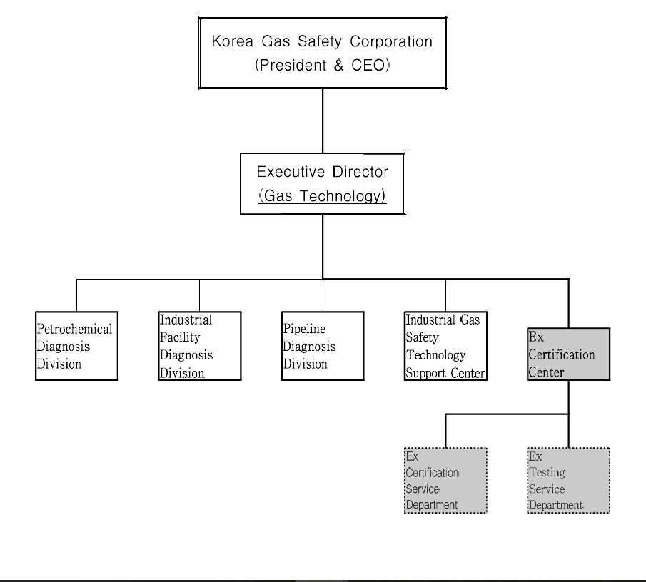
- Organisation chart – ExCB and ExTL

