INTERNATIONAL ELECTROTECHNICAL COMMISSION SYSTEM FOR
CERTIFICATION TO STANDARDS RELATING TO EQUIPENT FOR USE
IN EXPLOSIVE ATMOSPHERES (IECEx SYSTEM)

GENERAL INFORMATION
ON THE MEETINGS OF THE IECEx SYSTEM
to be held at the French Riviera, in Cannes (France)
17 – 21 September 2018

Dear Colleagues

This document contains details relating to the IECEx System Meetings to be held in Cannes (France), 17 – 21 September 2018

Details relating to general information, online meeting registration and accommodation bookings are included.

I thank you in anticipation of your assistance and invite you to contact me should you have any questions relating to the meetings.

Kind regards
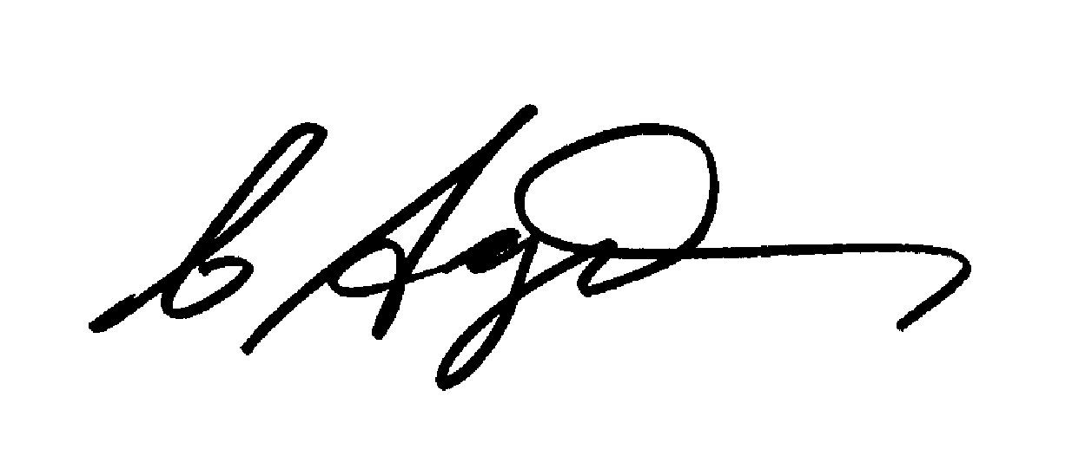
Chris Agius
IECEx Secretariat

Address:  Level 33, Australia Square  264 George Street  Sydney NSW 2000  Australia | Contact Details:  Tel: +61 2 4628 4690  Fax: +61 2 4627 5285  e-mail: info@iecex.com  http://www.iecex.com

ON THE MEETINGS OF THE IECEx SYSTEM
to be held in Cannes (France)
17 - 21 September 2018

MEETING CITY:

This year, the Annual IECEx series of meetings are being held in Cannes on the beautiful French Riviera coast located in the south of France. The meeting venue is located at the Mandelieu Congress Centre (Centre Expo Congrès). The Mandelieu Congress Centre is situated in the Bay of Cannes, between the Mediterranean Sea and the Estèrel mountains in the resort city of Cannes. This city is known for its association with the rich and famous, its luxury hotels and restaurants, and for hosting conferences, including the annual Cannes Film Festival. The Promenade de la Croisette is located nearby the Mandelieu Congress Centre venue and boasts the waterfront avenue known for picturesque beaches, restaurants, cafes and boutiques.

MEETING PLACE:

The meetings will all be held at:

Mandelieu Congress Centre
806 Avenue de Cannes
06210 Mandelieu-la-Napoule
France
Tel: +33 4 92 97 48 30
Website: http://www.frenchrivieraconvention.com/index.php

&

Pullmann Hotel
(*Monday afternoon only)
605 Avenue du Général de Gaulle
BP 50049
6211 Mandelieu La Napoule
France
Tel: +33 4 92 97 70 02
Website: http://www.pullmanhotels.com/gb/hotel-1168-pullman-cannes-mandelieu-royal-casino/index.shtml

MEETING SCHEDULE (draft):

Meetings of the IECEx System: Cannes, France
Meeting Schedule: 17 - 21 September 2018
Date | Meeting | Location
Monday,  17 September 2018 | Assessor Training: Evening**  (14:00 hrs - 16:30 hrs  **Assessors / Applicant Assessors only | *Pullmann Hotel  (note venue)
Monday,  17 September 2018 | ExTAG WG10 Meeting  (17:00 hrs – 18:30 hrs) | *Pullmann Hotel  (note venue)
Tuesday,  18 September 2018 | ExTAG Training Workshop  (09:00 hrs - 13:00 hrs) | Mandelieu Congress Centre
Tuesday,  18 September 2018 | ExTAG Meeting  (14:00 hrs – 17:00 hrs) | Mandelieu Congress Centre
Tuesday,  18 September 2018 | ExTAG Reception: Evening  (17:30 hrs – 19:00 hrs) | Mandelieu Congress Centre
Wednesday,  19 September 2018 | ExTAG Meeting  (09:00 hrs – 17:00 hrs) | Mandelieu Congress Centre
Thursday,  20 September 2018 | ExMC Meeting  (09:00 hrs – 16:00 hrs) | Mandelieu Congress Centre
Thursday,  20 September 2018 | ExMC Dinner: Evening  (18:00 hrs – 22:30 hrs) | Mandelieu Congress Centre
Friday,  21 September 2018 | ExMC Meeting: Full day  (09:00 hrs – 17:00 hrs) | Mandelieu Congress Centre

REFRESHMENTS AND LUNCH:

Please note that while morning tea and after tea breaks will be provided, ExTAG and ExMC delegates are responsible for their own lunch arrangements. There are several facilities in and around the Congress Center where lunch can be enjoyed. The Lunch break on these days will normally be from 12.30 p.m. to 14.00 p.m., except on Thursday due to the earlier adjournment.

HOTEL ROOM ACCOMMODATIONS:

For hotel booking, a web landing page is available where members can book directly. All the hotels are less than 3km from the Congress Center and some of them are walking distance.
The landing page can be accessed at the following address:
http://www.mandelieu-events.com/en/IECEX-69-cgr.html
and the password is : IECEx2018

Reservation Cut-off Date: There is no cut-off date. The system is based on “first in, first served” in the limit of rooms’ availability in each hotel.

MEETINGS REGISTRATION:

Confirm your registration prior to the meetings by completing the online form at
Cannes Meeting site
Once you have registered you will receive an automated e-mail response to your registration. If you have any questions or difficulties relating to the use of the Online System, please do not hesitate to contact the IECEx Secretariat info@iecex.com

For any further questions or details, please feel free to contact the Organising Committee or the IECEx Secretariat, contact details below:

Organising Committee
Mr Pierre Selva
Conformity Assessment & Market Surveillance Director Global Industry & Government Affairs
Schneider Electric
PLM – 2 Chemin des Sources
38050 Grenoble Cedex 9
France

E-mail: pierre2.selva@schneider-electric.com or viviane.jacquin@schneider-electric.com

with a copy to:
IECEx Secretariat
Ms Christine Kane, IECEx Secretariat
Level 33 Australia Square
264 George Street
Sydney NSW 2000 Australia
Tel: +61 2 4628 4690
Fax: +61 2 4627 5285
E-mail: christine.kane@iecex.com

The Registration Desk will be will be located at the Congress centre and available on the following days and times:

Date: | Time:
Sunday, 16 September 2018 | From 14.00 p.m. to 17.00 p.m.
Monday, 17 September 2018 | From 07.30 a.m. to 09.00 a.m.
Tuesday, 18 September 2018 | From 07.30 a.m. to 09.00 a.m.
Wednesday, 19 September 2018 | From 07.30 a.m. to 09.00 a.m.
Thursday, 20 September 2018 | From 07.30 a.m. to 09.00 a.m.
Friday, 21 September 2018 | From 07.30 a.m. to 09.00 a.m.

ExTAG RECEPTION ON 18 SEPTEMBER 2018:

ExTAG delegates and accompanying persons are invited to attend a reception after the ExTAG meetings adjourn.

Date: Tuesday, 18 September 2018
Time: 17.30 hrs - 19.00 hrs
Dress: Business Casual
Venue: Congress Center, close to the meeting room where we have the possibility, if the weather is good, to make on the terrace.

Delegates are asked to indicate whether they will attend the reception when completing the meeting registration form and also advise if there are any special dietary requirements. See “Meetings Registration” area above.

ExMC DINNER ON 20 SEPTEMBER 2018:

ExMC delegates and accompanying persons are invited to attend a dinner after the first day of ExMC meetings adjourn.

Date: Thursday, 20 September 2018
Schedule:

The dinner will be held in the Congress Center from 18:00 pm up to 22:30 pm. No shuttle is organized as the Hotels are in the close vicinity of the Center. We hope great weather to enjoy the terrace.

Dress: Business Casual
Venue: Congress Center

Delegates are asked to indicate whether they will attend the dinner when completing the meeting registration form and also advise if there are any special dietary requirements.

ARRIVAL BY AIR/TRAIN/ROAD:

Getting here, map...
The Congress and Exhibition centre is situated:
- 150 metres from the A8 Autoroute – Exit 40
- 20 minutes by taxi from Nice Côte d’Azur International Airport
- 15 minutes from Cannes Train Station
- 5 minutes from Cannes Mandelieu Airport

Congress and Exhibition Centre - Mandelieu-La Napoule
Boulevard des écureuils - Exit 40 off Autoroute A8.
06210 Mandelieu-La Napoule
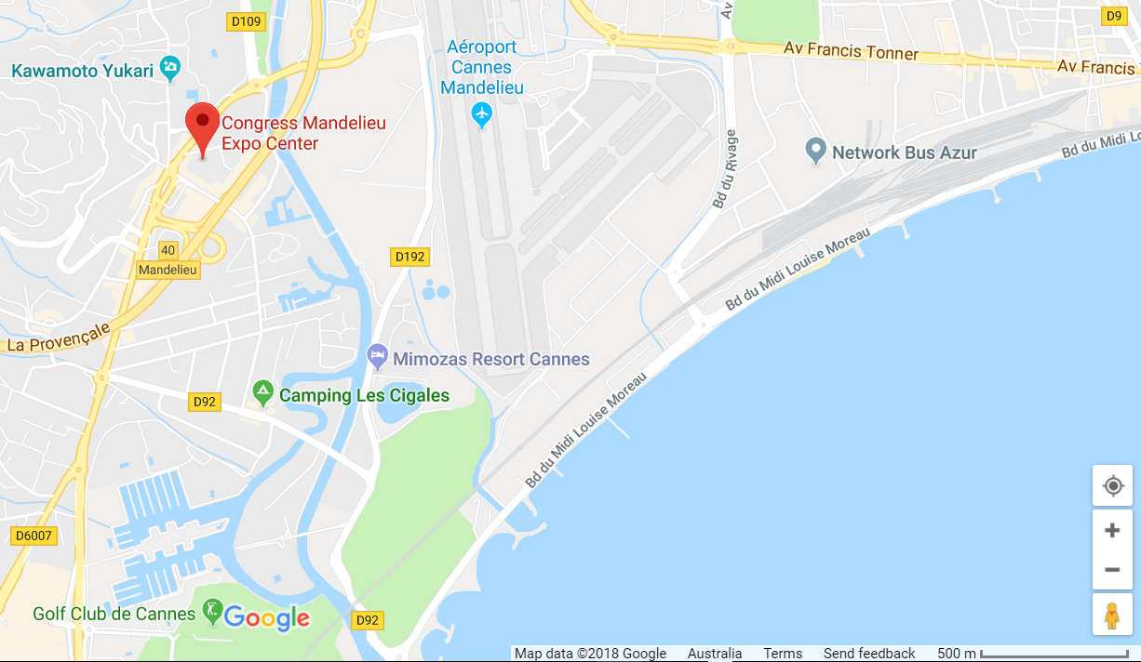

Getting to Mandelieu-La Napoule by train:
A large number of TGV high-speed trains provide a service to Cannes Train Station, 7 km from Mandelieu-La Napoule.
You can then either take a taxi or a bus to get here quickly.
To see train times and fares: www.ter-sncf.com/paca - www.sncf.fr
TER Website >>
Information about buses from Cannes SNCF Train Station:
Cannes Bus Station: 0825 825 599
Mandelieu Bus Station: 04 92 97 29 48 (50 metres from the Congress and Exhibition Centre)
Routes serving Mandelieu-La Napoule centre:
Route 20 (Cannes TGV - SNCF Train Station – Mandelieu-La Napoule centre)
Around 1 bus every 30 minutes
Timetables and map in PDF format: www.palmbus.fr

Cannes Taxi Rank:
- STEEN Denis - +33 (0)6 07 056 444
- Taxi David - +33 (0)6 09 525 425
- PICCIAU Pascal - +33 (0)6 07 141 277
- POLICARO Sébastien - +33 (0)6 09 843 737
Station de taxis Cannes : www.taxicannes.fr

Getting to Mandelieu-La Napoule by plane:
Nice Côte d’Azur International Airport
There are 40 daily flights to Paris, and 85 destinations.
Mandelieu-La Napoule can be reached from the airport in just 30 minutes by bus or by car.
Further information at www.nice.aeroport.fr

Cannes – Mandelieu Airport
Situated 2 minutes from the town centre, open to tourist and business flights.
Information at www.cannes.aeroport.fr

Getting to Mandelieu-La Napoule by bus:
Route 20 Palm Express: (Cannes TGV - SNCF Train Station – Mandelieu-La Napoule centre)
Grande Bretagne au Cannet - Lycée Carnot – SNCF Train Station – Cannes Town Hall - Vallombrosa – Coubertin Stadium - Les tourades - Salle Olympie - Capitou - Mandelieu Bus Station - Marco Polo - Cottage - Av. de la Mer - Cannes Marina - Minelle - L'Argentière - Balcon d'Azur.
Timetables and map: www.palmbus.fr
Route 22:
Along the seafront
Théoule-sur-Mer - Mandelieu-La Napoule - Cannes Coubertin
Horaires ligne 22 au format Pdf >>
Pour venir en Bus depuis l'aéroport de Nice :

To come by bus from Nice Airport:
Nice Côte d'Azur Airport site:
Timetables and fares: www.nice.aeroport.fr
Route 3003: Nice-Côte d'Azur Airport to Fréjus via Mandelieu-La Napoule
Timetables at Varlib.fr
Airport --> Aix - Marseille by the Autoroute and RN7 (L.E.R. 20)
www.info-ler.fr (choose Mandelieu-la Napoule town)

By car:
The Congress and Exhibition Centre is 180 metres from the Mandelieu-La Napoule Exit 40 off Autoroute A8.
You can avoid all the town traffic and congestion.
In addition, there is a free car park with 600 spaces 50 metres from the Congress and Exhibition Centre: the Parking des écureuils.

PARKING:

Car Parks:
Free indoor car park with 530 spaces situated 50 metres away from the Congress and Exhibition Centre.
Please contact your specific contact person about transport and transfers for your event.

ATMs (Automatic Banking Machines):

ATMs are readily available at each of the airports, Congress and Exhibition Centre - Mandelieu-La Napoule and most Hotels

BUSINESS HOURS

Banks are open Mondays to Fridays from 9:00am to 4:00pm.

Shops are generally open Monday to Friday and weekends with times varying from 9:00am to 9:00pm

CLIMATE AND CLOTHING:

September is one of the best times to visit Cannes, France.
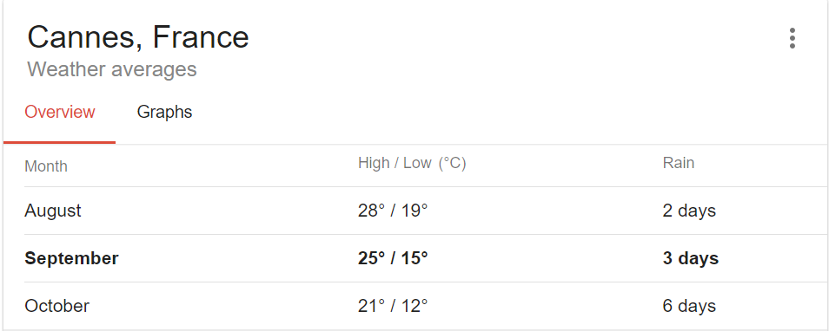

CREDIT CARDS:

Mastercard and Visa credit cards are accepted in all hotels, restaurants and shops. American Express are accepted in most hotels, restaurants and shops.

CURRENCY:
The Euro (€) is the official currency in France. Current exchange rates may be checked via various currency converters on the internet.

TIPPING / GRATUITY:
Tipping in restaurants and bars is not obligatory in France, if you enjoyed the treat given to you, you can leave a tip with any amount of your choice (between 1 and €2 in general).
A small tip can also be given to taxi drivers, deliverymen, the hairdresser or porters at hotels, if you are satisfied with the service.
TIME ZONE:
Summer time is GMT+2 and applies from the last sunday of March to the last sunday of October. Winter time is GMT+1.
ELECTRICITY SUPPLY:
Electricity standards:
- Single phase voltage: 220-230 V / Frequency: 50Hz. These standards are the same as for the rest of Europe, including the UK and Ireland.
- Plug type: Type C. This two-wire plug is ungrounded and has two round prongs. It is popularly known as the europlug. This is probably the single most widely used international plug. It is used in all countries of Europe except the UK, Ireland, Cyprus and Malta.


HEALTH AND FIRST AID:

In case of emergency, contact the reception of the hotel you are booked with.

PASSPORT, VISA AND VACCINATION:

Participants are advised to check their local travel agency about regulations regarding passport, visa and vaccination and, particularly, the length of notice required for obtaining a visa, if required. In case of doubt, information can be obtained from the nearest embassy or consulate.

All foreign nationals who wish to come to France must be able to present at the border regulatory documents indicating the purpose of stay, their livelihood and accommodation conditions.
It is required that you fill out a customs declaration and pay duties and taxes for goods purchased, even reserved for personal use or as presents, if their value exceeds these franchises.
If an invitation letter is required for visa applications, please contact Sandrine Vogt of AFNOR via Email: sandrine.vogt@afnor.org

