INTERNATIONAL ELECTROTECHNICAL COMMISSION SYSTEM FOR CERTIFICATION TO STANDARDS RELATING TO EQUIPMENT FOR USE IN EXPLOSIVE ATMOSPHERES (IECEx SYSTEM)

TITLE: Re-assessment and relocation report for the continued acceptance of SIRA Certification Service, UK, an Accepted Certification Body, (ExCB), within the IECEx System, Equipment Scheme 02.

Circulation to: Members of the IECEx Management Committee, ExMC

INTRODUCTION

In accordance with the 5 year re-assessment plan for the surveillance and monitoring of bodies within the IECEx System, the following document contains the IECEx Re-assessment Report for the continued acceptance of SIRA Certification Service, UK, as an Accepted Certification Body (ExCB).

This report is hereby submitted for endorsement during the ExMC 2016 Meeting being held in Umhlanga, South Africa.

Chris Agius

IECEx Secretariat

IECEx Secretariat  Australia Square  Level 33, 264 George Street  Sydney NSW 2000  Australia | Tel: +61 2 4628 4690  Fax: +61 2 4625 3480  Email: chris.agius@iecex.com
IECEx ASSESSMENT REPORT for SIRA Certification Service, Unit 6, Hawarden Industrial Park, Hawarden, Deeside, CH5 3US, United Kingdom
(IECEx Certification Body, ExCB)

Type of Assessment:

Initial Assessment for Candidate ExCB

Re-Assessment of ExCB X

Re-Location Assessment X

Scope Extension of ExCB

- OBJECT AND FIELD OF APPLICATION

  - Country:

United Kingdom

  - Name of Candidate ExCB

SIRA Certification Service

  - Members of the Assessment Team

Heinz Berger - IECEx Lead Assessor
Heinz Farke - IECEx Expert Assessor

  - Place and Date of Assessment

Sira Certification Service, Unit 6, Hawarden Industrial Park, Hawarden, Deeside, CH5 3US, United Kingdom

July 8th to 10th, 2015

  - Assessment References

- IECEx 02 Equipment Scheme rules
- IECEx 03 Service Facility Scheme rules
- IECEx 04 IECEx Mark Scheme rules
- IECEx OD 003-2 Assessment Procedures (current version)
- IECEx OD 005-2; Manufacturer Assessment (current version)
- IECEx OD 009 Equipment Scheme Procedures(current version)
- IECEx OD 107 Checklist ISO/IEC 17065 (current version)
- IECEx OD 17 Drawings and Documentation(current version)
- IECEx OD 024 Witness Testing/manufacturers and users Facility
- IECEx OD 025 Guidelines Manufacturer Assessments(current version)
- ISO/IEC 80079-34 Application of Quality Systems for Manufacture
- IECEx Document F-001 (QAR Form)
- ISO/IEC 17065:2012

  - Scope of Application
Number | Title | Acceptance
60079-0  Edition 5  Edition 6 | Explosive atmospheres - Part 0: Equipment - General requirements | YES
60079-1  Edition 6  Edition 7 | Explosive atmospheres - Part 1: Equipment protection by flameproof enclosures 'd' | YES
60079-2  Edition 5  Edition 6 | Explosive atmospheres -  Part 2: Equipment protection by pressurized enclosures 'p' | YES
60079-5  Edition 3  Edition 4 | Explosive atmospheres -  Part 5: Equipment protection by powder filling 'q' | YES
60079-6  Edition 3  Edition 4 | Explosive atmospheres -  Part 6: Equipment protection by oil immersion 'o' | YES
60079-7  Edition 4  Edition 5 | Explosive atmospheres -  Part 7: Equipment protection by increased safety 'e' | YES
60079-11  Edition 5  Edition 6 | Explosive atmospheres -  Part 11: Equipment protection by intrinsic safety 'i' | YES
60079-13  Edition 1 | Explosive atmospheres - Part 13: Equipment protection by pressurized room 'p' | YES
60079-15  Edition 3  Edition 4 | Explosive atmospheres -  Part 15: Equipment protection by type of protection 'n' | YES
60079-18  Edition 3  Edition 4 | Explosive atmospheres - Part 18: Equipment protection by encapsulation "m" | YES
60079-25  Edition 1  Edition 2 | Explosive atmospheres -  Part 25: Intrinsically safe systems | YES
60079-26  Edition 2  Edition 3 | Explosive atmospheres -  Part 26: Equipment with equipment protection level (EPL) Ga | YES
60079-27  Edition 1  Edition 2 | Explosive atmospheres -  Part 27: Fieldbus intrinsically safe concept (FISCO) | YES
60079-28  Edition 1  Edition 2 | Explosive atmospheres -  Part 28: Protection of equipment and transmission systems using optical radiation | YES
60079-29-1  Edition 1 | Explosive atmospheres -  Part 29-1: Gas detectors - Performance requirements of detectors for flammable gases | YES
60079-30-1  Edition 1 | Explosive atmospheres - Part 30-1: Electrical resistance trace heating - General and testing requirements | YES
60079-31  Edition 1  Edition 2 | Explosive atmospheres -  Part 31: Equipment dust ignition protection by enclosure "t" | YES
60079-35-1  Edition 1 | Explosive atmospheres -  Part 35-1: Caplights for use in mines susceptible to firedamp - General requirements - Construction and testing in relation to the risk of explosion | YES
61779-1  Edition 1 | Electrical apparatus for the detection and measurement of flammable gases -  Part 1: General requirements and test methods | YES
61779-2  Edition 1 | Electrical apparatus for the detection and measurement of flammable gases -  Part 2: Performance requirements for group I apparatus indicating a volume fraction up to 5% methane in air | YES
61779-3  Edition 1 | Electrical apparatus for the detection and measurement of flammable gases -  Part 3: Performance requirements for group I apparatus indicating a volume fraction up to 100% methane in air | YES
61779-4  Edition 1 | Electrical apparatus for the detection and measurement of flammable gases -  Part 4: Performance requirements for group II apparatus indicating a volume fraction up to 100% lower explosive limit | YES
61779-5  Edition 1 | Electrical apparatus for the detection and measurement of flammable gases -  Part 5: Performance requirements for group II apparatus indicating a volume fraction up to 100% gas | YES
61241-0  Edition 1 | Electrical apparatus for use in the presence of combustible dust –  Part 0: General requirements | YES
61241-1  Edition 1 | Electrical apparatus for use in the presence of combustible dust – Part 1: Protection by enclosures ‘tD’ | YES
61241-1-1  Edition 2 | Electrical apparatus for use in the presence of combustible dust –  Part 1: Electrical apparatus protected by enclosures and surface temperature limitation – Specification for apparatus | YES
61241-4  Edition 1 | Electrical apparatus for use in the presence of combustible dust –  Part 4: Type of protection ‘pD’ | YES
61241-11  Edition 1 | Electrical apparatus for use in the presence of combustible dust –  Part 11: Protection by intrinsic safety ‘iD’ | YES
61241-18  Edition 1 | Electrical apparatus for use in the presence of combustible dust –  Part 18: Protection by encapsulation ‘mD’ | YES
62013-1  Edition 1  Edition 2 | Caplights for use in mines susceptible to firedamp -  Part 1: General requirements - Construction and testing in relation to the risk of explosion | YES
62086-1  Edition 1 | Electrical apparatus for explosive gas atmospheres –  Electrical resistance trace heating – Part 1: General and testing requirements | YES

  - Candidate ExCB Persons Interviewed

Name | Position
Bill Lowe | Manager, International Programs
Alan Myler | Quality Manager
Andy C. Smith | Certification Manager – Ex Products
Wayne Thomas | Manager Accreditations – Europe and Asia
Helen Taft | Certification Manager (Audits)
Nick Blake | Certification Officer
Steve Cork | Manager Testing Laboratories

  - Legal Entity of the Candidate ExCB

Sira Certification Service is a private limited company. It is registered in the UK by Companies House under the registration number 02266287. The legal entity document was reviewed during the assessment and found to meet the requirements of the IECEx.

  - Associated Testing Laboratories

- CSA Group Testing UK Limited, Unit 6, Hawarden Industrial Park, Hawarden, Deeside, CH5 3US.

- Gas Performance Testing Services Limited (ExTL), lnchinnan Estate Renfrew, PA4 9RG, United Kingdom

  - Associated Certification Functions

IECEx 02 Product Certification
IECEx 03 Service Facility Certification
IECEx 05 Competent Person Certification
IECEx 04 Conformity Mark

  - National Marks and Certificates

Sira Certification Services is a Notified Body under the ATEX Directive: NB number is 0518. See Annex 5 for the NB Letter.

  - Financial Support

Sira Certification Service is a wholly owned subsidiary of CSA Certification UK, a holding company owned by CSA Group.

The income of CSA Group Testing UK Ltd is derived solely from its Testing and Certification activities.

The last audited accounts for the year ending March 2015 were seen during the visit and found to meet the requirements of the IECEx.

  - History

Sira Certification Service started issuing nationally accredited certificates in 1982. Sira also issued Certificates of Conformity against European Standards. Recognition as a Notified Body under ATEX (NB No 0518) followed and Sira has been an IECEx CB since August 1999.

From 2005 up until the end of June 2009 the 4 Sira companies, Sira Certification Services, Sira Test and Certification, Sira Environmental Ltd. and Sira Consulting Ltd. were owned by Volvere PLC who are a UK public limited company. In July 2009 the Sira group of companies was bought by CSA Certification UK Ltd which is registered in the UK under the number 06947589. In turn they are owned by CSA (CSA International of Canada).
In April 2014 Sira Consulting Ltd ceased trading. In March 2015 Sira Test and Certification Limited (the ExTL) changed its name to CSA Group Testing UK Limited. The name of the ExCB Sira Certification Services remains unchanged.

  - Standards Accepted

See clause 1.6 of this report.

  - National Differences to IEC Standards

National differences to IEC standards are listed in the latest version of the IECEx Scheme Bulletin.

- ORGANISATION

  - Names, Titles and Experience of the Senior Executives

Name | Title | Experience
I Rippin | Managing Director | 16 year
A C Smith | Certification Manager Ex Products | 13 years
O Hughes | Operations Manager | 5 years
W Thomas | Manager, Accreditations | 15 years

  - Name, Title and Experience of the Quality Management Representative

Name | Title | Experience
A Myler | Quality Manager | 5 years
I Rippin | Managing Director; Deputy Quality Manager | 16 years

  - Name and Title of Nominated Principal Contact

Name | Title | Comments
A C Smith | Certification Manager Ex Products | andy.smith@csagroup.org

  - Name and Title of Signatories for Certification

Name | Title
A C Smith | Certification Manager Ex Products
C Ellaby | Deputy Certification Manager
W Thomas | Certification Manager
N Blake | Certification Officer
P J Walsh | Technical Advisor
R Craig | Certification Officer
A Boyes | Certification Officer

  - Other Employees in ExCB activity

Name | Title | Responsibility and Experience in Ex
Tim Hack | Lead Auditor | Employee auditor  6 Years Ex experience
Alan Wright | Lead Auditor | Employee auditor  2 Years Ex experience
Graham Cutler | Lead Auditor | Associate auditor  15 Years Ex experience
Harry Mitchell | Lead Auditor | Associate auditor  15 Years Ex experience
Mike Jones | Lead Auditor | Associate auditor  7 Years Ex experience
Roger Stillman | Lead Auditor | Associate auditor  15 Years Ex experience
Mark Thomson | Lead Auditor | Associate auditor  2 Years Ex experience
David Ford | Lead Auditor | Associate auditor  12 Years Ex experience
Paul Snider | Lead Auditor | Associate auditor  2 Years Ex experience
Barry Hlushko | Lead Auditor | Associate auditor  1 Year Ex experience
Tom Wang | Lead Auditor | Associate auditor  8 Years Ex experience
Neha Kulkarni | Lead Auditor | Associate auditor  17 Years Ex experience
Justin Jackson | Lead Auditor | Associate auditor  25 Years Ex experience
Lyn Larson | Lead Auditor | Associate auditor  23 Years Ex experience
Tom Feindel | Lead Auditor | Associate auditor  2 Years Ex experience

  - Organizational Structure

See attached organization charts in ANNEX 1a, 1b and 1c

  - Administration (including Indemnity Insurance)

See ANNEX 1b and 1c for the administration of SIRA Certification Services

Sira Certification Service holds Indemnity Insurance from Marsh Canada Limited under the policy # PLB 009730. The current contract is valid from March 1st, 2015 to February 29th, 2016.

The documentation was reviewed during the assessment and found to meet the requirements of the IECEx.

- RESOURCES

A total of (29 engineers, 4 certification officers) 33 employees are directly involved in the product certification activities. A further 6 employees are involved in the Management Systems Certification which covers QMS and EMS and EX/ATEX QAR & QAN activities. A further 2 employees are involved in the Personnel Competence Certification.

There are a further 25 people involved in support and administration activities, trainings, etc.

There are 43 “Associates” who work on a part time basis for Sira as and when required. These Associates are used for a number of different activities. Of those listed, 17 may be used for QAN / QAR audits.

- COMMITTEES / Governing Board / Appeals / Advisory Board

The impartiality of the Sira activities is safeguarded by two impartiality committees:-

- Safety (covering the Explosive Atmosphere products) and Management systems (covering EN45012/ISO17021 QMS and EMS)
- Environmental (covering the MCERTS equipment)

The membership, rules and procedures are contained in section 2.3 of the SCS Quality Manual. There are also procedures in place for the exchange of information between the 3 committees to enable consistency of approach and discussions of common matters.

SCS Safety Impartiality Committee meets twice a year. The membership comprises a user/ installation group, independent auditors/ consultants and 3 manufacturer trade associations with an interest in hazardous area equipment.

All members have signed a confidentiality agreement. The agreements were reviewed during the assessment visit.

The committee have all met recently and detailed minutes of the meetings have been produced and where necessary appropriate actions detailed. The minutes of the last meeting were reviewed during this assessment visit.

The next meeting is scheduled for 3rd November 2015.

- CERTIFICATION OPERATIONS

  - National Approval/Certification Methods

Sira is a registered Notified Body under the European ATEX Directive 94/9/EC as described in URN 04/1805. Notified Body No 0518. The new ATEX directive will be introduced in April 2016.

  - Certification Policy

There is a quality policy in the SCS Quality Manual (clause 1.2) that makes clear reference to of the core aspects of a certification service and it also references the accompanying manuals which include relevant procedures for IECEx certification.

General policies and Procedures are described in the SCS Quality Manual. Specific hazardous area certification procedures are described in the SCS Hazardous Area Product Certification and Assessment Procedures Manual and specific Ex Quality Assurance procedures are described in SCS Ex Quality Assurance Certification Procedures Manual. The procedures were checked and found appropriate.

  - Application for Certification

Application for certification is described in the manual EXHAZ-PART-2---BASIC-PROCESS in clause 2.1, stage 1. The application form carries the number FORM 9118. The application process was reviewed during the assessment and found to meet the requirements of the IECEx.

  - Certification Decision

Certification decision is described in the manual EXHAZ-PART 4 “Certification Procedures” in clause 2.2. The procedure was reviewed during the assessment and found to meet the requirements of the IECEx.

- STATISTICS

  - Certificates Issued

Number of certificates issued under IECEx or the national schemes in the preceding four years for each type of protection:

Standards | Title | Number of issued certificates
 |  | 2012 | 2013 | 2014 | 2015 | Total
60079-0 | Explosive atmospheres - Part 0: Equipment - General requirements | --- | --- | --- | --- | Part 0 included in numbers below
60079-1 | Explosive atmospheres - Part 1: Equipment protection by flameproof enclosures 'd' | 207 | 211 | 176 | 88 | 682
60079-2 | Explosive atmospheres -  Part 2: Equipment protection by pressurized enclosures 'p' | 2 | 5 | 3 | 0 | 10
60079-5 | Explosive atmospheres -  Part 5: Equipment protection by powder filling 'q' | 3 | 4 | 2 | 2 | 11
60079-6 | Explosive atmospheres -  Part 6: Equipment protection by oil immersion 'o' | 0 | 0 | 3 | 0 | 3
60079-7 | Explosive atmospheres -  Part 7: Equipment protection by increased safety 'e' | 145 | 141 | 123 | 57 | 466
60079-11 | Explosive atmospheres -  Part 11: Equipment protection by intrinsic safety 'i' | 159 | 135 | 175 | 78 | 547
60079-13 | Explosive atmospheres - Part 13: Equipment protection by pressurized room 'p' | 0 | 0 | 0 | 0 | 0
60079-15 | Explosive atmospheres -  Part 15: Equipment protection by type of protection 'n' | 24 | 41 | 36 | 25 | 126
60079-18 | Explosive atmospheres - Part 18: Equipment protection by encapsulation "m" | 34 | 39 | 46 | 17 | 136
60079-25 | Explosive atmospheres -  Part 25: Intrinsically safe systems | 0 | 1 | 0 | 0 | 1
60079-26 | Explosive atmospheres -  Part 26: Equipment with equipment protection level (EPL) Ga | 64 | 73 | 85 | 42 | 264
60079-27 | Explosive atmospheres -  Part 27: Fieldbus intrinsically safe concept (FISCO) | 1 | 0 | 0 | 0 | 1
60079-28 | Explosive atmospheres -  Part 28: Protection of equipment and transmission systems using optical radiation | 1 | 9 | 10 | 9 | 29
60079-29-1 | Explosive atmospheres -  Part 29-1: Gas detectors - Performance requirements of detectors for flammable gases | 0 | 0 | 1 | 1 | 2
60079-30-1 | Explosive atmospheres - Part 30-1: Electrical resistance trace heating - General and testing requirements | 15 | 8 | 5 | 13 | 41
60079-31 | Explosive atmospheres -  Part 31: Equipment dust ignition protection by enclosure "t" | 168 | 166 | 146 | 79 | 559
60079-35-1 | Explosive atmospheres -  Part 35-1: Caplights for use in mines susceptible to firedamp - General requirements - Construction and testing in relation to the risk of explosion | 0 | 0 | 0 | 1 | 1
61779-1 | Electrical apparatus for the detection and measurement of flammable gases -  Part 1: General requirements and test methods | 0 | 1 | 2 | 0 | 3
61779-2 | Electrical apparatus for the detection and measurement of flammable gases -  Part 2: Performance requirements for group I apparatus indicating a volume fraction up to 5% methane in air | 0 | 0 | 0 | 0 | 0
61779-3 | Electrical apparatus for the detection and measurement of flammable gases -  Part 3: Performance requirements for group I apparatus indicating a volume fraction up to 100% methane in air | 0 | 0 | 0 | 0 | 0
61779-4 | Electrical apparatus for the detection and measurement of flammable gases -  Part 4: Performance requirements for group II apparatus indicating a volume fraction up to 100% lower explosive limit | 0 | 1 | 2 | 0 | 3
61779-5 | Electrical apparatus for the detection and measurement of flammable gases -  Part 5: Performance requirements for group II apparatus indicating a volume fraction up to 100% gas | 0 | 0 | 0 | 0 | 0
61241-0 | Electrical apparatus for use in the presence of combustible dust –  Part 0: General requirements | --- | --- | --- | --- | Part 0 included in numbers below
61241-1 | Electrical apparatus for use in the presence of combustible dust –  Part 1: Protection by enclosures ‘tD’ | 74 | 27 | 18 | 2 | 121
61241-1-1 | Electrical apparatus for use in the presence of combustible dust –  Part 1: Electrical apparatus protected by enclosures and surface temperature limitation – Specification for apparatus | 0 | 0 | 1 | 0 | 1
61241-4 | Electrical apparatus for use in the presence of combustible dust –  Part 4: Type of protection ‘pD’ | 2 | 0 | 1 | 0 | 3
61241-11 | Electrical apparatus for use in the presence of combustible dust –  Part 11: Protection by intrinsic safety ‘iD’ | 5 | 4 | 5 | 2 | 16
61241-18 | Electrical apparatus for use in the presence of combustible dust –  Part 18: Protection by encapsulation ‘mD’ | 0 | 0 | 0 | 0 | 0
62013-1 | Caplights for use in mines susceptible to firedamp -  Part 1: General requirements - Construction and testing in relation to the risk of explosion | 1 | 0 | 0 | 0 | 1
62086-1 | Electrical apparatus for explosive gas atmospheres –  Electrical resistance trace heating – Part 1: General and testing requirements | 0 | 0 | 0 | 0 | 0

- DOCUMENTATION

  - Quality Manual

The ExCB activities are described in the following manuals:

- SCS (Sira Certification Service)
- Hazardous Area Product Certification and Assessment Procedure Manual
- The procedures for QAR and QAN certification are contained in the ATEX IECEx Quality Assurance Manual Issue 8 dated 2/07/2015.

The SCS DOCUMENTATION STRUCTURE can be seen in the graph below. Within this structure, the Ex Competence Procedures and the Ex Product Procedure sub-manuals are relevant for IECEx activities.

Most documents are controlled and available within SCS by the IT-System called PROQUIS. The issue of controlled documents is to the extent necessary to provide ready access for all appropriate personnel.

The SCS Quality Manual is at issue 44 dated 19/06/2015. The Quality Manual describes the Quality System and consists of 10 sub-manuals. Included in the Quality Manual are descriptions of the organization, its generic policies and objectives relating to quality, and its general operations. The Hazardous Area Product Certification and Assessment Procedure Manual deals with the procedure as described in the IECEx System. The Quality Manuals were reviewed during the assessment and found to meet the requirements of the IECEx.

  - Procedures

The procedures for product certification are contained in the Hazardous Area Procedures Manual, sections 0-9 as follows:

Procedure title | No
Hazardous Area Manual – Part 0 – Introduction | EXHAZ-PART-0 INTRODUCTION
Hazardous Area Manual – Part 1 – Responsibilities | EXHAZ-PART-1 RESPONSIBILITIES
Hazardous Area Manual – Part 2 – Basic process | EXHAZ-PART-2 BASIC PROCESS
Hazardous Area Manual – Part 3 – Assessment report | EXHAZ-PART-3 ASSESS REPORT
Hazardous Area Manual – Part 4 – Certification | EXHAZ-PART-4 CERTIFICATION
Hazardous Area Manual – Part 5 – Consultancy | EXHAZ-PART-5 CONSULTANCY
Hazardous Area Manual – Part 6 – Record keeping | EXHAZ-PART-6 RECORD KEEPING
Hazardous Area Manual – Part 7 – Subcontracting | EXHAZ-PART-7 SUBCONTRACTING
Hazardous Area Manual – Part 8 – Witness testing | EXHAZ-PART-8 WITNESS TESTING
Hazardous Area Manual – Part 9 – IECEx process | EXHAZ-PART-9 IECEX PROCESS

  - Work Instructions

Work instructions needed for certification are included in the procedures mentioned in clauses 7.1 and 7.2 of this report.

PROQUIS (PE) work instructions are issued under the authority of the Quality Manager and are approved by the relevant Manager (which is dependent on the subject of the work instruction).

  - Records

The policy regarding records is detailed in section 3.8 of the SCS Quality Manual.
Details of the required records are contained in the respective manuals. Specific instructions regarding record keeping for the Hawarden site are contained in part 6 of the Hazardous Area Manual (record keeping).

Documents are stored in electronic and/or paper form.

Quality records such as audit reports, corrective and preventative actions and customer complaints have been kept in the PROQUIS system until recently when Sira transitioned this to the CSA records system.

All QAN / QAR audit records are in electronic form.

All historical technical records (prior to April 2014) are kept on the Z: drive of the Sira server in the scanned certificates folder. These are saved by manufacturer and the individual project number. After April 2014 all technical records are retained in “Documentum”, a documentation control system maintained by CSA Group.

  - Document Change Control

Document control and change is described in section 3.7 of the SCS Quality Manual.

Documents such as manuals and standards which regulate the operation of SCS are controlled by the document control centre, which is administered by the Quality Manager.

All SCS documents, including forms and publicity material, are subject to a controlled system of updating and amendment.

Where specific related bodies and associates do not have direct access to the PROQUIS system, updates to documentation which are applicable to their activities, will be sent manually either electronically by e-mail or CD as uncontrolled documents.

A record of the personnel and organisations that hold controlled copies of each Manual is held in the PROQUIS System.

Ongoing control of documentation to auditors and associates will be the responsibility of the appropriate Scheme Certification Manager and/or Company. A distribution list / address folder in the case of electronic e-mail must be maintained and proof of receipt recorded.

Control of standards is achieved by the electronic standards database, IHS, accessible through the CSA Group portal. Standards are labelled as ‘controlled’ or ‘uncontrolled’.

For the updating of standards Sira, through CSA, subscribes to the updating service provided by IHS for all controlled BS, EN, IEC and ISO standards.

Other controlled documents including UKAS and notified body related documents are updated by direct mailing from the issuing authorities or by checking relevant websites.

- CONFIDENTIALITY

Confidentiality is covered by section 3.2 of the SCS Quality Manual. All work is treated as confidential and employee’s contracts incorporate a confidentiality / impartiality statement as a condition of employment. The work is treated as confidential to that client unless otherwise agreed or as required by law.

Staff will ensure that confidential information is not left visible or easily accessible in areas that may be accessible to visitors.

Any other directors, members of SCS committees, associates and subcontractors, are required to sign a confidentiality agreement (SCS forms SCS/SF/011, 003, 010 or Form 3010).

The Associates Agreements also cover confidentiality, independence and integrity. The whole list of employees active in IECEx was available; several agreements were reviewed during the assessment and found to meet the requirements of the IECEx.

- PUBLICATIONS

Publications may either be released via the document control system or via the Marketing department. Technical publications are checked by the relevant technical experts and then released for issue by the Managing Director. General publicity material such as wall charts and training programs are not controlled via the document control systems.

Publications are mainly distributed by the Internet but some are printed.

Information is made available on the Sira website at www.csagroupuk.org, the website includes general and specific information about the certification programs, request for quotation forms etc. There are also links to the ATEX Notified Body Group, clarification sheets and IECEx TAG Decision Sheets.

IECEx CoCs issued by Sira Certification Services can be seen through the link to the IECEx website.

- NATIONAL ACCREDITATION

Sira holds an accreditation according to ISO/IEC 17065, issued by UKAS under the reference # 011 (Certification). See Annex 2 for the accreditation certificate. The scope of accreditation is detailed in the UKAS Product Certification Schedule which is available from the UKAS web site at www.ukas.com

UKAS accreditation certificates are valid as long as the schedule of accreditation is published on the UKAS Website. This means, that they are valid until a possible suspension or withdrawal. The latest certificate was issued on 28th January 2015.

Furthermore, Sira holds accreditations for ISO/IEC 17021 (Quality Systems) and
ISO 17024 (Personnel). The certificates can be seen as Annex 3 and 4.

- RECOGNITION AND AGREEMENTS

SCS maintains recognition agreements with a variety of certification bodies and test laboratories. For IECEx certification, only those that are an ExCB or ExTL are accepted.

- INTERNAL AUDIT AND PERIODIC MANAGEMENT REVIEW

Periodic internal audits are carried out as detailed the SCS Quality Manual Section 3.9.

The Quality Manager is responsible for ensuring that an internal audit programme is carried out at least annually to review the organisation’s compliance with relevant accreditation and Notified Body criteria as well as with its own Quality Manual & Procedures.

Audits are conducted either by the Quality Manager or a suitably qualified and experienced person. The minimum requirements for an internal auditor are that they have attended an appropriate training course or have had at least one year’s auditing experience.

Audits cover the requirements specified in the Quality Manual and relevant Procedures documents. In addition random audits of any area may be undertaken if the Managing Director or Quality Manager considers them necessary.

The performance of tasks carried out directly by the Quality Manager is audited by a competent person independent of the function being.

The audit programme was managed by using the Audit Module of the PROQUIS Management System. This is now undertaken in the CSA Group system. Results of audits are recorded by the auditor, together with any nonconformities and resulting actions. The system informs the appropriate person of the agreed non conformance/action with an appropriate timescale for completion. The auditor records a summary of the audit with general observations, conclusions and recommendations as appropriate. The Quality Manager/auditor will verify completion of the agreed corrective action.

The internal audit plan for 2015 as well as audits records were reviewed during the visit. Audits are being carried out, appropriate details are recorded and findings from the audits are addressed in an appropriate manner. The requirements of the IECEx are fulfilled.

Regarding Management Review meetings, two meetings per year are planned according to their procedure. The last management review was performed on November 19th, 2014. The minutes of the meeting were reviewed during the assessment and found to meet the requirements of the IECEx. The next meeting is foreseen in July 2015.

- SUBCONTRACTING, USE OF OTHER LABS AND USE OF OTHER LOCATIONS

Sira uses the following subcontractors and contractors:

EXOVA, Manchster M50 1RE, UK (IEC 60079-0, clause 26.10.2);
CSA Group, Toronto, Ontario M9W 1R3, Canada (IEC 60079-1, clause 19.3.2); IEC 60079-7, clauses 6.3.3, 6.4, 6.3.5 and 6.3.6);

Dekra EXAM, 44809 Bochum, Germany (IEC 60079-7, clause 6.6.4);

TÜV NORD CERT GmbH, 30519 Hannover, Germany (IEC 60079-28, clause 5.2.5);

PTB, Bundesallee 100, 38116 Braunschweig, Germany (IEC 60079-0, clause 26.14; IEC 60079-7, clauses 6.2.3 and 6.3.4.3.2; IEC 60079-15, clauses 11.3.4.3.3 and 22.13;

IEC 80079-34: 10 auditors as contractors for QARs.

Details are mentioned in the list subcontractors and contractors as part of the on-site assessment report.

The certification decision is not Sub-contracted. This is stated in section 2.2 of the Hazardous Areas Manual part 4 – certification.

Sub-contractors may be used for testing as detailed in the respective procedures manuals for quality assurance certification and product certification procedures.

- TRAINING

Training and competence records are maintained by the Quality Manager. Training requirements and competence levels are defined in the SCS Quality Manual, Section 2.12 and in the Hazardous Area Manual and ATEX / IECEx Quality Assurance Manual.

For the assessment engineers and certification personnel the following levels are defined: undergoing training, good basic working knowledge, competent, technical expert (can sign off reports at this level), expert and not requiring supervision. These are shown in a spreadsheet for each staff member against the relevant standards. Review is typically done annually but may be more or less frequently.

The test laboratory runs a separate system to document the competency of its staff. There is a spreadsheet that breaks down competencies by tests within standards. Staff members’ competencies range from not defined to shown as competent, under training, fully competent and expert. The spreadsheet is generally updated once a year. New starters undergo a three day training course in Ex. After that most training is on-the-job.

Training is carried out on as-needs basis rather than through formal training plans. There is induction training for new staff and much of training is on-the-job, often through the use of mentors. Each person has a personnel file which includes copies of any qualifications.

- ASSESSMENT OF MANUFACTURERS AND ISSUE OF QAR’S

Assessment of manufacturers is carried out using the ATEX / IECEx Quality Assurance Manual. This manual defines the competency requirements, including auditing and Ex expertise relevant to the Ex audit process. The procedure also includes the detailed procedures from OD009 made relevant to Sira.

The competency of assessors is recorded on individual files. Auditors undergo evaluation audits witnessed by QAR responsible staff.

The following QARs and associated certificates, where relevant were reviewed:

IECEx SIR QAR 06.0018/06; Manufacturer in UK, protection types “d”, “e” and “t”.

IECEx SIR QAR 15.0003/00; Manufacturer in the P.R. of China, protection type “n”

IECEx SIR QAR 15.0007/00; Manufacturer in Taiwan, protection type “is”

The QAR process is well understood and the QARs reviewed are in best order, hence fulfill the requirements of the IECEx.

- COMPLAINTS AND APPEALS (Including appeals to IECEx)

The policy regarding complaints is detailed in section 3.10 of the SCS Quality Manual and appeals are covered by section 3.13.

All complaints were recorded in the “PROQUIS” System maintained by the Quality Manager, now maintained in the CSA Group system, with each complaint being given a unique reference number. The entry is controlled via CSA procedure DQD 306 – handling customer complaints.

Information regarding the handling of complaints and appeals is published on the Sira web site, www.csagroupuk.org.

The complaints database was reviewed during the visit. There have not been complaints made to Sira concerning Ex.

- SPECIAL FACTS TO BE NOTED

  - Supporting Documentation

Copies of additional supporting information for this assessment have been provided to the applicant and the IECEx Secretariat. These include:

- Details of issues raised and how these have been resolved
- Competence Matrix
- List of Subcontractors and Contractors
- Checklist for ISO/IEC 17065

- COMMENTS (Including issues found during assessment)

During the whole assessment, Mr. Alex Penfold, Senior Assessment Manager for UKAS, was present as observer.

In parallel to the IECEx 02, 03 and 04 assessments, IECEx 05 was audited by Thierry Houiex.

During the assessment the activities of Sira in the IECEx 03 Scheme (Service Facilities) were reviewed. Procedures were checked as well as the assessment report IECEx SIR S0023-0, Facility in Thailand, for protection types “d”, “e” and “n”. The requirements of the IECEx are fulfilled.

During the assessment the IECEx Mark procedures were reviewed and found to meet the requirements of the IECEx.

Several non conformances were found in the area of subcontracting and contracting documentation and the recording of preparation of test plans. The competency matrix also required finalizing.

Actions taken by SCS were reviewed as part of post site assessment review and found to comply with the requirements of IECEx, enabling the assessment team to close out the Non conformances raised.

They were all resolved to the satisfaction of the assessment team.

- RECOMMENDATION

Based on the re- and relocation assessment performed from July 8th to 10th^{th}, 2015, the ExCB of SIRA Certification Services, Deeside, UK, is recommended for continued acceptance in the IECEx System (IECEx 02, 03, 04) as an IECEx Certification Body (ExCB) according to the scope of standards listed in this document.

Lead Assessor  Heinz Berger | Expert Assessor  Heinz Farke
Date: June 27th, 2016

List of Annexes:

Annex 1a: Overall Organization Chart of CSA Group Europe Holdings UK Ltd.
Annex 1b: Organization Chart of the ExCB and related ExTLs
Annex 1c: Detail Organization Chart of Sira Certification Service
Annex 2: ISO/IEC 17065 # 0011; Accreditation Certificate for ExCB from UKAS
Annex 3: ISO/IEC 17021 # 0011; Quality Management Systems to ISO 9001
Annex 4: ISO/IEC 17024 # 0011; Certification of Persons
Annex 5: NB letter # NB 0518
Annex 1a: Overall Organization Chart of CSA Group Europe Holdings UK Ltd.

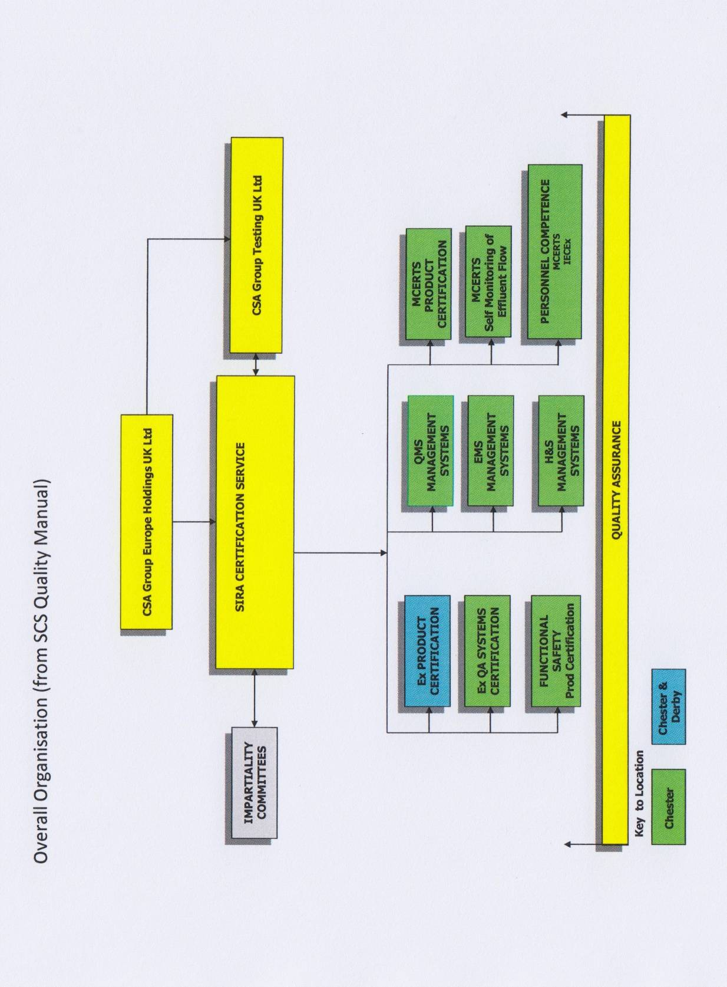

Annex 1b: Organization Chart of the ExCB and related ExTLs

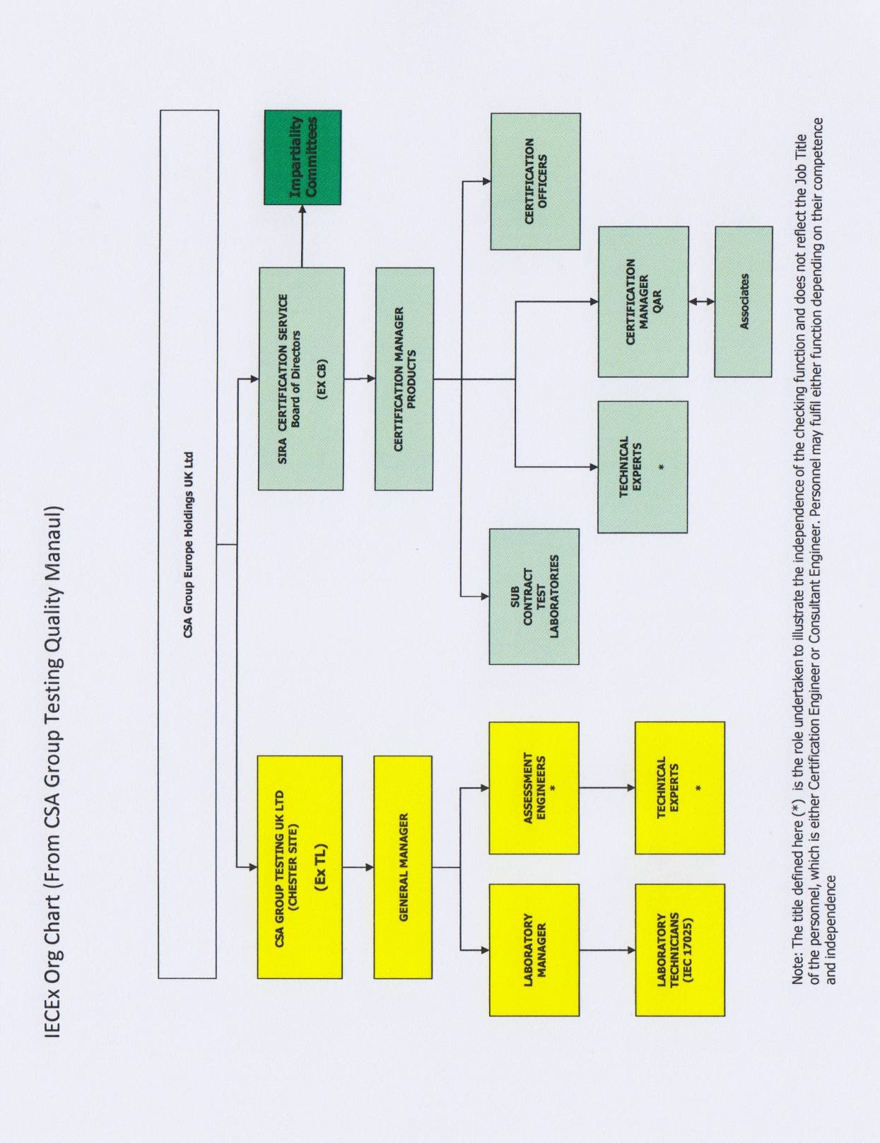

Annex 1c: Detail Organization Chart of Sira Certification Service

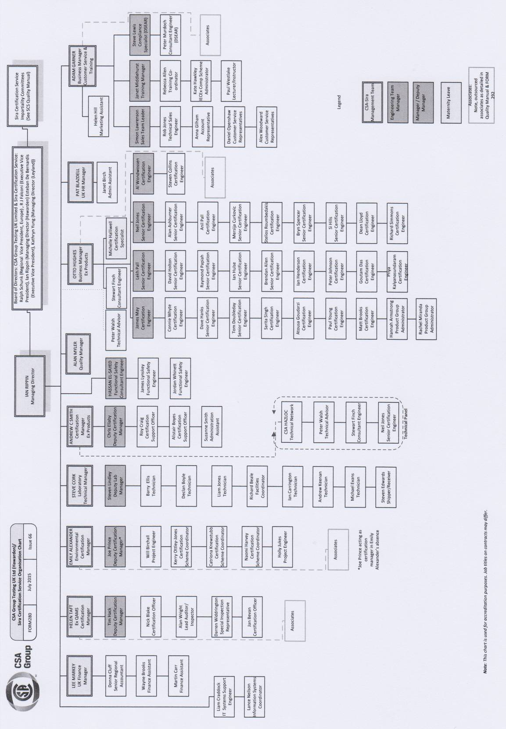

Annex 2: ISO/IEC 17065 # 0011; Accreditation Certificate for ExCB from UKAS

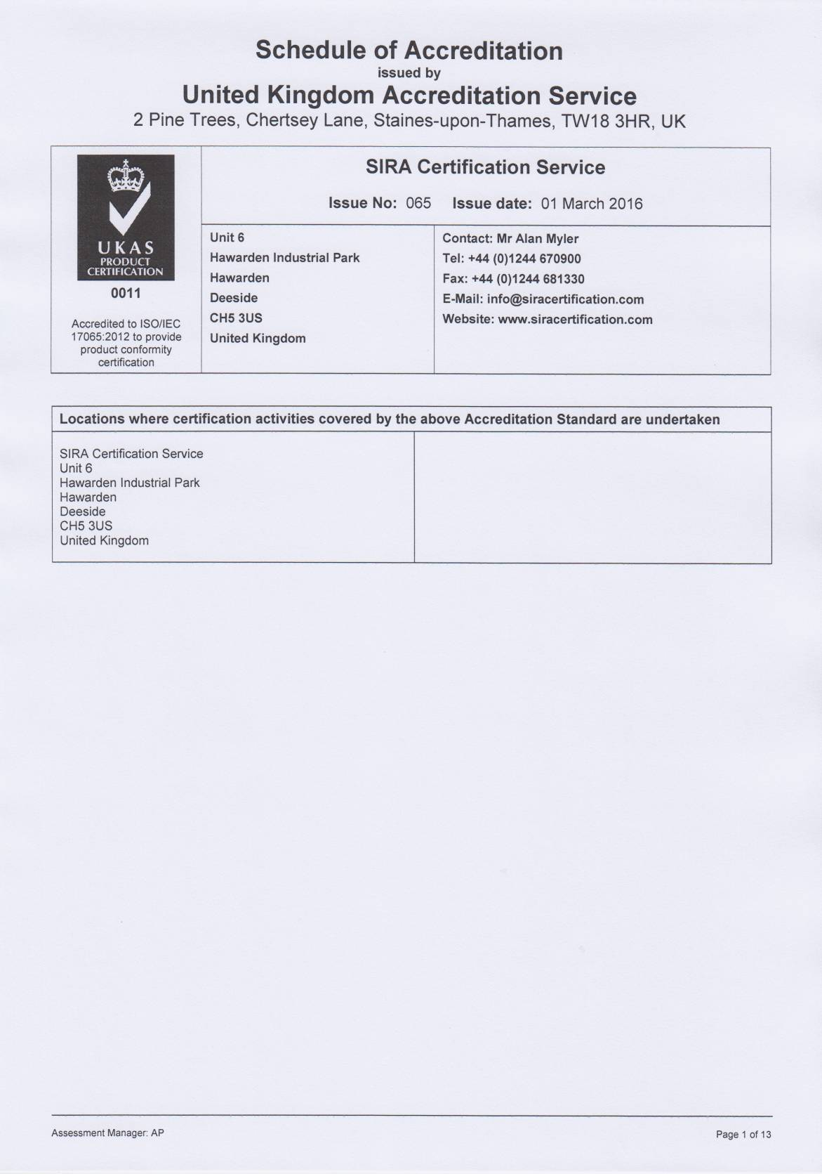

Annex 3: ISO/IEC 17021 # 0011; Quality Management Systems to ISO 9001

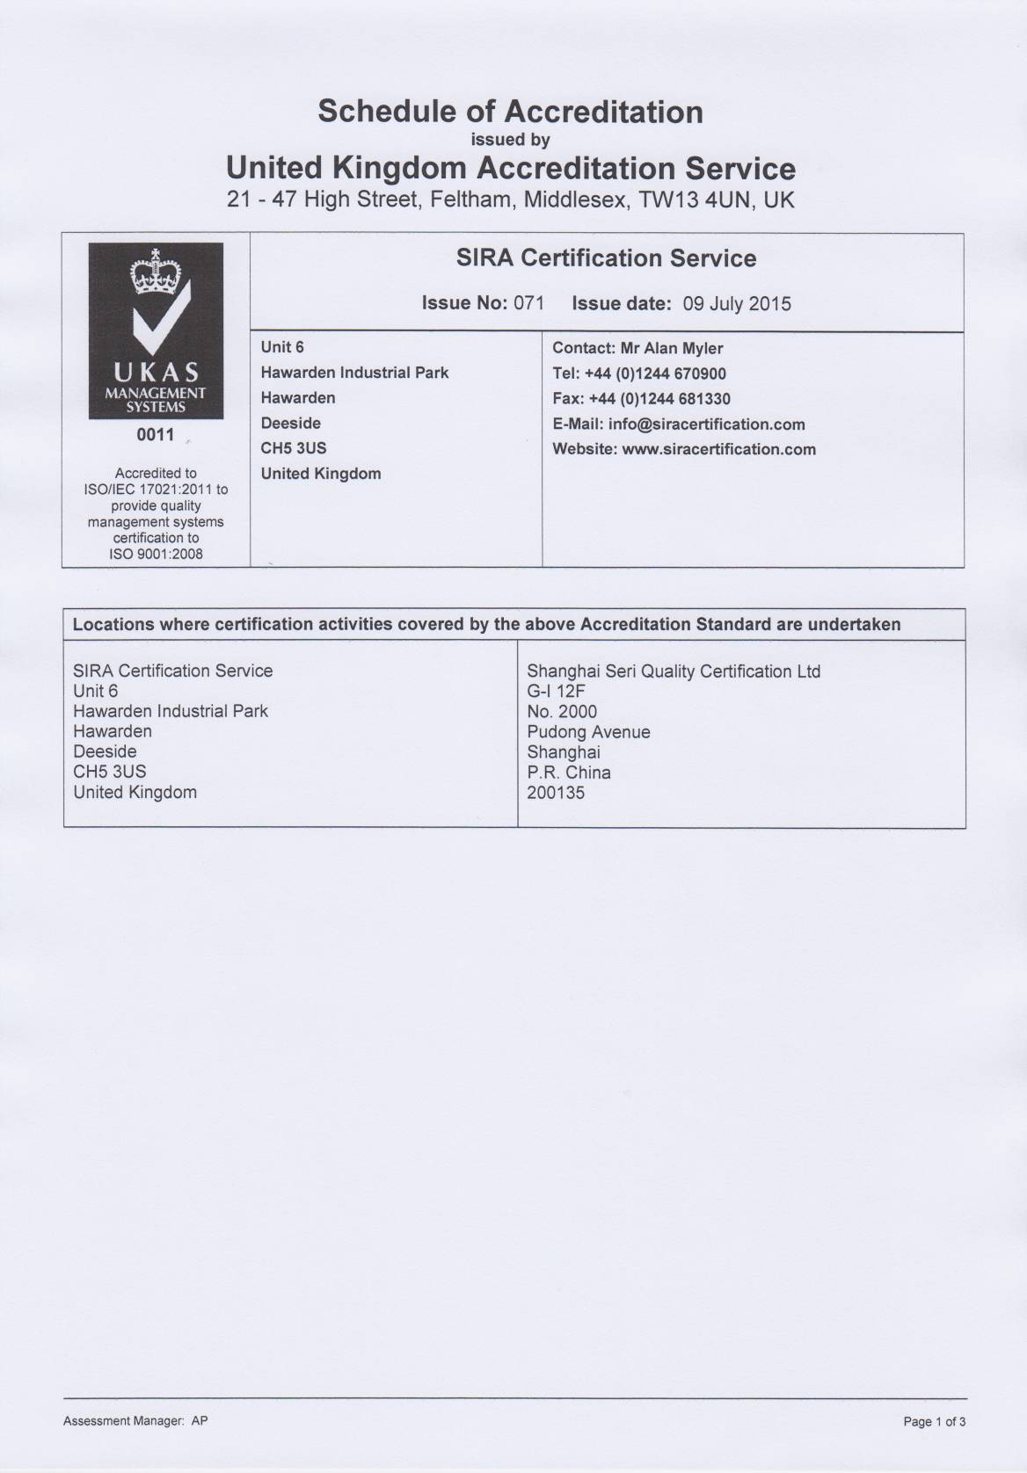

Annex 4: ISO/IEC 17024 # 0011; Certification of Persons

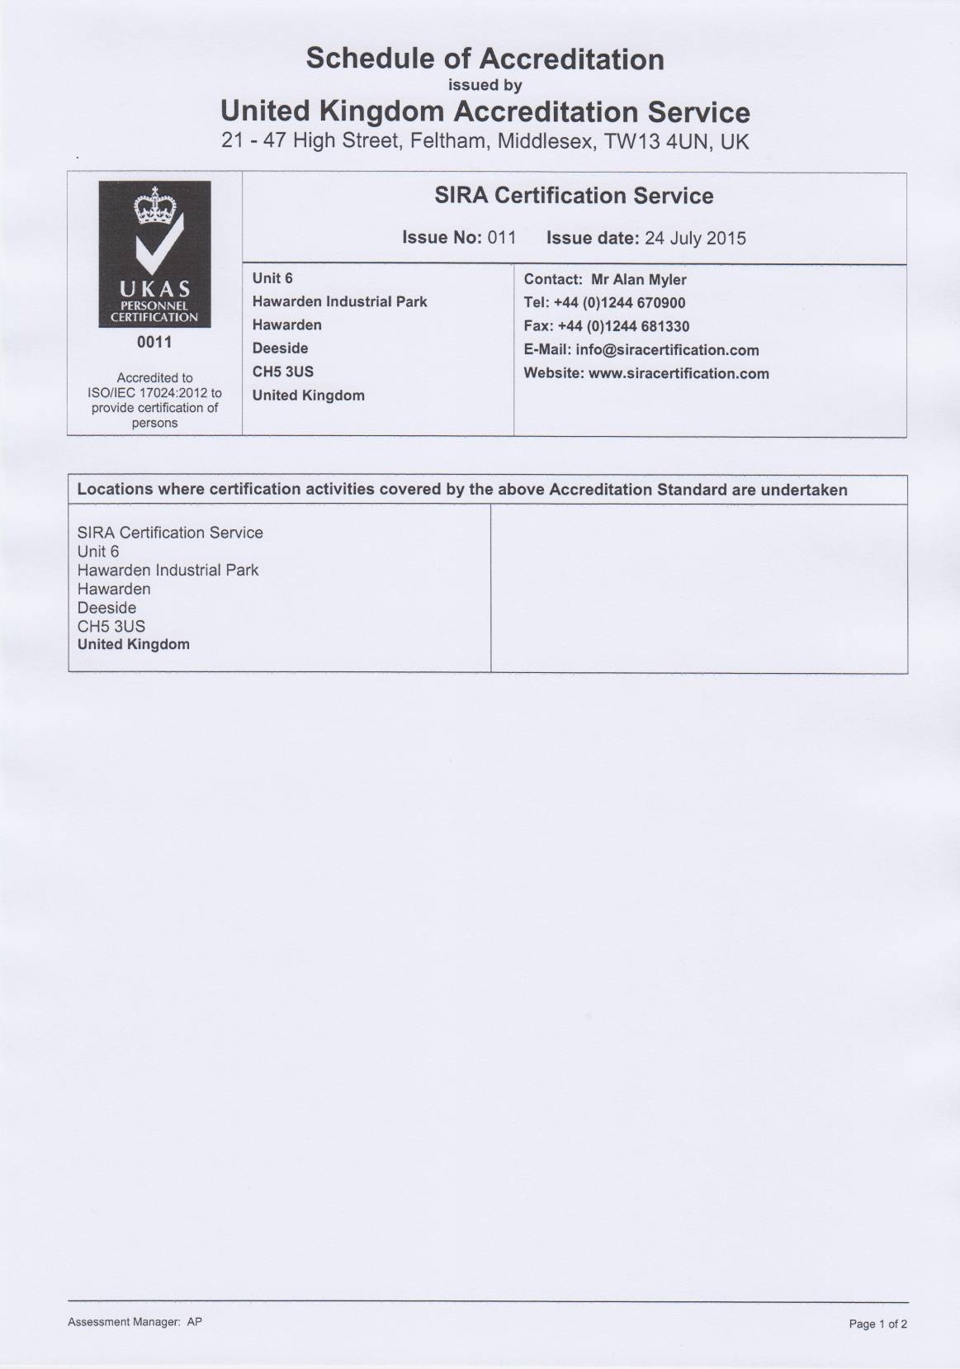

Annex 5: NB letter # NB 0518

