INTERNATIONAL ELECTROTECHNICAL COMMISSION SYSTEM FOR CERTIFICATION TO STANDARDS RELATING TO EQUIPMENT FOR USE IN EXPLOSIVE ATMOSPHERES (IECEx SYSTEM)

TITLE: Re-assessment Report for the continued acceptance of SP Technical Research Institute of Sweden as an Accepted Certification Body (ExCB) within the IECEx System, Equipment Scheme 02.

Circulation to: Members of the IECEx Management Committee, ExMC

INTRODUCTION

In accordance with the 5 year re-assessment plan for the surveillance and monitoring of bodies within the IECEx System, the following document contains the IECEx Re-assessment Report for the continued acceptance of SP Technical Research Institute of Sweden as an Accepted IECEx Certification Body (ExCB).

This report is hereby submitted for endorsement during the ExMC 2015 Meeting being held in Christchurch, New Zealand.

Chris Agius

IECEx Secretariat

IECEx Secretariat  Australia Square  Level 33, 264 George Street  Sydney NSW 2000  Australia | Tel: +61 2 4628 4690  Fax: +61 2 4625 3480  Email: chris.agius@iecex.com
IECEx ASSESSMENT REPORT FOR the
SP Technical Research Institute of Sweden

(IECEx Certification Body ExCB)

Type of Assessment:

Assessment for ExCB

Re-Assessment of ExCB X
Scope Extension of ExCB

Surveillance Assessment of ExCB

- OBJECT AND FIELD OF APPLICATION

  - Country:

Sweden

  - Name of ExCB

SP Technical Research Institute of Sweden

  - Members of the Assessment Team

Heinz Berger - IECEx Officer - IECEx Lead Assessor
Dr. Alexander Zalogin - IECEx Officer - IECEx Expert Assessor

  - Place and Date of Assessments

SP Technical Institute of Sweden
Certification Department
Box 857, SE-501 15 Boras, Sweden

September 30th – October 2nd, 2014

  - Assessment References

- IECEx 02 Equipment Scheme Rules (current version)
- IECEx OD 003-2 Assessment Procedures (current version)
- IECEx OD 005-1 and -2; Manufacturer Assessment (current version)
- IECEx OD/009 Equipment Scheme Procedures(current version)
- IECEx OD/107 Checklist ISO/IEC 17065 (current version)
- IECEx OD 17 Drawings and Documentation(current version)
- IECEx OD 024 Witness Testing/manufacturers and users Facility
- IECEx OD 025 Guidelines Manufacturer Assessments(current version)
- ISO/IEC 80079-34 Application of Quality Systems for Manufacture
- IECEx Document F-001 (QAR Form)
- ISO/IEC 17065:2012

  - Scope of Application

Number | Title | Acceptance
60079-0  Editions  3.1 4, 5, 6 | Explosive atmospheres - Part 0: Equipment - General requirements | YES
60079-1  Editions  3.2 4, 5, 6 | Explosive atmospheres - Part 1: Equipment protection by flameproof enclosures 'd' | YES
60079-2  Editions  4 5 | Explosive atmospheres - Part 2: Equipment protection by pressurized enclosures 'p' | YES
60079-5  Edition  2 3 | Explosive atmospheres - Part 5: Equipment protection by powder filling 'q' | YES
60079-6  Editions  2 3 | Explosive atmospheres - Part 6: Equipment protection by oil immersion 'o' | YES
60079-7  Editions  3, 4 | Explosive atmospheres - Part 7: Equipment protection by increased safety 'e' | YES
60079-11  Editions  4, 5, 6 | Explosive atmospheres - Part 11: Equipment protection by intrinsic safety 'i' | YES
60079-15  Editions  3, 4 | Explosive atmospheres - Part 15: Equipment protection by type of protection 'n' | YES
60079-18  Editions  1, 2, 3 | Explosive atmospheres - Part 18: Equipment protection by encapsulation "m" | YES
60079-25  Edition  1 | Explosive atmospheres - Part 25: Intrinsically safe systems | YES
60079-26  Editions  1, 2 | Explosive atmospheres - Part 26: Equipment with equipment protection level (EPL) Ga | YES
60079-27  Editions  1, 2 | Explosive atmospheres - Part 27: Fieldbus intrinsically safe concept (FISCO) | YES
60079-28  Edition 1 | Explosive atmospheres - Part 28: Protection of equipment and transmission systems using optical radiation | YES  Exclusion of ignition test
60079-31  Edition  1 | Explosive atmospheres - Part 31: Equipment dust ignition protection by enclosure "t" | YES
61241-0  Edition  1 | Electrical apparatus for use in the presence of combustible dust - Part 0: General requirements | YES
61241-1  Edition  1 | Electrical apparatus for use in the presence of combustible dust - Part 1: Protection by enclosures 'tD' | YES
61241-1-1  Edition  2 | Electrical apparatus for use in the presence of combustible dust - Part 1: Electrical apparatus protected by enclosures and surface temperature limitation - Specification for apparatus | YES
61241-4  Edition  1 | Electrical apparatus for use in the presence of combustible dust - Part 4: Type of protection 'pD' | YES
61241-11  Edition  1 | Electrical apparatus for use in the presence of combustible dust - Part 11: Protection by intrinsic safety 'iD' | YES
61241-18  Edition  1 | Electrical apparatus for use in the presence of combustible dust - Part 18: Protection by encapsulation 'mD' | YES

  - ExCB Persons Interviewed

Name | Position
Anders Nilsson | Head of Section Testing Laboratory
Lennart Aronsson | Section Manager, Product Certification
Peter Bremer | Certification Engineer
Robert Carlsson | Certification Engineer
Bodil Tufvesson | Auditor QAR

  - Legal Entity of the ExCB

SP Sveriges Tekniska Forskningsinstitut AB is a limited company fully owned by RISE Research Institutes of Sweden AB, which is owned by the Swedish State, Ministry of Industry and Commerce. The legal entity document was presented during the assessment. It is issued by Bolagsverket and the number is 556464-6874. The last adaption was performed on April 26th, 2012.

  - Associated Testing Laboratories

The ExTL is integral with the ExCB.
ExTL and ExCB are organisationally separated in different departments within SP. The quality management system and the operational procedures provide sufficient separation of the testing and certification activities.

  - Associated Certification Functions

SP operates as a Notified Body in the European certification scheme according to the ATEX Directive 94/9/EC and a large number of other directives. The NB number is 0402 for use of all directives SP is notified for. SP operates also in a wide range of other certification schemes (e.g. as a CBTL in CB Scheme) and for products and quality systems including ISO 9001.

  - National Marks and Certificates

There are marks in other areas than Ex. SP is issuing certificates in other areas other than Ex.

  - Financial Support

SP is self-funded under a not for profit concept. The financial situation could be seen in the annual report of SP.

  - History

In 1975 SP was moved from Stockholm to Borås.
Before 1993, SP (named Statens Provningsanstalt) was a national authority. Since 1994, SP is a company (Ltd.) fully owned by the Swedish Government. In 2007, the name of the company was changed to SP Technical Research Institute of Sweden.
SP applies its competence to the development and evaluation of technologies, material, products, and processes. SP provides certification of products and quality systems as an independent third party certification body. SP has ten subsidiaries, but not involved in Ex activities.
Type approval of explosion protected equipment started in the early 1960s. SP has provided certification according to European Directives for explosion protected equipment since 1994 and according to the ATEX Directive since 1997. SP is an approved ExCB in the IECEx system since August 1999.

  - Standards Accepted

See clause 1.6 of this report.

  - National Differences to IEC Standards

The national differences of Sweden are declared and detailed in the current edition of the IECEx Bulletin.

- ORGANISATION

  - Names, Titles and Experience of the Senior Executives

Name | Title | Experience Ex/Overall
Maria Khorsand | CEO Chief Executive Officer, SP
Lennart Månsson | Head of Department, Certification
Anders Nilsson | Section Manager product Safety | 15 / 26 years
Lennart Aronsson | Section Manager, Product Certification | 14 years

  - Name, Title and Experience of the Quality Management Representative

Name | Title | Experience
Magnus Holmgren | Quality Manager, SP | 19 years
Ingrid Isaksson | Quality Manager, Certification | 15 years
Lennart Aronsson | Member of SP Quality Group | 14 years

  - Name and Title of Nominated Principal Contact

Name | Title | Email
Robert Carlsson | Certification Engineer | robert.carlsson@sp.se

  - Name and Title of Signatories for Certification

Name | Title | Comments
Peter Bremer | Certification Engineer | IECEx CoC
Robert Carlsson | Certification Engineer | IECEx CoC

  - Other Employees in ExCB activity

Name | Title | Responsibility and Experience in Ex
Peter Bremer | Certification Engineer, Auditor | Product & quality system certification, > 29 years
Robert Carlsson | Certification Engineer | Product certification,  > 16 years
Lennart Aronsson | Certification Engineer,  Section Manager, Product Certification | Product & quality system certification, > 14 years
Bodil Tufvesson | Auditor | Auditing, > 5 years

  - Organizational Structure

See attached organization charts in ANNEX 1a and 1b.

2.7 Administration (including Indemnity Insurance)

2.7.1 Administrative Structure
The ExCB with the support of the ExTL deals with Ex projects. Sufficient administrative staff is available to support their operations

2.7.2 Indemnity Insurance

SP is covered by insurance contract issued by the company If P&C Insurance Ltd (publ), Barks väg 15, Solna Postal address: 106 80 Stockholm, Sweden. The policy # is LP 0000004630. The coverage is adequate according to ISO/IEC 17065. The insurance certificate was presented during the assessment.

- RESOURCES

The operation is well resourced with appropriate facilities, procedures and experienced staff (4 persons).

At the moment three persons are involved in Ex Certification supported by one secretary. Presently three persons are involved in Ex Quality Assessments supported by technical experts.

Additional external resources for Testing and Auditing are also available.

- COMMITTEES / Governing Board / Appeals / Advisory Board

The department Certification has its own board (separate from SP’s board) with six representatives:

- Four representatives from industry
- One representative from SP’s top management (without voting rights)
- SP Certification Manager (without voting rights)

The aforementioned board is supported by an expert group known as SPAREX committee which functions as the certification board expert group for Ex equipment. This board is convened by a Certification Officer.

The member list and the minutes of the last meeting held on 23rd of September 2014 were presented during the assessment.

- CERTIFICATION OPERATIONS

  - National Approval/Certification Methods

SP is involved in European Ex certification activities since 1994 and was appointed as a Notified Body (NB) in 1997 under NB number 0402, according to the ATEX Directive 94/9/EC. SP applied for operation using the new ATEX Directive 2014/34/EU. This directive may come into force in 2016.
Certification of Quality Management Systems of Ex manufacturers is performed according to SP certification rules SPCR 079 based on the relevant modules in the ATEX Directive 94/9/EC.

For ATEX certification rules, there is a suitable and well-defined work instruction (IP-SPCR 079).

  - Certification Policy

Procedure IP-SPCR 154 describes IECEx services according to the relevant documents. Documented policy covering conditions and procedure for granting, maintaining, extending, suspending and withdrawing certification are contained in the Quality Manual.The procedure was checked and found to be appropriate and to meet the requirements of the IECEx System.

  - Application for Certification

Documents for guidance to applicants are provided in booklets relevant to the certification involved. These documents include a description of the evaluation and certification procedures including the rights and duties of applicants.

The necessary information needed for the application is provided by document SPCR 154. The application form for IECEx and ATEX was reviewed during the assessment and found to meet the requirements of the IECEx.

  - Certification Decision

Certification Decision is taken by signing the Cover Sheet for ExTRs and QARs according to procedure IP-SPCR 154. After clearance of the certification file, the CoC will be created on the IECEx homepage according to procedure IP-SPCR 154.

  - Suspension and Cancellation of Certificates

Withdrawal and Cancellation of Certificates is handled according to work instruction IP 7.2.

In the case of IECEx CoCs withdrawals and cancellations of certificates are under the authority of the Certification Manager. The client may initiate the complaints mechanism if in disagreement. The procedures are in accordance with IECEx 02 and OD 009 and laid down in procedure IP-SPCR 154.
- STATISTICS

  - Certificates Issued

Number of certificates issued under national schemes and IECEx in the preceding four years for each type of protection:

Standards | Title | Number of certificates
 |  | 2011 | 2012 | 2013 | 2014 | Total
60079-0 and 61241-0 | Explosive atmospheres - Part 0: Equipment - General requirements |  |  |  |  | Parts 0 included in numbers below
60079-1 | Explosive atmospheres - Part 1: Equipment protection by flameproof enclosures 'd' | 1 | --- | --- | 1 | 2
60079-2 | Explosive atmospheres - Part 2: Equipment protection by pressurized enclosures 'p' | --- | --- | --- | --- | ---
60079-5 | Explosive atmospheres - Part 5: Equipment protection by powder filling 'q' | --- | --- | --- | --- | ---
60079-6 | Explosive atmospheres - Part 6: Equipment protection by oil immersion 'o' | --- | --- | --- | --- | ---
60079-7 | Explosive atmospheres - Part 7: Equipment protection by increased safety 'e' | 9 | 6 | --- | --- | 15
60079-11 | Explosive atmospheres - Part 11: Equipment protection by intrinsic safety 'i' | 3 | 3 | 5 | 2 | 13
60079-15 | Explosive atmospheres - Part 15: Equipment protection by type of protection 'n' | --- | --- | --- | --- | ---
60079-18 | Explosive atmospheres - Part 18: Equipment protection by encapsulation "m" | --- | --- | 2 | --- | 2
60079-25 | Explosive atmospheres - Part 25: Intrinsically safe systems | --- | --- | --- | --- | ---
60079-26 | Explosive atmospheres - Part 26: Equipment with equipment protection level (EPL) Ga | 2 | 2 | 3 | --- | 7
60079-27 | Explosive atmospheres - Part 27: Fieldbus intrinsically safe concept (FISCO) | --- | --- | --- | --- | ---
60079-28 | Explosive atmospheres - Part 28: Protection of equipment and transmission systems using optical radiation | --- | --- | --- | --- | ---
60079-31 | Explosive atmospheres - Part 31: Equipment dust ignition protection by enclosure "t" | --- | --- | --- | 1 | 1
61241-1 | Electrical apparatus for use in the presence of combustible dust - Part 1: Protection by enclosures 'tD' | 11 | 3 | --- | --- | 14
61241-1-1 | Electrical apparatus for use in the presence of combustible dust - Part 1: Electrical apparatus protected by enclosures and surface temperature limitation - Specification for apparatus | --- | --- | --- | --- | ---
61241-4 | Electrical apparatus for use in the presence of combustible dust - Part 4: Type of protection 'pD' | --- | --- | --- | --- | ---
61241-11 | Electrical apparatus for use in the presence of combustible dust - Part 11: Protection by intrinsic safety 'iD' | --- | --- | --- | --- | ---
61241-18 | Electrical apparatus for use in the presence of combustible dust - Part 18: Protection by encapsulation 'mD' | --- | --- | --- | --- | ---

- DOCUMENTATION

  - Quality Manual

The quality manual used by the ExCB is the SP Corporate manual together with the department (Certification) manual, which is well structured to the business of certification. It includes a well-defined policy, which has emphasis on the needs of the client and management of a system following EN ISO/IEC 17065. The Management System provides a clear differentiation between the operating procedures for testing and certification, under the requirements of IECEx and that conducted as part of national accreditation.

  - Procedures

According to procedure IP-SPCR154.The procedure was checked in detail and found to meet the requirements of the IECEx.

  - Work Instructions

According to procedure IP-SPCR154. See above.

  - Records

According to procedure IP-SPCR 154 “checklist”.The procedure was checked and found to be appropriate in meeting the requirements of the IECEx System. Records are kept at least ten years.

  - Document Change Control

Document change control is described in document # 10389, 10788, 10392, 10810, 10814, 11203, and 13661. The key document was checked during the assessment and found to meet the requirements of the IECEx.

- CONFIDENTIALITY

Confidentiality is described in SP document 10341 and 10344, and described for customers in the General Contract Terms for SP (section 4) and SPCR 154 (section 6.3). During the CV review, several confidentiality agreements were checked and found to meet the requirements of the IECEx.

- PUBLICATIONS

SP has a well presented homepage http://www.sp.se/en/Sidor/default.aspx where the IECEx Scheme is presented. Furthermore, a number of brochures are available mentioning Ex activities including IECEx.

- NATIONAL ACCREDITATION

SP is currently in a final stage to receive accreditation for EN ISO/IEC 17065 from SWEDAC (Swedish Accreditation body). Annex 2 shows the current accreditation certificate for EN 45011 (equivalent to Guide 65) from SWEDAC. The last surveillance audit by SWEDAC was performed in January 2014. A surveillance audit will be performed by Swedish Accreditation Body SWEDAC in week 48/2014 also involving product certification for Ex products.

The NB certificate is attached under Annex 3.

- RECOGNITION AND AGREEMENTS

Certificates issued by SP are recognized on national level and regional level (Europe). SP is a notified body according to the ATEX Directive 94/9/EC.

- INTERNAL AUDIT AND PERIODIC MANAGEMENT REVIEW

Internal audits are performed according to SP document 10302 and management reviews according to SP document 10307. The audits are performed on an annual schedule. The present internal audit plan covers the years 2014 to 2016. The records were checked and found to meet the requirements of the IECEx System

- SUBCONTRACTING, USE OF OTHER LABS AND USE OF OTHER LOCATIONS

Sub-contracting is used only in exceptional cases for a test where the integral ExTL use a sub-contractor. The sub-contractor is listed in IP-SPCR 154. ExTRs and QARs from other EXCBs are reviewed according to work instructions, according to 7.3 above.

- TRAINING

Competence requirements are specified in work instructions. Training records are kept in the CV files of the personnel department as seen during the review of the CV files.
A comprehensive competence list (“AGDA list”) was reviewed during the assessment with focus on IECEx activities and found to meet the requirements of the IECEx System

- ASSESSMENT OF MANUFACTURERS AND ISSUE OF QARS

The following QARs were reviewed in detail during the assessment:

SE/SP/QAR 09.001/03, protection types e and t, manufacturer in Sweden

SE/SP/QAR 14.0002/00, protection types d and e, manufacturer in Denmark

SE/SP/QAR 13.0001/01, protection type i, manufacturer in Denmark

SE/SP/QAR 14.0001/00, protection type t, manufacturer in Denmark

The whole chain from the initial to the latest surveillance assessment could be seen. It was found to meet the requirements of the IECEx.

- COMPLAINTS AND APPEALS (Including appeals to IECEx)

Appeals are handled according to the IECEx Rules and sub-clause 6.7 in procedure SPCR 154 as well as SP document 10295. This was checked during the assessment and found to meet the requirements of the IECEx.

- SPECIAL FACTS TO BE NOTED

  - Supporting Documentation

Copies of additional supporting information for this assessment have been provided to the applicant and the IECEx Secretariat. These include:

- Details of issues raised and how these have been resolved listed below as document control, advisory board and OD 24 procedure
- Competence Matrix
- List of Subcontractors and Contractors
- Checklist for ISO/IEC 17065

- COMMENTS (Including issues found during assessment)

The Ex Certification body of SP is very competent. During the assessment, issues were found in the area of document control, advisory board and OD 24 procedure. All were resolved to the satisfaction of the assessment team and subsequently closed.

- RECOMMENDATION

Based on the re assessment performed from September 30th to October 2nd, 2014, the ExCB of SP is recommended for continued acceptance in the IECEx Scheme as an IECEx Certification Body (ExCB) according to the scope of the standards listed in this document.

Lead Assessor  Heinz Berger | Expert Assessor  Dr. Alexander Zalogin

Date: October 2nd, 2014

List of Annexes:

ANNEX 1a: Overall Organization Chart of SP
ANNEX 1b: Organization Chart of SP and department Certification (CE) 2014
ANNEX 2: Accreditation SWEDAC according to EN 45011
ANNEX 3: Acceptance Letter Notified Body 0402

ANNEX 1a: Overall Organization Chart of SP

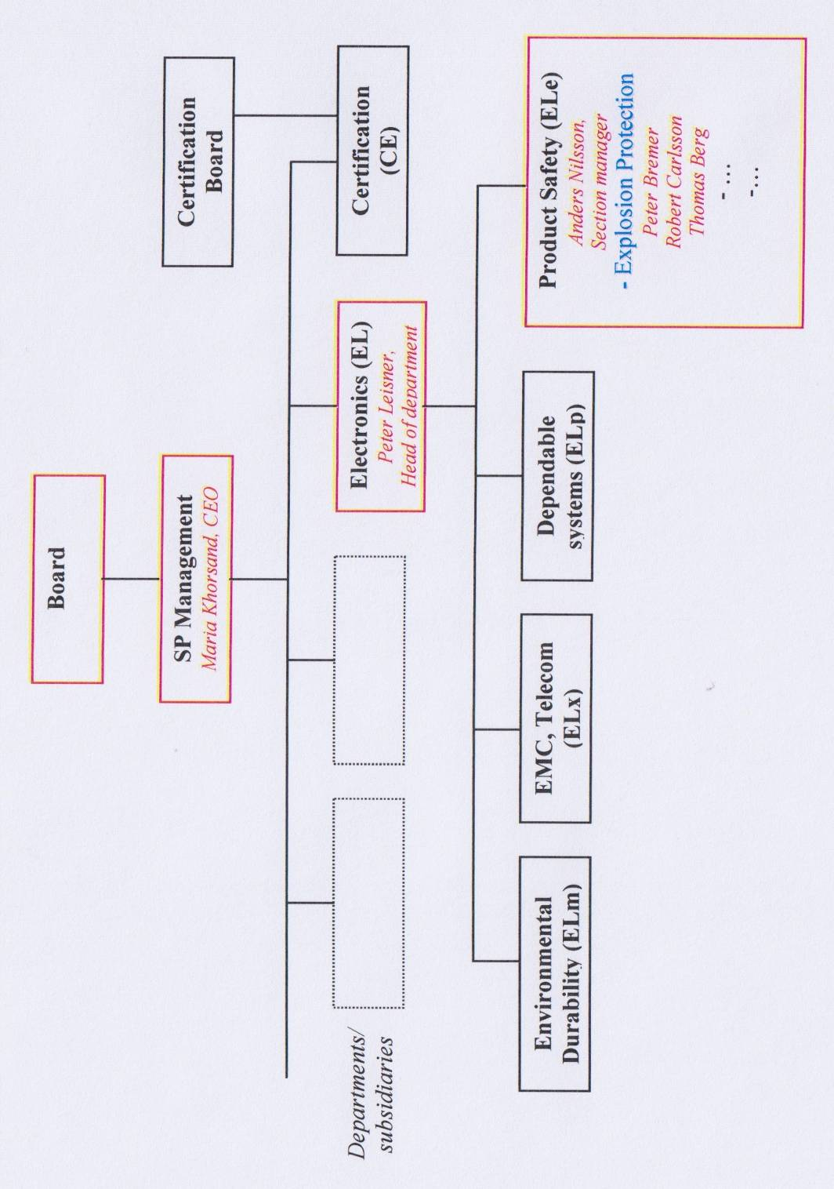

ANNEX 1b: Organization Chart of SP and department Certification (CE) 2014

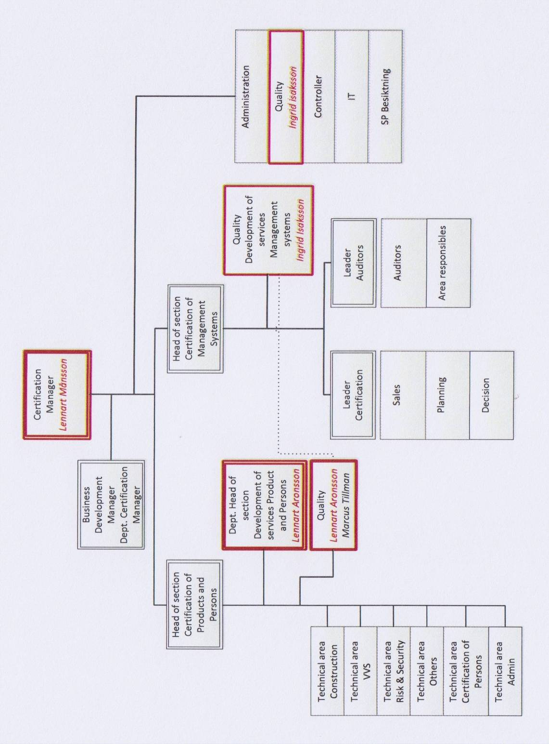

ANNEX 2: Accreditation SWEDAC according to EN 45011

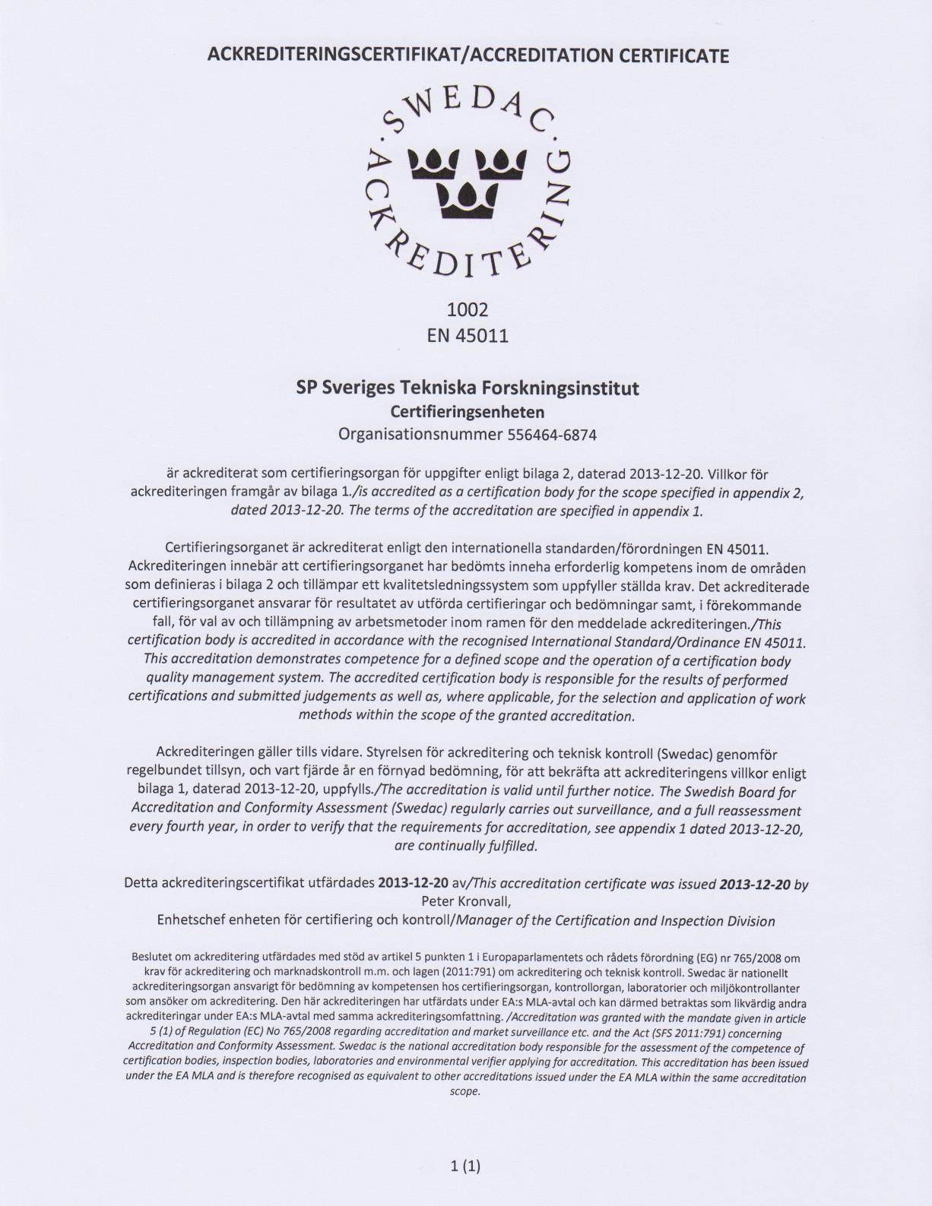

ANNEX 3: Acceptance Letter Notified Body 0402

