INTERNATIONAL ELECTROTECHNICAL COMMISSION (IEC) SYSTEM
FOR CERTIFICATION TO STANDARDS RELATING TO EQUIPMENT FOR
USE IN EXPLOSIVE ATMOSPHERES (IECEx SYSTEM)

Ex Management Committee, ExMC

TITLE: IECEx System Report Card - 2015

INTRODUCTION

The Secretariat has prepared this document as an annual Report Card to IECEx Members on both the state of the IECEx System and progress on a number of matters since the 2014 IECEx ExMC meeting in The Hague, such as:

- IECEx System Membership
- Statistics of issued IECEx Certificates of Conformity, ExTRs, QARs
- A breakdown of the number of ‘Issue 0’ Equipment CoCs compared to supplementary issues
- Identification of Conformity Mark Licenses issued
- Review of the IECEx System including review of Certificates and issued Test Reports and QARs
- Inclusion of the number of Companies holding IECEx certification
- Promotional Activities
- Secretariat and General Technical Administration

This document is issued for information to members and is listed on the IECEx 2015 ExMC meeting agenda for noting and any necessary discussion.

Address:  IECEx Secretariat  Level 33, Australia Square  264 George Street  Sydney NSW 2000  Australia | Contact Details:  Tel: +61 2 4628 4690  Fax: +61 2 4627 5285  e-mail: info@iecex.com  http://www.iecex.com
IECEx System Report Card - 2015

- General Overview

Discussions and decisions from the 2014 series of IECEx Meetings in The Hague set the tone and direction for further development, growth and expansion of the IECEx System and its Schemes.

The Secretariat is pleased to report on the following key points concerning IECEx operation since the 2014 IECEx meetings in The Hague:

- At the time of preparing this report, Israel is recorded as the most recent Country to join IECEx and there is continued interest from various countries including Belgium, Saudi Arabia and Ireland
- Operation of the IECEx Certified Service Facilities Scheme, now starting to take traction, with 168 Certificates issued to date since Scheme commencement in late 2007
- Operation of the IECEx Certificate of Personal Competence (CoPC) Scheme also gaining traction with 843 Certificates issued to date since Scheme commencement in late 2010. Of the 843 issued Certificates, 169 have been issued already in 2015.
- Increased use of IECEx Unit Verification Certificates
- Promotion of the Publication from the United Nations, UNECE, Common Regulatory Objective for the Ex Sector continues to support IECEx
- Additional enhancements to the IECEx On-Line Certificate of Conformity System, to provide additional tools for ExCBs to assist in their management of surveillance activities of issued Certificates
- The marked increase in the demand and issue of IECEx Certificates of Conformity and Reports, as reported in 2008, 2009, 2010, 2011, 2012, 2013 and 2014, continues in 2015 with year on year growth being maintained.
- Continued processing of Scope extensions from ExTLs and ExCBs
- Promotion at Regional and International forums
- Greater involvement by industry, end-users and regulators
- An increase in the number of day to day industry inquiries being directed at the IECEx Secretariat – this is reflected in the increased e-mail traffic of the Secretariat
- Work on the expansion and update of the “IECEx Mobile Device Applications”

- Membership

IECEx System Membership, as of 18th August 2015 stands at:

- 33 Countries as members of the IECEx Management Committee, ExMC

- With four separate Certification Schemes
  - IECEx Certified Equipment Scheme (Rules = IECEx 02)
  - IECEx Certified Service Facilities Scheme (Rules = IECEx 03)
  - IECEx Conformity Mark Licensing System (Regulations = IECEx 04)
  - IECEx Certification of Personnel Competencies (CoPC) Scheme
(Rules = IECEx 05)
and the recently introduced IECEx Recognised Training Provider Program (RTPP)

- IECEx Certified Equipment Scheme
  - 50 Accepted ExCBs (+ 11 Applicants)
  - 57 Accepted ExTLs (+ 8 Applicants)

- IECEx Certified Service Facilities Scheme
  - 13 Accepted ExCBs (+ 2 Applicants)

- IECEx Conformity Mark Licensing System
  - 15 Accepted License issuing ExCBs

- IECEx Certification of Personnel Competencies (CoPC) Scheme
  - 8 Accepted ExCBs (+ 4 Applicants)

- IECEx Recognised Training Provider Program (RTPP)
  - 4 Recognised Training Providers (RTPs)

- Statistics – Certificates, Licenses and Reports

At 30th June 2015 there were 49,497 Issued IECEx Reports, Certificates and Licenses across all the following four IECEx Schemes compared with 40,319 for the same time last year (30th June 2014) – this represents a growth of 18.5%.

- The IECEx Certified Equipment Scheme, IECEx 02 (see Table 1A)
- The IECEx Certified Service Facilities Scheme, IECEx 03. (see Table 2)
- The IECEx Conformity Mark Licensing System, IECEx 04 (see Table 3)
- The IECEx Certification of Personnel Competencies (CoPC) Scheme, IECEx 05 (see Table 4)

The figure “Totals”, in Table 1A, show the total number of combined Equipment CoCs (Certificates of Conformity), ExTRs (IECEx Test Reports) and QARs (IECEx Quality Audit Reports) issued under the IECEx Certified Equipment Scheme. Table 1B shows a comparison between new Certificates (Issue 0) compared to supplementary issues of existing Certificates (i.e. changes to existing certificates, Issue 1 and above).

Figure 1A provides an overview trend of the number of Certificates and Reports issued since 2003, under the IECEx 02 Scheme (Certified Equipment Scheme), while Figure 2 provides a breakdown of the percentage weighting of CoCs compared to ExTRs and QARs issued over the life of the IECEx System.

The conclusion drawn from these statistics is that the IECEx Certified Equipment Scheme is still experiencing significant and sustained growth. The following factors are seen as facilitating this growth:
- Penetration of new markets, such as the Gulf Region
- Industry’s recognition of the value that certification under an Internationally accepted Regime brings to risk mitigation as part of their compliance regime
- The increasing involvement by industry in the management and operation of IECEx
- The credibility of the IECEx System based on compliance to IEC Standards, a common assessment system for all ExCBs and ExTLs, and ongoing surveillance;
- Increased awareness and recognition of IECEx as “world's best practice” via the formal endorsement by the UNECE, as per new United Nations approved CRO publication, March 2011
- One set of operational procedures and reporting formats (i.e. the IECEx way of Ex Certification);
- The transparency of IECEx activities provided by the IECEx website and On-Line CoC system;
- A greater level of industry understanding of the IECEx system by way of promotion of IECEx by IECEx Officers and Members;
- A growing international awareness of the value of structured International Conformity Assessment Systems such as IECEx;
- The value of networking among all Ex experts including ExCBs and ExTLs and associated technical discussion forums provided, e.g. ExTAG;
- A dedicated technical Secretariat

IECEx 02 – IECEx Certified Equipment Scheme

Year ending Figures IECEx 02 Certified Equipment Scheme

Table 1A- Total number of IECEx Equipment CoCs and Reports issued

In the Year | CoCs* |  |  | ExTRs* |  |  |  | QARs* |  |  | Total* |  | CoC Drafts
2001 to 2007 | 1866 |  |  | 2025 |  |  |  | 971 |  |  | 4862
2008 | 1258 |  |  | 1166 |  |  |  | 350 |  |  | 2774 |  | 499
2009 | 1490 |  |  | 1347 |  |  |  | 712 |  |  | 3549 |  | 618
2010 | 2070 |  |  | 1897 |  |  |  | 947 |  |  | 4914 |  | 675
2011 | 2626 |  |  | 2143 |  |  |  | 966 |  |  | 5735 |  | 1000
2012 | 2680 |  |  | 2301 |  |  |  | 1019 |  |  | 6000 |  | 1150
2013 | 3104 |  |  | 2783 |  |  |  | 1027 |  |  | 6914 |  | 1286
2014 | 3562 |  |  | 3265 |  |  |  | 1246 |  |  | 8073 |  | 1461
YTD @ 30 June 2015 | 1901 |  |  | 1795 |  |  |  | 729 |  |  | 4425 |  | 1627
Totals | 20557 |  |  | 18722 |  |  |  | 7967 |  |  | 47246
Unit Verification Certificates

One hundred and thirty one (131) IECEx Equipment Unit Verification Certificates have been issued since the 30th June 2014

Table 1B – Issue 0 CoCs (New Certificates as opposed to up issues) expressed as % of all CoCs (Equipment Scheme)

Issue 0 CoCs expressed as % of all CoCs

Issued in the Year | # All CoCs | # “Issue 0”  CoCs | “Issue 0” as % of all CoCs
2008 | 1258 | 693 | 55.1%
2009 | 1490 | 799 | 53.6%
2010 | 2070 | 1032 | 49.9%
2011 | 2626 | 1158 | 44.1%
2012 | 2680 | 1172 | 43.7%
2013 | 3104 | 1337 | 43.1%
2014 | 3562 | 1517 | 42.6%
YTD @ 30 June 2015 | 1901 | 961 | 50.6 %

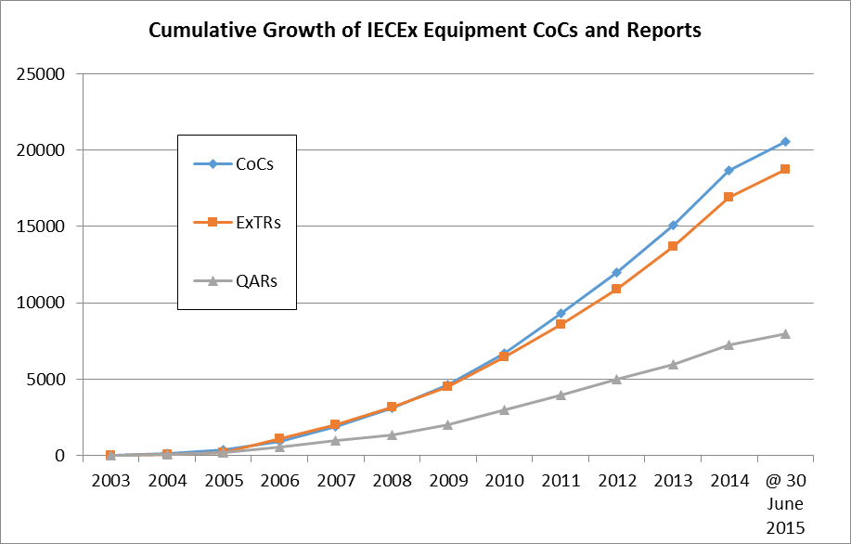

Figure 1A – Cumulative Growth of Issued IECEx CoCs, ExTRs and QARs for the IECEx Certified Equipment Scheme

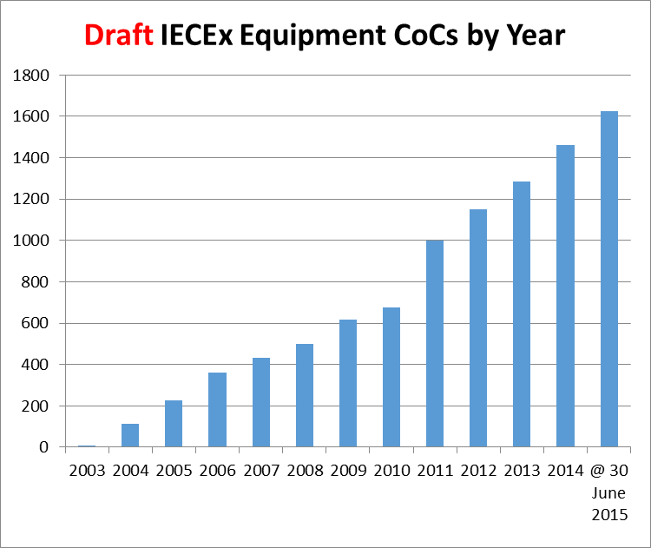

Figure 1B – Comparison of draft IECEx Equipment CoCs as indicative of future year on year growth of the Scheme

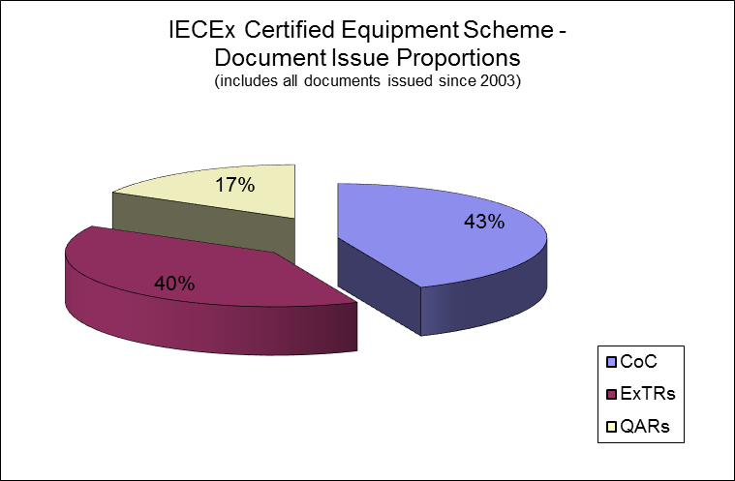

Figure 2 – CoCs, ExTRs, QARs Percentages

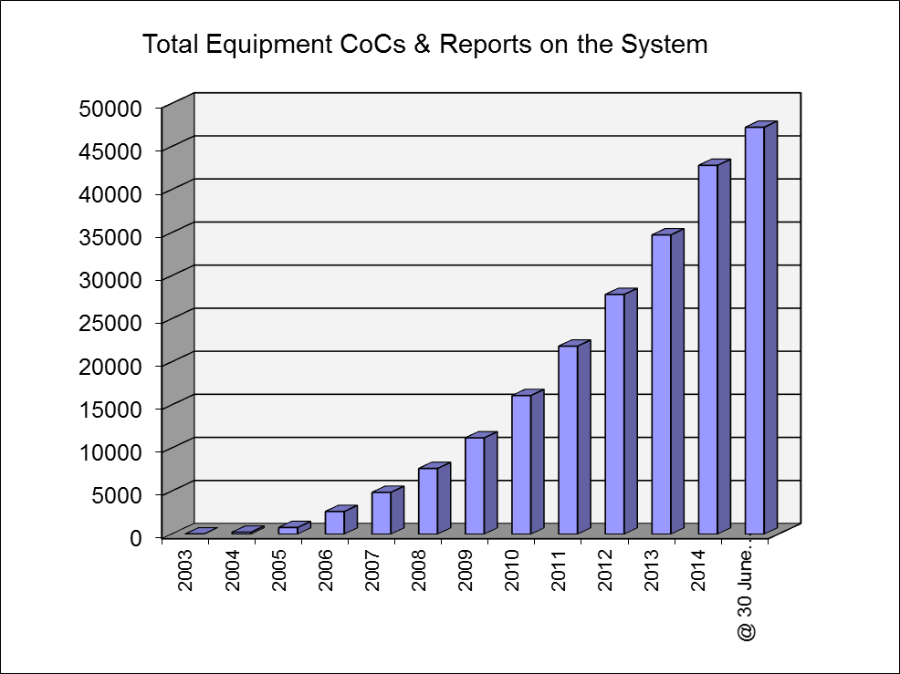

Figure 3 - Total IECEx Equipment Scheme CoCs, ExTRs and QARs at each Year end and to 30 June 2015.
IECEx 03 – IECEx Certified Service Facilities Scheme

Table 2 – Year End Figures IECEx 03 Certified Service Facilities Scheme

Total number of Certified Services CoCs issued
(Scheme commenced end 2007)

In the Year | CoCs | FARs | Total | Drafts
2007 | 3 | 4 | 7
2008 | 12 | 47 | 59
2009 | 15 | 33 | 48 | 9
2010 | 26 | 42 | 68 | 7
2011 | 31 | 53 | 84 | 8
2012 | 21 | 22 | 43 | 9
2013 | 26 | 61 | 87 | 12
2014 | 23 | 65 | 88 | 1
YTD @ 30 June 2015 | 11 | 41 | 52 | 6
Totals | 168 | 368 | 536

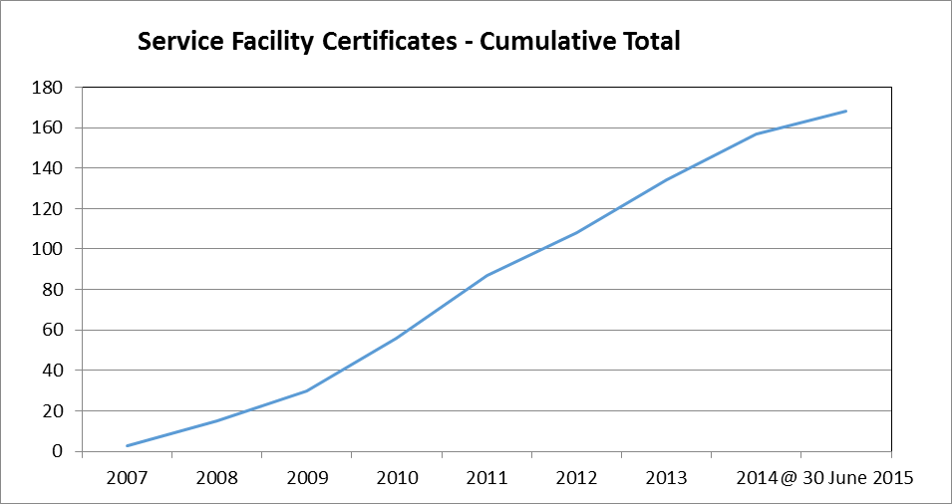

Figure 4 – Cumulative Total of IECEx Certified Service Facility Certificates (CoC) at each Year end and to 30 June 2015
IECEx 04 – IECEx Conformity Mark Licensing System

Table 3 – Year End Figures IECEx 04 Conformity Mark Licenses

Total number Conformity Mark Licenses issued
(System commenced 2009)
In the Year | Licenses | Number of CoCs attached to Licenses | Drafts
2009 | 4 | 10 | 0
2010 | 3 | 34 | 2
2011 | 7 | 83 | 3
2012 | 7 | 71 | 8
2013 | 2 | 2 | 9
2014 | 5 | 17 | 9
YTD @ 30 June 2015 | 1 | 11 | 9
Totals | 29 | 228

IECEx 05 – Certificate of Personnel Competence Scheme (CoPC)

Table 4 – Year End Figures IECEx 05 Personnel Competence

Total number CoPC Certificates issued
(Scheme commenced late 2010)

In the Year | CoPC Certificates | Drafts
2010 | 7 | 0
2011 | 64 | 0
2012 | 88 | 0
2013 | 153 | 3
2014 | 362 | 1
YTD @ 30 June 2015 | 169 | 0
Totals | 843
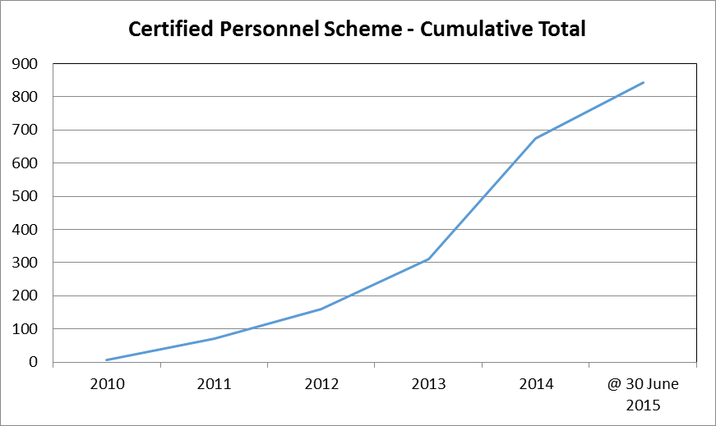

Figure 5 – Cumulative Total of IECEx Certified Personnel Certificates (CoC) at each Year end and to 30 June 2015

- Surveillance of the IECEx System
To ensure integrity of the System a range of measures and activities are undertaken within IECEx – these include:
- Initial Assessment and qualification of all ExTLs and ExCBs seeking to join IECEx
- Surveillance of all ExTLs and ExCBs (annual confirmation of accreditation for those with accreditation and annual site visits for those without accreditation)
- Re-assessment applied to all ExTLs and ExCBs involving assessment on site to review Testing/Certification facilities, capabilities, practices and review of Certificates, ExTRs and QARs files
- Mid-Term Surveillance Assessments (introduced in 2014) involving sample reviews of ExTRs and QARs
- In-built security features of the IECEx On-Line Certificate system - ie. ExCBs can only issue Certificates covering Standards within their scope
- IT Tools to aid in the management control of issued CoCs, ExTRs, QARs, FARs and PCARs
- “Out of Date” QAR listing to assist ExCBs manage and control the on-going surveillance due dates plus an Administrator feature for the Secretariat to monitor performance of all ExCBs.
- Review of On-Line System for Certificates issued in 2014 and 2015 YTD – the results of this review are outlined in 4.1 following.
4.1 Review of Online CoCs, ExTRs and QARs for second half of 2014 and 2015 Year to Date (2015 YTD)

Introduction
Separate to the sites assessment visits for Initial, Surveillance, Re-Assessment and Mid-Term purposes, the Secretariat also conducts regular reviews of online IECEx Equipment Certificates of Conformity. Since the 2014 meetings in The Hague, random sampling of approximately 10% of all certificates originally issued or updated by ExCBs for the IECEx Certified Equipment, IECEx Certified Service Facility and IECEx Certified Person schemes was conducted as detailed below.

Objective
The objective of the Secretariat’s on-line review is to conduct a Quality check that the information on the sampled Certificates is correct and complete as compared to a defined criteria which include the following:

For Certified Equipment Certificates:
- Date of issue appropriate (i.e. not showing in the future)
- A Test Report number and File Reference included.
- Manufacturer name detail is consistent with their other certificates
- Manufacturer’s site street (not a PO Box) address given
- Any attached Annex has a reference to the CoC number
- Referenced Annexes are attached
- Conditions of Certification listed for “X” type Certificates
- Equipment description is clear and sufficiently detailed
- No major editorial mistakes (including linking to a draft ExTR)
- Correct links to valid ExTR and QAR
- Linked QAR is current
- Manufacturer on CoC matches ExTR
- Manufacturer on CoC matches QAR and QAR covers all manufacturing locations
- Standards listed on CoC matches Standards (including Edition #) on ExTR
- Scope of Certificate matches QAR and ExTR ExCB capability.
- Type of Protection Concept on CoC matches standards and QAR
- Where more than 1 issue exists that they are linked and changes explained on CoC
- Statement of Limitations is included in CoC for Component certificates (“U” type)
- Unit Verification Certificates have been denoted with “V” and include Serial #(s)

For IECEx Certified Service Facility Certificates:
- CoC Date of Issue OK (not into the future)
- CoC and FAR addresses for applicant are valid (not PO Box)
- Scope of Services is valid
- Listed FAR is valid (ie. Is relevant and not expired)
- FAR Facility same as audited site
- FAR Details of change are specified (where appropriate)
- FAR specifies issuing ExCB
- CoC linked to multiple FARs (with some expired)

For IECEx Certified Person Certificates:
- Name on CoPC same as on PCAR
- CoPC is current / valid
- Scope of Competence Units same on CoPC as on PCAR
- Listed PCAR is valid (ie. Not expired)
- FAR specifies issuing ExCB
- Photograph is “recognizable”
- CoC linked to draft PCAR

Certificates and Reports reviewed
The following quantities of IECEx Certificates (representing a ~10% sample) selected at random from all those published in the second half of 2014 and 2015 YTD were audited against the elements listed above:
- 321 x IECEx Equipment CoCs
- 34 x IECEx Service Facility CoCs (with no issues found)
- 36 x IECEx Certified Person CoCs (with no issues found)

The results of the audit of IECEx Certified Equipment Scheme Certificates follow:

Item | Previously observed Certificate Deficiency as Review Criteria  for Certified Equipment Certificates reviewed. | # of CoCs with Deficiency
A | Date of issue NOT appropriate (i.e. showing in the future) | 0
B | A Test Report number or File Reference NOT included | 0
C | Manufacturer name detail NOT consistent with their other certificates | 0
D | Full Manufacturer’s site street address NOT provided (eg. a PO Box used) | 0
E | Attached Annex(es) do NOT reference the CoC number | 0
F | Referenced Annexes are NOT attached | 0
G | “Conditions of Certification” details NOT specified for “X” type Certificates | 0
H | Equipment description is NOT clear and sufficiently detailed | 0
I | Major editorial mistakes | 0
J | CoC is NOT correctly linked to valid ExTR and/or QAR (main issue observed was linking of an issued CoC to a draft ExTR) | 2
K | Linked QAR is NOT current | 3
L | Manufacturer on CoC does NOT match ExTR details | 0
M | Manufacturer on CoC does NOT match QAR details and/or QAR(s) does NOT cover all manufacturing locations listed on CoC | 7
N | Standards listed on CoC do NOT match Standards (including Edition #) on ExTR (main issue observed was CoC citing later Edition than ExTR) | 7
O | Scope of Certificate exceeds QAR and ExTR issuing ExCB’s capability | 0
P | Type of Protection Concept on CoC does NOT match standards and QAR | 1
Q | CoC Issues subsequent to Issue 0 are NOT linked and/or details of changes between Issues are NOT detailed on subsequent CoC | 0
R | “Statement of Limitations” details NOT included in CoC for Component certificates (“U” type) | 0
S | Unit Verification Certificates have NOT been denoted with “V” and/or do NOT include Serial #(s) for certified units of product | 0

In summary:
- IECEx Certified Equipment Certificates with zero issues = 301
- IECEx Certified Equipment Certificates with one issue = 16
- IECEx Certified Equipment Certificates with multiple issues = 4
- % of IECEx Certified Equipment Certificates audited with at least one issue = 6%
- % of IECEx Certified Equipment Certificates audited with multiple issues = 1%

Conclusion
The results of this review show an improvement on the results of a similar review conducted in 2014 and identifies a number of areas that require additional attention. The ExCBs observed to have issues with particular Certified Equipment Certificates have been very responsive in addressing these and proactive in taking action to prevent future recurrence.

- IECEx Achievements since 2014 IECEx Meetings in The Hague
Significant achievements since the 2014 ExMC Meeting include:

- Comments on Revised System + Scheme Rules

Document No. | Title
ExMC/987/CD | Comments on draft IEC Harmonised Basic Rules
ExMC/988/CD | Draft IECEx Supplement to the draft IEC Harmonised Basic Rules

- New and Updated Publications of IECEx Operational Documents and Guides

Document No. | Title
OD 003-2  Ed 2.0 | Assessment Procedures for IECEx acceptance of Candidate Accepted Certification Bodies (ExCBs) and Ex Testing Laboratories (ExTLs) – Part 2: Assessment, surveillance assessment and re-assessment of ExCBs and ExTLs operating in the IECEx 02, IECEx Equipment Scheme
OD 011-1  Ed 4.1 | Guidance on Use of the IECEx Internet based “On-Line” Certificate of Conformity System, Part 1: General Information
OD 011-2  Ed 4.4 | Guidance on Use of the IECEx Internet based “On-Line” Certificate of Conformity System, Part 2: Creating IECEx Equipment Certificates of Conformity CoCs
OD 011-3  Ed 1.3 | Guidance on Use of the IECEx Internet based “On-Line” Certificate of Conformity System, Part 3: Creating IECEx Service Facility Certificates of Conformity CoCs
OD 011-4  Ed 1.3 | Guidance on Use of the IECEx Internet based “On-Line” Certificate of Conformity System, Part 4: Creating IECEx Conformity Mark Licenses
OD 011-5  Ed 1.1 | Guidance on Use of the IECEx Internet based “On-Line” Certificate of Conformity System Part 5: Creating IECEx Certificates of Personnel Competence CoPCs
OD 034  Ed 2.0 | Operational Document - Guidance on the preparation of IECEx Equipment Certificates and Reports covering more than one identifiable item of equipment
OD 233  Ed 1.0 | IECEx Certified Equipment Scheme - Assessment of Ex “s” Equipment – English and Portugese Versions
OD 503  Ed 3.0 | IECEx Scheme for Certification of Personnel Competence for Explosive Atmospheres – ExCB Procedures for issuing and maintaining IECEx Certificates of Personnel Competence (3rd Edition) - Portuguese Version
OD 504  Ed 3.0 | IECEx Scheme for Certification of Personnel Competence for Explosive Atmospheres – Specification for Units of Competence Assessment Outcomes (3rd Edition) - Portuguese Version
OD 506  Ed 1.0 | Guidance on the use of the IECEx Certificates of Personnel Competence Scheme’s Assessment Question Bank by ExCBs( 1st Edition) – English and Portugese Versions
OD 521  Ed 1.0 | IECEx Scheme for Certification of Personnel Competence for Explosive Atmospheres - IECEx Recognised Training Provider Program – English and Portugese Versions

- 2015 IECEx International Conference
Successful operation of the third International IECEx Conference by run by IECEx in conjunction with the IECEx Member Body for Poland, UDT, in Gdansk, Poland over 22nd and 23rd April 2015. This year’s conference was attended by 134 delegates from 19 countries and generously supported by sponsors, exhibitors and international speakers. The 2015 Conference website is maintained throughout 2015 showing Program and Presentations and listed Sponsors http://www.iecex.com/gdansk/

We also look forward to replicating the success of Dubai 2012, Malaysia 2014 and Gdansk 2015 IECEx International Conferences at a similar event planned for 16th and 17th March 2016 in Delhi, India.

- 2015 series of IECEx Operational Meetings
The 2015 series of IECEx Operational Meetings were held in Toronto, Canada over 18th to 23rd May 2015 hosted by QPS Evaluation Services Inc. Meetings held included:

Date | Meeting
Monday, 18 May 2015 | IECEx ExPCC WG4
Tuesday, 19 May 2015 | IECEx WG1 + WG5
Wednesday, 20 May 2015 | IECEx ExPCC
Thursday, 21 May 2015 | AM: ExMarkco
Thursday, 21 May 2015 | PM: IECEx ExMC WG13
Friday, 22 may 2015 | IECEx Executive
Saturday, 23 May 2015 | IECEx ExMC WG15

- Scheme Promotional Activities
As part of the IECEx promotion and marketing strategy, the IECEx Executive and Secretariat continue in delivering presentations at key events in addition to supporting IECEx experts in their national and regional promotion of IECEx. The following are examples of recent or upcoming promotional activities of the IECEx System:
- 2015 IECEx Conference in Gdansk, Poland
- 2015 PCIC Europe participation
- 2015 PCIC Middle East participation
- 2015 GSO Conference, Riyadh, Saudi Arabia – March 2015
- 2015 China IECEx Conference
- IECEx Industry Symposium, Singapore – April 2015
- 2015 NEK / PreSafe / Trainor / IECEx Secretariat ‘Norway Roadshow’ – April 2015
- Belgium NC consultation meeting – June 2015
- Monthly news articles in all IEC e-Tech on-line magazines, library maintained at http://www.iecex.com/news_releases.htm
- Regular news articles published in HazardEx prepared by IECEx experts including Thorsten Arnhold, Ron Sinclair, Jim Munro and Others

The IECEx Chairman, Executive and Secretariat remain available to provide any additional information on these items or assistance with the preparation of any presentations that Members may be involved with.

- Secretariat and General Technical Administration

7.1 Day to day duties of the Technical Secretariat can be broadly categorized as:
- Processing applications and managing assessments of new bodies and re-assessment of existing bodies
- Processing the applications of Scope extensions, e.g. new editions of Standards and other changes, e.g. name changes of existing bodies along with their maintenance via surveillance and re-assessments
- Support to ExCBs in the day to day use of the Centralised On-Line CoC system
- Revision and up dating of IECEx Schemes rules and Operational Documents and forms
- IECEx Schemes development and Growth across all IECEx Schemes
- In conjunction with Chairman and Officers, IECEx System regular reporting to CAB and participation in CAB Working Groups
- Respond to general inquiries from industry
- Day to day management of System finances, in conjunction with Treasurer and Executive

  - As an indicator of the IECEx System development and growth, since the first Report card issued in 2008 IECEx Paris meetings, the following additional statistics are provided:

General items prepared and issued according to the day to day management and operation of the IECEx System are provided below with a comparison to the figures reported at the 2007, 2008, 2009, 2010, 2011, 2012, 2013 and 2014 presented in ExMC/390/Inf, ExMC/461/R, ExMC/544/R, and ExMC/621/R, ExMC/699/R, ExMC/749/R, ExMC/859/R and ExMC/938/R (updated for the full year of 2014) respectively.

ITEM | 2007  (ExMC/390/Inf) | 2008  (ExMC/461/R) | 2009  (ExMC/544/R) | 2010  (ExMC/621/R) | 2011  (ExMC/699/R) | 2012  (ExMC/749/R) | 2013  (ExMC/859/R) | 2014  (ExMC/938/R) as updated for full year | 2015 @ 30 June
Committee Documents Prepared and Issued¹ | 62 | 104 | 136 | 124 | 148 | 152 | 153 | 168 | 97
Operational Documents (new or revised) | 7 | 5 | 7 | 13 | 13 | 5 | 18 | 21 | 9
ExTAG Decision Sheets Issued | 2 | 5 | 1 | 6 | 6 | 6 | 11 | 5 | 5
IECEx Guides (new or Revised) | 0 | 4 | 0 | 1 | 1 | 3 | 0 | 4 | 1
IECEx Scheme Rules  (new or revised) | 0 | 2 | 1 | 3 | 3 | 2 | 5 | 3 | 0
Others, e.g. News articles | 7 | 15 | 11 | 14 | 32 | 23 | 11 | 17 | 8
Total IECEx Items issued ² | 78 | 135 | 156 | 161 | 203 | 191 | 198 | 218 | 120
¹ Comprises ExMC, ExTAG, ExMarkCo, ExPCC
² Total excludes other items such as reports to CAB and participation in CAB and related Working Groups

7.3 Mobile Device Application for Smart Phones and Pad Devices (iPhone/iPads)
In response to request from users of the IECEx System seeking ease of access to IECEx Certificates of Conformity, especially while in the field, IEC and IECEx launched the IECEx Mobile Application in 2013. While a first for IECEx it is was also a first for IEC as it entered the “Mobile Applications” Domain.

Development work is now being finalized on the next generation of the App that will include On-Line and Off-Line mode access to Certificates from the 02, 03 and 05 IECEx Schemes plus the usual keyword search capabilities.

7.4 E-mail Traffic, handled by Secretariat (excluding those dealt with by IECEx Chairman, Officers, WG Conveners, Members and Assessors):
The following level of e-mail traffic was handled by the IECEx Secretariat and does not include additional mails dealt with by the IECEx Chairman, Officers and Assessors. These figures are provided as a guide to IECEx Members of the levels of IECEx activity and show a constant level of e-mails in comparison with 2007, 2008, 2009, 2010, 2011, 2012, 2013 and 2014 figures.

ITEM | 2007  (ExMC/390/Inf) | 2008  (ExMC/461/R) | 2009  (ExMC/544/R) | 2010  (ExMC/621/R) | 2011  (ExMC/699/R) | 2012  (ExMC/749/R) | 2013  (ExMC/859/R) | 2014  (ExMC/938/R) as updated for the full year | 2015 @ 30 June
Total E-mail Traffic of the IECEx Secretariat | 16,150 | 17,500 | 17,300 | 18,200 | 18,880 | 19,660 | 21,055 | 22,812 | 11,588
* Out of office or other miscellaneous e-mails have been filtered and are excluded from above figures

7.5 Management of Assessments + Applications for Scope extensions – all IECEx Schemes.

ITEM | 2007  (ExMC/390/Inf) | 2008  (ExMC/461/R) | 2009  (ExMC/544/R) | 2010  (ExMC/621/R) | 2011  (ExMC/699/R) | 2012  (ExMC/749/R) | 2013  (ExMC/859/R) | 2014  (ExMC/938/R) | 2015 YTD
Site assessments | 22 | 19 | 17 | 14 | 17 | 23 | 19 | 25 | 21
Scope extensions | 32 | 32 | 37 | 42 | 89  Standards  / Units  43 Applications | 81  Standards  / Units  38  Applications | 61  Standards  / Units  30  Applications | 46  Standards  / Units  28  Applications | 162  Standards  / Units  75  Applications
Mid-term Surveillance  Audits |  |  |  |  |  |  |  | 6 | 8  (reports pending)

The above Table outlines the number of IECEx site Assessments conducted on Ex Certification Bodies and Ex Test Laboratories for Initial, Surveillance, Re-assessments and Mid-term purposes.

Following the ExMC Decision during the 2013 Fortaleza meeting to introduce a “mid- term” surveillance audits of ExCBs and ExTLs, the IECEx Secretariat commenced the implementation of this decision during 2014 using procedures and criteria detailed in IECEx Operational Document OD 003-2. Members are reminded that these mid-term surveillance audits are focused on the re-assuring of confidence in the technical capability of the Test Lab and Certification Body by focusing the assessment on issued ExTRs and QARs as well as the Certificates issued. The main purpose is to establish whether or not the scheduled five year re-assessment should be brought forward on the basis of any issues identified OR that it may remain as originally scheduled.

The Secretariat is pleased to report on the excellent cooperation with ExCBs and ExTLs noting the mid-term assessments conducted to date in 2014 and 2015 on the following ExCBs and ExTLs:
- FTZU of CZ
- SIMTARS of AU
- TUV Nord of DE
- TestSafe of AU
- VTT of FI
- BKI of HU

We are pleased to advise that following mid-term surveillance visits the technical assessors have not raised any major issues that bring into question either the on-going acceptance of the ExTL or ExCB nor the need to bring forward the 5 year planned re-assessment. Other midterm assessments are currently underway.

- Finances

8.1 Overview
The sound financial performance of IECEx is reported in the 2014 Audited Accounts, ExMC/1023/DV. In summary income and expenditure were generally according to the approved 2014 Budget, with income above budget and expenditure contained to below budget.

8.2 Invoices Issued / Processed since 2014 ExMC Meeting
The day to day management of financial management activities for the IECEx system are detailed in the following table of invoices and statements being issued as well as monitoring the receipt of payments

Documents | Reported for 2010 | Reported for 2011 | Reported for 2012 | Reported  for 2013 | Reported for 2014 | Reported for 2015 YTD
Invoices issued – Annual Fees | 33 | 33 | 33 | 33 | 33 | 33
Statements Issued – CoC Fees | 66 | 71 | 77 | 83 | 89 | 45
Invoices Issued – CoC Fees | 58 | 63 | 69 | 75 | 76 | 51
Invoices Issued – Application Fees | 1 | 4 | 3 | 2 | 6 | 11
Invoices Issued – Assessment Fees | 17 | 17 | 26 | 14 | 18 | 22
Invoices processed / Central Approval – Assessor Charges | 33 | 34 | 50 | 50 | 55 | 38
TOTAL Invoices issued and processed | 208 | 222 | 258 | 257 | 277 | 200

In noting the following:
- overall response to on-time payment of invoices by Members generally good
- income being maintained above 2015 approved budget

We are pleased to advise that there are no specific issues concerning finance at this time. A further update report will be given during the 2015 ExMC meeting by the Treasurer and Secretary.

9 Concluding Remarks
IECEx continues to enjoy significant and sustained growth in both exposure and demand for its services. The Global Financial crisis has appeared to have little effect on overall demand for IECEx other than to assume that the current annual rate of growth may have even been higher. Despite impressive annual growth and the following indicators of continued growth in the future:
- Growth in number of Certificates and Reports
- Growth in income, mainly from certificate fees
IECEx continues to maintain a conservative approach to budgetary planning.

The instant and “On-Line” nature of the IECEx Certification system based on electronic format master controlled certificates coupled with the increased industry involvement in the Scheme’s operation are seen as a significant drivers of interest and demand for IECEx. It is worth noting that Certificates issued by ALL IECEx Certifiers are found in the one single location as opposed to the need to search individual ExCB websites.

The continued growth and success of IECEx is founded on the solid participation by various sectors of industry in the day to day management of the IECEx System via participation in ExMC, its Committees and the various Working Groups. Over recent years we have seen a growing level of this industry participation, especially from end-users and also regulators as well as manufacturers and Ex repairers. This participation and contribution is a key ingredient to the success that the IECEx community continues to enjoy.

The Secretariat acknowledges, with gratitude, the diligent leadership of the IECEx Chairman, supported by the IECEx Executive along with Conveners of the many expert Working Groups and their experts all of which are vital to enable IECEx to continue in its quest to serve the international Ex community.

Chris Agius
IECEx Executive Secretary
August 2015

