IECEx Operational Document

IEC System for Certification to Standards relating to Equipment for use in Explosive Atmospheres

OD 011-2
Guidance on Use of the IECEx Internet based “On-Line” Certificate of Conformity System – Second Generation
Part 2: Creating IECEx Equipment Certificates of Conformity CoCs and supporting Reports (ExTR Summary and QAR Summary)

CONTENTS

1 IECEx Equipment Certificates of Conformity (CoCs) 5
1.1 General Information 5
1.1.1 System 5
1.1.2 Passwords Secure Access 5
1.1.3 Further Guidance 5
1.1.4 Printing CoCs as documents and PDF files 5
1.2 Notes for each field of the Certificate 6
1.2.1 Certificate No: 6
1.2.2 Ex Component Certificates 6
1.2.3 History 6
1.2.4 Status 6
1.2.5 Date of Issue 7
1.2.6 Issue No. 7
1.2.7 Applicant 7
1.2.8 Equipment (name) 8
1.2.9 Type of Protection 8
1.2.10 Marking 8
1.2.11 Approved for issue on behalf of the IECEx Certification Body 8
1.2.12 Position 8
1.2.13 Signature (printed version only) 9
1.2.14 Date (printed version only) 9
1.2.15 Manufacturer 9
1.2.16 Manufacturing locations (Where more than one) 9
1.2.17 Standards 9
1.2.18 IECEx Test & Assessment Report Summaries (Test Report Summary (ExTR) and Quality Assessment Report Summary ( QAR)) 9
1.2.19 Equipment (Field) 10
1.2.20 Specific Conditions of Use 10
1.2.21 Annex and Attachments 10
2 Creation of a new IECEx Equipment Certificate of Conformity 12
2.1 Entering new CoC details 12
2.2 Entering ExTR and QAR details 14
2.3 Formatting Features 15
2.4 Creating a “New Issue” of an existing CoC 15
3 Entering Registration of an IECEx ExTR Summary 16
3.1 Registration of a new IECEx ExTR Summary 16
3.2 Notes for the various fields of an ExTR Summary: 17
3.3 Supplementary or changes to an issued ExTR Summary 18
4 Registration of an IECEx QAR Summary 19
4.1 Registration of a new IECEx QAR Summary 19
4.2 Notes for the various Fields of an IECEx QAR Summary: 20
4.3 Supplementary or changes/updates to an Issued QAR Summary 22
4.3.1 Application: 22
4.4 Management of the validity of QAR Summaries and linked Certificates 22
5 Creation of an UNIT VERIFICATION type of IECEx Equipment Certificate of Conformity 23
5.1 Entering new Unit Verification CoC details 23
5 Section 5 Creating IECEx Equipment Unit Verification Certificates of Conformity 31
5.1 Entering new Unit Verification CoC Details………………………..…….……………. 231

ANNEX A Typical Scenarios and Process Outcomes in Managing QARs ……………….. 36

INTERNATIONAL ELECTROTECHNICAL COMMISSION

IECEx Operational Document OD 011-2

Guidance on Use of the IECEx “On-Line” Certificate of Conformity System
Part 2: Creating IECEx Equipment Certificates of Conformity CoCs

INTRODUCTION

This Operational Document provides guidance for IECEx Certification Bodies (ExCBs) when creating IECEx Equipment Certificates of Conformity (CoCs) using the IECEx Internet based “On-Line” Equipment Certificate of Conformity System.
OD 011 consists of five parts as follows:
OD011, Guidance on Use of the IECEx Internet based “On-Line” Certificate of Conformity System
OD 011-1 Part 1: General Information
OD 011-2 Part 2: Creating IECEx Equipment Certificates of Conformity CoCs (This part)
OD 011-3 Part 3: Creating IECEx Service Facility Certificates of Conformity CoCs
OD 011-4 Part 4: Creating IECEx Conformity Mark Licenses
OD 011-5 Part 5: Creating Certificates of Personnel Competence
OD 011-10 Part 10: IECEx OCS Back Office
This Document should be read in conjunction with OD 011-1, Part 1: General Information. As a means of promoting the IECEx and its Members, OD 011-1 has been prepared in a format suitable for public access.
Inquiries relating to this IECEx “On-Line” CoC System or any other aspect of the IECEx Scheme may be directed to the IECEx Secretary, Mr Chris Agius using the contact details below.
Document History

Date | Summary
2003 08 | Original Issue (Edition 1)
2009 05 | Edition 4.2 This edition of IECEx OD 011-2 has been issued to take into account a number of editorial formatting changes. Clause 1.2.2 has been updated. The Annexes in the previous edition have been redesignated as Sections.
2010-08 | Edition 4.3 This edition of IECEx OD 011-2 has been issued to edit how “Related Certificates” are recorded in all issues of a QAR, provide printing guidance and make reference to Part 5.
2015-02 | Edition 4.4 This edition of IECEx OD 011-2 has been issued to (1) take into account a number of editorial layout changes to a QAR and (2) incorporate the content of the Special Addendum to IECEx OD 011-2 Edition 1 as Section 5.  Also a number of Clauses have been updated. Changes are shown with a “Red” margin.
2019_01 | Edition 4.5 This edition created to reflect changes of layout and imagery of on-line Certificate System
2019_11 | Edition 5.0 is a complete revision to cover the use of the second generation of IECEx On-line Certificate System (IECEx OCS)

Address:  IECEx Secretariat  Level 33, Australia Square  264 George Street  Sydney NSW 2000  Australia |  | Tel: +61 2 4628 4690  Fax: +61 2 4627 5285  Email: chris.agius@iecex.com

Guidance on Use of the IECEx “On-Line” Certificate of Conformity System
Part 2: Creating IECEx Equipment Certificates of Conformity CoCs

IECEx Equipment Certificates of Conformity (CoCs)

General Information

System
The IECEx CoC System is based on the IECEx On-line Certificate System (“IECEx OCS”) that uses HTML as per most Web based documents. The items below provide guidance to ExCBs when creating CoCs.

Passwords Secure Access
The IECEx OCS uses a two level password system (as outlined in IECEx OD 011-1 and below) to provide the necessary security for the content of IECEx Certificates and supporting Reports.
- A 1st level password (that provides ExCBBasic access rights) that the ExCB’s Official IECEx representative may provide to various staff within their organisation, to enable them to create a new certificate as a Draft. This level password will enable the staff member to create a new draft certificate and save it as a draft. It WILL NOT allow them to change the status from “Draft” to “Current”.
- A 2nd level password (that provides ExCBAdmin access rights) that is assigned to the official IECEx representative for issue only for the function that is authorised (within the ExCB management system) to formally issue certificates. This 2nd level password enables the person the same access as the 1st level password PLUS the authority to change the Status from “Draft” to “Current”.
The two levels of passwords mean that entering certificate information can be done by staff within the ExCB other than the certification authority. The 2nd level password ensures that there is the final check by the authorised person.
It is most important that the ExCB’s official representative to IECEx ensures that these passwords are kept secure and that they notify the IECEx Secretary immediately, of any possible breaches of security as new passwords can be assigned.

Further Guidance
For further information or guidance on using this new IECEx OCS please contact the IECEx Secretariat.

Printing CoCs as documents and PDF files
The second generation IECEx OCS displays and stores IECEx Certificates and Reports as PDF files – the following guidance is provided to assist with printing CoCs from the IECEx OCS as hard copy documents.
The preferred browser is Internet Explorer 10 or later. Compatibility with other browsers like Google Chrome is maintained, but should functional issues occur, revert back to Internet Explorer.

The facility to ‘‘download’ CoCs to electronic files in PDF format is available (uncontrolled version) however it should be understood that these are uncontrolled copies and may not represent the latest version that is maintained on the IECEx OCS as the Master version. Also,
please note that PDF files ‘printed’ by public users are secured files that cannot be edited. They should also be referred to as uncontrolled versions, as any subsequent changes or edits to the on-line master version CoC (controlled copy) will differ from the previous PDF version.

To accommodate the need for ExCBs to provide uncontrolled copies of certificates with electronic signatures and other additions the facility for ExCBs to ‘print’ CoCs as unsecured PDF files exists – this requires the ExCB to login using their password (refer Section 1.1.2) and then open the file to be ‘printed to PDF’ and use the “print to pdf’ tool – this will create an unsecured PDF file that can be edited using Adobe Acrobat or similar software to insert text, images, etcetra.

Notes for each field of the Certificate

Certificate No:
The certificate number consists of the following characters:
IECEx YYY ZZ.0000
The “0000” field is automatically generated by the System and advances in number by “1” for new versions.
Note that a facility exists to add a suffix to the certificate number to denote that additional information (such as conditions or exclusions to the certificate) exists within or attached to the certificate.
Concerning the use of the “X” suffix to cover conditions, this suffix is automatically added to the certificate number when the ExCB selects “YES” to the field “Specific Conditions of Use” when creating a normal Equipment certificate (ie, NOT an Ex Component type certificate).
The use of the “U” suffix indicates that the certificate relates to the certification of a component. Ex Component certificates may be issued for items of equipment that will not and cannot be used independently or separately from other equipment or components.

Ex Component Certificates
When an ExCB is preparing a Ex Component Certificate the Component Certificate option needs to be selected under the Report / Certificate type section after selection of the Create icon. This will then select the Component Certificate template which contains the necessary features that are required for a Component Certificate, including the “Label Header” and “Schedule of Limitations” fields. The option also exists to select “Unit Verification” by clicking the Unit Verification button for a Component Certificate. When up-issuing an old current version Component Certificate (pre-June 2018) the new template will be automatically used when the Component Certificate button is selected.

History
All new CoCs will contain a “History” block. The History block will show all the Issues of a particular CoC that have been created and the respective date. Also each “Issue” entry is an active link to that particular Issue of the CoC.

Status
Operational Document OD 011-1 provides an explanation of the Status options. The “Draft” status should be selected when the ExCB is compiling or preparing the CoC. When saved as a Draft, the CoC remains on the System BUT IT CANNOT be viewed by other ExCBs or the public.

When ready to formally issue the CoC, the issuing ExCB re-enters the IECEx CoC “On-Line” System and then selects the Draft CoC. Once the Draft CoC appears, the ExCB then selects “Edit” from the options located directly above the CoC. This then opens all fields of the Draft CoC ready for any last-minute changes. Once complete and ready to issue, the issuing ExCB (using a level 2 password access) changes the “Status” field from “Draft” to “Current” and then selects the “Save” option, located directly above the certificate. This step is regarded as the ExCB’s official “Decision to Issue” the certificate, which is similar to the ExCB’s Authorizing Officer signing a paper certificate.

Please note that a Current CoC may only be edited by the ExCB in the first 14 days following the entered Issue Date regardless of the date it was made Current. Should minor edits of the CoC be required after the 14 day period, the ExCB should contact the Secretariat who can change the status of the CoC back to draft for the minor edits. The ExCB must not change the issue date of the CoC when they save and make the draft CoC Current. If a significant amount of time has lapsed between the issue date and the request to amend the CoC, the Secretariat reserves the right not to put the CoC back to draft, and the ExCB will be required to up-issue the CoC to implement any changes to the CoC.

Once saved as “Current” the CoC is then available for anyone to view or print.

Once a CoC is issued as Current, the issuing ExCB must include the manufacturer under a surveillance program (QAR), in accordance with the IECEx Operational Document OD 025 and OD 009. During this surveillance program, an ExCB may identify the need to change the status of an IECEx CoC from Current to Suspended or even Cancelled (refer also to IECEx OD 209). In this case the ExCB should contact the IECEx Secretariat for assistance as per section 2.2 of this OD.

Date of Issue
The Date of Issue should be regarded as the date on which the ExCB is satisfied that all the requirements of the IECEx System have been satisfied.

Issue No.
The Issue Number acts as a change control device to record the number of changes that have been made to the CoC, with “Issue No. 0” representing the “Original Issue”.

Examples of changes to an IECEx CoC which would require a new version of a CoC cover two broad areas of Administrative and Technical changes. These include:
- Change of Company Name or Certificate Holder;
- Change of product design;
- Change in Manufacturing location;
- Change in ExCB conducting audits and issuing the QAR.
It is imperative that the ExCB understand that the CoCs they issue, are their responsibility. For further details contact the IECEx Secretariat.

Where a manufacturer requests a change to an IECEx CoC, the ExCB must first judge whether such a change is appropriate or whether the change is so great that a new CoC should be issued. An example of this would be the adding of a new series of product models this may be best dealt with by the issuing a new certificate and considered a technical change.

It should be noted that when conducting an audit visit of manufacturers, the one audit visit and hence one IECEx Quality Assessment Report (QAR) might be used to cover more than one IECEx CoC. For example, the one audit visit and one QAR may be used by a manufacturer holding an IECEx CoC for motors and another IECEx CoC for luminaries providing both manufacturing areas are covered during the audit visit.

When an ExCB issues a change to a CoC, the ExCB must include the details of the change in the “Details of Certificate Changes” field. The “Details of Certificate Change” field has been made mandatory and must contain the details before the CoC can be saved.

NOTE: all versions of IECEx Certificates are all available for public view so there is no need to try to include information about every variation of product or standard on the latest version of a certificate series”

Applicant
This section of the CoC normally reflects the name and address of the manufacturer, however the location shown may be the head office of the manufacturer, which can be different to the location of manufacture of the product (refer 1.2.16 – Manufacturer below) shown on page 2 of the CoC. For equipment produced or sold under license, the applicant name and address may be the name and address of the licensee (See IECEx 02, Clause 3.16 and 9.8), but the name and address of the manufacturer are still required to be shown (1.2.16) on page 2 of the CoC.

Equipment (name)
Requires name of equipment and a brief description of the product (that may be an apparatus, fitting, device, component), in terms of its type, function or application and may include details of model or range numbers or names. The equipment name may also assist the public with the search features to identify what they may be looking for, example ‘gas detector’ model xxx. Details of all models in a range should be included in the “Equipment” field to enable readers to determine if a certificate applies to equipment on-site.

If an Ex Component Certificate has been selected, then this field will be referenced as Ex Component.

Optional accessory:
In most cases this may not be required. Again, if there is insufficient space more information may be included in, with a reference to, the Certificate Schedule.

Type of Protection
Relates to the name of the type (or level) of Ex protection, for example, Increased Safety “e”

This should show the type of protection, followed by the symbol for each type of protection including any “a”, “b” or “c” suffix designations if applicable. The following are examples of what should be shown in this field:
- for an IECEx CoC involving IEC 60079-1, IEC 60079-7 and IEC 60079-0 for EPL Gb, this field should read - - Flameproof “d” and Increased safety “e”
- for an IECEx CoC involving IEC 60079-11 and IEC 60079-0 for EPL Ga, this field should read - - Intrinsic safety “ia”
- for an IECEx CoC involving IEC 60079-7, IEC 60079-28, IEC 60079-31 and IEC 60079-0 for EPL Gb, this field should read - - Increased safety “e”, Inherently safe optical radiation, “op is” and Equipment dust ignition protection by enclosure “t”

Further guidance on Types of Ex protection, their accepted descriptions and identifiers (eg. Flameproof enclosures “d”) and the relevant Standards is provided in IEC 60079-0, Clause 1.

Marking
This should show what would be seen on the marking plate concerning the Ex aspect of the product, including the way the Certificate Number should appear.

This should show the Ex marking string as detailed in IEC 60079-0, including the symbol Ex, the symbol for each type of protection used, the symbol of the group, the maximum surface temperature, the equipment protection level and the range of ambient temperature or the symbol “X”, where appropriate.

As an example, a product to be marked with “Ex d IIC T4 IP65” must have this ‘marking string’ defined in the Marking field of the Certificate.

Further guidance on marking requirements and examples of acceptable formats can be found in IEC 60079-0, Clause 29.

Approved for issue on behalf of the IECEx Certification Body
This name should be the person within the ExCB authorized, in accordance with the ExCB’s quality system, to issue Certificates. In many cases this person is regarded as the ExCB’s “Signatory”.

Position
This is the title of the signatory’s position within the ExCB.

Signature (printed version only)
This space has been provided for instances where an uncontrolled paper certificate or a copy of a certificate, endorsed by the issuing ExCB may be required. The blank space for signatures only appears when the Certificate is printed as a hard copy.

Date (printed version only)
This space is intended for paper copies of the certificates and is the date when the IECEx Certificate of Conformity is signed.

Manufacturer
The name and address of the organization that produces the product (refer to IECEx 02, clause 3.17) except for licensed equipment (See IECEx 02, Clause 9.8). The address listed should be the location where the product is principally produced. A physical (street) address is required and a Postal Box number is not acceptable.

Manufacturing locations (Where more than one)
This space is for the inclusion of more than one manufacturing site. When selecting additional manufacturing locations, it is necessary to “Save” the Draft CoC first then “Edit” to add more Locations. Once the information has been entered it may be deleted/edited as required. When a New Issue of a CoC is raised (See Section 2.2) all existing Locations from the Previous issue is copied into the New Issue. These existing Locations maybe deleted/edited and new Locations added in the New Issue. Previous Issues must not and cannot be changed.
All manufacturing locations MUST be listed on the CoC and the QAR or QARs selected in the CoC should accurately reflect the manufacturing locations. At present a maximum of 10 manufacturers can be added to one CoC.

Standards
These are the standards covered by the Certificate of Conformity. The ExCB can only add to the CoC those Standards that are within the approved scope of the ExCB.

IECEx Test & Assessment Report Summaries (Test Report Summary (ExTR) and Quality Assessment Report Summary (QAR))

IECEx Test Report (ExTRs) Summary
The reference number of each IECEx Test Report Summary is automatically assigned by the IECEx OCS. Generally, an ExTR will have been issued before it comes time to create a CoC. Therefore the ExCB must use the “Insert/delete ExTR” to insert a link to the appropriate ExTR. The CoC must reflect the Standards and the editions thereof that are listed in the ExTR. [Refer to Section 3 for further guidance and also IECEx OD 010, Operational Document - Guidance for the Preparation of IECEx Test Reports (ExTRs) by IECEx Certification Bodies (ExTRs) and the Processing of ExTRs by Receiving ExCBs”, Parts 1 and 2]

IECEx Quality Assessment Report (QAR) Summary
The reference number of each IECEx Quality Assessment Report Summary is automatically assigned by the IECEx OCS. Generally a QAR will have been issued before it comes time to create a CoC. Therefore the ExCB must use the “Insert/delete ExQAR” to insert a link to the appropriate QAR. [Refer to Section 4 for further guidance and also IECEx OD009, IECEx Certified Equipment Scheme - Procedures for the Issuing of IECEx Certificates of Conformity, IECEx Test Reports and IECEx Quality Assessment Reports.]
When a CoC is up-issued it is good housekeeping to select the latest version of the QAR and remove the old version of the QAR unless there is good reason to use both versions to support the updated CoC. It is also important that should a manufacturing location change, the latest version/s of the QAR is used and old version/s are removed from the CoC. Essentially, the up-issued CoC should reflect the current status of the QAR or QARs.

Equipment (Field)
This field on the certificate is where detailed information is entered to clearly describe the product(s) covered by the IECEx CoC. A “clear description” of a product (that may be an apparatus, fitting, device or component) should include its type, function or application and may include details of model or range numbers or names. If there is insufficient space for all relevant details eg. for all models in a range, these additional details should be included in an Annex attached to the Certificate and referenced in the Equipment field.

The use of only a brand, range name or a Model or Range designation in this field is not permitted.
As with all other fields, this field accepts basic text being entered directly into the field. A formatting feature is provided to allow special characters to be directly entered into the Certificate – it is suggested that this be used as an alternative to ‘pasting’ formatted text from other documents.
NOTE: In instances where an applicant or ExCB attempts to include large amounts of text or large tables in this field the system will display a “Warning” message but the CoC can still be saved. In such cases it is recommended that the information be included in an attachment to the CoC.

Specific Conditions of Use
Where Specific Conditions of Use are relevant to a particular item of IECEx Certified equipment the Specific Conditions of Use = “YES” option box must be checked. This will automatically assign an “X” after the IECEx CoC number.
Note: The symbol “X” is used to provide a means of identifying that essential information for the installation, use, and maintenance of the equipment is contained within the certificate. (refer Clause 3.53 of IEC 60079-0)
NOTE: If the inclusion of large amounts of text or large tables are included in this field and if the content of this field is very large, a “Warning” message will display but the CoC can still be saved. In such cases it is recommended that the information be included in an attachment to the CoC.
NOTE: IEC TC31 reminds ExCBs that IEC 60079-14 is for installation requirements and does not cover conditions of use for IECEx certificates other than noting they shall be met (in addition to the requirements of IEC 60079-14). To avoid user confusion, IECEx Certificates must not mention a Specific Condition of Use for anything that is covered in IEC 60079-14 because the inclusion of conditions of use which are covered in IEC 60079-14 can create a problem for users where there is any discrepancy in the wording or implied conditions between the certificate and IEC 60079-14. In these cases, users may be unsure as to which document they are required to comply with. For example, since IEC 60079-14 covers the requirements for allowable types of glands with different types of Ex equipment, all certificates should be silent on gland details.

Annex and Attachments
The IECEx “On-Line” Certificate of Conformity System provides a facility for the addition of attachments or annexes to the certificate by selecting the CHOOSE NEW FILES TO UPLOAD icon to enable the addition of attachments or annexes to the CoC.
Any annex or attachment to the CoC MUST contain the following information as a minimum:
- The words “Addendum to IECEx Certificate …………” or “Annex to ……” on the first page.
- IECEx CoC Reference Number (on all pages)
- Page Number and Total number of Pages (on all pages), e.g. “Page 1 of X”
- Clear details of the information

The preferred file format for annexes and attachments is unsecured PDF as this format enables the option of printing the CoC and associated annexes or attachments to a PDF document.

The annex MUST NOT be used as an alternative to providing a clear description in the Equipment Field. Important equipment information, including equipment description must be included in the CoC. This also enhances the capability of search feature that only interrogate the content of the CoCs (and not the Attachments).

Creation of a new IECEx Equipment Certificate of Conformity

Entering new CoC details
STEP 1: Select “View Certificates & Licenses” from IECEx Website: www.iecex.com

STEP 2: Select ExCB Login and then log on using the assigned user name and password.

STEP 3: Select “Create”

STEP 4: Select type of Certificate or Report

STEP 5: Select the icon to open edit mode, then add details (IECEx OD 011-1 provides more guidance on data entry processes etc.) and then save as either status = Draft or Current.
Note that some fields (for example, the Applicant field) utilise the ‘auto-suggest’ tool that draws on data already in the IECEx OCS that can be selected so as to avoid the need to type content. The facility also exists to add details to the IECEx OCS database by creating new identities.
You will notice the Status options of “Suspended” and “Cancelled” in addition to “Draft” and “Current” – please contact the IECEx Secretariat for assistance in setting an issued CoC to either “Suspended” status (eg. to enable correction or resolution of problems before restoring to “Current”) or “Cancelled” status (eg. in the situation where a manufacturer no longer needs the CoC or no longer manufactures the product covered by the CoC) It is important to note that Cancellation is permanent and “Cancelled” CoCs cannot be restored to “Current”. Before contacting the Secretariat for assistance in changing a CoC’s status please advise the CoC’s applicant of intended action and agree on a date of effectivity of the cancellation or suspension – the Secretariat will edit the CoC to include this and a comment on the reason for status change as part of the process status editing. IECEx OD 209 provides more detailed information about the suspension and cancellation of certificates.

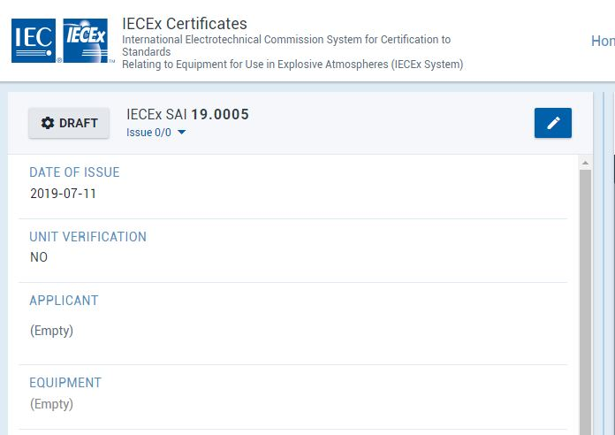

The status of a Certificate or Report can be changed by an ExCBAdmin level user by clicking on the status indicator to reveal the Change issue status icon The status options available to ExCBs are presented in the “Update Status” window when editing a certificate or report – refer example (that shows the full range of options – the actual options vary according to access level rights) below:

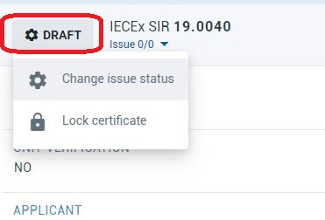

Entering ExTR and QAR details
The System provides for the linkage of the Certificate to one or more ExTR Summaries and one or more QAR Summaries that have been previously issued (status = “Issued”) on the IECEx OCS by an issuing ExCB.
When in the “creation” or “edit” mode to create or update an IECEx Certificate, selecting the ExTR field title or the QAR field title opens a window in which the appropriate ExTR Summary or QAR Summary can be searched, highlighted and then selected by use of the icon to move it to the Selected window as shown below. The icon pointing the other way can be used to remove items from the Selected window.
NOTE: ExTRs that do not apply to product or variation that is specified on a particular version of a certificate must not be linked to that certificate

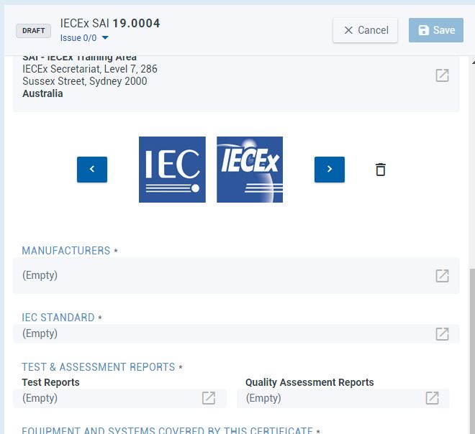
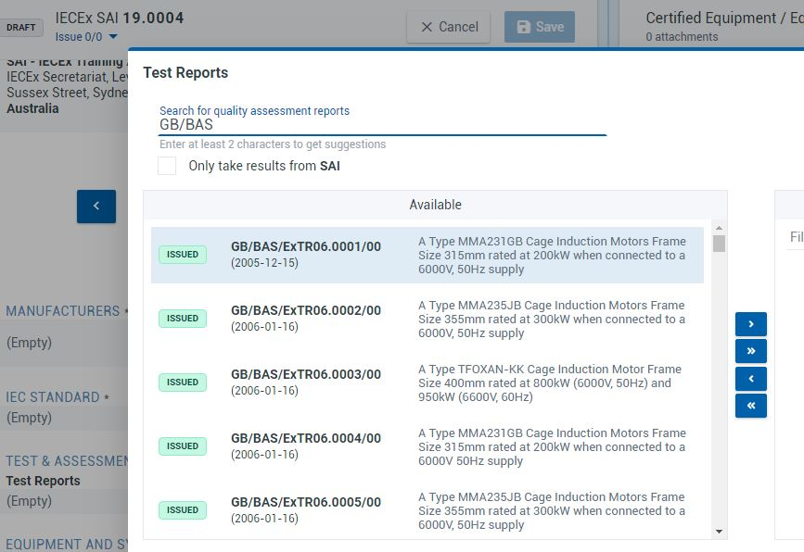

Formatting Features
When in the edit or creation mode of an IECEx Certificate, there are formatting options to enable ExCBs staff to enter information directly into the Certificate field without the need to create HTML file codes and cut and paste from other software (whilst this is possible, caution needs to be taken so that hidden formatting coding (that can affect the appearance of the PDF file) is not introduced.
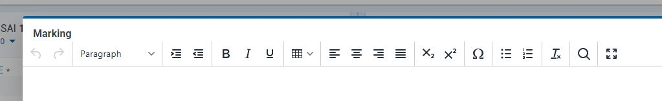
Note: hovering the mouse cursor over an edit bar menu item will display an explanation of its purpose.

Creating a “New Issue” of an existing CoC
STEP 1: Open appropriate CoC and select the icon to open a “New issue”, select “CONFIRM”, fill in details and save (noting that the content of the earlier issue is copied into the new issue and can be retained, edited or removed as required). The “Details of Certificate Changes” field in the new issue will be empty therefore all relevant details of changes for this issue must be added as this field.
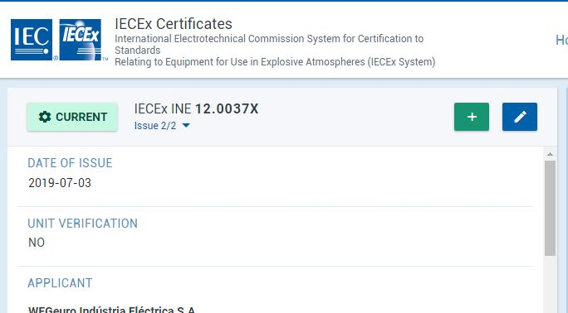

Entering Registration of an IECEx ExTR Summary

Registration of a new IECEx ExTR Summary
STEP 1: Select ExCB Login and then log on using the assigned user name and password.

STEP 2: Select “Create”

STEP 3: Select type of Certificate or Report as ‘ExTR’

STEP 4: Select the icon to open edit mode, then add details (IECEx OD 011-1 provides more guidance on data entry processes etc.) and then save as either status = Draft or Issued (noting that only users with ExCBAdmin level access rights can set an ExTR Summary to status of Issued). Note that some fields utilise the ‘auto-suggest’ tool that draws on date already in the IECEx OCS that can be selected so as to avoid the need to type content. The facility also exists to add details to the IECEx OCS database by creating new identities.
General Notes:
The IECEx “On-Line” Certificate System allows for the “live” entering of information and details of ExTRs and QARs as well as the IECEx Certificate of Conformity itself.
The System recognizes that ExTRs and QARs may be issued independently as well as in conjunction with the issuing of an IECEx Certificate of Conformity.
Furthermore, the System is structured on a “linkage” system whereby an IECEx certificate of Conformity may be linked to one or more ExTRs and QARs. For example, where a product that is to be covered by an IECEx Certificate of Conformity is manufactured at two or more locations, then there may be two or more QARs issued one being for each manufacturing location, especially if manufactured in more than 1 country.

Notes for the various fields of an ExTR Summary:
ExTR Number This number is generated by the System with the following assigned attributes – an example of an ExTR endorsed in Norway (NO) by the ExCB “Presafe” follows:-
NO / PRE / ExTR 05.0001 / 00

Country Code

ExCB endorsing ExTR

ExTR Reference Number

Revision number of the ExTR
with 00 assigned for the original issue

Note: The System allows for additional reference numbers to be added, for internal ExCB use, but the System only lists according to the number generated by the System. In addition, there is a comments field where additional information may also be included, such as ExCB file numbers etc.
Status
This feature allows the ExTR to be saved as either a “Draft” or as “Issued”. Note that the ExTR must be saved as status = “Issued” before the linked Certificate can be saved as status = “Current”.

ExTR Free Reference Number:
This field enables an ExCB to include any internal reference number to assist in internal traceability purposes. Note that the IECEx “On-Line” System uses the automatically generated Number and therefore the preferred situation is for the ExTL and ExCB to adopt the ExTR numbering system that is automatically generated by the System. In any case, the System will not allow a deletion or change to the automated Number that has been assigned by the System.

Date of Issue:
(Mandatory Field – this field must include content for the ExTR to set to status = “Issued”):
The date of issue of the ExTR is to be specified here. The system will default by showing the current day that the “New ExTR” window was opened.

Details of Change:
The details of change should be completed when a new version of an existing ExTR is issued.

List of Standards:
(Mandatory Field):
As selected from the drop down list

Issuing ExTL
(Mandatory Field):
As selected from the drop down list, with the default being the body that opened the ExTR details window.

Endorsing ExCB
(Mandatory Field)
As selected from the drop down list, with the default being the body that opened the ExTR details window.

Manufacturer
(Mandatory Field)
(refer to IECEx 02, clause 3.17)

Ex Protection
(Mandatory Field)
An example of such information is Ex d e IIC T3 or Ex d I

Ratings
This is generally any electrical or other operational ratings that may apply.

Model Reference
(Mandatory Field)

Related IECEx Certificate
(Automatic field)
The related CoC number is automatically inserted when the ExTR is linked to a CoC

Comments
(Optional Field)
This area is completely free for the ExCB to record any relevant information that may assist the International Ex industry understand the product and or the ExTR.

Attachments
This field enables the optional attachment of additional information or documents if necessary.

Supplementary or changes to an issued ExTR Summary
Application: This Clause applies where it is necessary to issue a supplement to an issued ExTR, for example to correct an error that was contained in the original ExTR.
STEP 1: Open appropriate ExTR Summary select the icon to open a “New issue”, select “CONFIRM” and fill in details (noting that the content of the earlier issue is copied into the new issue and can be retained, edited or removed as required). The “Comments” field may be used to outline the details of changes as compared to the earlier version.
Step 2: When completed, select “Save” from the top bar of the edit screen to save the ExTR Summary as status of Draft or Issued (noting that only users with ExCBAdmin level access rights can set an ExTR Summary to status of Issued)

Registration of an IECEx QAR Summary

Registration of a new IECEx QAR Summary
STEP 1: Select ExCB Login and then log on using the assigned user name and password.

STEP 2: Select “Create”

STEP 3: Select type of Certificate or Report as ‘QAR’
STEP 4: Select the icon to open edit mode, then add details (IECEx OD 011-1 provides more guidance on data entry processes etc.) and then save as either status = Draft or Issued (noting that only users with ExCBAdmin level access rights can set a QAR Summary to status of Issued).
Note that some fields utilise the ‘auto-suggest’ tool that draws on date already in the IECEx OCS that can be selected so as to avoid the need to type content. The facility also exists to add details to the IECEx OCS database by creating new identities.
General Notes:
The IECEx “On-Line” Certificate System allows for the “live” entering of information and details of ExTRs and QARs as well as the IECEx Certificate of Conformity itself.
The System recognizes that ExTRs and QARs may be issued independently as well as in conjunction with the issuing of an IECEx Certificate of Conformity.
Furthermore, the System is structured on a “linkage” system whereby an IECEx Certificate of Conformity may be linked to one or more ExTRs and QARs. For example, where a product that is to be covered by an IECEx Certificate of Conformity is manufactured at two or more locations, then there may be two or more QARs issued one being for each manufacturing location, especially if manufactured in more than one country.

Notes for the various Fields of an IECEx QAR Summary:
QAR Number This number is generated by the System with the following assigned attributes- an example of an QAR issued in Great Britain (GB) by the ExCB ‘SGS Baseefa’ follows:
GB/ BAS / QAR05.0001 / 00

Country Code

ExCB issuing the QAR

ExTR Reference Number

Revision number of the QAR
with 00 assigned for the original issue

Note: The System allows for additional reference numbers to be added for internal ExCB use, but the System only lists according to the number generated by the System. In addition, there is a comments field where additional information may also be included, such as ExCB file numbers etc.
Status
This feature allows the QAR to be saved as either a “Draft” or as “Issued”. Note that the QAR must be saved as status = “Issued” before it can be linked to a CoC.

QAR Free Reference Number
This field enables an ExCB to add numbers/letters or other characters to the QAR Reference Number generated by the “On-Line” CoC System.

The preferred situation is for the ExCB to adopt the QAR numbering system that is automatically generated by the System.

In any case, the system will not allow a deletion or change to the automated Number that has been assigned by the System.

Audit Date:
This is the date that the relevant audit summarised in the QAR was conducted. In future and subsequent updates or “new versions” of the QAR this date will need to be updated to reflect the date of subsequent Surveillance or Re-assessment audits.

Date of Issue:
The date of issue of the particular version of the QAR is to be specified here. This date is the day that the relevant ExCB endorsed the QAR and registered it on the IECEx On-line System. Guidance on audit follow up actions that precede the issue of a QAR for different types of assessments is provided in Section 6.8.1 of IECEx OD 025.

Note: This field was originally titled “Date of original issue” but was changed to “Date of Issue” following ExMC acceptance of a recommendation by ExMC WG5 in June 2013. Note that QARs registered under the original approach will not automatically show the correct Date of Issue as explained above.

Valid until:
The expiry date of the validity of the QAR is to be entered.
According to Clause 8.3.2 of IECEx 02, a QAR has a limited duration of three years – therefore the validity date of a QAR should be not more than three years after the Audit Date for the initial assessment (Audit Date) or the most recent re-assessment of the manufacturer and manufacturing sites listed on the QAR. [refer IECEx OD 025, Clauses 3.16, 3.17 and 3.18 regarding the different types of assessment].
It is not intended that this field be used to advise the date of the next surveillance audit.

It is at the discretion of the ExCB if they wish the Valid until date to be less than 3 years. The ExCB may purposely reduce the re-assessment date (valid until), due to initial findings from the original assessment. The date cannot be greater than 3 years from the Audit Date.

Sites audited:
This is where the site(s) must be clearly shown by using a street address – a Postal Box address for the manufacturer is not acceptable.

Issuing ExCB
This is usually the ExCB that opened the new QAR Details.

Manufacturer
The name and contact address for the manufacturer must be recorded here. In most cases the site audited may also be the same address for the manufacturer in which case this would be repeated. (refer to IECEx 02, clause 3.17)

Location of Manufacture
Refer to definitions 3.17, 3.18 and 3.19 in IECEx 02 regarding locations and sites that must be considered as manufacturing locations. The location(s) of manufacture must match the Manufacture Location(s) on the CoC.

Product information
Some information about the type of products covered to be recorded here.

Protection concepts
Information about the protection techniques covered is to be recorded here.

Related QARs
The “Related QARs” field is visible when a new version of a QAR is saved. This field shows all the previous versions of the QAR. These are “live” links” and each QAR can be opened to view history.

Related IECEx Certificate
(Automatic field)
As it is possible that a QAR can be issued without issuing an IECEx CoC, this field may be empty. However, it should be noted that the related CoC number is automatically inserted when the QAR is linked to a CoC.

Related Certificates
(manual insertion)
This field is only to be used for CoCs that were issued prior to 2007, when the automatic linking feature was not yet available. This feature is being maintained only for old CoCs (pre 2007) that are still current and may required to be up-issued, using this manual insertion feature.

Related IECEx Certificates for Previous Versions
The “Related IECEx Certificates for all previous versions” field is also visible and shows all CoCs that were automatically linked to previous versions. This means that the latest version of a QAR will not only list the CoCs linked to that version but will contain a list of all CoCs linked to all previous versions.

Comments
(Optional Field)
This area is completely free for the ExCB to record any relevant information that may assist the International Ex industry understand the product and /or the QAR. This field is useful to track the history of a QAR, or to include such messages as, Manufacturer name change, or change of address or QAR will be discontinued and taken over by QARxxx

Attachments
This field enables the optional attachment of additional information or documents if necessary.

Supplementary or changes/updates to an Issued QAR Summary

Application:
This Clause applies where it is necessary to issue a supplement (New version) to an issued QAR. In most cases the cause for the update will be to inform that a surveillance audit has been completed when the “Valid until” date has been reached [refer IECEx OD 009, Step 13 for guidance].
Note: When the QAR is updated, normally there is no need to update the CoC as it is automatically linked to a previous issue of the QAR. Also any issue of a QAR is automatically linked to all other issues of the QAR. It is good housekeeping that when a CoC is up-issued, the QAR is updated to the latest issue and the QARs are reviewed ensuring only those that are relevant to the CoC are included.
It is preferred that QARs are updated (by preparing a New Version) as opposed to the creation of a New QAR (ie. with different QAR number) following a surveillance audit so that the links to associated CoCs are maintained.

Where a New QAR is issued by an ExCB to
- reflect that they have taken over the surveillance of the manufacturer [refer to IECEx OD 250 for typical scenarios], or
- supersede the original QAR, the ExCB must use the Comment field to (i) reference the Original QAR in the New QAR and (ii) explain the reason for issue of the New QAR. This action will enable the IEC Secretariat to remove the superseded QAR from the ExCB(s) lists of “Out-of-Date QARs” and “CoCs with Out-of-Date QARs” [refer to IECEx OD 250 for more information on this process].

It is recommended that the “Comment” field of the new QAR version be used to indicate the reason for the issue of this version of the QAR, ie. whether it was for an initial assessment, a surveillance assessment or a re-assessment conducted at or before the three year expiry date of the QAR [refer IECEx OD 025, Clauses 3.16, 3.17 and 3.18 regarding the different types of assessment] – this will assist in determining the validity date of the QAR when planning the next audit [refer IECEx 02, Clause 8.3.7 for guidance in determining the frequency of surveillance assessments].
STEP 1: Open appropriate QAR Summary select the icon to open a “New issue”, select “CONFIRM” and fill in details (noting that the content of the earlier issue is copied into the new issue and can be retained, edited or removed as required). The “Comments” field may be used to outline the details of changes as compared to the earlier version.
Step 2: When completed, select “Save” from the top bar of the edit screen to save the QAR Summary as status of Draft or Issued (noting that only users with ExCBAdmin level access rights can set a QAR Summary to status of Issued)

Management of the validity of QAR Summaries and linked Certificates
The IECEx OCS ‘Back Office’ (refer to IECEx OD 011-1 and IECEx OD 011-10 for more details) includes reports on the validity status of QAR Summaries and also the details of Certificates that are linked to QAR Summaries where the ‘Valid until date’ has passed.
IECEx OD 250 provides guidance on the necessary actions to be taken under various scenarios for ‘out of date QARs’.
These reports available in the ‘Back Office’ (and sorting within columns and advanced filtering tools for the reports) are available under the ‘Reports / Reports – Out of Date’ section as shown below:
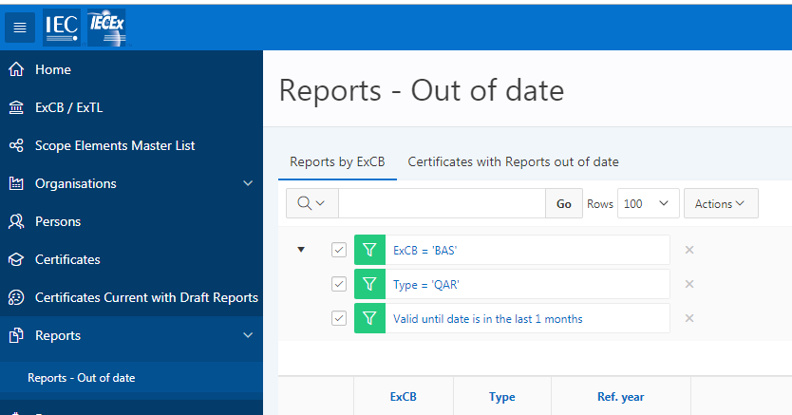
Feature (2)

Creation of an UNIT VERIFICATION type of IECEx Equipment Certificate of Conformity

Entering new Unit Verification CoC details
Unit Verification is used to issue IECEx Certificates that cover a defined number of products/items that are produced under a single production run. Unit Verification CoCs must list the serial numbers or other unique identification to be clear which specific items are covered by Certification. No QAR is required or verified at the time of issuing an IECEx Unit Verification Certificate. (refer to IECEx OD 033 for further information in regards to Unit Verification)
STEP 1: Select “View Certificates & Licenses” from IECEx Website: www.iecex.com
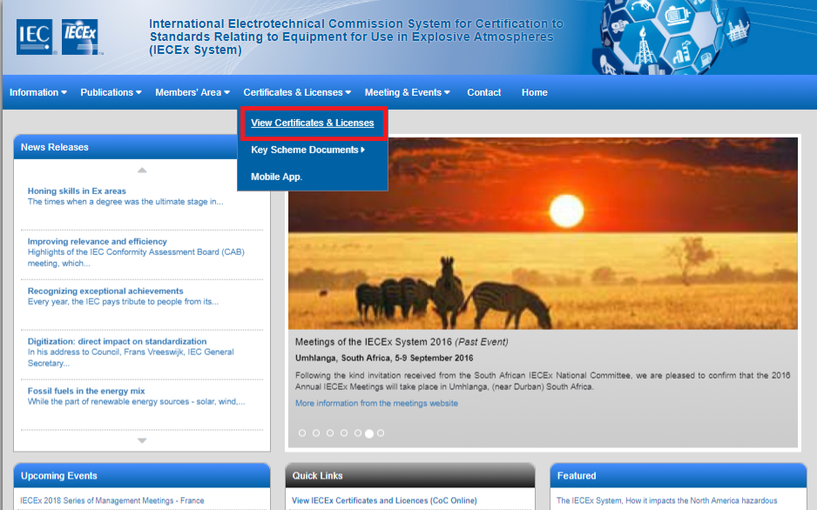

STEP 2: Select ExCB Login and then log on using the assigned user name and password.

STEP 3: Select “Create”

STEP 4: Select type of Certificate or Report as either Equipment Certificate OR Component Certificate type (either type can be a Unit Verification Certificate) as appropriate.

STEP 5: Select the icon to open edit mode, then add details (IECEx OD 011-1 provides more guidance on data entry processes etc.) and then save as either status = Draft or Current (noting that only users with ExCBAdmin level access rights can set a CoC to status of Current).
Note that some fields utilise the ‘auto-suggest’ tool that draws on date already in the IECEx OCS that can be selected so as to avoid the need to type content. The facility also exists to add details to the IECEx OCS database by creating new identities.
STEP 6: Select UNIT VERIFICATION = YES option as shown in the following example. This action will also modify the title of the Certificate to include ‘UNIT VERIFICATION” and add a statement that explains why the Certificate is not linked to a QAR Summary.

STEP 7: Insert relevant details as if preparing a normal Equipment or Component Certificate AND also insert the Serial Number(s) or other form of unique identification for each unit of equipment to be covered by the Certificate

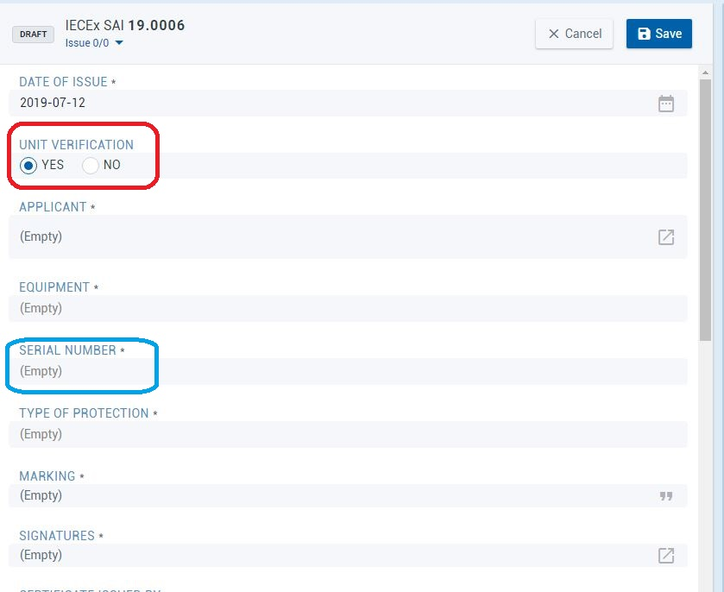

Note that it is not permitted to change an already issued Equipment or Component Certificate to Unit Verification. It is also not permitted to ‘up-issue’ a Unit Verification Certificate (for example to add extra units of equipment. As IECEx Unit Verification certificates cover specific items, any changes to products covered by an IECEx Unit Verification Certificate, that are not already provided for by the certificate, shall require the issuing of a new Unit Verification Certificate, as per OD 033. If there is a need to create a New version of a Unit Verification Certificate to correct editorial errors, a request to the IECEx Secretariat will be required.

ANNEX A
Informative

Review of Certificates of Conformity Quality Check and the Top Six Identified Items for Improvement

The Secretariat conducts regular reviews of the online IECEx Equipment Certificates of Conformity, targeting a sample rate of 15% of issued Certificates. Overall, the results of this ongoing review illustrate that ExCBs are doing an excellent job. However, the reviews have identified items for improvement. The items for improvement are listed here to assist ExCBs for internal training purposes and as a continuous improvement tool, ensuring that all Certificates that are created are accurate and in accordance with this document, IECEx OD 011-2

- Equipment Name and Equipment Description is NOT clear and sufficiently detailed.
The information within these fields should provide the necessary information for the end user and provide key information so that the IECEx Search Tools assists end users to browse CoC products efficiently.

- Manufacturer on CoC does NOT match QAR details and/or QAR(s) does NOT cover all manufacturing locations listed on the CoC.
Refer to sections 1.2.16 and 1.2.17 of this OD for further information.

- Linked QAR is NOT current
To best manage QARs and their validity, ExCBs must manage the audit process so that QARs do not lapse. If a QAR lapses, then the CoC must be suspended, or cancelled depending on the situation. Refer to OD 250 for further information.

ExCBs not tracking CoCs linked to other ExCBs QARs. It is the responsibility of the issuing ExCB of the CoC to ensure that the CoC is always linked to a current QAR, whether the QAR is their own or generated by another ExCB.
(Refer to OD 250 for further information on the management of QARs)

- Standards listed on the CoC do NOT match Standards (including Edition #) on the ExTR (main issue observed was CoC citing later Edition than ExTR).
When inserting multiple Standards from the menu list, the Ctrl button must be held down so caution should be used as well as a review when selecting Standards.

- Certificates of Conformity have the feature of PDF downloading of CoCs as documents. This feature, although very useful, may create erroneous character or text as a result of ‘copy and paste’ due to compatibility issues between HTLM and XML. Refer to section 1.1.4 of this OD for further information.

- Draft CoCs are created, but are later determined to be not required, so the ExCB clicks on the Cancelled (status) option in the edit view of the draft CoC. The Cancelled status should not be used to Cancel an unwanted draft or a draft that was created by mistake. The Cancelled option must only be used by the Secretariat, as per OD 209.

Draft certificates should be reviewed by ExCBs and when they are determined to be of no use (will not be made Current) should be deleted by the ExCB. Once deleted, they will no longer be accessible by the ExCB or the Secretariat.

