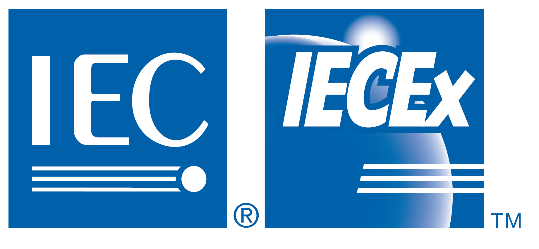



2018 IECEx INTERNATIONAL CONFERENCE

Safety of Equipment, Services and Personnel in Explosive Atmospheres
Split, Croatia - 23rd April 2018 – 0830 to 1730
Hotel Le Méridien Lav

IEC System for Certification to Standards Relating to Equipment for Use
in Explosive Atmospheres (IECEx)

GENEROUSLY SUPPORTED AND SPONSORED BY
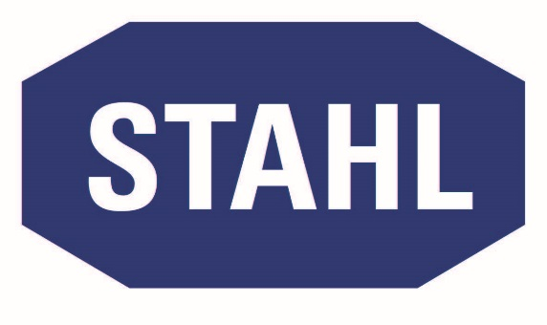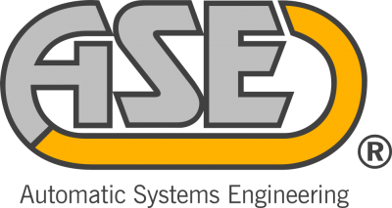
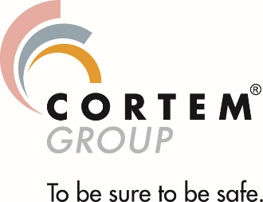

2018 IECEx International Conference
Equipment and Services in Explosive Atmospheres
Split, Croatia – 23rd April 2018
To meet the world’s ever-increasing energy demand, the Oil and Gas industry has built larger and more complex installations for extraction, processing and distribution, and made higher and higher capital investment. To protect this investment and the persons working in and around these installations, compliance with international safety standards is paramount.

The IEC (International Electrotechnical Commission) has long been involved in developing International Standards for equipment used in hazardous areas. Set up in 1946, IEC Technical Committee (TC) 31: Equipment for explosive atmospheres, has a complete series of International Standards that cover all specific requirements for Ex equipment and systems, from general requirements to protection levels for apparatus used by all sectors that operate in hazardous environments, such as oil refineries, offshore oil rigs, gas plants, shipyards, mines, pharmaceutics, cosmetics, food production, wood, paper, textile and many other industry specific sectors.

All sectors of the Ex industry have embraced IEC International Standards but producing equipment based on Ex standards is not enough.

Most manufacturers, suppliers and end-users trade on the global scene and have to meet the very strict requirements put in place by national regulations and legislation – proving their adherence to those requirements can be both costly and time-intensive.

To provide a global and credible means of ensuring compliance with its International Standards, the IEC established the IECEx System for Certification to Standards Relating to Equipment for Use in Explosive Atmospheres.

Since its inception in 1996, IECEx has established a number of Schemes that provide assurance that equipment and systems are manufactured and operated according to the highest international standards of safety in the areas of:
- Equipment by the IECEx Certified Equipment Scheme
- Services by the IECEx Certified Service Facilities
Scheme (e.g. repair and overhaul)
- Personnel competence by the IECEx Certification of
Personnel Competence Scheme (CoPC)

Through more than 95 IECEx-approved Ex Certification Bodies (ExCBs) in 31 countries, IECEx certification has become the world’s single best practice for demonstrating compliance with International Standards. Its credentials include acceptance by end-users – Oil and Gas producers, mining, transportation and many more – and also the recent formal endorsement by the United Nations, through the UN Economic Commission for Europe (UNECE), as the recommended model for regulating the safety of equipment and persons working in areas where the potential for an explosive atmosphere may exist.

All IECEx Certificates issued by ExCBs are in one location at www.iecex.com. If it is not shown on the IECEx website, then the certificate does NOT exist!

2018 IECEx International Conference – Split

The IEC and IECEx, together with Croatian Standards Institute and in conjunction with UNECE, are organizing the 2018 IECEx International Conference in Split, Croatia on 23rd April 2018.

A great networking opportunity
The full day event is a unique opportunity for industries in the region to not only become better acquainted with IECEx and find out how they can best benefit from the services the System provides, but also to get involved and form precious contacts and networks within the Ex community of experts.

World experts share experience and knowledge
The conference will bring together experts from all over the world, involved in international standardization, equipment manufacturing, inspection, repair and overhaul of Ex equipment and systems, and the assessment and certification of personnel competence. Issues concerning requirements and regulations in the region will also be covered.

Through their presentations and direct contact with participants, these experts will be able to share their experience and detailed knowledge on all matters pertaining to the Ex field, such as plant design, principles and practical applications of area classification, installation and repair in compliance to IEC International Standards.

They will answer questions, provide advice and give valuable information to anyone involved in the Ex sector.
Get involved, participate in this exclusive event.

Practical information
Admission to the conference is FREE of charge with all Attendees receiving an official “IECEx Certificate of Attendance”.
The conference will be held in Split with details to be included shortly on the official IECEx website.
To reserve your place for this important event please visit the IECEx website www.iecex.com, or for further information please send all enquiries to info@iecex.com
Requests for Invitation Letters for Visa applications and any other local assistance, please contact Marino Kelava at marino.kelava@fiditas.com, the IECEx Conference organizer in Split.

Programme
07:45 – 08:30 | Registration
08:30 – 08:40 | Welcoming remarks Mr Chris Agius – IECEx Executive Secretary
08:40 – 09:00 | Opening Address / Key Note Speech  dr. sc. Martina Dalić  Republic of Croatia - Deputy Prime Minister and Minister of Economy, Entrepreneurship and Crafts
09:00 – 9:30 | Overview and Vision of the IECEx International Certification System and operational areas to :  - Facilitate World Trade in Equipment and Services  - Single On-Line Certificate System  - Whole Life Cycle  - Human Factor  Dr Thorsten Arnhold – IECEx Chairman
09:30 – 10:00 | The IECEx International Certification System - UNECE endorsement and the CRO  Ms Lorenza Jachia - UNECE
10:00 – 10:30 | Coffee/Tea break
10:30 – 11:00 | Area Classification – Principles and Practices according to IEC 60079-10 series  Mr Peter Thurnherr – thuba Ltd
11:00 – 11:30 | Practical approach to Ex installations according to the requirements of IEC 60079-14 and the inspection requirements of IEC 60079-17  Mr Peter Thurnherr- thuba Ltd
11:30 –12:00 | IECEx Certified Services Scheme – opportunities for experts from this region  Mr Ron Sinclair – SGS Baseefa
12:00 –13:30 | Lunch – RStahl AG - Sponsored Event  (lunch will be provided free of charge to facilitate networking opportunities)
13:30 - 14:00 | Overview of some national or regional Ex verification or approval systems and how use of IECEx facilitates such approvals in addition to providing international certification  Mr Ron Sinclair – SGS Baseefa
14:00 – 14:30 | IECEx Certified Equipment Scheme  - Process to gain IECEx Certificate  - Value in holding an IECEx Certificate  Mr Damir Korunić - Ex Agencija
14:30 – 15:00 | Assembly certification for explosive dust atmospheres – An explanation of the importance to correctly address the hazards and extent of these hazards prior to design and operation of assemblies containing explosive dust atmospheres along with the need to test explosive properties of dusts to securely mitigate explosion risks  Mr Marino Kelava - Fiditas
15:00 – 15:30 | Coffee/Tea break
15:30 – 16:00 | Competence of Personnel in Hazardous Areas  - What is ‘competence’ and how is it obtained  - Why it is important  - Validation and certification of competence  Mr Arpad Veress - Ind-Ex
16:00 – 16:30 | End User Feedback – A detailed presentation covering the industry needs of the user concerning, day to day operations  - Equipment procurement  - Installation / Maintenance / Repair  - Competence of people  Mr Mario Cikojevic  Maintenance Manager - CEMEX
16:30 – 17:30 | Open Forum, to offer all attendees the opportunity to raise questions concerning Ex aspects and IECEx and to consider an industry position concerning Ex and IEC TC 31 Standards and IECEx.
17:30 | Close + final remarks Mr Chris Agius – IECEx Executive Secretary
5
To reserve your place for this important event, please contact the IECEx Secretariat at rego@iecex.com

