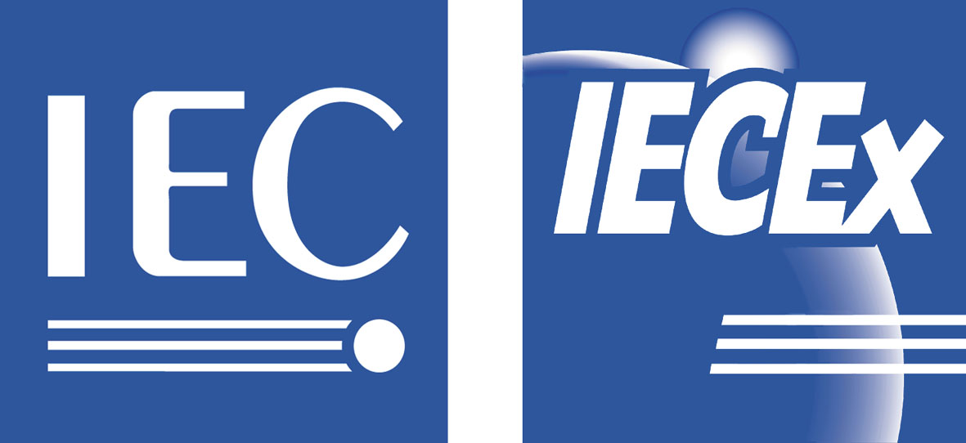 | INTERNATIONAL ELECTROTECHNICAL COMMISSION (IEC) SCHEME FOR CERTIFICATION TO STANDARDS RELATING TO EQUIPMENT FOR USE IN EXPLOSIVE ATMOSPHERES (IECEx SCHEME)
Sponsors include: |  | 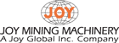 |  | 
 |  | 

USNC/IECEx, in association with IECEx presents

2007 Industry Symposium

26th September 2007, Denver Marriott City Center, Denver Ballroom

Return this form by mail or fax: NEMA USNC/IECEx Symposium
(2350-0142)
C/o SunTrust Bank
PO Box 79680
Baltimore, MD 21279-0678
Fax: 00 +1 (703) 841-3316 -- NEMA Accounting (Receivables)

Name
Nickname for badge
Title
Company
Address
City | State | ZIP
Telephone number | Fax number | e-mail address

Registration Fee:
 | IECEx Delegate | $ 0.00
 | IECEx Observer | $ 0.00
 | Sponsor | $ 0.00
 | All Others | $ 200.00
Total Enclosed
Check made payable to NEMA |  | VISA | MasterCard
(Please note we do not accept American Express)
Card No. |  | Exp. Date
Cardholder Name |  | Signature
Payment must accompany registration and must be received prior to attending the symposium.
CANCELLATION POLICY: All cancellations must be received in writing. Refund amount is determined by the date that you notify NEMA of your cancellation. NEMA regrets that it cannot make exceptions to the reservation and cancellation policy for any reason, including personal emergencies. Substitutions, however, are permitted.

