INTERNATIONAL ELECTROTECHNICAL COMMISSION (IEC) SCHEME FOR CERTIFICATION TO STANDARDS RELATING TO EQUIPMENT FOR USE IN EXPLOSIVE ATMOSPHERES
(IECEx SCHEME)
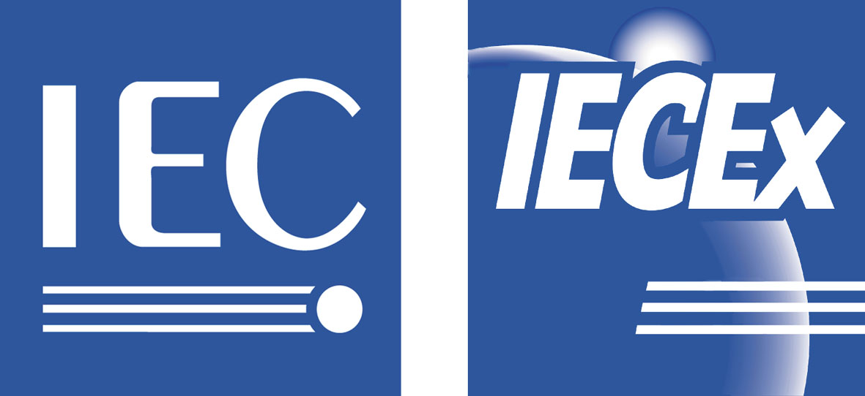

IECEx US Member Body, in association with IECEx present

2007 Industry Symposium
Program
Date: 26th September 2007, Denver

0900 – 0910 Opening address
- Welcome to attendees
- Opening remarks from IECEx Chairman, Dr Uwe Klausmeyer, PTB Germany

0910 – 0920 Address by International Electrotechnical Commission (IEC)
Vice President, Mr Don Gray

0920 – 1015 IECEx and North America (Mr Paul Kelly, Underwriters Laboratories)
- Outline of Ex and any additional requirements for North America
- How IECEx assists entry into US Markets
- How IECEx assists entry to foreign markets by US based manufacturers

1015 – 1045 Coffee Break

1045 – 1140 IECEx Past and Present (Mr Chris Agius, IECEx Secretary)
- Outline of history of IECEx
- Principles of IECEx Certification
- Service provided by the IECEx Scheme
- Live Demonstration of the IECEx “On-Line” Certificate of Conformity System

1140 – 1215 IECEx and China requirements (Mr Liu Weijun, Chief Engineer of CNCA China)
- Outline of China Certification & Accreditation, and Ex Conformity Assessment System
- IECEx Certification in China

1215 – 1345 Lunch

INTERNATIONAL ELECTROTECHNICAL COMMISSION (IEC) SCHEME FOR CERTIFICATION TO STANDARDS RELATING TO EQUIPMENT FOR USE IN EXPLOSIVE ATMOSPHERES
(IECEx SCHEME)

1345 – 1430 IECEx and Europe (Mr Ron Sinclair, Baseefa)
- Outline of Ex and any additional requirements for Europe and the ATEX Directive
- How IECEx assists entry into EU Markets
- How IECEx assists entry into foreign markets by EU based manufacturers

1430 – 1515 IECEx – A Regulator’s perspective
- Mr David Chirdon, Mine Safety & Health Administration

1515 – 1545 Coffee Break

1545 – 1615 IECEx an industry perspective
- Manufacturer’s view (Mr Jon Miller, Detector Electronics)
- An end user view (Mr Patrick Leroux, TOTAL Oil)

1615 – 1645 IECEx the future
- Summary of Standards update from Mr Jim Munro, TC 31 Chairman
- IECEx Scheme future (Mr Chris Agius IECEx Secretary)

1645 – 1700 OPEN FORUM - Questions

To register contact
Mr. Joel Solis
NEMA

Tel.: + 1 703 841 3267 Fax: + 1 703 841 3267

E-mail: joel_solis@nema.org

