INTERNATIONAL ELECTROTECHNICAL COMMISSION

IEC SCHEME FOR CERTIFICATION TO STANDARDS FOR
ELECTRICAL EQUIPMENT FOR EXPLOSIVE ATMOSPHERES
(IECEx SCHEME)

Title: Short circuit testing of IS batteries

CIRCULATED TO: Ex Testing and Assessment Group (ExTAG)

Introduction

This document, ExTAG/51/CC is issued on behalf of the ExTAG Secretary, Mr Michel Brenon at the request of the document originator, Dr Wolf Dill and provides a compilation of comments received concerning the proposed ExTAG Decision Sheet, ExTAG/49/CD

For background information, members are reminded that the original draft decision sheet, document ExTAG/42/CD, was noted during the Budapest 2004 ExTAG meeting. During the meeting delegates were invited to submit further comments to the ExTAG Secretariat. Once comment was received a revised draft document ExTAG/49/CD was issued for comment. Comments received concerning ExTAG/49/CD are now presented in this document and include responses to the comments from Dr Wolf Dill.

Based on these comments Dr Wolf Dill has prepared a further revised draft decision sheet, document ExTAG/49A/CD, for ExTAG consideration.

The comments detailed in is document, ExTAG/51/CC are issued for the information of ExTAG Members when considering ExTAG/49A/CD.

Any comment concerning either this document or ExTAG/49A/CD should be sent

by 2004 07 15, to the ExTAG Secretariat as follows,

ExTAG Secretariat
C/o Christine Kane

E-mail: christine.kane@iecex.com

Fax: +61 2 8206 6272

Address:  IECEx Secretariat  286 Sussex Street  Sydney NSW 2000  Australia | Tel: +61 2 8206 6940  Fax: +61 2 8206 6272  Email: chris.agius@iecex.com

COMPILATION OF COMMENTS ON COMMITTEE DRAFT
Reference number of the CD  ExTAG/49/CD | Date of Circulation:  2004 05

Title of the Committee Draft

ExTAG/49/CD TITLE: Short circuit testing of IS batteries

The above-mentioned document was circulated to members of ExTAG with a request that comments be submitted by 15th July 2004.

Comments received – ExTAG Members from AU DK GB RU
Additional comments included by W. Dill shown in Blue Text

Required ACTION:

- To accept the comments of the Convener, Dr Wolf Dill or provide comments to the ExTAG Secretary as instructed on page 1.

- An invitation to take over the role of Dr Wolf Dill and then for the newly appointed delegate to prepare a revised document based on the original ExTAG/49/CD and the attached compilation of comments.

No. | ExTAG  Member | Type of comment (General/ Technical/  Editorial) | Paragraph  No. | COMMENTS | Proposed change | Proposal from the document originator  (Dr Wolf Dill)
1 | ITACS  and Industry  (AU) | General | 5 | Ambient temperature during short circuit test  Cells should be tested at any temperature between laboratory ambient and the specified maximum ambient which gives the most onerous conditions and the values obtained are used directly in the T Class assessment.  Note: According to recent laboratory experience most of the Alkaline type cells produce the highest currents at room temperature (~ 23°C) while some NiCd cells have the highest output currents e.g. at ~40°C°C.  Many cells may have maximum short circuit currents at the lowest ambient temperatures typically -20ºC. |  | Agree  Proposal:  Change wording of note to:  Note: According to recent laboratory experience most of the Alkaline type cells produce the highest currents at room temperature (~ 23°C) while some NiCd cells have the highest output currents e.g. at ~40°C°C, but also cells having maximum short circuit currents at the lowest ambient temperatures, typically -20ºC were found.
2 | ITACS  and Industry (AU) | Technical | 5 | Data on most onerous temperature should be included in standard. |  | Support.  But only very general information may be included, because chemical compostion of cells is under rapid development.
3 | ITACS  and Industry (AU) | General | 6 | Testing at temperatures other than room temperature  In a chamber - no fan working - the cell should be positioned horizontally close to the thermally low conductive bottom to reduce convective heat transport.  Why restrict the cells position to horizontal when clause 10.9.2 states test conducted facing downwards? |  | The main reason to propose horizontal position was to provide a uniform approach – mainly adapted to cylindrical cells - , without claiming this would be the most onerous situation.  The uniform method would avoid discrepancies when comparing and verifying test results.  Proposal:  change to:  … the cell should be positioned horizontally or vertically close to the thermally low conductive bottom to reduce convective heat transport.
4 | SIRA  (GB) | Editorial | 7 | 4) Software error: bottom of page 2, last para reads "Test results will be acceptable if n cylindrical cells....." Also later is para. Not  sure what " n" should be. It looks like ".....n" should be "for". |  | Agree  This was typing error.
5 | SIRA  (GB) | General | 8 | 1) The status of the "Background information" should be clarified - is it merely informative or does it have the status of the standard (i.e. normative)? We would like to know this because we want to be able to waive spark tests for single cells (paragraph 3) but the standard does not allow this. Is the decision sheet allowing us to waive these tests? |  | Decision sheets shall not change standards. When they are accepted ExTLs and ExCBs shall apply them.  “Background information” in a Decision Sheet will only contain information, but no “mandatory” requirements.  General remark GR1  The draft DS was produced to harmonise laboratory procedures for 10.9.3 b)  maximum surface temperature (for T-classification).  By the way: Waiving of physical spark testing is allowed by IEC 79-11 clause 10.9.3 a)  a) Spark ignition assessment or testing shall be carried …  Compare also 31G_128_CD_IEC60079-11_ED5, 10.6.3  Proposal:  Remove the paragraph
6 | SIRA  (GB) | Technical | 8 | 2) Reference the same paragraph: assuming we can waive tests subject to the limitations on current plus inductance, can we waive tests for all cells below 3.7V or only for lithium-manganese-dioxide? The paragraph starts by talking about lithium cells but contains the statement as follows: "This voltage [3.7V] is far below the minimum voltage for sparks". Can all cells up to 3.7V be thus exempted from spark testing if inductance is not an issue? See point 3 below: all cells we would typically be testing are below 20Ah but this may be a typo. |  | See GR1 above.  Proposal:  The header should give more precision to avoid misunderstanding.  The reference to waiving of spark tests should be removed
7 | SIRA  (GB) | Editorial | 8 | 3) Possible typographical error: page 3, end of para 1: should the units be Ah? Does not seem to fit in with "small" cells. |  | Agree
8 | CCVE  RU) | Technical | 8 | The proposed boundary value of capacity at 20Ah accepted for intrinsically safe cells and batteries called "small" is unfounded. We think this limit should be substantiated from a viewpoint of intrinsic safety. |  | Agree  The 20 Ah limit in IEC since many years has been used to mark up a soft borderline between 79-11 and 79-7.  Of course thermal limits will create technical limits which might be much lower than 20 Ah.  Proposal:  No change
9 | ITACS and Industry  (AU) | General | 9 | Identification of cells by type only  Experience shows that it should not be acceptable to test and certify cells without defining manufacturer and type. Even for cells of the same manufacturer and of the same type repeated tests have shown that modified chemical concept of the cells result in increased temperatures.  Isn’t this a repeat of the “Preselection of acceptable cell types” requirements above |  | This paragraph should give the explanation for the quoted rule.  Prososal:  No change
10 | ITACS and  Industry  (AU) | Technical | 10 | Waiving spark tests for single cells  In table 5 of IEC 79-11 lithium-manganese-dioxide is the type of cell with the maximum voltage: 3,7 V. This voltage is far below the minimum voltage for sparks. Only high currents plus an inductance or the interconnection of cells (battery) can cause ignitions by sparks  Spark testing cells/batteries in general is impractical as the spark test has a “normal” limit of 3 A and many cells have short circuit currents of tens of amperes. Also the batteries start going flat after a couple of revolutions of the spark test apparatus. |  | Agree  See GR1 above.  See also 31G_128_CD_IEC60079-11_ED5, 100.6.3
11 | ITACS and  Industry  (AU) | Technical | 10 | Spark tests for single cells:  Is this clause suggesting that spark testing be eliminated for l-m-d cells?  The short circuit currents of many cells make the effect of inductance a real hazard, spark tests of the actual design should NOT be waived. | Spark tests of the actual design should NOT be waived. Spark testing may not be possible with spark apparatus due to potential short circuit current exceeding the limits of the break -flash apparatus. Cells will start to go flat after a few revolutions of the break-flash apparatus, so you may not be testing the most onerous condition. | Agree  See GR 1 above.
12 | CCVE  (RU) | Technical | 10 | We cannot agree with the proposal to waive spark tests for single cells and accumulators. The reasoning provided shows that in the considered case spark ignition of explosive mixture is impossible, but it does not mean that ignition will not be possible at all. Therefore, this reasoning can be accepted as evidence of the fact that the ignition mechanism in this case differs from that in case of spark discharge.  Experience shows that ignition in circuits of similar power supply sources occurs at significantly lower currents than those possible at short-circuit. |  | Agree  See GR 1 above.  Please have a look into 31G_128e_CD_IEC_60079-11, Ed 5, 10.6.3.
13 | CCVE  (RU) | Technical | 10 | Thus, on investigation of low voltage power supply sources igniting currents values were obtained shown in the attached graphs.  These investigations have been performed using a special-purpose unit recommended for tests in the National Standard of the Russian Federation GOST R 51330.10. This unit is intended for testing of intrinsic safety of electrical circuits in which currents exceed 3A. This unit allowed to simulate breakage of a wire in which current flows in explosive mixture and to reproduce a real process of emergence of ignition source in a circuit. On superficial analysis, ignition mechanism in this case can be considered as ignition of a heated body (molten metal).Wire breakage was achieved by tension on wire pulling through two pairs of rotating with a variable speed rollers pressed to it at a certain distance. The unit is designed in a way that wire breakage can be repeated many times. The tested power supply is connected to the breakage device by short wires. The wire to be broken is a copper tinned wire of 0.26 mm in diameter. |  | IEC 31G_128_CD_IEC60079-11_ED5 states in 10.6.3:  Where the apparatus contains cells that shall not be changed in the hazardous area, the spark ignition discharge at the terminals of a single cell does not require to be tested, provided that:  - the single cell delivers a maximum voltage of less than 4 V and  - the product of the maximum voltage and transient current at the cell terminals does not  exceed 33 W  The attached graph provided by CCVE (RU) underlines this approach:  According to the graph 4V with 28 A would not ignite with an inductance of 1 µH; this is beyond the limit given by the draft ED5, which would restrict waiving spart testing to a limit of 8.25 A.
14 | CCVE  (RU) | Technical | 10 | As it can be seen from the graphs attached, ignition in the circuit with inductance of about 1 μH is observed at currents that do not exceed 30-40A and it decreases sharply as the circuit inductance increases. It is known that short-circuit current of modern cells and batteries can be many times higher than these values.  To our opinion, introduction of the proposed recommendation (waiving spark tests for single cells) in the standard would be premature. To solve the problem of selection of intrinsically safe parameters of power supply sources with a voltage in the specified range additional investigations are needed with use for interruption of circuit of a device different from the standard one according to IEC 60079-11.  (See Annex B attached graph)
15 | ITACS and  Industry  (AU) | Technical | 12 | 9V-Blocks  According to experience single cells of most of the 9-V-blocks have solid insulation between the cells of less than 150 µm (6LR61) or the clearance is less than 0.5 mm (6F22) and therefore 9-Vblocks should be short circuited at their outer contacts.  As the segregation between individual cells is not infallible then cells should be shorted individually as well as complete batteries and the worst case used. |  | There might be some problems to open 9V-Blocks to contact and short individual cells and then get reproducible results.  Short circuit of the whole assembly at least will be a very onerous condition as far as surface temperature is concerned.  Please have also a look into 31G_128e_CD_IEC_60079-11, Ed 5, 10.6.3.  Proposal:  Less restrictive wording
16 | ITACS and  Industry  (AU) | Technical | 13 | Influence of internal resistance and test set-up  A cell made of wrapped electrodes normally has the lowest internal resistance. The internal resistance measured at the outside contacts during the test is increased by the additional resistance between the electrodes and the external contacts.  Using the internal resistance of cells as part of the safety features can be flawed. As cell manufacturers are free to change the chemical composition which will affect the internal resistance |  | Agree.  There has not been the intention with this DS to include internal cell resistance into safety assessment. The intention of this comment was to draw attention to influences on measured short circuit values.  But please have a look into 31G_128e_CD_IEC_60079-11, Ed 5, 10.6.3 last para.  Proposal:  No change
17 | ITACS and  Industry  (AU) | Editorial | 13 | Influence of internal resistance:  Informative not normative. |  | Agree
18 | ITACS and  Industry  (AU) | Editorial | 14 | Evaluation of maximum surface temp:  Informative not normative. |  | Agree
19 | UL-DEMKO  (DK | General |  | I have looked at the interpretation and I think it covers the decision made, so I will support the Decision sheet.  If I should make some proposal it would be that I would like to include the wording from the proposal to Ed 5 of IEC60079-11:  Where the apparatus contains cells that shall not be changed in the hazardous area, the spark ignition discharge at the terminals of a single cell does not require to be tested, provided that:  - the single cell delivers a maximum voltage of less than 4 V and  - the product of the maximum voltage and transient current at the cell terminals does not exceed 33 W.  NOTE 1 – This relaxation of not requiring to test the spark discharge at the terminals of a single cell is based on the fact that at 4 V, the voltage is too less to strike an arc in the absence of inductance, and the resistive ignition curves in the Appendix allow up to 33 W as a product of voltage and current, with a safety factor of 1.5 for Group IIC.  (See Annex A attached file: Pages from 31G_128e_CD_IEC_60079-11, Ed) |  | The draft DS was written before the Dubrovnik meeting of the MT for 79-11.  Proposal:  Include a sentence to draw attention to the draft next edition of the standard as additional useful information.

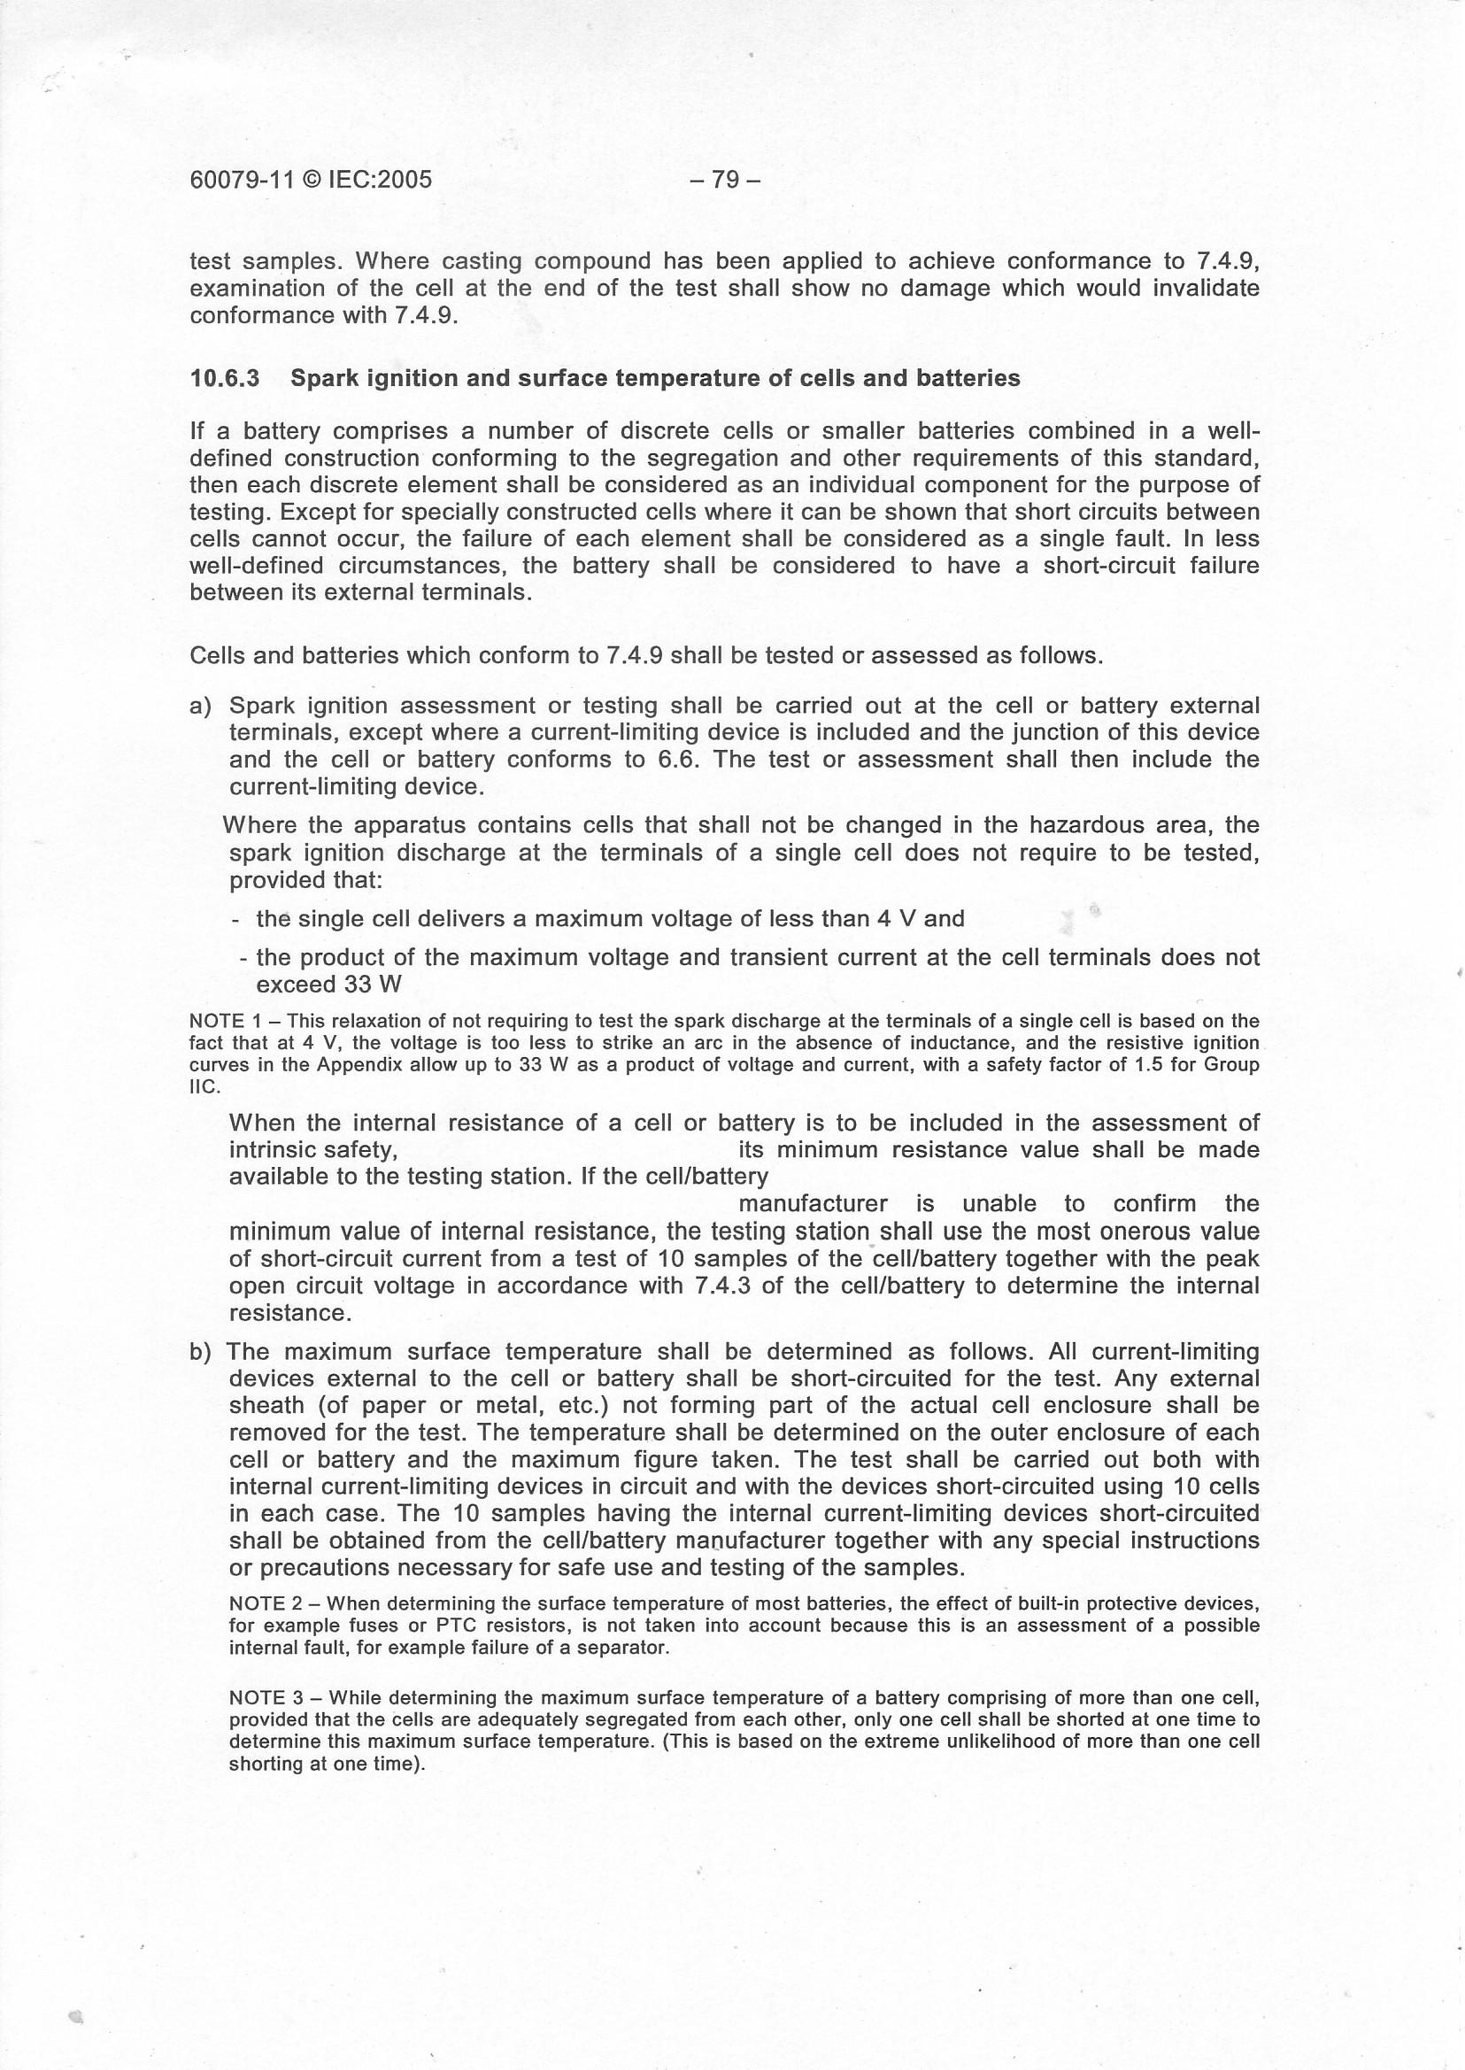

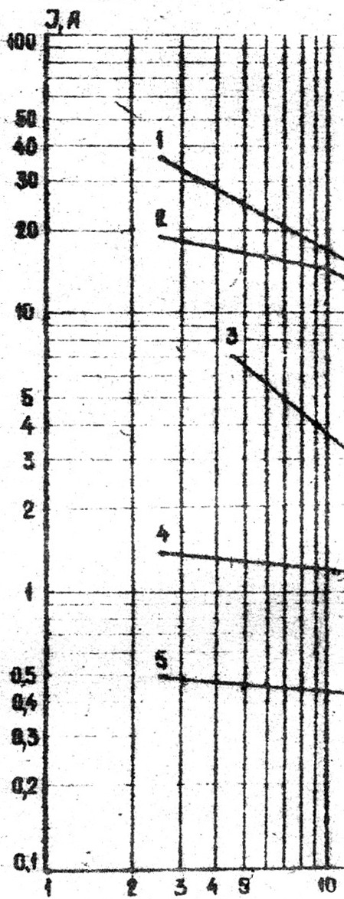

Graph of ignition current against voltage of power supply source (ignition probability
P = 10^{-8,} explosive mixture is 8.5% methane-air mixture)

1) inductance L < 1μH 2 ) inductance L = 9.2μH 3) inductance L ≅0.1 mH
4) inductance L = 1 mH 5) inductance L = 10 mH

