INTERNATIONAL ELECTROTECHNICAL COMMISSION (IEC) SYSTEM FOR CERTIFICATION TO STANDARDS RELATING TO EQUIPMENT FOR USE IN EXPLOSIVE ATMOSPHERES (IECEx SYSTEM)

Circulated to: ExTAG – IECEx Testing and Assessment Group

TITLE: Draft ExTAG Decision Sheet – Clarification on use of thermocouples.

INTRODUCTION
Draft Decision Sheet ExTAG/362/CD was prepared and issued to Members for comment.

Comments received were collated in ExTAG/386/CC which also contains responses from the Originator Mr Ron Webb.

This revised Draft Decision Sheet ExTAG/362A/CD has been prepared taking into account comments received and is issued for final consideration during the 2015 ExTAG Christchurch meeting.

Julien Gauthier

Julien Gauthier
ExTAG Secretary

Address:  IECEx Secretariat  Level 33 Australia Square  264 George Street  Sydney NSW 2000  Australia  Web: www.iecex.com | ExTAG Secretary  Mr Julien Gauthier  LCIE S.A.  33 Avenue du General Leclerc  92260 Fontenay-aux-Roses  FRANCE  Tel: +33 1 40 95 55 26  Fax: +33 1 40 95 89 37  Email : julien.gauthier@fr.bureauveritas.com

Background Information: IEC 60079-0 and subordinate standards require that surface, and sometimes service, temperatures are determined.
The method of determining temperature often relies on the use of thermocouples.
Experience has shown that the method of manufacture and the method of attachment of thermocouples can differ from laboratory to laboratory.
Estimates of uncertainty of measurement are often not fully applied.

There exists an IECEE document CTL-OP 108 which addresses some of the issues and can help overcome some of the perceived issues.

QUESTION: Should the IECEE document CTL-OP 108 be adopted as the recommended practice for ExTLs to utilize thermocouples?

ANSWER: Yes, It is recommended to prepare and use thermocouples in accordance with IECEE document CTL-OP 108. It is further recommended to use thermocouples with a lead diameter of 0.2mm

IECEE CTL-OP 108 Ed. 2.0

COMMITTEE OF TESTING LABORATORIES

OPERATIONAL PROCEDURE

Procedure
1.1 Thermocouples shall be prepared by staff trained in preparation of thermocouples.

1.2 Thermocouples are to be prepared as noted:

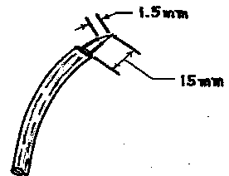
1.2.1 Inner insulation stripped back approximately 1.5 mm from tip.
1.2.2 Outer insulation, if any, stripped back approximately 15 mm from tip.
1.2.3 The tip is to be joined by a single point weld. Other reliable and consistent methods of joining the thermocouple wires may be used upon prior acceptance of the CTL.
Note: Dimensions given are typical, not required.
1.3 Placement - The measuring thermocouple junction must be placed where the temperature is to be measured. The element must be placed and applied so that it reaches the same temperature as the part in question. Be cautious of possible electrical shock hazard and stress on the measuring equipment, if the thermocouple is connected to live parts of if thermocouples are connected to parts of different polarity. It may be appropriate to place additional electrical insulating sleeving over the conductors (not the thermocouple junction).

1.4 Attachment - The thermocouple junction shall be applied to be in intimate contact with the surface of the part to be measured in order to reach the same temperature as the part being measured. The thermocouple junction shall be in good thermal contact with the part being measured. The method of attachment shall be done in a way to have a minimal effect upon the temperatures measured.

1.5 Leads shall be located in the same temperature environment as the bead itself.

1.5.1 Heat will be conducted along the thermocouple wire. Where the thermocouple junction is at a different temperature than the immediately adjacent leads, heat flow will take place for the leads to the junction or from the junction to the leads, and the best temperature measurement of the surface in contact with the junction will not be made.

1.5.2 This problem is minimized by thin leads. Generally, 0.320 mm (28 AWG) or 0.254 mm (30 AWG) thermocouples should be used.

1.6 Securing of Thermocouples - Several methods of securing thermocouples are tying, cementing, adhesive, peening, welding and soldering:

1.6.1 Tying - Tying with thread is used primarily for round items such as wire insulation.

1.6.2 Cement - Two examples are Kaolin powder mixed with sodium silicate solution in approximately equal proportions by volume and Cyanoacrylate adhesive (e. g. Henkel Sicomet). Cement is used to:

1.6.2.1 Secure the thermocouple to the surface whose temperature is being measured.

1.6.2.2 Provide a better thermal bond than would be obtained by a point contact of the junction with the surface.

1.6.2.3 Reduce the surface area of the junction and leads exposed to air at a temperature different from that being measured.

1.6.3 The thermocouple should be secured in position prior to application of the cement.

1.6.4 In order to prevent loosening of the junction and separation of the cement, the cement should be allowed to thoroughly set before reassembling the unit under test.

1.6.5 Soldering is useful for attaching thermocouples to copper or other metal surfaces to which solder will adhere. The advantage of using solder is better thermal conductivity and greater mechanical security for the junction will be obtained than with cement.

1.6.6 It should be noted that the temperature would be sensed primarily at the point furthest from the junction where the solder bridges the thermocouple leads. Cold solder joints and excessive solder should be avoided.

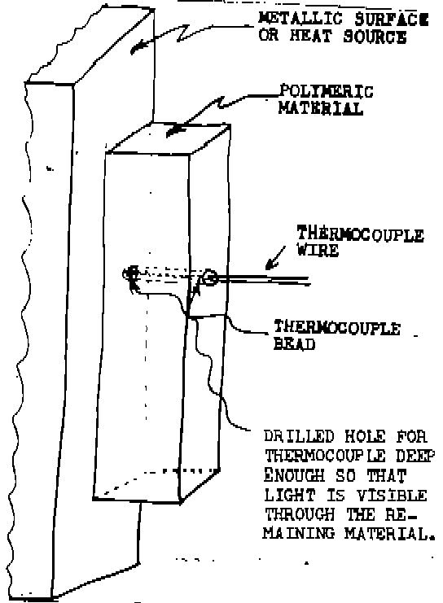
1.6.7 Confinement - Thermocouples can often be confined between layers of material or between metal and insulating materials and held in good thermal contact by pressure on the two surfaces.

1.6.8 Care shall be exercised to see that a confined thermocouple or its junction does not cause a separation between normally mating surfaces, which would change the temperature distribution at the point being measured.

1.6.9 A groove or hole may be placed in one of the materials to accept the thermocouple and its leads to preclude the above condition.

1.6.10 A thermocouple should ordinarily be kept slightly recessed beneath the surface, to be certain that the temperature being measured is not that of the adjacent surface material.

1.6.11 Peening - The thermocouple junction may be placed in a cavity and the metal peened over.

1.6.12 Tape - Pressure sensitive tape conveniently holds thermocouple leads in place.

1.6.13 Use as little tape as possible consistent with good mechanical securement of the thermocouple.

1.6.14 Glass tape with thermosetting adhesive is useful for high temperature applications.

1.6.15 Tape can be used to provide strain relief for the thermocouple.

1.6.16 The tape should be located remote from the junction.

1.7 Connection - Where practical thermocouples shall be connected directly to the temperature measuring instrument. Where it is not practical to connect thermocouples directly to the instrument, thermocouple extension wires and connectors of the type for the thermocouples used shall be employed.

1.8 Exception - Thermocouple connectors need not be used in the limited situation where the thermoelectric affects of the junctions made are nullified such as shown in the following example for feed through connectors. Thermocouple wires TC#1 and TC#2 are the same type. Connections are made to the same type of conductors (e.g. copper alloy). The temperatures T1 and T2 at the connections are the same.

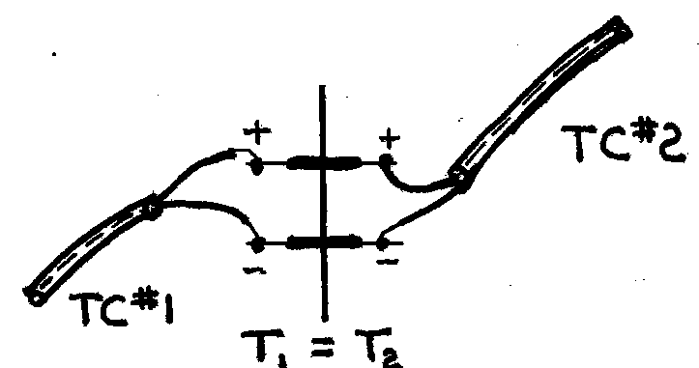

1.9 The temperatures of the two reference(cold) junctions mentioned in the exceptions, must be the same as each other and the same as the temperature measuring instrument as well. The junctions and instrument must be protected (shielded) from heat and cold air flows, sunshine, heat emission from the test sample, lamps, soldering irons, etc., which could result in a change in the temperature of the reference junctions.

1.10 Use - The type of thermocouples utilized shall be used within the manufactured specification operating parameters for that type of thermocouple (e.g. temperature operating range).

1.11 Guidance - Additional guidance on preparation and use of thermocouples can be found in the following publications:

1.11.1 “Manual on The Use of Thermocouples in Temperature Measurement”, American Society for Testing and Materials, Special Technical Publication 470A.

1.11.2 “Temperature Measurement Thermocouples”, ANSI-MC96.1-1982.

1.11.3 “Calibration of Thermocouples”, European Cooperation for Accreditation of Laboratories, EA-10/08(formerly EAL-G31).

1.11.4 "Traceability of Temperature Measurement", UKAS LAB11.

1.11.5 "Thermocouples Part 1: Reference Tables", IEC 60584-1.

1.11.6 "Thermocouples Part 2: Tolerances", IEC 60584-2.

1.11.7 "Thermocouples Part 2: Tolerances", IEC 60584-2.

