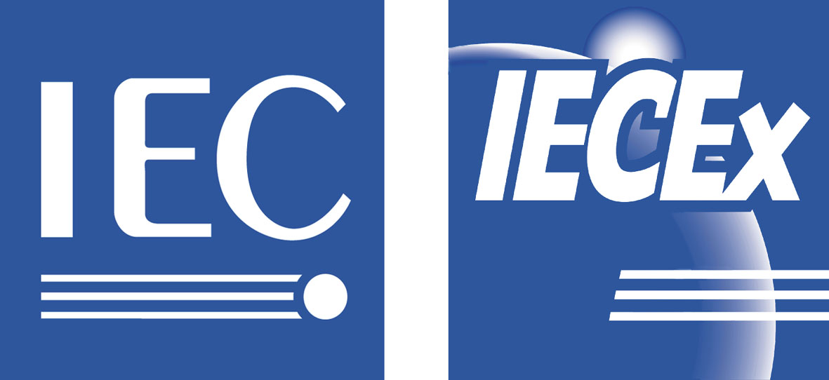 | ExMC/945/CD  July 2014

INTERNATIONAL ELECTROTECHNICAL COMMISSION (IEC) SYSTEM
FOR CERTIFICATION TO STANDARDS RELATING TO EQUIPMENT FOR
USE IN EXPLOSIVE ATMOSPHERES (IECEx SYSTEM)

For Consideration by Members of the IECEx Management Committee, ExMC

Consideration of Restructure of Committees Reporting to the IECEx Management Committee, ExMC, concerning the IECEx 03 Services Scheme
------------------

Introduction

During the 2013 ExMC Fortaleza meeting, Decision 2013/37A was taken (copy below) and agreed that the IECEx Executive be asked to consider the structure of Committees reporting to the ExMC, mainly with regard to the concern that the current ExTAG Committee consists of ExCBs and ExTL operating in both the IECEx 02 Equipment and IECEx 03 Services Schemes with some Members holding the view that a separate forum is needed to deal with IECEx 03 Scheme matters.

ExMC Decision 2013/37A – acceptance of ExMC WG13 Recommendation #4 to ExMC (refer ExMC/871/R as extracted below)

That a new WG or Committee be established under the ExMC to enable the transfer of the stewardship of the Services Scheme from the ExTAG to the ExMC (in consultation with the ExTAG).

This document is presented as an initial discussion paper for ExMC to consider as a result of discussion during the 2014 Dubai meeting of the IECEx Executive

The IECEx Executive also noted that while ExMC WG10 have been responsible for the maintenance of IECEx 03 Scheme documents that perhaps it is time to elevate this to a dedicated Committee such as being suggested in this discussion paper.

During the Executive’s Dubai 2014 meeting the Executive also noted the proposed management structure for the new IEC Conformity Assessment System for Renewable Energies (IECRE System) that will rely on sector or technology specific Operational Management Committees (OMCs) and considered one option as follows:
- ExMC becomes the IECEx System Management Committee to be supported by
- IECEx 02 Certified Equipment Scheme Operational Committee
- ExMarkCo renamed as IECEx 04 Conformity Mark Licensing System Operational Committee
- IECEx 03 Certified Service Facility Scheme Operational Committee
- ExPCC renamed as IECEx 05 Certified Personnel Competence Scheme Operational Committee

Visiting address:  IECEx Secretariat  Level 33 Australia Square  264 George Street  Sydney NSW 2000  Australia | Contact Details:  Tel: +61 2 4628 4690  Fax: +61 2 4627 5285  E-mail: info@iecex.com  http://www.iecex.com

ExMC Members will be asked to consider the points raised in this discussion paper, during the ExMC 2014 meeting in The Hague, with the view to provide the IECEx Executive with a direction for the preparation of any proposed amendments that may be required, to the IECEx System rules.

IECEx Executive

Proposals for discussion during the 2014 ExMC Meeting in the Hague

OPTION #1 - as per 2014 Meeting (Dubai) of IECEx Executive, Agenda Item 5.1 …..
(representing most change and restructure with respect to Annex A as a summary of current IECEx Rules)

The current ExMC becomes the IECEx System Management Committee to be supported by
- a new IECEx 02 Certified Equipment Scheme Operational Committee
- the ExMarkCo renamed as IECEx 04 Conformity Mark Licensing System Operational Committee
- a new IECEx 03 Certified Service Facility Scheme Operational Committee
- the ExPCC renamed as IECEx 05 Certified Personnel Competence Scheme Operational Committee and supported by existing ExPCC Working Groups
and
- the existing ExTAG continues to consider matters regarding ExCB and ExTL operations across the 02 Scheme
- the existing ExMC Working Groups including ExMC WG10 that will continue to maintain the 300 Series of IECEx Operational Documents as guided by the new IECEx 03 Certified Service Facility Scheme Operational Committee via the new IECEx System Management Committee.

OPTION #2 – alternative suggestion from IECEx Secretariat
(representing least change and restructure)

- ExMC retained as per current role and structure to manage and receive reports from
  - ExMarkCo as currently constituted and operated
  - ExPCC as currently constituted and operated
  - ExMC Working Groups as currently constituted and operated (with the possible exception of the current ExMC WG10 – refer below)

- ExTAG retained as per current role to provide a forum for ExCBs and ExTLs operating in the IECEx Certified Equipment Scheme ONLY and renamed as IECEx 02 Scheme ExTAG

- A new IECEx 03 Scheme ExAG (Ex Assessment Group) be established with appropriate membership and structure to provide a forum for ExCBs operating in the IECEx Certified Service Facility Scheme.
It is suggested that an appropriate membership will at least include representatives from ExCBs operating in the 03 Scheme, including those ExCBs that have made application to participate in the 03 Scheme, IECEx certified service facilities, clients of IECEx certified service facilities, and regulators in this area to participate as Observers, similar to the current ExTAG Committee practise.
It is also suggested that considerations on the membership and structure of the new ExAG include a review of whether the ExMC WG10 membership is active and, if not, whether ExMC WG10 should be disbanded and reconstituted under the new ExAG. An alternative to this could be the tasking of an ad hoc group of the new ExAG to review and revise the 300 Series of ODs as directed by the ExAG.

Annex A

Current IECEx Rules

Extracts from IECEx 01 Edition 6.1 as current at July 2014

6 Organization (of IECEx)
6.1 The organization comprises:
a) an IECEx Management Committee (ExMC);
b) an Ex Testing and Assessment Group (ExTAG);
c) an IECEx Conformity Mark Committee (ExMarkCo);
d) an IECEx Personnel Certification Committee (ExPCC);
e) a Board of Appeal; and
f) a Secretariat.

9 Committees reporting to the ExMC

9.1 Conformity Assessment Bodies Committee (ExTAG)

9.1.1 The Conformity Assessment Bodies Committee referred to as the Ex Testing and Assessment Group (ExTAG) deals with matters of a technical nature concerning the application of the IEC International Standards to the assessment and testing of Ex equipment and matters relating to the assessment and surveillance of a manufacturer’s or service provider’s quality system. The principle role of ExTAG is to facilitate common application of testing, assessment and auditing requirements in the issue and maintenance of an IECEx Certificate of Conformity.

9.1.2 All ExCBs and ExTLs shall be members of the ExTAG. Where an organization is both an ExCB and an ExTL, it shall have only a single membership.
The Chairman and/or Secretaries of IEC TC 31 and subcommittees shall be ex officio members of the ExTAG, in order to facilitate the solution of problems relating to the application of the IEC International Standards.

9.1.3 The duties of the ExTAG are:
a) to harmonize the application of the requirements of standards;
b) to detail the way in which the tests specified in the standards have to be carried out so as
to achieve the necessary reproducibility of test results;
c) to harmonize the design and use of the test equipment referred to in the standards and to
make recommendations to the relevant IEC technical committee or subcommittee for
improvement of those standards; and
d) to provide ExCBs and ExTLs with a forum in which practical testing and assessment
problems can be demonstrated and discussed.

Extracts from IECEx 03-2, 03-3, 03-4 and 03-5 (all Edition 1.0) as current at July 2014

4 Governing of the IECEx Certified Service Facilities Scheme
This IECEx Certified Service Facilities Scheme (referred to throughout this document as “Scheme”) shall be governed by the Ex Management Committee (ExMC), whose responsibilities in this respect are defined in the Basic Rules of the IECEx System, Publication IECEx 01.

