INTERNATIONAL ELECTROTECHNICAL COMMISSION (IEC) SYSTEM
FOR CERTIFICATION TO STANDARDS RELATING TO EQUIPMENT FOR
USE IN EXPLOSIVE ATMOSPHERES (IECEx SYSTEM)

Ex Management Committee, ExMC

TITLE: IECEx System Report Card - 2013

INTRODUCTION

The Secretariat has prepared this document as an annual Report Card to IECEx Members on both the state of the IECEx System and progress on a number of matters since the Calgary 2012 meetings, such as:

- IECEx System Membership
- Statistics of issued IECEx Certificates of Conformity, ExTRs, QARs
- A breakdown of the number of ‘Issue 0’ Equipment CoCs compared to Up Issues (Table 1B)
- Identification of Mark Licenses issued
- Review of the IECEx System including review of Certificates and issued Test Reports and QARs
- Inclusion of the number of Companies holding IECEx certification
- Promotional Activities
- Secretariat and General Technical Administration

This document is issued for information to members and is listed on the IECEx 2013 ExMC meeting agenda for noting and any necessary discussion.

Address:  SAI Building  Level 7  286 Sussex Street  Sydney NSW 2000  Australia | Contact Details:  Tel: +61 2 8206 6940  Fax: +61 2 8206 6272  e-mail: chris.agius@iecex.com  http://www.iecex.com
IECEx System Report Card - 2013

- General Overview

Discussions and decisions from the 2012 series of IECEx Meetings in Calgary set the tone and direction for further development, growth and expansion of the IECEx System and its Schemes.

The Secretariat is pleased to report on the following key points concerning IECEx operation since the 2012 IECEx Calgary meetings:

  - At the time of preparing this report, Spain has joined IECEx and there is continued interest from various countries including the United Arab Emirates, Ireland, and Belgium
  - Operation of the IECEx Certified Service Facilities Scheme, now starting to take traction, with 119 Certificates issued to date since commencement in late 2007.
  - Operation of the IECEx Certificate of Personal Competence, CoPC Scheme also gaining traction with 242 Certificates issued to date since commencement in late 2010.
  - Increased use of IECEx Unit Verification Certificates
  - Promotion of the Publication from the United Nations, UNECE, Common Regulatory Objective for the Ex Sector continues to support IECEx
  - Additional enhancements to the IECEx On-Line Certificate of Conformity System, to provide additional tools for ExCB to assist in their management of surveillance activities of issued Certificates
  - The marked increase in the demand and issue of IECEx Certificates of Conformity and Reports, as reported in 2008, 2009, 2010, 2011 and 2012 continues in 2013 with year on year growth being maintained.
  - Continued processing of Scope extensions from ExTLs and ExCBs
  - Promotion at Regional and International forums
  - Greater industry involvement, including users and regulators
  - A marked increase in the number of day to day industry inquiries being directed at the IECEx Secretariat, which is reflected in the increased e-mail traffic of the Secretariat
  - Launch of the new “IECEx Mobile Device Application”
  - Others

- Membership

IECEx System Membership, as of 14th August 2013 stands at:

- 31 Countries, members of the IECEx Management Committee, ExMC

- With four separate Certification Schemes
  - IECEx Certified Equipment Scheme (Rules = IECEx 02)
  - IECEx Certified Service Facilities Scheme (Rules = IECEx 03)
  - IECEx Conformity Mark Licensing System (Regulations = IECEx 04)
  - IECEx Certification of Personnel Competencies (CoPC) Scheme
(Rules = IECEx 05)

- IECEx Certified Equipment Scheme
  - 44 Approved ExCBs (+ Applicants)
  - 50 Approved ExTLs (+ Applicants)

- IECEx Certified Service Facilities Scheme
  - 13 Approved ExCBs (+ Applicants)

- IECEx Conformity Mark Licensing System
  - 14 Approved License issuing ExCBs

- IECEx Certification of Personnel Competencies (CoPC) Scheme
  - 7 Approved ExCBs (+ Applicants)

- Statistics – Certificates, Licenses and Reports

At 30th July 2013 there were 32,435 Issued IECEx Reports, Certificates and Licenses across all the following four IECEx Schemes compared with 25,302 for the same time last year (30th July 2012) – this represents a growth of 28.2% since Calgary 2012.

- The IECEx Certified Equipment Scheme, IECEx 02 (see Table 1A)
- The IECEx Certified Service Facilities Scheme, IECEx 03. (see Table 2)
- The IECEx Conformity Mark Licensing System, IECEx 04 (see Table 3)
- The IECEx Certification of Personnel Competencies (CoPC) Scheme, IECEx 05 (see Table 4)

The figure “Totals”, in Table 1A, show the total number of combined Equipment CoCs (Certificates of Conformity), ExTRs (IECEx Test Reports) and QARs (IECEx Quality Audit Reports) issued under the IECEx Certified Equipment Scheme. Table 1B shows a comparison between new Certificates (Issue 0) compared to new issues of existing Certificates (i.e. changes to existing certificates, Issue 1 and above).

In addition, the number of Equipment CoCs at the “DRAFT” status, i.e. awaiting completion of the certification process (jobs in hand) as shown in Table 1A stands at 1,471 in the system (compared with 1150 for the same time last year) which demonstrates future use and growth of the Equipment Scheme (refer Figure 1B for the year on year growth of this metric). This is in addition to the 31,562 number of Equipment Certificates and Reports already issued.

Figure 1A provides an overview trend of the number of Certificates and Reports issued since 2003, under the IECEx 02 Scheme (Certified Equipment Scheme), while Figure 2 provides a breakdown of the percentage weighting of CoCs compared to ExTRs and QARs issued over the life of the IECEx System.

The conclusion drawn from these statistics is that the IECEx Certified Equipment Scheme is still experiencing significant and sustained growth. The following factors are seen as facilitating this growth.

- Penetration of new markets, such as the Gulf Region
- Industry’s recognition of the value that certification under an Internationally accepted Regime brings to risk mitigation as part of their compliance regime
- The increasing involvement by industry in the management and operation of IECEx
- The credibility of the IECEx System, compliance to IEC Standards, single Peer assessment system for all ExCBs and ExTLs + surveillance;
- Increased awareness and recognition of IECEx as “world's best practice”, e.g. the formal endorsement by the UNECE, as per new United Nations approved CRO publication, March 2011
- One set of operational procedures and reporting formats (i.e. the IECEx way of Ex Certification);
- The transparency of IECEx activities, provided by the IECEx website and On-Line CoC system;
- A greater level of industry understanding of the IECEx system by way of promotion of IECEx by IECEx Officers and Members;
- A growing international awareness of the value of Structured International Conformity Assessment Systems such as IECEx;
- The value of Networking among all Ex experts including ExCBs and ExTLs and associated technical discussion forums provided, e.g. ExTAG;
- A dedicated technical Secretariat;
- Others

IECEx 02 – IECEx Certified Equipment Scheme

Year ending Figures IECEx 02 Certified Equipment Scheme

Table 1A- Total number of IECEx Equipment CoCs and Reports issued

Total number of IECEx Equipment CoCs and Reports issued

Year | Applicants* | CoCs* |  | ExTRs* | QARs* | Total* | CoC Drafts
2003 to 2007 | Not recorded | 1866 |  | 2019 | 971 | 4856
2008 | 485 | 1258 |  | 1166 | 350 | 2774 | 499
2009 | 530 | 1490 |  | 1347 | 712 | 3549 | 618
2010 | 510 | 2070 |  | 1897 | 947 | 4914 | 675
2011 | 557 | 2626 |  | 2143 | 966 | 5735 | 1000
2012 | 456 | 2680 |  | 2301 | 1019 | 6000 | 1150
@ 30 July 2013 | 508 | 1744 |  | 1524 | 466 | 3734 | 1471
Totals | 3046 | 13734 |  | 12397 | 5431 | 31562
*Figures for the number of Draft certificates each year are NOT included in Totals

Unit Verification Certificates

Fifty seven (57) IECEx Equipment Unit Verification Certificates have been issued since Calgary 2012 meetings.

Table 1B – Issue 0 CoCs expressed as % of all CoCs (Equipment Scheme)

Issue 0 CoCs expressed as % of all CoCs

Year | # All CoCs | # “Issue 0”  CoCs | “Issue 0” as % of all CoCs
2008 | 1258 | 693 | 55.1%
2009 | 1490 | 799 | 53.6%
2010 | 2070 | 1032 | 49.9%
2011 | 2626 | 1158 | 44.1%
2012 | 2680 | 1172 | 43.7%
@ 30-Jul-13 | 1744 | 775 | 44.4%

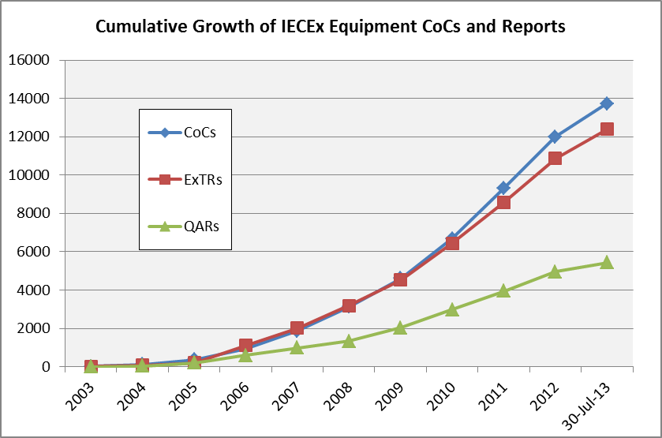

Figure 1A – Cumulative Growth of Issued IECEx CoCs, ExTRs and QARs for the IECEx Certified Equipment Scheme

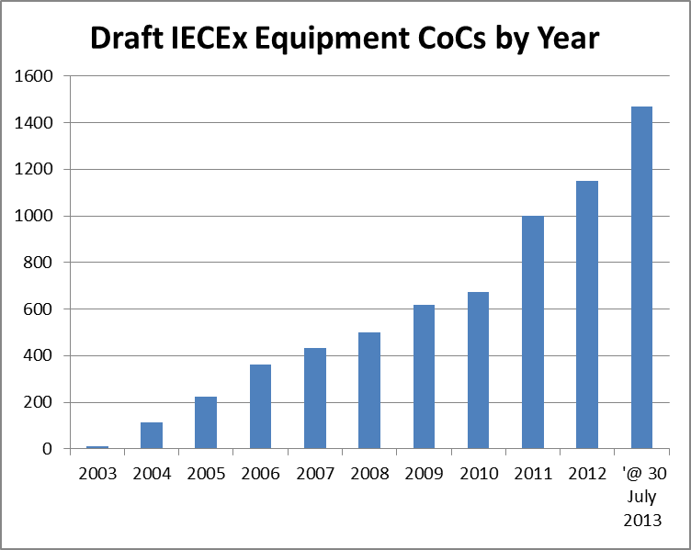

Figure 1B – Comparison of draft IECEx Equipment CoCs as indicative of future year on year growth of the Scheme

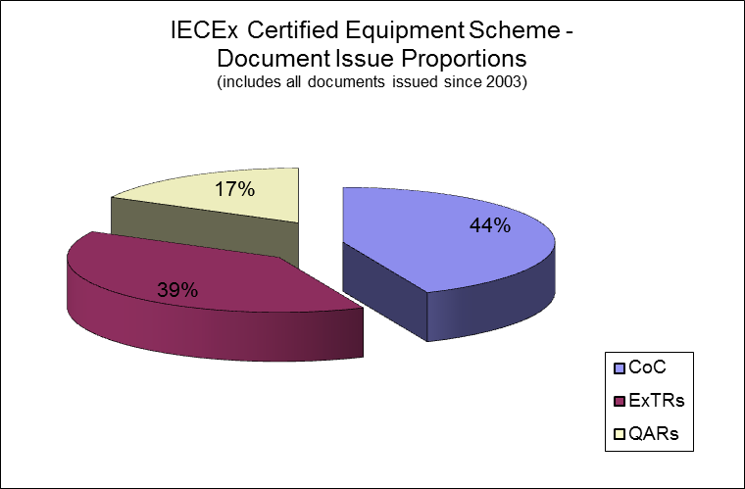

Figure 2 – CoCs, ExTRs, QARs Percentages

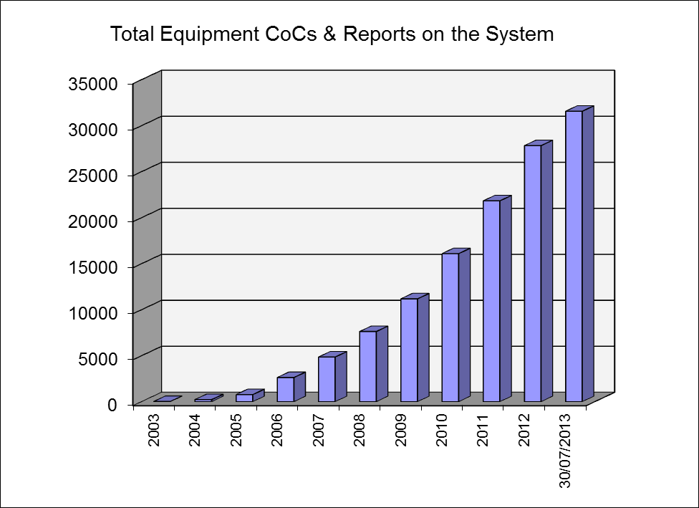

Figure 3 - Total IECEx Equipment Scheme CoCs, ExTRs and QARs at each Year end and to 30 July 2013.
IECEx 03 – IECEx Certified Service Facilities Scheme

Table 2 – Year End Figures IECEx 03 Certified Service Facilities Scheme

Total number of Certified Services CoCs issued
(Scheme commenced end 2007)

@ the end of the Year | CoCs | FARs | Total | Drafts
2007 | 3 | 17 | 20
2008 | 12 | 47 | 59
2009 | 15 | 33 | 48 | 9
2010 | 26 | 42 | 68 | 7
2011 | 31 | 53 | 84 | 8
2012 | 21 | 22 | 43 | 9
@ 30 July 2013 | 13 | 31 | 44 | 19
Totals | 121 | 245 | 366

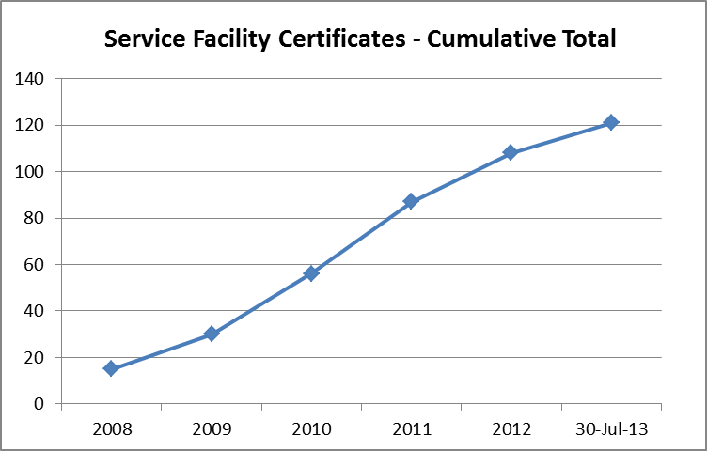

Figure 4 – Cumulative Total of IECEx Certified Service Facility Certificates (CoC) at each Year end and to 30 July 2013
IECEx 04 – IECEx Conformity Mark Licensing System

Table 3 – Year End Figures IECEx 04 Conformity Mark Licenses

Total number Conformity Mark Licenses issued
(System commenced 2009)
@ the end of the Year | Licenses | Number of CoCs attached to Licenses | Drafts
2009 | 4 | 10 | 0
2010 | 3 | 34 | 2
2011 | 7 | 83 | 3
2012 | 7 | 71 | 8
@ 30 July 2013 | 2 | 2 | 9
Totals | 23 | 200

IECEx 05 – Certificates of Personnel Competence Scheme

Table 4 – Year End Figures IECEx 05 Personnel Competence

Total number CoPC Certificates issued
(Scheme commenced late 2010)

@ end of the Year | CoPC Certificates | Drafts
2010 | 7 | 0
2011 | 64 | 0
2012 | 88 | 0
@ 30 July 2013 | 83 | 9
Totals | 242

- Surveillance of the IECEx System

To ensure integrity of the System a range of measures and activities are undertaken within IECEx which include:

- Peer assessment of all ExTLs and ExCBs seeking to join IECEx
- Annual surveillance of all ExTLs and ExCBs (confirmation of accreditation for those with accreditation and site visits for those without accreditation)
- Reassessment applied to all ExTLs and ExCBs involving assessment on site to review Testing/Certification facilities, capabilities, practices and review of Certificates, ExTRs and QARs files – the results of this review are outlined in 4.1 below.
- Sample reviews of ExTRs, QARs
- In-built security features of the IECEx On-Line Certificate system, eg ExCBs can only issue Certificates covering Standards within their scope
- IT Tools to aid in the management control of issued ExTRs and QARs and CoCs and FARs, PCARs
- On-going surveillance of the On-Line system at the Secretariat
- “Out of Date” QAR listing to assist ExCBs manage and control the on-going surveillance due dates, with Admin feature for the Secretariat to monitor performance of all ExCBs. (see feature below)
- Review of On-Line System for Certificates issued in 2012 – the results of this review are outlined in 4.2 below.

4.1 Review of ExTRs and QARs during Equipment ExCB Re-assessments

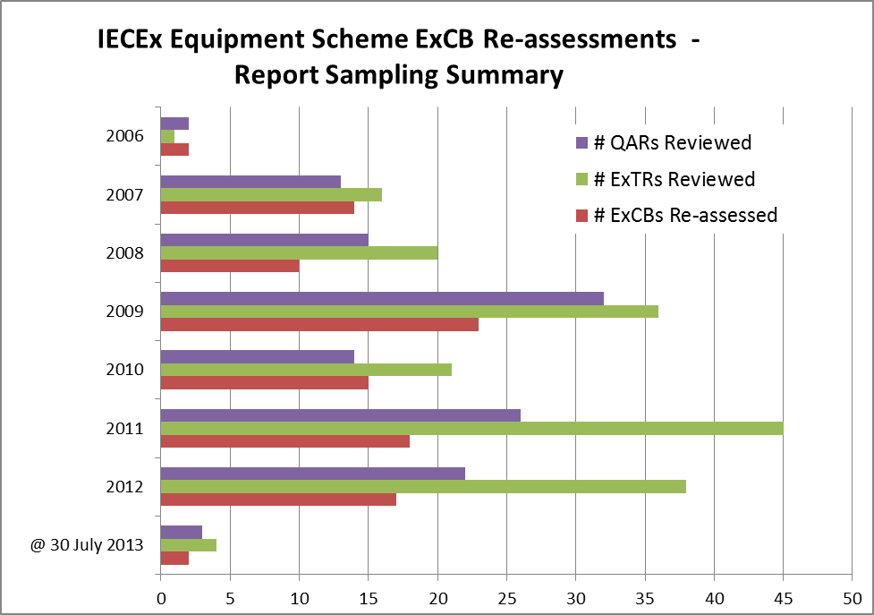

Figure 5 – Summary of IECEx Equipment Scheme Report Reviews

4.2 Review of Online CoCs, ExTRs and QARs for the 2012 Calendar year

Introduction
A review of online IECEx Equipment Certificates of Conformity published in 2012 was conducted by the IEC Secretariat over February 2013 on the basis of a random sampling of 10% of all certificates originally issued or updated in the 2012 calendar year by IECEx ExCBs for the IECEx Certified Equipment, IECEx Certified Service Facility and IECEx Certified Person schemes.
Objective
The objective of the review was to check that the information on the sampled Certificates is correct and complete as compared to the following criteria:

For Certified Equipment Certificates:
- Date of issue appropriate (i.e. not showing in the future)
- A Test Report number and File Reference included.
- Manufacturer name detail is consistent with their other certificates
- Manufacturer’s site street (not a PO Box) address given
- Any attached Annex has a reference to the CoC number
- Referenced Annexes are attached
- Conditions of Certification listed for “X” type Certificates
- Equipment description is clear and sufficiently detailed
- No major editorial mistakes (including linking to a draft ExTR)
- Correct links to valid ExTR and QAR
- Linked QAR is current
- Manufacturer on CoC matches ExTR
- Manufacturer on CoC matches QAR and QAR covers all manufacturing locations
- Standards listed on CoC matches Standards (including Edition #) on ExTR
- Scope of Certificate matches QAR and ExTR ExCB capability.
- Type of Protection Concept on CoC matches standards and QAR
- Where more than 1 issue exists that they are linked and changes explained on CoC
- Statement of Limitations is included in CoC for Component certificates (“U” type)
- Unit Verification Certificates have been denoted with “V” and include Serial #(s)

For IECEx Certified Service Facility Certificates:
- CoC Date of Issue OK (not in future)
- CoC and FAR addresses for applicant are valid (not PO Box)
- Scope of Services is valid
- Listed FAR is valid (ie. Not expired)
- FAR Facility same as audited site
- FAR Details of change are specified (where appropriate
- FAR specifies issuing ExCB

For IECEx Certified Person Certificates:
- Name on CoPC same as on PCAR
- CoPC is current / valid
- Scope of Competence Units same on CoPC as on PCAR
- Listed PCAR is valid (ie. Not expired)
- FAR specifies issuing ExCB
- Photograph is “recognizable”

Certificates and Reports reviewed
The quantities of IECEx Certificates (representing a 10% sample) selected at random from all those published in 2012 and audited against the elements listed above =
- 288 x IECEx Equipment CoCs
- 10 x IECEx Service Facility CoCs (NOTE: no issues were found with any of these)
- 8 x IECEx Certified Person CoCs (NOTE: no issues were found with any of these)

The results of the audit of IECEx Certified Equipment Certificates follow:

Item | Previously observed Certificate Deficiency as Review Criteria  For 288 Certified Equipment Certificates reviewed. | # of CoCs with Deficiency
A | Date of issue NOT appropriate (i.e. showing in the future) | 0
B | A Test Report number or File Reference NOT included | 0
C | Manufacturer name detail NOT consistent with their other certificates | 1
D | Full Manufacturer’s site street address NOT provided (eg. a PO Box used) | 1
E | Attached Annex(es) do NOT reference the CoC number | 2
F | Referenced Annexes are NOT attached | 1
G | “Conditions of Certification” details NOT specified for “X” type Certificates | 3
H | Equipment description is NOT clear and sufficiently detailed | 0
I | Major editorial mistakes | 1
J | CoC is NOT correctly linked to valid ExTR and/or QAR (main issue observed was linking of an issued CoC to a draft ExTR) | 12
K | Linked QAR is NOT current | 0
L | Manufacturer on CoC does NOT match ExTR details | 4
M | Manufacturer on CoC does NOT match QAR details and/or QAR(s) does NOT cover all manufacturing locations listed on CoC | 11
N | Standards listed on CoC do NOT match Standards (including Edition #) on ExTR (main issue observed was CoC citing later Edition than ExTR) | 9
O | Scope of Certificate exceeds QAR and ExTR issuing ExCB’s capability | 2
P | Type of Protection Concept on CoC does NOT match standards and QAR | 1
Q | CoC Issues subsequent to Issue 0 are NOT linked and/or details of changes between Issues are NOT detailed on subsequent CoC | 0
R | “Statement of Limitations” details NOT included in CoC for Component certificates (“U” type) | 5
S | Unit Verification Certificates have NOT been denoted with “V” and/or do NOT include Serial #(s) for certified units of product | 0

In summary:
- IECEx Certified Equipment Certificates with zero issues = 245
- IECEx Certified Equipment Certificates with at least one issue = 43
- IECEx Certified Equipment Certificates with multiple issues = 8
- % of IECEx Certified Equipment Certificates audited with at least one issue = 15%
- % of IECEx Certified Equipment Certificates audited with multiple issues = 3%

Conclusion
The results of this review show an improvement on the results of a similar review conducted in 2012 and identifies a number of areas that require additional attention. The ExCBs observed to have issues with particular Certified Equipment Certificates have been very responsive in addressing these and proactive in taking action to prevent future recurrence.

To ensure that the technical integrity of testing and auditing is maintained the Secretariat is proposing that a “mid-term” surveillance visit of ExTLs/ExCBs by an Assessor to focus on reviewing ExTR files of the ExTLs. Refer ExMC/857/DV for consideration at the Fortaleza ExMC meeting.

- IECEx Achievements since 2012 IECEx Calgary Meetings

Significant achievements since 2012 Calgary meetings include:

- Publication of Revised System + Scheme Rules

Document No. | Title
IECEx 05 | IECEx Scheme for Certification of Personnel Competence for Explosive Atmospheres – Rules of Procedure
IECEx 03-2 | IECEx Certified Service Facilities Scheme – Part 2: Selection of Ex equipment and design of Ex installations – Rules of Procedure
IECEx 03-3 | IECEx Certified Service Facilities Scheme – Part 3: Ex installation and initial inspection – Rules of Procedure
IECEx 03-4 | IECEx Certified Service Facilities Scheme – Part 4: Ex inspection and maintenance – Rules of Procedure
IECEx 03-5 | IECEx Certified Service Facilities Scheme – Part 5: Repair, overhaul and reclamation of Ex equipment – Rules of Procedure

- New and Updated Publications of IECEx Operational Documents

Document No. | Title
OD 018 | Harmonised CHECK LIST FOR TESTING AND CALIBRATION LABORATORIES ISO/IEC 17025
OD 313-5 | IECEx Certified Service Facility Scheme – Part 5: Repair, overhaul and reclamation of Ex equipment - Assessment and Certification of Service Facilities involved in the repair, overhaul and modification of Ex equipment – Procedures.
OD 314-5 | IECEx Certified Service Facility Scheme – Part 5: Repair, overhaul and reclamation of Ex equipment - Quality Management System requirements for IECEx Service Facilities involved in the repair, overhaul and modification of Ex equipment.
OD 315-5 | IECEx Certified Service Facility Scheme – Part 5: Repair, overhaul and reclamation of Ex equipment - Additional Requirements for IECEx Service Facilities involved in the repair, overhaul and modification of Ex equipment.
OD 316-5 | IECEx Certified Service Facility Scheme – Part 5: Repair, overhaul and reclamation of Ex equipment - Assessment Procedures for IECEx acceptance of Candidate Certification Bodies (ExCBs) for the purpose of issuing IECEx Certificates to Ex Service Facilities involved in the repair, overhaul and modifications of Ex equipment.
OD 313-2 | IECEx Certified Service Facility Scheme – Part 2: Selection of Ex equipment and design of Ex installations, Assessment and Certification of Service Facilities providing selection of Ex equipment and design of Ex installations related services – Procedures.
OD 314-2 | IECEx Certified Service Facility Scheme – Part 2: Selection of Ex equipment and design of Ex installations, Quality Management System requirements for IECEx Service Facilities providing selection of Ex equipment and design of Ex installations related services.
OD 316-2 | IECEx Certified Service Facility Scheme – Part 2: Selection of Ex equipment and design of Ex installations, Assessment Procedures for IECEx acceptance of Candidate Certification Bodies (ExCBs) for the purpose of issuing IECEx Certificates to Ex Service Facilities providing selection of Ex equipment and design of Ex installations related services.
OD 313-3 | IECEx Certified Service Facility Scheme – Part 3: Ex installation and initial inspection, Assessment and Certification of Service Facilities providing Ex installation and initial inspection service – Procedures.
OD 314-3 | IECEx Certified Service Facility Scheme – Part 3: Ex installation and initial inspection, Quality Management System requirements for IECEx Service Facilities providing Ex installation and initial inspection service.
OD 316-3 | IECEx Certified Service Facility Scheme – Part 3: Ex installation and initial inspection, Assessment Procedures for IECEx acceptance of Candidate Certification Bodies (ExCBs) for the purpose of issuing IECEx Certificates to Ex Service Facilities providing Ex installation and initial inspection service.
OD 313-4 | IECEx Certified Service Facility Scheme – Part 4: Ex Inspection and Maintenance, Assessment and Certification of Service Facilities providing Ex installation related services – Procedures.
OD 314-4 | IECEx Certified Service Facility Scheme – Part 4: Ex Inspection and Maintenance, Quality Management System requirements for IECEx Service Facilities providing Ex installation related services.
OD 316-4 | IECEx Certified Service Facility Scheme – Part 4: Ex Inspection and Maintenance, Assessment Procedures for IECEx acceptance of Candidate Certification Bodies (ExCBs) for the purpose of issuing IECEx Certificates to Ex Service Facilities providing Ex installation related services.
OD 501 | IECEx Scheme for Certification of Personnel Competence for Explosive Atmospheres – Assessment procedures for IECEx acceptance of Certification Bodies (ExCBs) for the purpose of issuing and maintaining IECEx Certificates of Personnel Competence (CoPCs)
OD 502 | IECEx Scheme for Certification of Personnel Competence for Explosive Atmospheres – Application for an IECEx Certificate of Personnel Competence (CoPC), documentation and information requirements
OD 503 | IECEx Scheme for Certification of Personnel Competence for Explosive Atmospheres – ExCB Procedures for issuing and maintaining IECEx Certificates of Personnel Competence
OD 504 | IECEx Scheme for Certification of Personnel Competence for Explosive Atmospheres – Specification for Units of Competence Assessment Outcomes

- Building on the success of the First International IECEx Conference jointly conducted with Emirates Authority For Standardisation & Metrology and the United Nations, UNECE in Dubai in March 2012, we look forward to the United Arab Emirates joining the IECEx System later in 2013.

We also look forward to replicating the success of Dubai 2012 at a similar event planned for 19th and 20th February 2014 in Malaysia organized by the IEC and IECEx, together with Department of Standards Malaysia, and in conjunction with UNECE (United Nations Economic Commission for Europe). This two day event will provide a unique opportunity for industries in the region to get better acquainted with IEC International Standards and Conformity Assessment Systems in general and find out how they can derive most benefit from the IECEx services that cover Ex equipment and systems, repair and overhaul facilities, and certification of personnel competence.

- The second meeting of IECEx Committee, ExPCC, IECEx Certificate of Personal Competence Scheme Committee, was held at SGS Baseefa, in Buxton, UK in June 2013 and as can be seen below, the interest in this Scheme is reflected in the great attendance at this meeting.



- Publication of the United Nations UNECE Common Regulatory Objective (CRO) Publication in English continues to direct interest towards IECEx.

To assist in building on this success, translations into Russian and Arabic have been completed and work continues on translations into French, Spanish, Portugese and Chinese.

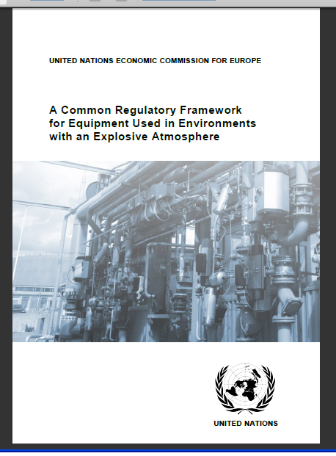

- Scheme Promotional Activities

As part of the IECEx promotion and marketing strategy, the IECEx Executive and Secretariat continue in delivering presentations at key events in addition to supporting IECEx experts in their national and regional promotion of IECEx. The following are examples of recent or upcoming promotional activities of the IECEx System:

- Industry presentation by the Secretariat in South Africa in July 2013
- Joint IECEx / UNECE Paper presented at the 2012 PCIC Middle East Conference, Abu Dhabi
- IECEx Vice Chairman, Alexander Zalogin presentation to EU-Russia Industrialists Round Table Conference scheduled for Kazan (Russia) October 2012
- ExPCC Chairman Ralph Wigg facilitating a Workshop at the IEC Young Professionals Forum in Oslo IEC GM
- IECEx AFSEC (African Electrotechnical Standarisation Commission) 2 day Workshop and capacity building by Thierry Houeix and Peter Thurnherr, Nov 2012
- 2013 October – Indonesia, presentation on IEC Conformity Assessment by the IECEx Secretariat
- 2014 IECEx Conference in conjunction with the Malaysian National Committee and UNECE
- 2014 PCIC Middle East – IECEx paper to be presented by the Secretariat
- Monthly news articles in all IEC e-Tech on-line magazines, library maintained at http://www.iecex.com/news_releases.htm
- Regular news articles published in HazardEx prepared by IECEx experts including Ron Sinclair, Jim Munro and Others
- Others

The IECEx Chairman, Executive and Secretariat remain available to provide any additional information on these items or assistance with the preparation of any presentations that Members may be involved with.

- Secretariat and General Technical Administration

7.1 Day to day duties of the Technical Secretariat can be broadly categorized as:
- Processing applications and managing assessments of new bodies and re-assessment of existing bodies
- Processing the applications of Scope extensions, e.g. new editions of Standards and other changes, e.g. name changes of existing bodies along with their maintenance via surveillance and re-assessments
- Support to ExCBs in the day to day use of the Centralised On-Line CoC system
- Revision and up dating of IECEx Schemes rules and Operational Documents and forms
- IECEx Schemes development and Growth across all IECEx Schemes
- In conjunction with Chairman and Officers, IECEx System regular reporting to CAB and participation in CAB Working Groups
- Respond to general inquiries from industry
- Day to day management of System finances, in conjunction with Treasurer

  - As an indicator of the IECEx System development and growth, since the first Report card issued in 2008 IECEx Paris meetings, the following additional statistics are provided: (Period to July 2013)

General items prepared and issued according to the day to day management and operation of the IECEx System are provided below with a comparison to the figures reported at the 2007, 2008, 2009, and 2010 presented in ExMC/390/Inf, ExMC/461/R, ExMC/544/R, and ExMC/621/R, ExMC/699/R and ExMC/749/R respectively.

ITEM | 2007  (ExMC/390/Inf) | 2008  (ExMC/461/R) | 2009  (ExMC/544/R) | 2010  (ExMC/621/R) | 2011  (ExMC/699/R) | 2012  (ExMC/749/R) | 2013  @ 30 July
Committee Documents Prepared and Issued¹ | 62 | 104 | 136 | 124 | 148 | 152 | 153
Operational Documents (new or Revised) | 7 | 5 | 7 | 13 | 13 | 5 | 18
ExTAG Decision Sheets Issued | 2 | 5 | 1 | 6 | 6 | 6 | 11
IECEx Guides (new or Revised) | 0 | 4 | 0 | 1 | 1 | 3 | 0
IECEx Scheme Rules (New or Revised) | 0 | 2 | 1 | 3 | 3 | 2 | 5
Others, e.g. News articles | 7 | 15 | 11 | 14 | 32 | 23 | 11
Total IECEx Items issued² | 78 | 135 | 156 | 161 | 203 | 191 | 198

¹ Comprises ExMC, ExTAG, ExMarkCo, ExPCC
² Total excludes other items such as reports to CAB and participation in CAB and related Working Groups

7.3 IECEx Website and On-Line Certificate System Upgrades
Since the 2012 IECEx meetings a number of upgrades and improvements to the IECEx website system have been implemented – details of the upgrades and improvement are provided in ExMC/879/CD.

7.4 Mobile Device Application for Smart Phones and Pad Devices (iPhone/iPads)

In response to request from users of the IECEx System, seeking ease of access to IECEx Certificates of Conformity, especially while in the field, IEC and IECEx launched the IECEx Mobile Application. While a first for IECEx it is also a first for IEC as it enters the “Mobile Applications” Domain.

This new Mobile Application provides both an On-Line and Off-Line mode for accessing IECEx Certificates with usual search capabilities.

Development work is now underway on the next generation of the App.

7.5 E-mail Traffic, handled by Secretariat (excluding those dealt with by IECEx Chairman, Officers, WG Conveners, Members and Assessors):

The following level of e-mail traffic was handled by the IECEx Secretariat and does not include additional mails dealt with by the IECEx Chairman, Officers and Assessors. These figures are provided as a guide to IECEx Members of the levels of IECEx activity and show a constant level of e-mails in comparison with 2007, 2008, 2009, 2010, and 2011 figures.

ITEM | 2007  (ExMC/390/Inf) | 2008  (ExMC/461/R) | 2009  (ExMC/544/R) | 2010  (ExMC/621/R) | 2011  (ExMC/699/R) | 2012  (ExMC/749/R) | 2013  @ 30 July
Total E-mail Traffic of the IECEx Secretariat | 16,150 | 17,500 | 17,300 | 18,200 | 18,880 | 19,660 | 21,055
* Out of office or other miscellaneous e-mails have been filtered and are excluded from above figures

7.6 Management of IECEx ExCB/ExTL Assessments + Applications for Scope extensions.

ITEM | 2007  (ExMC/390/Inf) | 2008  (ExMC/461/R) | 2009  (ExMC/544/R) | 2010  (ExMC/621/R) | 2011  (ExMC/699/R) | 2012  (ExMC/749/R) | 2013  @ 30 July
Site assessments & re-assessments | 22 | 19 | 17 | 14 | 17 | 23 | 19
Scope extensions | 32 | 32 | 37 | 42 | 89 Standards  / Units  43 Applications | 81  Standards  / Units  38  Applications | 61  Standards  / Units  30  Applications

- Finances

8.1 Overview
The sound financial performance of IECEx is reported in the 2012 Audited Accounts, ExMC/848/DV. While income and expenditure are generally according to the approved 2013 Budget, for the first half of 2013, income from IECEx Certificate Fees were in line with budget expectations while overall expenditure remains within or below budget.

8.2 INVOICES Issued / Processed since 2012 Calgary meeting
The day to day management of finances for the IECEx system has resulted in the following table of invoices and statements being issued as well as monitoring the receipt of payments

Documents | Reported Berlin 2010 | Reported Split 2011 | Reported Calgary 2012 | Report for  Fortaleza  2013
Invoices issued – Annual Fees | 33 | 33 | 33 | 34
Statements Issued – CoC Fees | 66 | 71 | 77 | 83
Invoices Issued – CoC Fees | 58 | 63 | 69 | 75
Invoices Issued – Application Fees | 1 | 4 | 3 | 2
Invoices Issued – Assessment Fees | 17 | 17 | 26 | 14
Invoices processed / Central Approval – Assessor Charges | 33 | 34 | 50 | 50
TOTAL Invoices issued and processed | 208 | 222 | 258 | 258

In noting the following:
- overall response to on-time payment of invoices by Members generally good
- income being maintained above 2013 approved budget

There are no specific issues concerning finance at this time. A further update report will be given during the 2013 Fortaleza ExMC meeting by the Treasurer and Secretary.

9 Concluding Remarks

IECEx continues to enjoy significant and sustained growth in both exposure and demand for its services. The Global Financial crisis has appeared to have little effect on overall demand for IECEx other than to assume that the current annual rate of growth may have even been higher. Despite impressive annual growth IECEx continues to maintain a conservative approach to budgetary planning.

Two significant indicators of annual growth are:
- Growth in number of Certificates + Reports
- Growth in income, mainly from certificate fees

The instant and “On-Line” nature of the IECEx Certification system, with its electronic master controlled certificates coupled with the increased industry involvement in the Scheme’s operation are seen as a significant drivers of interest and demand for IECEx, noting that Certificates issued by ALL IECEx Certifiers are found in the one single location as opposed to the need to search individual ExCB websites.

The continued growth and success of IECEx is founded on the solid participation by various sectors of industry in the day to day management of the IECEx System via participation in ExMC, its Committees and the various Working Groups. Over recent years we have seen a growing level of this industry participation, especially from end users and also regulators as well as manufacturers and Ex repairers. A key ingredient to the success that the IECEx community continues to enjoy.

The Secretariat acknowledges, with gratitude, the diligent leadership of the IECEx Chairman, supported by the IECEx Executive along with Conveners of the many expert Working Groups and their experts all of which are vital to enable IECEx to continue in its quest to serve the international Ex community.

Chris Agius
IECEx Executive Secretary
August 2013

