Report of the convenor of the ExMC/WG 08 „Regulatory Acceptance“

Date: 30th of August, 2012

Current status

The WG 08 has 7 members:
Heinz Berger (CH), Giovanni Hummel Borges (BR), David Chirdon (US), Ron Collis (AU), Vitaly Grudtsyn (RU), Jim Munro (AU), Ralph Wigg (AU)

The last meeting was on the 07th of September, 2011. Main decision was to push the promotion of the UNECE Model Regulation for Explosion Protection and the involvement of more countries in the work of the WG 08 and the UNECE sector initiative. Especially CN and US are in the focus. David Chirdon (US) has joined the WG 08 in 2012. CN will follow to send a representative soon. In 2012 there will be no meeting due to missing agenda items, therefore the next one will be in conjunction with the IECEx meetings 2013 in Brazil. Lorenza Jachia will be available in Calgary 2012 for presenting the UNECE Model Regulation on Monday, 03rd of September, 2012.

The promotion of the UNECE Model Regulation

http://www.unece.org/fileadmin/DAM/trade/wp6/SectoralInitiatives/EquipmentForExplosiveEnvironment/SIEEE_CRO_ENG.pdf

has been made successfully in 2012 by a conference in Dubai. Similar workshops need to be organized for other locations. It is intended to prepare a workshop in Brazil in conjunction with the IECEx meetings 2013 and in cooperation with INMETRO. As integral part of an industry symposium there will be an opportunity to learn about opinions of national regulators (in this case INMETRO) how to converge legislation internationally and how UNECE can play a key role for this important goal.

The technical work has been conducted in cooperation with the UNECE (Lorenza Jachia, Dr Frank Lienesch). Main focus for 2013 is to develop a blue print for a global market surveillance system for explosion protected equipment, using national structures in order to achieve governmental control on non-complying products. It is intended to classify not complying products (mainly with the applicable standard of the IEC 60079-0 group) in minor, relevant and critical non-conformances. An “appeal registry” (a website) will be in operation in order to collect observations. Within a group of designated independent conformity assessment bodies it has to be concluded about non-conformances by classifying in minor, relevant and critical. All details of this system will be published by a draft for “Guidelines for the Market Surveillance” which is based on existing national guidelines. Finally the international network of market surveillance experts needs to be established. The draft will be available before the next meeting in Brazil.

Dr Uwe Klausmeyer

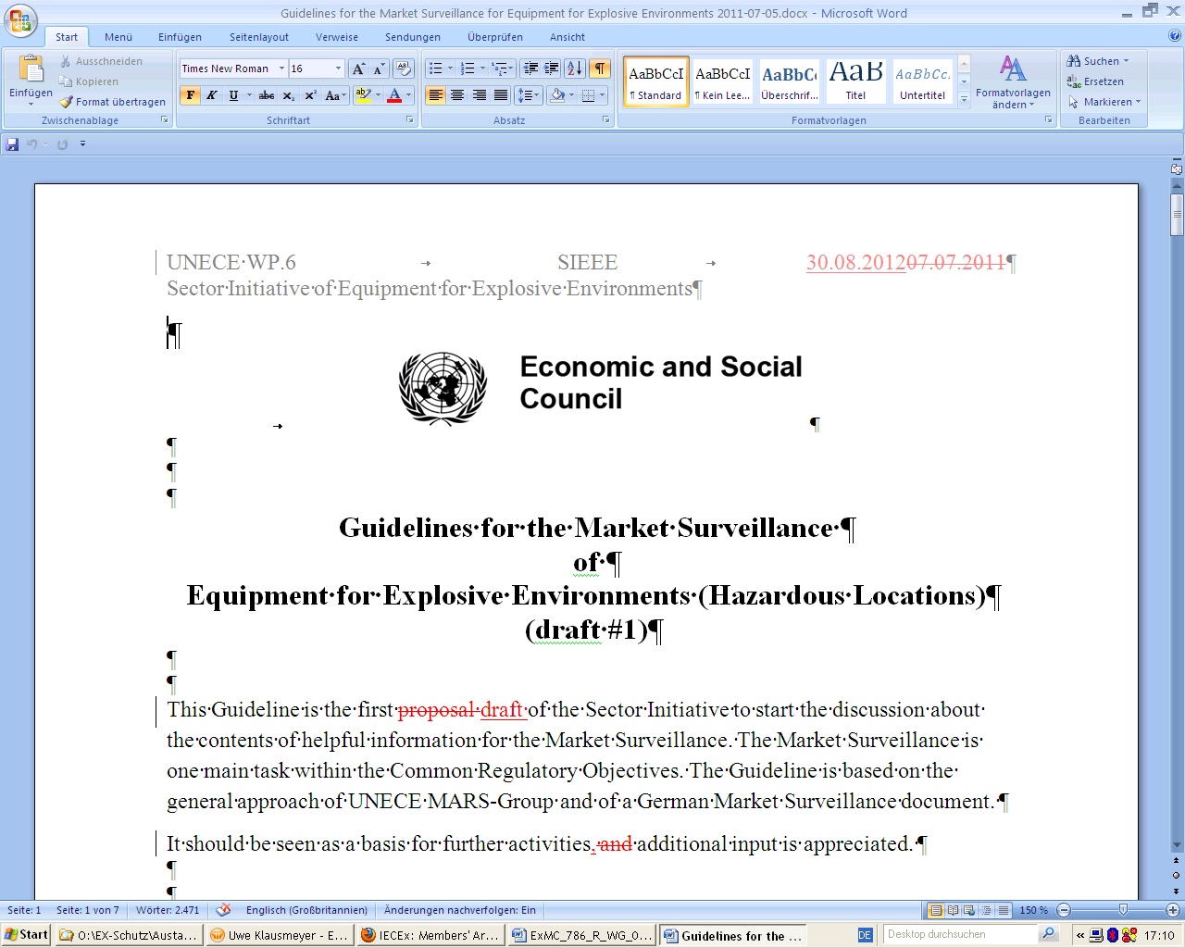

Figure 1: Draft of the Guidelines for the market surveillance of explosion protected equipment

