INTERNATIONAL ELECTROTECHNICAL COMMISSION SYSTEM FOR CERTIFICATION TO STANDARDS RELATING TO EQUIPMENT FOR USE IN EXPLOSIVE ATMOSPHERES (IECEx SYSTEM)

QUESTIONNAIRE

The current IECEx 02 rules require all tests to be:

· Conducted at the ExTL facility by ExTL/ExCB staff, or
· Witnessed, either in full or partially, at other than the ExTL facility by ExTL/ExCB staff in accordance with OD 024.

IECEx 02 does not allow any test to be accepted by the ExTL/ExCB that was not conducted by ExTL/ExCB staff or witnessed, either in full or partially, by ExTL/ExCB staff.

During the 2011 ExMC meeting in Split (Croatia), a question was raised as to the possibility of an IECEx 02 rules revision that would allow ExTLs/ExCBs to accept tests that were not witnessed at all, either in full or partially, by ExTL/ExCB staff (referred to as ‘un-witnessed’ tests). The rationale for accepting such ‘un-witnessed’ tests would be that, while not involving the direct presence of the ExTL/ExCBs, the ‘un-witnessed’ tests would be under the control of the ExTL/ExCBs through IECEx supervised / audited procedures (that do not exist at this time). In response to this question, and in accordance with ExMC Decision 2011/40, this survey is being sent to all IECEx Member bodies.

Therefore, we would appreciate IECEx Member Bodies completing this Questionnaire and returning it to the IECEx Secretariat, as indicated on the form by 31st January 2012.

Kind regards
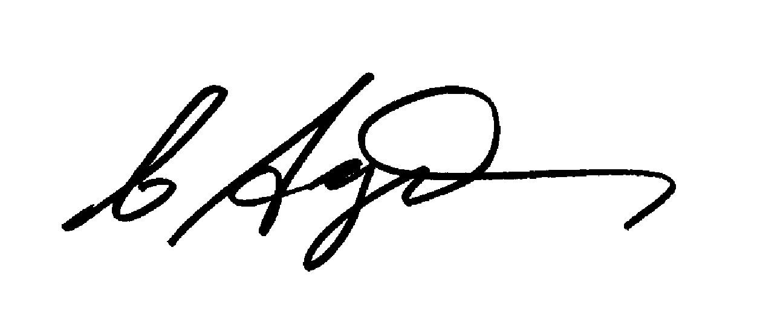
Chris Agius
IECEx Secretariat

IECEx Secretariat
Level 7 286 Sussex Street, Sydney NSW 2000 Australia
Telephone: +61 282066940 Telefax: +61282066272 E-mail: chris.agius@iecex.com Web: www.iecex.com

A response is requested from all IECEx Member bodies to the following questions
1. Do the regulations of your country allow for any of the tests from any of the IEC Ex standards to be accepted by your national testing & certification agencies for issuing national or regional certification without witnessing the testing, either in full or partially? (Tick One Option) □Yes □No

2. If you answered ‘Yes’ to Question 1 above, what controls exist to ensure that your national testing & certification agencies perform necessary supervision / auditing to declare responsibility for such ‘un-witnessed’ tests?
(Please provide a brief summary of any existing controls)

3. If answered ‘Yes’ to Question 1 above, are there any restrictions in your country as to which ‘un-witnessed’ tests from which IEC Ex standards can be so accepted?
(Tick One Option) □Yes □No

4. If answered ‘Yes’ to Question 3 above, which specific ‘un-witnessed’ tests from which specific IEC Ex standards can be so accepted?
(Please provide a list indicating test and standard)

5. If national regulations prevent some ExTLs/ExCBs from accepting ‘un-witnessed’ testing, which of the following would your country support?
a. Continuation of the restriction against any ExTL/ExCB accepting any ‘un-witnessed’ tests?
(Tick One Option) □ Yes □ No
b. Allowance for ExTLs/ExCBs to accept ‘un-witnessed’ tests if national regulations allow for such, while at the same time allowance for other ExTLs/ExCBs to not accept ‘un-witnessed’ tests if national regulations do not allow for such?
(Tick One Option) □ Yes □ No

Country:

Name:

Signature:

Date:

Please return this questionnaire before 31st January 2012 to:

Christine Kane
IECEx Secretariat
E-mail: christine.kane@iecex.com
Fax: +61 2 82066272

The IECEx Executive will review the responses to the survey from all IECEx Member Bodies, and will then communicate to all IECEx Member Bodies regarding the results. The Executive will also propose the path forward to address this issue.

