INTERNATIONAL ELECTROTECHNICAL COMMISSION SYSTEM
FOR CERTIFICATION TO STANDARDS RELATING TO EQUIPMENT FOR USE IN EXPLOSIVE ATMOSPHERES (IECEx SYSTEM)

Title: Notice of Meetings

IECEx 2011 - 2013 MEETINGS

Dear Madam/Sir

I am pleased to announce that we have received the following invitations to hold IECEx Annual Meetings

- 2011 Split, Croatia
- 2012 Malaysia
- 2013 Rio de Janeiro, Brazil

We are most appreciative to receive these kind invitations.

The IECEx Chairman and Officers have accepted these invitations, in order to enable the hosts to commence preparations and therefore seek ExMC endorsement during the Berlin 2010 Meeting. Further details will be announced during the 2010 IECEx Berlin Meeting.

In appreciation of the kind offer from the Croatian, Malaysian and Brazilian IECEx National Member Bodies we provide this information to assist members in their advanced planning.

We welcome other IECEx Members considering the future hosting of IECEx meetings for consideration at the ExMC Berlin 2010 meeting.

Kind regards
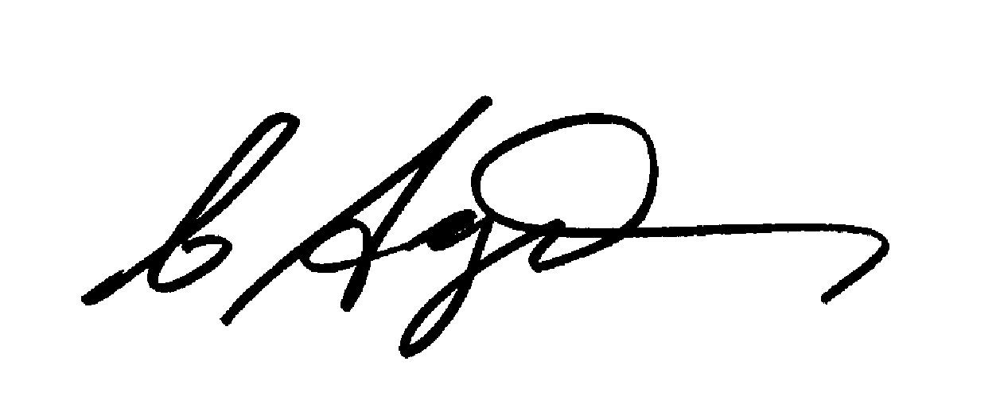
Chris Agius
IECEx Secretariat

Address:  SAI Global Building  286 Sussex Street  Sydney 2000  Australia | Tel: +61 2 8206 6940  Fax: +61 2 8206 6272  Email: chris.agius@iecex.com  www.iecex.com

