INTERNATIONAL ELECTROTECHNICAL COMMISSION SYSTEM
FOR CERTIFICATION TO STANDARDS RELATING TO EQUIPMENT FOR USE IN EXPLOSIVE ATMOSPHERES (IECEx SYESTEM)

IECEx 2010 MEETINGS
TO BE HELD IN BERLIN, GERMANY

Dear Madam/Sir

I am pleased to announce that the German National Committee have extended an invitation to the IECEx to hold the 2010 Annual Meetings in Berlin, Germany, during 29 August to 3 September 2010.

The IECEx Chairman and Officers have accepted this invitation, in order to enable the host to commence preparations, further details will be announced during the 2009 IECEx Melbourne Meeting.

In appreciation of the kind offer from the German National Committee we provide this information to assist members in planning their 2010 travels.

I thank you in anticipation of your assistance and invite you to contact me should you have any questions relating to the 2010 meetings.

Kind regards
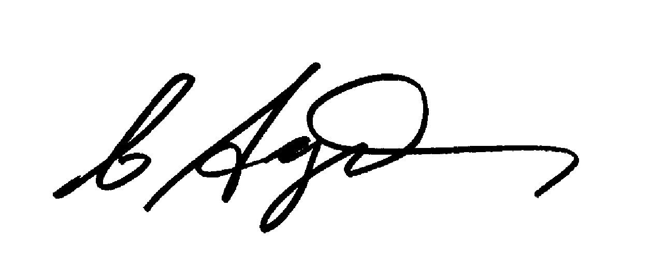
Chris Agius
IECEx Secretariat

Address:  SAI Global Building  286 Sussex Street  Sydney 2000  Australia | Tel: +61 2 8206 6940  Fax: +61 2 8206 6272  Email: chris.agius@iecex.com  www.iecex.com

