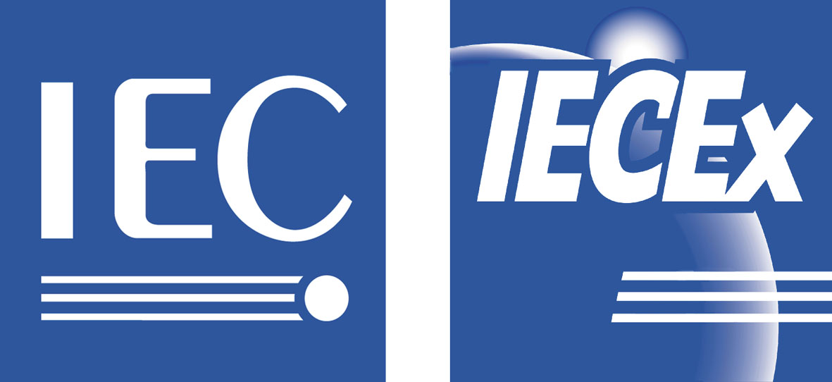 ExMC/297/Inf
September 2005

INTERNATIONAL ELECTROTECHNICAL COMMISSION SCHEME
FOR CERTIFICATION TO STANDARDS RELATING TO EQUIPMENT FOR
USE IN EXPLOSIVE ATMOSPHERES
(IECEx SCHEME)

Title: Statement from Mr Liu Weijun in support of his nomination as IECEx Vice Chairman

To: Members of the IECEx Management Committee, ExMC and ExTAG

INTRODUCTION

This document contains a statement from Mr Liu Weijun, Director General of Certification, CNCA in support of his nomination for consideration for the position of IECEx Vice Chairman and is for discussion under Item 5, IECEx Officers of the ExMC Agenda ExMC/256C/DA.

Chris Agius
Secretary IECEx

Address:  Standards Australia Building  286 Sussex Street  Sydney NSW 2000  Australia | Contact Details:  Tel: +61 2 8206 6940  Fax: +61 2 8206 6272  e-mail: chris.agius@iecex.com  http://www.iecex.com

Sep 23, 2005

Dear IECEx colleagues,
It’s my great honor to be nominated as a candidate for the IECEx Vice Chair.
China is always active in the IECEx since it joined the Scheme in 1996. With the direct involvement of, and attention from, the relevant government authorities, efforts have been made to build the capacity of the Ex certification body, labs and related staff. And we have established a set of standards and conformity assessment practices in line with the IECEx rules and international prevailing practices. In 2005, China jumped to the third in terms of imports and exports volume, and becomes an important manufacturing and trade center in the world. Thus, China’s participation and contribution will greatly push forward the IECEx scheme.
With China’s participation, the IECEx Scheme will achieve better geographical balance and more harmonious development of the participating economies. Relatively speaking, a sound Ex system covering standards and conformity assessments has already been in place in Europe, America and Australia while the overall level of development in Asia is rather unbalanced. With China’s participation, the Ex system in China will be improved, and the capacity in operating Ex system will also be enhanced as a result. Together with co-efforts from other Asian countries, the promotion of Ex scheme in Asia will definitely facilitate Asian regional trade and economy, raise the Ex product quality, and reduce country and regional differences.
China’s active role in the IECEx Scheme will guide and promote the Ex-related standards and conformity assessments in the developing countries. As one of the biggest developing countries, China takes the lead in improving its own system and actively participating in the international activities. We will devote ourselves to boosting confidence of the developing countries and their determination to enhance capacity building in their own country. This will also encourage more developing countries to actively participate in the IECEx scheme, and eventually become IECEx members. All these will promote the long-term and sustainable development of the IECEx across the globe.
In July 2005 China’s ExCB and ExTLs went through IECEx peer assessment. Next year when ExMC celebrates its 10th anniversary, China is to host the Ex annual meeting, and we will do our best to have a successful meeting.
In a word, I am ready to work with other IECEx officials and all the IECEx members to promote the development of IECEx Scheme in IEC, in China, and globally.
Thank you for your support.

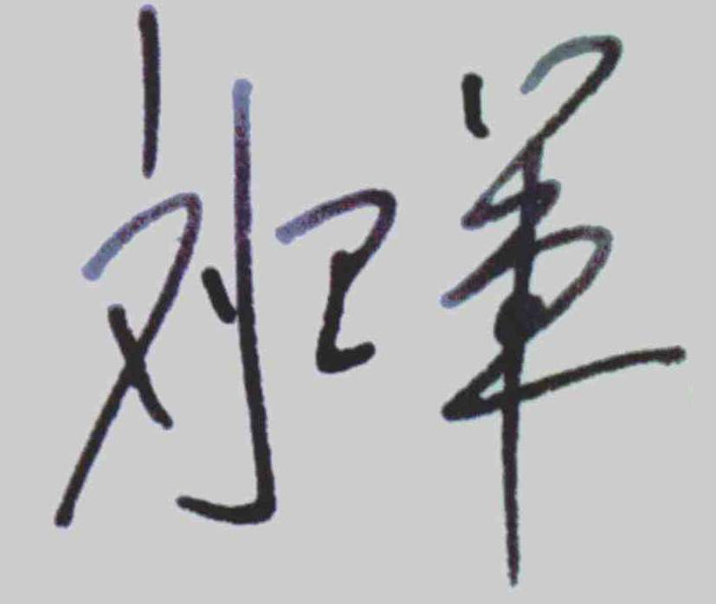
Best wishes,
Liu Weijun
Director General of Certification, CNCA

