INTERNATIONAL ELECTROTECHNICAL COMMISSION SCHEME FOR CERTIFICATION TO STANDARDS FOR EXPLOSIVE ATMOSPHERES (IECEx SCHEME)

Ex Management Committee, ExMC

TITLE: IECEx Assessment Report for acceptance of “ITACS” as an Ex Certification Body

This document contains the IECEx Assessment Report for the acceptance of “International Testing and Certification Services Pty . Ltd. (ITACS)” of Australia as an Ex Certification Body (ExCB) within the IECEx Scheme.

ITACS have been previously accepted as an ExTL operating with SIMTARS as an ExCB and have now completed the IECEx Assessment for consideration as an ExCB.

This ExCB assessment was conducted in conjunction with the re-assessment of ITACS as an ExTL. While the findings from the ExTL assessment were positive, a final report for issue to ExMC is pending.

The report is hereby submitted for voting

Please consider the assessment report and return the completed voting form to the Secretariat by 2005 06 15. Your speedy response to the voting process will be very much appreciated.

You may return your completed voting form (available in Word format) via fax or e-mail. Details below.

Address:  IECEx Secretariat  SAI Building  286 Sussex Street  Sydney 2000  Australia | Tel: +61 2 8206 6940  Fax: +61 2 8206 6272  Email: chris.agius@iecex.com  Internet: www.iecex.com

Voting Form

IECEx Assessment Report for acceptance of the following candidate as an
Ex Certification Body

ITACS of Australia

Yes. I agree with the acceptance of “ITACS” as an

Ex Certification Body (ExCB)

No. I do not agree with the acceptance of “ITACS” as an

Ex Certification Body (ExCB) within the IECEx Scheme, for the following reasons

Signature: _________________________________________

Name: ____________________________________________

Member Body: _____________________________________

Date: _____________________________________________

Please complete and return by 2005 6 15 to:

Mr Chris Agius
IECEx Secretariat

Contact Details:
E-mail: chris.agius@iecex.com
Tel: +61 2 8206 6940
Fax: +61 2 8206 6272

IECEx ASSESSMENT REPORT FORM

For Accepted Ex Certification Body (ExCB)

1. OBJECT AND FIELD OF APPLICATION

1.1 Country
Australia

1.2 ExCB under Assessment
International Testing and Certification Services Pty . Ltd. (ITACS)

1.3 Members of the Assessment Team
Ian Cleare, Lead assessor
Wolf Dill, Assessor (Day 1 only)

1.4 Place and Date of Re-Assessment
4-6 Second Street, Bowden, South Australia, 5007
2 + 3 December 2004

1.5 Assessment References
Document:
i) IECEx 02 Second Edition
ii) IECEx Operational Document OD/009/V1
iii) ISO/IEC Guide 65 1996

1.6 Requested Scope of Acceptance

Product Category Standard
General Requirements IEC 60079-0
Flameproof enclosure “d” IEC 60079-1
Pressurization “p” IEC 60079-2
Powder filling “q” IEC 60079-5
Oil immersion “o” IEC 60079-6
Increased safety “e” IEC 60079-7
Intrinsic safety “i” IEC 60079-11
Encapsulation “m” IEC 60079-18
Apparatus for combustible dusts IEC 61241-1-1
Part 4 Type of protection ‘pD’ IEC 61241-4

1.7 Any changes in Scope

See Sections 14 and 15 below.

1.8 ExCB Persons Interviewed

Name Position
David Gray | General Manager
Jurek Botiuk | Testing Manager
Chris Agius | Certification Officer
David Walker | Hazardous Area Equipment Manager
Daniel Ramm | Quality Manager

1.9 Legal Status of the ExCB
ITACS is a company registered in South Australia, Registration No. 0335759A. It is a wholly owned subsidiary of Gerard Corporation Pty Ltd.

1.10 Associated Testing Laboratories

Names of Laboratories Address
ITACS 4-6 Second Street, Bowden, South Australia, 5007
SIMTARS 2 Smith Street, Redbank, Queensland, 4301

1.11 National Marks and Certificates
AUSEx Scheme Certification Body
ANZEx Scheme Certification Body

1.12 Financial Support
ITACS has full accounting responsibility as a subsidiary of Gerard Corporation It’s operations are profitable and it has control of operating and capital expenditure within the parent company’s accounting policies.

1.13 Standards Accepted
IEC standards listed in 1.6.

1.14 National Differences to IEC Standards
None for the listed standards.

2. ORGANIZATION

2.1 Names, Titles and Experience of the Senior Executives

Name Title Experience
David Gray General Manager Appointed in 1989

2.2 Name, Title and Experience of the Quality Management Representative

Name Title Experience
Daniel Ramm Quality Manager Appointed in 2004

2.3 Name and Title of Nominated Principal Contact

Name Title Comments
David Gray General Manager

2.4 Names and Titles of Signatories for Certification

Name Title Comments
David Gray General Manager Testing Manager may sign

2.5 Other Employees in ExCB activity

Name | Title | Responsibility
Jurek Botiuk | Testing Manager | Management of evaluation and testing
David Walker | HAE* Manager | Management of HAE Business Unit  Evaluation and testing of HAE
Chris Agius+ | Certification Officer  HAE* Auditor | Review of ExTRs and QARs  QA audits
Ralph Wigg+ | HAE* Auditor | QA audits
Adam Kennewell | Testing Officer | Evaluation and testing
Phil Sinclair | Testing Officer | Evaluation and testing
Daniel Ramm | Testing Team Leader | Supervision of testing
Alyssa Veale | Office Manager | Administration
* HAE = Hazardous Area Equipment
+ Contract personnel, working within ITACS’s quality management system

2.6 Organisational Structure
 |  | David Gray  General Manager |  | Daniel Ramm  Quality Manager
Chris Agius  Certification Officer | Alyssa Veale  Office Manager | Jurek Botiuk  Testing Manager | David Walker  HAE Manager  HAE Auditor | (Other Managers)
 |  | Daniel Ramm  Testing Team Leader | Chris Agius  Ralph Wigg  HAE Auditors
Adam Kennewell
Phil Sinclair
Testing Officers

3. RESOURCES
ITACS appears to have an adequate number of staff for the current level of business. There are a few experienced staff in hazardous area evaluation and testing and others undergoing training. There are three contract workers who make up the necessary complement for the ExCB functions. The company is sufficiently small for the General Manager to be closely involved with all facets of the work but recent growth has revealed the need for a more sophisticated approach to organization, management and documentation.

The laboratory and offices are located in an industrial unit which provides an adequate environment for the work. The testing equipment is suitable for the range of tests carried out in house. Certain tests are sub-contracted to another ExTL. (See ExTL Re-assessment Report for further details.)

4. COMMITTEES AND APPEAL PROCEDURES
ITACS has a Certification Committee with four members currently and a fifth, representing manufacturer interests being sought. The four members are the General Manager, the Certification Officer, a representative of the regulatory authorities and a representative from end-users. The committee has met twice since June 2004, but would normally meet on an annual basis. The draft minutes of the meeting held on 1 December were sighted.

There is a procedure specifying the appeals process, including reference to the role of the Certification Committee. There have been no appeals to date.

5. CERTIFICATION OPERATIONS

5.1 National Approval/Certification Methods
ITACS operates in the two national Ex certification schemes. The AUSEx scheme is a Type 1 scheme which is being phased out as the ANZEx scheme (Type 5) is phased in. The ANZEx scheme is very close to the IECEx in structure and operation.

5.2 Certification Policy
Certification policy is set out in the Certification Manual which satisfies the requirements of Guide 65. The practice was observed to conform to the policy.

5.3 Staff Work Instructions
Staff work instructions are contained in a comprehensive set of Test Methods and Procedures which include ExTAG decisions. The TMPs are cross referenced to the standards to which they relate.

5.4 Application for Certification
Applications for certification are made on an application form which provides the information required by Guide 65. The information facilitates contract review, quotation and job planning.

5.5 Sub-Contractors
ITACS has documented agreements for work carried out by sub-contractors on the basis of their NATA accreditation. Some minor shortcomings with the placing of purchase orders for sub-contract work were noted.

6. STATISTICS
Certificates issued during the past 2 years:
Flameproof d 9
Intrinsic safety i 11
Increased safety e 7
Special s 0
Powder filled q 0
Encapsulated m 0
Type n n 2
Pressurised p 0
Gas Detectors 0
Apparatus for Dusts D 9

7. NATIONAL ACCREDITATION
ITACS is accredited by JASANZ, the national accreditation body for certification and by NATA, the national laboratory accreditation body. The current JASANZ accreditation certificate No. Z2870404AA was issued on 13 September 2004 with a draft schedule. A copy of the certificate and final schedule are given in Annex A For details of NATA accreditation, see ExTL Re-Assessment report.

8. LIABILITY INSURANCE
ITACS carries commercial insurance for professional indemnity and is covered by the Gerard group under their Public Liability and Workcover insurance.

9. QUALITY MANUAL
The Quality Manual meets the requirements of Guide 65, although, as noted above, a more robust management system would help to maintain conformity as the business develops. The procedures are demonstrably linked to the IECEx requirements, although dated references to the IECEx documents would aid updating in response to changes in those documents.

10. INTERNAL AUDIT AND PERIODIC REVIEW
Internal audits and management reviews are carried out but a better system for recording and following up non-conformities and improvement opportunities would assist in getting better value from the process. It was noted that the internal audit plan for 2004 was behind schedule though not yet overdue.

11. COMPLAINTS
ITACS has a policy for the handling of complaints, the register showing two recorded during 2004 and none in the preceding three years. Evidence of follow up and customer satisfaction was sighted.

12. WITHDRAWAL AND CANCELLATION OF CERTIFICATES
ITACS has a procedure for the withdrawal and cancellation of certificates, though none had been withdrawn or cancelled.

13. REVIEW OF ISSUED CERTIFICATES AND EXTRS
The only IECEx CoC job to have been undertaken was reviewed and, at its current partly completed state, was found to comply with the IECEx requirements.

14. FINDINGS FROM THE ASSESSMENT
ITACS was found to comply with the ExCB requirements, although little Type 5 work had as yet been carried out. Some areas for improvement were noted, principally related to the need for a more formalized and robust management system. ITACS’s NATA accreditation did not include Ex ‘p’ It was therefore agreed that ‘p’ be excluded from the ExCB scope for the time being. There was some discussion on the inclusion of Ex ‘d’ in the ExCB scope and it was agreed to recommend inclusion on the basis of an agreement with an ExTL covering that type of protection. (See ExTL Re-Assessment report for further information.)

15. RECOMMENDATIONS
It is recommended that ITACS be accepted as an ExCB for the requested scope but with the exclusion of Ex ‘p’. It is further recommended that a sample of ITACS’s CoC files be examined during the first twelve months of its operation as an ExCB, as selected by the IECEx Secretary.

Ian Cleare Wolf Dill
Lead Assessor Assessor

LIST OF ANNEXES
Annex A. JAS-ANZ accreditation certificate and schedule
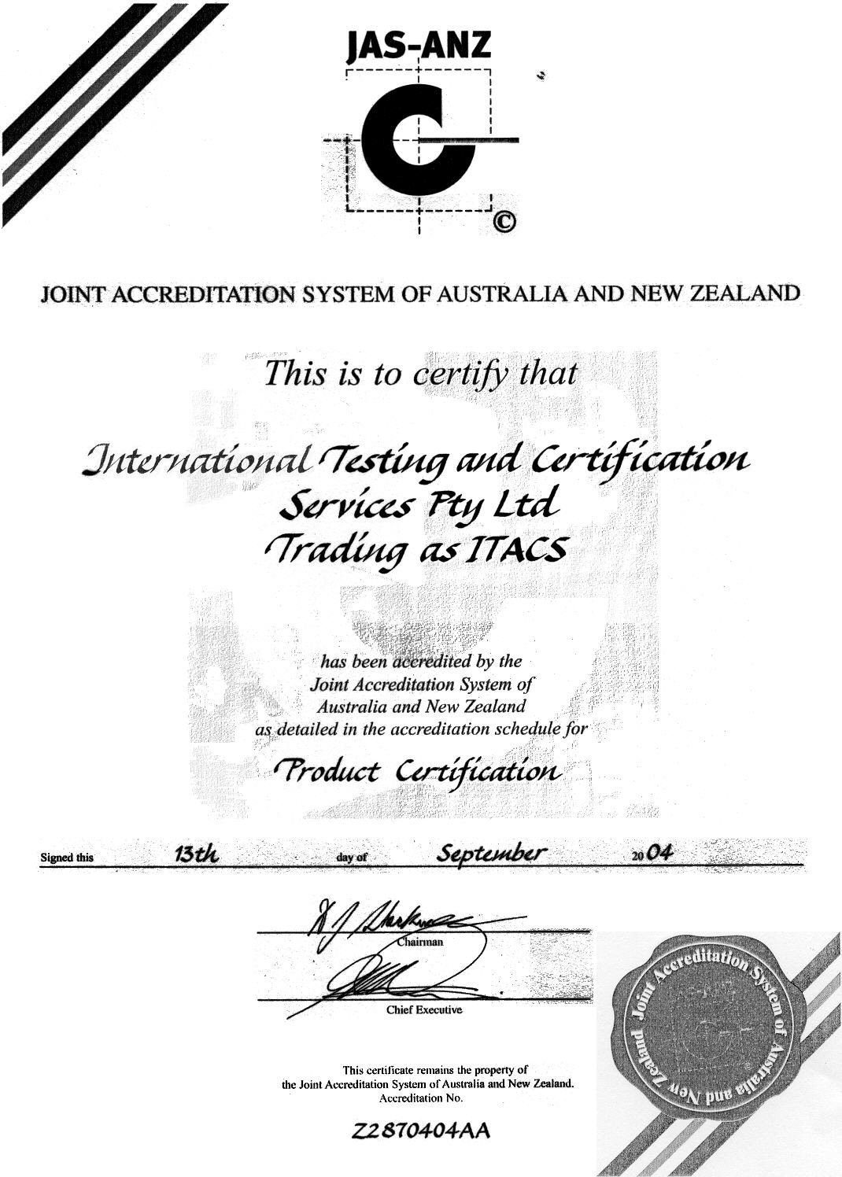
ANNEX A. JAS-ANZ Accreditation Certificate and Schedule
Annex A
