INTERNATIONAL ELECTROTECHNICAL COMMISSION SYSTEM FOR
CERTIFICATION TO STANDARDS RELATING TO EQUIPENT FOR USE
IN EXPLOSIVE ATMOSPHERES (IECEx SYSTEM)

Title: Information on National Differences to IECEx Standards

Circulated to: IECEx Member Bodies

Introduction

The IECEx Secretariat is in the process of preparing the 5th edition of the IECEx Bulletin. In order to ensure that the information contained in the Bulletin is accurate we would ask you to please complete the following questionnaire and return it to the IECEx Secretariat by Monday 2nd November 2015.

This document also provides an example of the standard method to be used for recording and presenting National Differences should it be necessary.

To reduce time and costs in the handling of this information by the IECEx Secretariat it would be most helpful if the information were presented in an electronic word document version to Sarah Hardie at sarah.hardie@iecex.com

Kind regards
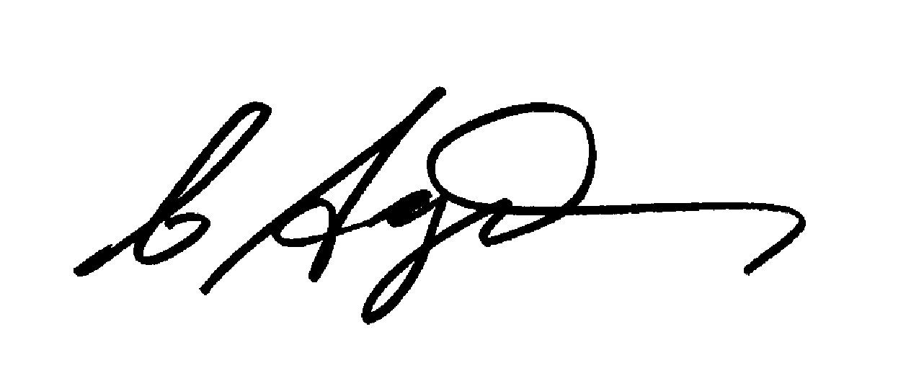
Chris Agius
IECEx Secretariat

Address:  Level 33, Australia Square  264 George Street  Sydney NSW 2000  Australia | Contact Details:  Tel: +61 2 4628 4690  Fax: +61 2 4627 5285  e-mail:chris.agius@iecex.com  http://www.iecex.com

NOTE for information:

Generally there are three types of differences between the IEC Standard and the corresponding National Standard. These are best described as follows:

1 where a requirement contained in the IEC Standard DOES NOT exist in the corresponding National Standard.

2 where a requirement contained in the National Standard DOES NOT exist in the corresponding IEC Standard.

3 where requirements contained in the IEC standard are varied by the corresponding National Standard.

Action required by the IECEx Member Bodies

Step 1

- Complete Annex 1 Table of Contents Commences Page 3

Step 2

- Where Annex 1 indicates that National Differences exist then please complete Annex 2 Details of National Differences, for each set of differences in Word Format and send to IECEx Secretariat Page 13

Step 3
- In order for the IECEx Secretariat to respond to regular enquiries regarding the acceptance of IECEx Certificates we kindly ask you to complete Annex 3 National Way of Ex Equipment Certification Survey. Page 14

Should you require any further assistance please do not hesitate to contact Sarah Hardie from the IECEx Secretariat sarah.hardie@iecex.com

Annex 1: Table of Contents

Country: Australia

Has …. adopted the following IEC Standards?
(please indicate by inserting a tick in the appropriate column for each Standard)

IEC Pub. No. | YES | NO | If 'Yes'  Do you have National differences? |  | Comment/s  (e.g. national differences  previously supplied, national  differences to be supplied by)
IEC Pub. No. | YES | NO | Yes | No
60079-0

60079-0 1983
2nd ed.

Amd l 1987 02 to
60079-0 2nd ed.

Amd 2 1991 10 to
60079-0 2nd ed.

60079-0 1998
3rd ed.

60079-0 2000
Consol.
ed. 3.1

60079-0 2004
4th ed.

60079-0 2007
5th ed.

60079-0 2011
6th ed.

60079-1

60079-1 1990
3rd ed.

Amd 1 1993 08 to
60079-1 3rd ed.

Amd 2 1998 05 to
60079-1 3rd ed.

60079-1 2001
4th ed.
Corrigendum 1

60079-1 2003
5th ed.

60079-1 2007
6th ed.

60079-1 2014
7th ed.

60079-2

60079-2 1983
3rd ed.

60079- 2 2001
4th ed.

60079-2 2007
5th ed.

60079-2 2014
6th ed.

60079-5

60079-5 1997
2nd ed.

Amd 1 2nd ed.
60079-5 2003

60079-5 2007
3rd ed.

60079-5 2015
4th ed.
60079-6

60079-6 1995
2nd ed.

60079-6 2007
3rd ed.

60079-6 2015
4th ed.

60079-7

60079-7 1990
2nd ed.

Amd l 1991 04
to 60079-7 2nd ed.

Amd 2 1993 04
to 60079-7 2nd ed.

60079-7 2001
3rd ed.

60079-7 2006
4th ed.

60079-7 2015
5th ed.

60079-11

60079-11 1991
3rd ed.

60079-11 1999
4th ed.

60079-11 2006
5th ed.

60079-11 2011
6th ed.

60079-13

60079-13 2010
1st ed.

60079-15

60079-15 1987
1st ed.

60079-15 2001
2nd ed.

60079-15 2005
3rd ed.

60079-15 2010
4th ed.

TR 60079-16

TR 60079-16 1990
1st ed.

60079-18

60079-18 1992
1st ed.

60079-18 2004
2nd ed.

60079-18 2009
3rd ed.

60079-18 2014
4th ed.
60079-25

60079-25 2003
1st ed.

60079-25 2010
2nd ed.

60079-26

60079-26 2004
1st ed.

60079-26 2006
2nd ed.

60079-26 2014
3rd ed.

60079-27

60079-27 2005
1st ed.

60079-27 2008
2nd ed.

60079-28

60079-28 2006
1st ed.

60079-28 2015
2nd ed.

60079-29-1

60079-29-1 2007
1st ed.

60079-29-2

60079-29-2 2007
1st ed.

60079-29-2 2015
2nd ed.

60079-29-4

60079-29-4 2009
1st ed.

60079-30-1

60079-30-1 2007
1st ed.

60079-31

60079-31 2008
1st ed.

60079-31 2013
2nd ed.

TS 60079-32-1

TS 60079-32-1 2013
1st ed.

60079-32-2

60079-32-2 2015
1st ed.

60079-33

60079-33 2012
1st ed.

60079-35-1

60079-35-1 2011
1st ed.

60079-35-2

60079-35-2 2011
1st ed.

TS 60079-39

IEC TS 60079-39 2015
1st ed.

TS 60079-40

IEC TS 60079-40 2015
1st ed.

61241-0

61241-0 2004
1st ed.

61241-1

61241-1 2004
1st ed.

61241-1-1

61241-1-1 1993
1st ed.

61241-1-1 1999
2nd ed.

61241-4

61241-4 2001
1st ed.

61241-11

61241-11 2005
1st ed.

61241-18

61241-18 2004
1st ed.

61779 -1

61779 -1 1998
1st ed.

61779 -2

61779 -2 1998
1st ed.

61779 -3

61779 -3 1998
1st ed.

61779 -4

61779 -4 1998
1st ed.

61779 -5

61779 -5 1998
1st ed.

62013-1

62013-1 1999
1st ed.

62013-1 2005
2nd ed.

62013-2

62013-2 2000
1st ed.

62013-2 2005
2nd ed.

62086-1

62086-1 2001
1st ed.

62086-2

62086-2 2001
1st ed.

ANNEX 2: DETAILS OF NATIONAL DIFFERENCES

The following provides an example of how the national differences should be presented to the IECEx Secretariat.

IEC Standard Number IEC …..

IEC Clause or
Annex
Number Details of Differences

XX.1 Replace the Clause with the following……………………

XX.2 Add the following extra requirement to this Clause……………………
details of extra requirement(s)

XX.3 This requirement does not apply

XX.4 Add the following additional Clause or Section or Annex…….

The above information must be presented to the IECEx Secretariat for each IECEx Standard for which the country is participating within the IECEx System.

Updated information must be forwarded to the IECEx Secretariat when either the IECEx Standards or the National Standards are revised or amended.
Annex 3- National Way of Ex Equipment Certification Survey

 | Please select YES or NO in the table below, add comments where appropriate and then proceed to the next Question | YES | NO | Comments
Q1 | Do regulations in your country prevent the use of IECEx Certificates of Conformity for Ex Equipment for direct market access? | Now please provide details in Comments
Q2 | Do regulations in your country prevent the use of IECEx Certificates of Conformity for Ex Equipment in addition to any national certification? | Now please provide details in Comments
Q3 | Do regulations in your country prevent the use of IECEx ExTRs as the basis for national certification? | Now please provide details in Comments
Q4 | Do regulations in your country restrict bodies able to issue IECEx ExTRs when used as the basis for national certification? | Now please provide details in Comments
Q5 | Do regulations in your country prevent the use of IECEx QARs as the basis for national certification? | Now please provide details in Comments
Q6 | Do regulations in your country have additional certification requirements for the installation of Ex equipment? | Now please provide details in Comments

