INTERNATIONAL ELECTROTECHNICAL COMMISSION SYSTEM FOR
CERTIFICATION TO STANDARDS RELATING TO EQUIPENT FOR USE
IN EXPLOSIVE ATMOSPHERES (IECEx SYSTEM)

Title: IECEx Remarks concerning the proposed IEC Harmonised Basic Rules – Proposed from ExMC WG1 and Executive Toronto 2015 meetings

Circulated to: IECEx Member Bodies

Introduction

ExMC WG1 and the IECEx Executive reviewed the CAB proposed draft “IEC Harmonised Basic Rules” and Draft IECEx Supplement, namely:-

- ExMC/987/CD – Draft Harmonised Basic Rules
- ExMC/988/CD – Draft IECEx Supplement

during their respective meetings held in Toronto during May 2015.

This document sets out the comments and proposed position for ExMC to consider as the IECEx position when reporting back to CAB.

These comments are taken from the ExMC WG1 Report to ExMC, document ExMC/1019/R.

ExMC Members will be asked to consider the comments contained in this document during the ExMC 2015 Christchurch meeting.

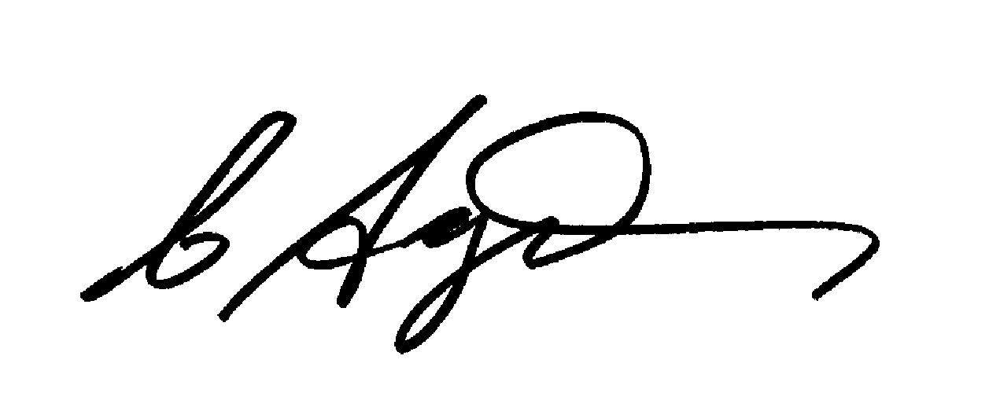
Chris Agius
IECEx Secretariat

Address:  Level 33, Australia Square  264 George Street  Sydney NSW 2000  Australia | Contact Details:  Tel: +61 2 4628 4690  Fax: +61 2 4627 5285  e-mail:chris.agius@iecex.com  http://www.iecex.com

From Toronto ExMC WG1 meeting

- IEC Conformity Assessment Systems Harmonised Basic Rules
Members considered the draft IEC Harmonised Basic Rules and a proposed IECEx Supplement.
Documents considered :
- prExMC/987/CD, IEC Harmonised Basic Rules (HBR) - Draft
- prExMC/988/CD, IECEx Supplement – Proposed Draft
via an initial address by the IECEx Secretary that provided the background to the concept of a single Harmonised Basic Rules (HBRs) for all four IEC Conformity Assessment Systems and then a further presentation by the IECEx Secretary on the specific details of the two documents circulated as meeting papers.

In support of the comments by the IECEx Secretary, the IECEx Chairman commented that even if the HBRs exist it is essential that the CA Systems retain the right to prepare, endorse and maintain lower hierarchy documents such as Operational Documents, Guides, etc.

Following discussion on the two papers (ExMC/987/CD and ExMC/988/CD), the meeting indicated general agreement with the concept of Harmonised BR with the supplement and agreed to propose the following changes for ExMC consideration to be submitted to CAB:

RECOMMENDATION: that the following changes to be proposed to CAB by the ExMC:
- Draft IEC 01 maybe needs a different label, perhaps IEC CAB 01
- Clause 12 of IEC 01 to add more about voting via correspondence and limit to 1 month noting most of IECEx voting is done via correspondence
- Clarify in Annex B if the Chairman can be anyone or is to be the CAB Chairman
- Amend Supplement from ExSSC to ExSFC in 7 d)
- Amend Line 51 of Draft IEC 01 to “…may be complimented or varied by CA System supplements….” to allow future situation of varying Harmonised BR by the Supplement
- Amend “variation” to “supplements” in Clause 0 of the Supplement
- Remove duplication from Clauses 1, 2 and 3 of Supplement with respect to the text in Annex of the HBRs
- Amend title of Clause 3 to “Scope of System”
- Editorials edits regarding the use of upper case text
- Clause 6 of the supplement to include generic reference to Working Groups as being part of the Organisation
- Insert missing item #s in Supplement so that Clause and Item #s align with those in HBRs
- Format of the supplement to include all Clause references of IEC 01
- Line 76 of supplement replace “7.4i” with the text of 7.4i of the current IECEx 01
- Add “ …via correspondence” to the beginning 12.4 of the Supplement
- Add “….to provide a consultation forum to the ExMC on matters relating to ….” to 9.4.3 of the Supplement and also to the Clause describing ExTAG activities
- Reformat the Supplement and list the committees under ExMC according to IECEx 02, IECEx 03, IECEx 04, IECEx 05
- Request that CAB clarify the use of “Specifications in the HBR so as to not be confused with “Technical Specifications”

From Toronto Executive meeting

- NEW BUSINESS
Members considered the following items of new business:

  - IEC Conformity Assessment Systems Harmonised Basic Rules
Members considered the draft IEC Harmonised Basic Rules and a proposed IECEx Supplement.

Following a review of ExMC WG1’s proposed revisions of prExMC/988/CD and noting the plan to update the drafts and send to ExMC for their consideration in 2015 meeting it was agreed that there are no major concerns and accepted the edits proposed by ExMC WG1

