INTERNATIONAL ELECTROTECHNICAL COMMISSION (IEC) SCHEME
FOR CERTIFICATION TO STANDARDS RELATING TO EQUIPMENT FOR
USE IN EXPLOSIVE ATMOSPHERES (IECEx SCHEME)

Title: Discussion Paper on determination of output parameters Co and Lo when applying clause 10.1.5.2 of IEC 60079-11

Circulation: ExTAG Members

INTRODUCTION

This discussion paper has been introduced to provide a background for discussions at the ExTAG meeting in Melbourne 2009.

The allowable output parameters Co and Lo can be determined either by assessment or test. When testing, the capacitance and inductance may be connected in several configurations.

It is hoped that the discussions will allow a consistent method to be used when testing according to Clause 10.1.5.2 of IEC 60079-11.

Ajay Maira
TestSafe Australia
On behalf of ET6-1-1 (Australian sub-committee for Ex TAG matters)

IECEx / ExTAG Discussion Sheet

Title: Application of clause 10.1.5.2 a) of IEC 60079-11 for circuits containing both inductance and capacitance

Standard(s)  IEC 60079-11:2006 | Clause(s):  10.1.5.2
Subject: voltage limitation  Status of Document: CDV | Keywords  spark testing, inductance, capacitance, combination | Date: 2009 08 18  Originator of proposal:  Ajay Maira, TestSafe Australia, Australia
Related document: N/A

Question: When testing for the combination of both inductance and capacitance, how shall they be connected to the spark test circuit?

Background:

It has been observed that the configuration of the test circuit containing the inductance, capacitance and spark test apparatus has an influence on the test result.

The intention of the discussion is to arrive at a consistent method of testing the combination.

Discussion:

The following spark testing configurations are available:

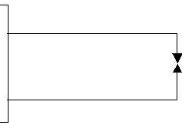 | 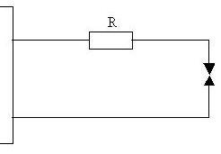
Short Circuit | With load resistor
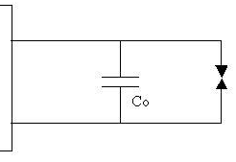 | 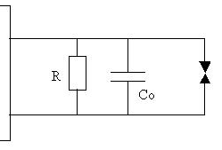
Capacitance | Capacitance with load resistor
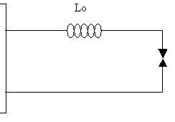 | 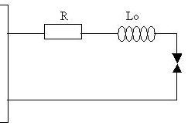
Inductance | Inductance with load resistor
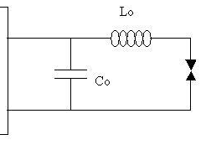 | 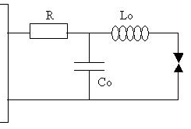
Capacitance and Inductance ‘CL’ | Capacitance and Inductance ‘CL’ with load resistor
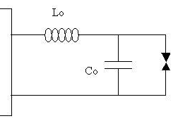 | 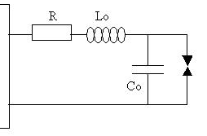
Inductance and Capacitance ‘LC’ | Inductance and Capacitance ‘LC’ with load resistor
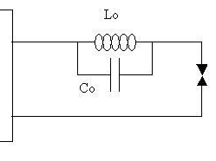 | 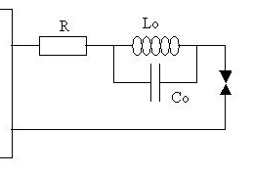
Inductance and Capacitance ‘Tank’ | Inductance and Capacitance ‘Tank’ with load resistor

Possible result of the discussion:

All the combinations must be tested when determining the Co and Lo for a power source. However, if the Co and Lo are declared to be of only one of the above configuration, it is acceptable to declare the Co and Lo with information on how the combination can be connected.

