IEC ExMC Bern Meeting 10 – 11 – 12 / 10 / 01

Report of Working 7 M. Michel Brenon Convenor

(Item 13 of ExMC/93/DA) Regulations governing the use of the IECEx Mark of Conformity

Introduction

WG 7 work is primarily based on documents

- ExMC/ 26 / CD 1999 07 Sydney
Draft regulation for the use of IECEx

- ExMC/ 29 / Inf 2000 09 Braunschweig
Legal advice date 1994 05

- ExMC / 36 / CD 1999 08 Sydney
- Use of IECEx Mark : Proposal to CAB

- ExMC / 40 / RM 1999 08 Sydeny
Draft Minutes Item 14

Consideration and recommendations

- WG7 has not yet met

- Members of the group have provided input to the convenor

a) Report on iSO CASCO WG12 report Ian Cleare
b) Rules of NF Mark in English Mr Michel Brenon
- Attached document Mr Yong-Kuk Kim IECEx KR proposal IECEx Mark

3 WG 7 has noted draft ISO/CASCO CD 17030 (See WG 12) has been recently made available (01 / 10 / 01)
Topic . Third Party Marks of Conformity and their use
This document is to be voted 01 / 12 / 31

- Scope of WG7 is related somehow to the IECEx Rules
In light of these elements WG 7 considers the following issues to be convened now
  - Rules on use of the Mark
  - Protection of the Mark,e.g design, ownership

- Observations
It is advisable to separate issues governing the case of the mark and issues related to legal aspects although there is an obvious connection but provided legal aspect are solved in the mean time, following items appear to be covered

  - Conditions of access to the mark for manufacturers

Type Certification.plus initail assessment of the manufacturers site; is okay gives access to
the right for the use of the mark (This could be materialised by a licence)

5.2 Conditions to maintain the right to use the Mark to a manufacturer

These points can be covered by the Group in lighjt of the ExMC / 26 / CD, in light of actual example of Mark Ruling and in light of ISO/CASCO Document here above mentioned and received in October.

It is advisable also to examine the way to „ease“ access to this MARK bearing in mind the observations reported in ExMC / 40 / RM Item 14

- Usage of the mark requires full participation to the Scheme
- Approach standard by standard exists

As the Mark is a powerful tool of promotion, large access should be considered provided it does not impair the credibility of the mark

- Recommendations

  - WG 7 to update ExMC / 26 / CD
  - WG 7 to examine means of allowing a larger access to the Mark and enable appropriate recommendations to the ExMC

WG 7 requests these suggestions to be considered by the ExMC and thence consequently to propose within two months realistic planning to provide above outputs

M Brenon
Convenor

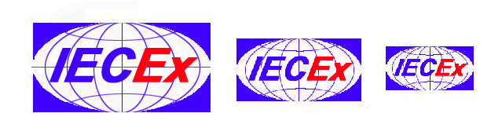

Proposed by IECEx-KR(KOSHA)

The proposed mark symbolizes one mark, world-wide and global, which are aimed at by IECEx Scheme.

This mark is composed up with the combination of an ellipse in a rectangle and a rectangle containing the ellipse, which implys 'safety' and 'stability'. The rectangle means an enclosure of Ex equipments, and the ellipse with lines in it expresses the earth.

The color of letter and others are chosen simply into two colors as follows.
- 'IEC' : blue
- 'Ex' : red (warning danger)
- Rectangle : blue
- Ellipse : blue

The font of the letter and ratio of width and height could be changed.

