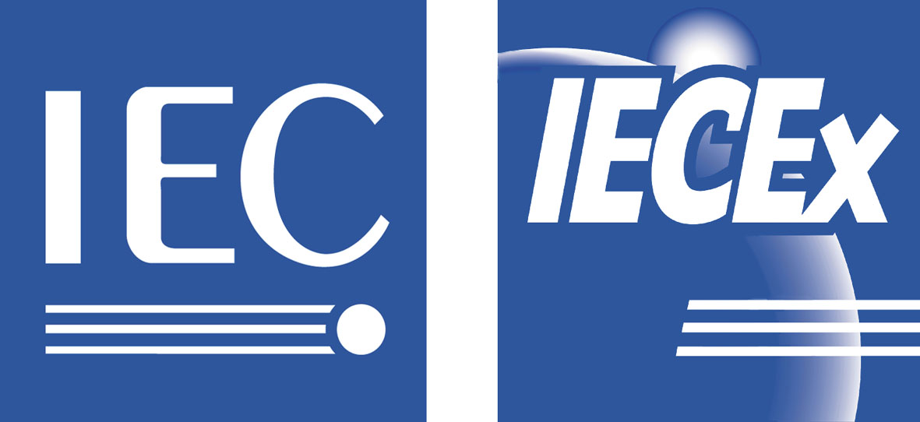 2003 07

Secretariat

INTERNATIONAL ELECTROTECHNICAL COMMISSION
IEC SCHEME FOR CERTIFICATION TO STANDARDS FOR ELECTRICAL EQUIPMENT FOR EXPLOSIVE ATMOSPHERES (IECEx SCHEME)
CIRCULATED TO: Members of ExMC, ExTAG, IECEx Assessors and
Working Group 4 -

Title: Assessor Application

Introduction
This document contains updated details relating to the IECEx Assessor Questionnaire. The document supersedes ExMC/43/Q.
The document is issued for your information.

Should any of the information contained in this document require amendment please notify the IECEx Secretariat

Address:  286 Sussex Street  Sydney 2000  Australia | Tel: +61 2 8206 6940  Fax: +61 2 8206 6272  Email: chris.agius@iecex.com  Web: www.iecex.com

IECEx Assessor Questionnaire
Surname | Millington | Forename | Steve | Title (Mr, Ms, Dr etc) | Mr
Address | 25 the Boulevarde, Killingworth
Country | Australia | Area/Zip/Postal Code
Telephone | 0409 836 286 | Fax | (02) 65721201 | E mail | millings@minerals.nsw.gov.au

Education:
Date |  | Qualification
1976 |  | Certificate of Electrical Engineering
1977 |  | Certificate of Competency as Mine Electrical Engineer

Current CV to be attached.

Membership of Professional Bodies

Date |  | Body |  | Grade of membership
 |  | Engineers Australia - MEMMES |  | Member

Training:
Date |  | Training Provider |  | Course Title |  | Duration
29/6/2001 |  | Audit Services International |  | Audit Training |  | 5 days
Experience
Dates |  | Employer |  | Type of Business |  | Duties
(from/to)
1977 / 1982 |  | BHP Tower Colliery |  | Underground Coal Mine |  | Electrical Engineer in Charge
1982 / 1999 |  | West Wallsend Colliery |  | Underground Coal Mine |  | Electrical Engineer in Charge
1999 / - |  | NSW Department Mineral Resources |  | Government Regulator of Mining Industry |  | Inspector of Electrical Engineering

Assessment/audit experience | Lead Auditor |  | Auditor |  | Expert
Number of external assessments/audits carried out in past two years | 36 |  | 12
Number of external assessments/audits days in past two years relevant to assessment of Ex certification bodies and Ex testing laboratories | nil

Referees who may be contacted to ascertain personal attributes and management capabilities relevant to assessment of IECEx certification bodies and testing laboratories (ISO 19011 : 2002 Clause 7)

Surname |  | Waudby |  | Title |  | Mr
Forename(s) |  | John |  | Country |  | Australia
Address |  | Lot 1766 Bulls Garden road |  | Telephone | (02) 49422300 |  | Fax | (02) 49422323
 |  | Gateshead, NSW 2290

Surname |  |  |  | Title
Forename(s) |  |  |  | Country
Address |  |  |  | Telephone |  | Fax

The proposed daily fee for my service is The fees will be invoiced by me my company
CHF (Swiss Francs)
1,000 (Standard fee determined by the IECEx Scheme)

(Note: Fees are subject to acceptance by the Ex certification Committee and by applicants. Travel and living expenses will be reimbursed in addition to daily fees).
If appointed as an IECEx assessor I will conduct my work to the requisite standard of integrity, competence, impartiality and confidentiality.
I certify that the information given in this questionnaire is true and correct.

Signed: |  |  |  | Date: | 25/8/2003

Endorsed by IECEx Member Body

On behalf of the Australian (country) member Body of the IECEx, I confirm that the details given in this questionnaire have been checked and found to be correct and has our support.
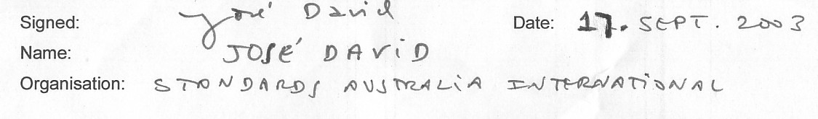

Curriculum Vitae
Name: | Steven James Millington
Address: | 25 the Boulevarde Killingworth NSW 2278
Telephone: | Home: 02 49532991, Work: 02 65721899, Mobile 0409836286
Date of Birth: | 28th September 1953
Nationality: | Australian
Marital Status: | Married, 3 Children

Education:
1972 - 1976
NSW College of TAFE
Certificate of Electrical Engineering

1966 - 1971
Warners Bay High School
Higher School Certificate Levels: Maths I, Science IIF, English, Economics

Training Courses Attended:
QAS Audit Training
OH&S Management System Audit Training
Report Writing
Investigation Training
Project Management
Budgeting
Train the Trainer

Skills Profile:
- Fluent in Microsoft Office applications
- Certificate of Competency as Mine Electrical Engineer
- Class A competent Person for Explosion Protected Apparatus

Other Activities:
- Part time TAFE teacher from 1988 to 1993
- Toastmasters international 2001

Membership of Professional Bodies:
MEMMES
Engineers Australia.

Hobbies and Interests:
Cycling
Referees:
John Francis Waudby  Senior Inspector of Electrical Engineering  Department of Mineral Resources  02 49422300 | Paul Healey  Area Manager  Department of Mineral Resources  02 49422300

Career History:

October 1999 - Present
NSW Department of Mineral Resources - Inspector of Electrical Engineering
At the DMR I am responsible for Electrical Engineering Safety in Mines through the application of risk management principles, best practice and benchmarking, development of legislation, codes and standards, assessment of installation standards and practices, investigation of incidents , and application of the DMR Enforcement Policy.

I am involved in setting competency standards, and I am the examinations convenor for the Mine Electrical Engineer's Certificate of Competency.

The role of Inspector of Electrical Engineering involves intensive communication with the mining industry, and mining industry support infrastructure, and is based on detailed strategic planning

I am a member of several Australian Standards Committees including EL-014, and participate in many Electrical Engineering Safety forums.

July 1982 - October 1999
West Wallsend Colliery - Electrical Engineer in Charge - Engineering Manager
Responsible for all Electrical Engineering matters relating to production and maintenance, including management of the electrical engineering budget. From 1996 to 1999 I held the position of Engineering Manager with responsibility for both electrical and mechanical engineering streams.

July 1977 - January 1982
Tower Colliery - Electrical Engineer in Charge
Responsible for all Electrical Engineering matters relating to production and maintenance, including management of the electrical engineering budget.

July 1976 - June 1977
Munmorah State Mine
Assistant Electrical Engineer

January 1972 - June 1976
Awaba State Mine
Apprentice electrical fitter and tradesman

25/8/2003

