INTERNATIONAL ELECTROTECHNICAL COMMISSION SYSTEM FOR
CERTIFICATION TO STANDARDS RELATING TO EQUIPENT FOR USE
IN EXPLOSIVE ATMOSPHERES (IECEx SYSTEM)

GENERAL INFORMATION ON THE
OPERATIONAL MEETINGS
OF THE IECEx SYSTEM
to be held in Singapore
4 – 7 March 2024

Dear Colleagues

This document contains details relating to the IECEx System Operational Meetings to be held in Singapore over 4th – 7th March 2024

Details relating to general information, meeting venue location and accommodation bookings are included.

I thank you in anticipation of your assistance and invite you to contact me should you have any questions relating to the meetings.

Kind regards
Chris Agius
IECEx Secretariat

Address:  Level 33, Australia Square  264 George Street  Sydney NSW 2000  Australia | Contact Details:  Tel: +61 2 4628 4690  Fax: +61 2 4627 5285  e-mail: info@iecex.com
MEETING SCHEDULE
Meetings are scheduled for 9:00AM to 5.00PM daily with a lunch break of 12:30- 1:30PM. Lunch is NOT provided.

DATE | 2024-03-04 | 2024-03-05 | 2024-03-06 | 2024-03-07
Day / Time | Monday | Tuesday | Wednesday | Thursday
AM | ExSFC | ExPCC WG2 | ExPCC | ExMC WG5
PM | ExSFC | ExPCC WG3 | ExPCC | SPARE

COFFEE/TEA BREAKS

Morning and afternoon coffee breaks will be served at 10.30 a.m. and 15:30 p.m.

MEETINGS VENUE
IEC Asia-Pacific Regional Centre (IEC-APRC)
No.2 Bukit Merah Central
#15-02
Singapore 159835

Meeting Room: Podium Block, P303 (3rd floor)

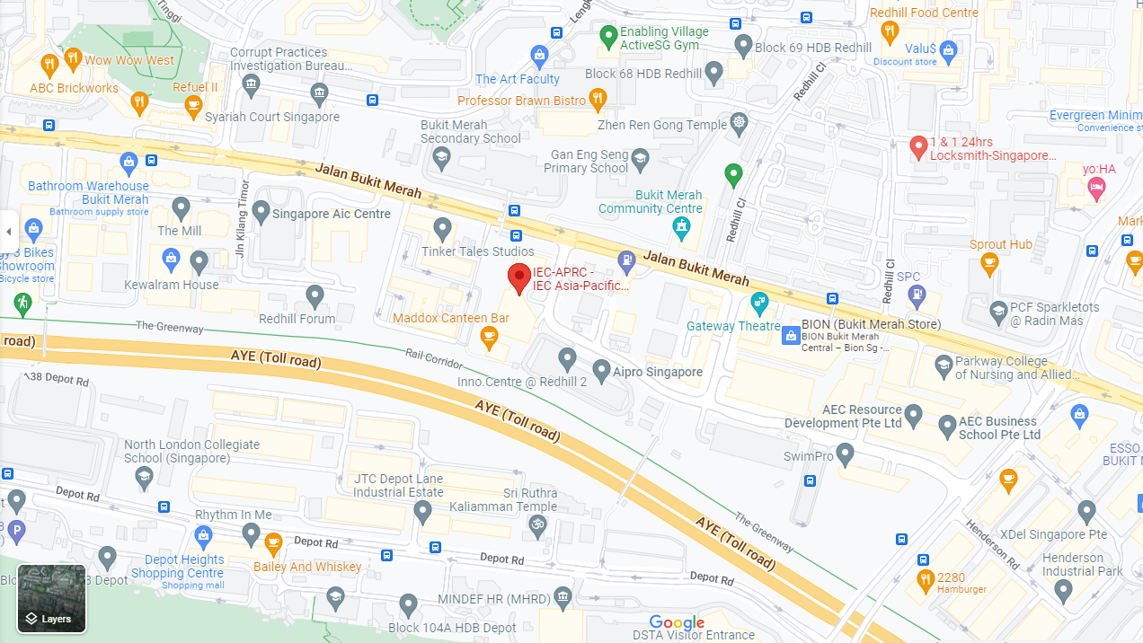

GETTING TO MEETING VENUE

Delegates will need to make their own arrangements for travelling to the meeting venue. For members staying at hotels located in the City Area, the taxi fare is about SGD 15-25 from the hotel to the IEC-APRC. Each taxi seats a maximum of four and the journey takes between 15-30 minutes, depending on traffic conditions.

MEETING ROOM FACILITIES
LCD projector, Wifi internet access and electrical power points are available in the meeting room. Delegates will need to provide their own plug adaptors to suit the square 3-pin, 230 volts AC, 50 cycle sockets and plugs used in Singapore.

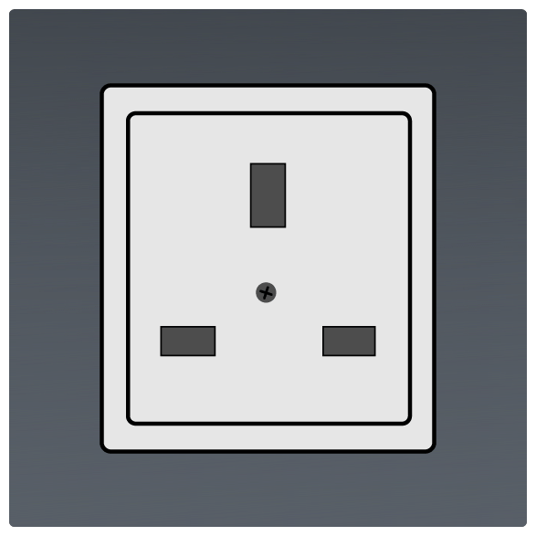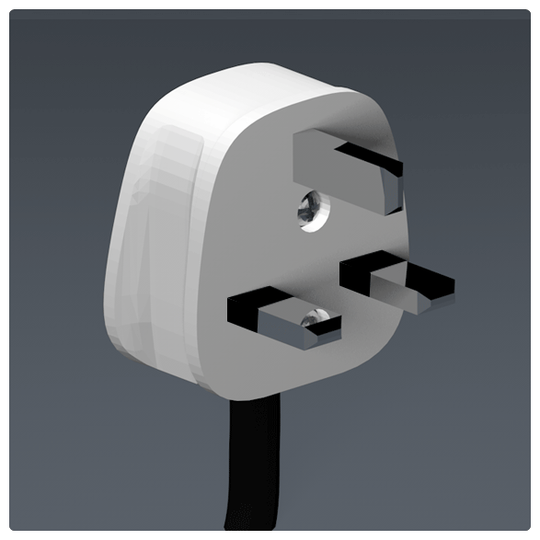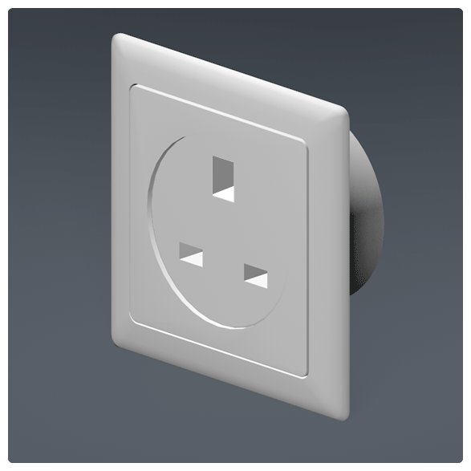

HOTEL ACCOMMODATION – Suggested
* This hotel is suggested because IEC has corporate rates with them.
** Please note that availability of all hotel rooms are based on a first come, first served basis.
*** Members should also note that accommodation at other hotels may be limited due to events
in Singapore over the period of these meetings

Concorde Hotel Singapore
100 Orchard Road, Singapore 238840.

Contact Person:
Ms. Nelly Voon-Arriola, Assistant Director of Sales
Tel: +65 6733 8855
Web: http://singapore.concordehotelsresorts.com/

Room reservation Link: Please click on the this link >> IECEx to reserve your booking at the rates listed below (that were current on 7th November 2023).

Room Type | Single | Twin/ Double
Deluxe Plus | $ 255.00 ++ | $ 270.00 ++
Premier Club | $ 305.00 ++ | $ 325.00 ++
++ = additional 10% Service Charges and 9% GST apply

Cancellation Charge
The Hotel reserves the right to charge for the full duration for any cancellation or release of individual rooms reservation made less than 7 days prior to the arrival date.

PASSPORT & VISA

Delegates and accompanying persons are advised to check with their agency concerning regulations for Visas. If in any doubt, information can be obtained from your nearest local Singapore Embassy or Consulate.
If you need an invitation letter for visa application, please contact:
Dennis Chew
Regional Director, IEC-APRC
Email: dch@iec.ch
cc: cpa@iec.ch

KEY INFORMATION – SINGAPORE
ARRIVAL
Travellers seeking to enter Singapore should comply with the prevailing Public Health as well as Entry Requirements listed in the ICA website to ensure a smooth journey.

Please refer to the link at SG Arrival Card (SGAC) with electronic health declaration and fill in the form within 3 days prior to arriving Singapore.
Getting from Changi Airport to the city centre is possible via the highly efficient public transportation network of taxis, buses and the Mass Rapid Transit (MRT) rail system. Delegates and accompanying persons wishing to buy an EZ link card to access public transport can do so at locations listed here.

The taxi ride from Changi International Airport to the city centre takes about 20-30 minutes, with the estimated fare costing about SGD 40 or less. You may also download the Grab app to book a taxi service in Singapore.

CONTROLLED & PROHIBITED GOODS FOR IMPORT
Please take note that Singapore has very strict regulations on goods import especially electronic cigarettes which are on the list of prohibited goods to be imported while cigarettes must be duty paid. For the full list, please refer to the Singapore Customs website: https://www.customs.gov.sg/businesses/importing-goods/controlled-and-prohibited-goods-for-import

CURRENCY AND CREDIT CARDS
The currency is Singapore Dollar (SGD). Credit cards are welcomed in most restaurants and malls. Tipping is not mandatory.

LANGUAGE
English is widely spoken and understood.

WEATHER
Due to Singapore's geographic location which is near the earth's equator, the weather is warm and fairly humid throughout the year with approximate temperatures of 33ºC during the day and 25ºC in the evening.

USEFUL LINKS
About Singapore: www.yoursingapore.com/content/traveller/en/experience.html
Changi Airport: www.changiairport.com

