|  |  |
| --- | --- |
|  | IECEx OD 530 |
| Edition 2.1, 2023 -12 |

05

IECEx

OPERATIONAL DOCUMENT

IEC System for Certification to Standards relating to Equipment for use in Explosive Atmospheres (IECEx System)

IECEx Scheme for Certification of Personnel Competence for Explosive Atmospheres

Instructions for use of *GetCertified* software for managing IECEx Certification of Personnel Competence assessments

INTERNATIONAL ELECTROTECHNICAL COMMISSION

CONTENTS

CONTENTS 1

INTERNATIONAL ELECTROTECHNICAL COMMISSION 3

1 Application of the *GetCertified* software 3

2 Normative references 3

3 Terms and definitions 3

4 Access 4

4.1 Access to the*GetCertified* software 4

4.2 Levels of Access by user type 4

4.3 Creating user profiles and assigning access rights 5

4.3.1 IECEx Certification Body Administrator level 5

4.3.2 IECEx Assessment Manager and IECEx Candidate level 5

4.3.3 Process for assigning user access level 5

4.3.4 User access profile setup process 6

4.4 Creating User Groups 6

4.5 Certification Body Workspaces 6

5 Question Pools 7

5.1 Question Pool Creation 7

5.2 Question Pool Editing and Additions 9

5.3 Translation of Question Pools 9

6 Preparation for Assessments 10

6.1 Standardised settings and preferences 10

6.2 Copying previously used Tests for a new Test 11

6.3 Creating Testing sessions for new and unused Tests 12

6.4 Creating new Testing sessions for Tests previously used for other Testing sessions 16

6.5 Assigning Users as individuals and via User Groups 19

6.6 Paper based assessments as alternative to online Testing sessions 21

6.7 Test Keys for Examiners for use in reviewing candidate test results 22

7 Candidate participation in a Testing Session 23

7.1 User Profiles and User Groups 23

7.2 Notifications to Candidates 25

7.3 Candidate access to the session 26

8 Post assessment processes 27

8.1 Grading of candidate session results - SELECTED REPONSE QUESTIONS 27

8.2 Grading of candidate session results - CONSTRUCTED REPONSE QUESTIONS 29

8.3 Communicating assessment results to candidates 32

Annex A 34

A.1 Suggested instructions text – Selected Response Questions 34

A.2 Suggested instructions text – Constructed Response Questions 34

IECEx Operational Document 530

IECEx Scheme for Certification of

Personnel Competence for Explosive Atmospheres –

Instructions for use of *GetCertified* software for managing IECEx Certification of Personnel Competence assessments

This IECEx Operational Document provides instructions for use of the GetCertified software (by YouTestMe) in managing the IECEx Question Bank and the assessment of candidates for IECEx certification under the IECEx Scheme for Certification of Personnel Competence.

This Operational Document also serves as a reference document for the IECEx Secretariat as Administrator of the GetCertified system and for the IECEx ExPCC Working Group # 3 that manages the IECEx Question Bank. For this reason, some features mentioned may not be available to ExCBs and some tasks or processes outlined are NOT to be completed by ExCBs with prior consultation with IECEx ExPCC Working Group # 3 and the IECEx Secretariat.

Document History

|  |  |
| --- | --- |
| Date | Summary |
| October 2023 | Original issue (Edition 1.0) |
| November 2023 | Edition 2.0 - Published to include updated images and to reflect changes of operation or appearance of the YouTestMe interface screens |
| December 2023 | Edition 2.1 – Published to add details about Workspaces as new Clause 4.5 |

Address:

IECEx Secretariat

Email: [info@iecex.com](mailto:info@iecex.com)

<http://www.iecex.com>

INTERNATIONAL ELECTROTECHNICAL COMMISSION

IECEx Operational Document 530

IECEx Scheme for Certification of

Personnel Competence for Explosive Atmospheres –

Instructions for use of *GetCertified* software for managing IECEx Certification of Personnel Competence assessments

# Application of the *GetCertified* software

A licence for use of the *GetCertified* software (developed and provided by YouTestMe) has been purchased by the IEC for use by all IECEx 05 Scheme Certification Bodies (ExCBs) for preparing, conducting and reporting on assessments for IECEx CoPC and EFOC Certificate issue in accordance with IECEx OD 503. This licence includes support services that are available on request via the IECEx Secretariat and as a comprehensive range of Youtube videos and hyperlinks to these are included as relevant in this document.

Note that the capability of GetCertified is broader than IECEx needs at this time and whilst the support pages mention capabilities such as proctoring, user self-registration, training etcetra, not all features have been activated or configured for IECEx use at this time. This document explains the use of GetCertified as it has been configured and customised for IECEx purposes – in configuring the software, the IECEx Secretariat has created profiles, templates, question pools and example Testing sessions so that ExCB staff do not need to prepare these nor obtain the skills and knowledge to do so.

Furthermore, several functions have been customised to meet IECEx needs and you may find that, as explained in this document, the IECEx version of GetCertified may vary from the standard set of functions mentioned in the Youtube videos and other support material. All questions and concerns on this aspect must be raised directly with the IECEx Secretariat (and not to YouTestMe)

# Normative references

The following documents, in whole or part, are normatively referenced in this IECEx Operational Document and are essential for its application. For dated references, only the edition cited applies. For undated references, the latest edition of the referenced document (including any amendments) applies. At the time of publication, the editions indicated were valid. The IECEx Management Committee shall decide the timetable for the introduction of revised editions of the publications.

* *IECEx OD 503, ExCB Procedures for issuing and maintaining IECEx Certificates of Personnel Competence*
* IECEx OD 504, *IECEx Scheme for Certification of Personnel Competence for Explosive Atmospheres – Specification for Units of Competence Assessment Outcomes*

# Terms and definitions

For the purposes of this document, the terms, definitions, and explanatory information provided in IECEx 05, IECEx OD 504 and IECEx OD 504 and the following apply

For the definitions of any other terms, particularly those of a more general nature, reference should be made to IEC 60050-426 or other appropriate parts of the IEV (International Electrotechnical Vocabulary).

Test

A set of questions and answers (based on the contents of the IECEx Question Bank) that has been created and published to GetCertified for specific IECEx Units of Competence and has defined properties and permissions regarding its use and access by various levels of user. Tests are used as the basis for creating *Testing sessions.* The specifications of a Test include which *Question Pools* are used and the number of questions from each *Question Pool* that need to be answered (as specified in Table 3 of IECEx OD 503) by candidates being assessed for an IECEx Unit of Competence or a combination of IECEx Units of Competence.

Testing session

The application of a *Test* that is made available to specific assessment candidates over a specified period of time. Multiple Testing sessions can be based on a single *Test*.

Question Pool

A term used in the GetCertified reference material that is equivalent to and has the same purpose as the term “question bank” used in IECEx OD 503. Each question pool loaded by the IECEx Secretariat to the GetCertified software is based on the content of specific Critical Aspects of Evidence defined in IECEx OD 504.

IECEx Administrator

A role within the IECEx Secretariat that has the highest level of access to the facilities of the GetCertified software

IECEx Certification Body Administrator

A role within an ExCB that has access rights that enable use of a limited set of facilities of the GetCertified software for ExCB management of assessment activities

IECEx Assessment Manager

A role within an ExCB that has access rights needed to conduct assessments that enable use of a limited set of facilities of the GetCertified software for coordinating assessment activities for their ExCB

IECEx Candidate

A person that has applied for and been accepted by an ExCB to participate in an assessment of competence as the basis for certification

# Access

## Access to the*GetCertified* software

The latest and current version of the *GetCertified* software (developed and provided by YouTestMe) is available via the following URL / link: <https://iecex.youtestme.com/ytm33/login.xhtml>

General information about GetCertified is available @ <https://www.youtube.com/playlist?list=PLNr69myqMnd-nirVxTZacvWLbFFXUsI17>

The main support page is available @ <https://www.youtestme.com/support-and-faq> and an topic-by-topic indexed support page is also available @ <https://wiki.youtestme.com/index.php/IECEx_Help_Center>

## Levels of Access by user type

Each type of user requires a username and password to access and use the software and to complete assessment activities as a certification candidate.

A basic summary of access rights and permissions for each user type follows:

|  |  |  |  |  |
| --- | --- | --- | --- | --- |
|  | **IECEx User Type / Role** | | | |
| **Function / Right** | **IECEx Administrator** | **IECEx Certification Body / ExCB Administrator** | **IECEx Assessment Manager** | **IECEx Candidate** |
| Create, edit or delete a user role | 🗹 |  |  |  |
| Create, edit or delete a user profile | 🗹 |  |  |  |
| Create a new user profile | 🗹 | 🗹 | 🗹 |  |
| Edit a user’s profile | 🗹 | 🗹 | 🗹 |  |
| View a list of ALL users | 🗹 | 🗹 | 🗹 |  |
| Export users list to Excel | 🗹 | 🗹 | 🗹 |  |
| Manage a user’s status (activate, lock or suspend) | 🗹 | 🗹 | 🗹 |  |
| Manage system settings | 🗹 |  |  |  |
| Create user groups | 🗹 | 🗹 | 🗹 |  |
| Create user groups and view and edit all groups | 🗹 |  |  |  |
| Create and edit question pools + translations | 🗹 | 🗹 |  |  |
| Create and edit Testing session templates | 🗹 | 🗹 | 🗹 |  |
| Create and organise Testing sessions | 🗹 | 🗹 | 🗹 |  |
| Assign candidates to a session | 🗹 | 🗹 | 🗹 |  |
| Manage any Testing session for any ExCB | 🗹 | 🗹 | 🗹 |  |
| Manage Testing sessions for own ExCB only |  | 🗹 | 🗹 |  |
| Join an Testing session | 🗹 | 🗹 | 🗹 | 🗹 |
| Mark a candidate’s assessment ‘paper’ | 🗹 | 🗹 | 🗹 |  |
| Approve a candidate’s assessment results | 🗹 | 🗹 | 🗹 |  |
| View own assessment results |  |  |  | 🗹 |
| View candidate assessment results for own ExCB |  | 🗹 | 🗹 |  |
| View all candidate assessment results for all ExCBs | 🗹 |  |  |  |

Table 1 – Summary of Access Rights

## Creating user profiles and assigning access rights

### IECEx Certification Body Administrator level

Access at the IECEx Certification Body Administrator level can be provided on request to the IECEx Secretariat.

### IECEx Assessment Manager and IECEx Candidate level

Access at the IECEx Assessment Manager and IECEx Candidate levels can be granted by users with IECEx Certification Body Administrator access rights.

### Process for assigning user access level

The process for assigning user access level is illustrated @ [user roles](https://www.youtube.com/watch?v=WexINhY0EfQ)

NOTE 1:Usernames cannot have any spaces.

NOTE 2: Passwords must have at least 7 characters long, have a digit, a lowercase letter, an uppercase letter and a special character.

Note that the software includes options for pre-defined roles. These must not be used and only the roles of:

* IECEx Certification Body Administrator
* IECEx Assessment Manager
* IECEx Candidate

as defined in this document and available as existing options in GetCertified may be applied for IECEx activities. Requests for addition of other IECEx roles shall be directed to the IECEx Secretariat with reasons for the need.

Languages other than English may be selected in the ‘Language in Tests” option if a question pool translation for this language has been prepared, approved and loaded for the Unit(s) of Competence to be assessed (refer Clause 5.3 in this document).

### User access profile setup process

The process for user access setup is explained in Clause 7.1 of this OD and illustrated @ [create users](https://www.youtube.com/watch?v=cgvdIMHBf-8)

It is **recommended** that user passwords are manually assigned (and are not automatically generated by the software) and that a record of these is maintained by the ExCB. If a user requests a change of password this can be done as illustrated @ <https://www.youtube.com/watch?v=jBfee17yHJc&feature=emb_title>

It is also **recommended** that users be advised to not change their password without prior consultation with the relevant ExCB.

In the situation where a large number of users need to have profiles setup it is possible to import the data using a pre-formatted Excel template as illustrated @ <https://www.youtube.com/watch?v=udK5dcn7ciA>

## Creating User Groups

Users (for example and typically, IECEx Candidates) can be assigned to a User Group to assist in inviting and managing multiple users in the same Testing session and to analyse the results for a Testing session.

The process for User Group creation is explained in detail in Clause 7.1 of this OD and also illustrated @ <https://www.youtube.com/watch?v=I4fKL2tVtqM>

## Certification Body Workspaces

A Workspace has been established for each IECEx ExCB to maintain separation between ExCBs’ work and to maintain the privacy of candidates’ details and results. The process to nominate which Workspace an ExCBs’ users will work is as follows:

1. Login to GetCertified using the previously advised access username and password
2. Select the **V** iconin the upper right of screen as shown below

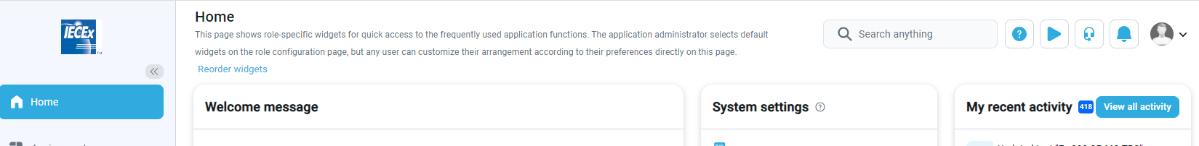

1. If you then see “All workspaces” displayed in your user details window that appears, you need to click on this text. Once you have selected this for the first time the system should default to this Workspace. If a user conducts work for more than one ExCB and is required to work in multiple Workspaces the step below can be followed at each login to select the appropriate Workspace.
2. You will then see a **Choose w**A red line on a black background

   Description automatically generatedA red line on a black background

   Description automatically generated**orkspace** window appear ... then click on the *All workspaces* window to display a list of all ExCBs Workspaces

1. Select the correct ExCB Workspace for your work
2. Select Save
3. Repeat Step 2 above to check that your ExCB now appears as your assigned Workspace

# Question Pools

GetCertified utilises “question pools” to prepare assessments – the IECEx Question Bank managed by ExPCC Working Group #3 for the ExPCC is used to create and maintain the question pools employed for IECEx assessment of competence. ExCBs do NOT need to create Question Pools and must NOT do this without consultation with ExPCC Working Group #3. The following subclauses of Clause 5 are included in this OD as a reference to ExPCC Working Group #3 and to the IECEx Secretariat that maintains overall Adminstrator access and rights for GetCertified.

## Question Pool Creation

Each Critical Aspect of Evidence (CAE)or “Module” defined in IECEx OD 504 AND each type of question (selected response or constructed response) within each CAE requires a separate question pool in GetCertified. These question pools will be created by the IECEx Secretariat using the IECEx Question Bank as the source of questions and answers to be used by ExCBs in conducting assessments. Further, the IECEx Secretariat will prepare standard Testing session templates that are referenced by the software when an Testing session for a Unit or combination of Units is being prepared – these will be based on the relationship between Units of Competence and the CAE defined in IECEx OD 504, Section 6.

The types, structure and naming of IECEx question pools is illustrated in Figure 1 following where Pools for Selected Response have an “SR” suffix and those for Constructed Response have a “CR” suffix and the addition of “MG” if the results from tests using these need to be manually reviewed and graded by the ExCB (refer Clauses 6.6 and 8.2 following in this OD for more details):

Figure 1: IECEx Question pools structure and naming convention

An example of the content of a question pool used in GetCertified for IECEx assessments is shown in Figure 2 following:

Figure 2: Example of content of an IECEx question pool for CAE 5.1

The process of question pool creation is explained @ <https://wiki.youtestme.com/youtestme/helpPages/Question_pools_tests.html>

**RECOMMENDATION**: In preparing and using question pools for CONSTRUCTED RESPONSE type questions, it is recommended that ExPCC WG3 use “***Open Ended***” type questions with selection of the ***Manual grading*** option so that candidates are **not** graded automatically and are **not** required to provide an answer exactly the same as the model answer specified in the pool for the question. Guidance on the preparation of Open Ended questions is illustrated @ <https://www.youtube.com/watch?v=utGzmJtI8Us>

The GetCertified software includes a facility to upload question bank data from other sources and file formats via use of a special Excel template. An example of the template is embedded below



and an example of a filled-in template is shown in Figure 3 following:



Figure 3: Example of completed import template

Details of the use of the template are explained @ [How to bulk import questions to the question pool using an Excel file](https://www.youtestme.com/kb/how-to-import-questions-to-the-question-pool-using-an-excel-template/) and in the below embedded file



and as illustrated @ [Importing Questions with Excel Template](https://www.youtube.com/watch?v=3Q11GFd8jAs&list=PLNr69myqMnd_sWd6Z2slEJEflONA5828l&index=2)

Questions and answer sets that utilize images or other media can be imported as explained in the embedded file below and via a “.zip archive” as shown in the screenshot below:



## Question Pool Editing and Additions

Addition to, or editing of, question pools and standards Testing session templates will be done by ExPCC Working Group #3 with the assistance of the IECEx Secretariat. Additions and edits will be done in response to input to ExPCC WG3 discussions and additional questions and answer sets from existing and applicant ExCBs.

## Translation of Question Pools

GetCertified includes a facility for candidates to (1) view the text in a language other than English (that is the default language) and (2) see the assessment questions and answers and complete the assessment in a language other than English. The language to be used by the candidate is selected when the user profile for the candidate is setup (refer Figure 4 following).

Enabling of languages (after translated Question Pools are provided) for use within GetCertified can be done by the IECEx Secretariat on request.

The process for preparing question pools in other languages is illustrated @ <https://www.youtube.com/watch?v=pZSZxncy6A8&ab_channel=YouTestMe>

Note that the translation of the question pool needs to be provided by the ExCB(s) that wish to use it. The ExCB(s) shall use the current version of the approved IECEx Question Bank as the source reference and the ExCB(s) shall accept responsibility for (1) the accuracy of the translation, and (2) timely maintenance and update of the translation when the IECEx Question Bank is expanded or edited.

Figure 4: Selection of Candidate Language options (on User specific basis)

# Preparation for Assessments

## Standardised settings and preferences

As a means of assisting ExCBs in preparing for assessments and of ensuring consistency, the Settings and associated preferences in GetCertified configured for IECEx use have been set based on the following principles:

1. Every Testing session will use different questions to previous sessions in the same Unit or combination of Units and the order of Selected Response type questions common to sessions will appear in a different randomised order
2. Every candidate will receive their Selected Response type assessment questions in a different randomised order to other candidates in the same session. To assist ExCBs in grading Constructed Response answers, the Constructed Response type questions will appear in the same order for all candidates in a particular session. To further simplify the ExCB’s task of reviewing and grading candidates’ answers for Constructed Response questions, these tests will be presented at random to candidates from a limited number of versions - the current template is set to create and use TWO versions however the template can, on request to the IECEx Secretariat, be revised to create and randomly provide more versions (noting that this can increase the workload for examiners. PDF files of the Questions and Answers for each version are available to examiners as explained in Clause 6.6 following in this OD)
3. Candidates cannot go back (for example, to change their answer) to questions after they have been answered
4. All questions must be answered in the time allowed for each (as specified in IECEx OD 503 for each question type)
5. Candidates cannot browse the internet or change to other monitor screens during the assessment (attempts to do so will result in an automatic suspension of the session)
6. Candidates can re-sit or resume (after pausing or after an automatic suspension) an Testing session if permitted to do so by the relevant ExCB’s Assessment Manager.

## Copying previously used Tests for a new Test

A process of copying previously used **Tests** for creating new **Tests** is a method of ensuring that all settings and preferences are standardised within an ExCB and across all ExCBs. It should not be necessary for ExCBs to create new tests (refer process for creating new Testing Session for a published Test in Clause 6.3 following) as Tests for Units and typical combinations of Units will be available as published Tests in GetCertifed. Contact the IECEx Secretariat if new Tests need to be created. The steps of the copying of existing tests and publishing new tests process are as follows:

1. Select Tests
2. Select Manage tests
3. Select (by clicking on the hyperlinks in the Name column) a Test to be copied from the list under *Test information*

1. Select Options and then select *Create a copy*

1. Edit Test name and confirm (via tabs for Settings, Test Instructions, Questions and Grading Configuration on the menu bar) that all details are correct for the new Test

1. Select Publish test

## Creating Testing sessions for new and unused Tests

1. Schedule a Testing session for new candidates to complete a published Test that has NOT been previously used in a Testing session by use of the Tests / Manage tests sessions for existing published Tests and then select (by clicking on the hyperlinks in the Name column) an existing test from the options presented

1. Select Schedule a testing session based on the selected Testt

1. Select New testing session

1. Fill in details of new Session name, the availability date range for candidates to access and attempt the new session, choose how candidates will be assigned to the session and then select Save/. Clause 6.5 following explains the process of assigning candidates to a Testing session

1. The new session is titled as “*New* *Session on New Test Example”* it will, after being saved, appear in the summary of all Testing sessions for a specific Test as shown below (this session being the only one scheduled at this time for the specific Test)

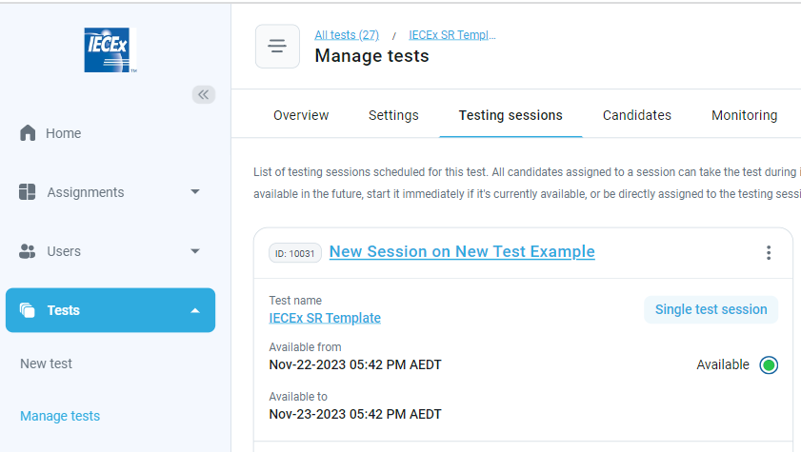

1. Assign Test Administrator(s) to the new Testing session by finding the relevant new Testing Session from the summary windows of all Testing sessions based on the published Test – see example below

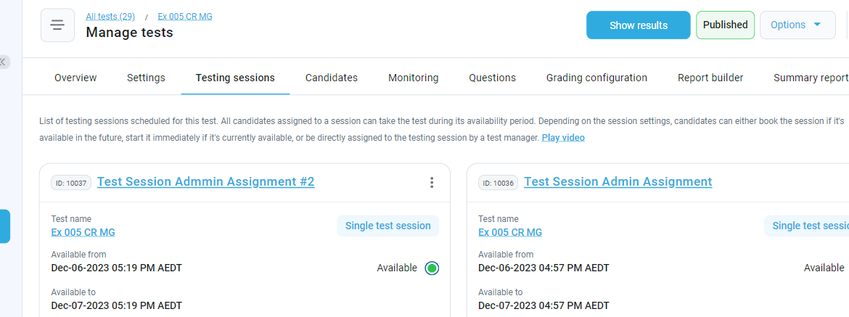

1. Click on the ‘three dot’ icon for the relevant new Testing session
2. Select View all details icon

1. Select Test administration from the menu  bar

1. Select Assign managers
2. Add the relevant ExCB staff that will be managing and grading candidates result by ticking them and then use Confirm to update the settings of the Testing session

1. A red line in a black background

   Description automatically generatedUse the Trash icon to remove IECExAdministrator#1 (as a default Manager for all Testing sessions) from the list

## Creating new Testing sessions for Tests previously used for other Testing sessions

Schedule a new Testing session for new candidates to complete a published Test that has ALREADY been previously used in a Testing session by the following process.

Note that it can seen if a Test has been previously used in a Testing session by

1. Selecting Tests then Manage tests
2. Selecting a Test from the summaries under Test information (by clicking on the hyperlink for Test name in the Names column)
3. Selecting Manage testing sessions
4. Checking if boxes for Testing sessions appear … if none are visible then no Testing sessions have used this Test previously

Process Steps:

1. Select Tests then Manage tests sessions for existing published Tests and then select (by clicking on the hyperlink for Test name in the Names column) a Test to be used for the new Testing session

1. After selection of the required Test by selecting its name from the list of Published Tests, select the Manage testing sessions icon.

1. Select the New testing session icon.

1. Fill in details of new Session name, the availability date range for candidates to access and attempt the new session, choose how candidates will be assigned to the session and then select Save as shown in the following figure:

As an example, if the new session is titled as “*Session Repeat Example”* it will, after being saved, appear in the summary of all Testing sessions for a specific Test (in this case, the Test is Ex 001 SR Partial #3) as shown below alongside a previous Testing session based on the Ex 001 SR Partial #3 test:

1. Assign Test Administrator(s) to the new Testing session by finding the relevant new Testing Session from the summary windows of all Testing sessions based on the published Test – see example below

1. Click on the ‘three dot’ icon for the relevant new Testing session
2. Select View all details icon

1. Select Test administration from the menu  bar

1. Select Assign managers
2. Add the relevant ExCB staff that will be managing and grading candidates result by ticking them and then use Confirm to update the settings of the Testing session

1. A red line in a black background

   Description automatically generatedUse the Trash icon to remove IECExAdministrator#1 (as a default Manager for all Testing sessions) from the list

## Assigning Users as individuals and via User Groups

Users that exist in the system (refer to Clause 7.1 for the process of loading users to the system) can be manually assigned to Testing sessions by

1. selecting ***Tests*** from the menu bar
2. then selecting ***Manage Tests*** from the revealed roll down menu
3. Select Manage testing sessions
4. Select Testing sessions for this Test from the menu bar

1. Choose the relevant Testing session from the summary boxes displayed for the relevant Test (if none are displayed you will need to create a Testing session based on the relevant Test before you can proceed to assign candidates)
2. Click on the ‘three dot’ icon to display options as shown below and then select *Assign candidates*

1. Add candidates from the list of users in the system by ticking all those that will participate in testing session and then select Confirm.as shown in Figure 8 – this will instruct the system to automatically issue notification emails to all candidates. Note that User profiles need to be set up using the process in Clause 7.1 of this OD BEFORE this step so that they appear in the list of candidate options as shown in Figure 8:

Figure 8: Adding individual Candidates to a Testing session

If Users already exist as part of an existing User Group they can be added to the Testing session as a group by selecting the following options shown in the example below and then specifying the relevant User Group from the list presented when setting up the Testing session

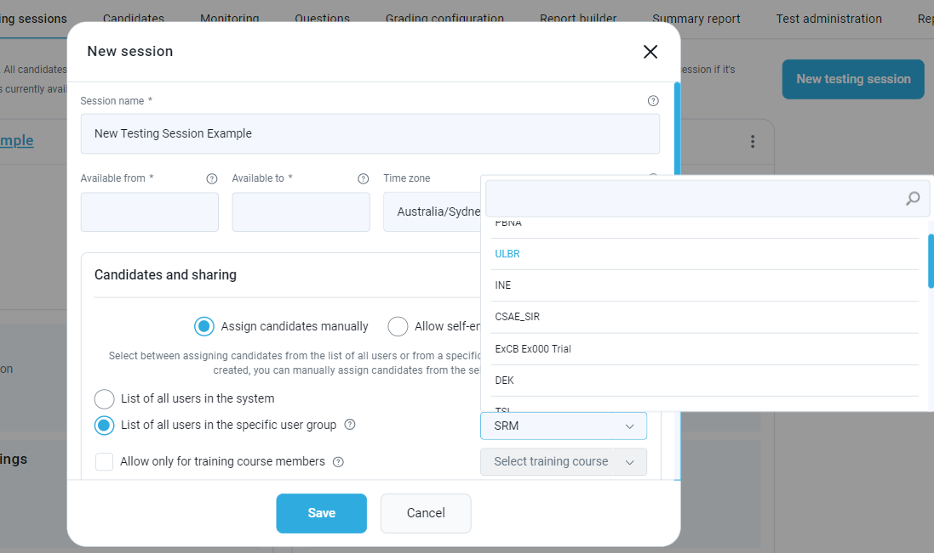

## Paper based assessments as alternative to online Testing sessions

Whilst GetCertified is designed primarily for use in conducting on-line assessments, it has the facility to export Testing session question ‘papers’ as PDF files that can be used to print hard copy / “paper based” assessment papers.

Note: automatic marking of constructed response type questions (refer to the Recommendation in Clause 5.1) is NOT able to be done by GetCertified for online or for paper based assessments.

If required by an ExCB for use in a paper based Testing session, a ***Test Key*** as a PDF file of the questions can be created via the following process:

For ***Constructed Response*** tests the process is as follows

1. Select Tests / Manage Tests
2. Select a test for which you require the Test Key
3. Select “Export as PDF”

1. Select “*Download the test as a PDF*” option and select which version of the test is required (in the case where there are multiple versions of the same test) and then select Export

You can also download a complete *assessment packag*e via the following steps

1. selecting ***Tests*** from the menu bar
2. then selecting ***Manage Tests*** from the revealed roll down menu
3. Select Manage testing sessions
4. Select Testing sessions for this Test from the menu bar as shown following …

1. Select the relevant Testing session from the summaries presented
2. Click on the ‘three dot’ icon to display options as shown below and then select *Export paper-based assignment package*

## Test Keys for Examiners for use in reviewing candidate test results

1. Note the provision to export a **Test Key** (as a set of tested questions and their correct answer) as a very useful tool for reviewing and grading Constructed Response type question test results - for **Constructed Response** tests the process is as follows
2. Select Tests / Manage Tests
3. Select a test (and Version(s) of where multiple versions are available) for which you require the Test Key
4. Select “Export as PDF”

1. Select “*Download the test as a PDF (with correct answers)*” option and select which version of the test is required (in the case where there are multiple versions of the same test and hence the correct version will be useful in marking and grading test results for candidates that completed that version) the select “Export”

1. Note ALSO the provision to import results from paper based tests (for example, for automated marking etcetra) – guidance on this is available @ <https://www.youtestme.com/kb/how-to-import-offline-test-responses/>

# Candidate participation in a Testing Session

## User Profiles and User Groups

The creation of a Testing session requires assigning candidates (as “Users”) to the Testing session so that they receive notifications with links that enable them to join and complete the Testing session

Create ***INDIVIDUAL User profiles*** for all candidates for the test session that will use this new test by:

1. Selecting Users from Home screen then select User profiles

1. Select *Create new user* from menu bar

1. Fill in the Application credentials details as required by the mandatory fields and then select Save. In filling in details please note that, as shown in the following diagram …
   1. Regarding Passwords, it is recommended that you select “**Manually inserted**” instead of “Generated” and then manually assign a password to the candidate.
   2. The Role to be selected for IECEx candidates is “**IECEx Candidate**”.
   3. The inclusion of the candidate’s email address is mandatory because the system uses emails to communicate with candidates about their Testing session schedule and their results after completing the Testing session
   4. There is an optional facility for setting a Password expiration date … it is recommended that you do not do this UNLESS local privacy laws or other requirements force this. An alternative to setting a password expiration date is the facility to set a candidate’s User status from Active to Suspended or Locked which will prevent them from accessing their records and new testing sessions
   5. The Time Zone should be that for where the candidate is located or where they will complete the Test as online testing session
   6. Specify the candidate’s preferred language for reading GetCertified screens etcetra (this does NOT automatically change the language used for the questions to be answered in the Testing session.
   7. An option exists to specify the Language in tests … please do NOT change this from English unless a Text exists with translations of Questions and Answers from the English based IECEx Question Bank test to the language that you wish to use for this candidate.

Create ***User Groups*** for candidates with common aspects (typically these will be groups that are being assessed by a specific IECEx ExCB and can also be further refined to allocate candidates to a User Group for a specific Testing session however note that this can complicate post testing session administration) by:

1. Selecting Users from Home screen then select User groups – this will display all User groups accessible by your ExCB

1. Select + New top level group from the upper right of screen

1. Provide a name (in this example, “YTM ExCB Training Group” has been used) and other details for the new User Group on the User groups Information page for the new User Group and then select *Members* from the menu bar

1. Select Assign members in the upper right of screen and then proceed to choose (by ticking beside their name as shown below) Users that need to be added to the User Group and when finished selecting User Group members, select Confirm

1. Check that all required members have been added to the User Group as shown below (if any are missing use the Assign members icon again to add more members to the User Group). Note that Users will automatically receive an email advising them of their addition to a User Group … they do NOT need to act on this or respond to it.

## Notifications to Candidates

After the ExCB’s Administrator or Assessment Manager has created a user profile for a candidate and added the candidate to a User Group for a specific Testing session, the software will automatically send an email to the candidate. This email (an example is shown in Figure 9 following) contains the session title, a hyperlink to the session and details of the date and time period in which the session is available to the candidate (these are specified when the ExCB sets up the Testing session).

Note that the ExCB can use previous text to appear in the notification email or they can specify different text and instructions in emails for different sessions.

Figure 9: Example of Notification email to a candidate

## Candidate access to the session

After selection of the session hyperlink in the notification email, candidates need to:

1. Open the hyperlink in the notification email
2. Select the Assignments icon

1. Select My tests under the ‘Assignments’ icon to show available test sessions completed (refer Figure 10)

Figure 10: Example of “My tests” page for a candidate

1. Read any instructions on screen BEFORE clicking on the Start button
2. Start assessment, answer questions and click on A blue square with a white arrow

   Description automatically generated OR depending on your browser, the Next Question icon to advance to the next question OR Finish Test when the last question (as indicated by the lack of the Next Question icons) has been answered OR to exit the testing session

# Post assessment processes

## Grading of candidate session results - SELECTED REPONSE QUESTIONS

GetCertified has a function that can automatically grade and record the results of the assessment of a candidate for SELECTED RESPONSE type questions – an example of the output of this tool for single candidate is shown in Figure 11 following. Details for all candidates in a user group for a specific Testing session ae also available for view.

Figure 11: Example of a Candidates Grading report

The full details for each candidate are available to the Test Manager via selection of (1) Manage Tests, then (2) Tests, (3) the test for which results are to be reviewed

then selection of the candidate for which results will be reviewed is possible …

Select the options icon

Then select Actions and then select *Verify selected attempts* after which the candidate will be notified of their result.

and then confirm via selection of Yes in the Confirmation dialog window that appears

The Test Manager can then use the ‘chart’ icon to view the Candidates personal report as a Summary OR on a question-by-question basis as shown below:

## Grading of candidate session results - CONSTRUCTED REPONSE QUESTIONS

Whilst GetCertified has a facility for automatic grading of Open Ended type questions (as used for Constructed Response type questions for IECEx assessments) the format and wording of the question is critical for a fair assessment of IECEx candidates. As many questions in the IECEx Question Bank that has been developed over many years prior to the use of GetCertified, the format and content of these are not all suitable for automatic grading. For this reason, ExCBs will need to continue to manually review and grade candidates’ responses to Constructed Response type questions. The process for this is illustrated below in Figures 12, 13, 14 and 15.

After candidates have completed the testing session the assigned Test Manager will receive a notification (see example below) that the candidate’s answers can now be reviewed and graded (select Grade to open the candidate’s results)

Figure 12: Example of notification to Test Manager

This will open the candidate’s result (which will show a Result = Failed until Grading has been done manually – see example below of a candidate’s results that have NOT yet been graded). Select Grade to conduct the manual review and grading. (Note the facility for Next candidate > as a way of moving to the results for other candidates in the same testing session)

Figure 13: Example of candidate grading page for the Test Manager

This will provide the opportunity to select and grade the candidate’s answer for each question (which will have its status as graded or not graded shown and they can be filtered via these)

Figure 14: Example of question by question grading page for the Test Manager

Compare the Candidates’ *Answered result* to the *Correct Answer* (from the IECEx Question Bank Model Answers) and then Grade the answer as CORRECT by setting Achieved points to 1.00 (as shown below) OR to 0.00 to record this answer as INCORRECT and then select Submit.

Note that in the example below “zzzz” is obviously NOT correct but for illustration purposes this answer has manually been graded as Correct with Achieved points assigned as 1.00

Figure 15: Example of a questions grading page for the Test Manager

Candidate’s testing results can also be accessed for grading via the following process

1. Select Tests / Manage tests
2. Select Test used for the Testing Session to be graded
3. Select Manage testing sessions to access list of Testing sessions for this Test
4. Choose the Testing session to be graded
5. Select the ‘three dot’ icon and then the *Manage candidates* option (refer below)

1. Select ‘chart icon’ to open personal report for the candidate to be graded

1. Select Questions from the menu bar

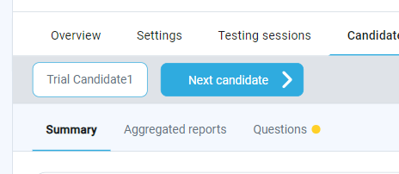

1. Once the Test Manager has access (via either method above) to the candidate’s personal report they can use the **Grade** icon to access the answer to each question and then select Cancel to return to the list of questions where answer have been or need to be graded as indicated by their status

1. When all answers have been graded, Verify the report via use of the Verify icon as shown below

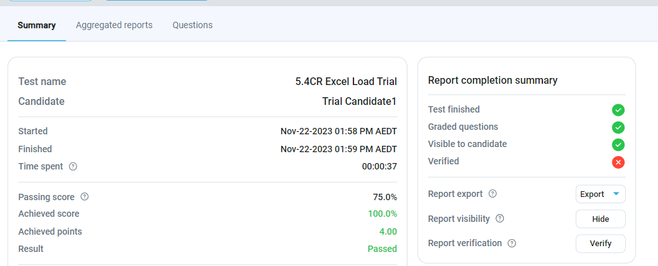

1. The *Report completion summary* will then show that all steps have been completed for the grading of this Testing session for this candidate (see below) and the overall graded result for this Testing session for this candidate.

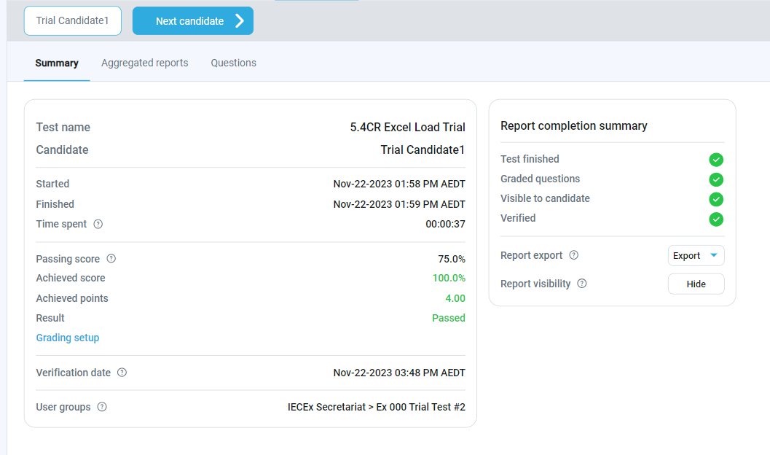

1. You can then use the Next candidate icon to move to the answers for other candidates in the same Testing session …



## Communicating assessment results to candidates

Unless otherwise stated or requested, the standard Testing session templates configured for IECEx assessments require the approval of the results by the relevant ExCB Assessment Manager before these can be viewed by the candidate and before the results notification email is sent to the candidate via the email address in their user profile (refer Figure 16 for an example of the content of the notification and a link that can be used to access the results)

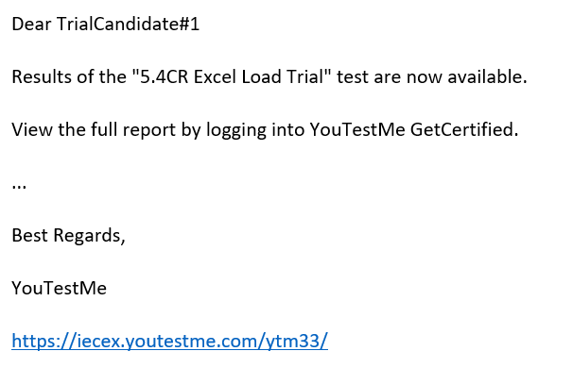

Figure 16: Example of result notification email to a candidate

Candidates can then use the link in the notification email to open the software where they can

1. Select *Assignments / My tests*

1. Select the test that displays a Completed icon and then select Personal report to view the outcomes of their reviewed, graded and verified assessment results.

Figure 17: Example of personal report accessible to a candidate



This Annex includes suggested text to be used by ExCBs when preparing Testing sessions.

* 1. Suggested instructions text – Selected Response Questions

**TEST INSTRUCTIONS FOR IECEx CERTIFICATION CANDIDATES - *PLEASE READ CAREFULLY***

1. This test uses Selected Response or 'multiple choice' type questions where only one of the four answer options is correct or the most correct. Question and answer sets are assigned randomly from the IECEx Question Bank so you will mostly have different questions to other candidates and any questions common among candidates will appear in a different order for each candidate.
2. You have a **maximum** of two (2) minutes to answer each question (the time remaining for each question is displayed by the timer in the upper right of screen during the test)
3. You cannot go back to answer missed questions so all questions must be answered in the order in which they are presented. Once a question has been answered this will be indicated by a blue icon for the question in the lower left of screen.
4. You cannot go back to answered questions to change your answer so please answer carefully.
5. After you have answered the last required question select the Finish Test icon
6. Please note the ***warning message*** on the permissions page that you are required to complete before the test commences - if you try to minimise from full screen display, open other documents or web browsers, move to a second screen or attempt to copy or print screen content the test session will be closed and can only be opened by the IECEx Certification Body for you to continue or recommence the test.
7. The test session will automatically close after you have completed all questions within the allowed maximum time.
8. Your results and a link to access to your personal report will be emailed to you after the Examiner has reviewed and approved these
9. If the test session includes multiple test sessions (for example for several modules or "critical aspects of evidence” as per IECEx OD 504) you will need to select either "Finish Section" to move to the next section of the test after all questions in the current section have been answered OR select "Finish Test" to complete the testing session.
   1. Suggested instructions text – Constructed Response Questions

**TEST INSTRUCTIONS FOR IECEx CERTIFICATION CANDIDATES - *PLEASE READ CAREFULLY***

1. This test uses Constructed Response or 'short written answer' type questions. Questions are assigned randomly from the IECEx Question Bank so you will mostly have different questions to other candidates and any questions common among candidates will appear in a different order for each candidate.
2. You have a **maximum** of three (3) minutes to answer each question (the time remaining for each question is displayed by the timer in the upper right of screen during the test)
3. You cannot go back to answer missed questions so all questions must be answered in the order in which they are presented. Once a question has been answered this will be indicated by a blue icon for the question in the lower left of screen.
4. You cannot go back to answered questions to change your answer so please answer carefully.
5. After you have answered the last required question select the Finish Test icon
6. Please note the ***warning message*** on the permissions page that you are required to complete before the test commences - if you try to minimise from full screen display, open other documents or web browsers, move to a second screen or attempt to copy or print screen content the test session will be closed and can only be opened by the IECEx Certification Body for you to continue or recommence the test.
7. The test session will automatically close after you have completed all questions within the allowed maximum time.
8. Your results and a link to access to your personal report will be emailed to you after the Examiner has reviewed and approved these
9. If the test session includes multiple test sessions (for example for several modules or "critical aspects of evidence” as per IECEx OD 504) you will need to select either "Finish Section" to move to the next section of the test after all questions in the current section have been answered OR select "Finish Test" to complete the testing session.