GENERAL INFORMATION
2018 IECEx International Conference on Equipment and Services in Explosive Atmospheres Jakarta, Indonesia

Meeting Dates:
August 8 – 9, 2018

Meeting Venue
Sheraton Grand Jakarta Gandaria City Hotel *****
Jl. Sultan Iskandar Muda, Kebayoran, Jakarta, Jakarta, 12240, Indonesia

Transportation (Soekarno Hatta International Airport (SHIA) – Venue)

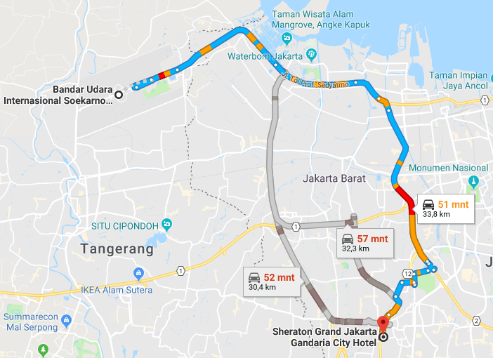

The Venue is located about 30 km from SHIA. There are two most recommended mode of transportation to take from SHIA to the venue or vice versa.
1) Shuttle service
You can book a shuttle service direct to the Venue with a fare of USD 35.7 for one way in the reservation form of Grand Sheraton Jakarta Gandaria City or submit your inquiry in the Hotel website : (http://www.sheratongrandjakartagandariacity.com/en/forms/airportpickups?channel=LPSIDP) .

2) Taxi
You can take a taxi to Sheraton Grand Jakarta Gandaria City Hotel, which will take around 50 minutes with a fare of approximately USD 15. It is recommended to take a taxi from the taxi counter available at the airport.

Organizing Committee and Host Committee
IECEx in association with The United Nations Economic Commission for Europe (UNECE) and The National Standardization Agency of Indonesia (BSN)

IECEx Secretariat  264 George Street  Sydney NSW 2000  Tel: + 61 2 4628 4690  Email: mailto:rego@iecex.com | National Standardization Agency of Indonesia  BPPT 1 Building, 9th – 12th floor,  Jl. MH Thamrin no 8 Jakarta Pusat,  DKI Jakarta  Tel: +62 21 3927422 ext 124
Contact Person from the host country
Should you need further information please don't hesitate to contact:
Mr. Fery Kurniawan, Ms. Dewi Nurlatifah
Center for Cooperation on Standardization – BSN
Tel: +62 21 3927422 ext. 124
Email: fery85@bsn.go.id; dewi.nurlatifah@bsn.go.id; kerj_int@bsn.go.id

Registration
Delegates are kindly requested to confirm their participation at the 2018 IECEx International Conference by visiting the IECEx Website (link below) and clicking the Online Registration Link. An automated response will confirm your registration and provide you with a Registration Number, please have this number available for the morning registration as this will help facilitate an efficient registration process.

Kindly include the following information with your registration:
- Name and contact email
- Organization/Employer
- Country of Residence
- Dietary (special) Requirements for Lunch on Day 1 and Day 2
https://www.iecex.com/meeting-and-events/2018-iecex-international-conference-jakarta-indonesia/conference-registration/
Please also note other relevant information on the IECEx website for this event including Conference Program.

Visa Regulation
Foreign nationals entering Indonesia are generally required to have a valid passport and a Indonesian visa assigned by overseas branch of Indonesian embassy or consular offices. It is recommended that the participant make immediate inquiries regarding visa requirements with their nearest participant Indonesian Embassy or Consulate. Should you require an official invitation letter from the host, please sent your enquiry by sending the completed Form for Invitation Letter Request and email with subject “invitation letter request” to: Ms. Dewi Nurlatifah

For further information regarding visa regulation, kindly access the following link:
- http://www.imigrasi.go.id/index.php/en/
- http://www.imigrasi.go.id/index.php/en/layanan-publik/bebas-visa

Accommodation
Recommended hotel for you you to stay during the IECEx International Conference are:
- Sheraton Grand Jakarta Gandaria City Hotel
- Veranda Hotel @ Pakubuwono
- DoubleTree by Hilton Jakarta – Diponegoro
- Hotel Gran Mahakam
- Grand Kemang Jakarta
Climate
Indonesia is known as the “belt of emeralds across the equator”. Located in the tropical zone, Jakarta’s climate is hot and humid . There is significant rainfall in most months of the year. The short dry season has little effect on the overall climate.The temperature here averages 27.6 °C.
Currency and Exchange
Banks are usually open on Monday through Friday from 08.30 am - 02.30 pm. Money changers are available at most major shopping centers, the airport, and major banks. Hotels and Shopping Centers normally accept major Credit Cards, such as Visa Card, American Express, Master Card, Dinners Club etc.

The Indonesian Currency is Rupiah (Rp). Approximately, USD 1.00 is equal to Rp. 14.085.- (as of May 9, 2017). Exchange services are available for cash and travelers cheques in Banks, Hotels and Foreign Exchange Places. Bank Notes are issued in the following denominations:
Rp. 2,000.-; Rp. 5,000.-; Rp. 10,000.-; Rp. 20,000.-; Rp. 50,000.-; Rp. 100,000.- and in coins are Rp. 100.-; Rp. 200.-; Rp. 500.-; Rp. 1,000.-

Insurance
The Host and the IECEx will assume no liability whatsoever for injury or damage to persons or property during the conference. Please make your own arrangements for health insurance and any other necessary insurance that might be required

First Aid
The Venue and also all hotels provide fast emergency aid. In case of emergency, dial 119 or contact the reception of the hotel.

Local Time
Indonesia is divided into 3 times zones:
  - West Indonesia Standard time is GMT + 7 hours
  - Central Indonesia Standard time is GMT + 8 hours
  - East Indonesia Standard time is GMT + 9 hours
Jakarta is in West Indonesia Standards time.

Language
The native language of Jakarta is Indonesia (bahasa) but many people in Jakarta are fluent in English.

A few words of greeting for your trip:
  - Good morning Selamat pagi
  - Good afternoon Selamat siang
  - Good evening Selamat sore
  - Good night Selamat malam
  - Would you like to help me? Dapatkah anda membantu saya?
  - Thank you Terima kasih
  - How are you? Apa kabar ?
  - Fine, thank you Baik, terima kasih
  - How much is this? Berapa harganya ini?
  - Good bye Selamat tinggal
  - See you later Sampai bertemu lagi

Voltage and Frequency
The standard voltage in Bali - Indonesia is 220V at 50Hz with two plugged cord.
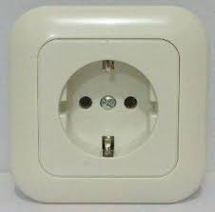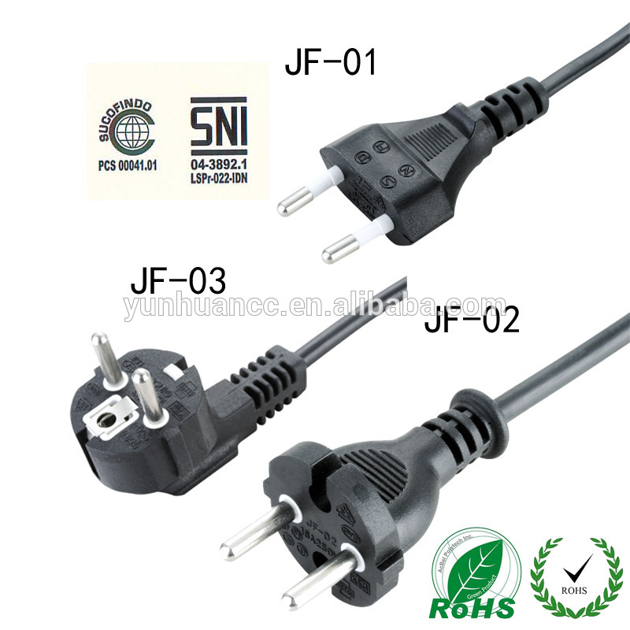

Telecommunications
In Indonesia, the international telephone access code is +62. Most hotels will charge fees for local and long-distance calls made from guest rooms.
Many hotels are equipped with high speed cable or wireless internet connection (a charge may be applied), and some hotels have business center which provide you with fax and copy services.
For delegates who anticipate using their phones often or who will be staying in Bali for an extended period of days, it may be less expensive to buy a local SIM card which is available at most stores.

Near Interesting Places in Jakarta

- Gandaria City Mall
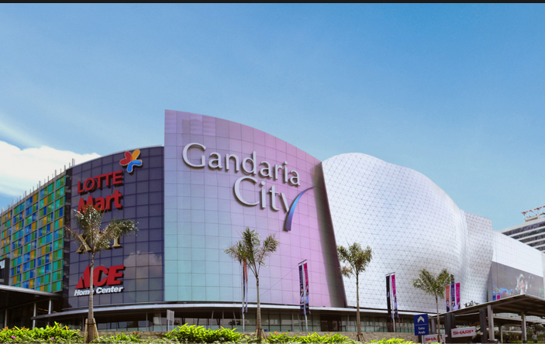
Gandaria City is a leading, elegant and luxurious shopping center located in a strategic location around an exclusive residence and also integrates with a business center in South Jakarta. Located on a high-traffic route connecting North West and South Jakarta and located just 5 kilometers from the outer ring road, Gandaria City has become the main shopping destination in Jakarta for the upper middle class who are looking for the best quality national and international products such as Furla, Hugo Boss, Guess, Mango, and many more. Gandaria City is the first mall in Indonesia that have IMAX in its movie theater, H&M, LC Waikiki and Uniqlo opens its first store in South Jakarta in Gandaria City. In F&B, Gandaria City has a lane way dining area dedicated for F&B, called Mainstreet, where various cuisines are offered here, including Asian, European and Indonesian dishes.

- The National Monument (Monas)

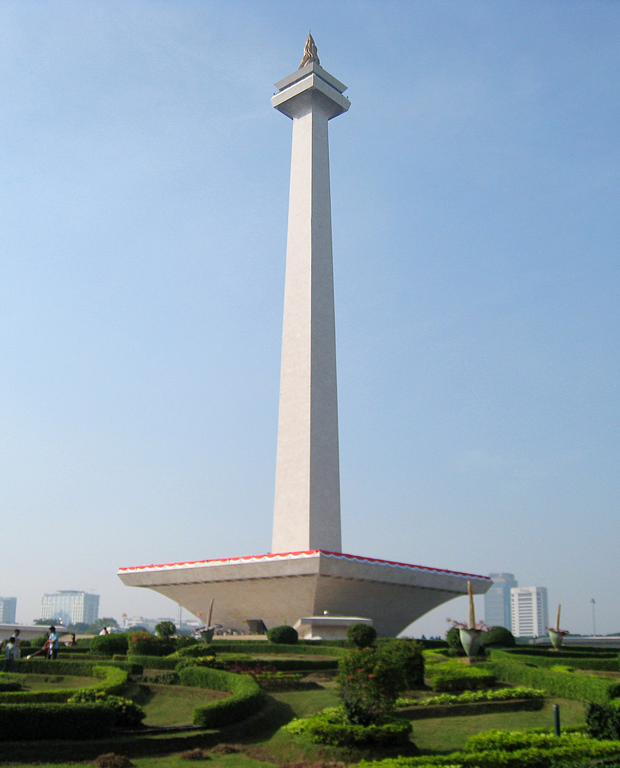
The National Monument (Monas) is a 132 m (433 ft) tower in the center of Merdeka Square, Central Jakarta, symbolizing the fight for Indonesia. It is the national monument of the Republic of Indonesia, built to commemorate the struggle for Indonesian independence. Construction began in 1961 under the direction of President Soekarno. It is topped by a flame covered with gold foil. Inside you will found The National History Museum. The monument and the museum are open daily from 08.00 until 15.00 Western Indonesia Time.

- The National Museum of Indonesia
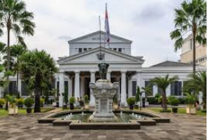
The National Museum of Indonesia (Museum Nasional), is an archeological, historical, ethnological, and geographical museum located in Medan Merdeka Barat Street, Central Jakarta, right on the west side of Merdeka Square. Total collection recorded 140.00 units, which contain ancient statues, inscription, ceramic, textile, historical relic and categorized by ethnography. Popularly known as Elephant Museum after the elephant statue in its forecourt.

- Jakarta Old Town
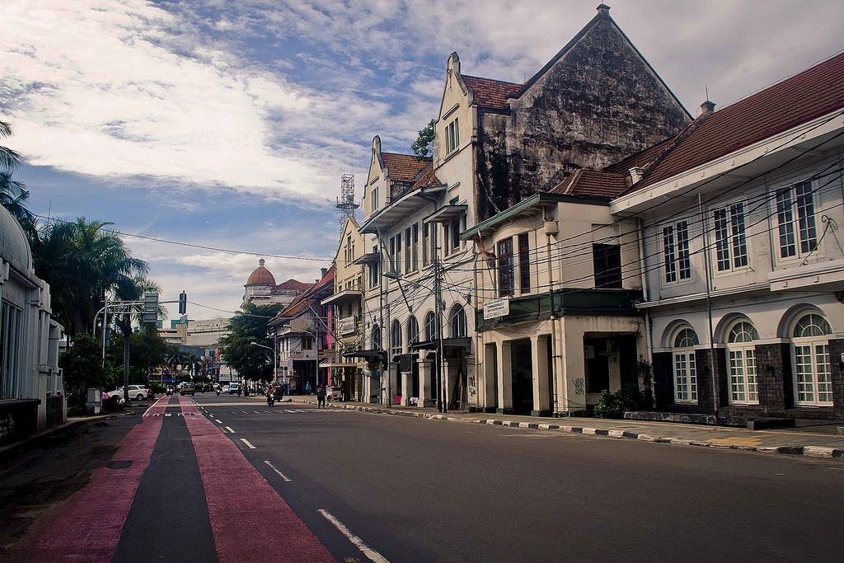
Kota Tua Jakarta ("Jakarta Old Town"), officially known as Kota Tua, is a neighborhood comprising the original downtown area of Jakarta, Indonesia. It is also known as Oud Batavia. It spans 1.3 square kilometres within North Jakarta and West Jakarta. Kota Tua is a remainder of Oud Batavia, the first walled settlement of the Dutch in Jakarta area. Kota Tua, Jakarta, was the pioneer of the current Jakarta City. It was started from a small port at the mouth of Ciliwung River in about centuries ago. The port city was then developed became a busy international trading center. At Kota Tua area you can see old buildings with architecture style influenced by the Dutch or European architecture style, Chinese and even some of them with combination of Dutch and Chinese architecture. Kota Tua is one of a very interesting place or area to visit when you travel to Jakarta since it’s a center of historical tourism object in Jakarta

- Grand Indonesia

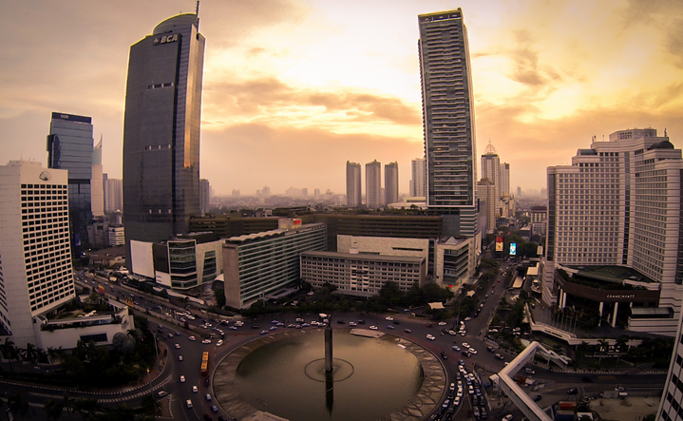
The Grand Indonesia complex is one of Southeast Asia’s largest malls. It’s located at Jl. MH. Thamrin No. 1, Central Jakarta. The complex is spread over two vast buildings, the West Mall and East Mall, and features eight levels of retail shops. Grand Indonesia shopping mall is one of the biggest integrated shopping town in Jakarta with unique and different decoration in every floor level. There is Cinema, Playground, Banks, Big department store, Branded stores, Biggest book store and famous local & International Restaurants.

- Plaza Indonesia
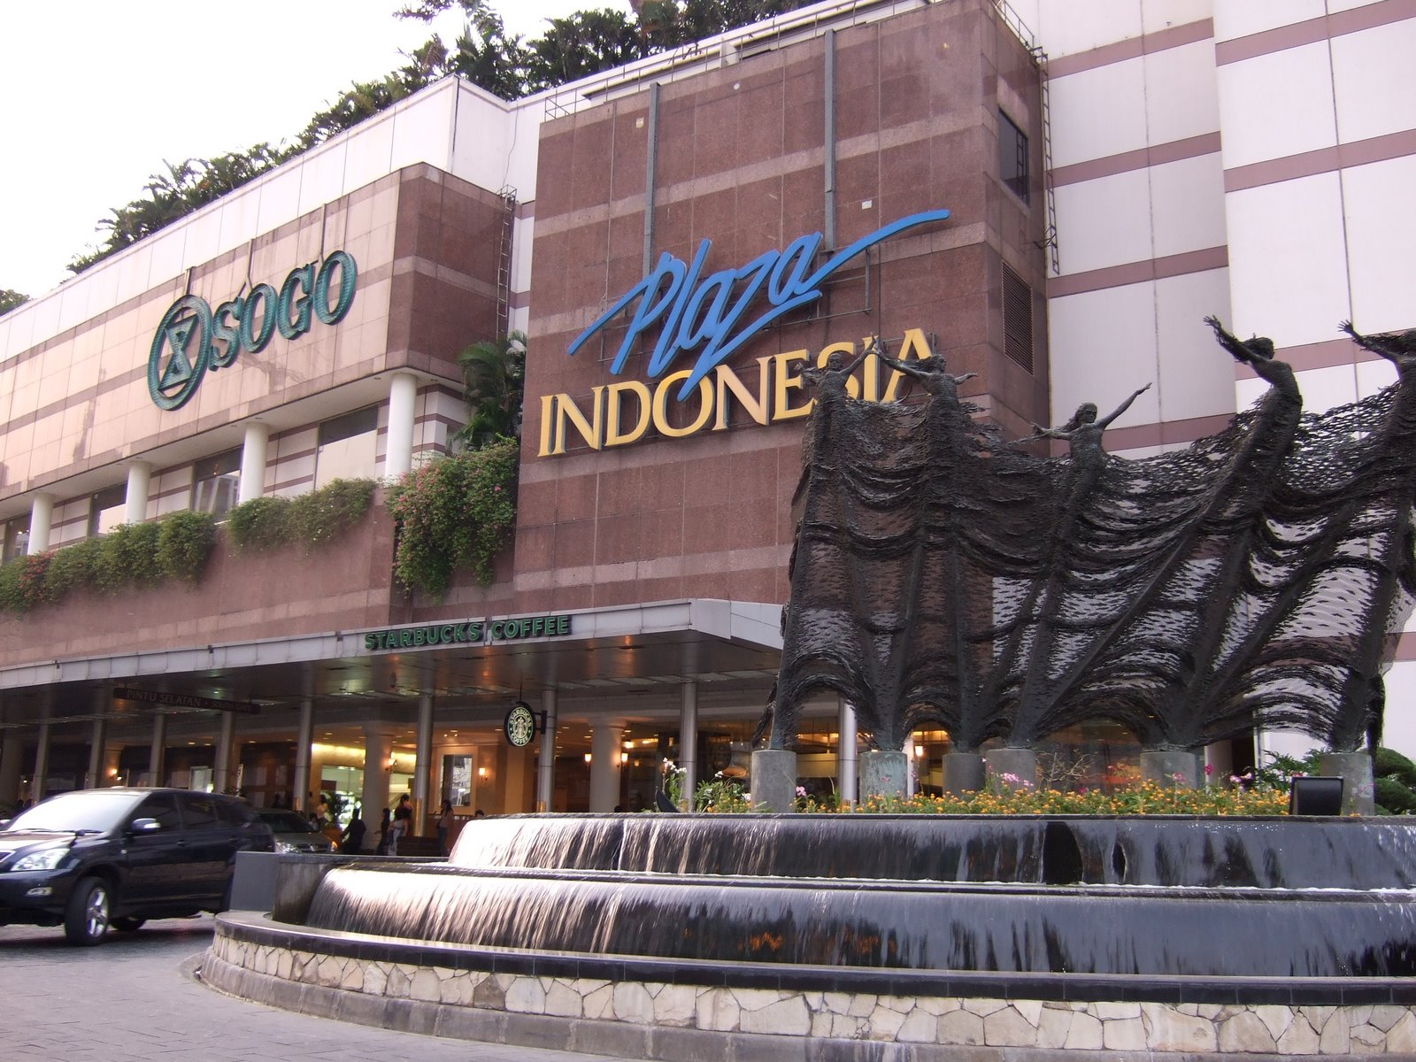
Centrally located next to the Hotel Indonesia Kempinski roundabout at Jl. MH. Thamrin Kav. 28-30, Central Jakarta. Beautiful big modern mall filled with amazing shops, this is one of Jakarta’s most popular malls for international luxury brands such as Louis Vuitton, Balenciaga and Tod’s. A vast array of shops can be found as well as food and beverage outlets such as Sushi Tei, Shabu Nobu, Kitchenette, Pancious and Pizza e Birra.

- Thamrin City
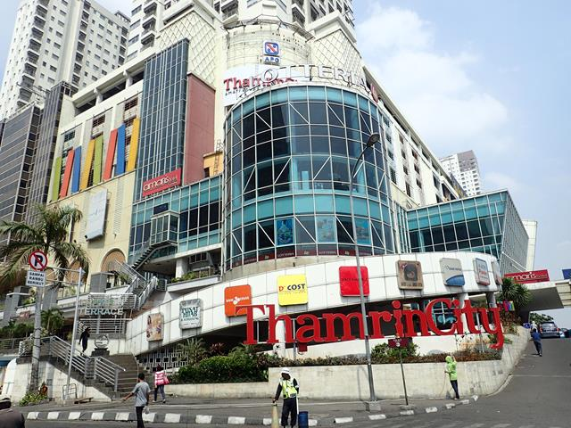
Thamrin City shopping mall is another place that is frequently visited by shoppers seeking new clothes, known as a place to shop for batik in Jakarta, the batik section at Thamrin City offers various designs of ready-to-wear batik from regions countrywide. Batik can be found on D1, D and the first and second floors. Apart from locals, the place is also popular among foreigners such as Singaporeans and Malaysians. Thamrin City offers goods similar to those sold at Tanah Abang. As it is less crowded, some people find it a more convenient place to shop. The prices are quiet affordable and you mostly you can negotiate the price here. However, visiting the mall can be confusing as the different sections are rather unorganized. In some areas, the stores are very cramped and visually similar, making it almost impossible to pinpoint a store’s location unless you are familiar with the place or have the exact address. it is important to remember from which lot you came in (e.g. Lot A, B, C etc).
Invitation letter for visa application 2018
IECEx International Conference on Equipment and Services in Explosive Atmospheres
August 8 – 9, 2018, Jakarta - Indonesia

Should you require an official invitation letter from the host, please sent your enquiry by email
email with subject “invitation letter request” to: Ms. Dewi Nurlatifah (mailto: dewi.nurlatifah@bsn.go.id; kerj_int@bsn.go.id)

Full Name
Organization / Employer
Job Title
Passport number
Passport Expire Date
Country of passport
Dates of Conference attended
Date of arrival
Date of departure
Email

