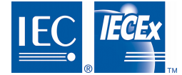
ExMC(Washington/FR)06
September 2017

IECEx ExMC Meeting
Yokohama
2017-09-21

IECEx ExMC Meeting, Washington

Comment of the French Member Body on item 18.3 of the agenda ExMC-1260C-DA
Document ExMC/1280/DV
The French member body asks that the feasibility and management of the fees as proposed be discussed, considering that at the beginning of a project, it is not known whether or not a CoC would be issued.

Thank you for your attention to this matter. Please contact me if you have any questions.
Sincerely,
Secretary, French Member Body

