IECEx OD 211
IECEx
OPERATIONAL DOCUMENT

IECEx OD 211, 2023,Ed1.0
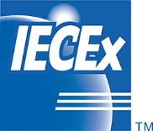
Edition 1.0 2023-12
IECEx Certified Equipment Scheme –
National Differences of Standards operated by the IECEx – Procedure for using the IECEx On-line Bulletin
IEC System for Certification to Standards Relating to Equipment for Use in Explosive Atmospheres (IECEx System)
THIS PUBLICATION IS COPYRIGHT PROTECTED
Copyright © 2023 IEC, Geneva, Switzerland

All rights reserved. Unless otherwise specified, no part of this publication may be reproduced or utilized in any form or by any means, electronic or mechanical, including photocopying and microfilm, without permission in writing from either IEC or IEC's member National Committee in the country of the requester. If you have any questions about IEC copyright or have an enquiry about obtaining additional rights to this publication, please contact the address below or your local IEC member National Committee for further information..

IEC Central Office Tel: +41 22 919 02 11
3, rue de Varembé info@iec.ch
CH-1211 Geneva 20 www.iec.ch
Switzerland

About the IEC
The International Electrotechnical Commission (IEC) is the leading global organization that prepares and publishes International Standards for all electrical, electronic and related technologies.

About IEC publications
The technical content of IEC publications is kept under constant review by the IEC. Please make sure that you have the latest edition, a corrigendum or an amendment might have been published.

IEC publications search - webstore.iec.ch/advsearchform
The advanced search enables to find IEC publications by a variety of criteria (reference number, text, technical committee, …). It also gives information on projects, replaced and withdrawn publications.

IEC Just Published - webstore.iec.ch/justpublished
Stay up to date on all new IEC publications. Just Published details all new publications released. Available online and once a month by email.

IEC Customer Service Centre - webstore.iec.ch/csc
If you wish to give us your feedback on this publication or need further assistance, please contact the Customer Service Centre: sales@iec.ch.
IEC online collection - oc.iec.ch
Discover our powerful search engine and read freely all the publications previews. With a subscription you will always have access to up to date content tailored to your needs.

Electropedia - www.electropedia.org
The world's leading online dictionary on electrotechnology, containing more than 22 000 terminological entries in English and French, with equivalent terms in 18 additional languages. Also known as the International Electrotechnical Vocabulary (IEV) online.

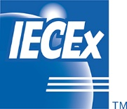

INTERNATIONAL
ELECTROTECHNICAL
COMMISSION

IECEx Certified Equipment Scheme –
IECEx National Differences of Standards operated by the IECEx – Introduction and procedure on using the IECEx On-line Bulletin
IECEx OD 211

Edition 1.0 2023-12

IECEx
OPERATIONAL DOCUMENT

IEC System for Certification to Standards Relating to Equipment for Use in Explosive Atmospheres (IECEx System)

CONTENTS
CONTENTS 2
INTERNATIONAL ELECTROTECHNICAL COMMISSION 3
FOREWORD 3
INTRODUCTION 5
1. Preface 6
2. Normative references 6
3. Terms and definitions 6
3.1 Member body 6
3.2 ExCB staff 6
3.3 ExTL staff 6
3.4 Public 6
4. IECEx On-line Bulletin 7
4.1 Assessing the IECEx Bulletin – public view 7
4.2 Full access to the IECEx On-line Bulletin with login 9
Logging in 10
Go to the IECEx On-line Bulletin, click “Login” button on the top right hand side of the page. Fill in your username and password and click on the blue “Login” button. 10
Annex A (informative) 13
A.1 Guidance for IECEx Member Body or delegate on the use of the On-line Bulletin for administrative data entry and management 13
Logging in 13
Go to the IECEx On-line Bulletin, click “Login” button on the top right hand side of the page. Fill in your username and password and click on the blue “Login” button. 13

INTERNATIONAL ELECTROTECHNICAL COMMISSION
____________

IECEx Operational Document OD 211 –

IECEx Certified Equipment Scheme –
IECEx National Differences of Standards operated by the IECEx – Introduction and procedure on using the IECEx On-line Bulletin
Edition 1.0

FOREWORD
Standards provide the technical frameworks, metrics and specifications regulators, manufacturers and end users can reference in legislation. As technologies evolve, standards are revised, and legislation remains up to date.
By incorporating standards and editions operated by the IECEx with full acceptance or when applicable, with National Differences of the standard by the National Member Body, then policy makers and regulators provide a platform that encourages the cooperation of competitors under common rules.
Most national or regional domains derive their own standards from the published international standards and issue a national version, which are aligned to the international standard and edition operated by the IECEx but also may contain National Differences, and then adopt as their own national or regional standard.
National differences create complexities for Ex suppliers and manufacturers as well as end users, so a single mechanism for harmonized standards, single testing, and worldwide recognition of certificates provides would be an ideal outcome. It is also appreciated that it may be necessary to have national differences due to some obvious differences between electrical standards for voltage and frequency, as well as earth grounding requirements by region. Other national differences may be more specific that address specific risks associated with underground mining, or petrochemical facilities.
The definition of national differences as defined by the IECEx Certified Equipment Scheme covering equipment for use in explosive atmospheres – Rules of Procedure is as follows:
National differences are those requirements or test parameters in the corresponding national standard which, when applied to equipment complying only with the IEC Standard accepted for use in the IECEx Certified Equipment Scheme, might entail non-compliance of that equipment with the relevant national standard.
Note 1 to entry: When a requirement in the Standard is not implemented in the corresponding national standard, which is also a national difference.
Note 2 to entry: Those restrictive requirements in a national standard that address risk of explosion issues (i.e. other than general safety requirements that address risks such as fire, electric shock and personal injury), which do not deviate from the criteria included in the corresponding Standard accepted for use in the IECEx Certified Equipment Scheme, but which limit the possibility to offer the relevant equipment for sale in the country concerned, are also considered to be national differences
The IECEx Rules of Procedure as states the following:
Participating countries
7.1 Participation In order for a country to participate in the management of the IECEx Certified Equipment Scheme the country must first be a member of the IECEx System and comply with the requirements for IECEx membership, as detailed in IECEx 01-S, IECEx Supplement to Harmonized Basic Rules IEC CA 01. Countries that are existing members of the IECEx System shall be considered members of the IECEx Certified Equipment Scheme.
7.2 National differences. The candidate member body of the IECEx Certified Equipment Scheme shall specify national differences from the IEC Standard(s) in the application.
7.3 Changes. The member body of the IECEx System shall notify the ExMC of any changes in the national differences declared in its application. Notification of any changes should be made within three months.
Section 11.1.3 Application IECEx Rules of Procedure also state:
Where separate national certification or approval is required in a country as a condition to supply a product for use in that country, the candidate certification body shall declare that the national certification or approval can be based on an ExTR. When national differences or other conditions have to be fulfilled, they shall be as declared by the member body of the IECEx System and published in the IECEx Bulletin. There shall not be more than one set of national differences for each country.
This publication also provides guidance for the National Member Body or their delegate on the updating and maintenance of the IECEx On-line Bulletin established in accordance with the requirements defined in this operational document to maintain an IECEx Bulletin as per clause 12.3 of the IECEx 02 Rules of Procedure.
This operational document IECEx OD 211 provides a guide to access the IECEx On-line bulletin matrix for public viewing by standard (including edition) by country and if the standard is accepted in full or if national differences exist. Further access to the IECEx On-line bulletin matrix can assessed and viewed depending on security access.
Document history
Date | Summary
2023-09 | Edition 1.0 IECEx On-line Bulletin. This Edition 1.0 is the introduces the new IECEx On-line Bulletin and replaces Edition 5 last published 2016-04 which was a static document.

Address: Contact details:
IECEx Secretariat c/o IEC Sydney Office Tel: +61 2 4628 4690
The Executive Centre Fax: +61 2 4627 5285
Australia Square, Level 33 info@iecex.com
264 George Street www.iecex.com
Sydney, NSW 2000
Australia

INTRODUCTION
At the request of IECEx Member Bodies, the IECEx Secretariat has introduced the IECEx On-line Bulletin that allows for the efficient, up-to-date collection and management of National Differences (ND) by country and by relevant Standards and editions operated by the IECEx. This online platform which is accessible through the IECEx website, streamlines the collection and management of national differences.

The primary goal of the IECEx On-line Bulletin is to provide a global, up-to-date list of national differences that is easily accessible to our members, ExCBs and ExTLs or whether there are no national differences (full acceptance) of the Standard. This promotes consistency and harmonization in the implementation of Standards operated by the IECEx. The Bulletin facilitates updates by IECEx Member Bodies or their designated representatives.

The IECEx On-line Bulletin offers several key features:
- Accessibility: Users can easily access information by country and by Standard or edition of Standard.
- IECEx On-line Bulletin views based on pre-assigned access rights.
  - IECEx ExCBs, ExTLs and Member Bodies – full access
  - Public access – The public view of the IECEx On-line Bulletin offers an overview of the status of national differences by country and by Standard (full acceptance or national differences exist).
- Administrative Guidance: OD 211 (this document) also provides administrative guidance for managing national differences for each Standard and edition or confirming full acceptance.
- Responsibility: Member Bodies are responsible for ensuring the accuracy of the information they provide to the IECEx On-line Bulletin. Neither the IEC nor the IECEx Secretariat is liable for the information's accuracy.

The IECEx On-line Bulletin enables updates by national member bodies, or their delegate using an administrative secure login to provide national differences or confirm if they have declared adoption of the Standard without national differences. The matrix summary view by Standard, edition of the Standard and by Country provides easily accessible and current information replacing the previous IECEx Bulletin which was published as a static document. The IECEx On-line Bulletin will reference past Bulletin content to assist the MB or their delegate to review and update ND so the information is current and will be referred to as the live on-line version.

The IECEx Member Bodies (MB), ExCBs and ExTLs will have full access to the detailed ND as submitted by the National Member Body or their delegate, which is password protected. The administrative rights to post MBs national differences or declare full acceptance will be assigned to the MBs or their delegate. It will be responsibility of the MB to ensure their ND by Standard and by edition are uploaded and made current on the IECEx On-line Bulletin.

The IECEx On-line Bulletin has been designed to be intuitive with easy access to information by country and by standards operated by the IECEx. OD 211 (this document) has been developed as an introduction to the IECEx On-line Bulletin, including its features and as a guide on how information can be accessed and viewed depending on access rights. This document also provides administrative guidance for the MB or their delegate on how to input NDs for each of the Standards and editions or by confirming there are no ND to a Standard or edition operated by the IECEx.

IECEx Certified Equipment Scheme – IECEx National Differences of Standards operated by the IECEx – Introduction and procedure for using the IECEx On-line Bulletin
Edition 1.0

Preface
This document provides instructions on how to use the IECEx On-line Bulletin to access information by Standard and by Country from the public view via the Bulletin Matrix and how to access the National Differences by Standard and by Country with login access rights.

This document also provides a guide for the National Member Bodies or their delegate on how to manage ND including the uploading of documents. The access to the administration section of the IECEx On-line Bulletin will be managed by the IECEx Secretariat.

Normative references
For dated references only the edition cited applies. For undated references the latest edition of the referenced applies with implementation dates as specified by the Management Committee.
- IECEx 02 – Rules of Procedure, Ed. 8.1 2022-10
- ExMC/1967/R, 2023-08 (as presented to the IECEx Member Bodies, 2023 Annual Meetings, Edinburgh, Scotland).
- Standards operated by the IECEx.

Terms and definitions
For the purposes of this operational document, the following definitions apply:

Member body
staff of a member body (IECEx Member Body) as defined in IECEx 02. For the purposes of the IECEx On-line bulletin, the member body may delegate their authority to maintain the IECEx On-line Bulletin, to a ExCB located within their country.

ExCB staff
staff of an ExCB (IECEx Certification Body) identified in ExCB competency records as being qualified to review test and assessment reports for the relevant test standard.

ExTL staff
staff of an ExTL (IECEx Testing Laboratory) identified in ExTL technical competency records as being qualified to conduct testing to the requirements of the relevant test standard.

Public
may be an end-user, manufacturer or regulator that may wish to access the public view of the ND matrix.

IECEx On-line Bulletin

Assessing the IECEx Bulletin – public view
Visit the IECEx Website - https://www.iecex.com/
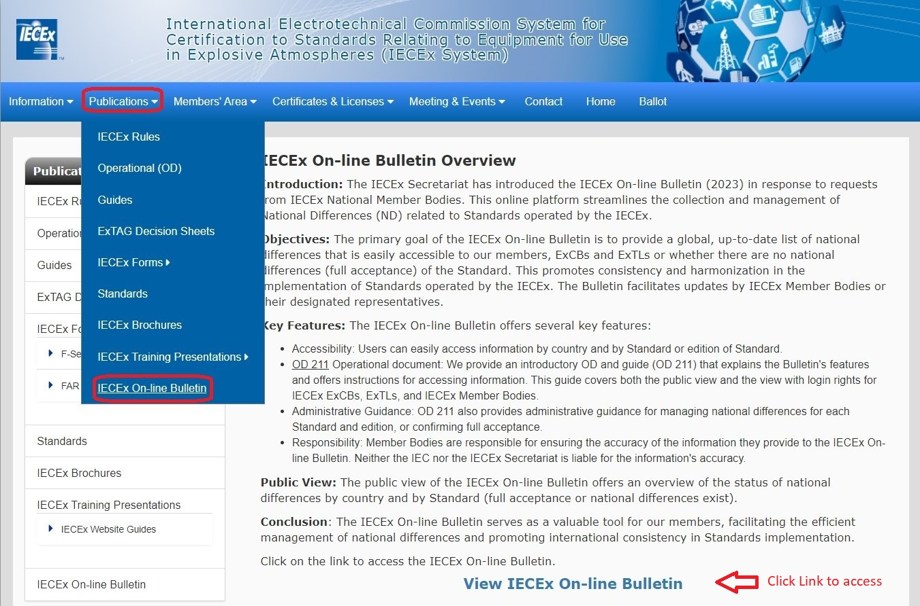
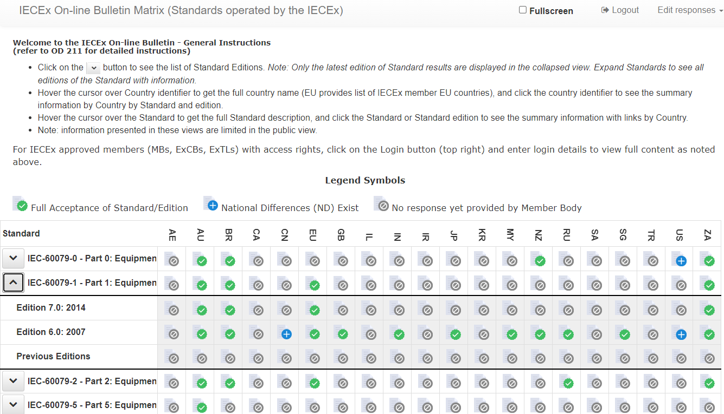
The On-line Bulletin matrix view below lists all of Standards operated by the IECEx and includes editions for each Standard. General instructions to view matrix information is included in the header of the matrix. Detailed information is located in OD 211 (this document).
If ‘No response’ icon is displayed, then the IECEx Member Body (MB) is yet to enter information. Contact MB for further information.
In public view, clicking on full acceptance provides the following (see screenshot below):

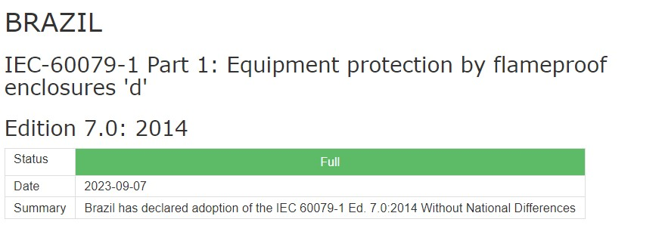
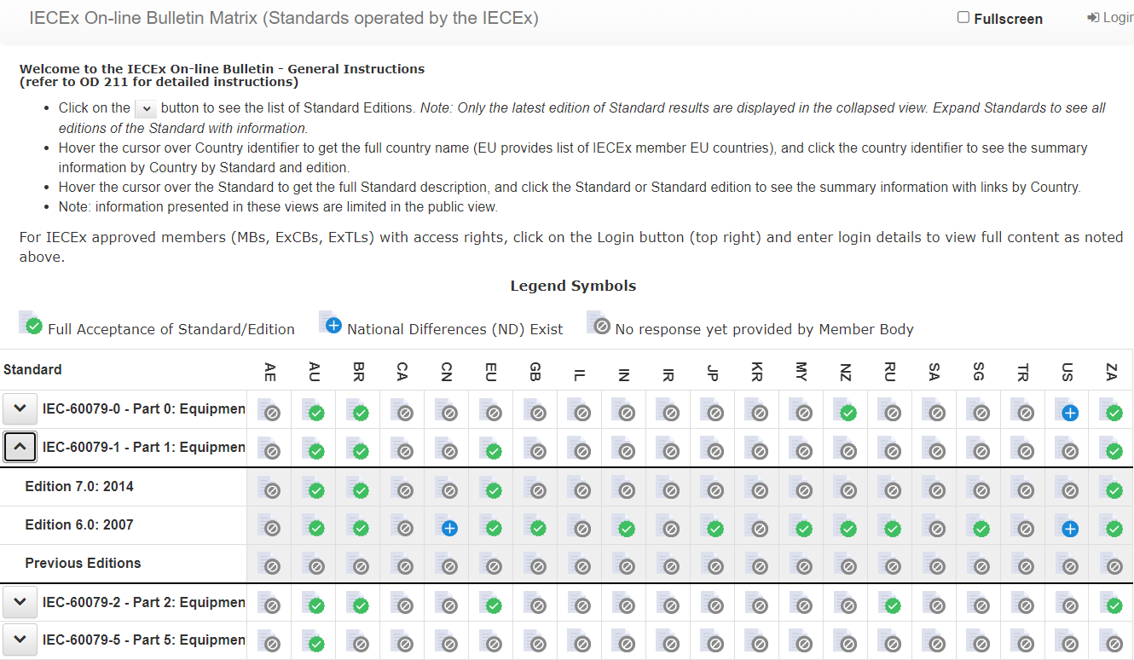
In public view, clicking on National Difference provides the following (example):

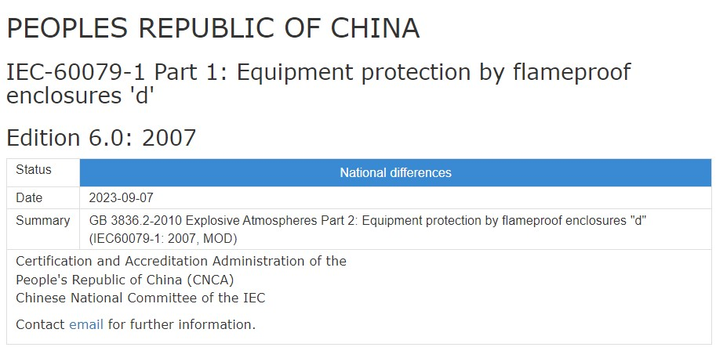

Full access to the IECEx On-line Bulletin with login
Full access to the IECEx On-line Bulletin can be assessed by the Publication page or the Member Body page on the IECEx website. Full access provides all submitted information by the country Member Body or their delegate for Standards and their editions operated by the IECEx including national differences with downloads if provided. Full access to the IECEx On-line Bulletin is provided to all Member Bodies, ExCBs and ExTLs, which is password protected. Access to login rights can only occur after contacting the IECEx Secretariat with an email sent to info@iecex.com requesting login rights. The email must include the following:
Name:
Position:
*Company:
Email Address:
Note: Company includes MB, ExCB or ExTL that are members of the IECEx.

Logging in

Go to the IECEx On-line Bulletin, click “Login” button on the top right-hand side of the page. Fill in your username and password and click on the blue “Login” button.
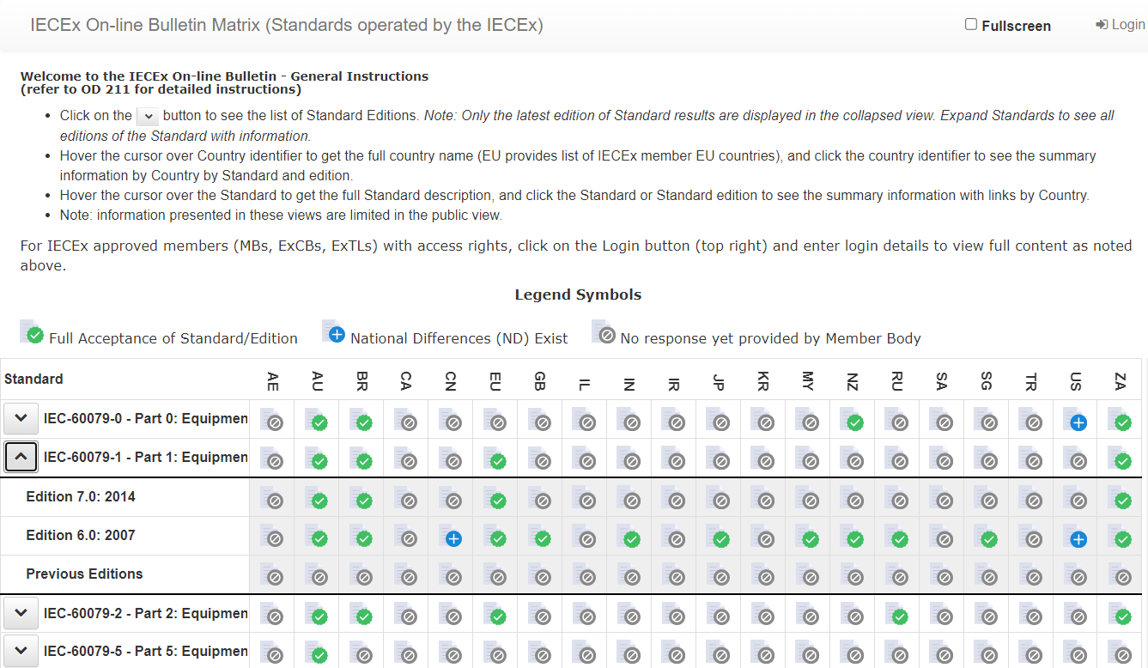
You can now access all secure material in the IECEx On-line Bulletin that has been provided by the IECEx Member Body or delegate.

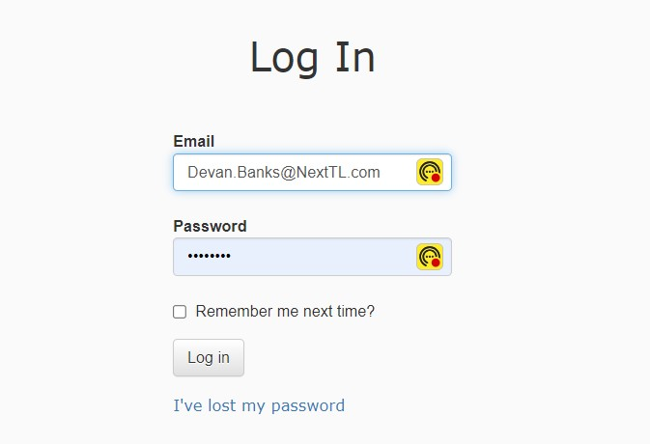
The login password can be reset automatically (if forgotten) or changed at any time by clicking ‘I’ve lost my password’.
Once logged in, simply click on the Standard and Edition of the Standard with the corresponding country to view submitted information. As noted in the IECEx On-line Bulletin, header instructions, when the bulletin matrix is in the collapsed view, only the status of the latest edition is displayed. Expand the accordion button see full content of all editions submitted.

Presentation views of the On-line Bulletin

By clicking on the Standard, this will open a new view pane that will display all country responses by the Standard.
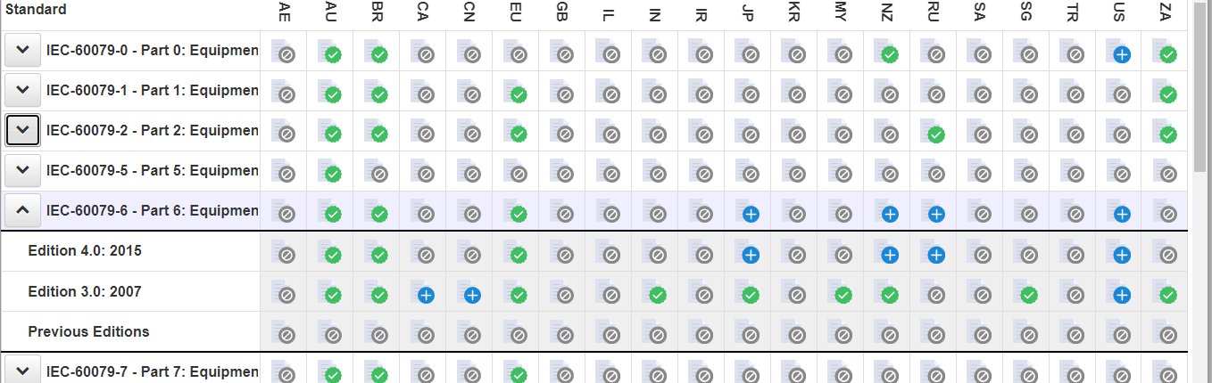
View showing responses by Standard by Country. Links in right column ‘Response’ can be now viewed by Country by Standard.
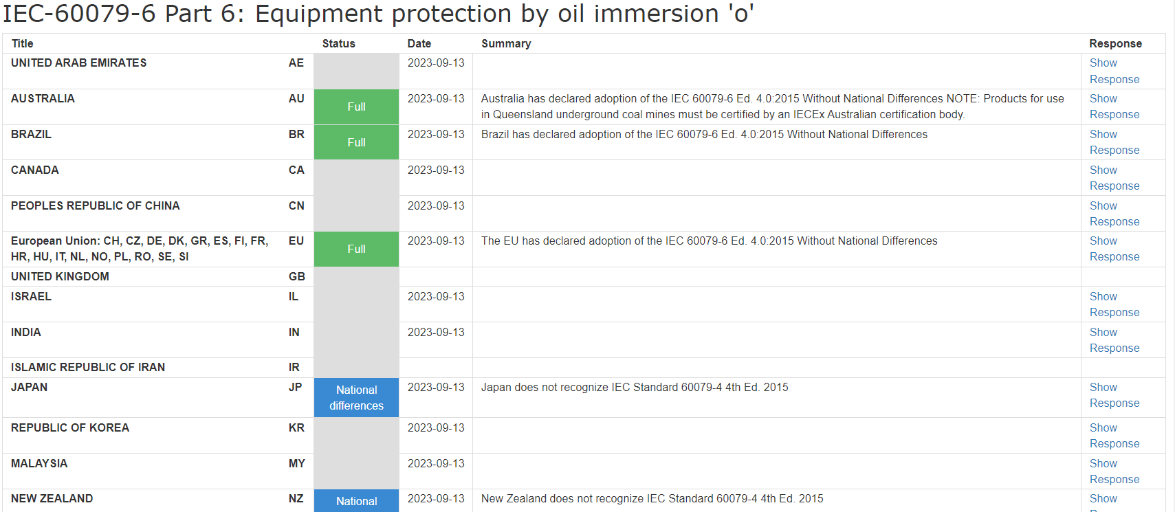
Links

By clicking on the country abbreviation in the main matrix page, you are presented with the full details by the country and by Standard. Click the ‘Show editions’ below country to get the view showing all editions. The links in right column ‘Response’ can be now viewed by Country by Standard and by edition.
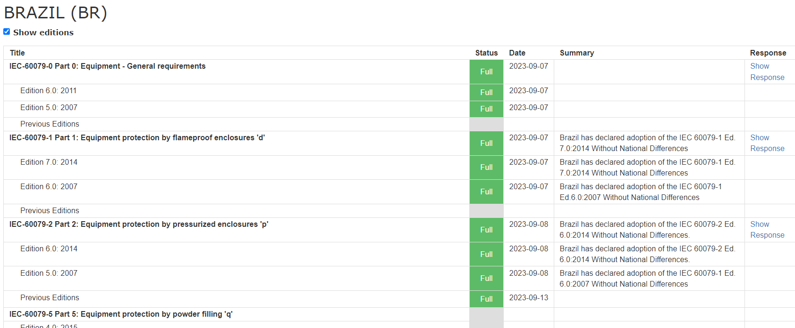
- (informative)
  - Guidance for IECEx Member Body or delegate on the use of the On-line Bulletin for administrative data entry and management
    - Password access
Staff of a Member Body or delegate associated with the MB (same country) will be provided, on request to the IECEx Secretariat via the info@iecex.com email account, with administrative rights for their country. The email must include the following:
Name:
Position:
Member Body (or delegate):
Email Address:
Access for a user is limited to a single unique password that can be used by suitably authorized staff of the member body in accordance with the body’s internal procedures. The individual staff member’s email addresses can then set their individual password and provide them with full administrative rights for their country.
The password enables MB staff to access the IECEx On-line Bulletin for their designated country to:
- Enter details of national differences, which may include the uploading of a document for each Standard and edition of the Standards operated by the IECEx.
- Enter specific contact information, with links in the public view form, so the public may reach out to the Member Body for further information, or to purchase the country national standard.
- Click the Full Acceptance of Standard/Edition which may include any specific requirements, to be noted in the overview section.
As Member Bodies or their delegate are responsible for the updating and maintenance of the IECEx On-Line Bulletin in accordance with the IECEx 02 Rules of Procedure, it is expected that the MB or delegate will be the primary administrators of the IECEx On-line Bulletin.
The IECEx On-line Bulletin can be found here.

Logging in

Go to the IECEx On-line Bulletin, click “Login” button on the top right-hand side of the page. Fill in your username and password and click on the blue “Login” button.
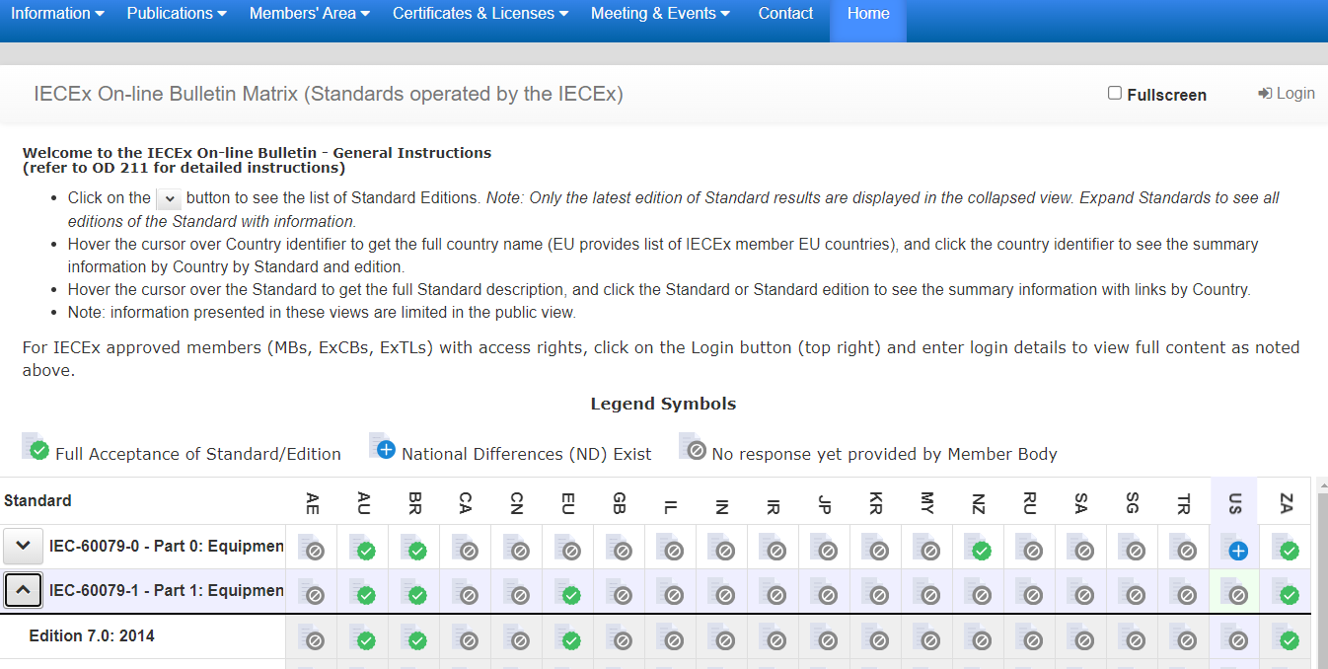
You can now access the administrative section of the IECEx On-line Bulletin for your registered country.

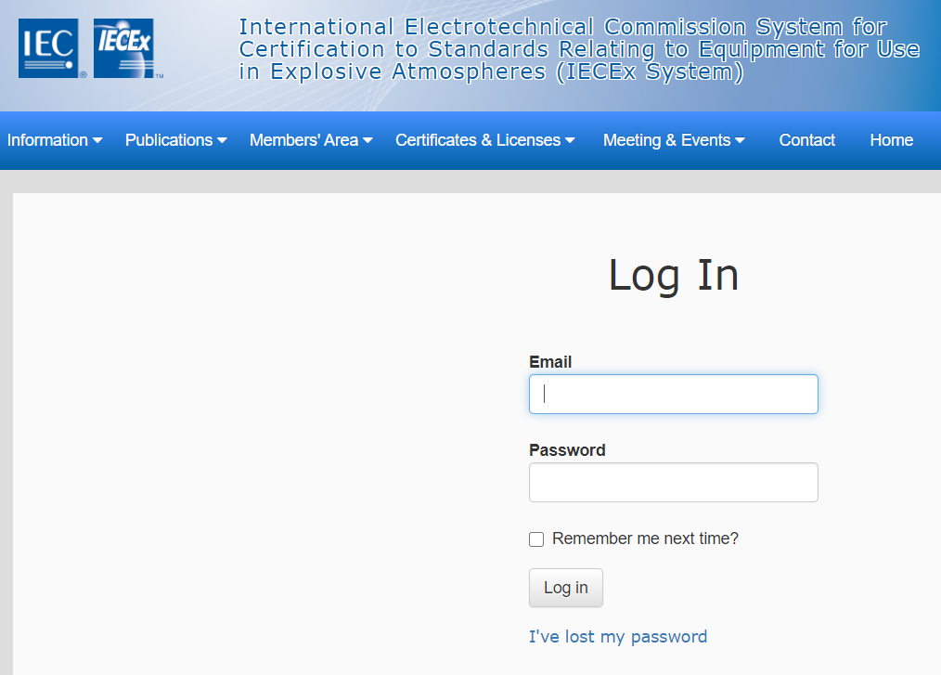
If you forget your password, you can use the “I’ve lost my password” link on the login page as shown below:
NOTE The system administrators cannot access this personalized password if you forget it.
If there is a need to reset a user’s password OR if access rights for a staff member of a Member Body or delegate needs to be revoked, contact the IECEx Secretariat for assistance.

    - Data entry
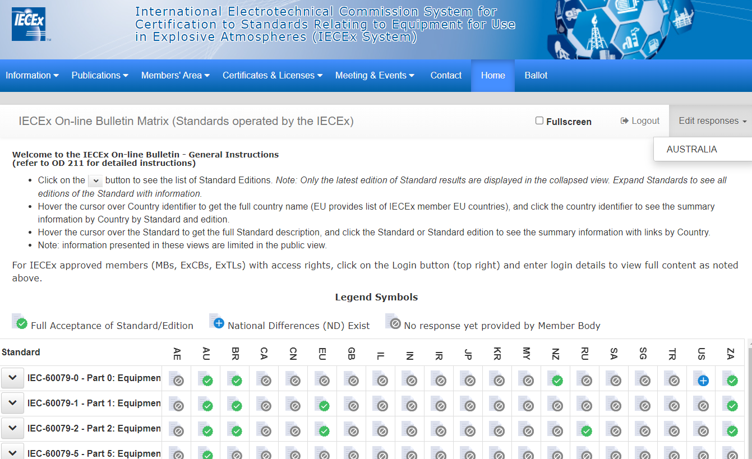
Access to enter data as the details of an agreement is done by first logging as an authorized user for your country. The login will display Country when clicking on the ‘Edit responses’ button, in the upper right corner when logged in. See screenshot below.

Data shall be entered into the Standards and editions field by clicking on the pencil on the left column as per the screenshot below:
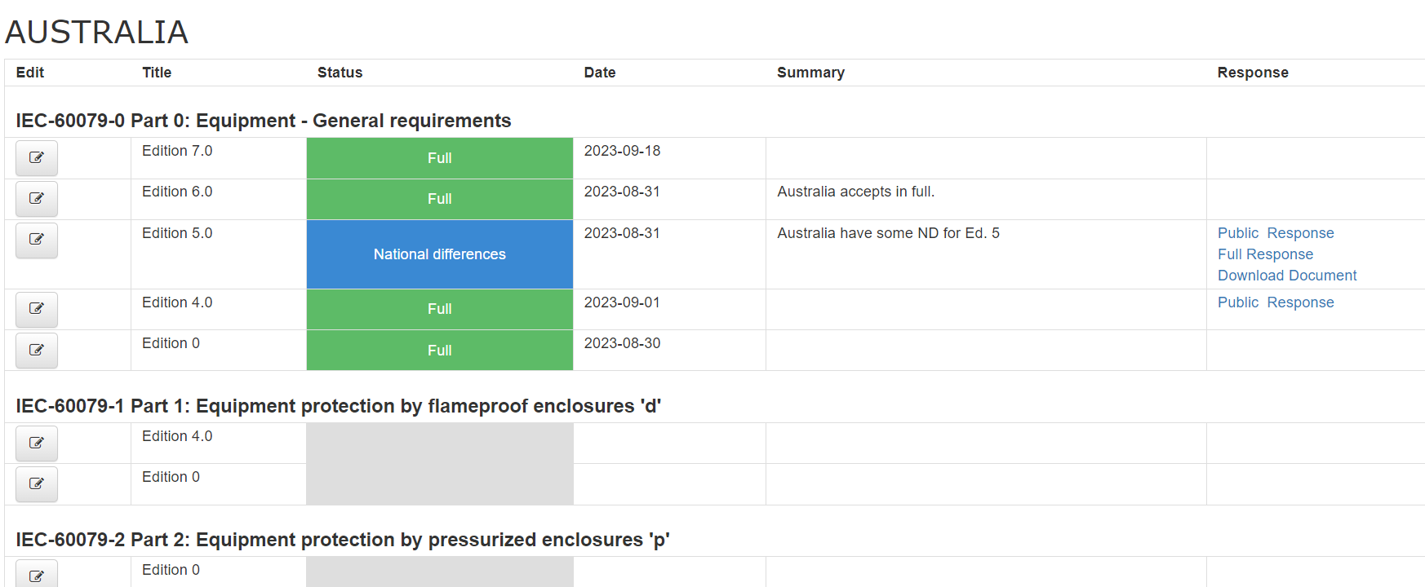
Click pencil to input data or edit
Caution should be exercised if cutting and pasting text with special characters from other documents as this may introduce hidden formatting codes that can disrupt the operation of the field and presentation of the data.

The Status field opens up and the selection can be made.
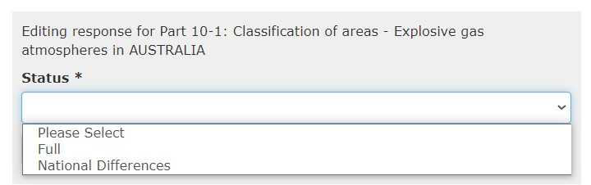
If Full is selected, then this opens three text fields to input further information, if required. The text fields may be used at the discretion of the Member Body and can be used to either inform authorised IECEx members or the public with specific communications. See examples below.
Summary: A paragraph informing others that the Standard is accepted in full. This text field is visible to the public.
Example: Country has declared adoption of the IEC 60079-1 Ed. 7.0:2014 Without National Differences

Full Response: This would be typically left blank if the Standard is accepted in full. This text field is not visible to the public and also provides the options to format the text.
Public Response: A statement that will be visible to the public. This may contain information on how to obtain more information specific to the Country. This text field permits links which may be an email address or a website.
Note: May include information on contacting the MB to purchase the Country Standard.
If National Differences is selected this opens the following options:
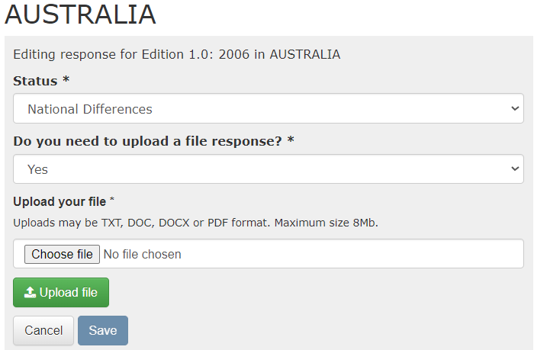
Click Yes to upload a document. Numerous file types are acceptable.
After uploading the document, you will be presented with two text fields, the Summary text field and the Public Response text field. (The Full Response is no longer required, as it will display that an attachment is available for download)
Alternatively, if a file document is not uploaded, you can simply click No, which will open the other three text fields, Summary, Full Response, and Public Response, where information can inserted in these fields as required.
Note: Remember to insert contact information or other info. in the Public field, so end users, manufacturers or regulators may know how to purchase a National Standard or who to contact for further information.
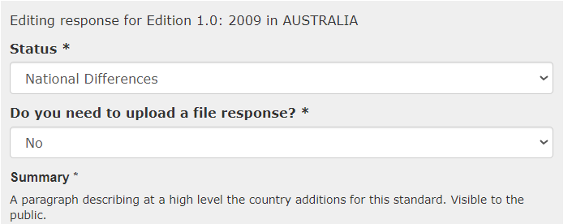
Note: Caution should be exercised if cutting and pasting text with special characters from other documents as this may introduce hidden formatting codes that can disrupt the operation of the field and presentation of the data.
    - Data modification/update
The Country input field also contains a Response column on the far right. This column provides access links to the responses previously made. Any edits will require clicking the edit column (pencil) on the left and saving.
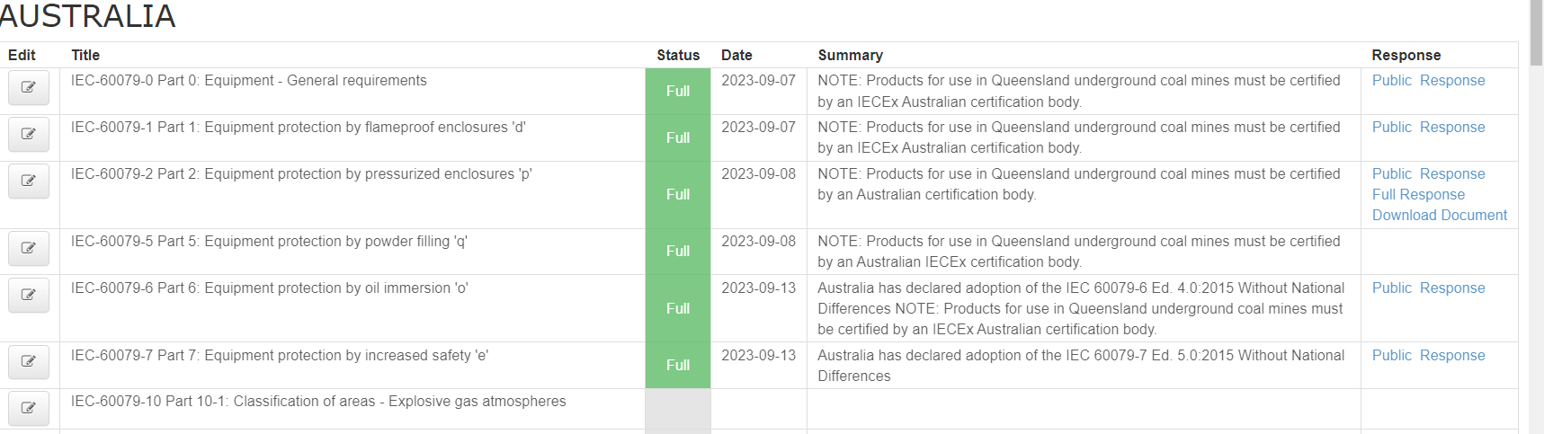
    - Deletions
Only edits of the records can be made by the MB or delegate. Should a full deletion of past ND acceptance, documents or comments be required, please contact the IECEx Secretariat to delete or edit the fields as requested by the MB or delegate.

